create database Kursi
use Kursi

-- 1. USERS
CREATE TABLE users (
id INT PRIMARY KEY IDENTITY(1,1),
name NVARCHAR(100) NOT NULL,
email NVARCHAR(150) UNIQUE NOT NULL,
password_hash NVARCHAR(255) NOT NULL,
--role NVARCHAR(20) NOT NULL CHECK (role IN ('professor', 'student')), Ketu jan te gjith users por tek roli ndahen
created_at DATETIME DEFAULT GETDATE()
);

-- 2. COURSES
-- A course belongs to one professor (via professor_id → users.id)
CREATE TABLE courses (
id INT PRIMARY KEY IDENTITY(1,1),
professor_id INT NOT NULL FOREIGN KEY REFERENCES users(id),
title NVARCHAR(200) NOT NULL,
description NVARCHAR(MAX),
created_at DATETIME DEFAULT GETDATE()
);

-- 3. ENROLLMENT QUESTIONS
-- Each course can have N questions. Type tells the frontend how to render it.
-- Drop in the right order (child first, then parent)
DROP TABLE enrollment_answers;
DROP TABLE enrollment_questions;

-- Recreate enrollment_questions (without course_id)
CREATE TABLE enrollment_questions (
id INT PRIMARY KEY IDENTITY(1,1),
question_text NVARCHAR(500) NOT NULL,
option_a NVARCHAR(200) NOT NULL,
option_b NVARCHAR(200) NOT NULL,
option_c NVARCHAR(200) NOT NULL,
option_d NVARCHAR(200),
display_order INT DEFAULT 0
);

-- Recreate enrollment_answers (same as before)
CREATE TABLE enrollment_answers (
id INT PRIMARY KEY IDENTITY(1,1),
application_id INT NOT NULL,
question_id INT NOT NULL,
selected_option NVARCHAR(1) NOT NULL CHECK (selected_option IN ('a', 'b', 'c', 'd')),
FOREIGN KEY (application_id) REFERENCES enrollment_applications(id),
FOREIGN KEY (question_id) REFERENCES enrollment_questions(id)
);

-- 4. ENROLLMENT APPLICATIONS
-- When a student applies, one row is created. Status tracks the decision.
CREATE TABLE enrollment_applications (
id INT PRIMARY KEY IDENTITY(1,1),
student_id INT NOT NULL FOREIGN KEY REFERENCES users(id),
course_id INT NOT NULL FOREIGN KEY REFERENCES courses(id),
status NVARCHAR(20) DEFAULT 'pending' CHECK (status IN ('pending', 'accepted', 'rejected')),
applied_at DATETIME DEFAULT GETDATE(),
UNIQUE(student_id, course_id) -- can't apply twice
);

-- 5. QUESTION ANSWERS
-- The student's answers linked to their application
CREATE TABLE enrollment_answers (
id INT PRIMARY KEY IDENTITY(1,1),
application_id INT NOT NULL FOREIGN KEY REFERENCES enrollment_applications(id),
question_id INT NOT NULL FOREIGN KEY REFERENCES enrollment_questions(id),
selected_option NVARCHAR(1) NOT NULL CHECK (selected_option IN ('a', 'b', 'c', 'd'))
);

-- 6. ASSIGNMENTS
-- Professor posts a task. file_url is optional (they might just write text).
CREATE TABLE assignments (
id INT PRIMARY KEY IDENTITY(1,1),
course_id INT NOT NULL FOREIGN KEY REFERENCES courses(id),
title NVARCHAR(200) NOT NULL,
description NVARCHAR(MAX),
file_url NVARCHAR(500), -- if professor uploads a file
due_date DATETIME,
created_at DATETIME DEFAULT GETDATE()
);

-- 7. SUBMISSIONS
-- Student replies to an assignment. Can be text, or a file upload.
CREATE TABLE submissions (
id INT PRIMARY KEY IDENTITY(1,1),
assignment_id INT NOT NULL FOREIGN KEY REFERENCES assignments(id),
student_id INT NOT NULL FOREIGN KEY REFERENCES users(id),
text_response NVARCHAR(MAX), -- if they type an answer
file_url NVARCHAR(500), -- if they upload a file
submitted_at DATETIME DEFAULT GETDATE(),
UNIQUE(assignment_id, student_id) -- one submission per student per assignment
);

Key Design Decisions to Understand
Foreign keys are relationships made explicit. courses.professor_id doesn't just store a number — it enforces that the number must exist in users.id. SQL Server will reject an insert if the professor doesn't exist. This is data integrity for free.
The UNIQUE constraint on enrollments (student_id, course_id) means the database itself prevents duplicate applications — you don't need to check this in your Node.js code.
status with CHECK means the column can only ever be 'pending', 'accepted', or 'rejected'. Again, the DB enforces your business rules.
file_url stores a path, not the file. Files live on disk (or later, S3/cloud). The DB just remembers where the file is. This is standard — never store raw files in SQL.

Insertimi I te dhenave
INSERT INTO enrollment_questions (question_text, option_a, option_b, option_c, option_d, display_order)
VALUES
('Why do you want to join this course?', 'Career growth', 'Personal interest', 'Required for degree', 'Other', 1),
('How many hours per week can you dedicate?', 'Less than 2', '2-5 hours', '5-10 hours', 'More than 10', 2),
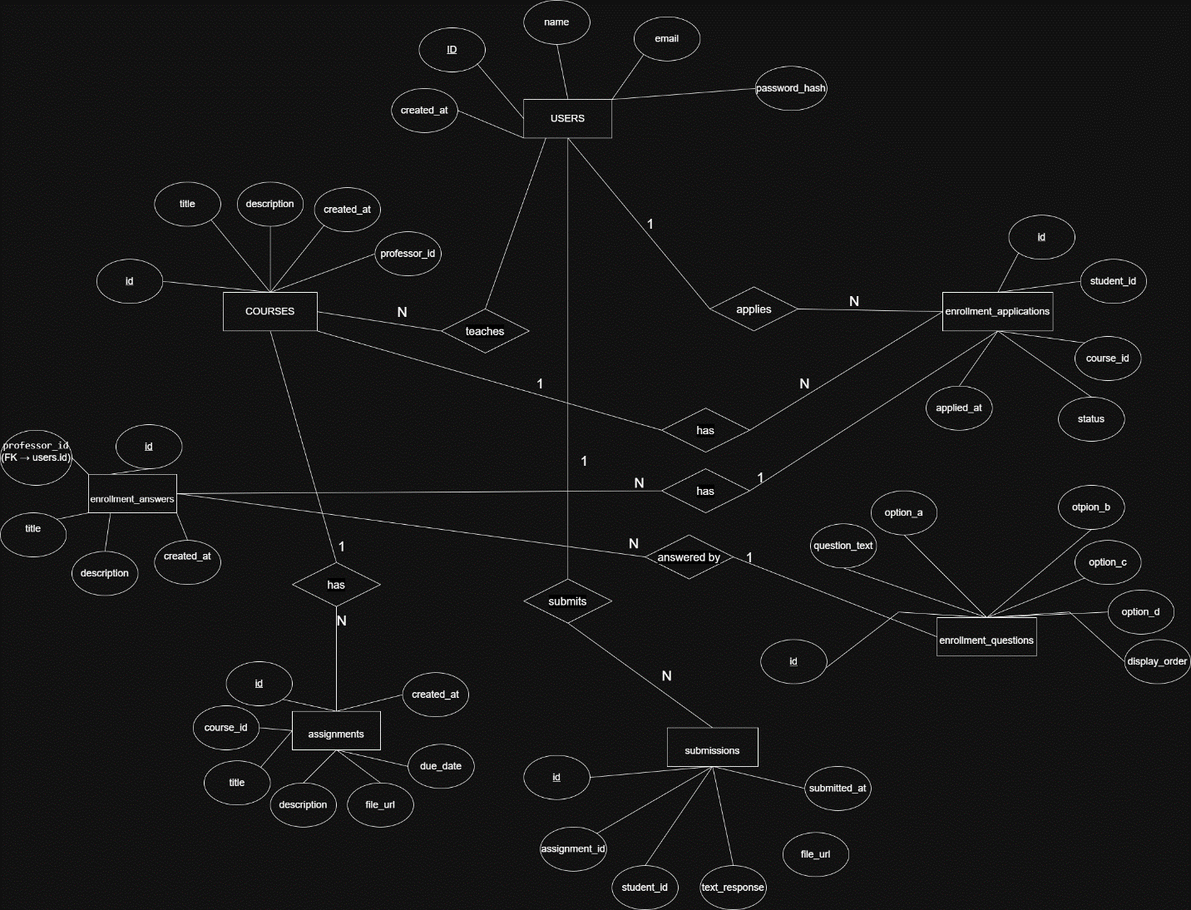
('What is your current experience level?', 'Beginner', 'Intermediate', 'Advanced', 'Expert', 3);

