Feature distillation after detector fine tuning across three starting pairs and fixed evaluation definitions
Hyerim Choi¹ and Tae-Kook Kim²*
¹ Department of Artificial Intelligence Convergence, Pukyong National University, Busan 48513, Republic of Korea.
² School of Computer and Artificial Intelligence Engineering, Pukyong National University, Busan 48513, Republic of Korea.
* Correspondence: king@pknu.ac.kr
ORCID for Hyerim Choi: 0009-0006-7311-4107

Abstract
Feature distillation can improve compact detectors, but its value after a substantial initial fine-tuning budget depends on the training intervention and evaluation definition. We studied a prespecified continuation regime using three independently fine-tuned YOLOv8 nano and large starting pairs. Each pair was trained for 100 epochs from fixed pretrained checkpoints. Seven matched student continuations then compared detection-only training with mean squared feature error and channel-wise distillation at coefficients 0.03, 0.3 and 3.0 for 40 epochs. All six base models and all 21 continuation paths at epochs 20 and 40 were evaluated, giving 48 fixed endpoints. We retained native ten-class BDD average precision, a common two-class evaluator on BDD and KITTI, and separate native KITTI scores. At epoch 40, the mean paired changes in BDD average precision were −0.0003, −0.0292 and −0.2597 percentage points for mean squared error, and +0.0096, −0.0497 and −0.2252 points for channel-wise distillation. Both coefficient-3 conditions decreased this metric in all three pairs. Common and native KITTI definitions yielded different descriptive effects; neither supports a causal explanation of transfer. Saved-state checks confirmed student updates and finite final states, while continuation mixed-precision counters recorded 916,981 applied and 299 skipped updates. The study provides an auditable sensitivity result for a narrow continuation regime, rather than a general ranking of distillation methods. Three pairs, reused validation populations, legacy annotation provenance and incomplete historical gradient instrumentation limit the conclusions.
Keywords: object detection; feature distillation; reproducibility; paired experiments; evaluation metrics

Introduction
A compact detector is useful only if its accuracy and computational cost suit its intended setting. Knowledge distillation adds a training signal from a larger model without necessarily changing the deployed student. Its effectiveness is therefore often assessed as an accuracy difference against a student trained without that signal. Such a difference is interpretable only when starting weights, training budgets, data order and evaluation rules are sufficiently controlled. This is especially important when the student has already received substantial task-specific training and the remaining gains may be small.
Feature imitation is an established approach. Fine-grained imitation emphasizes detector responses near objects [1], while focal and global distillation separates local and relational information [2]. Channel-wise distillation (CWD) transfers spatial probability distributions within feature channels [3]. These methods address different aspects of the representation, and their published gains do not imply that every later adaptation or training schedule will improve. Cho and Hariharan examined limits of transferring knowledge from more accurate teachers [4]. Work on projectors also shows that alignment and normalization can affect optimization [5]. These studies motivate careful comparisons; they do not identify the cause of any result in the present experiment.
Recent work continues to change the distillation design. The September 2026 CSCWD preprint transfers high-resolution teacher features across scales in a YOLO11 aerial-detection setting [6]. Our experiment instead retains same-scale features in YOLOv8 and studies a fixed continuation budget. We do not reproduce CSCWD, claim to outperform it, or treat its reported improvements as directly comparable to the driving-image results below. Our contribution concerns the interpretation and reproducibility of a bounded experiment, not a new loss function or detector architecture.
Earlier project experiments varied continuation randomness while sharing a starting student–teacher pair; some still earlier implementation records were unsuitable for estimating distillation effects. Those observations motivated a new protocol with independently fine-tuned starting pairs and explicit loader seeds. They are not pooled into the present sample, and historical pruning comparisons are outside the present analysis. The new protocol was frozen before its six base and 21 continuation runs, and all scheduled outcomes are reported.
We ask how paired mean squared error (MSE) and CWD continuation effects vary across three starting pairs and a fixed coefficient grid, and how their description changes when evaluation definitions are aligned. The design separates a primary BDD ten-class endpoint from secondary common-class and native KITTI diagnostics. It also checks whether the intended intervention actually updated parameters and whether numerical summaries can be traced to retained artifacts. This combination supplies a focused empirical result for continued training after 100 epochs; it does not estimate a general effect across architectures, datasets or schedules.

Materials and methods

Data provenance and evaluation populations
BDD100K provides varied driving imagery and multiple visual tasks [7]. This study uses a reconstructed legacy 2018-format label mirror, audited against the pinned source JSON, rather than authenticated official-host Detection 2020 labels. Of 70,000 candidate training images, 137 with unresolved labels were excluded before the new experiments. The remaining 69,863 images contain 1,286,870 native training boxes after removal of one exact duplicate. The validation population has 10,000 images and 185,526 boxes. No unidentified local test labels are used. The original labels and earlier outputs remain unchanged.
BDD validation had already been used in earlier project work. KITTI evaluation uses all 7,481 images of its public labeled object-detection training partition, also examined previously in this project [8]. It is an external dataset relative to BDD training, but neither a newly untouched holdout nor the official hidden KITTI test set. No KITTI score was used to select a coefficient, checkpoint, epoch or replacement run in this fixed stage. Common-category BDD annotations contain 115,768 person/car targets. The KITTI common projection contains 33,229 targets and 25,726 explicit ignore records.

Independent starting pairs and paired continuations
Ultralytics 8.2.103 was pinned [9]. For pair seeds 101, 202 and 303, YOLOv8 nano and large models each received 100 epochs of BDD fine tuning from fixed official COCO-pretrained checkpoints. Independence refers to task-specific initialization and training randomness, not to independent COCO pretraining or independent dataset samples. The three matched starting pairs are the unit of replication. Initial parameter digests and sampled actual input tensors differed across seeds within each architecture.
Base training used 640-pixel input, SGD with initial learning rate 0.01, final multiplier 0.01, momentum 0.937 and weight decay 0.0005. Batch sizes were 64 for nano and 16 for large, with nominal batch size 64 and the native accumulation behavior. Warmup lasted three epochs, mosaic closed during the last ten epochs, early stopping was disabled, and mixed precision was enabled. The final epoch-100 EMA checkpoint was retained, never a validation-selected best checkpoint. A preflight found that the native training-loader generator did not follow the requested seed. Before full training, it was replaced with a finite DataLoader whose generator seed is the pair seed plus 100003 times the zero-based epoch; workers were recreated each epoch while native data transforms and optimizer behavior were retained.
Each nano endpoint initiated seven 40-epoch continuations: a detection-only control and MSE or CWD at coefficients 0.03, 0.3 and 3.0. The paired large endpoint served as the frozen evaluation-mode teacher. Continuation data seeds were the pair seed plus 1000; an epoch-dependent generator used that seed plus 100003 times the one-based epoch. All seven arms in a pair used the same image and augmentation sequence. The first two actual input batches of every epoch were hashed, including image tensors, classes, boxes and batch indices. All 63 within-pair arm comparisons agreed over the 40 epochs for these sampled batches; this is not an assertion that every batch was archived.
Continuation used SGD in one parameter group with momentum 0.937, weight decay 0.0005 and no Nesterov momentum. The initial learning rate was 0.0001, with a cosine schedule over 40 epochs and final multiplier 0.1. Batch size was 64, with four workers and a final batch of 39 images. Mosaic, mixup and copy-paste were disabled. Native HSV, translation, scale and horizontal-flip augmentation remained active. The student was trainable except for its fixed distribution-focal-loss projection. The control followed the same optimization schedule. Gradient clipping used norm 10; the mixed-precision scaler started at 128. EMA used decay 0.9999 and time constant 2000. Epoch 40 is primary, while epoch 20 is a secondary checkpoint on the same 40-epoch schedule, not a separately optimized schedule.

Distillation objectives and normalization
Features were tapped at layers 15, 18 and 21. Student channel counts were 64, 128 and 256; teacher counts were 256, 512 and 512. Fresh learned 1 × 1 convolutions aligned the student to teacher channels at each scale. MSE was the mean squared difference across all batch, channel and spatial entries, summed across the three scales. CWD applied a spatial softmax separately within each channel to aligned student and detached teacher features. It summed teacher-to-student Kullback–Leibler divergence over spatial positions, averaged over batch and channels, and multiplied by the squared temperature, with temperature fixed at 4. The three scale losses were summed [3].
The optimized objective was the native batch-summed detection loss plus the actual batch size multiplied by the fixed coefficient and the summed feature loss. This explicit scaling matters: equal coefficients do not imply equal MSE and CWD objective strengths, and loss magnitude does not measure gradient contribution. Adapters were optimized with the student and discarded for inference. Teacher computation was detached in the trainer; offline checks establish teacher-file integrity, not a reconstruction of past live gradients. Complete frozen configuration files and loss diagnostics accompany the code release.

Fixed evaluation definitions
The roster was fixed to six base checkpoints plus both epochs 20 and 40 of all 21 continuations, for 48 endpoints. Standalone inference used FP32, square 640 × 640 input, batch size 32, confidence threshold 0.001, NMS IoU 0.7 and at most 300 detections per image. Original class-aware NMS considered all ten classes before person/car mapping. Saved input-shape, precision and image-ledger records verified actual execution. Native training-context validation numbers were retained as diagnostics and did not replace standalone scores.
The primary metric is native Ultralytics ten-class BDD AP50:95. Native matching and integration were left unchanged. The common diagnostic uses pycocotools 2.0.11 COCOeval [10,11], the same continuous-coordinate box convention on both datasets, IoUs from 0.50 to 0.95 in steps of 0.05, and the mean interpolated precision at 101 recall points. The two classes are person and car, equally weighted; all areas and every image are retained. This common diagnostic is distinct from native BDD integration and from the official KITTI metric.
The primary common KITTI view maps Van and Person_sitting to class-specific ignore records and DontCare regions to both classes using COCO crowd intersection-over-detection-area semantics. A second, no-ignore sensitivity view omits those ignore records. Neither duplicates native KITTI difficulty and ignore rules. Separately, the pinned original KITTI 2D matching core applies Car IoU > 0.7 and Pedestrian IoU > 0.5 with its original difficulty, neighbor-class and DontCare behavior [8]. Native AP_R40 averages saved precision slots 1–40, excluding slot 0. We retain all easy, moderate and hard class scores and summarize native results by the mean of Car and Pedestrian moderate AP_R40.
Before new external scoring, known-answer tests covered common matching and integration, annotation projections, serialization, empty images, duplicates, ignored regions and interrupted archive recovery. Actual GPU input geometry and precision were checked on synthetic fixtures for both architectures. Synthetic results validate software behavior, not detector accuracy. Image and label hashes bind evaluation inputs to the frozen plan. Prediction archives preserve committed batches and reject mismatched sources or inputs, enabling technical recovery without repeating completed inference.

Analysis and verification
For each coefficient and objective, the paired effect is the student score minus its pair-matched control score at the same epoch. We report all three values, their arithmetic mean and sample standard deviation, in percentage points. The same three pairs contribute every coefficient and epoch; 21 trajectories and 48 endpoints are not 21 or 48 independent replications. No significance threshold, equivalence margin, best-method selection or historical pooling was added after seeing results. The prespecified six epoch-40 contrasts remain primary, and all six epoch-20 contrasts remain secondary.
Saved-state audits checked changed raw parameters, finite model/adapter/EMA/optimizer tensors and final checkpoint equality to saved EMA after conversion to checkpoint precision. Continuation scaler-step accounting recorded applied and skipped optimizer updates, and saved EMA counts agreed with applied updates. Numerical audits verified all 48 endpoint artifact chains, replayed native BDD saved statistics and the three common score variants, and recomputed native KITTI precision integration. These audits reuse pinned metric implementations; they are not independent implementations of the matching algorithms. A separate local arithmetic checker then compared 960 metric values and all 16 group summaries and 12 contrasts through 4,480 numerical comparisons at absolute tolerance 10⁻¹².

Results

Primary effects across all strengths
The mean native BDD AP50:95 was 25.8932 for the base nano models and 33.2661 for the base large models. The epoch-40 detection-only controls averaged 25.9488. Table 1 reports every primary contrast. MSE at 0.03 was close to zero on average, with different signs across pairs. CWD at 0.03 increased the metric in all three pairs, but by only 0.0022–0.0188 percentage points. Both objectives at coefficient 3 decreased native BDD AP in all pairs. These observations describe the tested runs and are not equivalence or population-significance conclusions.
Table 1. All primary BDD ten-class AP50:95 contrasts at epoch 40. AP is reported on a 0–100 scale; differences and sample SD are percentage points. The control mean ± SD is 25.9488 ± 0.1666. Pair columns show treatment minus matched control.
Objective  coefficient | AP mean ± SD | Pair 101 | Pair 202 | Pair 303 | Difference  mean ± SD
MSE 0.03 | 25.9486 ± 0.1514 | +0.0199 | -0.0252 | +0.0045 | -0.0003 ± 0.0229
MSE 0.3 | 25.9197 ± 0.1549 | -0.0349 | -0.0385 | -0.0141 | -0.0292 ± 0.0132
MSE 3 | 25.6892 ± 0.0609 | -0.2328 | -0.3795 | -0.1667 | -0.2597 ± 0.1089
CWD 0.03 | 25.9585 ± 0.1584 | +0.0079 | +0.0022 | +0.0188 | +0.0096 ± 0.0084
CWD 0.3 | 25.8991 ± 0.0954 | -0.0341 | -0.1283 | +0.0133 | -0.0497 ± 0.0721
CWD 3 | 25.7237 ± 0.0415 | -0.1687 | -0.4009 | -0.1059 | -0.2252 ± 0.1554

Figure 1 shows the individual paired effects without treating standard deviation as a confidence interval. The largest mean primary reduction was 0.2597 percentage points for MSE at coefficient 3. All primary mean differences were within 0.26 points in magnitude. The small range should not be interpreted as a prespecified practical-equivalence finding; no such margin was defined.
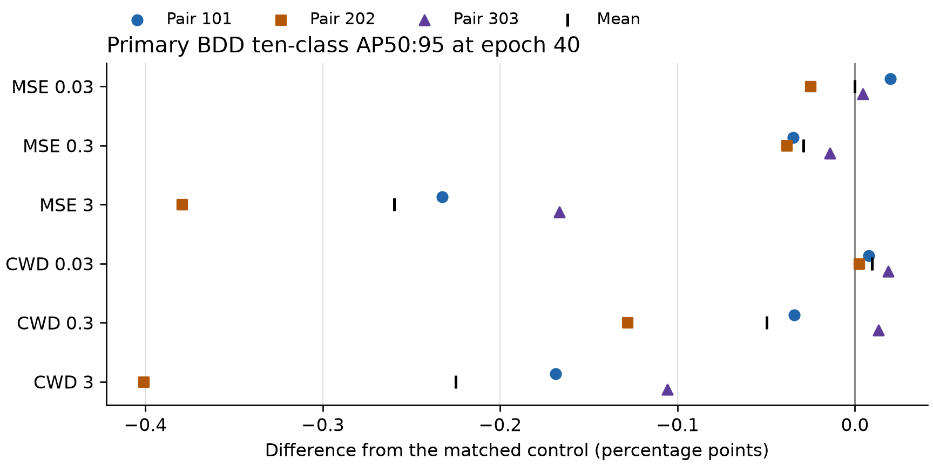
Figure 1. All three paired primary differences for each objective and coefficient. Colored points identify starting pairs; black ticks show means. Plotting code was prepared with OpenAI Codex assistance from the verified numeric table; no observations were generated or altered for the figure.

Common and native evaluation views
Table 2 retains the common BDD and both common KITTI variants alongside the native KITTI summary. At coefficient 3, common BDD differences were also negative on average: −0.1197 for MSE and −0.0890 for CWD. The corresponding common KITTI source-ignore changes were −0.0399 and +0.0099, whereas native KITTI mean-moderate changes were +0.0787 and +0.1061. These scores use different definitions and cannot be substituted for one another.
Table 2. Epoch-40 paired differences under every secondary evaluation definition, mean ± sample SD in percentage points. Common AP uses two classes and 101 recall points. KI and KN respectively denote KITTI source-ignore and no-ignore sensitivity views. Native KITTI is mean moderate Car/Pedestrian AP_R40.
Objective  coefficient | BDD common | KITTI KI | KITTI KN | KITTI native
MSE 0.03 | 0.0218 ± 0.0488 | -0.0132 ± 0.0269 | -0.0164 ± 0.0156 | 0.0087 ± 0.0213
MSE 0.3 | 0.0144 ± 0.0534 | 0.0021 ± 0.0399 | 0.0079 ± 0.0696 | 0.0419 ± 0.1891
MSE 3 | -0.1197 ± 0.0286 | -0.0399 ± 0.1167 | -0.0288 ± 0.1079 | 0.0787 ± 0.2718
CWD 0.03 | 0.0198 ± 0.0506 | -0.0187 ± 0.0072 | -0.0296 ± 0.0173 | -0.0146 ± 0.0140
CWD 0.3 | 0.0163 ± 0.0452 | -0.0094 ± 0.0721 | -0.0135 ± 0.0913 | 0.0682 ± 0.1633
CWD 3 | -0.0890 ± 0.0481 | 0.0099 ± 0.1833 | 0.0053 ± 0.1831 | 0.1061 ± 0.3936

Figure 2 illustrates pair-level variability under the common source-ignore and native KITTI definitions. In particular, positive native mean differences can coexist with near-zero or negative common mean differences. The comparison demonstrates dependence on the chosen endpoint. It does not isolate annotation effects, class composition, scene distribution, teacher quality or domain shift as a cause. The source-ignore and no-ignore values are both retained instead of choosing the more favorable diagnostic.
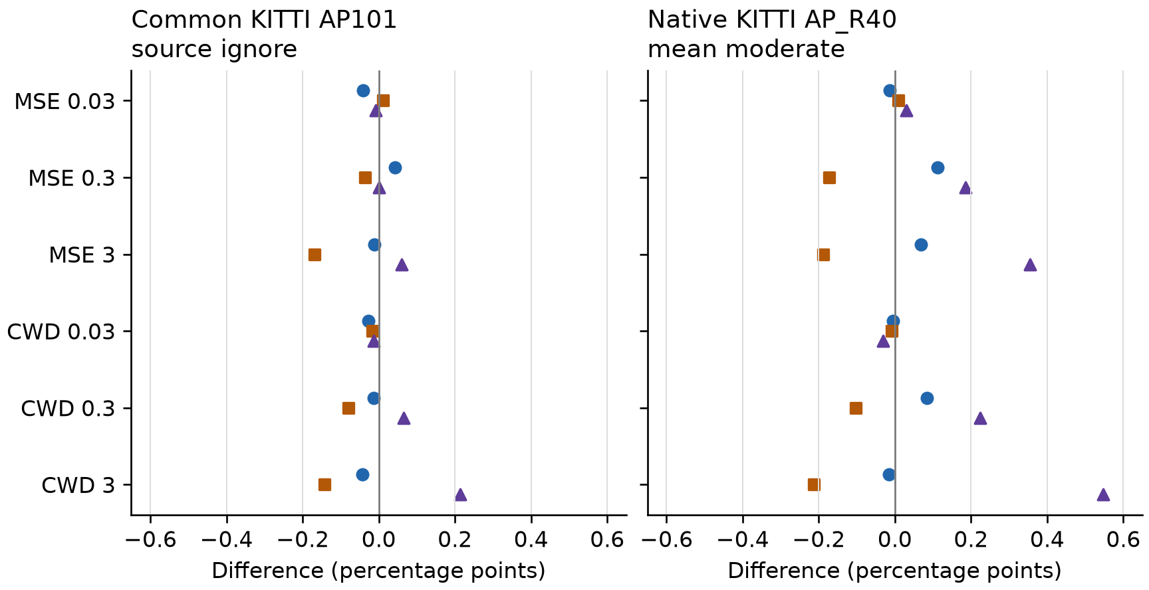
Figure 2. All epoch-40 paired KITTI effects under two distinct definitions. Colors and markers follow Figure 1. Both panels use the same axis range; individual points are three training pairs, not independent image samples. OpenAI Codex assisted with plotting code using the same verified observations.
The teacher bases averaged 42.1999 on common KITTI source-ignore AP and 76.7316 on native mean moderate AP_R40, compared with 38.9400 and 71.1691 for the student bases. Thus the larger models had higher averages on these definitions as well as native BDD. This descriptive teacher advantage does not establish how teacher representations affected the distillation gradients. Continued detection-only training raised the native BDD mean from 25.8932 to 25.9488 while lowering the native KITTI mean from 71.1691 to 70.6228; it is a contextual before/after observation, not a separately randomized comparison of training schedules.

Secondary endpoints and execution checks
All epoch-20 endpoints are retained in S1 Supplement and the machine-readable analysis. Their primary-metric paired mean differences were −0.0005, −0.0325 and −0.2774 for MSE, and −0.0076, −0.0082 and −0.2130 for CWD, in ascending coefficient order. The CWD 0.03 mean changed sign between epochs 20 and 40. Both high-coefficient means remained negative. We do not choose an epoch by its direction or interpret epoch 20 as a separate training replication.
All 27 scheduled training runs completed. Saved raw parameter tensors changed in every trainable student path, and final model, adapter, optimizer and EMA tensors were finite. Across the 21 continuations, 917,280 optimizer attempts comprised 916,981 applied updates and 299 mixed-precision skips. The first-batch weighted distillation-to-detection loss ratios averaged 0.00967, 0.09674 and 0.96735 for MSE, and 0.00721, 0.07215 and 0.72146 for CWD. These ratios explain the numerical scale of the tested objectives, not their causal gradient influence. All fixed-epoch loss summaries and every trajectory’s counters are retained in S1 Supplement and JSON.

Discussion
The principal result is conditional: adding these same-scale feature objectives to this conservative post-100-epoch schedule produced very small effects at coefficient 0.03 and negative mean BDD effects at larger coefficients. The negative coefficient-3 differences appeared in each starting pair for both losses. By changing task-specific starting pairs while preserving within-pair controls, the study goes beyond variation in continuation randomness around a single pair. However, three pairs remain a small sample, and all share pretrained sources and data populations.
This result does not contradict reports of successful detector distillation [1–3,6]. Those studies use their own architectures, loss designs and training regimes. Nor does it prove that feature distillation is ineffective after convergence: convergence itself was not established by a separate criterion, and the chosen continuation learning rate, adapters and augmentations form one specific intervention. We use “after fine tuning” to describe the observed 100-epoch starting point. Testing early-stage distillation, different projectors or other teachers would require separate, prospectively specified experiments. The present analysis offers no basis for selecting such settings using KITTI scores.
The two external score families answer different questions. Native KITTI applies class-specific overlaps and difficulty rules, whereas common AP averages ten IoU thresholds using a shared two-class implementation. Reporting both avoids presenting a favorable sign from one definition as universal transfer improvement. Even harmonized classes and integration do not align all annotation semantics or scene dependence. Our comparison therefore supports transparent metric reporting, not a causal mechanism for cross-dataset behavior.
The execution evidence also has a limited but concrete role. Parameter and state checks exclude the specific failure mode in which a completed student never changes. Actual scaler counts distinguish attempted from applied updates. Hashes and retained numerical statistics connect the published table to fixed files. These checks cannot validate the underlying research judgment, authenticate an unavailable official label release, or make an AI-assisted audit independent of its software assumptions. Reporting these boundaries is part of the result.

Limitations
The study includes one detector family, two feature objectives, three coefficients and three independently fine-tuned pairs. Shared COCO pretraining and reused BDD validation limit generalization; the legacy-label mirror is not authenticated Detection 2020 ground truth. Previously examined KITTI training images are not an untouched external test, and correlations among scenes are not modeled. No image bootstrap, confidence interval or significance/equivalence claim is made. The coefficient grid is a sensitivity analysis, not an optimization or method ranking.
Base training did not record actual per-step AMP applied/skipped counters, so they cannot be reconstructed from EMA totals. Only final raw continuation sidecars were retained; epoch-20 checkpoints are finite and hash-bound but lack the same independent full-precision EMA reconstruction as epoch 40. Per-batch gradient norms were not archived. There are 281 undefined or nonfinite epoch gradient-median records; their count does not reveal how many backward passes were nonfinite. Finite saved states and valid final updates do not prove that every intermediate gradient was finite. Numerical replay uses the pinned metric implementations, replays saved native BDD matches, and integrates native KITTI precision curves without independently repeating its C++ matching core.
Concurrent training wall time includes diagnostic evaluation and state writes. No isolated latency, energy, memory, pruning or deployment-safety benchmark was conducted in this stage. The students retain the nano inference architecture after adapter removal, but the study does not establish a new speedup. Full prediction archives and model binaries remain retained on the research server; the public package contains all endpoint metrics and hash-bound audit records, rather than a complete binary/raw-data archive. A durable access arrangement requires author review before journal submission.

Conclusions
Across three independently fine-tuned starting pairs, fixed MSE and CWD continuations yielded small low-coefficient effects and adverse high-coefficient BDD effects under the tested schedule. All 48 endpoints and all planned evaluation definitions are preserved. The contribution is a reproducible, bounded account of objective sensitivity and metric-dependent interpretation. Broader claims about distillation, teacher quality or domain shift require new evidence rather than a favorable subset of these results.

Data and code availability
The public project repository contains the frozen protocol, training and evaluation sources, synthetic validation records, all 48 endpoint scores, all paired contrasts, numerical audit proofs and figure source code. The new materials are labeled independent_replication_20261017 and are distinct from historical experiments. BDD and KITTI images and labels are obtained from their respective providers or the explicitly documented legacy mirror; they are not redistributed in this package. Checkpoint and prediction-archive hashes identify retained server artifacts. Full public deposition and permanent data access are not claimed in this author-review draft.
Public code and result repository

AI assistance
OpenAI Codex assisted with protocol and implementation development, code review, experiment orchestration, numerical analysis, literature and journal-policy retrieval, manuscript drafting and revision, and document and plotting code. Reported observations were computed by the recorded detector runs and evaluators. Automated checks included synthetic known-answer cases, artifact hashes, saved-state comparisons, numerical replay and a separate arithmetic calculation; these checks do not substitute for author validation. The figure legends identify assistance with plotting code. This draft records that assistance; the authors’ review and adoption of the analysis, references, disclosure and final wording remain pending.

Funding and author declarations
No research funding acknowledgment is included, following the author-provided funding information. The listed authors are Hyerim Choi and Tae-Kook Kim. Individual contribution roles, competing-interest statements and final author approval must be confirmed by both authors before submission; this draft does not assert that those declarations have been completed.

References
[1] Wang T, Yuan L, Zhang X, Feng J. Distilling Object Detectors with Fine-grained Feature Imitation. CVPR. 2019;4933–4942.
[2] Yang Z, et al. Focal and Global Knowledge Distillation for Detectors. CVPR. 2022;4643–4652.
[3] Shu C, et al. Channel-wise Knowledge Distillation for Dense Prediction. ICCV. 2021;5311–5320.
[4] Cho JH, Hariharan B. On the Efficacy of Knowledge Distillation. ICCV. 2019;4794–4802.
[5] Miles R, Mikolajczyk K. Understanding the Role of the Projector in Knowledge Distillation. AAAI. 2024. arXiv:2303.11098v5.
[6] Zamani A, Ghasemi-Naraghi Z. CSCWD: Cross-Scale Channel-wise Knowledge Distillation for Lightweight Tiny Object Detection on Edge Devices. Preprint. 2026. arXiv:2609.30395v1.
[7] Yu F, et al. BDD100K: A Diverse Driving Dataset for Heterogeneous Multitask Learning. CVPR. 2020.
[8] KITTI. Object detection evaluation and original developer kit. Accessed 21 October 2026.
[9] Ultralytics. Release v8.2.103. Version pinned for this study.
[10] Lin TY, et al. Microsoft COCO: Common Objects in Context. ECCV. 2014. arXiv:1405.0312.
[11] COCO API. Python COCOeval implementation. pycocotools 2.0.11 pinned in this study.
[12] BDD100K. Dataset download documentation distinguishing legacy and updated detection annotations.
[13] Solesensei. BDD100K legacy data mirror used in the project annotation audit.
Annotation provenance in Methods follows the project’s archived comparison to the legacy mirror [12,13]. The current review is a focused literature comparison, not a systematic review.

Supporting information
S1 Supplement. All 48 endpoint scores under five evaluation definitions; all native KITTI difficulty scores; both epochs’ paired summaries; objective-scale diagnostics; execution, recovery and verification boundaries. The accompanying JSON retains all 20 metrics per endpoint without rounding.

