Reassessing Pruning and Feature Distillation for Lightweight YOLOv8
Hyerim Choi¹, Tae-Kook Kim^{2,*}
¹Department of Artificial Intelligence Convergence, Pukyong National University, Busan 48513, Republic of Korea
²School of Computer and Artificial Intelligence Engineering, Pukyong National University, Busan 48513, Republic of Korea
Corresponding author: Tae-Kook Kim (e-mail: king@pknu.ac.kr).
ORCID (Hyerim Choi): 0009-0006-7311-4107.
ABSTRACT Compression results require evidence that the intended detector learned and that evaluation definitions support the claimed conclusion. We reassess YOLOv8 pruning and feature distillation through state audits, annotation reconstruction, two matched continuation studies and frozen external testing. Two archived distillation runs leave all 184 student parameter tensors unchanged, invalidating their treatment-effect interpretation. After correcting trainability and data seeding, two separate nine-run studies compare no-distillation continuation, mean-squared-error (MSE) feature matching and channel-wise distillation (CWD). The fresh phase excludes 137 images with unidentified annotations and trains new student and teacher models for 100 epochs on 69,863 source-reconstructed images. Its three-seed final average-precision differences across intersection-over-union thresholds 0.5 to 0.95 are -0.03193 and -0.07841 percentage points for MSE and CWD relative to matched controls. In a prespecified 25-model evaluation on 7,481 publicly labeled KITTI images unused for study training or selection, corresponding moderate Car/Pedestrian differences are +0.03705 and +0.14154 points. Both external differences are positive in every fresh seed, although every continuation remains below the fresh starting detector. Thus the internal negative result does not establish general distillation failure. Historical pruning reduces parameters from 3.013 to 1.196 million but increases measured single-precision model-only time from 1.239 to 1.313 milliseconds. The contribution is a reproducible reassessment that distinguishes intervention validity, annotation exposure and evaluation-dependent objective effects, with explicit limits from shared starting models, reused validation and legacy-source provenance.
INDEX TERMS Autonomous driving, BDD100K, knowledge distillation, model compression, object detection, reproducibility, structured pruning, YOLOv8.

I. INTRODUCTION
Efficient object detection for driving scenes requires evidence about both recognition quality and resource use. A small parameter count reduces the space needed to represent a model, but it does not determine how quickly a particular implementation executes. Similarly, an auxiliary training loss can decrease while the detector intended to benefit from that loss remains unchanged. These distinctions are especially consequential for compact detectors, where relatively small changes in accuracy can affect the choice of a deployment configuration. The Berkeley DeepDrive dataset BDD100K provides a diverse driving benchmark for examining such trade-offs [1], and the scaled You Only Look Once version 8 (YOLOv8) family provides a common implementation for constructing student and teacher detectors [2].
Knowledge distillation (KD) transfers information from a teacher through an additional training objective [3]. Structured pruning instead removes coupled channels and changes the deployed graph [4]. Combining the two can produce an efficient detector, but the contribution of each operation depends on the training and evaluation conditions. Reviews of pruning research have identified inconsistent comparisons and incomplete reporting as obstacles to interpreting compression results [5]. Recent applications combine distillation and pruning for construction imagery [6] and aerial detection [7]. Such systems motivate component analysis, but their reported gains cannot establish what an unchanged objective will do on a different student, dataset, or software implementation.
The present work revisits a YOLOv8 compression campaign on the ten-class BDD100K detection task. Initial comparisons appeared to show that feature distillation did not improve a trained nano detector and that using a smaller teacher did not change that outcome. A checkpoint-level audit revealed that the student parameters in two archived distillation runs had never changed. The apparent result therefore concerned an invalid training intervention, rather than the effectiveness of distillation. This finding changes the empirical question: before interpreting a neutral compression result, can the intended model update be demonstrated from gradients and saved states?
We address this question by separating the validity of a learning intervention from the accuracy and execution characteristics of the resulting detector. The study combines checkpoint and gradient evidence with a full comparison against annotations in JavaScript Object Notation (JSON), fresh evaluation of archived artifacts, class and illumination analyses, and interleaved runtime measurements. After an initial fixed-data validity probe, two separately reported nine-run phases compare continuation without KD, uniform mean-squared-error (MSE) feature matching, and channel-wise distillation (CWD) across three data and augmentation seeds per phase. The second phase excludes annotations of unknown origin and trains a fresh student and teacher from official Common Objects in Context (COCO)-pretrained weights. Endpoints and actual input/state checks are specified before aggregation. A fixed 25-model external evaluation then tests the two directly mapped categories on KITTI without adapting models to its scores.
Six questions organize the study. RQ1 asks whether the archived KD interventions changed the student parameters. RQ2 asks whether the evaluation conversion agrees with the source annotations and whether discrepancies alter the observed accuracy. RQ3 asks how available pruned artifacts trade structural savings for accuracy across classes and illumination groups. RQ4 asks whether corrected feature matching improves a student over continuation without KD under the examined training conditions. RQ5 asks whether structural savings translate into lower model-only latency in the measured execution environment. RQ6 asks whether the direction of a matched objective difference persists under a fixed external evaluation with explicitly different classes and scoring rules.
The first contribution is an intervention-verified comparison that separates an invalid historical KD result from two valid, conditional objective studies. The second is a quantified annotation audit, fixed-prediction sensitivity analysis, and fresh-training replication that removes exposure to the unidentified training labels. The third is a fixed external assessment that changes the interpretation of an internal negative result: small positive fresh-phase differences on KITTI coexist with negative BDD100K differences. Together with class, illumination and runtime measurements, the study identifies which component conclusions survive implementation and evaluation checks. It does not attribute historical artifact differences or cross-metric sign changes to an isolated causal mechanism.
The contribution is a reproducible empirical reassessment of specific YOLOv8 configurations, not a new detector, a general ranking of distillation methods, or evidence of deployment safety. All 18 objective-comparison runs and all 25 frozen external outcomes are reported, including both positive and negative differences. The two phases are not pooled as six independent starting-model repetitions. Artificial intelligence (AI) assistance in preparing the manuscript and experimental tools is disclosed in the Acknowledgment [8].
II. RELATED WORK
A. FEATURE DISTILLATION AND THE INTERPRETATION OF NEUTRAL RESULTS
The original KD formulation transfers predictive information from a larger model [3]. FitNets extended transfer to intermediate representations and introduced learned mappings between teacher and student feature dimensions [9]. Dense detection makes the transfer target more complicated: background locations can dominate a spatial average, while the useful information for classification and localization need not coincide. Fine-grained feature imitation emphasizes locations near objects [10], and focal and global distillation treats foreground, background, and spatial relationships separately [11]. Channel-wise distillation compares spatial distributions within channels [12], localization distillation transfers bounding-box information [13], and disparity-based distillation adjusts how feature differences are transferred [14]. These approaches provide substantive alternatives to uniform mean-squared-error (MSE) matching.
Teacher capacity is another relevant factor, but parameter ratio alone is not an explanatory test. Teacher-assistant distillation addresses a mismatch through an intermediate model [15], while Cho and Hariharan show that teacher strength and student benefit do not have a simple monotonic relationship [16]. To assess such explanations, the student must actually receive and apply the proposed training signal. A decreasing adapter loss with a frozen student does not satisfy that requirement. Our audit concerns this implementation condition and does not challenge the reported results of those methods.
B. STRUCTURED PRUNING AND COMBINED PIPELINES
Dependency-aware pruning groups parameters whose dimensions must change together, allowing channel removal in architectures with residual paths and concatenations [4]. This is relevant to YOLOv8 because independently deleting filters can invalidate downstream shapes. However, dependency handling is distinct from the ranking criterion, the allocation of pruning ratios, and the subsequent optimization schedule. A dependency-aware implementation can use local or global ranking; the two should not be inferred from the pruner's name.
Combined pipelines such as KSG-YOLO [6] and the aerial YOLOv8 compression framework [7] demonstrate the practical interest in using distillation alongside pruning. We cite them as examples of combined designs, without claiming that their component controls are absent or comparing their absolute accuracy with BDD100K. Their datasets, objectives, architectures, and execution stacks differ from the present study. The broader lesson from standardized pruning evaluation [5] is to make those differences explicit before attributing an outcome to a compression mechanism.
C. MEASUREMENT AND REPRODUCIBILITY
Parameter count, checkpoint size, estimated operations, and latency answer different questions. Serialization can include metadata and can store weights at a precision different from the precision used for inference. Convolution and batch-normalization fusion can also change the number of stored parameters without changing the detector's intended function. Benchmarking principles therefore require a stated execution boundary and configuration [17]. Our measurements are not MLPerf submissions; the citation motivates transparent specification of the measured workload.
Software state is part of that specification. PyTorch distinguishes a module's training mode from whether its parameters require gradients [18]. Calling the training-mode method changes behaviors such as batch normalization, but does not itself make frozen parameters trainable. Torch-Pruning also depends on a valid autograd graph when constructing structural dependencies [19]. These distinctions motivate explicit checks before a numerical result is interpreted as evidence about a learning method.
Our question differs from the objective-design questions in [10]-[14] and the compression designs in [6], [7]. We investigate whether an apparent component result can be attributed to the intended intervention once saved parameter states, annotation correspondence, and execution conditions are examined jointly. This is a gap in the evidence for the examined campaign, rather than a claim that prior studies universally omit such checks. The resulting audit and measured sensitivity provide a reusable way to distinguish a failed implementation from an unfavorable but valid experimental result.
III. MATERIALS AND METHODS
A. DATA AND ARCHIVED ARTIFACTS
The local BDD100K detection conversion contains 70,000 training images and 10,000 validation images, with corresponding label files. The class order is person, rider, car, bus, truck, bike, motor, traffic light, traffic sign, and train. SHA-256 comparison of every encoded image found no exact image-file overlap between these two splits. The training and validation splits contain 69,999 and 9,998 distinct image hashes, respectively; repeated files within each split are retained to preserve the historical evaluation population. This does not exclude perceptual duplicates or establish video-level independence. The validation labels contain 185,578 instances; only 15 belong to the train category. We retain all ten classes in the macro-average and report the rare category explicitly.
The original download was not documented contemporaneously. Subsequent tracing identified a Kaggle YOLO-format distribution [20] through five byte-identical configuration, label, and image samples. We then retrieved the original-format BDD100K JSON annotations from a public mirror distributed before the 2020 revision [21]. The official documentation distinguishes the legacy 2018 annotations from Detection 2020 and recommends the revised release [22]. Our full comparison establishes correspondence to the retrieved 2018 JSON; these experiments must not be described as Detection 2020 results. The mirror's JSON hashes are retained, but we do not claim authentication against an archive retrieved directly from the official host.
Comparison uses image filenames and multisets of class IDs and normalized center coordinates, width, and height rounded to six decimals. Row order is ignored while duplicate multiplicity is retained. All 185,526 positive-area validation boxes in 10,000 images match the JSON. The local conversion additionally contains 52 zero-area boxes in 51 images. For training, all 1,286,871 source boxes in 69,863 images match; these images also contain 393 extra zero-area boxes locally. Another 137 local training images, containing 1,141 boxes, are absent from the retrieved JSON and remain unverified. Thus correspondence is established for 99.80% of training images and all validation images, with the stated box discrepancies; it is not a verification of every training label.
The external package also supplies 20,000 labeled test images without a documented label-generation process. Official maintainers describe withheld test annotations and server-based evaluation [23]. We exclude these local test labels from every accuracy claim. One encoded image is shared between the local training and test directories. Neither the provenance audit nor the supplementary evaluation rewrites the historical training data. The historical trained models therefore remain conditional on the original conversion, including the unverified training subset. The fresh-training phase in Section III-H is explicitly separate and never initializes from those BDD-trained models.
All internal detector evaluations use an image size setting of 640 and the standard Ultralytics validation preprocessing. The archived baseline is a Common Objects in Context (COCO)-initialized YOLOv8n model trained for 100 epochs with batch size 64 and seed 0. The stored configuration specifies automatic optimizer selection. Inspection of the installed version shows that its long-run branch selects stochastic gradient descent (SGD), rather than AdamW. The large teacher's log contains 92 epochs, and the small teacher's log contains 100. The two available standalone KD logs contain 30 epochs each. Thus the historical campaign cannot be described as having a common 100-epoch budget across all conditions.
The archived implementation is identified by repository commit 4f5be41e22ea8696800e94611688777a7cbb883a [24]. The numerical reassessment uses the project's Python 3.12.3 environment, PyTorch 2.5.1 with CUDA 12.1, Ultralytics 8.2.103, and Torch-Pruning 1.6.0. The server has two NVIDIA GeForce RTX 4090 devices; each individual evaluation or training run uses one device. Checkpoint hashes, file sizes, class metrics, scripts, and configuration records accompany the analysis. Corrected code and the additional records are published separately at the revision specified in the Code and Data Availability statement.
B. AUDIT OF THE DISTILLATION IMPLEMENTATION
The archived standalone distillation script loads a trained student and calls its training-mode method. We inspect the number of parameters requiring gradients immediately after loading, after the mode change, and after explicitly enabling student training. We then backpropagate the feature-matching loss and count parameter tensors receiving gradients in the student and in the adapters. A separate check compares every named student parameter in each archived unfused state dictionary with the baseline. Running means, running variances, and batch counters are compared separately because they are buffers rather than learned parameters.
The distinction is essential: batch-normalization buffers can change during forward passes even when the convolutional and normalization parameters receive no gradient. The inference function can therefore change slightly despite the absence of student learning. Comparing saved states provides stronger evidence about this failure mode than comparing rounded validation scores alone. The two archived configurations are retained as audit records and excluded from estimates of successful KD treatment effects.
C. STRUCTURED PRUNING AND RECOVERY
The archived pruning implementation replaces each C2f split operation with separate convolution branches, transfers the existing weights, and applies the Ultralytics initialization routine that sets normalization attributes. We test the complete conversion sequence, including that initialization call, against the original model on a seeded input. This check verifies the tested conversion numerically; it is not a proof for every possible input or library version.
Pruning uses GroupNormPruner with GroupMagnitudeImportance and the default L2 criterion [4], [19]. The script does not enable global pruning. In the installed application programming interface (API), global_pruning defaults to false, so importance is used within dependency groups rather than to rank every group globally. The detection head is excluded as a direct pruning target, although its input dimensions can change through dependencies. Requested pruning ratios are 0.15, 0.30, and 0.45; these are channel-pruning settings and are not expected to equal the resulting fraction of removed parameters.
The available fine-tuned artifacts were produced by custom continuation loops. The r = 0.15 and r = 0.45 logs contain 100 epochs; the r = 0.30 log contains 80. The current fine-tuning script uses AdamW and a cosine schedule, with validation every five epochs and early stopping. Because the archived checkpoints and logs do not provide complete execution provenance for every historical invocation, we treat these as observed artifacts rather than a randomized comparison of pruning criteria. No claim of equal historical optimization budgets is made.
An additional r = 0.45 artifact was produced by pruning followed by KD from the unpruned nano detector. The recovery script hooks model.model[-2], which is the final neck C2f module in the evaluated graph. It aligns channels by taking the leading teacher channels and uses a single-scale MSE objective. It therefore differs from the three-scale learned-adapter objective, and channel indices after pruning do not necessarily retain their original semantic alignment. This row is descriptive and cannot establish a general failure of recovery distillation.
D. INDEPENDENT-DATA CONTINUATION EXPERIMENT
The earlier primary comparison contains nine runs: continuation without KD, uniform feature MSE, and CWD [12], each with data seeds 0, 1, and 2. Every run starts from the same archived trained nano checkpoint and uses the same trained large teacher where applicable. Thus seeds vary the continuation data and augmentation stream, not the baseline training initialization. All student parameters are trainable except the fixed distribution-focal-loss (DFL) integral projection. Teacher parameters remain frozen and the teacher stays in evaluation mode. Feature-dimension probes use evaluation mode to preserve batch-normalization buffers. Preflight checks verify student gradients and an actual weight update, unchanged probe buffers, and the fixed projection.
The auxiliary term uses neck outputs at layers 15, 18, and 21 (P3, P4, and P5). Student channel dimensions are 64, 128, and 256; teacher dimensions are 256, 512, and 512. Learned 1 by 1 convolutions map each student feature tensor to its teacher dimension. In the MSE arm, the loss at each scale is the squared feature difference averaged over every batch, channel, and spatial element. In the CWD arm, each channel is converted to a spatial probability distribution by softmax at temperature 4; teacher-to-student Kullback-Leibler divergence is summed over spatial positions, averaged over batch and channels, and multiplied by the squared temperature [12]. This is an adaptation of the established objective to these features, not a new distillation method. Teacher targets are detached.
$$L=L_{det}+Bλ\sum_{k=1}^{3}{l_{k}} (1)$$
In (1), Ldet is the native batch-summed detection loss, B is the actual minibatch size, lambda is 0.3, and the per-scale loss ell-k is either MSE or CWD as defined above. The no-KD control omits the auxiliary term. Multiplication by B makes the auxiliary mean comparable to a batch-summed objective; simply adding the same numeric coefficient to an unscaled mean would implement a different loss. The two KD objectives share the coefficient, adapters, and teacher, but this does not equalize their gradient magnitudes or establish an optimal coefficient for either method.
All earlier-phase runs use 20 full epochs over 70,000 images, nominal batch size 64, four data-loader workers, and one SGD parameter group with momentum 0.937 and weight decay 0.0005, without Nesterov momentum. The learning rate decreases from 0.0001 to 0.00001 by a cosine schedule, without warm-up. Mosaic, mixup, and copy-paste are disabled; other geometric and photometric augmentations retain the recorded defaults. Automatic mixed precision (AMP) starts with a gradient scale of 128 and clips the unscaled gradient norm at 10. Teacher and adapter construction is consistent before resetting random seeds; the control omits the teacher forward pass and has no adapter-learning signal. The matched budget is epochs and attempted minibatches, not training time or compute.
The data loader is rebuilt each epoch with an explicit generator seed equal to the run seed plus 100003 times the one-based epoch; worker seeds derive from this generator. We hash the actual augmented images and targets in the first two minibatches of every epoch. These sampled inputs must agree across arms for a paired seed and differ across the three seeds. This is an empirical input check at recorded batches, not a claim that every batch was hashed. Recorded student updates and distinct control states provide further validity checks. Teacher freezing, evaluation mode and detached targets are enforced by the executed code; the per-run JSON does not contain an independent teacher-gradient measurement.
The prespecified primary endpoint is the final epoch-20 exponential-moving-average (EMA) student, using decay 0.9999 and time constant 2000. Epoch-5 and epoch-10 evaluations are diagnostic and do not select a checkpoint. Every final run is retained. We report AP50:95 as the primary metric, AP50 secondarily, and the mean and sample standard deviation of the three paired KD-minus-control differences. No significance or equivalence claim is based on three seeds. Final saved student, adapter, EMA, and optimizer tensors are checked for finite values. AMP-skipped updates are recorded separately because an equal minibatch budget need not produce identical applied-update counts.
An earlier ten-epoch implementation probe used learning rate 0.001, mosaic augmentation, an auxiliary mean without the factor B, and a fixed internal data-loader seed. Its three control reruns produced one identical state, while three MSE runs varied adapter initialization. Those records are retained as a separate historical probe in the supporting package. They are not pooled with the nine independent-data runs or treated as a controlled test of the new schedule.
E. ACCURACY AND COMPLEXITY MEASUREMENTS
Fresh validation uses the full 10,000-image split, batch size 32, confidence threshold 0.001, nonmaximum-suppression (NMS) intersection-over-union threshold 0.7, and a maximum of 300 detections per image. The principal metrics are average precision (AP) at an intersection-over-union (IoU) threshold of 0.5, denoted AP50, and AP averaged over thresholds from 0.5 to 0.95 in increments of 0.05, denoted AP50:95. Both metrics average all ten classes. We report both as fractions and express absolute differences in percentage points where stated. These are Ultralytics metrics; we do not label them official BDD100K test-server results or pycocotools measurements.
Parameter counts and operation estimates are computed directly from each available checkpoint before validation can fuse its graph. Floating-point operations (FLOPs) use the installed Ultralytics THOP-based profiler at 640 by 640; the profiler convention counts two operations per multiply-accumulate. Results are implementation-dependent estimates, not measured instructions. Checkpoint size is file bytes divided by 2 to the power of 20 and is labeled mebibytes (MiB). Serialized files are not a direct measurement of resident inference memory. The two archived standalone KD files are already fused and are reported separately from unfused structural comparisons.
F. RUNTIME PROTOCOL
Timing evaluates the baseline, large teacher, and three pruned models under single precision (FP32) and half precision (FP16) on graphics processing unit (GPU) 0. Every model is loaded afresh, converted to the selected precision, placed in evaluation mode, and fused consistently. Inputs are resident random tensors of shape 1 by 3 by 640 by 640. The measured boundary includes the PyTorch model forward operation and excludes image decoding, host-to-device transfer, preprocessing, and nonmaximum suppression. No TensorRT, 8-bit integer (INT8), or end-to-end vehicle latency result is claimed.
Each of the ten configurations receives 100 warm-up iterations. Ten blocks then visit all configurations in independently shuffled orders using a fixed ordering seed. Each visit measures 200 forwards between CUDA events, with synchronization at the block boundaries. The reported mean and sample standard deviation are calculated from the ten block-average times. Aggregate throughput in frames per second (FPS) is 1000 divided by the mean time in milliseconds. It is not an independently estimated mean FPS and its reciprocal is not presented as a separate latency statistic. The coefficient of variation uses the same block-average times.
The measured GPU has no competing experiment from this study during timing, but a continuation run uses the other GPU on the same server. Host compute, storage, and server resources are consequently shared. Power limits and clocks are not locked. We retain this limitation rather than describing the environment as dedicated. Block variability does not measure per-image tail latency, and the benchmark is not a vehicle deployment certification.
G. ANNOTATION AND ILLUMINATION SENSITIVITY
A separate validation view reconstructs the 185,526 source-JSON boxes for the same 10,000 images. Seven archived operating points and all nine final EMA students are evaluated at image size 640, FP32, and batch size 8, retaining the thresholds in Section III-E. Original-label results remain primary for the historical reassessment and the nine-run comparison; the reconstructed-label results are secondary and are not selected according to which annotation set produces higher AP. Per-image true-positive flags at ten IoU thresholds, prediction confidence, predicted class, and target class are recorded using the existing Ultralytics matcher. Reaggregated AP must reproduce its full-set metric exactly.
To isolate annotation effects from differences between evaluation sessions, we keep predictions and their true-positive assignments fixed and compare target denominators with and without the 52 zero-area targets. Such targets cannot have positive IoU with a prediction. A separate baseline evaluation on the original labels, using the same batch size and precision, checks this reconstructed original-label AP against a direct run. This sensitivity analysis concerns the additional degenerate targets; it does not measure the effect of changing the entire annotation release or retraining on corrected labels.
The source JSON also supplies time-of-day attributes joined by image filename: daytime 5,258 images, night 3,929, dawn/dusk 778, and undefined 35. Illumination summaries use a fixed macro-average of nine road-object classes, excluding train because of its sparse support. A group summary is unavailable if any of the nine classes is absent; the undefined group is not compared. Global AP retains all ten classes. Group differences are descriptive because illumination is not randomized and scene composition also differs. These evaluations may share a GPU with training, so their elapsed time is not used for latency claims.
H. FRESH TRAINING ON SOURCE-RECONSTRUCTED LABELS
The second phase removes the 137 source-unverified training images and reconstructs labels for the remaining 69,863 from the retrieved legacy JSON. Both student and teacher restart from the official Ultralytics version-8.2.0 COCO-pretrained nano and large files; no historically trained BDD checkpoint initializes this phase. The native loader removes one exactly duplicated source box, retaining 1,286,870 targets from 1,286,871 source rows. This one-row reconciliation was verified before full training, with the source label preserved. The population remains legacy 2018 data from an audited mirror, not an authenticated Detection 2020 release.
Both bases train for 100 full epochs, seed 0, image size 640, deterministic mode, native SGD with Nesterov momentum 0.937, weight decay 0.0005, learning rate 0.01 and final multiplier 0.01 on a linear schedule, three warm-up epochs, AMP, eight workers and default augmentations. Mosaic is disabled for the final ten epochs and early stopping is disabled. Nano uses batch 64; large uses batch 16 with native nominal-batch 64 gradient accumulation, including its warm-up behavior. Both endpoints are final-epoch EMA last.pt files, never best-validation checkpoints. This is one newly trained student/teacher pair, not three independent base trainings.
The unchanged objective runner then performs control/MSE/CWD by data seeds 0/1/2 for 20 epochs with the conditions in Section III-D, replacing only the source checkpoints, teacher and dataset paths. Each epoch has 1,092 minibatches. The primary clean-phase endpoint is final-epoch-20 EMA ten-class AP50:95 on reconstructed validation labels, FP32, batch 32. All 11 new models also receive batch 8 per-class and illumination evaluation. Source/file hashes, exact image lists, every epoch and optimizer-skip record are retained. Because population, student training and teacher endpoint differ from the earlier phase, between-phase accuracy changes cannot be attributed solely to excluding 137 images.
I. FROZEN EXTERNAL EVALUATION ON KITTI
KITTI provides a separate driving dataset [25], with public training and hidden test partitions documented by the benchmark [26]. We use its 7,481 publicly labeled object-detection training images as an external test population for this study, with no fitting, adaptation, checkpoint selection or hyperparameter choice using its scores. This is not an official KITTI hidden-test submission. The 25-model roster is specified before inference: five archived operating points, all nine earlier final students, the two fresh bases, and all nine fresh final students. Every checkpoint hash is frozen before real KITTI inference. Official S3 archives are checked against the TensorFlow Datasets checksum registry [27], and extracted files pass archive-integrity checks. No exact encoded-file overlap with BDD images is found; disjoint native dimensions also rule out identical native pixel arrays, but not crops, resizing, sequence dependence or COCO pretraining overlap.
Only BDD car and person map directly to KITTI Car and Pedestrian. Cyclist is excluded because its joint rider-and-cycle box does not match separate BDD rider/bike labels. Native KITTI 2D matching, difficulty filters, Van/Person_sitting neighbors and DontCare treatment are preserved [26]. Car uses IoU 0.7 and Pedestrian 0.5; easy/moderate/hard values are reported. The local harness modifies paths, frame count and unused server/3D infrastructure without changing the 2D matching core. AP_R40 averages precision positions 1 through 40 of the 41-point curve; the primary external summary averages moderate Car and Pedestrian AP. Source, patch, compiler and binary hashes are preserved, and eight synthetic cases verify matching, missing predictions, false positives and ignore/difficulty handling before any real score.
Inference uses square letterboxing at 640, rect=False, batch 8, FP32, confidence 0.001, class-aware NMS at 0.7 and at most 300 detections across all ten classes before retaining person/car. There is no test-time augmentation. Coordinates return to original pixels for native scoring. Prediction files and batch markers are hashed. The evaluation changes population, class set and metric jointly; its AP cannot be directly substituted for BDD ten-class AP50:95. No external outcome is used to revise a model or extend training.
IV. RESULTS
A. ARCHIVED KD DID NOT UPDATE STUDENT PARAMETERS
Both available standalone KD checkpoints retain all 184 named parameter tensors exactly equal to the baseline, with a maximum absolute parameter difference of zero. Their 355 state-dictionary tensors are also identical to one another. Relative to the baseline, 171 buffer entries differ, including batch-normalization statistics and counters. A backward probe of the original feature objective produces no student parameter gradients and gradients for all six adapter tensors. Explicitly enabling the student restores gradient flow; the separate optimizer regression check confirms an actual student weight update.
TABLE I. AUDIT OF ARCHIVED STANDALONE KD
Teacher setting | Changed parameter tensors | Changed buffers | AP50
Large, λ = 0.3 | 0 / 184 | 171 | 0.459533
Small, λ = 1.0 | 0 / 184 | 171 | 0.459533

Buffer counts compare each archived state with the same baseline. Both KD state dictionaries are identical across all 355 tensors.
The fresh validation scores of the two archived KD artifacts are identical: AP50 = 0.459533 and AP50:95 = 0.257770, compared with 0.463426 and 0.259485 for the baseline. The small score difference can coexist with unchanged parameters because buffers and saved graph representations differ. It cannot be interpreted as the effect of learned teacher guidance. In particular, the equality between the large-teacher and small-teacher conditions provides no valid test of the capacity-gap explanation. No standalone large-teacher weight-1.0 artifact was located for direct reassessment, so its previously tabulated value is not used as new evidence.
B. ACCURACY AND COMPLEXITY OF THE AVAILABLE ARTIFACTS
Table II reports exact-checkpoint reassessment. The baseline reproduces the recorded accuracy, and the pruning results reproduce the earlier ordering. The teacher metrics are included as reference operating points, not as compute-matched training controls. Complete checkpoint hashes and class-level values are included in the accompanying evidence.
TABLE II. ARCHIVED ARTIFACT REASSESSMENT AND COMPLEXITY
Artifact | Params (M) | GFLOPs | AP50 | AP50:95
Nano baseline | 3.013 | 8.204 | 0.4634 | 0.2595
Small teacher | 11.139 | 28.666 | 0.5356 | 0.3062
Large teacher | 43.638 | 165.442 | 0.5832 | 0.3423
Pruned 0.15 | 2.286 | 6.445 | 0.4240 | 0.2326
Pruned 0.30 | 1.683 | 4.923 | 0.3805 | 0.2087
Pruned 0.45 | 1.196 | 3.798 | 0.3706 | 0.2017
0.45 + recovery KD | 1.196 | 3.798 | 0.3669 | 0.2005

Unfused parameter counts and THOP-based FLOPs at 640 × 640. Archived fused standalone KD models are excluded. Values are single-checkpoint validation results, not seed averages.
At r = 0.45, the unfused parameter count is reduced by 60.32% and the profiled operation count by 53.71%. The checkpoint occupies 2.529 MiB rather than 5.945 MiB, a 57.45% reduction. AP50 decreases by 9.28 percentage points (20.03% relative), and AP50:95 decreases from 0.259485 to 0.201670. The recovery-KD artifact reaches AP50 = 0.366949; this single historical comparison does not isolate the effect of a general recovery method.
The three ratios should not be interpreted as successive deletion steps on one model. They are separately produced artifacts with different continuation histories. The smaller AP50 gap between the r = 0.30 and r = 0.45 rows is an observed spacing between operating points, not evidence of a general inflection in a pruning response curve. Likewise, AP50:95 degradation does not isolate localization error: changes in classification, recall, and ranking also affect average precision.
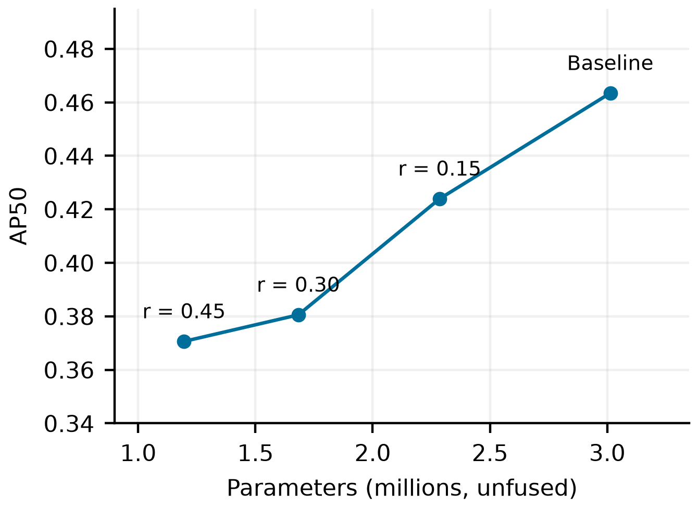
FIGURE 1. Accuracy and parameter count of the baseline and three pruned artifacts. Connecting lines aid reading and do not imply sequential pruning or a fitted response curve.
The complete C2f conversion sequence, including normalization-attribute initialization, gives zero maximum absolute output difference on the seeded test input. Omitting the initialization call does not produce the same result. This illustrates why the executable sequence, not just the diagram of a block replacement, is part of the reproducibility record. This check supports use of the conversion in the examined environment without implying equivalence of an arbitrary reimplementation.
C. CLASS-SPECIFIC EFFECTS OF PRUNING
The overall metric hides substantial differences among object categories. Table III gives the baseline and r = 0.45 values together with validation support. Motor and bike AP50 decrease by approximately 14.21 and 11.81 percentage points, respectively; person AP50 decreases by 10.85 points. The car decrease is smaller, at 5.08 points. These are differences between the evaluated artifacts and do not isolate an intrinsic causal sensitivity of each class to channel pruning.
TABLE III. CLASS-SPECIFIC AP50 BEFORE AND AFTER PRUNING
Class | Instances | Baseline | r = 0.45 | Δ (pp)
person | 13265 | 0.541 | 0.432 | -10.85
rider | 649 | 0.371 | 0.278 | -9.33
car | 102540 | 0.749 | 0.698 | -5.08
bus | 1597 | 0.565 | 0.479 | -8.61
truck | 4247 | 0.581 | 0.506 | -7.51
bike | 1007 | 0.365 | 0.247 | -11.81
motor | 452 | 0.357 | 0.215 | -14.21
traffic light | 26891 | 0.529 | 0.398 | -13.05
traffic sign | 34915 | 0.574 | 0.450 | -12.44
train | 15 | 0.002 | 0.003 | +0.09

AP50 is a fraction. Δ is the pruned value minus the baseline in percentage points; pp denotes percentage points.
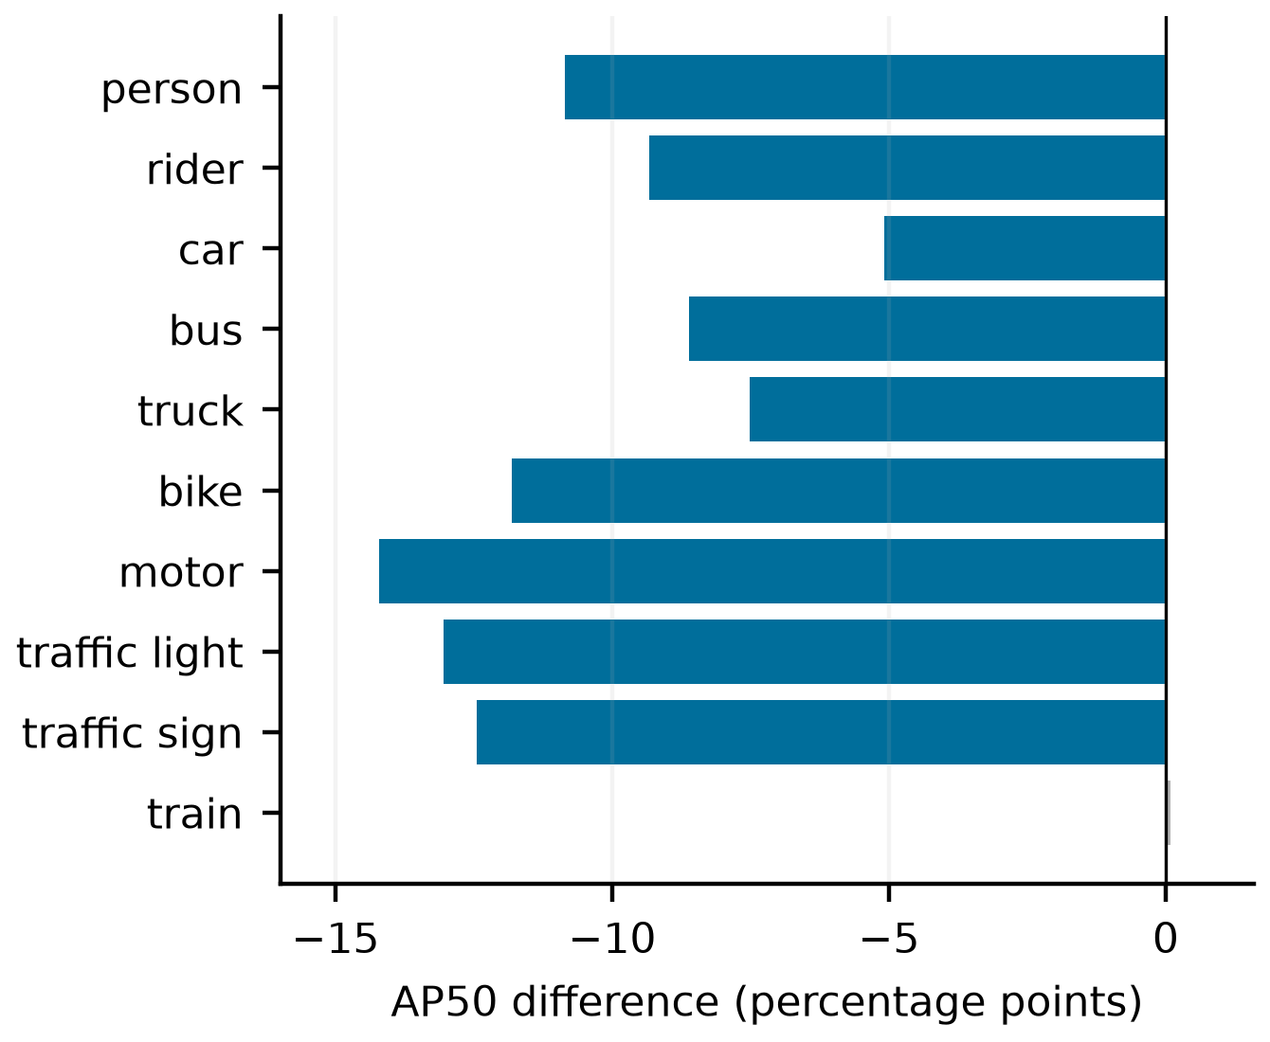
FIGURE 2. Class-specific AP50 change at r = 0.45. The train category has only 15 validation instances; its small positive value is not evidence of a stable benefit.
The train class has only 15 validation instances and very low AP in both models. Its small positive difference must not be interpreted as a reliable improvement. Equal weighting of classes in the macro-average does not make their estimates equally stable. These data therefore do not support choosing a pruned detector solely by its average AP or claiming that vulnerable-road-user detection has been preserved. A deployment decision requires class-level operating requirements and application-specific error analysis.
D. MATCHED CONTINUATION WITH A TRAINABLE STUDENT
All nine earlier-phase runs completed 20 epochs and passed the input-pairing checks. The first two actual augmented minibatches in each of the 20 epochs agree across arms within each seed and differ across seeds. The three control states are distinct. Each run changes all 183 trainable student parameter tensors while preserving the fixed integral projection; the executed code freezes teacher parameters and detaches its targets. These checks establish that the intended intervention was applied and that the old fixed-data control duplication does not recur.
TABLE IV. EARLIER PHASE FINAL EPOCH-20 EMA RESULTS
Arm | Seed | AP50 | AP50:95 | Δ95 (pp)
Control | 0 | 0.463525 | 0.258903 | +0.0000
Control | 1 | 0.463442 | 0.259059 | +0.0000
Control | 2 | 0.464460 | 0.259402 | +0.0000
MSE | 0 | 0.463549 | 0.258554 | -0.0348
MSE | 1 | 0.463120 | 0.259081 | +0.0023
MSE | 2 | 0.464154 | 0.258976 | -0.0427
CWD | 0 | 0.463270 | 0.258839 | -0.0064
CWD | 1 | 0.462477 | 0.258787 | -0.0272
CWD | 2 | 0.464348 | 0.259053 | -0.0350

Original local validation labels, FP32, batch 32, all ten classes. Δ95 is the primary AP50:95 difference from the control with the same data seed. All runs share one trained baseline; no best-seed or best-epoch selection.
Across the three data seeds, primary AP50:95 mean ± sample standard deviation (SD) is Control 0.259121 ± 0.000256, MSE 0.258870 ± 0.000279, CWD 0.258893 ± 0.000141. AP50 means are 0.463809, 0.463608, 0.463365, in the same order. These SD values describe continuation-seed variation conditional on the shared initial detector.
The paired primary difference is -0.0251 ± 0.0240 percentage points for MSE and -0.0229 ± 0.0148 for CWD. MSE is lower than its matched control in two seeds and higher by only 0.0023 points in the remaining seed; CWD is lower in all three. Neither objective gives a consistent positive primary-endpoint benefit. All nine final AP50:95 scores are below the starting baseline value of 0.259485, although AP50 alone is slightly higher for some runs. These observations establish neither statistical equivalence nor general inferiority of distillation.
Each run attempts 21,880 minibatches. AMP skips 4–6 optimizer steps per run (0.018–0.027%), leaving 21,874–21,876 applied updates; the corresponding EMA counters agree exactly. All final saved student, adapter, EMA, and optimizer tensors and all recorded objective means are finite. Some raw epoch median-gradient-norm diagnostics are nonfinite in epochs with recorded AMP skips; these diagnostics are retained without replacing them with invented finite values. The numerical-state audit and per-run counts are supplied with the raw records. Thus the design matches planned minibatches and epochs, while disclosing the small applied-update differences.
The earlier fixed-data ten-epoch probe produced one unique control AP50 of 0.414972 and three adapter-initialization outcomes of 0.409498, 0.420087, and 0.420961. Its KD-minus-control differences range from -0.547 to +0.599 percentage points, all below the starting baseline in absolute AP50. Those executions verify repaired trainability but are not independent data repetitions. Several settings change jointly in the nine-run protocol, so the closer-to-baseline accuracy cannot be attributed to the learning-rate schedule alone. The earlier records remain supplementary and are not pooled with Table IV.
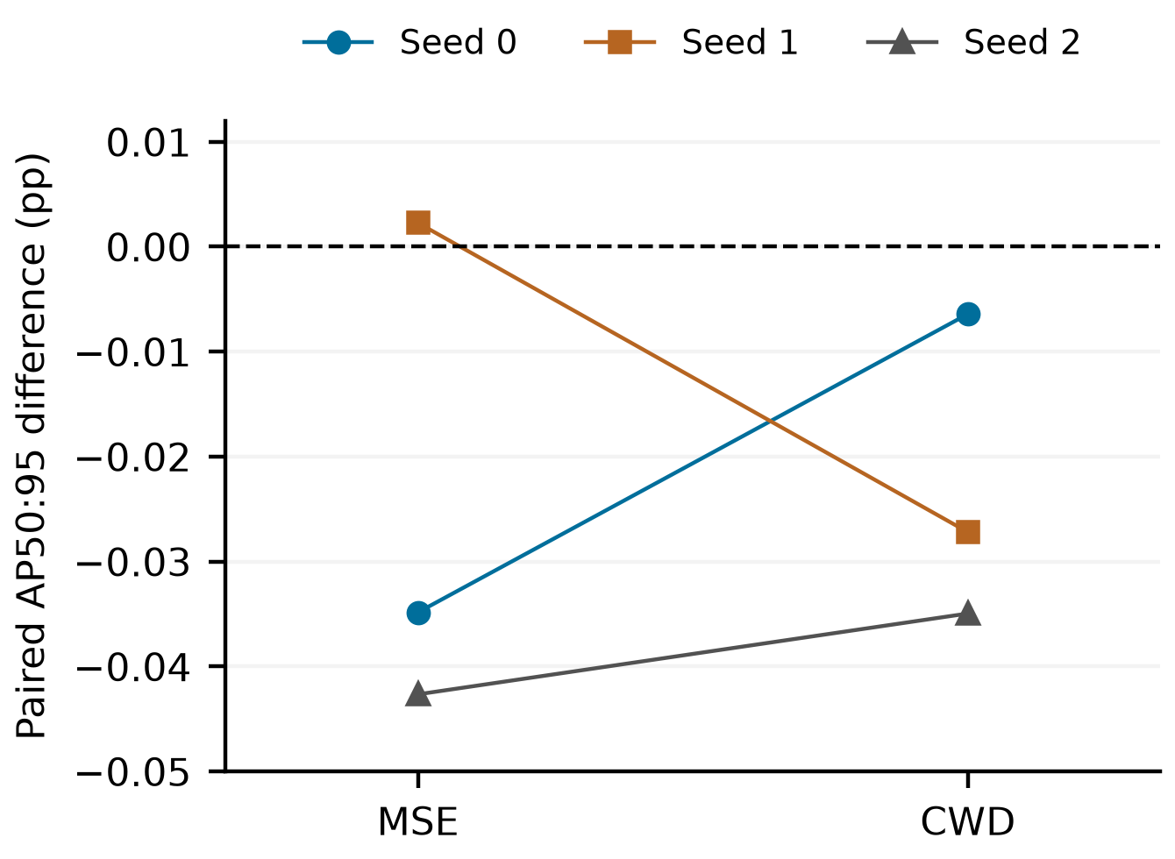
FIGURE 3. Final primary AP50:95 differences relative to the paired no-KD control. Points show every independent data seed; lines connect methods within a seed. Zero denotes no change; units are percentage points.
E. RUNTIME AFTER CONSISTENT GRAPH PREPARATION
TABLE V. INTERLEAVED MODEL-ONLY TIMING
Artifact | FP32 (ms) | FP16 (ms)
Baseline | 1.239 ± 0.010 | 1.331 ± 0.007
Large teacher | 4.660 ± 0.002 | 3.258 ± 0.002
Pruned 0.15 | 1.371 ± 0.010 | 1.508 ± 0.010
Pruned 0.30 | 1.330 ± 0.009 | 1.513 ± 0.010
Pruned 0.45 | 1.313 ± 0.008 | 1.450 ± 0.008

Mean ± sample SD of ten block-average times; 200 forwards per block, batch 1. Shared server, with another run on device 1. These are not per-image latency percentiles.
The FP32 baseline averages 1.2386 ms, whereas the most compressed artifact averages 1.3129 ms (6.00% longer). The r = 0.15 and r = 0.30 artifacts are also slower than the baseline in this measured workload. Across the ten precision/model settings, block coefficients of variation range from 0.047% to 0.797%. Thus the lack of acceleration is not explained merely by the large dispersion of the earlier summaries.
FP16 reduces the large teacher's mean time by 30.08% but increases the mean time of the compact baseline and pruned artifacts. This is a workload-specific precision comparison, not a general conclusion that half precision is slower. The corresponding accuracy under FP16 was not freshly reassessed in this timing run, so the table establishes execution time only.
The old timing table mixed an asserted mean FPS with a helper that actually returns the median of trial FPS. Original per-trial records were not available to reconcile those values. We therefore replace those summaries with the new raw-block measurement, and do not compute coefficients of variation using a median as though it were a mean. Differences between the old and new sessions cannot identify server contention as a sole cause: graph fusion, host behavior, clock state, and protocol differences are also relevant.
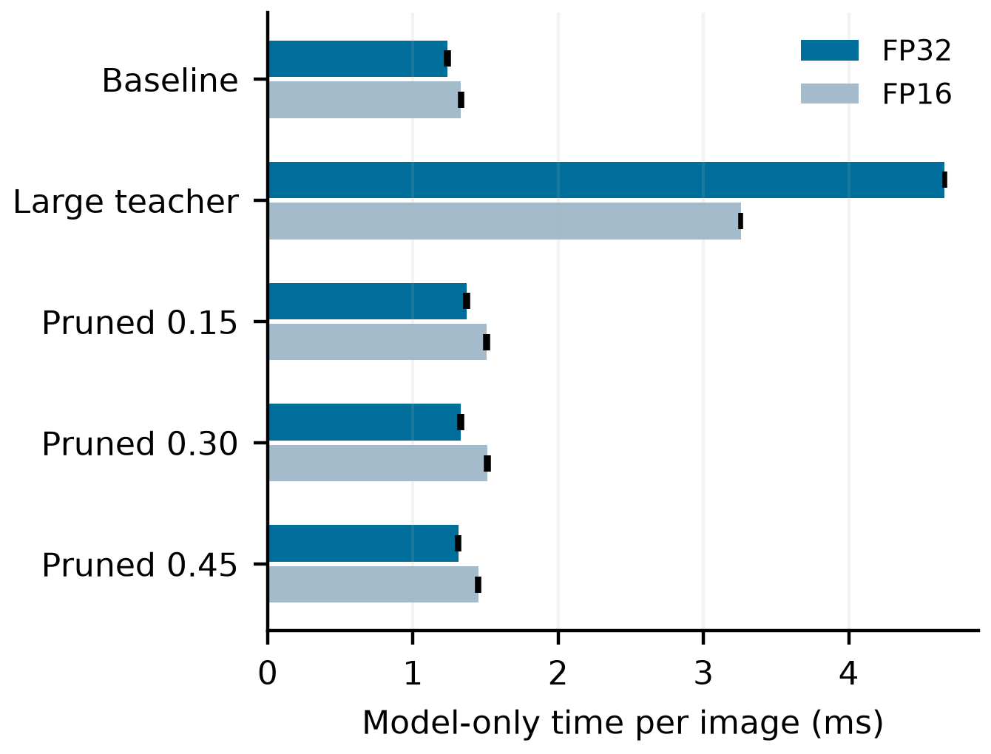
FIGURE 4. Mean model-only time after consistent fusion. Error bars show the standard deviation of block means. Preprocessing, transfers, and nonmaximum suppression are excluded.
F. ROBUSTNESS TO ANNOTATION DISCREPANCIES AND ILLUMINATION
All 16 reaggregated full-set scores match the evaluator output exactly. Removing the 52 extra zero-area targets changes baseline AP50 by +0.009036 percentage points and AP50:95 by +0.004922 points. The direct original-label baseline evaluation exactly reproduces both AP values inferred with fixed predictions. Across all 16 models, isolated AP50 changes range from +0.006699 to +0.010390 points. These discrepancies are measurable but much smaller than the pruning losses; they do not explain the historical baseline-to-pruned gap.
TABLE VI. RECONSTRUCTED-LABEL AP50 BY ILLUMINATION
Artifact | All 10 | Day 9 | Night 9 | Dawn 9
Nano baseline | 0.4635 | 0.5186 | 0.5077 | 0.4996
Pruned 0.15 | 0.4240 | 0.4715 | 0.4679 | 0.4809
Pruned 0.30 | 0.3806 | 0.4252 | 0.4195 | 0.4023
Pruned 0.45 | 0.3707 | 0.4104 | 0.4137 | 0.3916
0.45 + recovery KD | 0.3670 | 0.4073 | 0.4080 | 0.3875
Small teacher | 0.5358 | 0.5994 | 0.5783 | 0.5872
Large teacher | 0.5833 | 0.6572 | 0.6208 | 0.6431

All 10: ten-class AP50 over 10,000 images. Group columns: the same nine road classes excluding train; daytime n = 5,258, night n = 3,929, dawn/dusk n = 778. Undefined n = 35 is omitted because class support is incomplete. Global and group averages use different class sets.
The r = 0.45 artifact loses 10.82, 9.40, and 10.80 AP50 percentage points relative to the baseline in daytime, night, and dawn/dusk, respectively. The direction of the accuracy cost therefore persists across all three observed groups. These comparisons describe the available models within each group; they do not identify illumination as the cause of the difference or establish equal severity across groups. Full per-class AP50 and AP50:95, instance counts, and checkpoint hashes accompany the table.
The legacy-label reconstruction preserves the measured compression trade-off while resolving most of the annotation uncertainty. It does not remove the influence of the 137 unverified training images, create a held-out test set, or upgrade these results to the revised Detection 2020 benchmark. The nine-run continuation was evaluated under both annotation views using the prespecified primary/secondary distinction.
TABLE VII. SECONDARY PAIRED AP50:95 DIFFERENCES
Arm | All 10 | Day 9 | Night 9 | Dawn 9
MSE | -0.0305  ± 0.0208 | -0.0077  ± 0.0311 | -0.0412  ± 0.0442 | -0.1219  ± 0.0925
CWD | -0.0190  ± 0.0125 | -0.0003  ± 0.0232 | -0.0598  ± 0.0747 | +0.0233  ± 0.1080

KD minus paired control; mean ± sample SD over three data seeds, in percentage points. Reconstructed legacy labels, FP32, batch 8. Class populations follow Table VI. Every individual AP50/AP50:95 value and paired difference is supplied in the evidence package.
On the reconstructed labels, both KD objectives have negative global AP50:95 differences in all three seeds. Group means remain small and differ by objective and illumination: MSE is negative on average in every reported group, whereas CWD has a positive dawn/dusk mean with mixed individual signs. These descriptive subgroup outcomes do not establish illumination-specific benefit or harm. The secondary comparison supports the absence of a consistent global improvement in this setting; its precise differences are not identical to the primary endpoint. In particular, the tiny positive primary MSE seed-1 difference changes sign. Evaluation batch size changes from 32 to 8, so such changes cannot all be attributed to removing zero-area targets. Only the separate fixed-prediction comparison isolates that annotation effect.
G. SOURCE-RECONSTRUCTED REPLICATION AND EXTERNAL ASSESSMENT
Both fresh base models completed 100 epochs, and all nine source-reconstructed continuations completed their fixed 20-epoch endpoint. Every run passed the sampled input-pairing, changed-parameter and finite-state checks. The 180 within-seed run/epoch pairwise input comparisons agree, while all 540 between-seed comparisons differ. These comparisons concern the first two recorded minibatches of each epoch. All 183 trainable student tensors change, the DFL projection is preserved, and the three control states are distinct.
TABLE VIII. FRESH SOURCE-RECONSTRUCTED CONTINUATIONS
Arm | Seed | AP50 | AP50:95 | Δ95 (pp)
Control | 0 | 0.464381 | 0.258917 | +0.0000
Control | 1 | 0.464164 | 0.259107 | +0.0000
Control | 2 | 0.464488 | 0.259347 | +0.0000
MSE | 0 | 0.464083 | 0.258581 | -0.0335
MSE | 1 | 0.463951 | 0.258756 | -0.0352
MSE | 2 | 0.464486 | 0.259076 | -0.0271
CWD | 0 | 0.463050 | 0.258131 | -0.0785
CWD | 1 | 0.463752 | 0.258700 | -0.0407
CWD | 2 | 0.462992 | 0.258187 | -0.1159

All ten classes; reconstructed legacy validation labels, FP32, batch 32. Each arm shares one fresh student/teacher pair; Δ95 is relative to the control with the same data seed. Source-unverified 137 images are excluded from both new base trainings and continuations.
AP50:95 mean ± sample SD is CONTROL 0.259124 ± 0.000215, MSE 0.258804 ± 0.000251, CWD 0.258340 ± 0.000313. The MSE/control difference is -0.03193 ± 0.00428 percentage points, and the CWD/control difference is -0.07841 ± 0.03759 points. Both objectives have negative primary differences in all three seeds. This is a conditional result for the specified objectives and continuation budget, not a ranking of separately optimized distillation methods.
Each clean run attempts 21,840 minibatches. CWD seed 1 and MSE seed 2 skip four optimizer steps; the other seven runs skip five. Applied updates and EMA counters agree at 21,836 or 21,835. Final tensors and objective means are finite. Nonfinite raw median-gradient diagnostics occur only in epochs with recorded AMP skips and remain in the evidence. These counts differ from the historical phase because the training population and realized skips differ.
TABLE IX. FIXED EXTERNAL KITTI EVALUATION
Model or arm | Car | Ped. | Mean
Archived nano | 0.7828 | 0.6481 | 0.7154
Archived r=0.15 | 0.7730 | 0.6186 | 0.6958
Archived r=0.30 | 0.7643 | 0.5418 | 0.6530
Archived r=0.45 | 0.7548 | 0.5264 | 0.6406
Archived recovery | 0.7557 | 0.5125 | 0.6341
Fresh nano | 0.7797 | 0.6365 | 0.7081
Fresh large | 0.7963 | 0.7390 | 0.7677
Earlier control | 0.7770 | 0.6443 | 0.7107
Earlier MSE | 0.7777 | 0.6430 | 0.7103
Earlier CWD | 0.7780 | 0.6430 | 0.7105
Fresh control | 0.7758 | 0.6275 | 0.7017
Fresh MSE | 0.7759 | 0.6282 | 0.7020
Fresh CWD | 0.7764 | 0.6297 | 0.7031

Moderate AP_R40 fractions; Car/Pedestrian, all 7,481 publicly labeled KITTI training-partition images. Individual artifacts occupy the first seven rows; later rows average three fixed final EMA endpoints each. Earlier and fresh phases are separate. All 25 models and easy/moderate/hard values are in Supplementary Table S1.
In the fresh phase, external MSE/control differences are +0.00788, +0.06447, +0.03880 percentage points for seeds 0/1/2; CWD/control differences are +0.00755, +0.09634, +0.32072. Their means ± sample SD are +0.03705 ± 0.02833 and +0.14154 ± 0.16140 points, respectively. Thus both objectives show small positive external differences for all three fresh seeds, although all nine continuations remain below the fresh nano endpoint 0.708111. The fresh large teacher reaches 0.767655. In the earlier phase, external mean differences are -0.03405 points for MSE and -0.01905 for CWD, with mixed individual signs. No seed or artifact is omitted.
The internal negative and external positive differences in the fresh phase prevent a general negative conclusion about feature distillation. Dataset distribution, class population, ignored-region rules and AP definition change together between the evaluations. The sign contrast therefore does not isolate domain shift as a causal mechanism. Nor does the small gain over continued-training controls establish improvement over the starting student. Native precision curves reproduce all 150 class/difficulty AP values; all 187,025 prediction files and all 25 frozen source checkpoints pass an independent hash audit.
TABLE X. FRESH PHASE ILLUMINATION DIFFERENCES
Arm | All 10 | Day 9 | Night 9 | Dawn 9
MSE | -0.0312  ± 0.0082 | -0.0403  ± 0.0262 | -0.0122  ± 0.0206 | -0.0509  ± 0.0657
CWD | -0.0782  ± 0.0414 | -0.0956  ± 0.0622 | -0.0776  ± 0.0246 | -0.0806  ± 0.1299

KD minus same-seed control; mean ± sample SD, percentage points. Reconstructed labels, FP32, batch 8. Group populations and fixed nine-class definitions follow Table VI. All 11 fresh models, five image groups and per-class scores were independently reaggregated from saved statistics; maximum AP discrepancy is below 1e-12.
All reported group means are negative in the fresh phase, with mixed individual signs for MSE at night and CWD at dawn/dusk. These observations do not identify an illumination-specific causal effect. The reconstructed-label primary and secondary evaluations use different batches; their small numerical differences are not evidence of another annotation discrepancy.
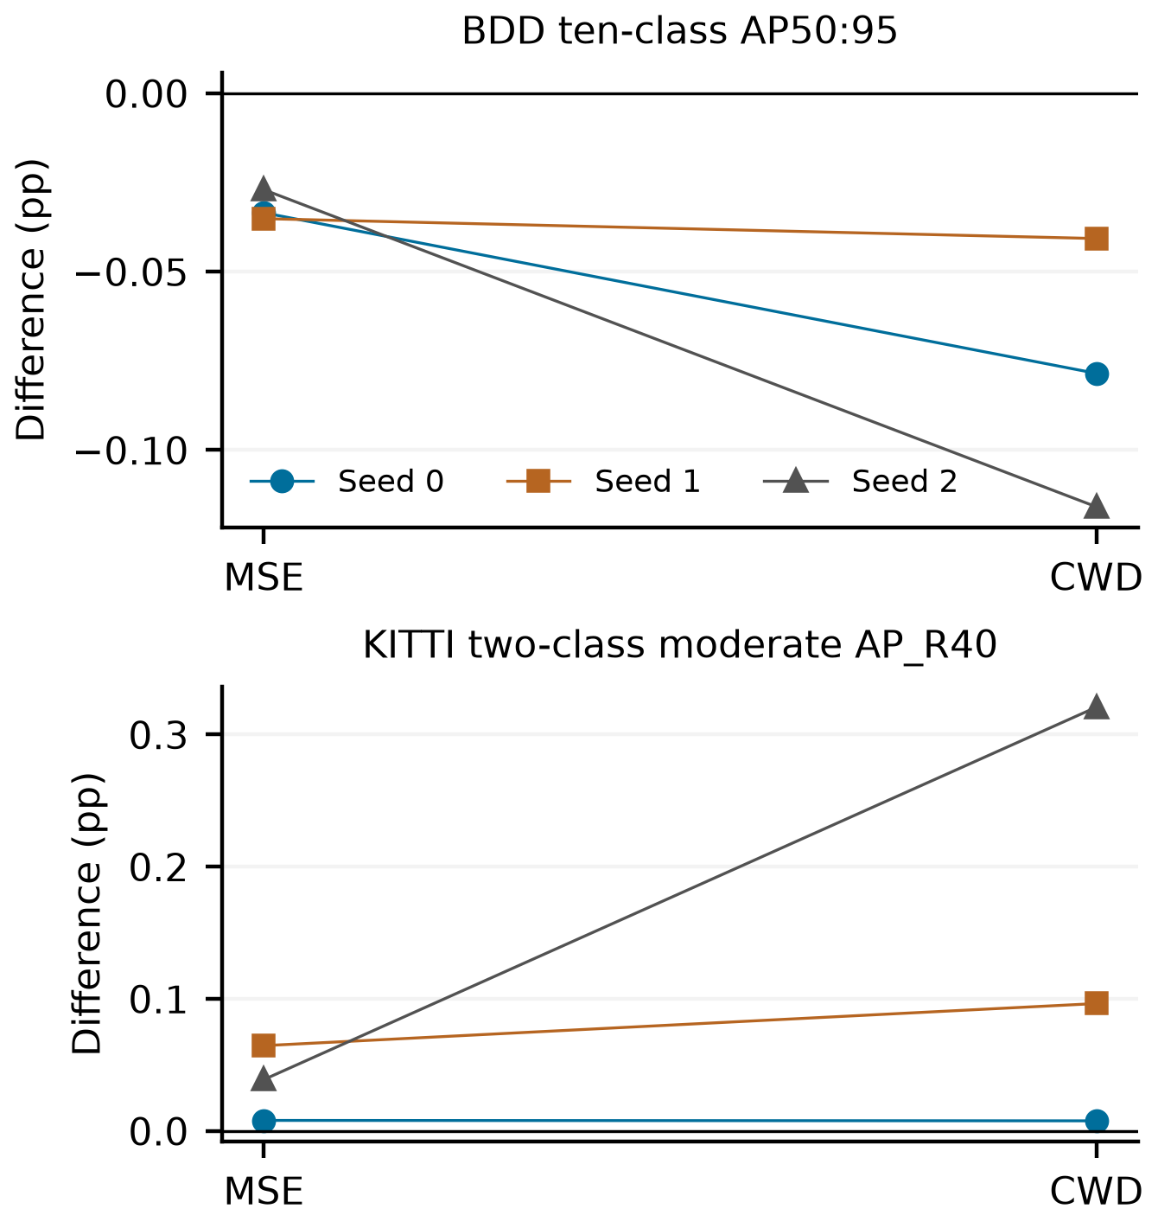
FIGURE 5. Fresh-phase paired differences for every seed. Internal and external panels have different class populations and AP definitions; their numerical magnitudes are not interchangeable. Lines only connect the same seed across objectives.
V. DISCUSSION AND LIMITATIONS
A. WHAT CONSTITUTES A VALID DISTILLATION RESULT
The audit establishes an implementation-specific failure: the intended student was frozen, while an auxiliary adapter could still optimize its own parameters. Training-mode activation and a decreasing scalar loss were insufficient to establish that the detector learned. This has a concrete implication for empirical compression studies. A neutral method result should be interpreted only after confirming trainability, gradient flow, an optimizer update, and a changed saved student state. The checks are inexpensive relative to extended detector training and remain relevant even when validation produces plausible numbers.
This conclusion is narrower than saying that unsuccessful KD results are implementation errors. The corrected comparison supplies a valid, conditional result: MSE and CWD reach slightly lower mean final AP50:95 than matched continuation without KD. Neither supplies a consistent positive internal difference across the examined seeds. In the fresh phase, however, both have small positive paired KITTI differences in every seed. This external result must be retained alongside the internal negative result; neither establishes a universal method ranking. The experiment does not show that the methods are equivalent, that their difference is practically negligible, or that KD generally fails. A shared coefficient and one conservative continuation schedule do not replace method-specific tuning. In addition, KD requires teacher computation, and AMP produces slightly different applied-update counts despite equal planned minibatch budgets.
The archived small-teacher condition is especially instructive. Teacher-size ablation is only meaningful if the manipulated teacher signal reaches parameters that can change the student's deployed function. Here the saved state is identical across two teacher choices. That equality invalidates the proposed ablation; it does not refute the capacity-gap mechanisms studied in [15], [16]. A new teacher-size study should include a matched continuation without KD for every relevant initialization and disclose how the teacher's own accuracy and calibration differ.
B. STRUCTURAL SAVINGS AND DEPLOYMENT DECISIONS
The pruned checkpoints provide reproducible structural reductions and measurable accuracy costs. They do not establish that the selected pruning criterion is superior to alternatives or that pruning is preferable to selecting a different small architecture. Historical training budgets and checkpoint selection differ, and only one artifact is available for each ratio. Treating the results as operating points preserves their practical information while avoiding a stronger attribution than the experiment supports.
The class-level analysis further limits practical recommendations. Memory savings may be attractive, but the largest tested reduction also changes detection quality differently across categories. There is no task-independent exchange rate between a removed parameter and a missed road user. AP per million parameters can summarize density but is not a safety metric or a sufficient deployment objective. We consequently avoid recommending the aggressive ratio merely because its adjacent aggregate score is close to another pruned row.
Runtime depends on the executable graph and numeric precision, including the tensor dimensions and operators selected after conversion. A reduction in the estimated operation count need not shorten an implementation dominated by memory access or dispatch costs. Our measurements do not separate those mechanisms with kernel profiling. Their supported conclusion concerns the observed workload on the measured GPU; explaining the mechanism or predicting an embedded device requires additional profiling and target-device measurements.
C. STATISTICAL AND EXTERNAL VALIDITY
BDD validation has been consulted repeatedly during the historical campaign. Fixed-final-epoch continuation removes one selection step but does not make that split untouched. Exact file-hash checks do not establish scene or near-duplicate independence. Fresh COCO initialization and exclusion of 137 images remove those unidentified BDD labels from new training; historical models retain their exposure. The 2018 mirror still lacks official-host authentication, and no Detection 2020 result is claimed.
Each nine-run phase varies three continuation data/augmentation seeds conditional on one trained student/teacher pair. The phases differ in more than label population and must not be pooled to estimate independent base-initialization variation. Three seeds provide limited information about broader distributions. We report every paired difference without post hoc significance thresholds or equivalence margins. A common coefficient 0.3, CWD temperature 4 and 20 epochs do not optimize each objective or establish convergence. Teacher quality and objective strength remain potential sources of setting dependence rather than tested explanations.
KITTI adds a fixed external test for this study but covers only two mapped categories, under different box, difficulty and ignore definitions. Frames may be correlated within sequences. No image-level audit of COCO pretraining is available, and publicly labeled training-partition evaluation must not be presented as a hidden-test leaderboard result. The changes in dataset, categories and scoring prevent attributing the internal/external sign contrast solely to domain shift. All continued fresh models remain below the fresh nano on the primary external summary, limiting any claim of practical improvement from the continuation itself.
Pruning remains limited to one magnitude criterion and unequal historical artifact budgets. Illumination uses fixed nine-class averages, with limited dawn/dusk support, and is not a randomized lighting intervention. We do not measure weather strata, INT8 accuracy, energy, adversarial robustness or automotive hardware. Desktop model-only timing and clean-image AP do not establish real-world safety or edge-device acceleration.
D. REPRODUCIBLE REPORTING OF COMPONENT EFFECTS
A credible component study needs both a scientific control and an implementation check. For continued KD, the relevant control continues the same student under the same planned data and epoch budget without the teacher term, with any skipped updates disclosed. For pruning, the comparison should disclose the conversion, criterion, ratio allocation, recovery budget, and selection rule. For timing, graph fusion, precision, input residency, synchronization, and aggregation should be recorded alongside the raw measurements. These requirements follow from different sources of uncertainty and cannot be satisfied by a single final score.
The supporting package provides the audit findings, numerical records, corrected scripts, and a regression test. It distinguishes the original repository state from the additional evaluation and continuation work. This permits the unchanged archived artifacts to be checked without presenting a repaired script as though it generated historical results. Versioned inference checkpoints, external prediction files and per-image validation statistics accompany the recorded protocols and numerical evidence. Exported checkpoints preserve every model tensor and module structure, with private training-location metadata removed; source and release hashes are distinguished and a deterministic raw-forward probe confirms equal output. These artifacts support independent reassessment without redistributing dataset images or source box archives.
VI. CONCLUSION
This reassessment separates implementation validity, annotation exposure, objective effects and measured runtime in lightweight YOLOv8. Two archived KD runs leave student parameters unchanged and cannot test teacher guidance. Two separately reported nine-run studies then apply valid matched objectives. Fresh training excludes 137 unidentified image annotations and yields MSE/control and CWD/control internal AP50:95 differences of -0.03193 and -0.07841 percentage points. Their external two-class moderate KITTI differences are +0.03705 and +0.14154 points, while every fresh continuation remains below its starting nano on that external summary. Thus the internal negative result does not generalize to every evaluation definition, nor do small external gains over continuation establish a better starting-model replacement. Historical pruning reduces structure but incurs class/illumination accuracy costs and does not accelerate the measured FP32 workload. The contribution is a reproducible account of which compression conclusions survive direct input, state, annotation and evaluation checks, bounded by shared starting pairs, validation reuse, legacy-source provenance and descriptive historical artifacts.
CODE AND DATA AVAILABILITY
Code and numerical records are publicly available at https://github.com/qkdlsem-maker/yolo-lightweight-optim [24]. Revision efcd6484a4844b976ca63484bd1fd5b8d8d983f0 identifies the earlier objective runner; revision 32bf5e46733e647b38e6a51a2c7e557b14ebf592 preserves the new protocol and preflight sources before final results. Verified completed results are archived at revision c54d758d431ec3dc07927d2a94c63dc4b3031132. The earlier records remain separately identified by revision 05e4a84ab61713f0e4b4d72ba8989c62b32e96a4. Historical scripts, repaired implementations, exact populations and all attempted/completed endpoints are distinguished.
The versioned release https://github.com/qkdlsem-maker/yolo-lightweight-optim/releases/tag/ieee-access-reassessment-20260930 supplies 25 inference checkpoints, all 187,025 external prediction files and 27 sets of per-image reconstructed-label statistics. A manifest maps frozen original checkpoint hashes to the metadata-sanitized release files. All model tensors, dtypes, module structures and class names match; deterministic central processing unit (CPU) FP32 raw outputs are bitwise equal on the recorded probe. The package retains the models' upstream license notices. Dataset images and full source box archives are not redistributed. Readers must obtain the underlying datasets under their applicable terms.
The supporting records include all 18 continuation endpoints, every epoch and sampled input hash, gradient and parameter-change checks, actual optimizer/EMA update counts, all 25 external outcomes, evaluator source/patch and synthetic cases, and all 27 reconstructed-label evaluations. Internal batch 32 primary scores remain distinct from batch 8 statistical reaggregation. The earlier fixed-data probe is separately labeled, and no unverified local test label is used for an accuracy claim.
ACKNOWLEDGMENT
OpenAI Codex [8] assisted with code inspection, implementation of the supplementary audit and evaluation scripts, numerical analysis, figure preparation, and drafting and revision of the Abstract and Sections I-VI. The tables and plots are derived from recorded computations, not generated experimental values. The authors are responsible for verifying the implementation, data, references, and final manuscript.
REFERENCES
[1] F. Yu et al., "BDD100K: A diverse driving dataset for heterogeneous multitask learning," in Proc. IEEE/CVF Conf. Comput. Vis. Pattern Recognit. (CVPR), 2020, pp. 2636-2645.
[2] Ultralytics, "Ultralytics v8.2.103," software release, 2024. Accessed: Sep. 22, 2026. [Online]. Available: https://github.com/ultralytics/ultralytics/releases/tag/v8.2.103
[3] G. Hinton, O. Vinyals, and J. Dean, "Distilling the knowledge in a neural network," arXiv:1503.02531, 2015. [Online]. Available: https://arxiv.org/abs/1503.02531
[4] G. Fang, X. Ma, M. Song, M. B. Mi, and X. Wang, "DepGraph: Towards any structural pruning," in Proc. IEEE/CVF Conf. Comput. Vis. Pattern Recognit. (CVPR), 2023, pp. 16091-16101.
[5] D. Blalock, J. J. G. Ortiz, J. Frankle, and J. Guttag, "What is the state of neural network pruning?" in Proc. Mach. Learn. Syst. (MLSys), vol. 2, 2020, pp. 129-146.
[6] Q. Lin and X. Yang, "KSG-YOLO: Application of YOLO-based detection with knowledge distillation and structured pruning in green assembly building scenarios," IEEE Access, vol. 13, pp. 193462-193473, 2025, doi: 10.1109/ACCESS.2025.3632200.
[7] M. Sabaghian, M. A. Keyvanrad, and S. M. Moghadami, "A novel compression framework for YOLOv8: Achieving real-time aerial object detection on edge devices via structured pruning and channel-wise distillation," arXiv:2509.12918v3, 2025. [Online]. Available: https://arxiv.org/abs/2509.12918v3
[8] OpenAI, "Codex," AI-assisted coding and writing system. Accessed: Sep. 22, 2026. [Online]. Available: https://openai.com/codex/
[9] A. Romero, N. Ballas, S. E. Kahou, A. Chassang, C. Gatta, and Y. Bengio, "FitNets: Hints for thin deep nets," in Proc. Int. Conf. Learn. Represent. (ICLR), 2015, arXiv:1412.6550. [Online]. Available: https://arxiv.org/abs/1412.6550
[10] T. Wang, L. Yuan, X. Zhang, and J. Feng, "Distilling object detectors with fine-grained feature imitation," in Proc. IEEE/CVF Conf. Comput. Vis. Pattern Recognit. (CVPR), 2019, pp. 4933-4942.
[11] Z. Yang, Z. Li, X. Jiang, Y. Gong, Z. Yuan, D. Zhao, and C. Yuan, "Focal and global knowledge distillation for detectors," in Proc. IEEE/CVF Conf. Comput. Vis. Pattern Recognit. (CVPR), 2022, pp. 4643-4652.
[12] C. Shu, Y. Liu, J. Gao, Z. Yan, and C. Shen, "Channel-wise knowledge distillation for dense prediction," in Proc. IEEE/CVF Int. Conf. Comput. Vis. (ICCV), 2021, pp. 5311-5320.
[13] Z. Zheng, R. Ye, P. Wang, D. Ren, W. Zuo, Q. Hou, and M.-M. Cheng, "Localization distillation for dense object detection," in Proc. IEEE/CVF Conf. Comput. Vis. Pattern Recognit. (CVPR), 2022, pp. 9407-9416.
[14] K. Liu, Y. Zhang, J. Zhang, J. Li, J. Wang, S. Wang, C. Yuan, and R. Guo, "DFD: Distilling the feature disparity differently for detectors," in Proc. 41st Int. Conf. Mach. Learn. (ICML), vol. 235, 2024, pp. 32421-32430.
[15] S. I. Mirzadeh, M. Farajtabar, A. Li, N. Levine, A. Matsukawa, and H. Ghasemzadeh, "Improved knowledge distillation via teacher assistant," in Proc. AAAI Conf. Artif. Intell., vol. 34, no. 4, 2020, pp. 5191-5198, doi: 10.1609/aaai.v34i04.5963.
[16] J. H. Cho and B. Hariharan, "On the efficacy of knowledge distillation," in Proc. IEEE/CVF Int. Conf. Comput. Vis. (ICCV), 2019, pp. 4794-4802.
[17] V. J. Reddi et al., "MLPerf inference benchmark," in Proc. ACM/IEEE 47th Annu. Int. Symp. Comput. Archit. (ISCA), 2020, pp. 446-459.
[18] PyTorch Contributors, "Autograd mechanics," PyTorch documentation. Accessed: Sep. 22, 2026. [Online]. Available: https://docs.pytorch.org/docs/2.14/notes/autograd.html
[19] G. Fang et al., "Torch-Pruning," software, version 1.6.0. Accessed: Sep. 22, 2026. [Online]. Available: https://github.com/VainF/Torch-Pruning
[20] a7madmostafa, "bdd100k Yolo-Format Dataset," Kaggle, ver. 4, Oct. 30, 2025. Accessed: Sep. 29, 2026. [Online]. Available: https://www.kaggle.com/datasets/a7madmostafa/bdd100k-yolo
[21] SoleSensei, "bdd100k," public mirror of the legacy BDD100K JSON annotations, Kaggle. Accessed: Sep. 29, 2026. [Online]. Available: https://www.kaggle.com/datasets/solesensei/solesensei_bdd100k
[22] BDD100K, "Data Download," official documentation distinguishing legacy 2018 labels and revised Detection 2020 labels. Accessed: Sep. 29, 2026. [Online]. Available: https://raw.githubusercontent.com/bdd100k/bdd100k/master/doc/source/download.rst
[23] BDD100K maintainers, "100k dataset test label file?," discussion 52, Mar. 2021-Mar. 2022. Accessed: Sep. 29, 2026. [Online]. Available: https://github.com/bdd100k/bdd100k/discussions/52
[24] H. Choi, "yolo-lightweight-optim," code and reproducibility records, revision c54d758d431ec3dc07927d2a94c63dc4b3031132. Accessed: Oct. 1, 2026. [Online]. Available: https://github.com/qkdlsem-maker/yolo-lightweight-optim/tree/c54d758d431ec3dc07927d2a94c63dc4b3031132
[25] A. Geiger, P. Lenz, and R. Urtasun, "Are we ready for autonomous driving? The KITTI vision benchmark suite," in Proc. IEEE Conf. Comput. Vis. Pattern Recognit. (CVPR), 2012, pp. 3354-3361, doi: 10.1109/CVPR.2012.6248074. [Online]. Available: https://www.cvlibs.net/publications/Geiger2012CVPR.pdf
[26] KITTI, "Object Detection Evaluation 2012," benchmark evaluation documentation. Accessed: Sep. 30, 2026. [Online]. Available: https://www.cvlibs.net/datasets/kitti/eval_object.php?obj_benchmark=2d
[27] TensorFlow Datasets, "KITTI archive checksums," official source repository. Accessed: Sep. 30, 2026. [Online]. Available: https://raw.githubusercontent.com/tensorflow/datasets/master/tensorflow_datasets/datasets/kitti/checksums.tsv

HYERIM CHOI is currently pursuing the master's degree with the Department of Artificial Intelligence Convergence, Pukyong National University, Busan, Republic of Korea. Her research interests include model compression, quantization, and efficient deep learning for edge devices, with applications to autonomous driving, including lane-change intention prediction and cross-domain generalization for intelligent vehicles.

TAE-KOOK KIM received the B.S., M.S., and Ph.D. degrees in electrical engineering from Korea University, Seoul, Republic of Korea, in 2004, 2006, and 2014, respectively. He was a Senior Research Engineer with the Mobile Communication Technology Research Center, LG Electronics, from 2006 to 2010, and a Principal Research Engineer with the Mobile Communications Business Division, Samsung Electronics, from 2014 to 2016. He was an Assistant Professor with the School of Artificial Intelligence, Tongmyong University, from 2016 to 2022, where he also served as the Dean of the College of AI Convergence. He is currently an Associate Professor with the School of Computer and Artificial Intelligence Engineering, Pukyong National University, Busan, Republic of Korea. His research interests include artificial intelligence, big data analytics, and the Internet of Things.

