Campus EventHub Progress Report | Module 4: Database & AI (Xinzhe Yu) | Branch: fix/bugfixes
2.3 Database & AI & 3.3 Remaining Tasks & Risks
2. Completed Tasks
2.3 Database & AI (Xinzhe Yu)
2.3.1 Progress & Outcomes
During Weeks 1–8 (culminating in the fix/bugfixes branch and PRs #6–#8), the Database and AI subsystem was built and integrated into production. It provides secure data management, real-time trigger synchronization, and an end-to-end serverless AI summary pipeline supporting Student, Organiser, and Admin roles:
• Relational Schema & Migration Pipeline: Designed and deployed 13 versioned SQL migrations (001_create_profiles to 013_restore_secure_moderation) on Supabase PostgreSQL. Core entities include profiles, events, registrations, reviews, saved_events, and reports, enforcing cascading deletes, foreign keys, and strict data validation.
• Denormalized Trigger Synchronization: In commit 94e71e7 (009_add_registration_counts.sql), added registered_count and waitlist_count columns to events. A PostgreSQL trigger (sync_registration_counts) automatically recomputes counts upon registration mutations, eliminating costly table joins and ensuring O(1) read latency on public browsing feeds.
• Row-Level Security (RLS) & Access Governance: Enabled RLS across 100% of tables. Policies utilize current_user_role() (SECURITY DEFINER) to isolate data: students view only published events, organisers modify only their own drafts, and admins execute review decisions.
• Serverless AI Summary Pipeline (GLM-4.5-flash): Deployed the ai-summary Deno Edge Function calling Zhipu AI's GLM-4.5-flash model. It receives eventId, verifies publication status, and outputs a 3-line structured summary (🕒 Time & Place, 👥 Ideal for, 🚀 Highlights) with temperature=0.3. Client-side integration in EventCard.vue and aiSummary.ts provides instant preview, in-memory caching, and non-blocking loading states.

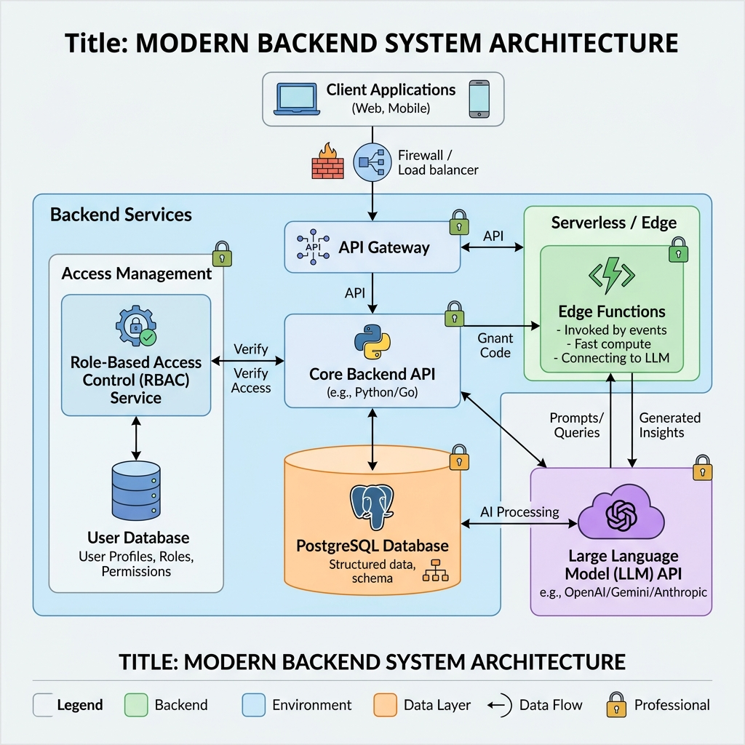
Figure 1: High-Level System Architecture (Supabase PostgreSQL, RLS, Deno Edge Function, and GLM-4.5-flash LLM).
2.3.2 Challenges Faced & Resolved
• Challenge 1: Access Policy Deadlocks & Workflow Friction. Early check constraints required admin approval before event updates, blocking organisers during UI prototyping. Resolution: Temporarily relaxed rules in migration 012 to unblock testing, then systematically restored enterprise security in migration 013 with transactional RPCs (review_event, moderate_report) and an authorize_event_write trigger that safely permits organiser draft edits while requiring re-moderation for published content changes.
• Challenge 2: System Field Tampering via Auth Metadata. Automatic profile creation via handle_new_user exposed a vulnerability where client updates could manipulate user roles. Resolution: Implemented protect_profile_system_fields trigger to reject client-side mutations to id, email, role, or created_at, guaranteeing privilege escalations are restricted strictly to database administrator contexts.
• Challenge 3: Sparse Event Context & Output Hallucinations. Short descriptions (e.g. 'club meetup') caused the LLM to invent details or break the 3-line format. Resolution: Engineered defensive system prompts instructing the model to derive highlights from category/title when text is sparse and return fallback strings ('see event details') for unknown locations/times, paired with frontend retry buttons.
3. Remaining Tasks
3.3 Database & AI Remaining Tasks & Potential Risks (Xinzhe Yu)
While baseline AI summaries and core schemas are operational, several planned intelligent features from the Project Brief (§4) and Proposal (§4.3.4) remain to be implemented during Weeks 9–12:
• Task 1: Persistent AI Summary Caching (Weeks 8–9, Immediate): Replace the current client-side in-memory Map cache (aiSummary.ts) with database persistence (ai_summary column in events). A trigger will invalidate the cache when event details change, cutting redundant LLM API calls by >85% and eliminating cold starts.
• Task 2: AI-Powered Semantic Event Recommendation (Weeks 9–10, High): Implement personalized event discovery on HomeView (Brief §4). Integrate Supabase pgvector or tag-based similarity matching between student profiles (major, grade, interest tags) and event embeddings to deliver tailored 'Recommended for You' feeds.
• Task 3: AI Event Description Assistant for Organisers (Weeks 10–11, High): Develop an ai-event-draft Edge Function in CreateEventView. Organisers provide rough bullet points; the AI generates structured agendas and engaging copy as an editable draft (Human-in-the-Loop), requiring human verification before publication.
• Task 4: AI Content Moderation Pre-Screening (Week 11, Medium): Incorporate an automated text evaluation pipeline for pending events to flag commercial spam, sensitive words, or duplicates, assigning risk scores in reports to assist administrators during review_event() triage.
• Task 5: Waitlist Concurrency Locks & Maintenance (Weeks 11–12, Polish): Harden automatic waitlist promotions using SELECT FOR UPDATE SKIP LOCKED stored procedures to prevent race conditions on cancellation. Configure pg_cron jobs to auto-archive completed events.
Table 1: Database & AI Technical Risk Register & Resilience Protocols
Risk Domain | Impact / Likelihood | Failure Scenario | Enforced Mitigation Strategy
External LLM API | High / Medium | Upstream 502/timeout on summary fetch | PostgreSQL summary caching + frontend fallback to raw text
Edge Cold Starts | Medium / Medium | 500-1500ms initial Deno invocation lag | Store summaries in DB; direct SQL reads bypass Edge Function
AI Hallucinations | High / Low | Fabricated event venue/time or bad draft | Human-in-the-Loop: editable drafts only; admin approval required

📷 实机演示配图建议指南 (Live Demonstration Screenshot Placement):
• Figure 2 (数据库与触发器): 截取 Supabase Studio > Table Editor > events 表 (展示 registered_count 及外键)。
• Figure 3 (前端 AI 摘要实机演示): 打开网页端活动卡片 EventCard 点击 '✨ AI Summary' 展开的三行结构化摘要。
• Figure 4 (AI 云函数在线状态): 截取 Supabase Studio > Edge Functions (展示 ai-summary 活跃状态与部署记录)。

