# 1

### [POST](https://www.ruankun.xyz/machinemother/swagger-ui.html#!/user45controller/updateUserUsingPOST) [/user/{userId}](https://www.ruankun.xyz/machinemother/swagger-ui.html#!/user45controller/updateUserUsingPOST)

1. 请求头

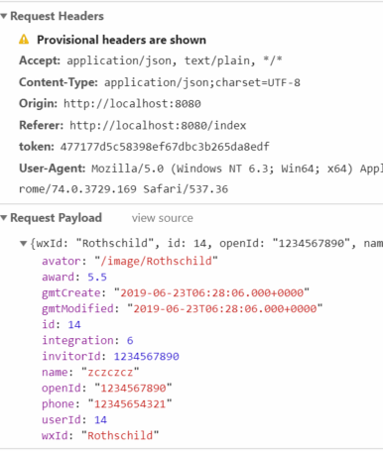

2．问题

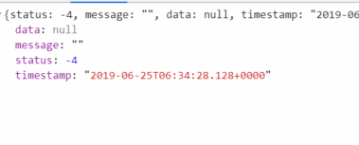

# 2

### [POST](https://www.ruankun.xyz/machinemother/swagger-ui.html#!/user45controller/updateIntegrationUsingPOST) [/user/{userId}/integration](https://www.ruankun.xyz/machinemother/swagger-ui.html#!/user45controller/updateIntegrationUsingPOST) ，，[POST](https://www.ruankun.xyz/machinemother/swagger-ui.html#!/user45controller/updateAwardUsingPOST) [/user/{userId}/award](https://www.ruankun.xyz/machinemother/swagger-ui.html#!/user45controller/updateAwardUsingPOST)

请求头

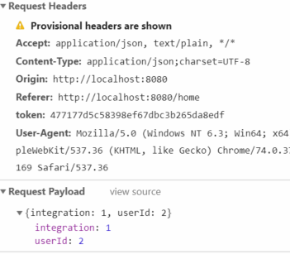

问题

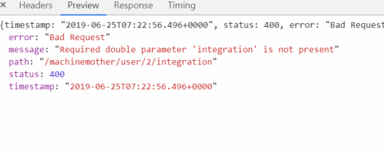

数值类型出错

|  |  |  |  |  |
| --- | --- | --- | --- | --- |
| 问题点 | 原因分析 | 解决方案 | 日期 | 结论 |
| 1 | 后台数据未动态更新，导致传入空值 | 与数据库表数据进行对照更新 | 6/25 |  |
| 2 | 数据类型出错 | 修改user中integration类型为Integer | 6/25 |  |