QKRT AutoNav Guide
This guide is meant to answer some commonly asked questions about ROS2 and provide a conceptual understanding for all concepts on this sub-team. This is also the 25/26 team leader (Noah’s) notes from the Udemy course he took to properly understand how everything works. Please contact him with any questions and concerns about this guide.
There are not many coding examples here for each of the topics. This document was written in 2 weeks and there is simply not enough time to explain coding examples for each topic.
However, I have decided to paste the link to all the coding examples here:
https://github.com/AntoBrandi/Self-Driving-and-ROS-2-Learn-by-Doing-Plan-Navigation
Please access this github and search for any coding example that you require. It is organized similarly to this guide. You may have to dig to find more information.

If you want to see where the images were “borrowed” from, check out this google drive:
https://drive.google.com/drive/folders/1Ac334C9GRzpmB9dQyl0CDKbpv_og1yDF
UPDATE: This guide now has “In Our Codebase” subsections sprinkled throughout. After each concept, you can see exactly where that concept lives in our actual code, with file paths and a couple of code snippets, plus how to tweak or extend it. Our workspace also has a README.md at the root — it is essentially the practical version of this guide, so read it once you finish here.

Table of Contents
QKRT AutoNav Guide 1
The AutoNav Team 5
What is ROS2? 5
Why use ROS2? 5
ROS2 Architecture 6
ROS2 Basics and General Workflow 6
ROS2 Communication 7
Workspace, Colcon, and Package creation 7
Sourcing Your Terminal and Workspace 7
Basic Coding Examples: Using Topics and Services 8
ROS2 Architecture and Helpful Tips 10
RVIZ2 10
TF Transformations 10
URDF and Xacro 12
Gazebo 13
Path Planning 13
Background info 13
Pose: Definition 13
Path Planning Configuration 14
Theory: Function Sampling, Graphs 15
Graph Construction 16
Occupancy Grids 17
Path Planning Algorithms 18
NAV2 Introduction 18
Lifecycle Nodes and Lifecycle Node Manager 19
NAV2 Map Server (nav2_map_server) 21
Quality of Service (QOS) Policies 21
NAV2 Path Planning Server 22
Execution 22
Background Info 22
Motion Planners 23
Path Following: PID Loop 24
PID Tuning 26
Path Following: Execution 26
Robot Localization 28
Background 28
Standard Robotics Reference Frame 28
Theory of Transformation Between Frames 29
AMCL Algorithm 31
Obstacle Avoidance 31
Costmap 31
NAV2 Costmap 2D and Costmap Layers 33
Navigation 35
NAV2 Servers 35
NAV2 Plugins 36
NAV2 Lifecycle Manager 36
Behavior Trees 36
BT Node Types 37
Ticks and Tick Propagation 38
Ports and Blackboards 39
NAV2 BT Navigator 40
NAV2 Behaviors and Behavior Server 41
Autonomous Navigation Overview 41

Table of Figures
Figure 1: COPYRIGHTED ROS2 Architecture from high-to-low level 6
Figure 2: Example of simplified map 14
Figure 3: COPYRIGHTED Example of Physical-to-Configuration Space Conversion 15
Figure 4: Diagram of Graph Used in Real Life 16
Figure 5: Diagram of Basic Graph 16
Figure 6: COPYRIGHTED Occupancy Grid Example 18
Figure 7: COPYRIGHTED Diagram of a Lifecycle Node 20
Figure 8: COPYRIGHTED Diagram of full Path Planning and Execution Loop 24
Figure 9: COPYRIGHTED Visual Depiction of DWA Algorithm 27
Figure 10 :COPYRIGHTED Diagram of Robot Transformations, Including Translation Matrix, Rotation Matrix, and Combined Transformation Matrix 29
Figure 11: COPYRIGHTED Diagram and Equations of Obtaining Transformations Between Different Frames. The Matrix "I" is the Identity Matrix. 30
Figure 12: COPYRIGHTED Diagram of Costmap vs. Occupancy Grid, Including a Pictorial and Numerical Representation 32
Figure 13: COPYRIGHTED Diagram of Local vs. Global Costmap 33
Figure 14: COPYRIGHTED Image of Inflation Layer and Cost Scaling Factor 34
Figure 15: COPYRIGHTED Example Behavior Tree 36
Figure 16: COPYRIGHTED Visual Example of BT Nodes 37
Figure 17: COPYRIGHTED Example of BT Tick Propagating Through the Tree. The Next Tick Will Pass Through the "CloseFridge" Node. 39
Figure 18: COPYRIGHTED Example of BT With Ports and Blackboard 40
Figure 19: COPYRIGHTED Diagram Showing Autonomous Navigation Stack, Starting at the Left Side of the BT Navigator 41

The AutoNav Team
If this is your first time reading this, welcome to the team! Our goal is to implement a failsafe autonomous navigation system for the sentry robot. This guide should hopefully teach you how we are able to do this, at a conceptual level.

Where Our Code Actually Lives
Before diving into the theory, here is a quick tour of the repo so the “In Our Codebase” subsections later make sense. All of our code lives in one ROS2 workspace (called qkrt-nav on the robot’s Jetson). Inside /src, we have 7 packages, and each one has one job:
- sentry_bringup – the launch files that start everything (real_robot.launch.py and simulated_robot.launch.py), plus a couple of helper scripts
- sentry_description – the URDF/Xacro robot model, meshes, RViz configs, and Gazebo worlds
- sentry_localization – the EKF, SLAM, and AMCL configs (i.e. “where am I?”)
- sentry_navigation – all the NAV2 server configs, behavior trees, and mission logic (i.e. “where am I going?”)
- sentry_communication – the serial bridge that talks to the MCB (the robot’s main circuit board)
- omni_pursuit_controller – our custom NAV2 controller plugin, written in C++
- ldlidar_ros2 – the third-party driver for our two lidars (we didn’t write this, don’t touch it)
There is also a README.md at the root of the workspace. It contains the full system pipeline, a topic map, known bugs, and startup instructions for the physical robot. Seriously, read it.

What is ROS2?
ROS stands for Robot Operating System. It is the framework we are using for AutoNav. ROS (the original ROS) was developed to unify different robotic functions. These include localization, path planning, obstacle avoidance, mapping, and more (note, these are some of the main functions of mobile robots).
Before ROS, each function was developed independently and was hard to integrate. As ROS was developed in the early 2000’s, it had many limitations. As the community kept developing and contributing to new ROS features, the architecture couldn’t keep up. These included real-time robotic operations (RTOS systems), swarm/fleet robotics, embedded platforms (raspberry pi, NVidia jetson), and more. ROS2, the newer version, was created more recently to overcome these limitations.

Why use ROS2?
ROS2 provides a standard framework for creating robotics packages and features. The main advantage is that ROS2 handles hardware integration. Without ROS, you’d have to adjust or rewrite all your robotics scripts every time you swap a hardware component, such as cameras, wheels, sensors, or even new machines.
ROS2 allows modular package creation, and seamless integration across systems. It also has many SUPER HELPFUL community-built packages and features that you can simply import and use, without having to write everything from scratch.
Also, ROS2 is used frequently in industry. Most robotics companies start working in ROS2, and when they become big enough, they create and switch to their own frameworks. Nonetheless, it’s a great way to learn more advanced programming, as well as tools like Linux, Git, and VSCode.

ROS2 Architecture
Below is a very nice (AND COPYRIGHTED) Figure 1 diagram of the levels of abstraction of ROS2.

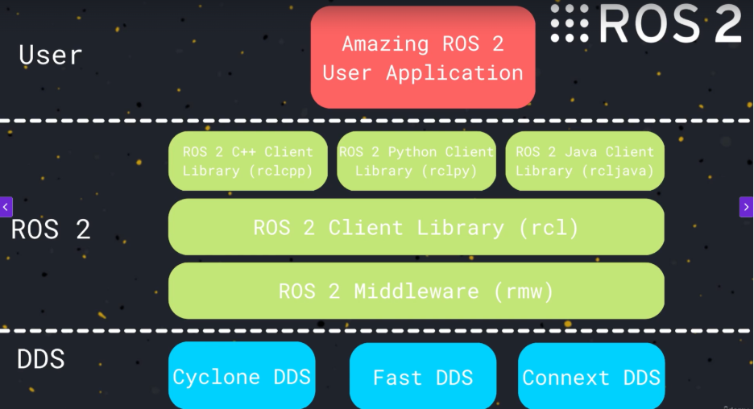
Figure 1: COPYRIGHTED ROS2 Architecture from high-to-low level

The highest level is ROS2 user applications (RVIZ, etc), while the lowest level includes DDS communication protocols. In practice, this looks something like:
Program a script --> use ROS client library to activate certain features --> ROS2 middleware --> communication between nodes/topics/services via DDS.
ROS 2 middleware is the layer that moves data between parts of your robot. DDS communication can be researched in your own time.

ROS2 Basics and General Workflow
ROS2 is organized as follows: you have a workspace folder. Inside, once your workspace is compiled, you will have 4 files: build, install, log, and src (source). The packages you build belong in /src. The package executables files lie in /install. We don’t touch the other two folders.
A package is a modular structure that encapsulates your code, its dependencies, and other useful information (see Workspace, Colcon, and Package creation). Each package serves a singular specific function. Using an example from our code, sentry_description is purely a physical and material description of the robot. sentry_bringup is responsible for launching the real and simulated robot. On a more general level, a package could be responsible for reading camera information, reading a sensor, communicating that information between nodes, etc.
Packages contain a directory for your scripts (/src [this stands for source]), as well as an XML file. An xml file is basically a text file with fields for information such as package description, package maintainer (name and email), etc. It also has a section to add depencencies. See the section about Basic Coding Examples: Using Topics and Services for more info on each file within the package.

ROS2 Communication
ROS2 uses nodes to launch the scripts we program. These nodes then communicate over topics, services, and sometimes actions. Read more about these communication protocols on the wiki: Understanding nodes — ROS 2 Documentation: Humble documentation
Go through understanding nodes, topics, services, actions, and launching nodes. Every script that you write inherits from the node class which is written and maintained by ROS. When your scripts gets wrapped in a ROS node, it can access the functionalities of topics, services, and actions. Within each node, you can publish and subscribe to any topic/service.

Workspace, Colcon, and Package creation
Quick summary: Each ROS project uses a workspace to manage all files/folders/packages. Packages go in /src. To compile packages, we need colcon. Colcon is the ROS “compiler” that builds your workspace and compiles your code. Once you have a working workspace, you can run: colcon build to compile the workspace and all packages and code.
See: Using colcon to build packages — ROS 2 Documentation: Humble documentation
Go through colcon, creating a workspace, and creating a package tutorials for more detail. You will learn here how to instantiate your own workspace, package, and to then compile it.

In Our Codebase
Our workspace follows this exact structure: packages go in /src, and we build with:
colcon build --symlink-install
The --symlink-install flag is a quality of life upgrade: instead of copying your python scripts and config files into /install, it links to them. This means you can edit only a python script or a Yaml config file (text file) and just relaunch, without rebuilding. You still need to rebuild when you add a NEW file, change script entry points, or touch any C++ (C++ always needs compiling, sorry).
To add a brand new package, cd into /src and use ros2 pkg create command. Then look at any of our existing packages to copy the structure.
See: Using colcon to build packages — ROS 2 Documentation: Humble documentation for the command.

Sourcing Your Terminal and Workspace
This is going to be the cause of many issues and MUCH frustration.
In ROS2, you have an overlay and underlay. The underlay is the standard copy of ROS2 that runs when you launch any node. This includes the client libraries rclcpp or rclpy, dependencies, etc. The overlay includes all the packages that you’ve built. If you use a package in the overlay which is also used in the underlay, the overlay overrides the underlay. This way, you can customize ROS2’s standard packages (but we don’t have to worry about this).
When you run colcon build, the executable files for your nodes or project are created in the install folder of your workspace. You need to inform your terminal that your executibles exist, which is why we source the terminal.
The first step is to source the underlay by running:
source /opt/ros/humble/setup.bash
Alternatively, you can edit what’s known as your bashrc script. This runs automatically every time you open a new terminal. Instead of sourcing the underlay every time, you can run:
echo "source /opt/ros/humble/setup.bash" >> ~/.bashrc
source ~/.bashrc
This commands directly adds the sourcing line to your bashrc without having to manually open that file. Alternatively, if you want to manually add this line, you could run nano ~/.bashrc, navigate to the bottom, add the source /opt/ros/humble/setup.bash line, control+o, control+x (to save and exit), and then source your bashrc.
Now, the second step is to run colcon build:
colcon build
Finally, you can source the overlay. The following is good practice: after you build your workspace with colcon build, this terminal doesn’t yet know that your new packages exist. In a NEW SEPERATE TERMINAL, navigate to your workspace and run
source install/setup.bash OR . install/setup.bash
Your overlay should be sourced now and you can run your ros project inside the newly sourced terminal.

PRO TIP: run
sudo apt install terminator
and install terminator. Terminator is a terminal that holds multiple terminals. Once installed, type terminator into a blank terminal to open it up. In terminator, ctrl+shift+E and ctrl+shift+O creates new terminals horizontally and vertically, so you don’t have to open up 5 different terminals and have them all over the place.

In Our Codebase
On the robot, the workspace lives in ~/qkrt-nav. So the ritual is:
cd qkrt-nav && colcon build --symlink-install && source install/setup.bash
If ros2 launch tells you “package ‘sentry_bringup’ not found”, you did not source your terminal.

Basic Coding Examples: Using Topics and Services
See more tutorials for basic coding examples. Writing a simple publisher and subscriber (Python) — ROS 2 Documentation: Humble documentation
Go through publisher/subscriber and service/client in your language of choice. I will not explain the code itself here, as they do a much better job. However, I will explain all the boilerplate.

ROS2 Boilerplate: Dependencies, Entry Points, CMake, Python Config
A dependency is a library that you import which your code relies on. These can be found in the #include section of your code. All included libraries need to be added as dependencies. For example, the ros2 client library (rclcpp or rclpy) are runtime dependencies that you must add to the xml file when they are used in your script. They need to always be added in the XML file, see (ROS2 Basics and General Workflow) for more detail on what an XML is. An example of adding a dependency in xml would be:
<exec_depend>rclpy</exec_depend>
If you have a python package, you will have a config file. In here, you will fill out some similar fields to the xml. You will also have a section in the bottom to add your entry points to your package. An entry point allows colcon to map your terminal command to the function you want to run.
If your package name is example_pkg, your script is example_publisher, and you are running your main function, the entry allows the command
ros2 run example_pkg example_publisher
to be understood. The format for entry points is:
script_name = package_name.script_name:main
For each script, write an entry point so that you can run it with ros2 run.
e.g. ros2 run package_name script_name (matching the entry point)

If you have a cpp package, you will have a CMakeLists.txt file. Think of this file as an instruction sheet that tells the compiler how to translate your CPP script into executable files. You also need to declare dependencies here, using:
find_package(dependency_name REQUIRED) , dependency names should include at least rclcpp, and ament_cmake. Each dependency gets its own line here.
You also need to add an entry point via the command:
add_executable(executible_name src/executible_name.cpp)
Note, you can add multiple entry points. After, you need to write the command to add the dependencies to each node (they have only been declared thus far). You do this with:
ament_target_dependencies(node_name dependency_1 dependency_2) etc.
Lastly, we need to install the script and dependencies for each script, with the following command:
Install(TARGETS
node_name
DESTINATION lib/${PROJECT_NAME}
)

Ensure to add the same dependencies to the XML file as well. Remember to source your terminal in a new window, and then you can use ros2 run …

In Our Codebase
For a real python example of all this boilerplate, look at the sentry_communication package. Its setup.py declares the entry points exactly in the format above:
'comm_hub = sentry_communication.comm_hub:main'
which is why ros2 run sentry_communication comm_hub works. Inside comm_hub.py you can also see real publishers and subscribers:
self.odom_publisher_ = self.create_publisher(Odometry, 'odom', 10)
self.create_subscription(Twist, 'cmd_vel', self.listener_callback, 10)
For a real C++ example, look at omni_pursuit_controller/CMakeLists.txt. You will find the find_package(… REQUIRED) lines and ament_target_dependencies() exactly as described (it builds a shared library instead of an executable because it is a plugin, but the boilerplate is the same idea).
To add your own node: write the script inside an existing package, add an entry point to setup.py, add any new dependencies to package.xml, then colcon build and source. That is the whole loop.

ROS2 Architecture, Debugging and Helpful Tips
The command ros2 topic list tells you all active ros2 topics.
The command ros2 node list tills you all active ros2 nodes.
The command ros2 topic echo /topic_name e.g. /string outputs the data published to that topic. The --once flag can be added to the end to only get the most recent message, instead of a continuous stream. The --field flag will return only the requested field within a topic (such as --field angular_velocity.z)
The command ros2 topic info /topic_name tells you the number of publishers and subscribers currently active
The command ros2 topic hz /topic_name tells you the publishing frequency of a topic, in hz
The command ros2 topic info interface_name shows you the structure of data within a message. interface_name follows a structure of collection/type/name, for example, the standard String message would be in std_msgs/msg/String.
The command ros2 topic pub topic_interface_name “data”, where data is a string of information that matches the message type, manually publishes data via terminal. This is good for testing.
The command ros2 service call … does the same as the above but with a service.
Use ctrl+c to cancel all active processes in your terminal.

In Our Codebase: Topics Worth Echoing
On our robot, the topics you will echo most often while debugging are:
- /cmd_vel – the velocity command NAV2 wants the robot to execute
- /odom – wheel odometry from the MCB (via comm_hub)
- /scan – the merged lidar scan
- /joint_states – wheel + turret joint angles (the turret angle lives here!)
- /battery_health – battery level from the MCB, used by the mission controller
The full producer/consumer table for every topic lives in the README under “Topic Map”.

RVIZ2
Rviz is ros2’s visualizer. I won’t be able to explain all of its functionalities here, but I will give a brief overview. Run the command rviz2 in a new terminal to open it.
In RVIZ, you can visualize your URDF, plan and execute service requests, subscribe and visualize data that you have published on a topic, and more. You can also configure QoS policies and other parameters for each topic or service (see Quality of Service (QOS) Policies) among other parameters.
To start, hit “add” in the bottom left corner, click on “by topic”, and add the topic you want. You can then mess around with stuff from there.

In Our Codebase
Our saved RViz layouts live in src/sentry_description/rviz/. The easiest way to get a fully set up RViz is to let the launch file do it:
ros2 launch sentry_bringup real_robot.launch.py display:=true
Or open a config directly with rviz2 -d src/sentry_description/rviz/sentry_config.rviz. If you add displays and want to keep them, use File → Save Config so it lands back in that file.

TF Transformations
TF transformations are incredibly helpful and useful, and it is essential to have an understanding of this topic so that you can understand the information that builds on this topic.
At its core, TF transformations hold translational data between different moving frames of reference. A frame can be any object on our outside of the robot. For example, the robot’s center of mass, its head, and the tip of its arm are all frames. Also, if present, other moving robots, and static or dynamic obstacles could be frames.
TF operates in a tree structure. For those that are unfamiliar with a tree data structure, quickly look up what this is online. For specifically a TF tree, you must declare a root, and all other positions are mapped in reference to the root.
Let’s use an example robotic arm, with a moving base. I would declare my root to be the center of mass of my robot, base_link. Note, the base link is standard naming convention. For convenience, I could also define a base_footprint which represents the centre of mass of my robot, but the z coordinate is set to the floor, so we know how high up off the ground our other features are. This joint in the tree structure would look like base_link-→ base_footprint
Let’s define our new links wheel1, wheel2, wheel3, wheel4, arm_link_1, arm_link_2, gripper. Our joints would be base_footprintàwheel1, wheel2, wheel3, wheel4, base_footprintà arm_joint_1, arm_joint_1àarm_joint2, arm_joint_2 àgripper.
If we look at our tree, we will see:

base_link à base footprint
base_footprint à wheel 1
base_footprint à wheel 2
base_footprint à wheel 3
base_footprint à wheel 4
base_footprint à arm_joint_1 à arm_joint2 à gripper

The TF tree now knows the positions of all of the robot elements relative to its base. The TF tree is structured like this such that it can move back and forth between each element. This way, we can figure out both where the arm is relative to the base, and where the base is relative to the arm.
Remember that these frames store positional data. For example, I could say that the base_footprint is half the robot’s height lower than base_link, or [0, 0, ${-1 * robot_height / 2}]. This thing in square brackets is the transformational data itself, and TF uses this combined with linear algebra to know the position of everything relative to base_link. The same transformations can be constructed and applied for an obstacle or moving robot that is detected using lidar, depth cameras, etc. This still works if the obstacle is moving but requires some extra data and logic to implement.
If RVIZ is throwing a hissy fit and telling you that a TF transformation is broken, it means the translational data doesn’t exist, is not being published, or is not being published correctly/recognized.

In Our Codebase
Our TF tree is a textbook example of this section. Currently as of writing this, the chain is map → odom → base_link → gimbal_link → (supports) → turret_link → lidars and IMU. Note the plot twist: our lidars and IMU are mounted on the TURRET side of the tree, not the chassis. That means every sensor reading depends on the current turret angle, which is why we care so much about the gimbal_joint being correct.
Different nodes are responsible for different arrows of the tree:
- map → odom comes from SLAM Toolbox or AMCL (global localization)
- odom → base_link comes from the EKF (see ekf.yaml, publish_tf: true)
- base_link → everything else comes from robot_state_publisher, which reads our URDF plus the /joint_states topic (the turret angle is published there by comm_hub.py)
To see the tree yourself, run:
ros2 run tf2_tools view_frames
and open the generated PDF. When RViz throws its hissy fit about broken transforms, it is almost always one of the three publishers above not running — Known Bugs #6 and #7 in the README walk you through figuring out which.

URDF and Xacro
Brief introduction: a URDF file describes the physical shape, dimensions, and properties of a robot. It is written in XML (so it’s basically a text document). This document is used for building your robot BY describing your TF transformation (positional data) between links and joints.
Links are the building blocks of the robot and can be customized to a certain shape, dimension, and mass, among other properties like collision boxes.
When defining a link, the centre of mass is by default at “x y z” = “0 0 0”. You can change this, but it’s best to keep it like that. You can also define the “yaw pitch roll ” = “A B C”, which is the orientation of the link relative to itself.
Joints are defined by a parent link and a child link. For example, let’s use an example: base_link (the parent) is a square, and robo_arm_link (the child) as a rectangular prism. A joint allows me to define the position and orientation of the child link relative to the parent link. It also allows me to assign kinematic properties (sliding and rotation), but this is optional. See the wiki for all information about URDF and Xacro: URDF — ROS 2 Documentation: Humble documentation
The wiki does a better job, but Xacro stands for XML Macro, and it is a preprocessor for URDF (look up what a preprocessor is, or see the wiki link for more info). It allows you to define macros so you can build a part, such as a wheel. and reuse it multiple times. For example, if I were building a car, I would write a Xacro macro for a wheel, and then instantiate it four times. You can also use Xacro to add variable names and do math. See the wiki link for all the information.

In Our Codebase
Our entire robot is described in src/sentry_description/urdf/sentry_description.urdf.xacro. At the top you can see the Xacro part in action — all dimensions are declared once as properties:
<xacro:property name="wheel_radius" value="0.075"/>
and reused everywhere with ${wheel_radius}. So if the mechanical team changes a dimension, you change ONE line.
The most important joint in the whole file is the one connecting the chassis to the turret:
<joint name="gimbal_joint" type="continuous"> … <axis xyz="0 0 -1"/> </joint>
That axis="0 0 -1" (negative z) is intentional and load-bearing — it works together with sign conventions in comm_hub.py to make the turret stay still in the world when the chassis spins. If the turret rotates the wrong way in RViz, this axis and those signs are the suspects (see Known Bug #5 in the README).
To edit the model: change a property, colcon build, relaunch, and stare at RViz to check your work.

Gazebo
Gazebo is another, “higher-tech” robotics simulator. Here, you can build your own world and visualize it, while the navigation still uses the flat map or occupancy grid (see Occupancy Grids). You should not have to build your own gazebo world as it has been already done, but in case you have to edit it, here is some basic info.
Gazebo worlds are built using .sdf files. It’s quite similar to the URDF file, where the same structure is present, only this time, you can define different items, such as physical shapes. You can build or edit one in the Gazebo interface itself, but it’s better to just do it in the file for higher positional accuracy.
To launch a world, run
gazebo (/path_to_gazebo_world.sdf)

In Our Codebase
Our Gazebo worlds (.sdf files) live in src/sentry_description/worlds/, and simulation is a one-liner:
ros2 launch sentry_bringup simulated_robot.launch.py
In sim, Gazebo replaces a chunk of the real robot: a planar-move plugin moves the robot and publishes /odom, and a joint-state plugin publishes /joint_states. This is why comm_hub does not run in simulation, because there is no MCB to talk to. A small helper (sim_comm_hub_bridge.py in sentry_localization) fills in the gaps so the rest of the stack cannot tell the difference.

Path Planning

Background info
If you’re new to path planning, it’s self-explanatory. Given a map of your environment, your position, and a target position, you can write software algorithms to plan and execute a path. Fortunately, we have all these elements or can obtain/calculate them.
To plan and execute a path, we need a path planner and an executor. In our system, this is the path planning server and the controller server, respectively. The path planner is responsible for the high-level planning of the path, including what turns to make, what route to take, etc. The controller is responsible for following that path while reacting to unexpected events, such as another robot suddenly blocking the path, and stopping or moving around it.
The planner and controller operate in somewhat of a loop. The executor continuously collects new data in the environment, and this new data is fed to the planner, allowing the planner to adapt and recalculate if necessary.

Pose: Definition
Use this for the rest of this guide. A pose is a fancy way of saying position + rotation. For our cases, a pose contains the robot’s x, y, and z posisition, and rotation (r), in the format [x y z r].

Path Planning Configuration
To properly plan, we need a simplified, black and white map. Obstacles would be marked in black, while the white areas are places that the robot can move. Below in Figure 2, you can see basic examples of what this grid is supposed to look like.
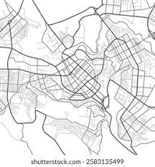
Figure 2: Example of simplified map

To know if the robot can fit in or through a specific area, we can create a robot footprint. This footprint can be a polygon of any shape/size so long as it somewhat accurately represents the robot geometry. For our robot, we use a parameter called robot radius as we can simplify our robot to be a circle as seen from above, as it beyblades (spins around while moving, to make our target plates harder to hit).
Alternatively, we can increase the size of the robot by doing the reverse: we can inflate all obstacles by the same robot radius we declare, thus creating an inflated version of our black and white map. This is called the configuration space. With our inflated map, any white point on the map now guarantees that the robot can move through there. Below, Figure 3 is another COPYRIGHTED image showing the transformation of a workspace into a configuration space.
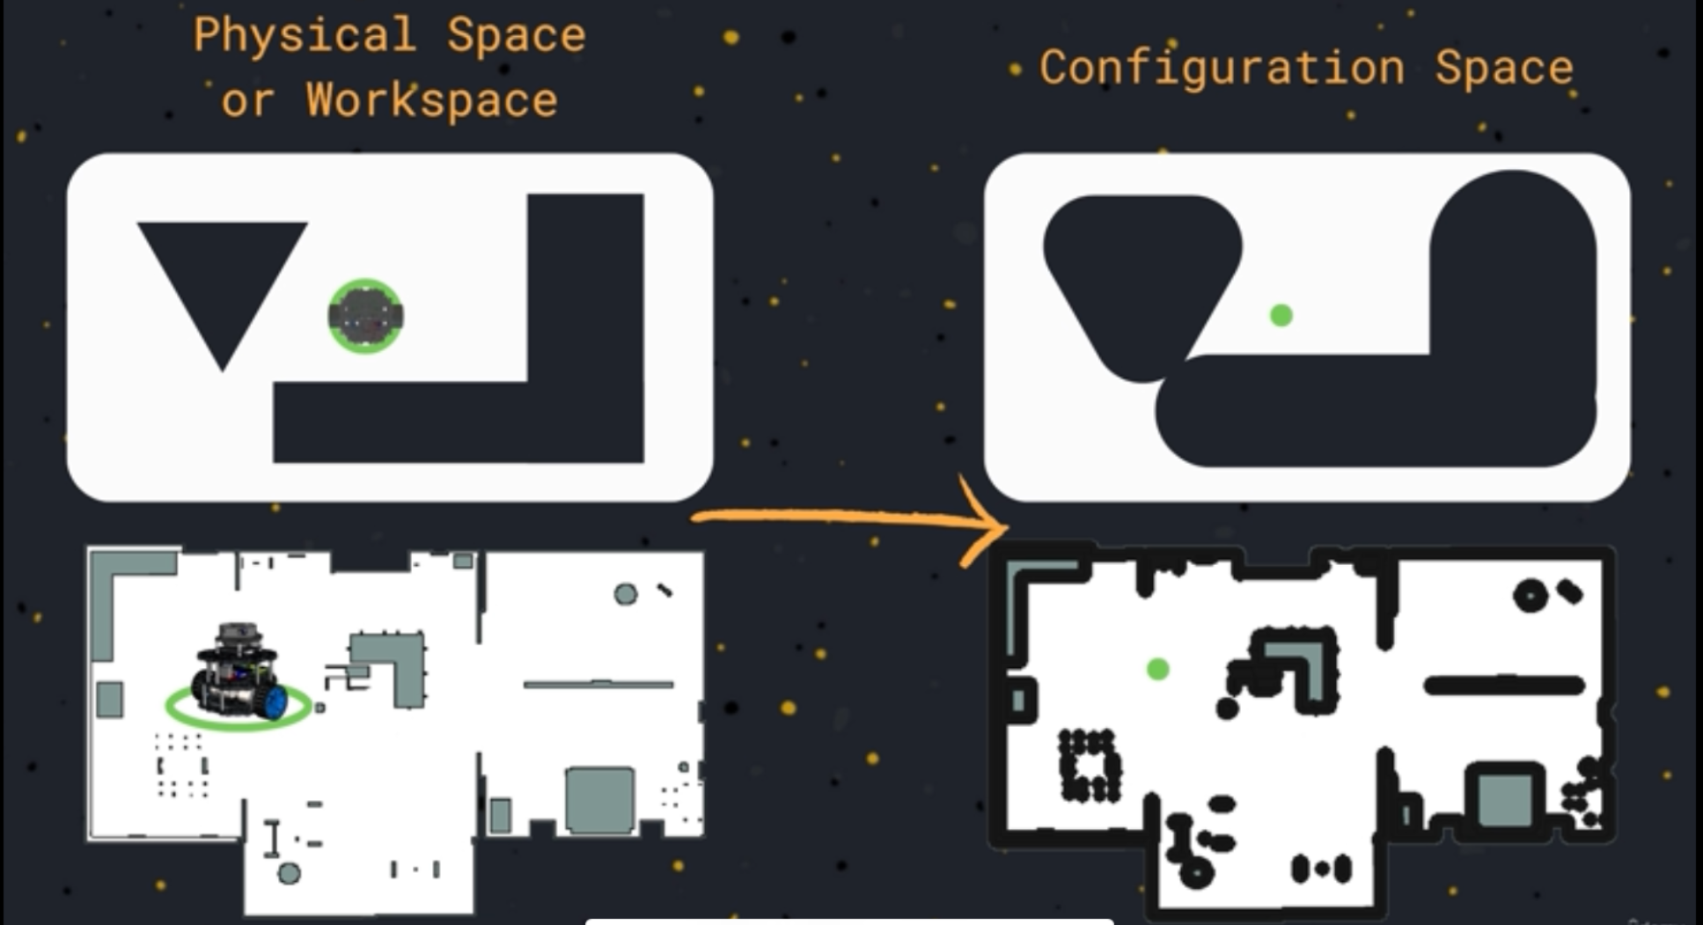
Figure 3: COPYRIGHTED Example of Physical-to-Configuration Space Conversion

In Our Codebase
We do BOTH of the tricks described above. Our robot footprint is a real polygon (an octagon, because our chassis is roughly a square with clipped corners), declared in the costmap configs:
footprint: "[[0.30, 0.24], [0.24, 0.30], [-0.24, 0.30], …]"
This appears in two places: src/sentry_navigation/config/controller_server.yaml (local costmap) and planner_server.yaml (global costmap). On top of the footprint, we also inflate all obstacles by an inflation_radius of 0.45 m. If the robot keeps clipping walls, increase the inflation radius; if it refuses to drive through gaps it should fit through, decrease it. Remember to change it in BOTH files.

Theory: Function Sampling, Graphs
We need a way for a computer to calculate and store paths. This is not trivial and requires some background theory.
Function sampling (or discretization) is known as taking a finite number of points of a function to create a function approximation. We need to do this because we want to store a function in a computer’s memory. For a continuous function, we have an infinite number of values within a given time period. If we tried to store this in computer memory, we’d need infinite memory. Therefore, we sample the function to approximate that function and then store the approximation in memory.
The rate of sampling can be large or small. Large sampling rates produce a better approximation but consume more memory, and a smaller sampling rate produces a poorer approximation and can introduce rounding and math errors, but it uses less memory.
Given that our map is a continuous function of places the robot can move, we cannot store every micrometer that the robot can move, therefore we must sample different points on the map. For example, we can create valid movement points every meter, millimeter, etc. If you do this, you end up creating a graph! Below, Figure 4 is an example of what this may look like in the real world (with a clearly TERRIBLE sampling rate):
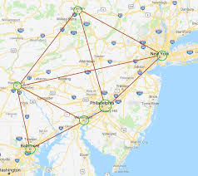
Figure 4: Diagram of Graph Used in Real Life
Graphs require their own in-depth course to fully understand. They are very difficult to learn at first, but here is a short explanation. Graphs are considered a data structure in the world of computer science. They are comprised of edges, and vertices (nodes). The vertices can represent cities, destinations, or anything else you want them to represent. They store a value which can be an int, string, etc. The things that connect the nodes are called edges. These could represent roads to different cities, among other things. Interestingly, they can also have weights (weighted edges), which could represent time, cost, fuel, etc. This is how we fundamentally store our maps, including our competition map. Below, Figure 5 is a basic example of a graph.
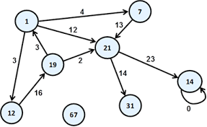
Figure 5: Diagram of Basic Graph

Graph Construction
To plan paths from our current position to our destination, we need a way to construct a graph from our map, and then later, we calculate the optimal path. This is helpful to understand as background info. Look into visibility graph algorithm, voirnoi graph algorithm, and cell decomposition algorithm. Each has their own advantages and disadvantages. There are also more algorithms out there, but these are some basic ones.
It is highly likely that we use cell decomposition for our NAV2 applications. The process begins with a conversion of our continuous map into a grid of cells (see Occupancy Grids section). Note, we can specify the cell size, for example, each cell could represent 10cm by 10cm. We then convert each cell into a node, and then connect that cell to its neighbors using weighted edges. These weights represent how hard it is to traverse that cell. For example, a connection to a cell that represents a regular floor tile may have a cost of 1, but a connection to a cell inside a slow zone or friction zone might have a higher cost, let’s say 5.
Once we have converted our grid of cells into a graph with weighted edges, we can search this graph. See the section about (Path Planning Algorithms) to learn how this works.

Occupancy Grids
Similar to the black and white map, an occupancy grid is another model of the environment that is a simplified representation of the features of the environment. The occupancy grid is comprised of cells, which represent a fixed dimension in the real world. For example, each screen pixel could represent 5cm, 10cm, etc. Each cell contains a value, representing the probability that it is occupied (percentage). For example, cells that have a value of 100 are definitely occupied, 0 are definitely free, and -1 means that the information of that cell is unknown.
In NAV2, this is stored as a single vector, where each [row, column] is stored in one “array”. For example, Positions could be stored like [00, 01, 02, 03, 10, 11, 12, 13…] , and values could be [100, 0, 0, 100, 100, 0, …etc]. This is stored in the nav_msgs/OccupancyGrid.mgs message. Below is an example image. Below, Figure 6 shows a somewhat lackluster example of an occupancy grid.
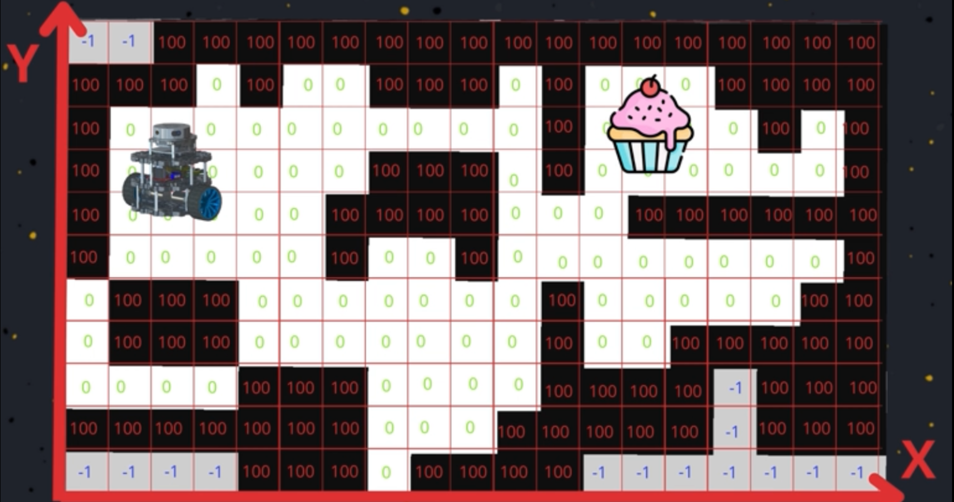
Figure 6: COPYRIGHTED Occupancy Grid Example
Note that editing or creating an occupancy grid is typically done in photo editing software.

In Our Codebase
Our occupancy grids live in src/sentry_localization/maps/. Each map is a pair of files: a .pgm (literally just a grayscale image of the arena) and a .yaml describing it (resolution in meters-per-pixel, origin, occupancy thresholds). Open one of the .pgm files in GIMP and you will recognize Figure 2 immediately.
The “editing in photo editing software” line above is accurate. Our keepout masks (e.g. ARCC20263v3Field_keepout.pgm) were made by painting zones onto a copy of the map. To use a specific map:
ros2 launch sentry_bringup real_robot.launch.py slam:=false map:=tron_room.yaml

Path Planning Algorithms
Once the occupancy grid has been set up and we have the robot’s position, location, and goal destination, we can search our graph of cells to find the best path to our destination. We use two main algorithms: A*, and Dijkstra’s algorithm. There are many resources online to learn about these algorithms, and it would take a long time to explain here.
CS students or those that have taken data structures may be familiar with these algorithms, as they use priority queues and heuristics (branch and bound algorithms) to determine the optimal path.
Note that we won’t have to hard code this, NAV2’s planner uses a mix of algorithms to determine the best path for us. This section is only for theory.
If you would like to see an actual implementation of these algorithms in ROS2, please contact the team lead and he will share his Udemy course examples.

In Our Codebase
Our planner is SmacPlanner2D, an A*-based planner, declared in src/sentry_navigation/config/planner_server.yaml:
plugin: "nav2_smac_planner/SmacPlanner2D"
So the “mix of algorithms” mentioned above is, for us, specifically A* on a 2D grid. If you ever want to try a different planner (NavFn uses Dijkstra, for example), you swap this one plugin line and its parameters — zero code required. That is the beauty of NAV2 plugins (covered later).

NAV2 Introduction
NAV2 is ROS2’s navigation stack. It is essentially a bunch of packages that can provide autonomous navigation, mapping, localization, and obstacle avoidance capabilities to any robot.

Lifecycle Nodes and Lifecycle Node Manager
Things start to get tricky here. Under the hood, NAV2 is built using lifecycle nodes (LCN) and a lifecycle node manager (LCNM). This new type of node exhibits a special behavior that you must specifically opt-into, which allows you to write logic that depends on the current life state of the node, whereas you cannot do this with a regular node.
Lifecycle nodes are glorified finite state machines. For those unaware of what a finite state machine (FSM) is, it is an object that can exist in different states which you can define. For example, if I were making an FSM to represent human activity, I could represent the states as “eating”, “walking”, “sleeping”, etc. FSMs can only exist in one unique state at a time, i.e. humans cannot be walking and sleeping at the same time. These states are stored in a variable, for example, human_state. In basic coding examples, the states are represented as constants and the human_state variable is of type int, or string. Then, each of my states could be assigned a value of ‘0’, ‘1’, ‘2’, where 0 = eating, 1 = walking, and 2 = sleeping. You can also look up FSMs online to get a better understanding.
Lifecycle nodes use this concept for the following quote unquote “node life” states: unconfigured, inactive, finalized, and active.
- Unconfigured: default state when starting up the LCN. When the “configure” command is called, it moves to inactive
- Inactive: the node initializes its components, including user-given parameters. It does not respond to any message or service requests at this time. Can move back to unconfigured via the “cleanup” command, and forward to the active state via the “activate” command
- Active: this is the active state of the node, all message and service requests are processed and logic is written here. The “deactivate” command moves the node back into the inactive state.
- Finalized: when the “shutdown” command is called in any of the states, the FSM moves here. This is where the node is safely cleaned up and destroyed

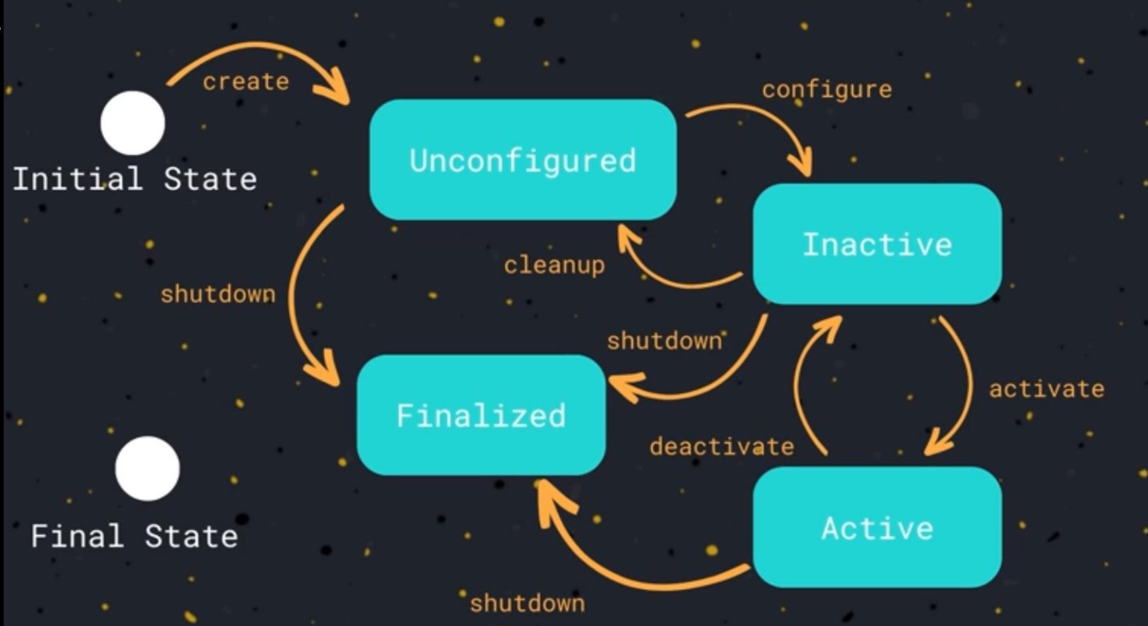
Figure 7: COPYRIGHTED Diagram of a Lifecycle Node

The reason we use lifecycle nodes is because navigation is safety-critical and highly interdependent, and lifecycle nodes are the only ROS 2 mechanism that let Nav2 guarantee that “nothing moves until everything is ready” every time.
- If anything is broken in the ROS2 pipeline, lifecycle nodes can block motion by default, making the system safe
- The different components in NAV2 need to start in the correct order, be recoverable independently, and depend on each other. Lifecycle nodes provide a way to coordinate this process.
- Ensures strict timing of startup and validates all parameters.
Lifecycle nodes can be controlled via the command line interface (CLI). When you start the node, you can run commands like:
ros2 lifecycle nodes – shows all active LCN’s
ros2 lifecycle get [/lcn_name] - gets the current state of the LCN, using the node name obtained from the previous name
ros2 lifecycle list [/lcn_name] – gets the current state and next possible transitions
ros2 lifecycle set [/lcn_name] [transition_number OR full_transition_name] – transitions the node (transition numbers go from 0-3, and I’m not sure which number represents each state).

In Our Codebase
Every NAV2 server we run (planner, controller, smoother, BT navigator) is a lifecycle node, and OUR lifecycle manager lives in src/sentry_navigation/launch/navigation.launch.py:
lifecycle_nodes_base = ["controller_server", "planner_server", "smoother_server", "bt_navigator"]
{"node_names": lifecycle_nodes}, {"autostart": True}
autostart: True means the manager walks every node through unconfigured → inactive → active for us at launch. Important gotcha: if you ever add a new NAV2 server, you MUST add its name to this list, or it will sit in the unconfigured state forever and silently do nothing. This is a classic “why is my robot not moving” bug.
You can also see the lifecycle states from the inside: our C++ controller plugin implements configure(), activate(), deactivate() and cleanup() in omni_pursuit_controller.cpp — those are the exact FSM transitions from Figure 7.

NAV2 Map Server (nav2_map_server)
The map server provides tools to read an occupancy grid, and allows us to convert it into a ros2 message (see the Occupancy Grids section). This service is called the nav2_map_server, and it publishes the map over the topic /map. It also provides a /load_map service, which allows dynamic editing of the environment, but this is not a focus for us.
You can start the map server with the following command (not sure, haven’t tested this):
ros2 run nav2_map_server map_server --ros-args -p yaml_filename:=[path_to_yaml_file.yaml]
Note, this command requires an occupancy grid to be present, and NAV2 to be setup properly with default map server parameters. This is already done for us. You should now have an active Lifecycle Node (LCN) managing the map server, and you can use the previous commands listed in Lifecycle Nodes and Lifecycle Node Manager to activate the node and see it working.
You should also be able to run
ros2 topic list and ros2 service list
and see the that the correct things are running. If you do
ros2 topic echo /map, you should see a bunch of numbers (occupancy grid) being posted.

In Our Codebase
We never run the map server by hand.global_localization.launch.py (in sentry_localization) starts it automatically whenever we launch with slam:=false, and hands it the map .yaml from our maps folder.
To create a new map, drive the robot around with SLAM running (the default), then save it:
ros2 service call /slam_toolbox/save_map slam_toolbox/srv/SaveMap "name: {data: 'my_room'}"
Move the resulting files into src/sentry_localization/maps/, rebuild, and launch with map:=my_room.yaml slam:=false.

Quality of Service (QOS) Policies
In ROS2, everything has a QOS policy, which defines certain features between the communication (DDS protocol) of different nodes. Examples include, message depth, history, reliability, lifespan, etc. To illustrate this, a QOS parameter that I can set in a simple publisher is message history. I can choose to allow the node to only store the latest message, or I can allow the node to store a queue of ‘n’ previously received messages.
This gets kind of complicated, but the reason we talk about this is because it can be a source of communication between nodes. For example, (see NAV2 Map Server (nav2_map_server) for more detail) if you confirm that /map is publishing an occupancy grid, but then try to visualize it in RVIZ2 and cannot see anything, this is likely the issue.
There are certain QOS protocols that are “better” than others. For example, sensors may use a “best effort” policy, while receivers use a “reliable” policy, where the “reliable” policy is superior to the “best effort” policy. This is due to the fact that sensors can drop readings sometimes, but the “reliable” policy requires every reading to be sent accurately, thus making it superior. This causes an incompatibility, resulting in no communication between the nodes.
Sometimes, nodes can run with different QOS policies. The ros2 documentation has summarized all of this info here: Quality of Service settings — ROS 2 Documentation: Humble documentation

Inside a publisher or subscriber, for example, you can change the protocols. Look up coding examples online. There is a rclpy and rclcpp library that you can import. For python, it is:
from rclpy.qos import QoSProfile, QoSReliabilityPolicy
To be honest, have chatgpt or alike explain how to use this library, I have never used it. However, at a high level, you can store different policies in a variable of that type, and when you instantiate your publisher or subscriber, you can add that policy as an additional argument.
To check your QoS policy, you can add the --verbose flag to ros2 topic info [/topic_name] (--verbose) ß inserted here.
If you use RVIZ2, you can also change these parameters if you expand the menu for your /map subscriber.

In Our Codebase
We deal with this exact issue in laser_merger.py (in sentry_bringup/scripts). The lidar drivers publish with “best effort” sensor QoS, so our subscriptions match it:
self.create_subscription(LaserScan, '/scan_left', self.scan_left_callback, qos_profile_sensor_data)
but the merged /scan output is published as RELIABLE, because SLAM and the costmaps want dependable data:
reliable_qos = QoSProfile(reliability=ReliabilityPolicy.RELIABLE, history=HistoryPolicy.KEEP_LAST, depth=10)
If you ever write a node that subscribes to a sensor topic and mysteriously receives nothing, a QoS mismatch is suspect number one. Check with ros2 topic info /scan --verbose before tearing your hair out.

NAV2 Path Planning Server
One of the servers used in the NAV2 navigation stack is the path planner server. This is the server that actually takes in the map data, current position, and desired goal position, and calculates a path. It then publishes a path on the /path topic.

In Our Codebase
Our planner server is configured in src/sentry_navigation/config/planner_server.yaml. The interesting knobs: expected_planner_frequency: 2.0 (how often we replan), tolerance: 0.10 (how close to the goal the path must end), and cost_penalty (how strongly the planner avoids high-cost cells near obstacles). The global costmap lives in the same file.
Because configs are just YAML, tuning the planner is edit → relaunch. No compiling. (If you did not build with --symlink-install, run a quick colcon build so the edited file gets copied into /install.)

Execution

Background Info
This section talks about the execution of the newly planned path. Mobile robots such as ours that operate in dynamic environments need a way to safely follow a calculated path while avoiding any new obstacles. For example, a pedestrian, other robot, or other new obstacle could change the environment and block the planned path, meaning a system needs to be in place to handle this. We call these Motion Planners.

Motion Planners

Output
This is a complex topic, so let’s start with the output. Once a motion planner has performed its calculations, it outputs a simple velocity command on the topic /cmd_vel. Note that this is also the final output of our NAV2 system, and is represented as a pose command [x y z r]. For our purposes, we will only send the x and y velocity commands, and rotation [x y r] as the robot cannot move in the z direction, unless someone wants to find a way to make it jump. We then send this command out from the jetson and into the main circuit board (mcb) via serial communication. The mcb handles the firmware and physical execution of these commands.
*Note: this feature here is the whole goal of our team – to send the velocity command autonomously instead of using a joystick.

In Our Codebase
This handoff is real, findable code. On the jetson side, NavSubscriber inside comm_hub.py (sentry_communication) listens for the velocity command and immediately packs it into a DJI serial frame for the mcb:
cmd = [msg.linear.y, msg.linear.x, 0.0]
One extra wrinkle on the real robot: NAV2’s commands are relative to the chassis, but our mcb expects them relative to the TURRET. So a small node called cmd_vel_gimbal_rotator.py (sentry_bringup/scripts) sits in the middle and rotates the velocity vector by the current turret angle. The full flow is: NAV2 → /cmd_vel → cmd_vel_gimbal_rotator → /cmd_vel_rotated → comm_hub → mcb. The comment block at the top of that file explains why it exists and the 2D rotation matrix it uses — it is genuinely a good read.

The Execution Loop
Let’s start with the motion planning loop: Once a new velocity command has been sent, the robot localizes itself again. This causes a change in the positional data of the robot (TF transformation). The new position is compared with its desired position, which is indicated by the path that was calculated by the planner. The result of this comparison provides a measure of how much the robot’s position deviates from the one on the specified path. Therefore, the task of the motion planning algorithm is to calculate a velocity command that minimizes this error, which would effectively bring the robot closer and closer to its desired position on the map.
During this process, the motion planner may also use some sensor data, such as the lidar scanner data on the /scan topic. By incorporating this information, it can prevent collision while still following the desired path. Also, the motion planning logic is executed repeatedly, up to hundreds of times per second, to compute a new output velocity command.
Therefore, the process is vel_cmdà (tf * /path) à (motion planner logic * /scan) à vel_cmd
Note that * represents the comparison between two things.
Note that the output velocity command may not be perfectly accurate as wheels can slip, and error can still be present, thus we still use global localization algorithms and odometry calculations to calculate the new position. This cycle repeats until the robot reaches its destination.
In addition to the motion planning loop, a larger, slower outer loop exists. Let’s call this the path replanning loop:
When a new position is detected, a comparison is made with the goal destination. The result of this comparison is fed back into the NAV2 Path Planning Server. A new path is then recalculated and is fed into the motion planner loop. This whole process can be seen down below in Figure 8:

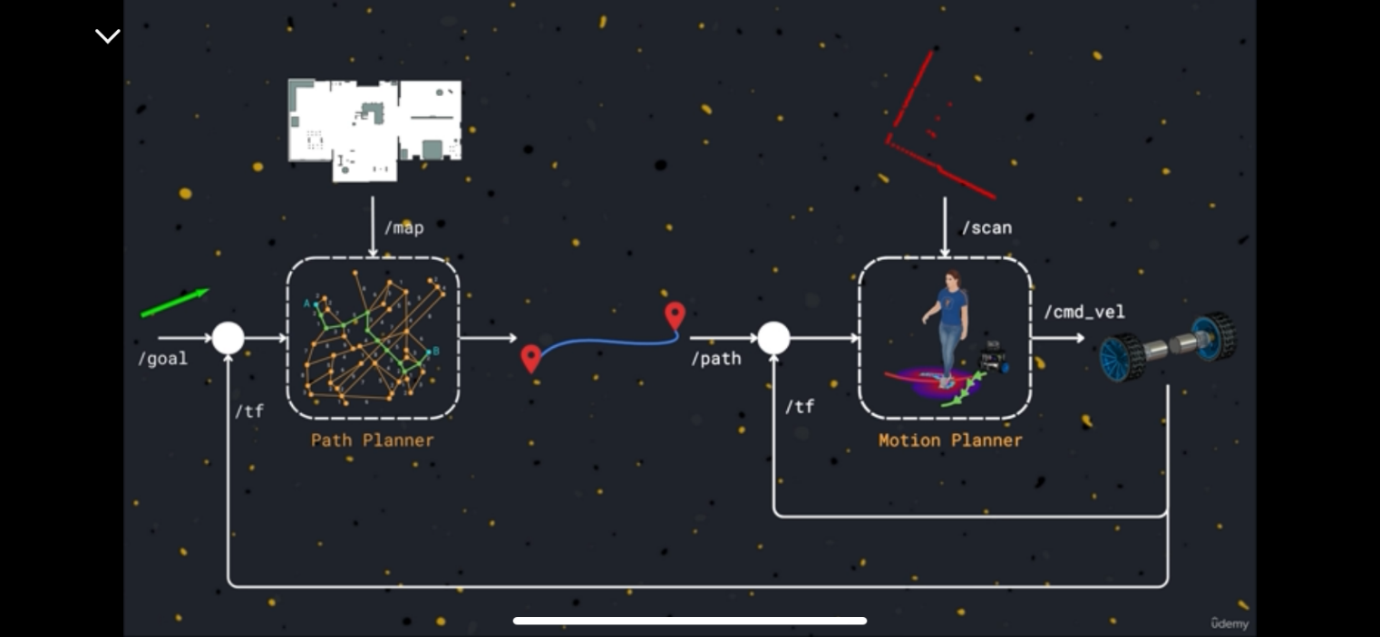
Figure 8: COPYRIGHTED Diagram of full Path Planning and Execution Loop

Path Following: PID Loop
This will explain how path following actually works, and how the motion planner calculates its velocity command. The process used is called a PID loop, standing for proportional, integral, and derivative. For those who participated in robotics competitions before, this may be familiar.
Whether it’s a physical line, or a path calculated by the planner, the process for following this path remains the same. This process is also executed tens of times, repeatedly and continuously. In essence, for each iteration, the goal is to calculate the velocity commands that will send you to your next point along the path. These points are often spaced at very small intervals. The PID loop is the way we do this.
Here are the basics of path following, and how PID plays its role. For this description, assume that these steps apply to each wheel motor on the robot. Let’s say you are following a curve. In any iteration, your next point will have a difference or change in x and y coordinates, and its rotation. You will need new desired wheel speeds for each of the motors to reach that point. Let’s define the error e(t) as the difference in the current motor speed and desired motor speed, noting the dependance on time. Let’s call our current velocity y(t), and our desired velocity r(t). We can describe this relationship as:
$$e\left(t\right)=r\left(t\right)−y\left(t\right)$$
When we send a velocity command, let’s say u(t), we want to minimize this error in velocity, to do it, we use the PID (proportional, integral, derivative) process.
Let’s first look at the formula for the final velocity command, u(t):
$$u\left(t\right)=\left[K | | p∗e\left(t\right)\right]+\left[K_{i}∗∫e\left(τ\right)dτ\right]+\left[\frac{K_{d}∗de\left(t\right)}{dt}\right]$$
The first term is the P (proportional) term. This term looks at the present error and produces a velocity command that is proportional to the magnitude of the error. In other words, higher current error, higher velocity command, and vice versa.
The second term is the I (integral) term. This term looks at the sum of the past errors and produces a velocity command that’s proportional to the magnitude of accumulated error. An example of this is the robot drifting off the line.
The third term is the D (derivative) term. This term looks into the future error by analyzing the rate of change of the error and produces a velocity command that’s proportional to how fast the error is changing. For example, if the wheel speed is decreasing slowly, this term corrects the error in wheel speed slightly. If a wheel slips and the motor speed is changing very quickly, this term corrects the error greatly,
The three coefficients Kp, Ki, and Kd, control the weights of each of these terms, and can be customized for different systems in a process called PID tuning.

PID Tuning
Although we probably won’t do this, the goal is to minimize oscillations of your robot or system. This may also be helpful for MREN103 students in their line following robot projects. Always start with Kp. Ideally, you want to tune kp so your robot initially slightly overshoots your path, and then stabilizes. Then, move to KI. Tune it so your robot still initially slightly overshoots your path, but then hugs the line. Finally, move to kd. Tune it so that you see no more oscillations and your robot should hug the line very quickly.

Path Following: Execution
For the robot to actually execute and follow the path calculated by the path, we need the following:
- Path given by NAV2 path planner
- Motion controller
  - Velocity command given by PID loop
  - Correctly tuned PID loop
  - Or, we can use another approach that is not PID
- Correctly matched coordinate frames (read entire Robot Localization section up until and including Theory of Transformation Between Frames)
  - The planner uses the map frame, but the robot’s new position TF frame is given relative to odom
  - The robots position must be mapped such that it’s position is relative to map, not odom
Once all these are running, the optimal path is continuously calculated and the PID loop iteratively follows the path.

In Our Codebase
Confession: we do not actually run a PID loop. Our custom controller (see the next section) computes the velocity command directly from geometry. The closest thing to a P-term is “approach velocity scaling” in omni_pursuit_controller.cpp. Inside approach_velocity_scaling_dist of the goal, speed scales down linearly with the remaining distance, like a proportional controller for stopping smoothly.
The “correctly matched coordinate frames” bullet above, however, is VERY real. Our controller had a bug where the robot’s pose (in the odom frame) was compared directly against the path (in the map frame), and every time map→odom drifted, the commanded direction flipped and the robot jittered back and forth. The fix (transforming the pose into the plan’s frame first) is documented in a big comment in omni_pursuit_controller.cpp. Read it and learn from our pain.

DWB Motion Planner: Our Approach
Another motion planning strategy is to use the DWA (dynamic window approach), or DWB approach. DWB is a fancier version of DWA. The approach works as follows:
- You need to know your robot’s drive mode (differential, Ackermann, omni-drive, etc). For our robot, we use omni-drive as we can move in all 4 cardinal directions at any moment.
- Hundreds of velocity commands are pseudo-randomly generated. A set of equations from the previous steps converts this command into the robot’s predicted path or trajectory
- The DWA algorithm selects the best possible velocity command based on the best possible trajectory that was determined.
  - A cost is assigned to each trajectory, and the trajectory with the best cost is selected. It is calculated via a weighted sum of different criteria, and either the highest or lowest cost trajectory is selected
  - For our purposes, assume the lowest cost is ideal. Examples of criteria include: distance to obstacles (higher cost when hitting an obstacle), distance from planned path (higher cost with further deviation), and velocity (commands that move the robot backwards may be penalized)
The DWA algorithm is flexible in the sense that you can create various criteria and weigh them differently. The equation for calculating cost typically follows the weighted sum structure:
$$Cost=\left(weight_{1}∗criteria_{1}\right)+\left(weigh_{2}∗criteria_{2}\right)+…$$
Another advantage is it’s ability to be dynamic and adapt to changing environments. If a new obstacle (person, robot, etc) appears unexpectedly, the algorithm will select a path that sticks to the path as best as possible, while avoiding the new obstacle. A diagram of this algorithm can be seen below in Figure 9:
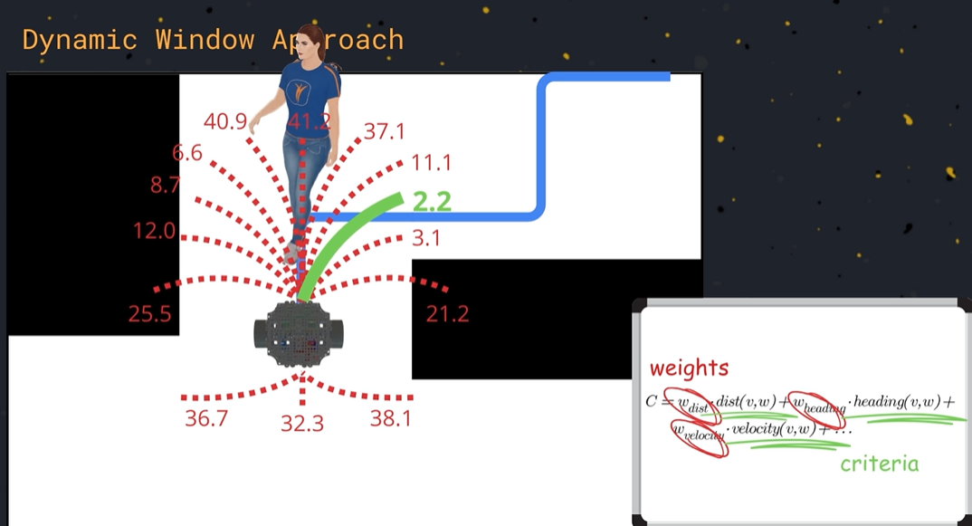
Figure 9: COPYRIGHTED Visual Depiction of DWA Algorithm
Fortunately, NAV2 has a DWB controller plugin, so we do not need to write this by hand, we only need to tune the plugin. Plugin tuning can be found online on the official NAV2 documentation.

In Our Codebase: Plot Twist, We Don’t Use DWB
History lesson: DWB was the plan when this guide was written, but we ended up writing our own controller instead:the OmniPursuitController, a holonomic “pure pursuit” controller. It lives in its own package, src/omni_pursuit_controller/, and is loaded in controller_server.yaml:
plugin: "nav2_omni_pursuit_controller::OmniPursuitController"
How it works, in one breath: find the closest point on the path, look 0.5 m further ahead along it (lookahead_dist), and drive straight toward that point at desired_linear_vel (0.30 m/s), slowing down near the goal. Because we are omni-drive, it never rotates the chassis — angular.z is always 0, and the turret aims independently. No sampling hundreds of trajectories like DWA; just chase a point that keeps sliding along the path.
All the tuning lives in controller_server.yaml: raise desired_linear_vel to go faster, raise lookahead_dist if the robot wiggles around the path (bigger lookahead = smoother, but it cuts corners), and max_linear_accel caps how violently the velocity can change per cycle (this killed a nasty jitter). To change the actual behavior, edit computeVelocityCommands() in omni_pursuit_controller.cpp.
Please note that this controller is subject to change in the future.

Robot Localization

Background
“Robot localization denotes the robot’s ability to establish its own position and orientation within a frame of reference” - Wikipedia. A reference frame is a point against which we express our position, namely the origin, the point at which we express the position of the other objects in space. In the world, this is the intersection of the Greenwich meridian and the equator, which is given a latitude and longitude of (0, 0). The pose is then calculated with respect to the origin using various techniques. For our robot, our pose is [x, y, r].
It is important that everyone in the world uses the same reference frame. For example, if someone took the intersection of the Greenwich meridian and the equator as the world’s origin, and I took my house as the world’s origin, asking these two people to move to the coordinates (1000, 500) would NOT be the same position. For example, I would move 1000 units to the right and 500 units up from my house, while the other person would move the same distance from the equator, causing a problem. You would not be able to localize or establish your own position within the world.
For this reason, we have developed a standard frame of reference for mobile robots.

Standard Robotics Reference Frame
Quickly reference the TF Transformations section to understand the next paragraph about the standard robotics reference frame. Just like the previously mentioned world coordinates system, we have a universally accepted coordinate system for robotics. These involve 3 reference frames: map, odom, and base_link.
map: can be set to any point in your world. This is your (0,0). For our competition map, it is the center of the field.
odom: the position that your robot first started in before any movement (our starting zone)
base_link: the moving reference frame of the mobile robot, usually at its center of rotation. Its movement has to be continuous.
These free frames are connected. The order of transformation of reference frames is mapàodomàbase_link. In other words, your base_link is in reference to odom, and odom is in reference to map, your (0,0) point in the world. In fact, the TF tree for NAV2 expects this exact transformation order with these exact names, and NAV2 will not work if a transformation is broken here.

Theory of Transformation Between Frames
This is more theory, as NAV2 does this by itself. This part is also linear algebra heavy, and will take a long time to explain, therefore I will only do an introduction.
Recall how TF transformations store transformation data between different frames. For example, a robotic arm may be [0, 0, 200] millimeters above its base, and we can apply that transformation to our current position to reach there. This is a matrix.
For a 2d navigating robot, we have a standard transformation matrix. Please look at Figure 10 below:

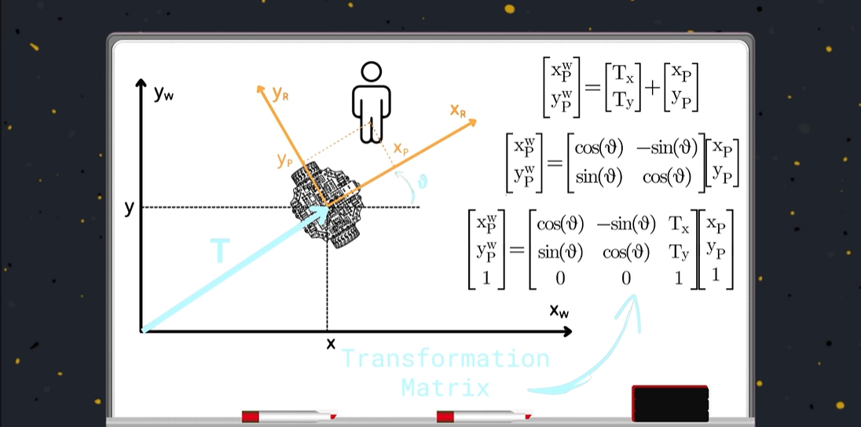
Figure 10 :COPYRIGHTED Diagram of Robot Transformations, Including Translation Matrix, Rotation Matrix, and Combined Transformation Matrix
The convention here is p – person, w – world. Also, for the letters on the left-hand side of the equation, the variable is read as “position of [bottom letter] with respect to [top letter]”.
The first equation is the translation matrix, representing the 2d coordinates of the person with respect to the world. We add the x and y position of the robot with respect to the world, and then x and y of the person with respect to the robot.
The second equation is the rotation matrix. Given the angle of the robot with respect to the original frame, and the position of the person in that rotated coordinate frame, we can find the position of the person relative to the world with that sine and cosine matrix. I won’t go through the derivation, you can look this up.
The third equation is what we get when we combine the two previous equations, and the third row is inserted to make the matrix square (i.e. equal number of rows and columns).
Using this transformation matrix, we can apply transformations between map, odom, base_link, and even a person to obtain the transformation of any of the other frames. This will make sense in the picture below, Figure 11, which has all the math and equations and diagrams that should explain this, as I won’t do a good job here.

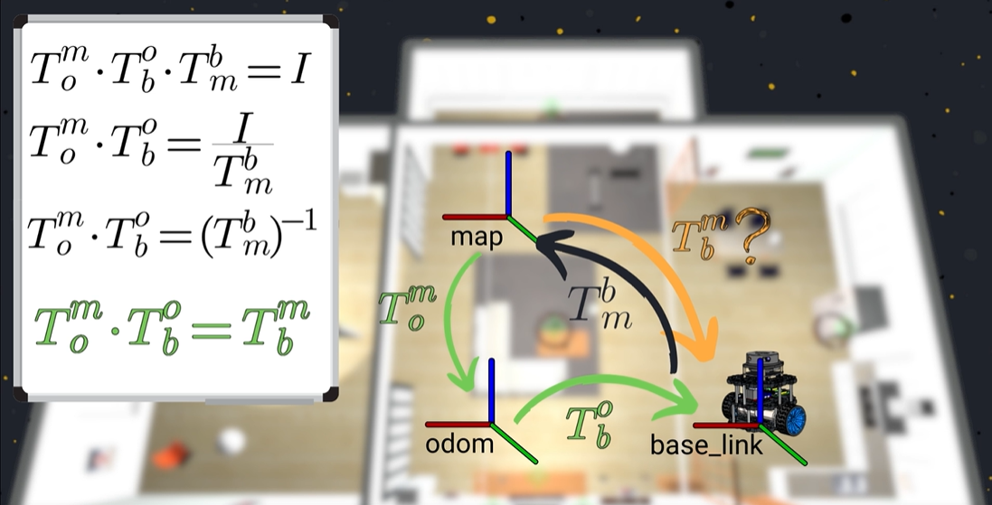
Figure 11: COPYRIGHTED Diagram and Equations of Obtaining Transformations Between Different Frames. The Matrix "I" is the Identity Matrix.

AMCL Algorithm

AMCL (Adaptive Monte-Carlo Localization) works by keeping many possible guesses of where the robot could be and gradually narrowing them down using sensor data and odometry. Each time the robot moves, odometry is used to shift all of these guesses forward, predicting where the robot might now be, even though this motion is imperfect and can drift over time. The robot’s sensor readings, usually from a laser scanner, are then compared to what the robot should see at each guessed position in the map. Guesses that match the map well are kept, while poor matches are thrown away and replaced with better ones. As this repeats, the guesses cluster around the robot’s true position. Instead of changing the odometry itself, AMCL publishes a correction between the map and odom frames, so the robot can move smoothly locally while still staying aligned with the fixed global map.
This is the default algorithm used in NAV2.

In Our Codebase
Our AMCL parameters live in src/sentry_localization/config/amcl.yaml. Two highlights: robot_model_type is nav2_amcl::OmniMotionModel (because mecanum wheels move sideways, the default differential model would be lying to it), and the particle count ranges from min_particles: 1000 up to max_particles: 15000. Many guesses while lost, few once confident, exactly like the description above.
AMCL only runs when we launch with slam:=false (otherwise SLAM Toolbox handles localization while building the map). If the robot’s starting pose is known, pass seed_initial_pose:=true with initial_pose_x/y/yaw to skip the “guesses spread everywhere” phase entirely.

Obstacle Avoidance
Until this section, we have no way to avoid obstacles. We used a static map of the environment, and our motion following algorithms are prone to error. We also have no way to track and update both new and moving obstacles. This section aims to tackle this issue, starting with the costmap.

Costmap
A costmap is a 2d map of the environment that is used for planning and navigation. It is NOT the same as an occupancy grid (see Occupancy Grids section). It is actually an extension of the occupancy grid. It is still a symbolic representation of the environment and can express a wide range of information that an occupancy grid cannot. For example, a costmap can use the data coming from a lidar or camera to generate an occupancy grid, where obstacles that are detected are marked as occupied in the costmap. It may also take a static map of the environment, and can also inflate the obstacles to ensure the robot maintains a safe distance from hazards (see Path Planning Configuration section). It can also integrate semantic information, such as keep-out zones, or restricted zones.
In summary, the task of a costmap is to integrate diverse information about the environment that we can take using different sources into a single 2D map. This map provides a unified and comprehensive representation of all the information that is collected about the environment. We can use this information to plan the path, and also to execute it with the autonomous navigation stack.
In a costmap, we use values from 0-255 to express a cell’s occupancy. With this greater range, we can convey more information about the environment. For example, in one cell, we can express whether it’s free, occupied, or how advisable it is to traverse that cell. We can use this to indicate areas that we want to either prefer or avoid.
Please see Figure 12 below, which shows a depiction of a costmap vs an occupancy grid. You may have to heavily zoom in to see it properly.
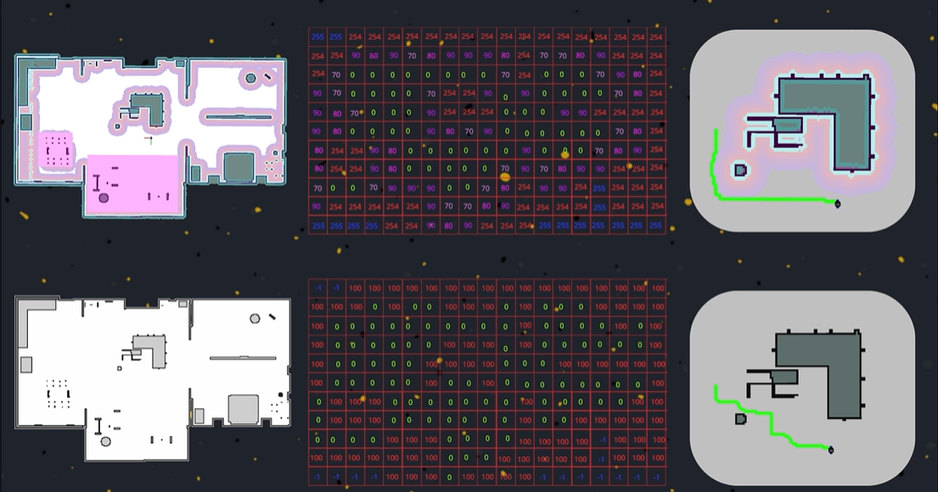
Figure 12: COPYRIGHTED Diagram of Costmap vs. Occupancy Grid, Including a Pictorial and Numerical Representation
Note the color scheme used for the costmap in Figure 12. The colour scheme used is:
- White – free/unoccupied
- Gray – unknown/not yet determined via sensors
- Light blue – lethally occupied (traversing this cell will result in a collision)
- Pink: Keepout zones (defined by user)
- Gradient colours: Not recommended to traverse. These are in place as technically the robot can pass through here, but it gets very close to an obstacle.

NAV2 Costmap 2D and Costmap Layers
In NAV2, we use two different costmaps: the local costmap and the global costmap. The local costmap uses immediate sensor data to update itself, allowing a very fast updating rate, often 10s of times per second. This is great for motion planning and dynamic obstacle avoidance. The global costmap updates much less frequently but allows the planner to recalculate its path in the presence of dynamic obstacles. Below, Figure 13 shows a visual example of this.

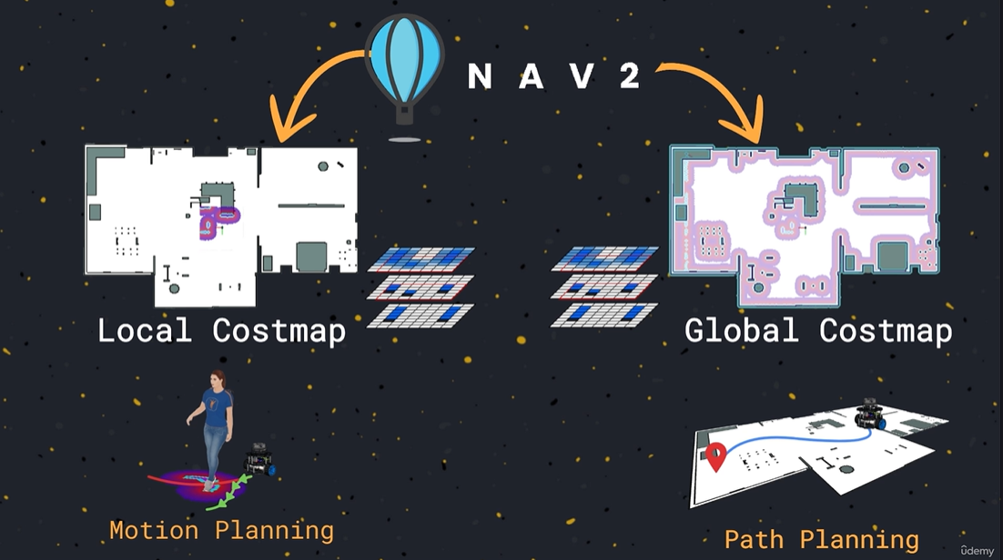
Figure 13: COPYRIGHTED Diagram of Local vs. Global Costmap
The local and global costmap are a result of the merging of multiple costmap layers. These include the static, obstacle, and inflation layers.
Below are the each of the layers of the costmap. To load the costmap independently of our simulation, run the following command. Note, your path may be different:
ros2 run nav2_costmap_2d nav2_costmap_2d --ros-args –params-file [/path-to-navigation-package/config/costmap.yaml]

Static Layer
The static layer is simply a static representation of the environment. For example, this is our competition map without any other robots present. Note that there is a pipeline that exists between the nav2_map_server and the static layer (see NAV2 Map Server (nav2_map_server) section). The nav2_map_server loads our pre-saved competition map and publishes it to the /map topic, which the static layer subscribes to. There is another tool called nav2_map_saver which can dynamically save a costmap in real time. This is more applicable if we didn’t have a pre-saved map, or we used SLAM algorithms (simultaneous localization and mapping).

Obstacle Layer
The obstacle layer is a dynamic and continuously updated representation of what is scanned by lidar or camera sensors. Lidar sensors will publish their info on the topic /scan, while cameras publish on the /cloud topic. Lidar sensors generate a 2d representation of the map, while cameras can generate 3D scans, also known as point clouds (hence the /cloud topic).
The method by which the obstacle layer is generated is called raytracing. Raytracing is a common issue in robotics, video game development, computer vision and more. Suppose our lidar detects a filled cell or hits an obstacle, the goal of raytracing is to calculate which cells that the laser beam has passed through. Read more about raytracing online.
This is the layer responsible for detecting new and moving objects.

Inflation Layer
The inflation layer is where all the previous layer’s obstacles or occupied cells are inflated by the size of the robot radius (see Path Planning Configuration). There are two important things here:
- There is a parameter called the cost scaling factor which controls the cell occupancy values around each obstacle. See Figure 14 for a depiction of this.
- The order in which layers are loaded matters, as the inflation layer applies its inflation algorithm to all previously loaded layers.

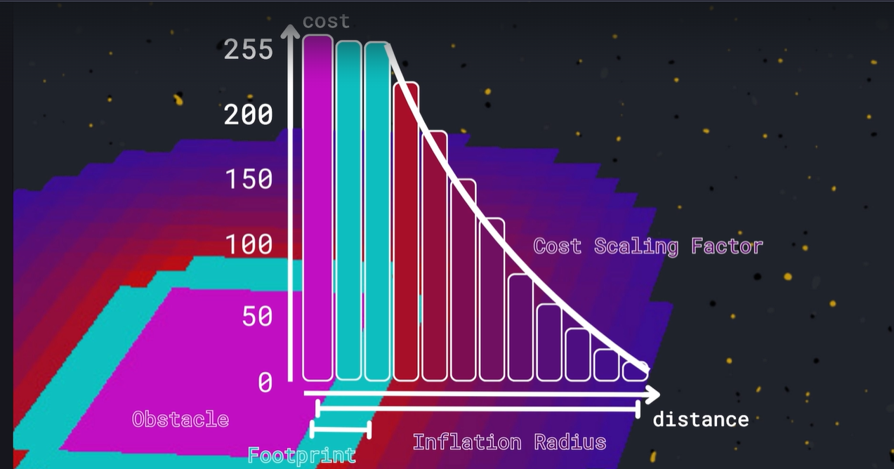
Figure 14: COPYRIGHTED Image of Inflation Layer and Cost Scaling Factor

In Our Codebase
Our two costmaps are configured in two files in src/sentry_navigation/config/: the local costmap at the bottom of controller_server.yaml (a rolling 5×5 m window around the robot, in the odom frame) and the global costmap at the bottom of planner_server.yaml (the whole map, in the map frame). Compare their layer lists:
plugins: ["obstacle_layer", "inflation_layer"] # local
plugins: ["static_layer", "obstacle_layer", "inflation_layer"] # global
The local costmap has no static layer — it only trusts live lidar. Both files contain the exact parameters from Figure 14: inflation_radius: 0.45 and cost_scaling_factor. Tune those to change how scared the robot is of walls.
We also use one layer type this guide has not mentioned yet: a keepout filter. The pink “keepout zones” from the costmap colour list are painted into a mask image (ARCC20263v3Field_keepout.pgm in the maps folder) and loaded when you launch with use_keepout:=true. This is how we stop the robot from pathing into places it technically fits but really should not go.

Navigation
Here’s the fun section.

NAV2 Servers
In NAV2, we have different servers that control the path planning, execution, localization, and obstacle avoidance. All servers implement a standardized interface and provides common functionalities for their specific goal (planning, motion control, etc). This ensures that developers, like us, do not have to worry about interfacing with hardware. We simply have to worry about writing the algorithms, and NAV2 handles the rest.
The servers include:
- Planner
- Smoother (smooths the planned path)
- Controller (or motion planner)
- Behavior server
- Behavior tree server (see NAV2 BT Navigator)
For each server, we have a YAML configuration file, allowing us to declare the parameters of these servers before use. To run an individual server, run:
ros2 run [server’s_package_name] [server_name]ros-args –params-file [/path-to-navigation-package/config/server_name.yaml]

In Our Codebase
One YAML per server, all in src/sentry_navigation/config/: planner_server.yaml, controller_server.yaml, smoother_server.yaml, bt_navigator.yaml, and behavior_server.yaml. You never have to type that ros2 run command by hand — navigation.launch.py starts every server with its config attached. So the workflow for tuning navigation is: edit the YAML, relaunch, observe, repeat.

NAV2 Plugins
NAV2 plugins allow you to extend the functionalities of the base servers. For example, you can write and override NAV2’s path planning logic or extend it with your own logic. This is where you would write custom logic and load it. Note, unfortunately any coding here must be done in C++, as the NAV2 servers are written and natively supported in only C++.
In terms of process, you would go to the NAV2 documentation website and read up on how to create a new plugin for the server you want. Inside the navigation package, you’d make a new cpp and hpp file and write the plugin there. You’d then launch it as a plugin via a special loading command in XML. Take a look at the coding examples I provided for a better idea on how to do this.

In Our Codebase
We actually did this! Our omni_pursuit_controller package IS a NAV2 controller plugin, and it shows all three pieces a plugin needs:
- The C++ class (src/omni_pursuit_controller.cpp) inherits from nav2_core::Controller and ends with the magic macro that registers it: PLUGINLIB_EXPORT_CLASS(…)
- A plugin description XML (nav2_pure_pursuit_controller.xml) that tells NAV2 the class exists, exported by a line in CMakeLists.txt
- A YAML line pointing the server at it — the plugin: line under FollowPath in controller_server.yaml
To write your own plugin, the honest fastest path is: copy this package, rename the class, and rewrite computeVelocityCommands() (for a controller) with your own logic. The boilerplate around it stays basically identical.

NAV2 Lifecycle Manager
The NAV2 servers are implemented as lifecycle nodes. This is why they can be started up independently. In order to launch and configure all lifecycle nodes correctly and in order, NAV2 has a lifecycle manager node which orchestrates this process. You typically activate this node in the launch file of your package, see our code for examples.
In our code, this is the lifecycle_manager node in src/sentry_navigation/launch/navigation.launch.py — see the In Our Codebase subsection under Lifecycle Nodes for the snippet and the classic “forgot to add my node to the list” bug.

Behavior Trees
As robotic software developers, our job is to make robots smarter, to enable them to perceive their surroundings, adapt to changes, and decide in every situation the best action to take to complete a given task. This is an extremely complex challenge that requires an equally powerful tool. Behavior trees were initially developed and adopted in video game development to program the behaviors of various game characters. Given their success, flexibility, and modularity, they were soon adopted in other fields such as robotics and also in certain areas of the artificial intelligence. A behavior tree allows us to structure different actions and different tasks within a single system. One of the main advantages of this tool is its modularity, meaning you can create complex behaviors as a composition of simpler ones. You can also make a behavior tree of behavior trees, where each sub-behavior tree dictates a different action.
Below, Figure 15 shows a basic example of a behavior tree. Note, the nodes will be explained in the next section.
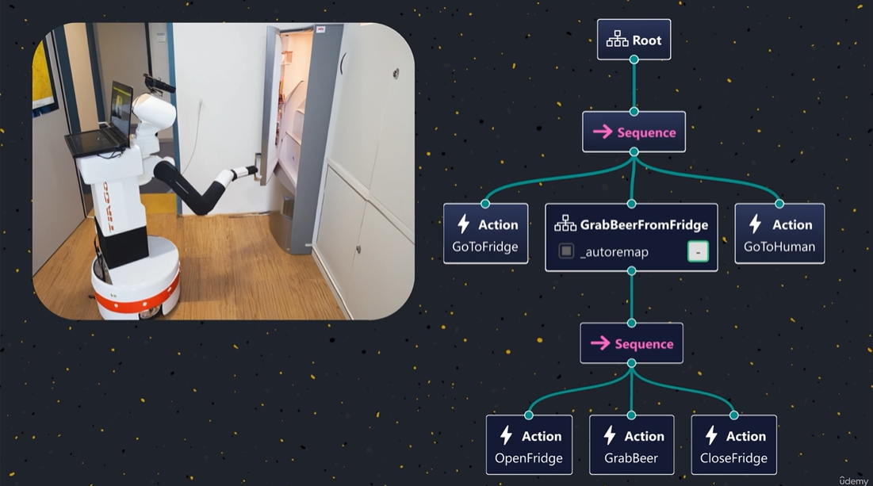
Figure 15: COPYRIGHTED Example Behavior Tree
Please use the following resources for behavior trees:
https://www.behaviortree.dev/docs/intro - Online Guide
https://arxiv.org/pdf/1709.00084 - Research paper style description of BT

BT Node Types
There are four classifications of BT nodes: Action, Control, Conditions, and Decorators.
- Actions are executable processes that can be called
- Control nodes typically have 1 or more child nodes and control the order of children activation. They also decide what to do when an action takes too much time to complete, or fails
- Condition nodes check for certain conditions, and their output depends on whether the condition was met. Typically, they are used in the logical flow of the tree, allowing complex behaviors to be added. An example could be if the robot health is low
- Decorator nodes have only one child, and the node manages its child’s execution behavior.
Below, Figure 16 is a diagram showing the different kinds of nodes, with some examples:
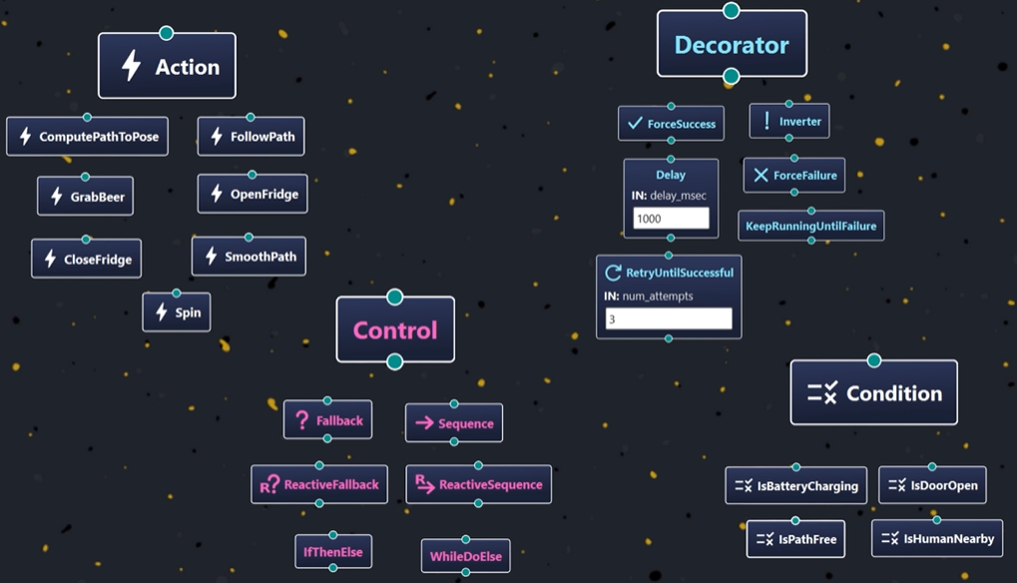
Figure 16: COPYRIGHTED Visual Example of BT Nodes

Ticks and Tick Propagation
The execution of a behavior tree is driven by a signal that is called tick, which propagates through all the nodes in the behavior tree until it reaches the terminal nodes, namely the leaves of the tree. When a node receives the tick, it executes the action for which it is programmed. For example, when the “grab beer” node in Figure 15 receives the tick, it performs the necessary operation to execute this action on the robot. When it executes, its programmed functionalities can only return three values: SUCCESS if it has completed the action correctly, FAILURE if the execution has failed, or RUNNING if the execution takes longer. The running state is particularly useful for actions that take time to complete. Instead of blocking the tick and so halting the behavior tree execution, the action is started and the node immediately returns, running until it's either completed successfully or it fails. Within a behavior tree, there is only one tick in the whole tree, and this is the one that propagates through all the nodes, triggering all the functionalities of the tree.
The most common control nodes that you will see are sequence and fallback nodes. Sequence will sequentially run all of its children from left to right, returning SUCCESS once all other children return SUCCESS. If any child fails, the sequence returns FAILURE. Fallback will run all of its children from left to right, returning SUCCESS when any of the nodes return success, and FAILURE if no node returns SUCCESS.
Below, Figure 17 shows an example of tick propagation. Note that one individual path is ticked each tick, not the whole tree.
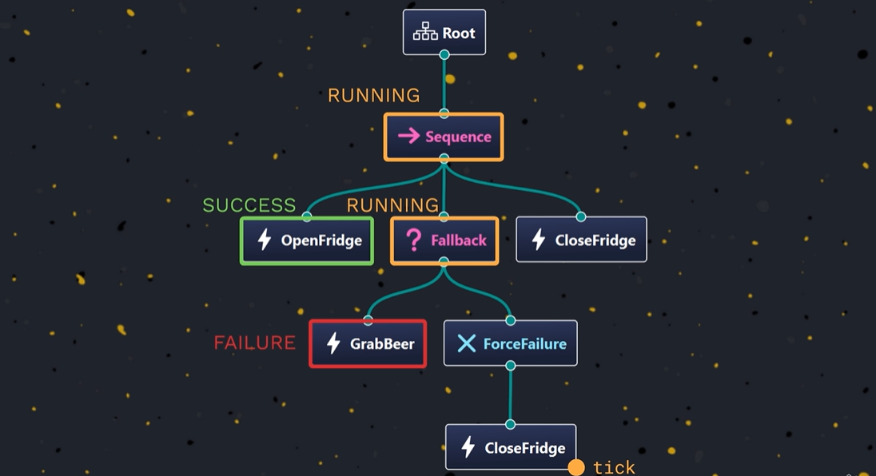
Figure 17: COPYRIGHTED Example of BT Tick Propagating Through the Tree. The Next Tick Will Pass Through the "CloseFridge" Node.
There are also NAV2 specific nodes, like PipelineSequence which is helpful for our use case. Read them all here: https://docs.nav2.org/behavior_trees/overview/nav2_specific_nodes.html#

Ports and Blackboards
To pass information along or within a BT, we have ports and blackboards. For each node, we can declare both input and output ports, and these include a variable of type that is specified by the user. This is how nodes can take in arguments and output a result.
Suppose we have our planner and smoother servers. The planner needs an output port for the calculated path, while the smoother needs an input port for that same variable. This is where blackboards come in.
Blackboards are a space that is shared between all nodes of a BT. You can declare global variables here that can be accessed by any other node. Keep in mind that this is error prone, as one node may be updating a variable out of order from other nodes, and overwriting data. Variables in the blackboard are structured in a key, type, value format/tuple. Below, Figure 18 shows a diagram of a basic BT that incorporates ports and a blackboard.
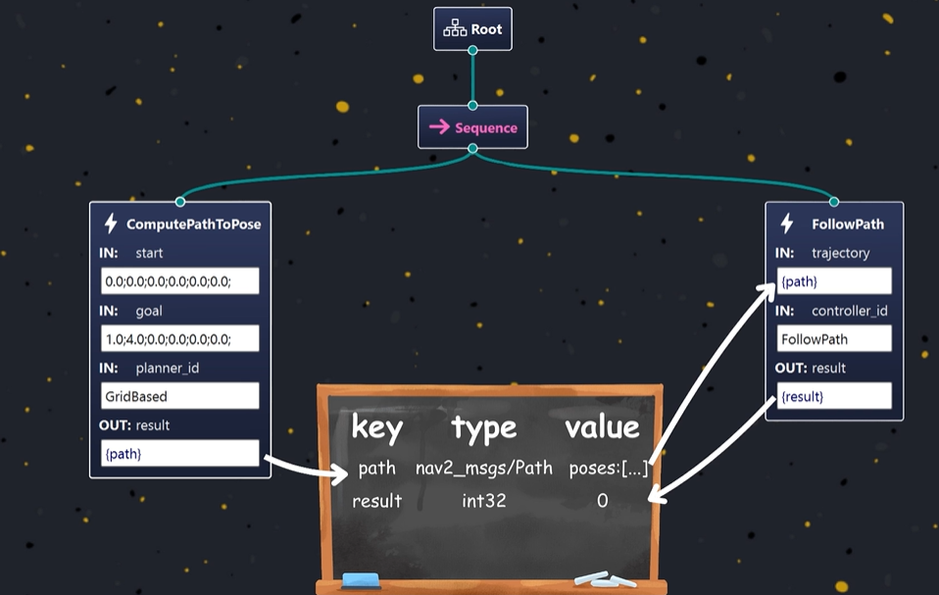
Figure 18: COPYRIGHTED Example of BT With Ports and Blackboard

NAV2 BT Navigator
This is another NAV2 server which runs the behavior tree by taking in position TF data, the robot odometry, and uses plugins that can navigate to a pose or through poses (waypoints), which are behavior trees. To create a behavior tree for the robot, we need an application called Groot2, which can be downloaded here: https://www.behaviortree.dev/groot/
This application allows us to visually edit behavior trees, which is then converted into XML code. To use this behavior tree, the path to this new xml file must be specified as a parameter inside the config.yaml file for the BT Navigator server.
As this is one of the main section of the team, the main resource we will use for understanding how we can improve the basic BT will be the NAV2 documentation at this link: https://docs.nav2.org/behavior_trees/overview/detailed_behavior_tree_walkthrough.html

In Our Codebase
Our behavior trees live in src/sentry_navigation/behavior_tree/. The one we actually run is simple_navigation.xml (navigation.launch.py passes its path to the BT navigator, exactly as described above). Here is its core:
<PipelineSequence name="NavigateWithReplanning">
<RateController hz="1.0"> <ComputePathToPose goal="{goal}" path="{path}"/> </RateController>
<FollowPath path="{path}" controller_id="FollowPath"/>
</PipelineSequence>
You can read it with just this guide: PipelineSequence (the NAV2-specific control node mentioned earlier) keeps both children ticking; RateController limits replanning to once per second; and {goal} and {path} are ports connected through the blackboard: ComputePathToPose writes {path}, FollowPath reads it. The whole thing is wrapped in a RecoveryNode that retries up to 6 times, clearing costmaps between attempts.
To change how the robot behaves: edit the XML (or build it visually in Groot2 and export). One catch, every node type you use must be listed in plugin_lib_names in bt_navigator.yaml, or the tree will fail to load. Compare replanning_navigation.xml against simple_navigation.xml for a slightly fancier example.

NAV2 Behaviors and Behavior Server
There may come a time when a path is blocked, or recovery behavior is necessary due to a variety of issues. NAV2 has pre-implemented basic behaviors that the robot can use. Examples include waiting, spinning, reversing, or idling until space has opened up to move.
The NAV2 Behavior server is a server that doesn’t do anything other than allow us to develop new plugins for behaviors. This may become necessary to us. We can also preload certain behaviors like the ones mentioned above. The behavior server manages the execution of these plugins through a control loop and also has direct publishing access to the /cmd_vel topic.

In Our Codebase
Honesty time: we have a behavior_server.yaml config, but the behavior server is currently NOT in the lifecycle node list in navigation.launch.py, so our only “recovery” today is clearing costmaps from inside the behavior tree. If you want real recoveries (spin, back up, wait), you would need to: launch the behavior server with its YAML, add "behavior_server" to the lifecycle_nodes list, and add the recovery nodes (Spin, BackUp, Wait) to the behavior tree XML. All the plumbing exists; nobody has wired it up yet.
The problem with standard nav2 behaviours like “back up”, “spin”, and “wait” is that none of those are actually helpful because our base and turret spin independently and so we don’t really have well defined directions for those. Custom logic will have to be written for recovery this year.

Autonomous Navigation Overview
Below, shows a visual representation of the entire autonomous navigation stack. Note that we start our process on the left side of the behavior tree in the BT navigator. You may need to zoom in.

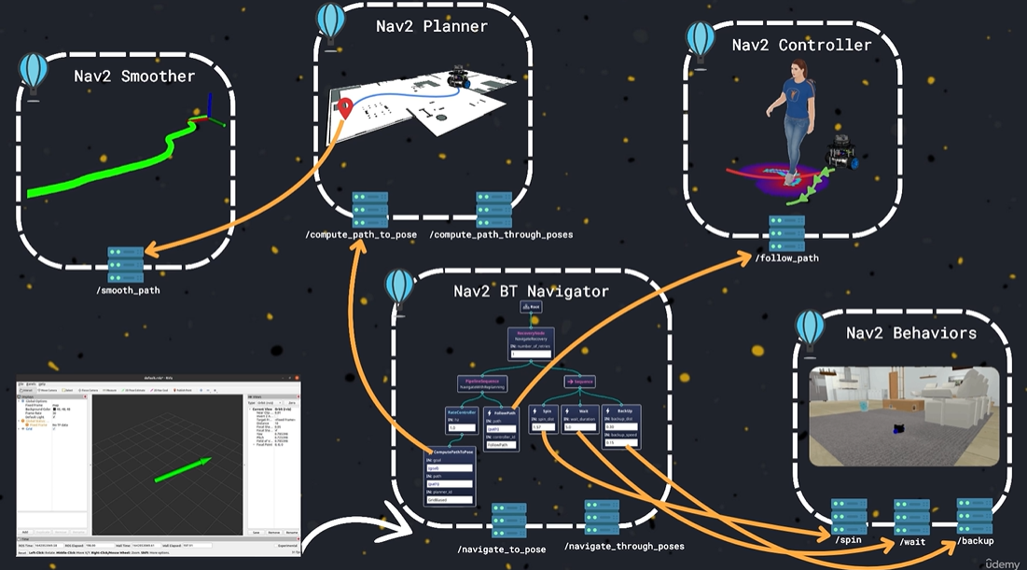
Figure 19: COPYRIGHTED Diagram Showing Autonomous Navigation Stack, Starting at the Left Side of the BT Navigator

In Our Codebase: The Whole Pipeline, End to End
Here is Figure 19 translated into our actual files and topics. Follow the data:
- The MCB streams wheel/turret/IMU data over serial → comm_hub.py parses it and publishes /odom, /imu, and /joint_states
- The EKF (ekf.yaml) fuses /odom + the turret-compensated IMU → publishes the odom → base_link transform
- The two lidars publish /scan_left and /scan_right → laser_merger.py deskews and merges them into /scan
- SLAM Toolbox or AMCL matches /scan against the map → publishes the map → odom transform
- NAV2 (planner → smoother → controller, orchestrated by the BT navigator running simple_navigation.xml) turns a goal pose into /cmd_vel
- cmd_vel_gimbal_rotator.py rotates the command into the turret frame → /cmd_vel_rotated → comm_hub.py → serial → MCB → the wheels actually turn
And at the top of it all sits our mission logic: battery_mission_controller.py (sentry_navigation/scripts) watches /battery_health and sends NavigateToPose goals — go to the arena centre when the battery is healthy, retreat home when it is low. It decides WHERE to go; NAV2 figures out HOW. That split (mission logic vs. navigation) is exactly where you would plug in smarter competition strategies.
To watch the whole thing run:
ros2 launch sentry_bringup simulated_robot.launch.py use_battery_mission:=true
The README’s “System Pipeline” section is this same story with every topic name spelled out. Now that you have finished the guide, go read it — you will understand every line.

