**CSCI 367 - Computer Networks I**

Network Overview – TCP/IP

**References**

<https://en.wikipedia.org/wiki/History_of_the_Internet>

<https://www.invent.org/inductees/robert-m-metcalfe>

<https://www.usg.edu/galileo/skills/unit07/internet07_02.phtml>

1. The Internet is nothing more than a bunch of networks all connected together. Much of the architecture of the internet was developed by the Advanced Research Project Agency (ARPA).
2. The Advanced Research Projects Agency (ARPA) of the U.S. Department of Defense awarded contracts in 1969 for the development of the ARPANET project, directed by Robert Taylor and managed by Lawrence Roberts. ARPANET adopted the packet switching technology proposed by Davies and Baran, underpinned by mathematical work in the early 1970s by Leonard Kleinrock at UCLA. The network was built by Bolt, Beranek, and Newman.
   1. <https://en.wikipedia.org/wiki/History_of_the_Internet>
3. January 1, 1983 is considered the official birthday of the Internet. Prior to this, the various computer networks did not have a standard way to communicate with each other. A new communications protocol was established called Transfer Control Protocol/Internetwork Protocol (TCP/IP). This allowed different kinds of computers on different networks to "talk" to each other. ARPANET and the Defense Data Network officially changed to the TCP/IP standard on January 1, 1983, hence the birth of the Internet. All networks could now be connected by a universal language.
   1. <https://www.usg.edu/galileo/skills/unit07/internet07_02.phtml>
4. Computers communicate and share data over a network using network protocols.
   1. A network protocol defines:
      1. The set of rules that control how computers communicate.
      2. The format of the data being exchanged.
   2. Two of the more common networking communication protocols are the Internet Protocol (IP), and the Transmission Control Protocol (TCP).
5. Typically, an operating system comes supplied with network communication software that includes support for the transmission of data over the network using the IP and TCP protocols.
6. Networked computers communicate by sending and receiving information. The computers involved in a network communication session are often referred to as remote hosts.
   1. When computers communicate over a network, data is exchanged.
   2. The program that makes a request for data is called the client and the program that responds and sends data back is called the server.
   3. During a network communication session, the roles can be reversed—the server can make a request for data and the client can respond and send data back.
   4. The actual computer that the server software is installed on—not the server software itself—is often referred to as the server, but technically, the server software installed on the computer is the server. The computer simply hosts the server software.
7. When data is sent from an application program on one networked computer to an application program on another networked computer, the data travels down through the TCP/IP Stack on the sending computer, and up the TCP/IP Stack on the other computer:

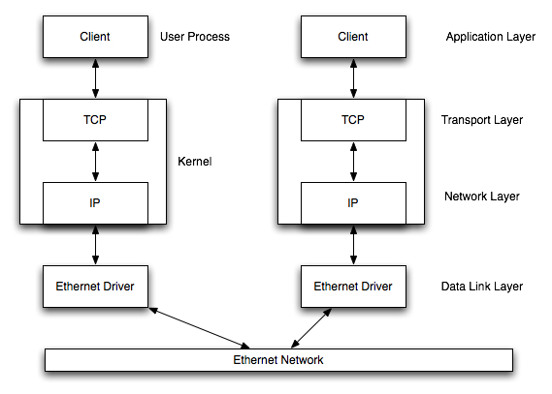

1. A typical TCP/IP Stack consists of the following layers: Application Layer, Transport Layer, Internet Layer, Data Link Layer and Physical Network Layer.
   1. The Application Layer interfaces with the Transport Layer, which interfaces with the Internet Layer, which interfaces with the Data Link Layer which interfaces with the Physical Network Layer.
   2. Typically, the Transport Layer implements the TCP protocol, the Internet Layer implements the IP protocol, and the Data Link Layer implements Ethernet technology.
   3. The Physical Network Layer represents the networking hardware, such as the electronics and cabling.
2. To send a request, the client application utilizes the TCP/IP stack on the client.
   1. The client application first makes system calls using the Transport Layer API (Application Programming Interface).
   2. The Transport Layer then makes calls using the Internet Layer API.
   3. The Internet Layer API makes calls using the Data Link Layer API.
   4. The Data Link Layer interfaces with the Physical Network Layer which then sends the request packet over the network.
3. Once the request gets to the server, it’s processed by the server’s TCP/IP stack.
   1. The request is first processed by the Physical Network Layer, then the Data Link Layer, then the Internet Layer, then the Transport Layer, and finally by the Application Layer.
   2. After the server application processes the data, the server application sends back a response using its TCP/IP stack.
   3. The server application makes calls using the Transport Layer API, the Transport Layer makes calls using the Internet Layer API, the Internet Layer makes calls using the Data Link Layer API.
   4. The Data Link Layer interfaces with the Physical Network Layer which then sends the response packet over the network.
   5. Once the response gets to the client, it’s then processed by the client’s TCP/IP stack.
4. The IP protocol dictates the size of the packets as well as many other communication details. The TCP protocol specifies the rules for reliable, connection-oriented communication.
   1. The TCP protocol ensures that the data sent by one program is received by another program.
   2. If a computer sends a packet of data over the network, the TCP protocol ensures that the destination computer receives the packet.
   3. This is accomplished by having the computer that sent the packet wait for an acknowledgement from the destination computer.
   4. If no acknowledgement is received, the sending computer resends the packet.
5. It’s important to understand that TCP/IP is a protocol—a set of rules governing communication between two networked devices.
   1. The TCP/IP protocol doesn’t define an implementation.
   2. It’s up to individual operating system vendors to supply a TCP/IP implementation.
   3. Most TCP/IP implementation are subsystems of the operating system.
6. When a connection is made to a website using a browser, the browser plays the role of the client and the web server software on the computer that hosts the website plays the role of the server.
   1. After the client (browser) makes a connection to the web server, the web server sends information back to your computer in the form of HTML (Hypertext Markup Language) data.
   2. The browser program on your computer parses this data and renders a web page on your screen.
7. A server computer may have many network application programs running. Application programs used on servers are also referred to as server programs or services.
8. Here are some of the common server network application programs:
   1. A DHCP (Dynamic Host Configuration Protocol) program that processes DHCP client requests.
   2. A DNS (Domain Name Server) program that processes DNS client requests.
   3. A daytime program that processes daytime client requests.
   4. An HTTP program that processes HTTP client requests.
   5. A telnet program that processes telnet client requests.
9. Each of these network application programs running on the server computer has an associated port number that’s used to map the client requests to the appropriate server program (service).
   1. Port number 67 is reserved for server computers that have a DHCP service.
   2. Port number 53 is reserved for server computers that have a DNS service.
   3. Port number 13 is reserved for server computers that have a daytime service.
   4. Port number 80 is reserved for server computers that have a HTTP service.
   5. Port number 23 is reserved for server computers that have a telnet service.
   6. Ports 67, 53, 13, 80, and 23 are some of the well-known ports.
   7. The well-known ports are assigned to common server network application programs. For example, a DHCP server listens for client requests on port 67, a DNS server listens for client requests on port 53, a daytime server listens for client requests on port 13, an HTTP server listens on port 80, and a telnet server listens on port 23. These are all well-known port numbers.
   8. Each client application program has an associated port number. When a client application sends a request to a server computer, the server has to know the client’s application port number so that the server response can be sent to the correct client program.
10. The following diagram illustrates a connection between a client computer and a server computer.
    1. The client sends an HTTP request to port 80 on the server computer. Port 80 is usually associated with an HTTP server program.
    2. The HTTP server program processes the request and sends back an HTTP response to port 2025.
    3. In this scenario, the header section of the TCP segment would consist of the two port numbers, 2025 and 80.

216.155.1.41

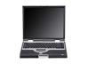

164.67.235.91



4000

2025

6072

13

80

23

Client Computer

Server Computer

HTTP Server Port

Client Port for HTTP Server Data

216.155.1.41



164.67.235.91



4000

2025

6072

13

80

23

Client Computer

Server Computer

HTTP Server Port

Client Port for HTTP Server Data