**CSCI 367 - Computer Networks I**

**Network – System Test Commands**

**Ipconfig -- Windows**

ipconfig /h

ipconfig

ipconfig /all

**Ipconfig -- Linux**

sudo apt install net-tools

ip route show

ifconfig (deprecated)

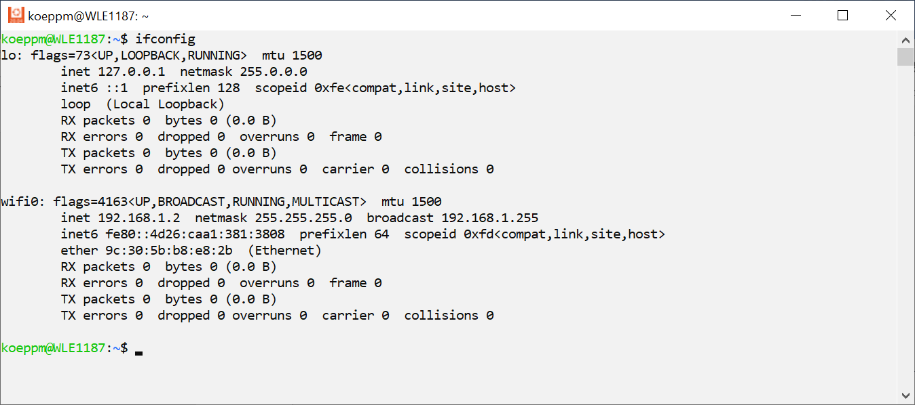

**Ping**

ping /help

ping 127.0.0.1

ping 192.168.1.1

Ping: <https://docs.microsoft.com/en-us/windows-server/administration/windows-commands/ping>

Echo Protocol: <https://datatracker.ietf.org/doc/html/rfc862>

Internet Control Message Protocol (ICMP): <https://datatracker.ietf.org/doc/html/rfc792>

Google DNS Server: ping 8.8.8.8

**Trace Route**

Windows: tracert

Linux: traceroute

Linux: sudo apt-get install traceroute

**Network Statistics – netstat /?**

**Search for a specific port**

Windows Command-Line: netstat -na | find "1234"

Linux bash Shell: netstat -na | grep "1234"

Windows PowerShell: netstat -na | Select-String "1234"

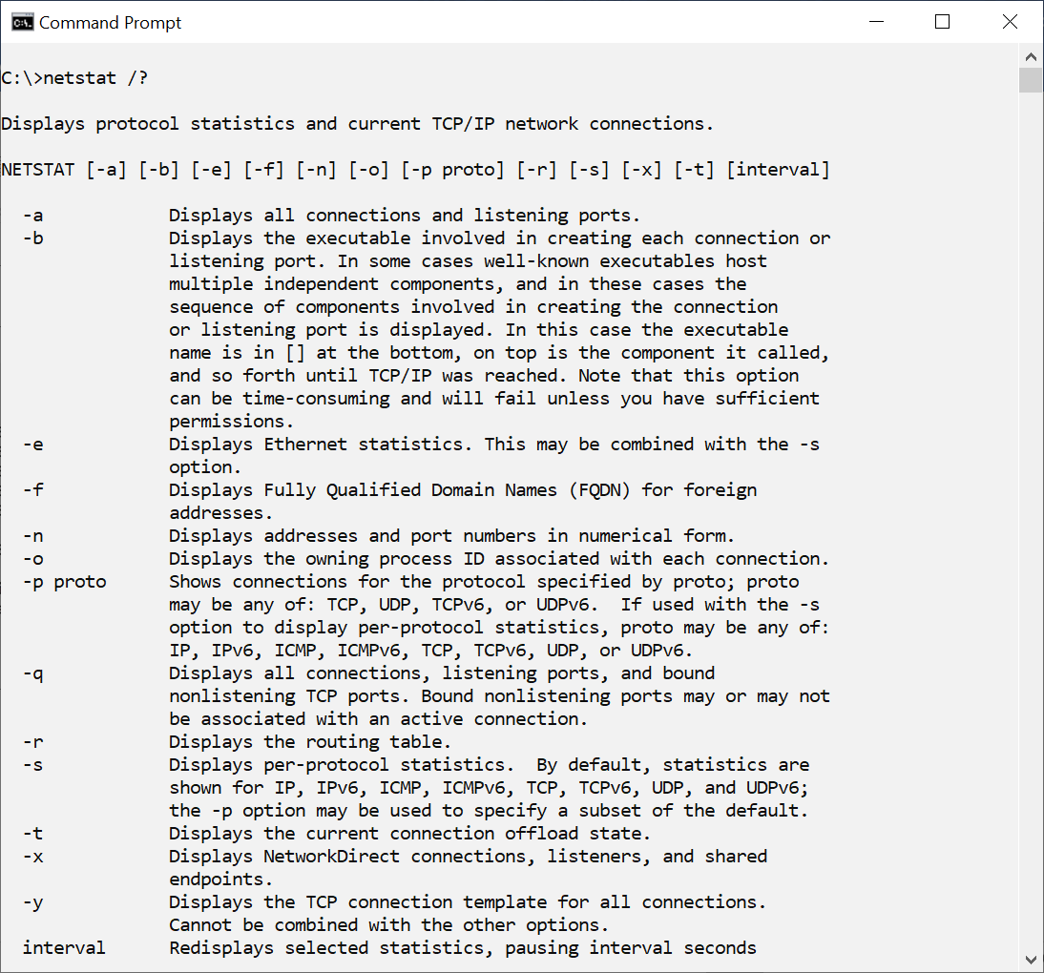

**Network Administration – net /?**

Windows Command-Line: net stop hns

**Network Administration – netsh /?**

Windows Command-Line: netsh interface ipv4 show excludedportrange protocol=tcp

