**CSCI 367 - Computer Networks I (5)**

Ethernet – Ethernet II & Ethernet IEEE 802.3

References

Ethernet II vs. IEEE 802.3 Frames:

* <https://www.freecodecamp.org/news/the-complete-guide-to-the-ethernet-protocol/>
* <https://www.geeksforgeeks.org/what-is-minimum-ethernet-frame-size/>

Ethernet Frame Collisions:

* <https://en.wikipedia.org/wiki/Speed_of_electricity>
* <https://en.wikipedia.org/wiki/Carrier-sense_multiple_access>
* <https://www.geeksforgeeks.org/carrier-sense-multiple-access-csma/>

1. Data sent between clients and servers is typically sent in chunks. These chunks are referred to as network packets. A network packet consists of a hierarchy of smaller packets.
   1. Each part of a network packet consists of a header section and a payload section.
   2. An Ethernet-based network sends and receives Ethernet frames.
      1. An Ethernet frame consists of a header section that contains the source and destination MAC (Medium Access Control) addresses of the devices that are attached to the network, and a data section, commonly called the frame’s payload.
      2. A device’s MAC address is often referred to as the physical address.
   3. Reference: <https://en.wikipedia.org/wiki/Ethernet_frame>
   4. Reference: <https://www.geeksforgeeks.org/ethernet-frame-format/>

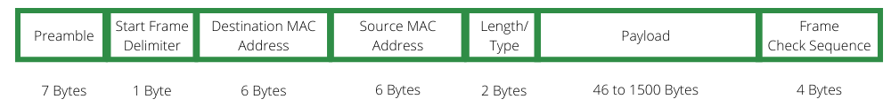

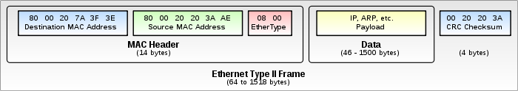

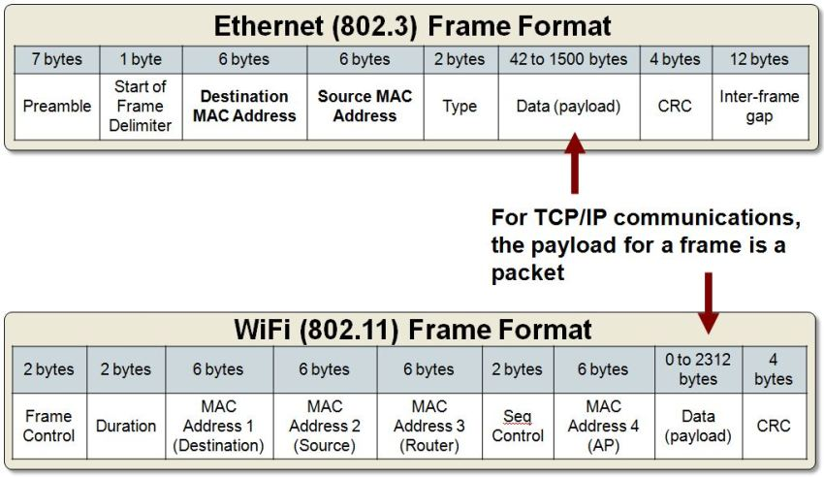

1. Each computer or device that’s connected to a network has a network interface card (NIC).
   1. Each NIC has a unique MAC address, which is a six-byte value.
   2. Each part of this MAC address is written as a hexadecimal digit.
   3. The first three hexadecimal digits represent a unique manufacturer’s id, and the second three hexadecimal digits represent a unique number that’s assigned to each NIC card produced by a specific manufacturer.
   4. When one device needs to send a packet to another device, the sending device needs to know the MAC address of the destination device.
2. Each computer’s NIC is connected to a network switch via a cable. This combination of a NIC, network switch, and cable, allow packets to be sent from one networked device to another. Below is a diagram illustrating a computer network and the MAC addresses of each device on the network:

**Computer Networks**

Router

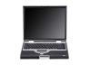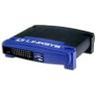

2A-B3-54-EF-4B-5C



Networks

2A-B3-54-EF-4B-5D

2A-B3-54-EF-4B-5E

B1-1B-54-E2-45-22

B1-1B-54-E2-45-23

AA-2D-FA-EF-4B-E1

AA-2D-FA-EF-4B-E2

AA-2D-FA-EF-4B-E3

Switch

Switch

1. The MTU (Maximum Transmission Unit) defines the largest Layer-2 Datalink packet that can be sent over a communications link (the MTU is considered a property of a Layer-2 Datalink).
2. An Ethernet frame is the last phase of encapsulation before it gets transmitted over the Layer-1 Physical Layer.
3. The standard Ethernet header is 14 bytes, with a Frame Checksum (FCS) of 4 bytes appended to the end of the frame.
   1. Destination MAC: 6 bytes
   2. Source MAC: 6 bytes
   3. Type/Length Field: 2 bytes (typically IPv4)
   4. Checksum Field: 4 bytes
4. An Ethernet packet usually includes a preamble, but we don’t consider the preamble part of the Ethernet frame.
5. The IEEE 802.3 specification limits the payload portion of the 802.3 Ethernet frame to a minimum of 46 and a maximum of 1500 bytes.
6. The IEEE 802.3 specification limits the Ethernet frame’s MTU to 1518 bytes. The MTU is broken down into the following fields:
   1. Ethernet Header (14 bytes)
      1. Destination MAC: 6 bytes
      2. Source MAC: 6 bytes
      3. Type Field: 2 bytes (typically IPv4)
   2. Frame Payload: 1500 bytes (maximum)
   3. Ethernet Checksum: 4 bytes
7. Because the Layer 3 Network packet is encapsulated in the payload portion of an Ethernet frame, 1500 bytes is the largest IP packet (datagram) allowed over an Ethernet communications link.