**CSCI 367 - Computer Networks I**

**Network – Address Resolution Protocol (ARP)**

**References**

<https://www.auvik.com/franklyit/blog/what-is-an-arp-table/>

<https://www.technipages.com/windows-10-flush-arp-cache>

<https://www.thewindowsclub.com/how-to-clear-arp-cache-in-windows>

<https://tech4fresher.com/how-to-flush-arp-cache-in-windows-10-and-11/>

**Diagrams**

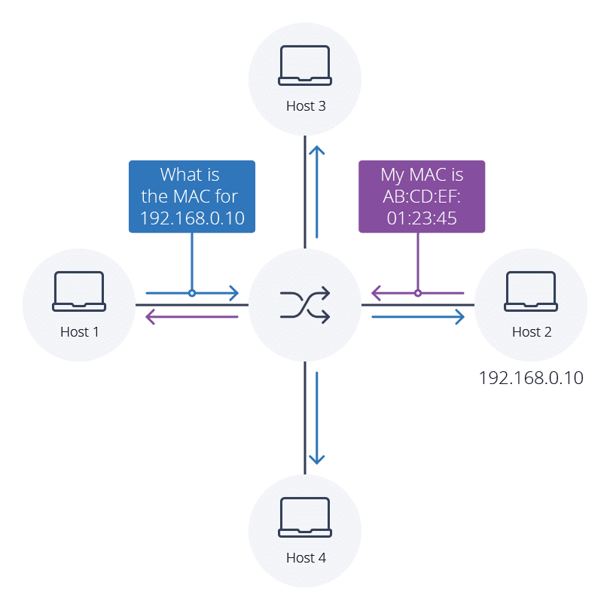

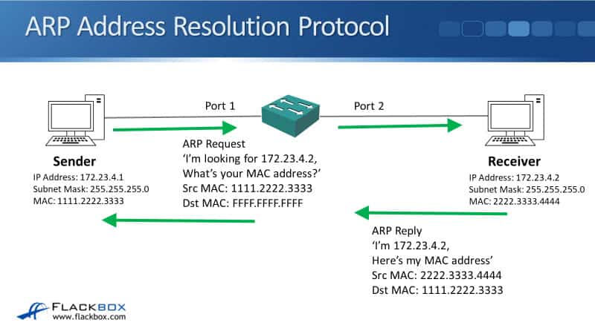

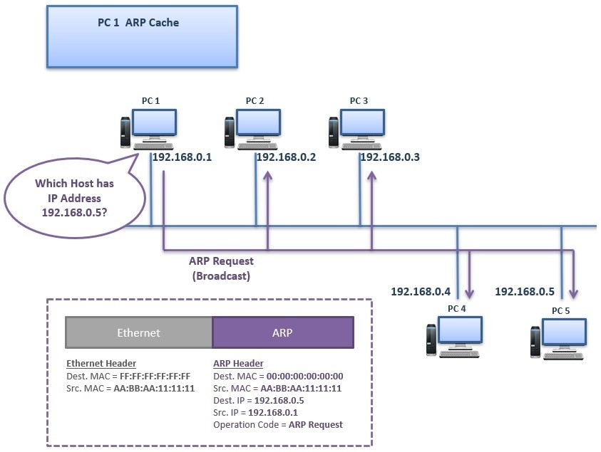

**Commands**

arp /? – Display ARP Commands and Options

arp -a – Display ARP Cache

arp -d – Clear ARP Cache

**Scenario – ARP Request for Gateway IP Address**

1. IPCONFIG

1. ARP REQUEST packet. To generate this ARP REQUEST/RESPONSE, clear the ARP cache. This immediately generates an ARP packet from the host to the gateway.

Wireshark Filter: (eth.src == 10:0c:6b:28:6f:41 && arp.dst.proto_ipv4 == 192.168.1.6) || (eth.dst == 10:0c:6b:28:6f:41 && arp.src.proto_ipv4 == 192.168.1.6)

1. ARP RESONSE packet.

Wireshark Filter: (eth.src == 10:0c:6b:28:6f:41 && arp.dst.proto_ipv4 == 192.168.1.6) || (eth.dst == 10:0c:6b:28:6f:41 && arp.src.proto_ipv4 == 192.168.1.6)

**Scenario – ARP Request for Host IP Address on LAN**

**Packet Capture**: See ARP_ICMP_LAN_Host.pcapng

1. IPCONFIG

1. ICMP Ping

1. ARP REQUEST packet.

Wireshark Filter: arp || icmp

1. ARP RESONSE packet.

Wireshark Filter: arp || icmp

