**CSCI 367 - Computer Networks I**

**Network – DNS Domain Name System (DNS)**

**References**

<https://www.cloudflare.com/learning/dns/what-is-dns/>

<https://aws.amazon.com/route53/what-is-dns/>

<https://en.wikiversity.org/wiki/Computer_Networks/Ipconfig/DNS_Cache_Options>

**Diagrams**

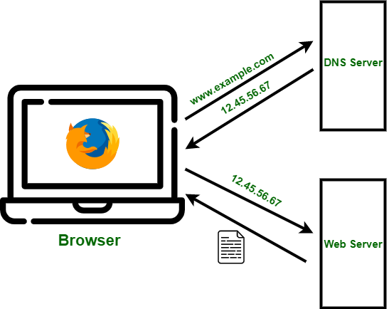



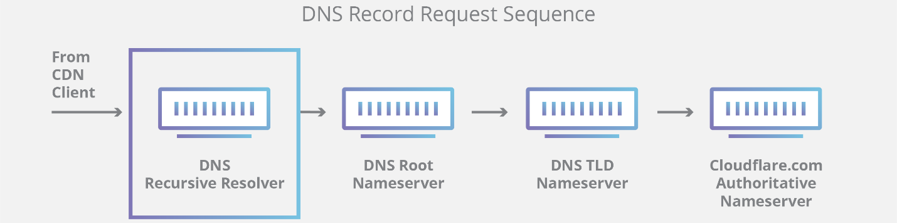

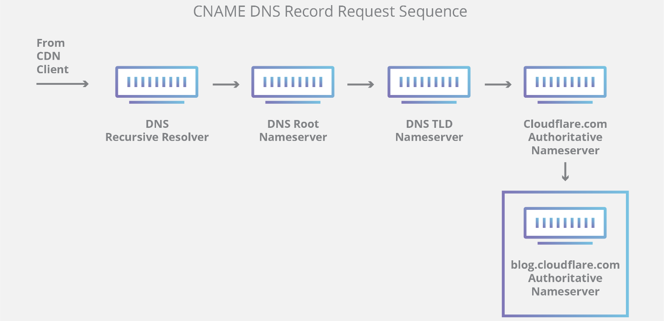

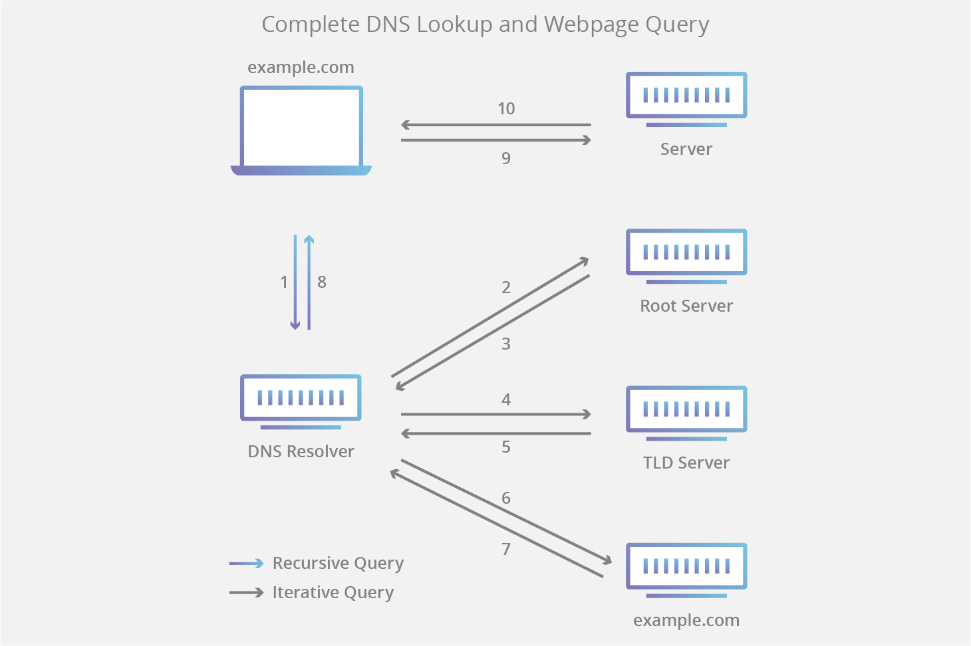

**Commands**

ipconfig /displaydns

ipconfig /flushdns

Hosts File: Windows: C:\Windows\System32\drivers\etc\hosts

Hosts File: Linux: /etc/hostss\etc

Ipconfig /all

ipconfig /flushdns

ipconfig /displaydns

