**CSCI 367 - Computer Networks I**

Network – Gateways, Routers and Access Points

1. A gateway defines the single point of access for computers inside a LAN to computers outside the LAN.
   1. If a computer on Network A wants to connect to a computer on Network B, both networks must have gateways that provide exit and entry points for the computers to communicate.
   2. Gateways define the boundaries of your network.
   3. Gateways typically have two IP addresses. One is the internal IP address, which computers inside the network communicate to; the other is an external IP address for those outside the network.
2. Routers determine the shortest possible path your data can travel from Computer A to Computer B.
   1. Routers are programmed with routing tables to determine the shortest possible path between Computer A and Computer B.
   2. To transfer data from one network to another network, a router contains a routing table.
   3. The routing table contains a list of IP addresses that the router uses to determine the next hop router that the data should be sent to.
3. A modem is the gateway to the internet. A cable, fiber optic, or telephone line comes through your neighborhood, to your house, and connects to your modem.
   1. The modem translates the digital 1s and 0s from your computer into analog information for the cable or telephone wire to carry out to the world and translates incoming analog signals in the same way.
   2. This is called *modulation* and *demodulation*, respectively, and it’s where the “mo-dem” gets its name.

References

<https://www.minim.com/blog/modem-vs-router-vs-gateway-explained>

<https://us.hitrontech.com/learn/what-is-a-gateway/>

Router and Cable Modem Configurations

Router-WIFI-AP (Access Point) Ports.

WAN Port & 4-Port Internal Ethernet (Layer-2) Switch

Cable Modem Network Connections

Host Connected to Cable Modem’s Ethernet Port

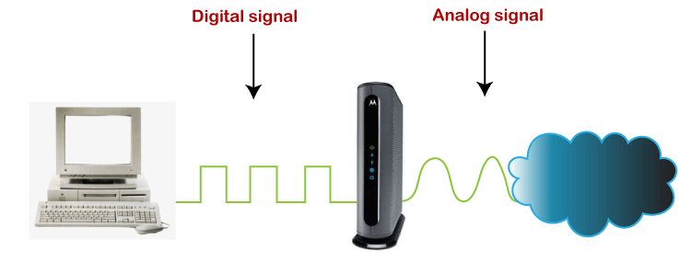

Cable Modem Contains a D/A Digital to Analog Component and a A/D Analog to Digital Component

D/A Component Modulates Digital Signal

A/D Component Demodulates Analog Signal

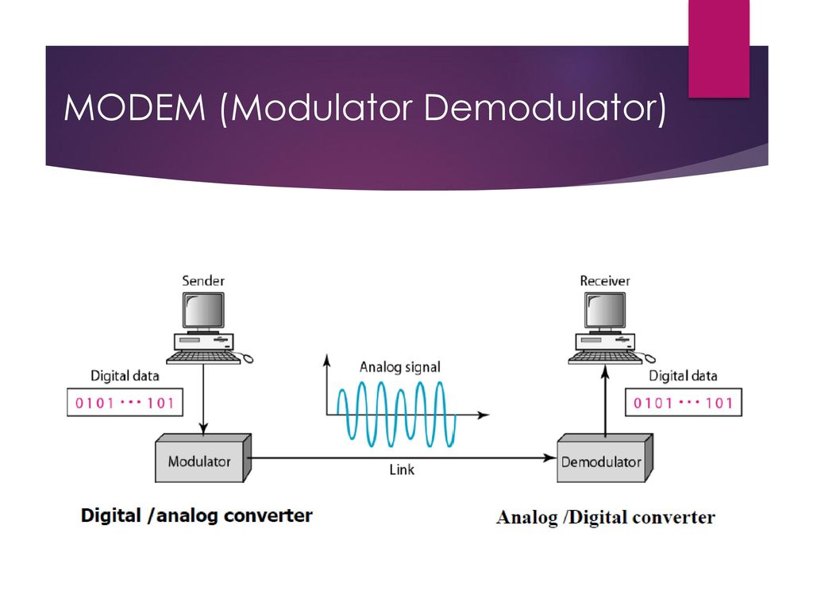

Cable Modem Interface to Router/WIFI-AP

WIFI Router’s WAN Port Connected to Cable Modem’s Ethernet Port

Cable Modem Interface to Router/WIFI-AP with Host Laptop WIFI Connection

WIFI Router’s WAN Port Connected to Cable Modem’s Ethernet Port

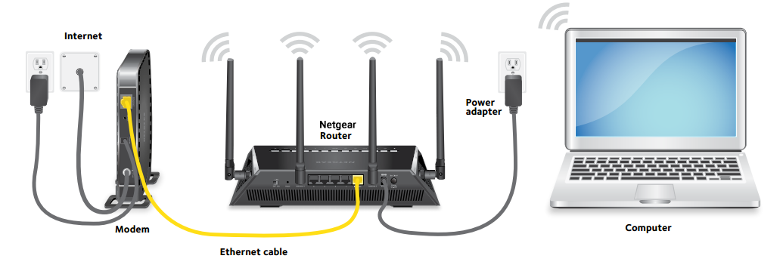

Cable Modem Interface to Router/WIFI-AP with Host Laptop WIFI Connection

WIFI Router’s WAN Port Connected to Cable Modem’s Ethernet Port

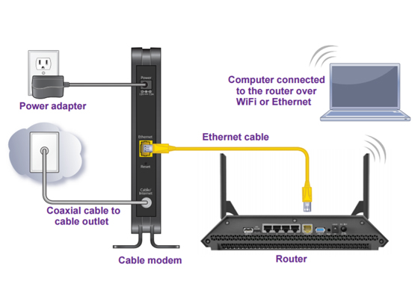

Cable Modem Interface to Router/WIFI-AP with Host Laptop Ethernet Cable Connection

WIFI Router’s WAN Port Connected to Cable Modem’s Ethernet Port

Host Laptop Ethernet Port Connected to WIFI Router’s LAN Switch

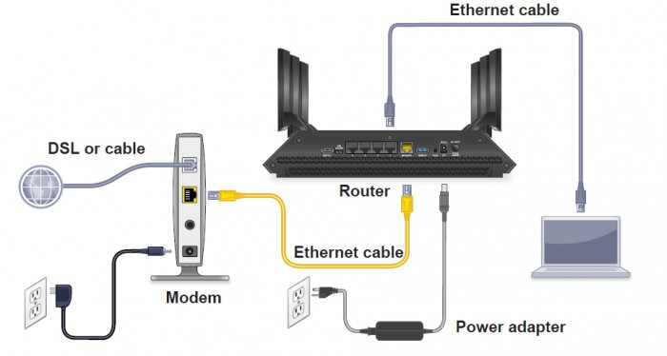

Router’s WAN Port Connected to Cable Modem’s Ethernet Port

Host Laptop Ethernet Port Connected to a Router Internal Switch Port

External Ethernet (Layer-2) Switch Connected to a Router Internal Switch Port

Host PC Ethernet Port Connected to External Ethernet (Layer-2) Switch Port

Cable Modem Interfaces to CMTS (Cable Modem Termination System)

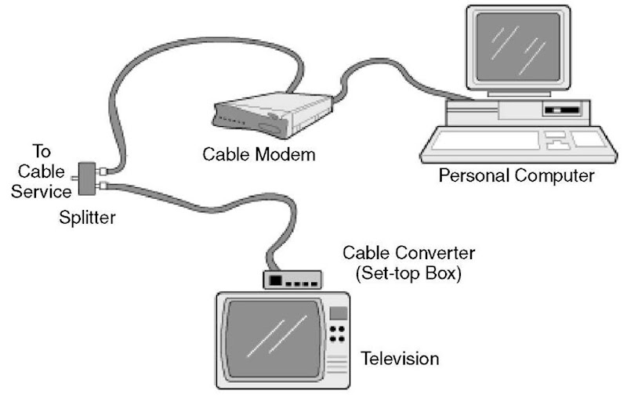

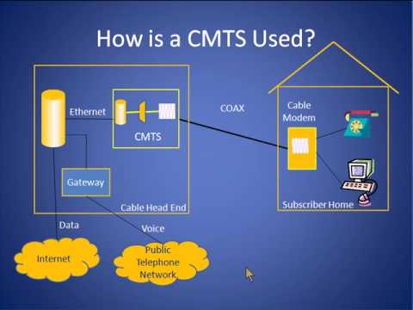

**Networking Cables**

