**CSCI 367 - Computer Networks I**

**TCP/IP Sockets – Daytime Client – TCP Transport Layer Protocol**

**Source Code Listing**

See 01_DaytimeClient_TCP.

**Compilation**

/usr/bin/gcc-9 -g -o Program Program.c

A socket is a programming abstraction used in client-server software applications. Sockets hide low-level network communication details and makes it easier to write software applications that send and receive data over the network. Sockets are one of the main network communication components used to program network applications. The client program shown below uses sockets to communicate with a daytime server.

The client program uses a socket to connect to a server program on a remote networked computer. It then sends a daytime request to the server and receives a response. Following are two diagrams that illustrate the client-server communication cycle. First, the client sends a request for the current date and time:

216.456.1.41



129.6.15.28



4000

2025

6072

13

80

23

Client Computer

Server Computer

Daytime Server Port

Client Port for Daytime Server Data

Then the server returns a response that includes the current date and time:

216.456.1.41



129.6.15.28



4000

2025

6072

13

80

23

Client Computer

Server Computer

Daytime Server Port

Client Port for Daytime Server Data

When I run the program, it produces the following output:

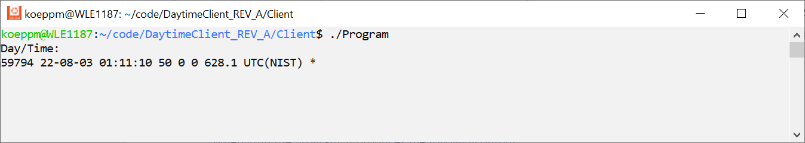

The preceding output displays the current date and time. The server computer that sent this response is associated with the URL given by time-a.nist.gov. This URL maps to the IP address 129.6.15.28, that’s associated with a computer operated by the National Institute of Standards and Technology. According to their website:

*The NIST Internet Time Service (ITS) allows users to synchronize computer clocks via the Internet. The time information provided by the service is directly traceable to UTC(NIST). The service responds to time requests from any Internet client in several formats including the DAYTIME, TIME, and NTP protocols.*

Like all daytime server applications, this server application listens on port 13, the well-known port for a daytime server.

Let’s now analyze the program in more detail. First, to send a request to the daytime server, the client first needs to know where the server is located on the network. As mentioned above, a computer’s IP address serves this purpose. In the program above, the server computer’s address is given by the following dotted decimal value: 129.6.15.28. This IP address is associated with a computer on the internet that has an application that processes requests for the day and time. Using this IP address, routers on the internet route the request to the destination computer. Once the destination computer receives the request, the port number that’s encapsulated in the TCP part of the network packet is extracted by the server’s TCP/IP system software. The port number allows the TCP/IP software to direct the TCP segment’s data portion to the appropriate server program.