# The explanation for the game

The color puzzle is a type sliding puzzle played with 14 chips of different colors on a 3x5 board. Initially, the player shakes the 14 chips together in his/her hand and places them on a flat surface arranged in 3 rows and 5 columns as shown below:

|  |  |  |  |  |
| --- | --- | --- | --- | --- |
| o | o | o | o | o |
| o | o | o | o | o |
| o | o | o | o |  |

The goal of the game is to rearrange the chips into a symmetrical arrangement by sliding them one at a time into the empty space. Only a chip directly next to the empty space, not including diagonally, can be moved into it. A symmetrical arrangement (a goal state) is one which is balanced around the middle row. In other words, the top row must be identical to the bottom row, and there are no constraints on the middle row.

**A Sample Game:**

To illustrate the game, let’s take a configuration with: 6 red chips, 4 blue chips, 2 white chips and 2 yellow chips. Given the following initial random configuration:

|  |  |  |  |  |
| --- | --- | --- | --- | --- |
|  | red | red | red | red |
| red | blue | white | blue | Blue |
| white | yellow | blue | red | yellow |

To represent the positions on the board, let us use letters as follows:

|  |  |  |  |  |
| --- | --- | --- | --- | --- |
| A | B | C | D | E |
| F | G | H | I | J |
| K | L | M | N | O |

Since a chip can only move into the empty cell, all that is required is to record the chip that moved. The following 23 moves will reconfigure the board to a goal state:

1. B 2. C 3. H 4. M 5. N 6. O 7. J 8. I

9. N 10. M 11. L 12. K 13. F 14. A 15. B 16. C

17. D 18. I 19. H 20. C 21. D 22. E 23. J

and will lead to the goal state:

|  |  |  |  |  |
| --- | --- | --- | --- | --- |
| red | white | yellow | red | blue |
| red | blue | red | blue |  |
| red | white | Yellow | Red | blue |

However, the following 16 moves is a shorter (and better) way to reach a goal state from the same initial configuration:

1. B 2. G 3. L 4. K 5. F 6. G 7. L

8. M 9. N 10. I 11. D 12. E 13. J 14. O

15. N 16. I

leading to the goal state:

|  |  |  |  |  |
| --- | --- | --- | --- | --- |
| red | blue | red | red | Blue |
| yellow | white | white |  | yellow |
| red | blue | red | red | blue |

# The program manual

The program has two modes: manual play and auto solve. Both require picking an input file. The manual play mode will only read the first game configuration from the input file while the auto solve mode will read all the games.

**Manual play mode:**

Players can use arrow keys to move a chip into the empty cell (the one with a big X) of the board. For example, in the inputted configuration in Figure 1, the red chip in cell B will be moved into the empty cell when the player press the arrow key left. Or the player can choose to move the red chip in cell F by pressing arrow key up.

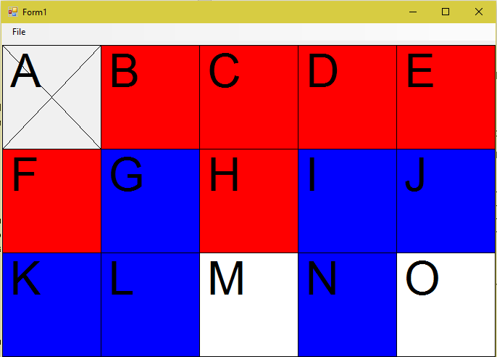

Figure 1

Figure 2 shows screenshot of the end game.

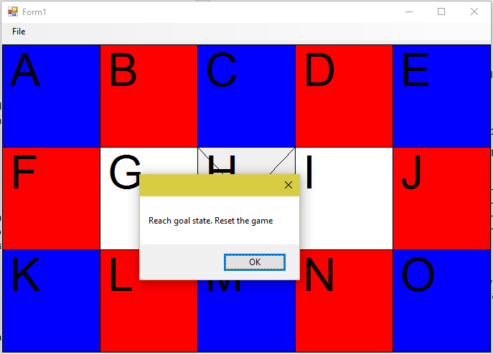

Figure 2

**Auto solve mode:**

In this mode, the program will try to give better solutions within reasonable time using its heuristic function and display the progress of solving inputted games in an additional window shown in Figure 3.

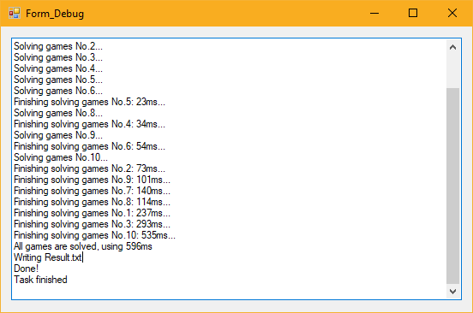

Figure 3

**Input file**

In an valid input file, each line will represent an initial configuration. Each chip color will be represented by a unique character (‘r’, ‘b’, ‘w’, ‘y’ or ‘p’) and the empty slot will be indicated by the character ‘e’. For example, the line:

e r r r r r b w b b w y b r y

represents the initial puzzle given above (empty at position A, red at positions B, C, D, E, F, blue at G, white at H, ...)

**Output file (will be generated in the same directory where the executable is)**

For each puzzle (each line of the input file), the program generates a line in the output file indicating the sequence of moves necessary to solve the game and the time (real time in milliseconds) required to solve it. At the end of the output file, it shows the total number of moves it took to solve all puzzles of the input file and the total time for all puzzles.