SchoolMatch AI: Intelligent School Selection Application for Hong Kong Parents
COMP 3130SEF Mobile Application Programming Project Report
Course Code and Title: COMP 3130SEF Mobile Application Programming
Application Name: SchoolMatch AI
Student Name(s):
Student ID(s):
Submission Date: March 2026

Abstract
SchoolMatch AI is a native Android application designed to help Hong Kong parents browse school information more efficiently, filter results, and obtain recommendations based on home address and user preferences. The project integrates school list browsing, keyword search, AI matching, a school detail page, map viewing, and a newly added list slide-in animation feature. In the current implementation, the home page displays the school list and search function; the matching page calls Google Geocoding API and the Education Bureau school JSON data source, then ranks schools according to distance and preferences; the map page opens Google Maps search results through WebView; and the detail page supports direct phone dialing and website opening. The new animation also improves visual presentation and user experience.

1. Project Background and Objectives
Parents in Hong Kong often need to compare school names, districts, addresses, and personal preferences at the same time, but the relevant information is scattered and manual comparison is time-consuming. The goal of SchoolMatch AI is to integrate these processes into one mobile application so that users can first browse schools, then narrow their choices through search and intelligent matching, and finally explore schools further through the detail page and map view.

2. Main System Features

2.1 Main School List and Real-Time Search
MainActivity provides the home page of the school list. The current version initializes the list with sample data and uses RecyclerView to display school names and district information. At the same time, the system filters results instantly when the user types in the search box, making it easier to find a target school or district.
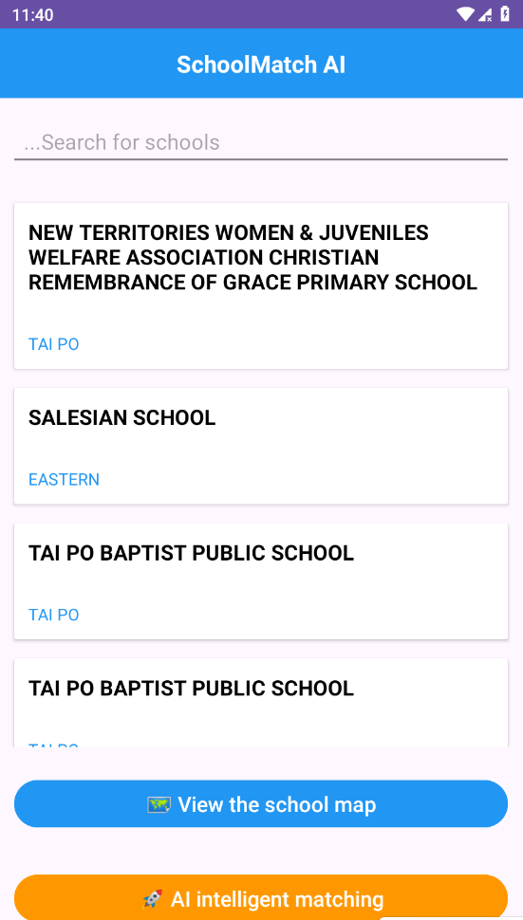
Figure 1. Main page showing the school list
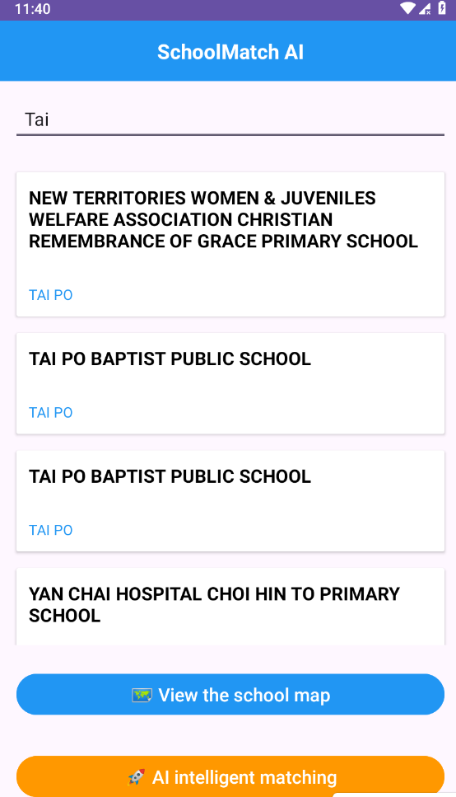
Figure 2. Search result after entering a keyword
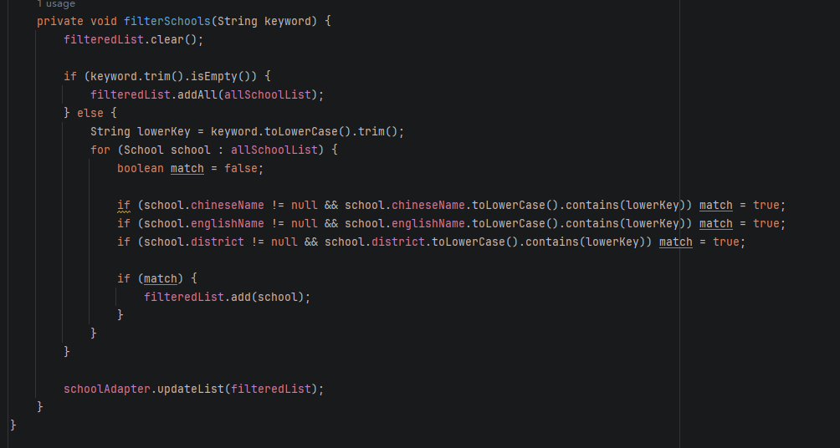
Figure 3. Search filtering logic in MainActivity

2.2 AI Matching and Recommendation Results
MatchActivity is the most representative module of the project. Users enter their home address and choose school level, gender preference, and religion. The system first converts the address into coordinates through Google Geocoding API, then reads the public Education Bureau JSON data and calculates a weighted score for each school. The final ranking considers school level, gender, religion, and geographic distance, so the recommendation result is more targeted than a simple search.
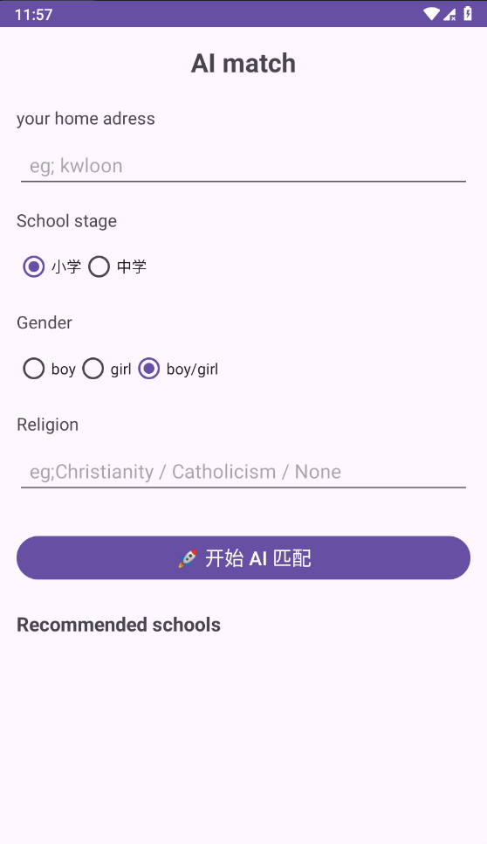
Figure 4. AI matching input page
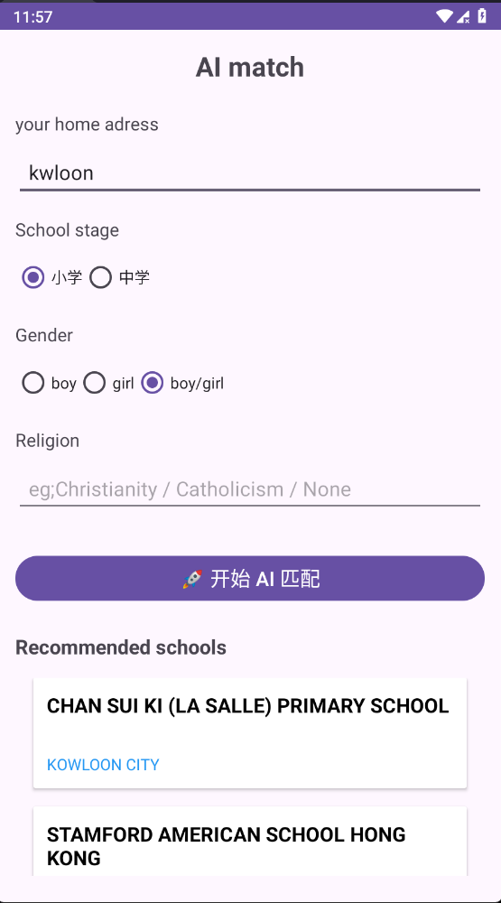
Figure 5. AI matching result page
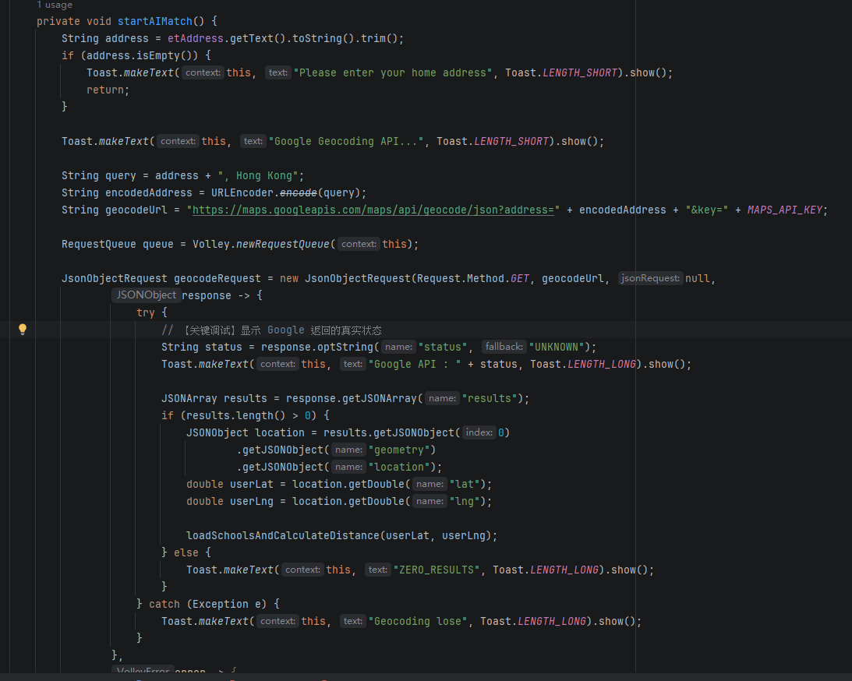
Figure 6. Geocoding and matching start logic
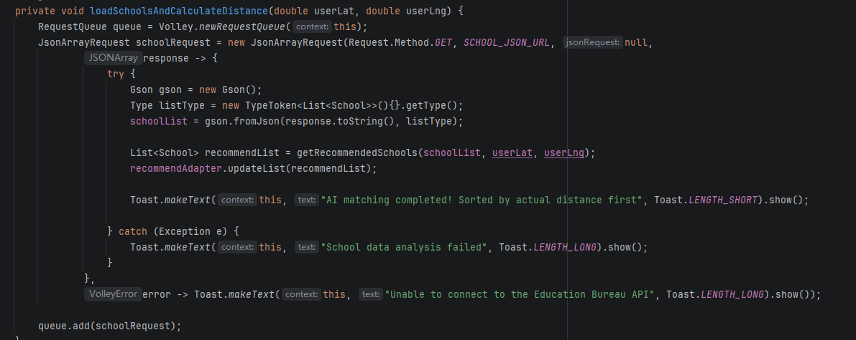
Figure 7. Loading Education Bureau JSON data and updating the recommendation list
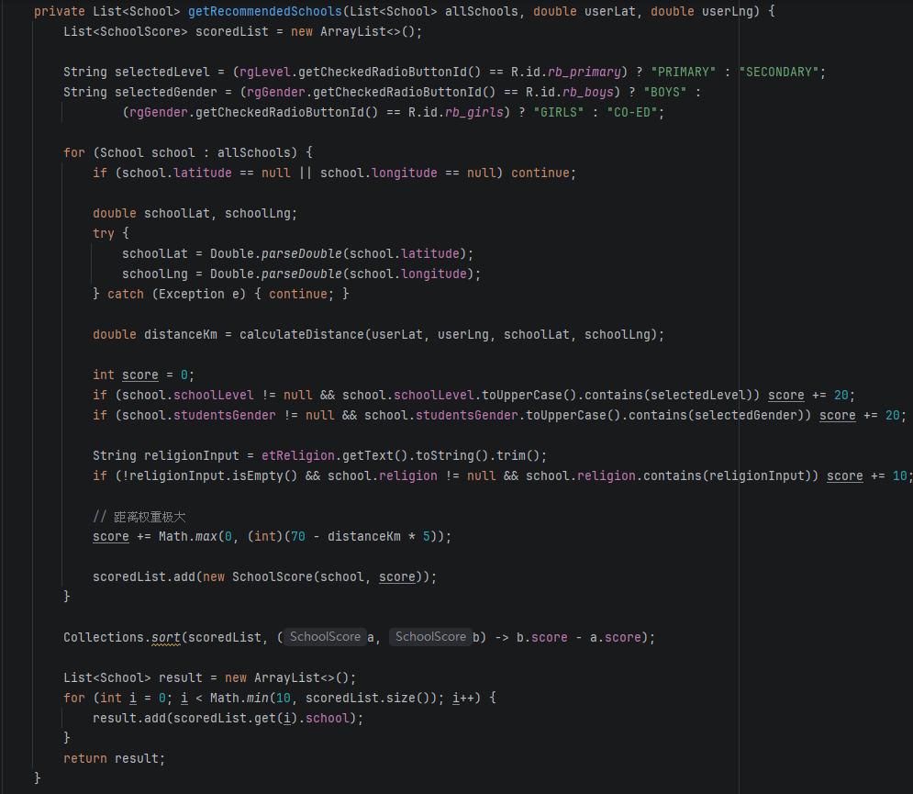
Figure 8. Recommendation scoring and ranking logic

2.3 School Detail Page and Practical Actions
When the user taps a school item, the system opens SchoolDetailActivity. The detail page displays the school name, district, and telephone number, and provides one-tap phone dialing and school website opening. This design turns static school information into actionable interaction and increases the practical value of the application.

Figure 9. School detail page
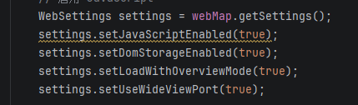
Figure 10. Dialing and website-opening logic

2.4 Map Page
The project also provides a map viewing function. In the current implementation, MapActivity uses WebView to open Google Maps search results and enables JavaScript and DOM storage so that the web map can be displayed correctly. Compared with a native marker-based map, this approach has lower implementation cost while still providing location browsing capability.

Figure 11. Core WebView settings for the map page

2.5 New Feature: List Slide-In Animation
To better address the higher-grade criterion of “Appropriate use of graphics and animations,” a list slide-in animation has been added. Whenever the school list is loaded or updated, each card enters the screen from below while gradually becoming visible. This design improves the visual dynamics of the interface, helps users perceive that content has been refreshed, and makes the whole application look more polished and professional.
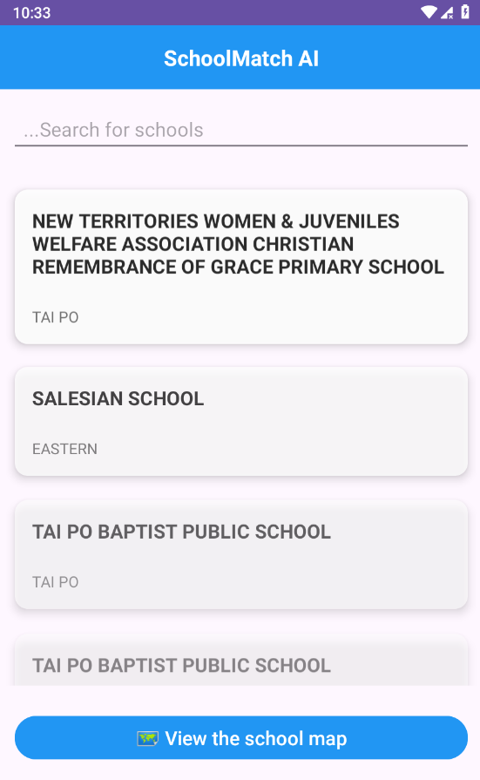
Figure 12. Home page after adding the list slide-in animation effect
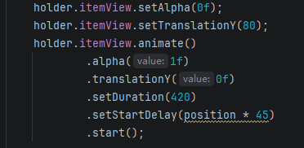
Figure 13. Core code in SchoolAdapter for implementing the list slide-in animation

3. Explanation for Higher Grades
According to the project requirements, higher grades may be obtained through graphics and animations, multimedia, innovative ideas, and significant features. This project addresses these points as follows:
- Appropriate use of graphics and animations: the RecyclerView item slide-in animation improves visual effect and interaction quality.
- Innovative idea: the project integrates school browsing, address geocoding, real-distance calculation, and preference-based weighted scoring into one AI matching workflow.
- Significant features: the application already includes the school list and search, AI intelligent matching, school detail page, map viewing, phone dialing, website opening, and list animation as multiple distinct features.
- Appropriate use of multimedia: the current version mainly focuses on web map viewing, interactive navigation, and executable actions; this can be further extended in the future with richer media such as sound or video.

4. Technical Implementation and Technologies Used
The main technologies used in this project are listed below:
- Development environment: Android Studio
- List presentation: RecyclerView with a custom SchoolAdapter
- Networking: Volley
- JSON parsing: Gson and @SerializedName mapping in School.java
- AI recommendation logic: Google Geocoding API + Education Bureau SCH_LOC_EDB.json + weighted ranking by distance and user preferences
- Distance algorithm: Haversine formula
- Map implementation: WebView loading Google Maps search results
- Navigation: Intent
- Detail page actions: Intent.ACTION_DIAL and Intent.ACTION_VIEW
- Animation techniques: View Property Animation, including alpha, translationY, setDuration(), and setStartDelay()

5. Evaluation and Conclusion
Overall, SchoolMatch AI has implemented a runnable school information application and completed multiple distinct features, including the school list and search, AI intelligent matching, detail page interaction, map viewing, and the newly added list animation. From the perspective of the course requirements, the project demonstrates Android interface design, data processing, API usage, animation implementation, and practical feature integration. For future improvement, the application could load real-time API data directly on the home page, add native Google Maps markers, and introduce richer filtering dimensions and multimedia content.

References
Education Bureau of Hong Kong. School Location and Information JSON Data.
Google Maps Platform Documentation.
Android Developers. Volley Overview.
Google Gson Documentation.

