**Webscraping task: segmentation of the Polish parliament’s speaker’s speeches**

**Your task is to adjust the data for the provided CSV file based on the description below.**

Our data for the 1991-2011 Polish parliamentary speeches lacks proper segmentation regarding the parliament’s speaker (if the chair variable’s value is 1 within the dataset). At the beginning of a session, the very first speech of the speaker contains all of his/her speeches of that session, and only the other actors’ speeches are included thereafter separately. An example:

2010.08.06 (<https://orka2.sejm.gov.pl/Debata6.nsf/7075e4662b58d9b1c125737f0039d549/87e2b23e4b30becfc125777a002a87f0?OpenDocument>)

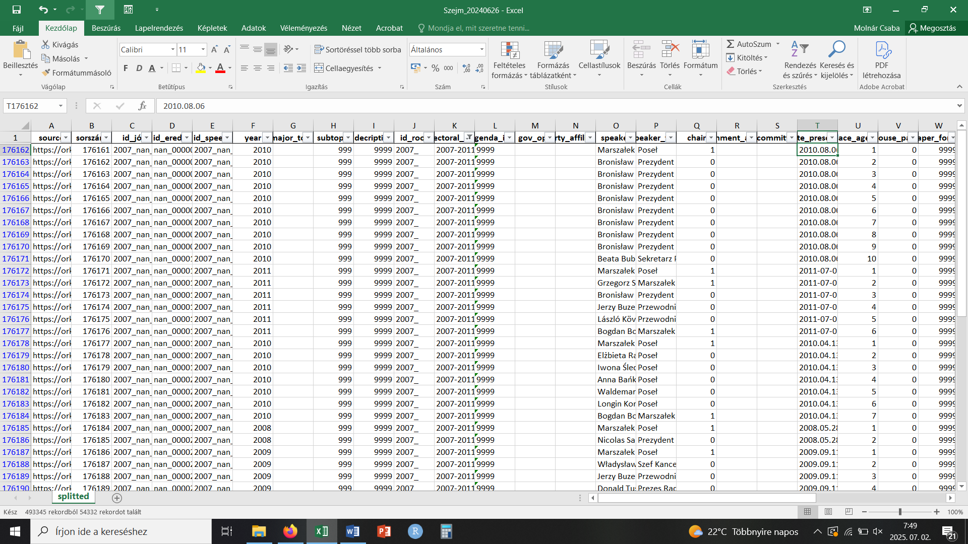

The speech by the Speaker (Marszalek in Polish) is in the first row (where the value of chair is 1), followed by other speeches in the next 9 rows (where the value of chair is 0). Out of this, 8 are delivered by the President of the Republic Bronisław Komorowski, and 1 is delivered by a secretary (Beata Bublewicz). By clicking the above link, we can see the Speaker’s speech (and some information on the session day in general in brackets before the name or title of the speaker, which should be omitted from the corpus):

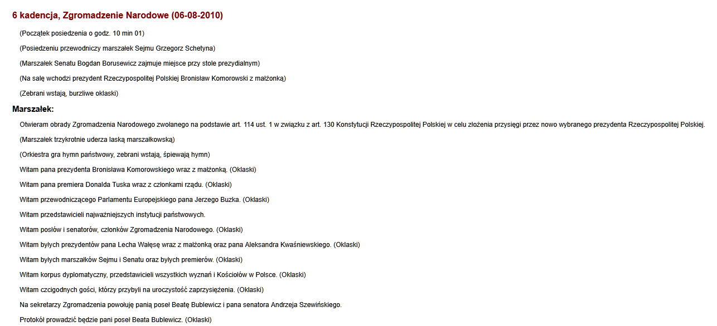

Further down below, we can find the other speeches with hyperlinks containing the name and the title of the speaker:

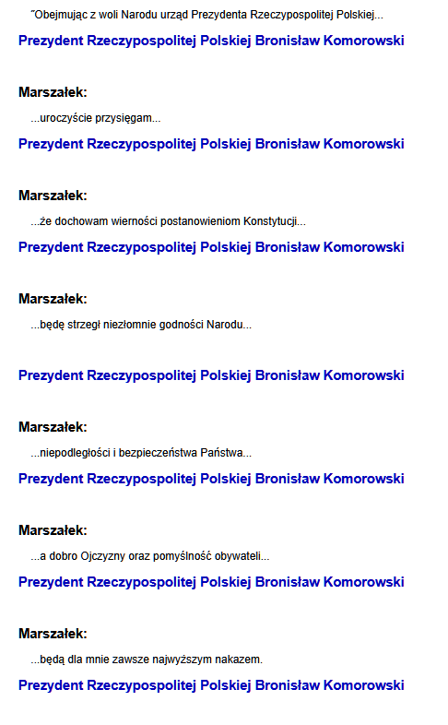

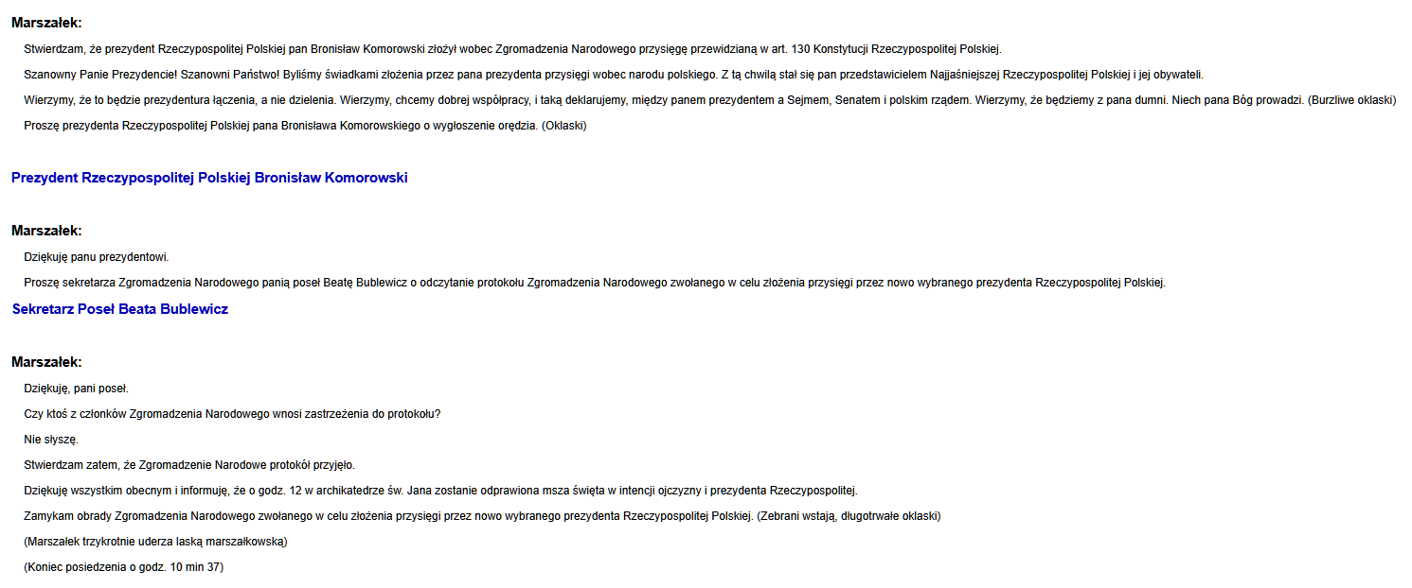

The further parts of the speaker's speech are among the hyperlinked text lines. The links themselves point to speeches that already exist in our data and can be found after the chair's speech on each session day.

The task is to split the Speaker’s speech into the parts between the hyperlink texts and create new rows within the dataset for them between the other speeches on the right places. The metadata of the original row of the chair’s speeches should be used, with the exception of the following:

* The “text” should have the split text segment
* agenda_item: should include the next row’s agenda item
* place_agenda: a running number by session, this variable needs to be recreated; each row’s value will change based on the new order after the segmentation

Place the new, segmented speeches between the already existing rows of the other actors’ speeches where they occur within the given session day..

This is how the segmentation looks in the page’s source:

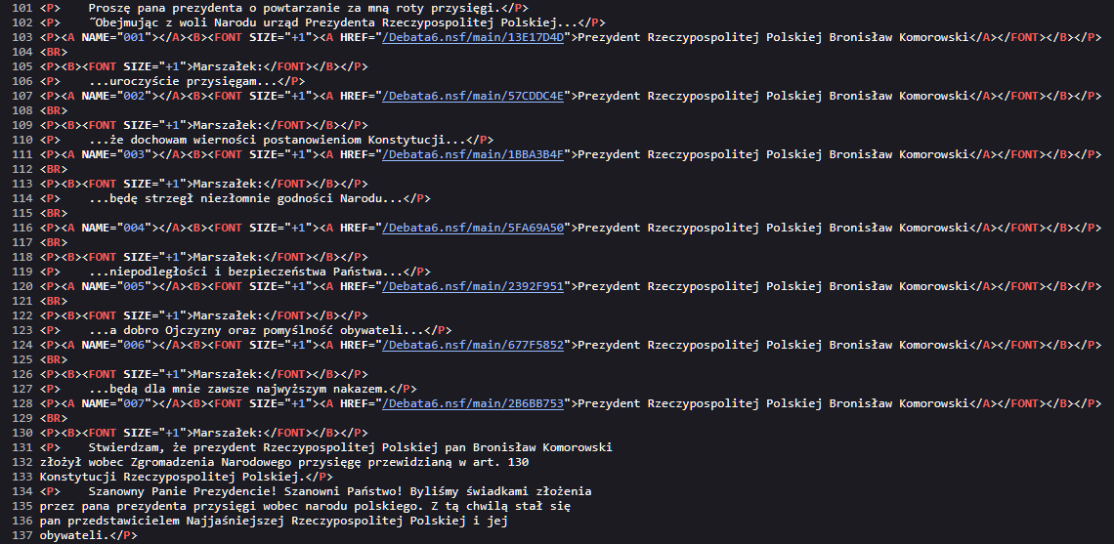

We can see where the text is between which specific links, which are already included in the database in the following rows.