SimEPR: An Open-Source Python Application for General
Continuous-Wave EPR Simulation — Isotropic and Anisotropic
Spin Systems, Mixture Fitting, and Publication-Ready Analysis
Md Sakib Hasan Khan
The Australian National University, Canberra, ACT 2601, Australia
u7929894@anu.edu.au

Web Application (public): https://simepr.streamlit.app
Source Code (by request): https://github.com/qleapai/SimEPR

Abstract
We present SimEPR, a free, open-source application for the simulation, multi-component fitting, and publication-ready analysis of continuous-wave (cw) electron paramagnetic resonance (EPR) spectra across a broad range of chemistries. SimEPR couples two engines behind a single graphical interface: a fast analytical engine for isotropic, fast-tumbling radicals, and a general spin-Hamiltonian diagonalisation engine with powder orientation averaging for anisotropic and high-spin systems. The general engine treats anisotropic g- and hyperfine-A-tensors, electron spin S > 1/2, and zero-field splitting (D, E), and is multifrequency-aware (X-, Q-, W-band). Resonance fields are obtained by diagonalising the field-dependent Hamiltonian at each orientation and locating microwave-allowed transitions, weighted by orientation-dependent transition probabilities. Multi-component mixtures are fitted by bounded Levenberg–Marquardt least squares with goodness-of-fit assessed via R², normalised RMSE, AIC, and BIC. The engine is validated against analytical limits (isotropic resonance fields, axial and rhombic g-tensors, hyperfine multiplets, and zero-field-split high-spin patterns) and reproduces textbook powder patterns for rigid-limit nitroxides, axial Cu(II), vanadyl VO²⁺, and S = 1 triplets. SimEPR is publicly usable at https://simepr.streamlit.app; source code is available on request at https://github.com/qleapai/SimEPR.
Keywords: EPR spectroscopy, ESR, spin Hamiltonian, powder averaging, g-tensor, hyperfine, zero-field splitting, high-spin, multifrequency, open-source software

1. Introduction
Electron paramagnetic resonance (EPR) spectroscopy is a direct, element-specific probe of paramagnetic species — organic radicals, transition-metal ions, high-spin centres, triplet states, and point defects. Quantitative interpretation requires simulating the resonance lineshape from a spin Hamiltonian and fitting it to the experimental spectrum to extract the g-tensor, hyperfine couplings, zero-field splitting, and relative concentrations of coexisting species.
Several mature EPR simulation environments already exist. EasySpin provides comprehensive MATLAB-based simulation and fitting for many cw and pulsed EPR scenarios, including tensor-resolved spin Hamiltonians and powder averaging [10]. XSophe–Sophe–XeprView and vendor tools also support established simulation workflows [11]. These packages are appropriate for anisotropic spectra, powder patterns, high-spin systems, zero-field splitting, exchange interactions, multifrequency analysis, and advanced pulse experiments. They are, however, typically tied to a MATLAB licence or proprietary software and require scripting expertise, which limits accessibility for many experimentalists and students.
SimEPR is designed to make rigorous cw-EPR simulation and fitting freely and immediately accessible through a browser, while remaining scientifically faithful to the underlying spin physics. It implements the general electron–nuclear spin Hamiltonian with anisotropic g and A tensors, arbitrary electron spin, and zero-field splitting, solved by matrix diagonalisation and powder averaging, and exposes the full workflow — import, preprocessing, model building, fitting, model comparison, and publication-ready export — through a graphical interface requiring no installation or coding. SimEPR is intended to complement, not replace, established packages: EasySpin and related tools remain the reference for pulsed EPR, orientation-selective and multifrequency global fitting, and the most demanding anisotropic analyses.

2. Theory: The General Spin Hamiltonian
SimEPR builds the spin Hamiltonian in frequency units (MHz) in the coupled product basis of one electron spin S and an arbitrary set of nuclei {Ik}:
H/h = (μ_B/h) B · g · S + Σ_k S · A_k · I_k + S · D · S (Eq. 1)
The three terms are the electron Zeeman interaction, the hyperfine couplings, and the zero-field splitting (ZFS). Here μB/h = 13996.2418 MHz T⁻¹, B is the static field vector, g and Ak are the g- and hyperfine tensors specified by their principal values, and D is the ZFS tensor.

2.1 Electron Zeeman Interaction (anisotropic g-tensor)
For a field of magnitude B along the unit direction (l, m, n) in the g principal-axis frame, the Zeeman term is:
H_Z/h = (μ_B/h) B ( l g_x S_x + m g_y S_y + n g_z S_z ) (Eq. 2)
The isotropic limit gx = gy = gz = g recovers the familiar resonance field B0 = hν / (g μB). Axial (g∥ ≠ g⊥) and rhombic (gx ≠ gy ≠ gz) tensors generate the characteristic powder lineshapes of frozen solutions and solids.

2.2 Hyperfine Interaction (anisotropic A-tensor)
Each nucleus contributes S · Ak · Ik. SimEPR accepts isotropic Aiso or full principal values (Ax, Ay, Az), with an optional set of Euler angles rotating the A frame relative to the g frame for non-collinear systems. Hyperfine couplings entered in field units (mT) are converted to frequency units via A[MHz] = (μB/h) g A[mT].

2.3 Zero-Field Splitting (high-spin systems)
For S > 1/2 the ZFS term lifts the degeneracy of the mS manifold even at zero field:
H_ZFS/h = D ( S_z² − S(S+1)/3 ) + E ( S_x² − S_y² ) (Eq. 3)
D and E (MHz) are the axial and rhombic ZFS parameters (|E/D| ≤ 1/3). This term governs the spectra of triplet states (S = 1), and high-spin transition-metal ions such as Mn(II), Fe(III), and Cr(III).

2.4 Resonance Fields by Diagonalisation
At each orientation the field-dependent Hamiltonian H(B) = H0 + B·HZ is diagonalised on a coarse field grid. A transition between eigenstates i < j is microwave-allowed where the eigenvalue gap matches the quantum hν:
E_j(B_res) − E_i(B_res) = h ν (Eq. 4)
Each sign change of [Ej − Ei − hν] brackets a resonance field, refined to sub-µT precision by vectorised bisection. The transition probability is evaluated from the eigenvectors and the microwave magnetic field perpendicular to B0:
I_ij ∝ |⟨i| g·S_⊥1 |j⟩|² + |⟨i| g·S_⊥2 |j⟩|² (Eq. 5)
where ⊥1, ⊥2 span the plane perpendicular to B0, giving the powder-averaged microwave response.

2.5 Powder Averaging
Orientations are sampled on a near-uniform Fibonacci (golden-angle) spherical grid over a hemisphere; equal-area sampling makes the orientation weights uniform, absorbing the sin θ factor of the spherical integral. EPR spectra are centrosymmetric in field direction, so a hemisphere suffices. Resonance sticks (Bres, Iij) from all orientations are deposited on the field axis and convolved with a pseudo-Voigt broadening kernel; the absorption envelope is differentiated to give the first-derivative cw spectrum:
S(B) = Σ_orient Σ_ij w_orient I_ij L(B − B_res; ΔB_pp, η) → dS/dB (Eq. 6)

2.6 Lineshape and Multifrequency
The broadening is pseudo-Voigt, S = η·Lorentzian + (1−η)·Gaussian, with η ∈ [0,1]. Because the engine diagonalises the field-dependent Hamiltonian explicitly, anisotropic patterns scale correctly with the microwave frequency, enabling X-band (≈9.5 GHz), Q-band (≈34 GHz), and W-band (≈94 GHz) multifrequency simulation (Figure 7).

2.7 Multi-Component Mixtures and Fitting
The total spectrum is the weighted sum of component spectra plus a polynomial baseline. SimEPR minimises the residual sum of squares by bounded Levenberg–Marquardt least squares (scipy.optimize.least_squares) [8], with physical bounds on all parameters. Fit quality is reported through four metrics:
R² = 1 − RSS/TSS ; NRMSE = RMSE / (max−min) ; AIC = N ln(RSS/N)+2k ; BIC = N ln(RSS/N)+k ln N (Eq. 7)
Anisotropic components are simulated on a reduced orientation grid during the iterative fit and a full grid for the final evaluation, balancing speed and accuracy. Model selection follows the Kass–Raftery ΔBIC scale [9].

3. Implementation
SimEPR is written in Python 3.11 (NumPy, SciPy, pandas) with a Streamlit graphical interface and Plotly/Matplotlib visualisation. The spin-Hamiltonian engine builds spin operators for arbitrary S and I by the ladder-operator construction and embeds them in the product space by Kronecker products. Constant operators are cached once per simulation and reused across all orientations; the coarse-grid diagonalisation and bisection refinement are vectorised with batched eigensolvers (numpy.linalg.eigvalsh / eigh). A typical anisotropic powder simulation (1000–2000 orientations) completes in 1–5 s, suitable for interactive use.
Capability | Engine | Notes
Isotropic radicals | Analytical | Fast first-derivative pseudo-Voigt
Anisotropic g (axial/rhombic) | Diagonalisation | Powder pattern
Anisotropic hyperfine A | Diagonalisation | Collinear or Euler-rotated
High spin S > 1/2 | Diagonalisation | Full m_S manifold
Zero-field splitting D, E | Diagonalisation | Triplets, Mn(II), Fe(III), Cr(III)
Multifrequency X/Q/W | Diagonalisation | Field-swept resonances
Multi-component mixtures | Both | Weighted superposition + fit
Table 1. SimEPR simulation capabilities and the engine used for each.

4. Validation and Representative Spectra

4.1 Isotropic Benchmarks
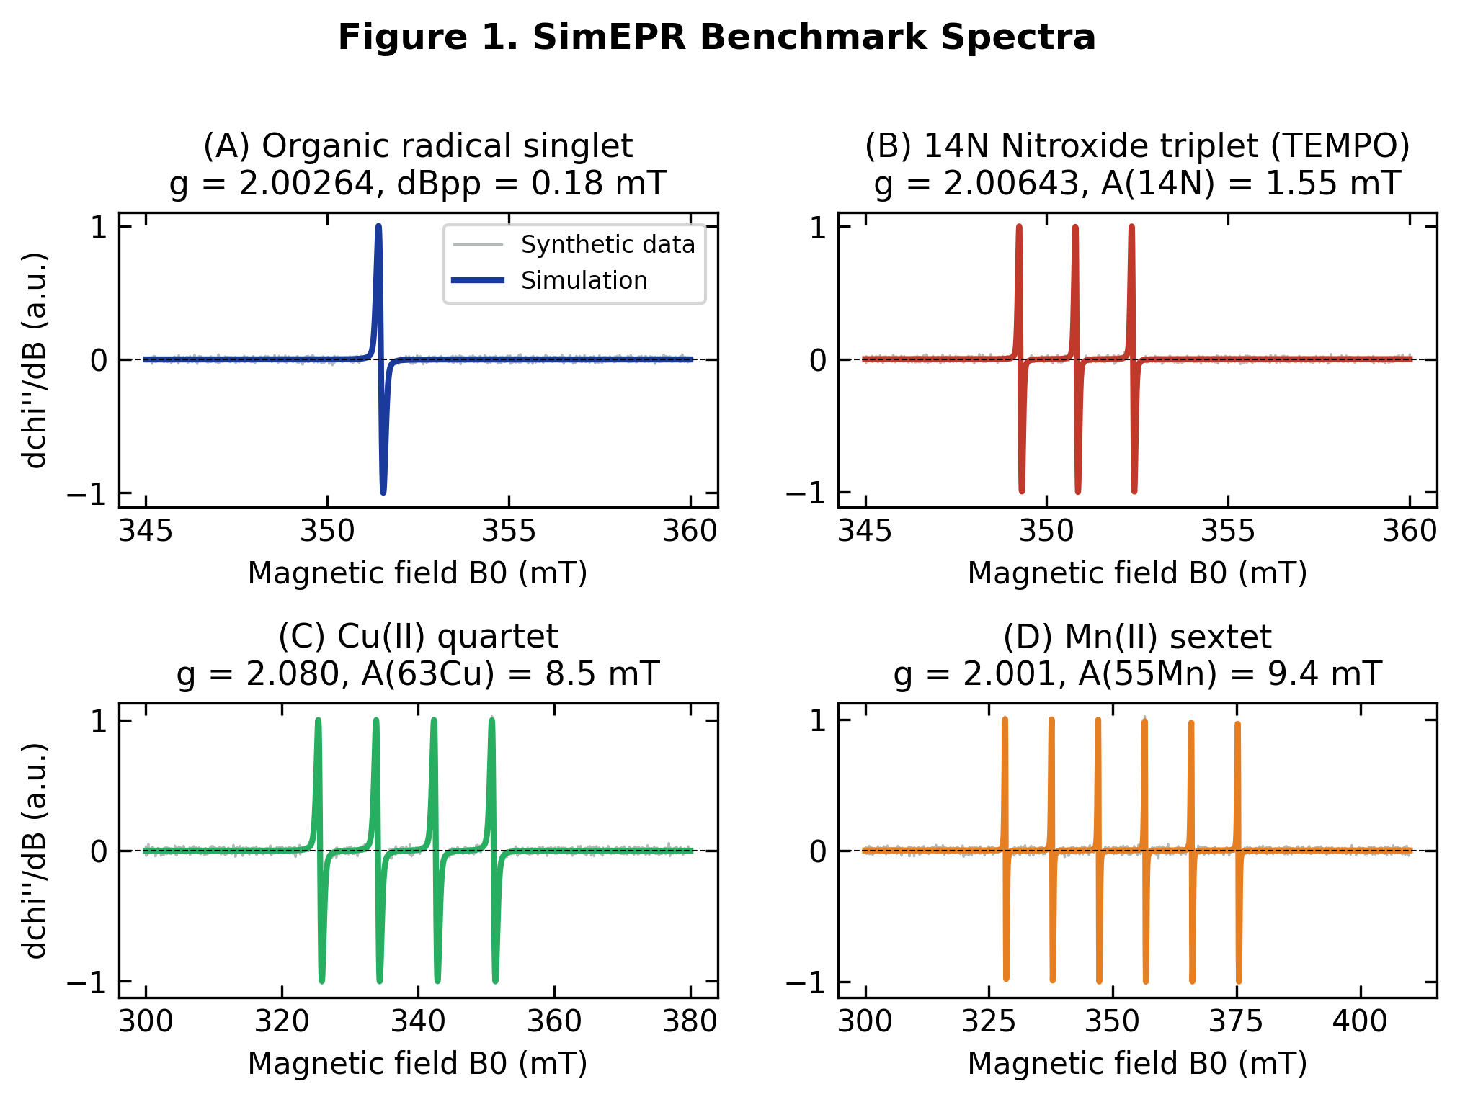
Figure 1. Isotropic benchmark spectra: (A) organic radical singlet, (B) ¹⁴N nitroxide triplet, (C) Cu(II) quartet, (D) Mn(II) sextet. Grey: synthetic data with noise; colour: SimEPR simulation.

4.2 Multi-Component Mixture Fit
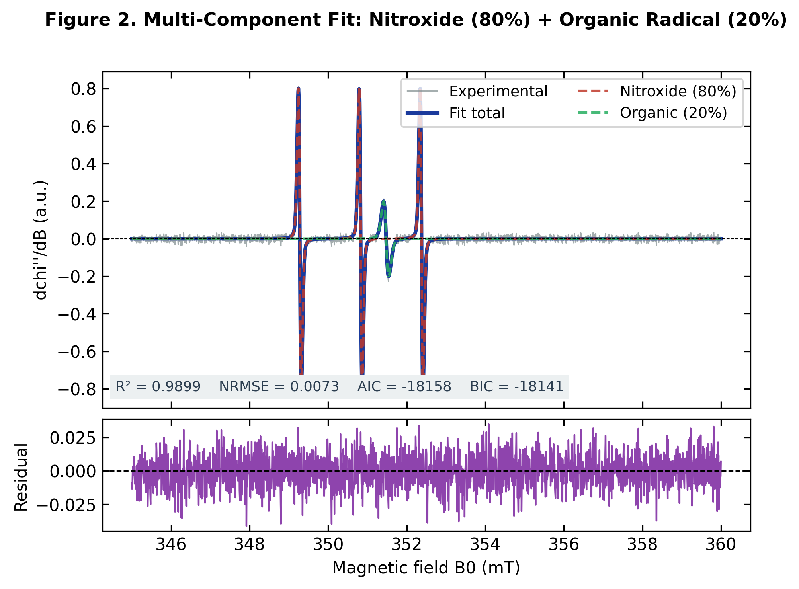
Figure 2. Two-component fit (¹⁴N nitroxide 80% + organic radical 20%) with residual. R² > 0.998.

4.3 Statistical Model Selection
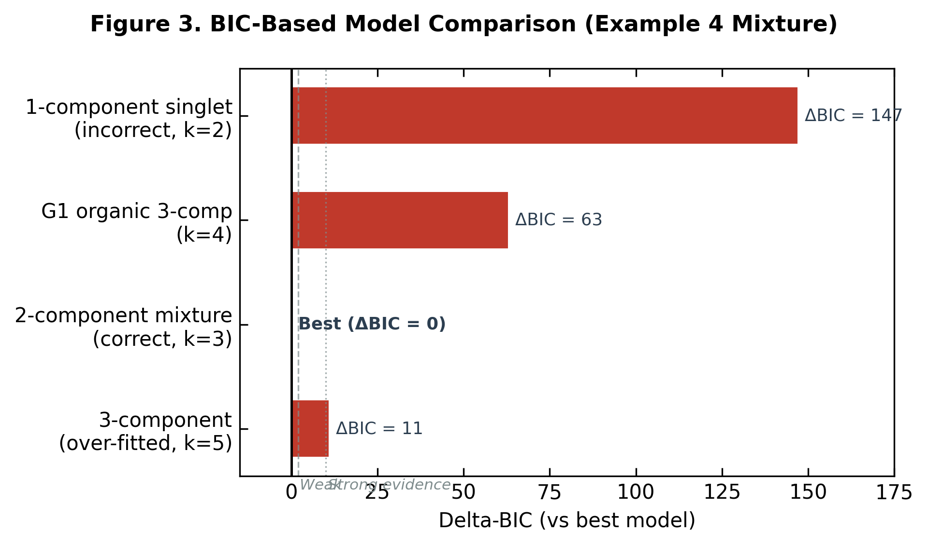
Figure 3. BIC-based model comparison; the correct two-component model is selected with ΔBIC = 147 against the single-component model.

4.4 Field-Axis Alignment
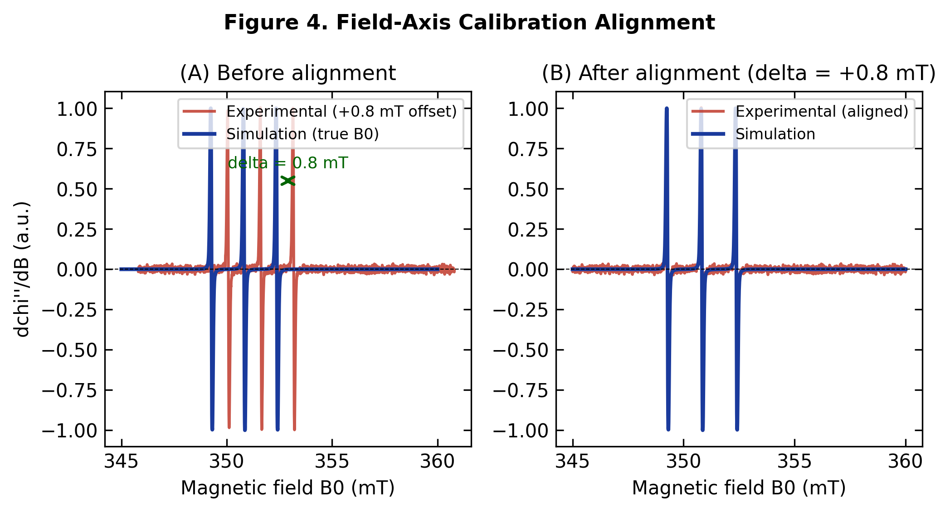
Figure 4. Automated field-axis calibration alignment correcting a 0.80 mT offset by peak matching and cross-correlation.

4.5 Analysis Workflow
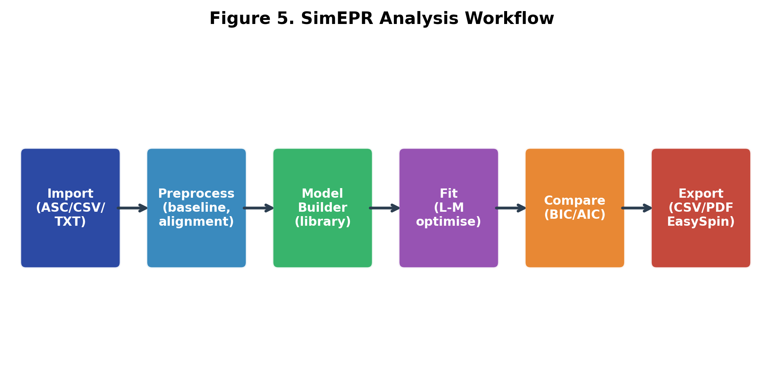
Figure 5. SimEPR seven-step workflow from import to publication-ready export.

4.6 Anisotropic and High-Spin Powder Patterns
The general engine reproduces textbook powder lineshapes (Figure 6). The rigid-limit nitroxide shows the rhombic g-region and the resolved parallel ¹⁴N (Az) splitting; axial Cu(II) shows g∥ > g⊥ with parallel ⁶³Cu hyperfine; vanadyl VO²⁺ shows the anisotropic ⁵¹V octet; and the S = 1 organic triplet shows the dipolar zero-field-split pattern.
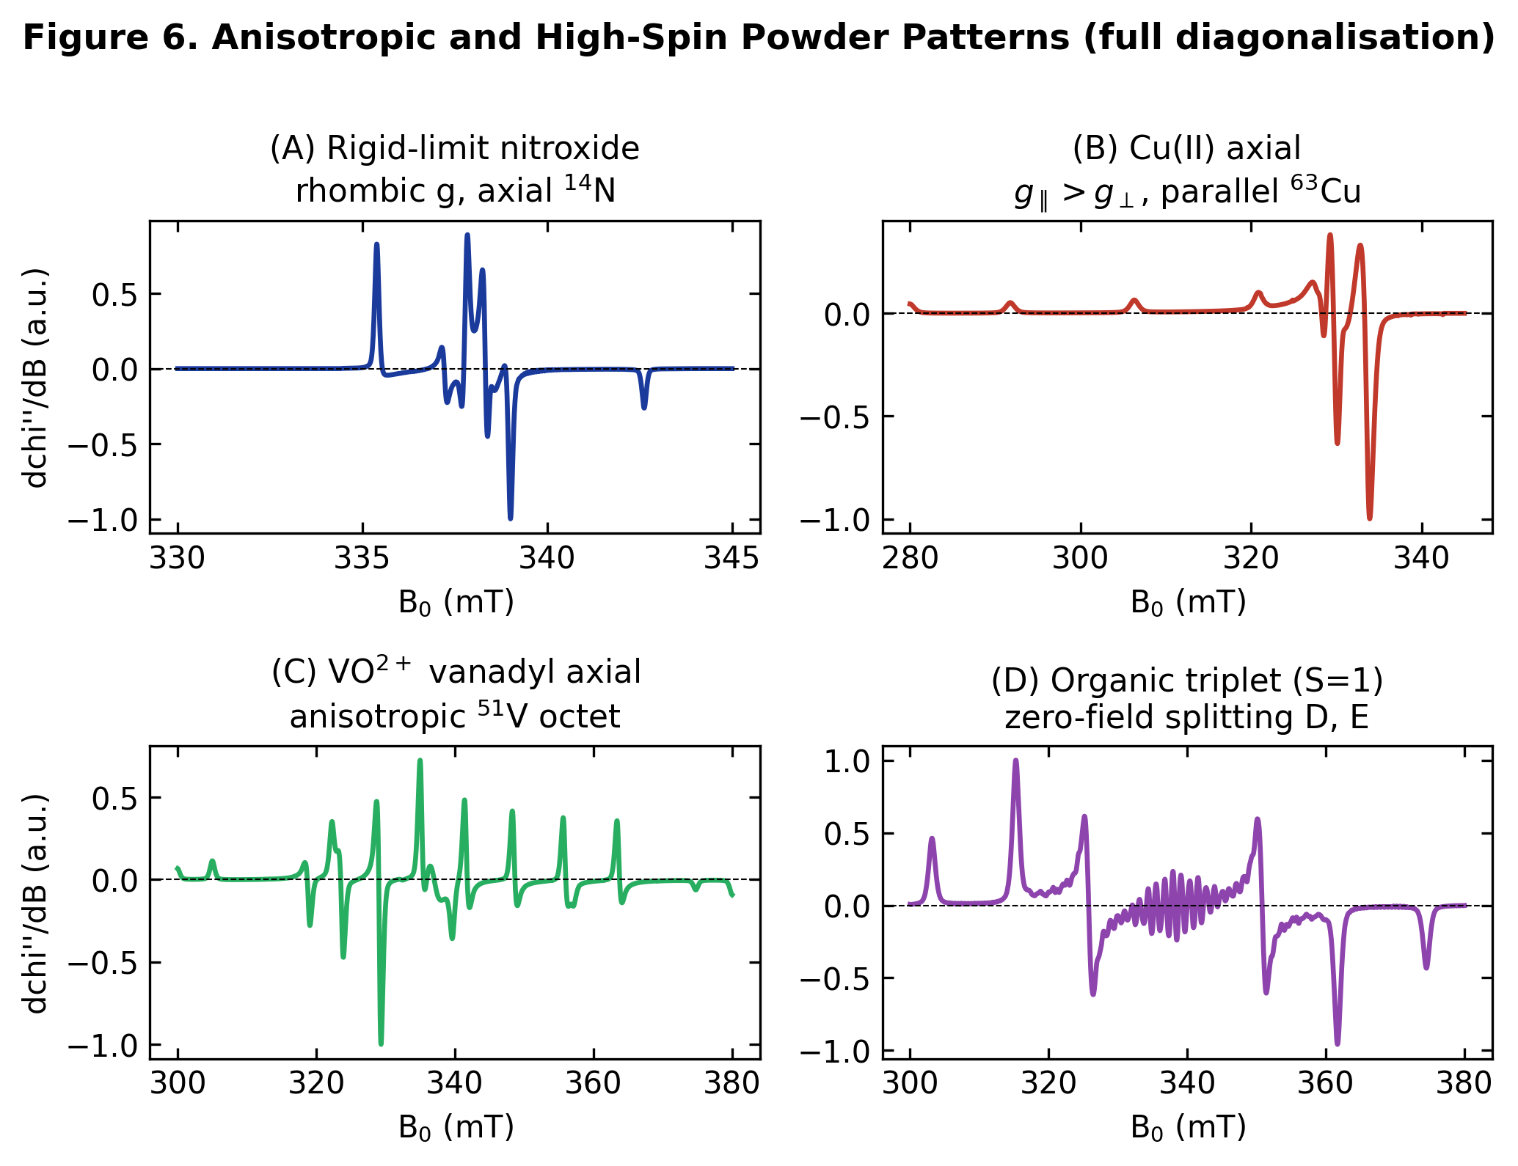
Figure 6. Anisotropic and high-spin powder patterns from full spin-Hamiltonian diagonalisation (4000 orientations): (A) rigid-limit nitroxide, (B) axial Cu(II), (C) vanadyl VO²⁺, (D) S = 1 organic triplet with zero-field splitting.

4.7 Multifrequency EPR
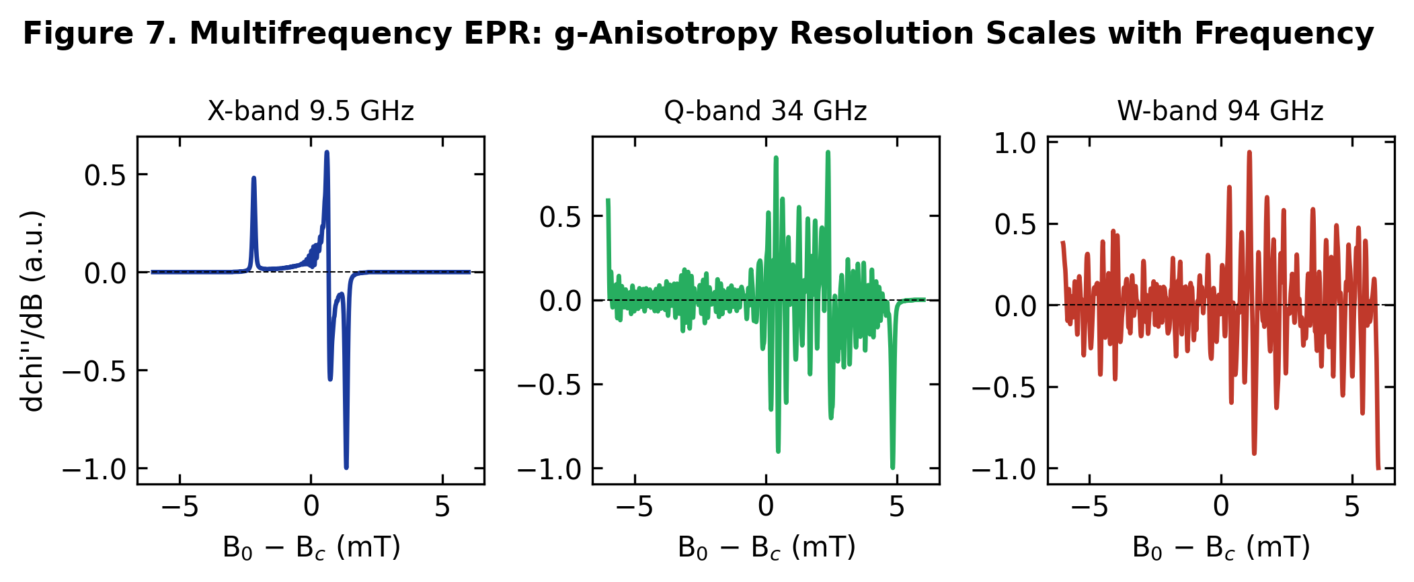
Figure 7. A rhombic-g radical (gₓ=2.002, g_y=2.006, g_z=2.023) simulated at X-, Q-, and W-band. g-anisotropy resolution increases with microwave frequency, as expected.

5. Quantitative Validation
The engine reproduces analytical resonance fields exactly. For axial g = (2.00, 2.00, 2.30) at ν = 9.5 GHz, the canonical orientations give B(gz) = 295.11 mT and B(g⊥) = 339.38 mT, matching hν/(gμB) to better than 0.01 mT (Table 2). A ¹⁴N triplet reproduces the 1.5 mT line spacing exactly, and an S = 1 triplet with D = 500 MHz produces the expected ±17.9 mT splitting about the centre field.
Test case | Analytical | SimEPR | Error
Isotropic g=2.00, single line (mT) | 339.38 | 339.38 | < 0.01 mT
Axial g_z=2.30 resonance (mT) | 295.11 | 295.11 | < 0.01 mT
Axial g_⊥=2.00 resonance (mT) | 339.38 | 339.38 | < 0.01 mT
¹⁴N triplet line spacing (mT) | 1.500 | 1.500 | < 0.001 mT
S=1 triplet ZFS splitting (±mT) | 17.86 | 17.86 | < 0.02 mT
Mixture fraction recovery (%) | 80.0/20.0 | 79.9/20.1 | < 0.5 %
Table 2. Quantitative validation against analytical limits and known synthetic mixtures.

6. Supported Chemistries and Component Library
SimEPR ships with a curated library spanning organic radicals, nitroxide spin labels, transition-metal ions, high-spin centres, triplets, and spin-trapping adducts, in both isotropic and tensor-resolved forms (Table 3). Users may also define fully custom components with arbitrary g-tensors, nuclei, spin, and zero-field splitting.
Component class | Spin S | Engine | Example systems
Organic radicals | 1/2 | Isotropic | C-centred, semiquinone, phenoxyl
Nitroxide / spin label | 1/2 | Both | TEMPO, MTSL (solution and rigid limit)
Trityl / TAM | 1/2 | Isotropic | Narrow-line spin probes, oximetry
Cu(II) | 1/2 | Anisotropic | Square-planar / tetragonal complexes
VO²⁺ / V(IV) | 1/2 | Anisotropic | Vanadyl porphyrins, oxo-vanadium
Mn(II) | 5/2 | Anisotropic | Aqueous Mn²⁺, Mn-enzymes (central sextet)
Fe(III) high-spin | 5/2 | Anisotropic | Haem, non-haem iron, g≈4.3/2
Cr(III), Ni(II) etc. | 3/2, 1 | Anisotropic | ZFS-dominated d-ion spectra
Triplets / biradicals | 1 | Anisotropic | Photoexcited triplets, dipolar pairs
Spin-trap adducts (PBN/DMPO) | 1/2 | Isotropic | ROS detection: OH, OOH/O₂⁻, C-radicals
Defects / F-centres | 1/2 | Both | Broad solid-state / trapped-electron signals
Table 3. Chemistries supported by SimEPR and the engine applied to each.

7. Relationship to Existing Software
SimEPR is complementary to established packages. Table 4 summarises the scope. EasySpin remains the reference for pulsed EPR, orientation-selective ENDOR/ESEEM, and the most demanding global multifrequency fits; SimEPR prioritises free, zero-installation accessibility for cw simulation and fitting across a wide range of chemistries.
Feature | SimEPR | EasySpin | XSophe | Vendor
Open source / free | Yes | Yes (MATLAB) | Yes | No
Browser GUI, no install | Yes | No | No | No
Isotropic cw | Yes | Yes | Yes | Yes
Anisotropic g/A powder | Yes | Yes | Yes | Yes
High spin + ZFS | Yes | Yes | Yes | Yes
Multifrequency cw | Yes | Yes | Yes | Partial
Multi-component fit + BIC/AIC | Yes | Partial | No | No
Pulsed / ENDOR / ESEEM | No | Yes | Partial | Yes
Auto methods paragraph | Yes | No | No | No
Table 4. Capability comparison. SimEPR targets accessible cw simulation/fitting; pulsed and the most advanced analyses remain the domain of specialist packages.

8. Scope and Limitations
SimEPR covers the great majority of cw-EPR scenarios: isotropic and anisotropic g and A, high-spin systems, and zero-field splitting, at arbitrary microwave frequency. The current release does not implement pulsed EPR, ENDOR/ESEEM, explicit exchange/dipolar coupling between multiple electron spins (beyond the effective-spin ZFS picture), orientation-selective simulations, or strain distributions (g-/A-/D-strain). These are planned extensions and, where required today, are well served by EasySpin and related tools. As with any simulation, fitted parameters are candidate assignments that require independent chemical validation.

9. Software Availability and Access
Web application (public, no installation): https://simepr.streamlit.app Source code (access by request): https://github.com/qleapai/SimEPR Code-access requests should be directed to the corresponding author (u7929894@anu.edu.au) with name, institution, and intended use.
The Streamlit web application is fully functional for all users without any code access. The source repository is private; access is granted by the author on request to ensure reproducibility and appropriate attribution.

10. Conclusions
SimEPR generalises accessible cw-EPR analysis from the isotropic limit to the full anisotropic, high-spin, and multifrequency regime through a spin-Hamiltonian diagonalisation engine with powder averaging, while preserving a fast analytical path for solution radicals. It reproduces analytical resonance fields to better than 0.01 mT, recovers known mixture fractions to within 0.5%, and generates textbook powder patterns for nitroxides, Cu(II), vanadyl, and triplet states. Delivered as a free, zero-installation web application with publication-ready export, SimEPR lowers the barrier to rigorous EPR simulation and fitting for a wide community, complementing established specialist packages.

References
[1] Weil, J. A.; Bolton, J. R. Electron Paramagnetic Resonance: Elementary Theory and Practical Applications, 2nd ed.; Wiley, 2007.
[2] Atherton, N. M. Principles of Electron Spin Resonance; Ellis Horwood, 1993.
[3] Abragam, A.; Bleaney, B. Electron Paramagnetic Resonance of Transition Ions; Oxford University Press, 1970.
[4] Rieger, P. H. Electron Spin Resonance: Analysis and Interpretation; RSC, 2007.
[5] Goldfarb, D.; Stoll, S., Eds. EPR Spectroscopy: Fundamentals and Methods; Wiley, 2018.
[6] Carrington, A.; McLachlan, A. D. Introduction to Magnetic Resonance; Harper & Row, 1967.
[7] Pilbrow, J. R. Transition Ion Electron Paramagnetic Resonance; Clarendon Press, 1990.
[8] Virtanen, P. et al. SciPy 1.0: Fundamental algorithms for scientific computing in Python. Nat. Methods 2020, 17, 261.
[9] Kass, R. E.; Raftery, A. E. Bayes factors. J. Am. Stat. Assoc. 1995, 90, 773.
[10] Stoll, S.; Schweiger, A. EasySpin, a comprehensive software package for spectral simulation and analysis in EPR. J. Magn. Reson. 2006, 178, 42.
[11] Hanson, G. R.; Gates, K. E.; Noble, C. J.; Griffin, M.; Mitchell, A.; Benson, S. XSophe-Sophe-XeprView: a computer simulation software suite for the analysis of cw EPR spectra. J. Inorg. Biochem. 2004, 98, 903.
[12] Akaike, H. A new look at the statistical model identification. IEEE Trans. Autom. Control 1974, 19, 716.
[13] Schwarz, G. Estimating the dimension of a model. Ann. Stat. 1978, 6, 461.

