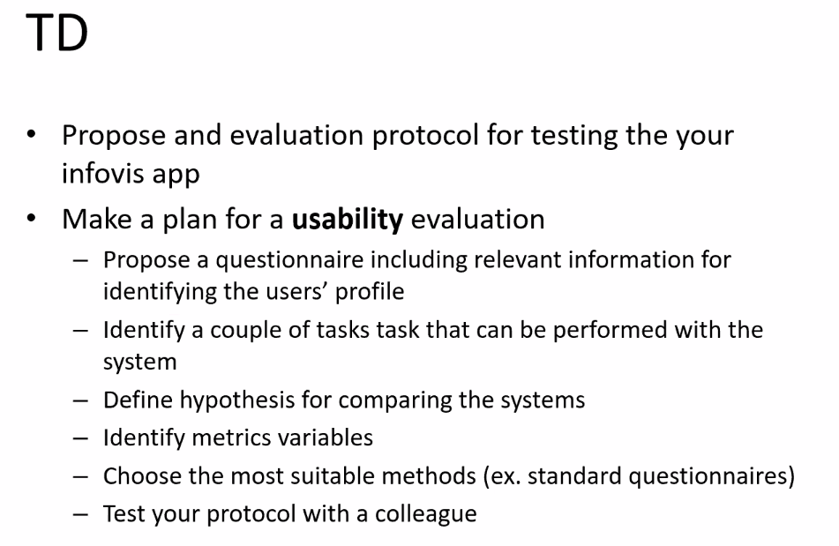
Short description
Short description of the database
which attributes are used
transformation used
visualization techniques
tasks supported by the technique
TD report

