Encrypt SMS
College of Computer & Information Sciences
Lucas Olson
Regis University
1/16/21
Version 1.7

Table of Contents
Revision History 4
Project GitHub Link: 4
Abstract 5
Application Description 6
Use Cases 7
Use Case Diagram 7
Fully Dressed Use Cases 8
Read/Send SMS. 8
Encrypt/Decrypt SMS. 8
Packaging. 9
Test Cases 10
Send SMS. 10
Read SMS. 10
Package SMS. 11
Encrypt SMS. 11
Design Goals 12
Architecture 12
1+1 Architecture 13
Logical View 13
Scenarios 14
Common Good 15
Week 1 Status 16
Documentation Progress 16
Development Progress 16
Week 2 Status 16
Documentation Progress 16
Development Progress 16
Week 3 Status 16
Documentation Progress 16
Development Progress 16
Week 4 Status 16
Documentation Progress 17
Development Progress 17
Week 5 Status 19
Documentation Progress 19
Development Progress 19
Week 5 Work Log 20
Week 6 Status 20
Documentation Progress 20
Development Progress 20
Week 6 Work Log 21
Week 7 Status 21
Week 8 Status 21

Revision History
Revision | Date | Summary
1.1 | 1/16/21 | Initial document created
1.2 | 1/21/21 | Formal document created with tables, diagrams and structured architecture.
1.3 | 1/29/21 | Name changed, revision history, and multi-view architecture
1.4 | 2/7/21 | Use cases started, week 4 details added with screenshots
1.5 | 2/14/21 | Week 5 details. Test cases added for this week 2/19/21 and Work Log
1.6 | 2/21/21 | Week 6 details with work log
1.7 | 2/23/21 | Week 7 TODO::

Project GitHub Link:

Everything in Development Branch
https://github.com/qleseid/EncryptSMS.git

Abstract
The secure short message service (SMS) application will primarily consist of a mobile application initially focused around the Android environment. The encompassing project will also include web software for application management purposes. The premise of the project is to provide a means to encrypt and manage SMS messages while using native SMS transmission protocols. This will allow users to send encrypted messages without depending upon a data connection. Also, users maintain the ability to revoke access to messages sent to recipients.

Application Description
The security of information has always been a top priority throughout human existence. In today's data driven world the need for security has only increased as the threats against data continue to grow. Application developers have been busy creating secure means for users to communicate which is evident by the countless chat applications available for download. These applications have a few inherent flaws: They depend upon a data connection, the user has minimal control over their data and its security, and the users are locked into a specific application design. Encrypt SMS overcomes these limitations by providing a service that will either add an additional capability to native applications or be contained in a standalone application that mirrors SMS application design best practices. This application will use standard mobile SMS protocols as the means to transmit the messages. The user retains ultimate control over their data through locally stored private keys. Only the public keys are shared with authorized recipients.
A website will be deployed for an ease of managing participating contacts with the application. There will be additional protocols developed to facilitate a users ability to use the service without the need for a data connection. Additionally, the application itself will connect to the websites database for seamless contact updates. By having three different contact management avenues, the application will have the ability to reach ever SMS user.

Use Cases
The following use cases will be in prioritized order. The first case will represent the highest priority followed by the next highest priority case and so on. The application will include use cases that deal with managing the application database, integrate into the native system, and authenticate a user profile but are excluded from this list.
- Read/Send SMS
- Encrypt/Decrypt SMS
- Packaging

Use Case Diagram
Figure 1. Use case diagram for Encrypt SMS

Fully Dressed Use Cases

Read/Send SMS.
Primary Actor: User

Assumptions:
User is authenticated and the application is open.
Stakeholders:
User: Needs a container to transport the SMS to/from the UI.
Pre-conditions:
The user has opened or successfully logged into application. User is presented with the main activity. The user can see a list of conversations contained within a RecyclerView. They are provided a drawer style navigation along with buttons to adjust settings and create new conversations.
Post-conditions (Success Guarantee):
A new SMS can be read/sent as if using a native application.
Flow of Events:
- User clicks a conversation from the list.
- A new fragment opens the conversation dialog view. Received SMS can be scrolled and read. An entry form allows for the creation of a new SMS at the bottom of this fragment.
- Upon clicking the SEND button, the application queries the database for encryption details associated with desired contact.
ALT FLOW 3a. No encryption data found.
  - Toast message prompts user to request information or send unsecured.
  - Application request data from contact, or cloud database.
ALT FLOW 3b. Navigate UP clicked.
  - Fragment state is saved and returns to the conversation list view in main activity.
- Successful transmission of SMS in desired format and user was able to read received messages.

Encrypt/Decrypt SMS.
Primary Actor: User

Assumptions:
User is authenticated and the application is open.
Stakeholders:
User: Needs a container to encrypt/decrypt the SMS to/from the UI.
Pre-conditions:
The user has opened or successfully logged into application. User has selected a conversation and is attempting to read/send an SMS. Database contains the required data for securely working with desired contact. User has initiated the sending of a message, or is reading current conversation.
Post-conditions (Success Guarantee):
A new SMS is properly encrypted for transmission, or decrypted for reading.
Flow of Events:
- User has sent an encrypted message.
ALT FLOW 1a. User is reading the conversation
  - If in plain-text, decryption has worked.
- SMS is moved to the security function.
- Recipient’s data is used to create a traffic key to encrypt SMS.
- SMS is moved to the packaging function for transmission.

Packaging.
Primary Actor: User

Assumptions:
User is authenticated, application is open, and an SMS is received by the packaging function.
Stakeholders:
User: Needs SMS to be properly structured to ensure proper interaction with SMS native transmission protocols.
Pre-conditions:
The packaging function has received an SMS payload.
Post-conditions (Success Guarantee):
A properly structured SMS is created and returned.
Flow of Events:
- SMS is received by function.
- Encrypted SMS are delivered to the security function.
ALT FLOW 2a. Encrypted messages for sending arrive from security function.
- Encrypted data is sent to Android API for transmission.
- Decrypted SMS are received back from security function.
- SMS is sent to the UI.

Test Cases

Send SMS.
Test Case #: 1 | Test Case Name: Send SMS | Page: 1 of 1
System: Encrypt SMS | Subsystem: SMS, Phone, Providers
Short Description: Test sending an SMS

Pre-conditions:
The user has the application up and running

Steps | Action | Expected Response | Pass/Fail | Comments
1 | Select a conversation or new button | Conversation view loads
2 | Enter valid phone number | Number is displayed in correct format
3 | Tap message input box | Keyboard is displayed
4 | Enter the message in text box | Keyboard functions and message is displayed
5 | Tap the send button | Message is added to conversation list and status is updated

Read SMS.
Test Case #: 2 | Test Case Name: Read SMS | Page: 1 of 1
System: Encrypt SMS | Subsystem: SMS, Phone, Providers
Short Description: Test reading an SMS

Pre-conditions:
The user has the application up and running

Steps | Action | Expected Response | Pass/Fail | Comments
1 | Select a conversation | Prompt for PIN code
2 | Enter valid PIN | Conversation view loaded with plain-text
3 | ALT: Invalid PIN entry | Conversation view loads with encrypted text

Package SMS.
Test Case #: 3 | Test Case Name: Package SMS | Page: 1 of 1
System: Encrypt SMS | Subsystem: SMS, Phone, Providers, Cryptography
Short Description: Test packaging an SMS in correct sizes after encryption

Pre-conditions:
The user has correctly sent an SMS

Steps | Action | Expected Response | Pass/Fail | Comments
1 | Deliver message to package class | Message format is verified and cleaned
2 | Message size is calculated | New message delivered with correct parts
3 | Each part is encrypted | Encrypted data returned within size limit
4 | Message parts are labeled | Correct parts order returned
5 | SMS package sent for transmission | Delivery intent received with no errors

Encrypt SMS.
Test Case #: 4 | Test Case Name: Encrypt SMS | Page: 1 of 1
System: Encrypt SMS | Subsystem: SMS, Phone, Providers, Cryptography
Short Description: Test the encryption process of an SMS for transmission

Pre-conditions:
The user has correctly sent an SMS and packaging is processing the message

Steps | Action | Expected Response | Pass/Fail | Comments
1 | Deliver message to encryption class | Message format is verified and cleaned
2 | Traffic key is read from database | Key is for correct contact and valid
3 | Encrypted message with key | Encrypted data is returned
4 | Verify encrypted data | Data is correctly encrypted
5 | Deliver message to packaging | Packaging receives message

Design Goals

- Implement a private/public encryption key protocol.
- Create either an Android API for use in an SMS app or a standalone app.
- Build a database to house the public keys.
- Build a web-server to communicate with the database and interface with users.
- Isolate and abstract the encrypt/decrypt process to facilitate seamless security updates.
- Mimic TLS packet protocol for a means of transmitting data.

Architecture
The application architecture itself will follow a 3-Tier/MVVC design. The first tier will be the front-end, or presentation layer for user interactions and management. The second tier will contain the service/business layer where user actions are processed and executed in the business logic. Finally, the last tier will contain the data and its underlying support structure.
The web application will follow a similar N-Tier structure with a front-end website that interacts with a server application at the second level. The server then interacts with the database tier to serve the user with appropriate information. The sever will deploy multiple services to accomplish the redundant user interfaces previously discussed. The web software will only be a secondary means of managing the keys used within the mobile application.

1+1 Architecture
The application itself is fairly small and straightforward. Because of the simple nature, the process, physical, and development views have been omitted. The logical view and scenarios are more than adequate to provide the overall structure and function of this application.

Logical View
The initial product under development will be an Android SMS application. This application will use the native SMS transmission protocol and implement an offline encryption service to allow users to send and receive secure messages. The class diagram in Figure 2. will provide the basic logical functionality of the application.
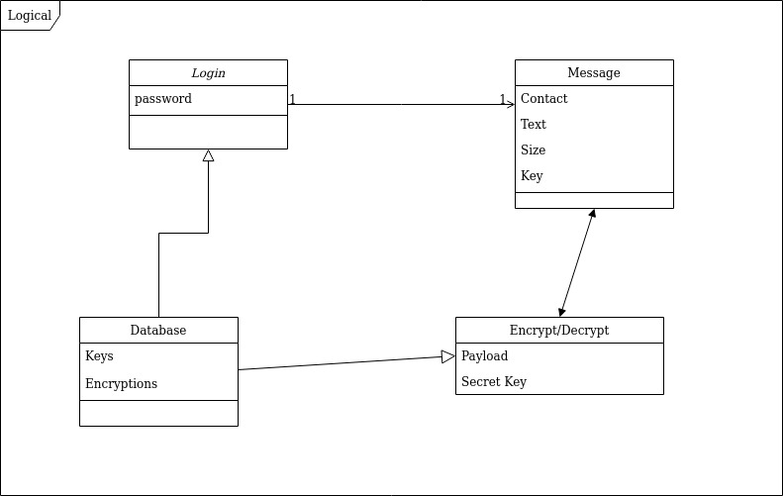Figure 2. Class diagram for logical view.

Scenarios
The following images show the basic look and feel as use cases are enacted by the user. Actual application images were chosen over object scenario diagrams for the added detail that can be afforded.
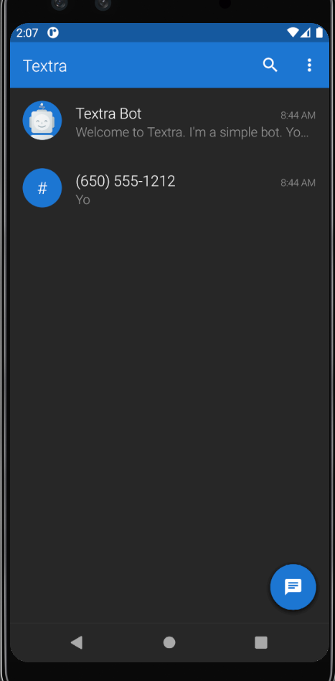
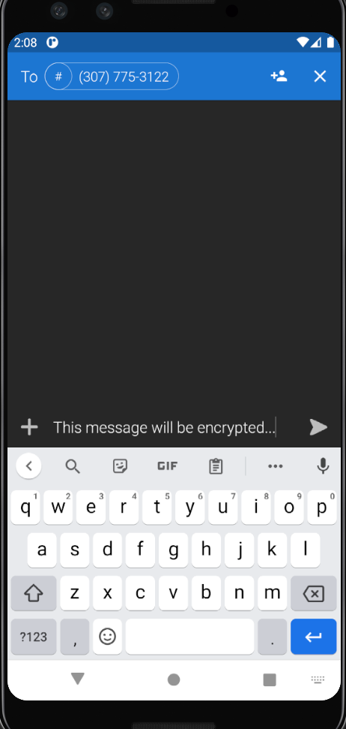

Common Good
The explosion of mobile technology has created more connections to the world in ways unimaginable only a few years ago. Mobile technology systems have placed tremendously powerful devices in the reach of almost everyone around the globe. This was accomplish by abstracting away the complicated systems involved and making them easy to use. The average user needs minimal application knowledge to accomplish their tasks and are often oblivious to the threats surrounding the data they produce and share. Often times there is a tiny minority of people that understands the implications and importance of data security; they bare the burden of creating a change for the common good.
Even though millions of secure applications are used to communicate every day, a large part of textual communication still happens through native SMS routes. The importance of finding a way to secure this avenue hopefully speaks for itself. Additionally, the ability to manage and revoke those secure communications provides another level of security within our culture. Take a moment to reflect, how often do we see text messages displayed completely out of context and the inevitable character damage it causes? The context becomes additional clouded when the time-frame is examined. How many people can truthfully say they are the same person from a decade ago. And should a few short conversations define who we are for the rest of our lives?

Week 1 Status

Documentation Progress
Started the Field-book again in OneNote. Much of this week I’ve already setup on my home system, so this will be a nice review

Development Progress
The project, and what projects we can do is still a mystery. The syllabus doesn’t provide the greatest clarity of what’s to come in the next 4 months. I hope to find out more from the discussion forum.

Week 2 Status

Documentation Progress
Built a brief proposal that wasn’t even close to adequate. This document is the official replacement for it and will be the running document for this project. Still hashing out the project and use cases. I’ve settled on a FAMP stack for the web side of my project and MySQL will mix nicely with SqLite and Android.

Development Progress
No hard development beyond installing server software and building this document.

Week 3 Status

Documentation Progress
Application’s name changed from Secure SMS to Encrypt SMS because previous research had already used that name. This document was graded last week and found to be missing the Multi-view architecture which has been added. It also received a revision history table with brief descriptions because this part of the document will serve great change depth. My presentation idea of serial communication and UART type interfacing was approved during the Zoom call on Friday. I’m not sure how long it will need to be, but I hope to do a live demo with a router.

Development Progress
This week was full of reading sources to build the AB. I’m starting to eliminate encryption protocols that won’t be useful in this project. ECC is looking to be the best choice so far. The application was created late this week in Android Studios. It’s only an empty shell at the moment and will continue to fill it in with functionality as I go.

Week 4 Status

Documentation Progress
The document continues to expand with some good info. There is constant refinement as well to make a more professional document that holds the focus on the application instead of the documentation.

Development Progress
Still working on creating the UI of the application. The pieces are almost there and then connecting the back-end will come shortly after. It looks like I need to learn some sort of Injector function for my application whether it’s Dagger or Hilt. This will add another steep learning curve to the matter but I look forward to the challenge. The UI is coming as seen below, but without data, it isn’t very exciting yet.

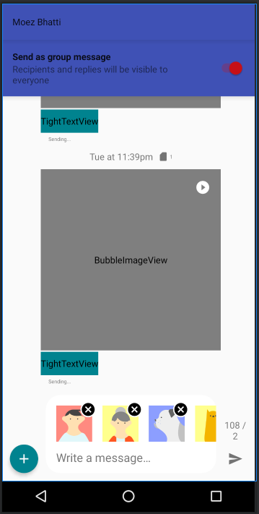
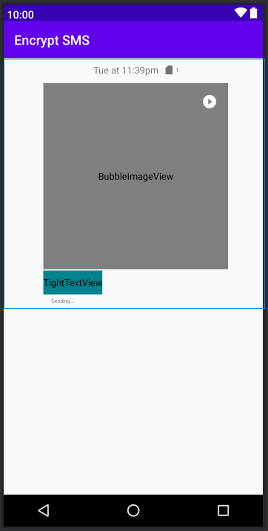

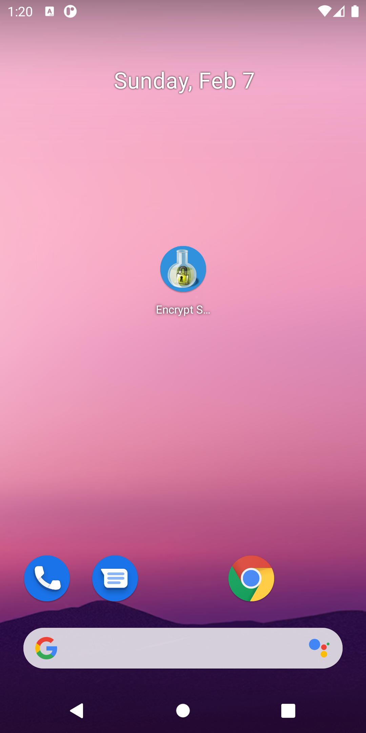
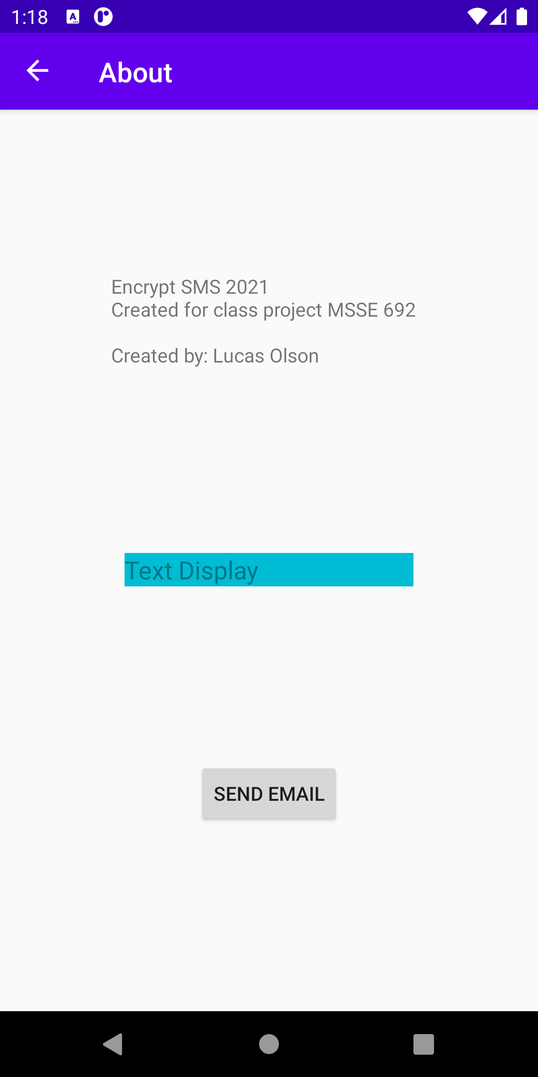
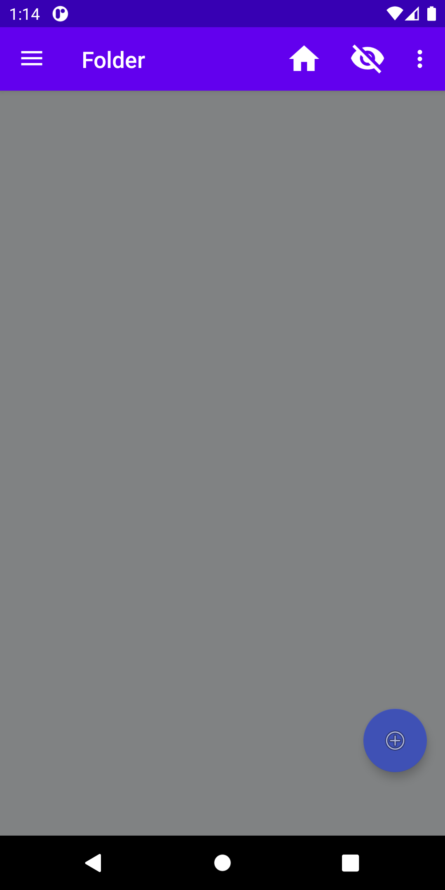
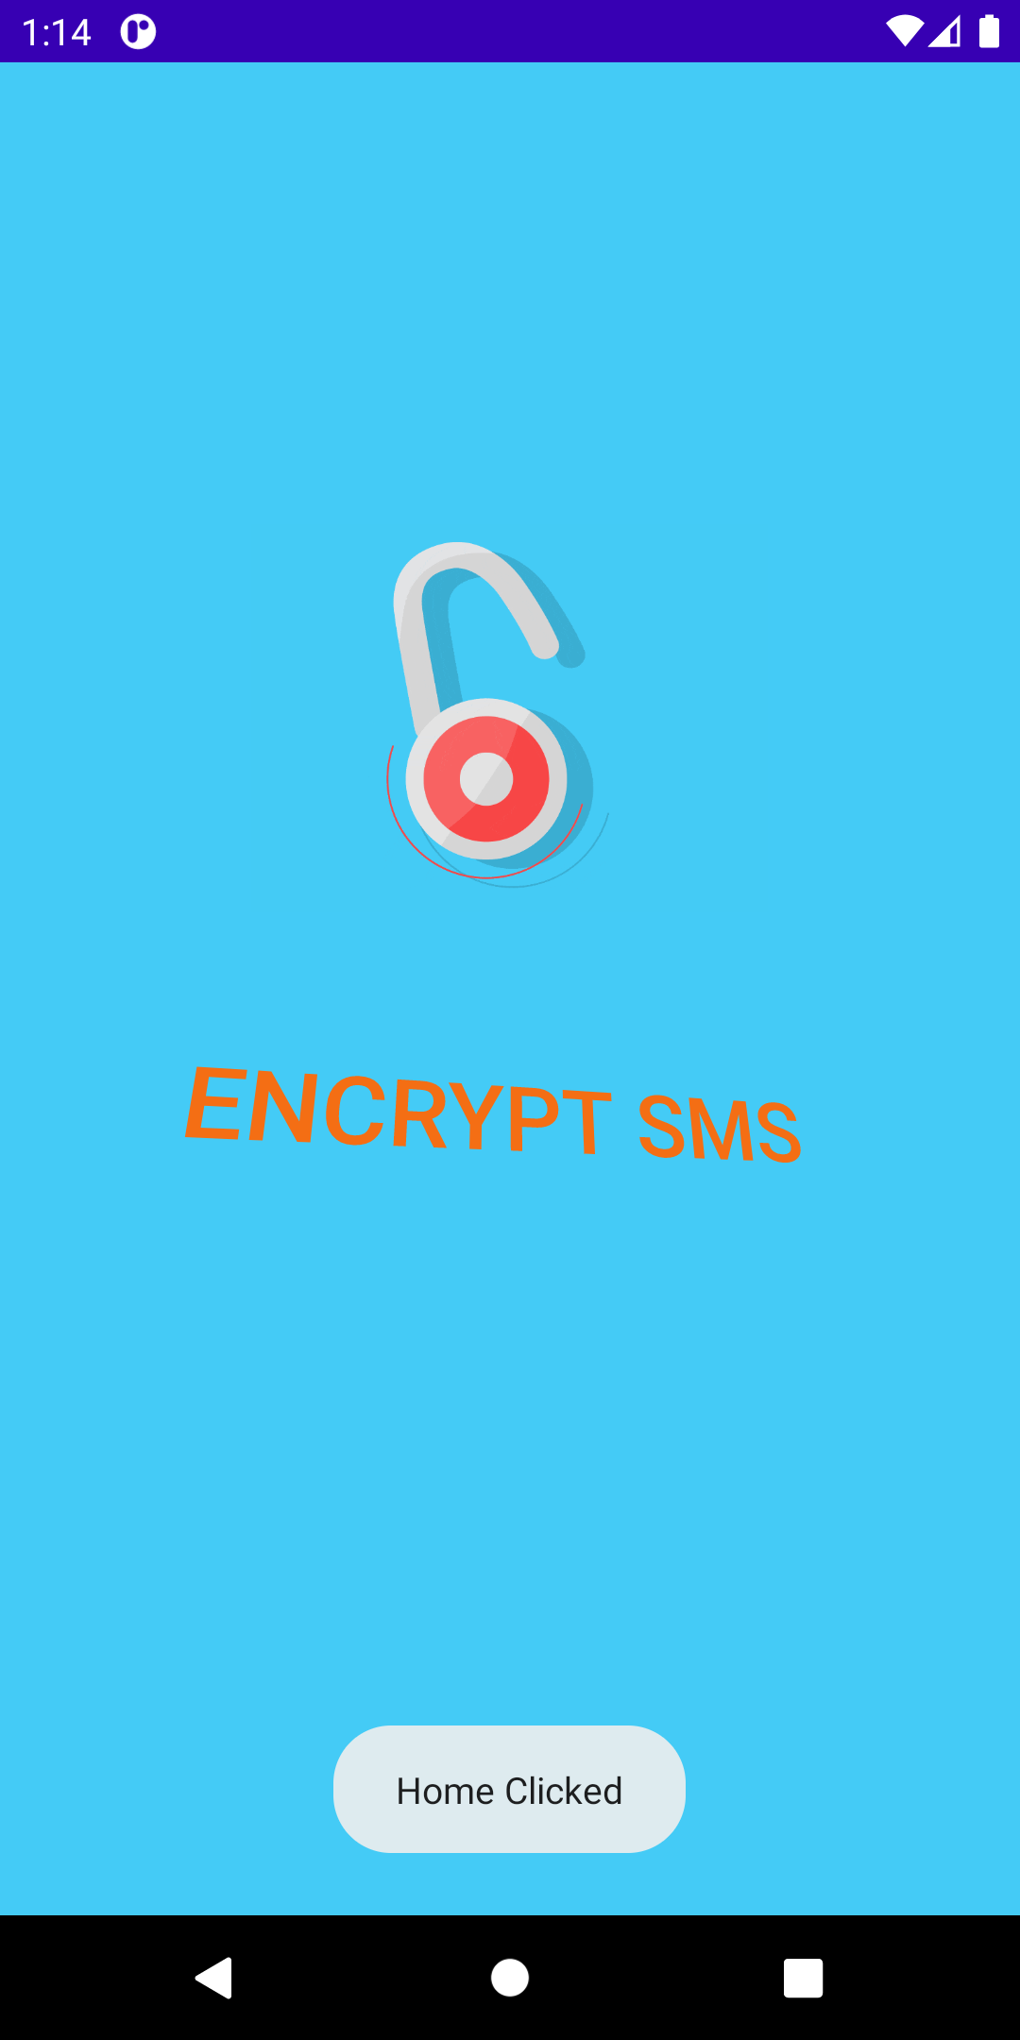

Week 5 Status

Documentation Progress
The addition of my project GitHub link, Testing Use Case which came late, and this weekly update are the changes to the document. My lack of real world experience I think shows in this document, but I believe it’s professionally structured and fits my keep it simple style.

Development Progress
The development progressed well for being sick most of the week. Wednesday through Saturday were completely lost as I spent most of it in bed. I’ve finished the views to a point that will get me progressing towards actually encrypting SMS. Android doesn’t provide great information surrounding SMS and how the system works. Android uses several classes called “providers” that store and manage data which can be used by many system and user applications. This is where native SMS data is stored. Since KitKat, the API became public, but the permissions to access and use the databases are a bit weird. An application can always read the databases with minimal permission, but can’t write to it without being the default application. Getting this default status is another crazy rabbit hole of mystery and pain. The weird part comes when the device receives a message. If there isn’t a default application for that intent, then the system will record the message with the SMS provider. If there is a default application, the intent is delivered to it, and the application has the soul responsibility to record the message with the providers in the correct format. Different apps format the data slightly different and some use their own SMS database with terrible consistency with the provider database. I haven’t identified any missed messages, but updating the seen, read, or sending status doesn’t happen with most.
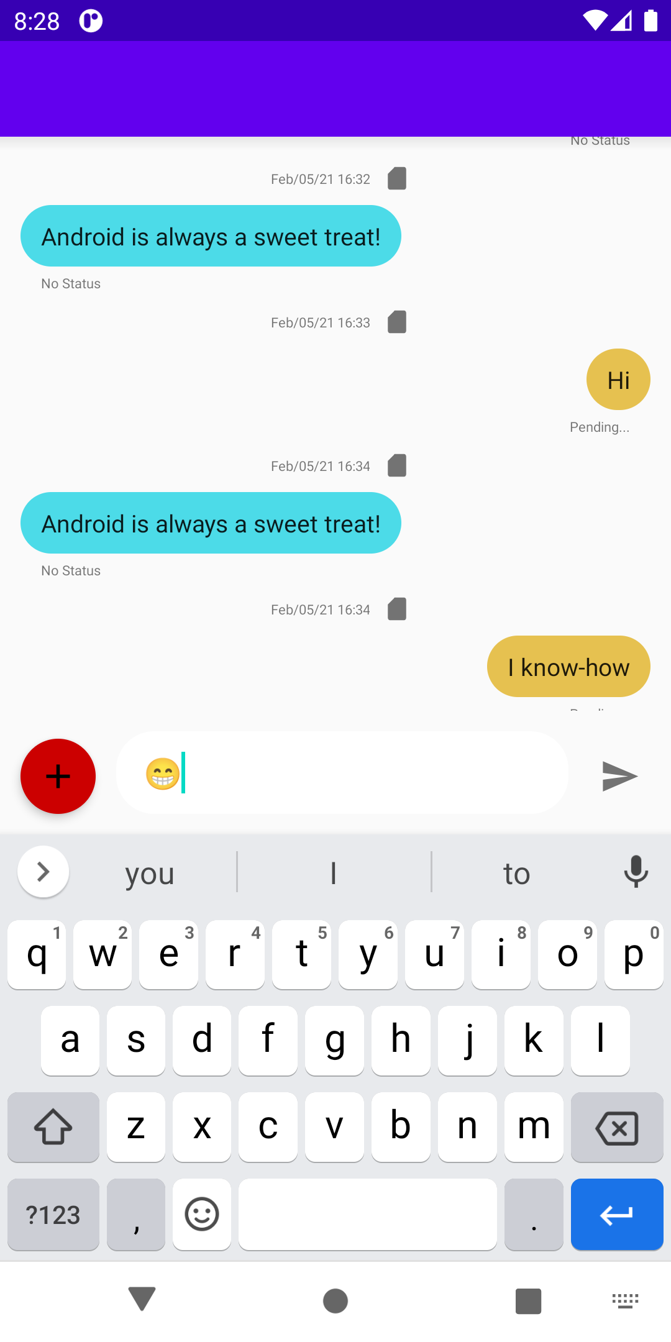
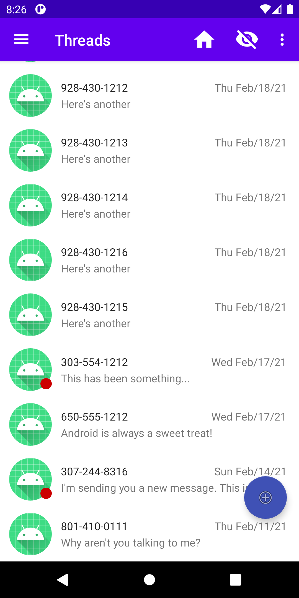

Week 5 Work Log
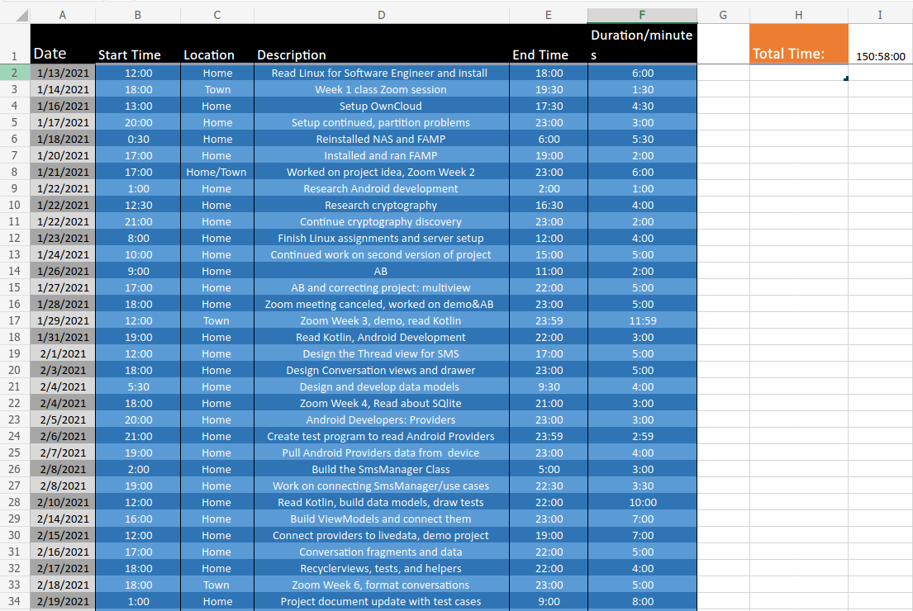

Week 6 Status

Documentation Progress
A week 5 late revision brought most the changes to the document this week. The
only other changes is this section discussing the work of the week. The document itself has been worked to help the internal format which should reduce the need to manually manipulate spacing and alignment issues.

Development Progress
The project is finally getting into the meat of what it’s intended to do. There wasn’t any good base applications to work from at the beginning of this project, so a completely new SMS application had to be made. It’s still missing many features, but has the desired functionality needed to develop encrypting a native SMS. This week will see an application that can send and receive SMS in both plain-text and encrypted format. This initial structure can only handle single text. Once the desired function is running, then a helper class can be injected to handle anything that is multiple messages in length. Every carrier supports a single message with 140 or less characters, this will be the cutoff.

Week 6 Work Log
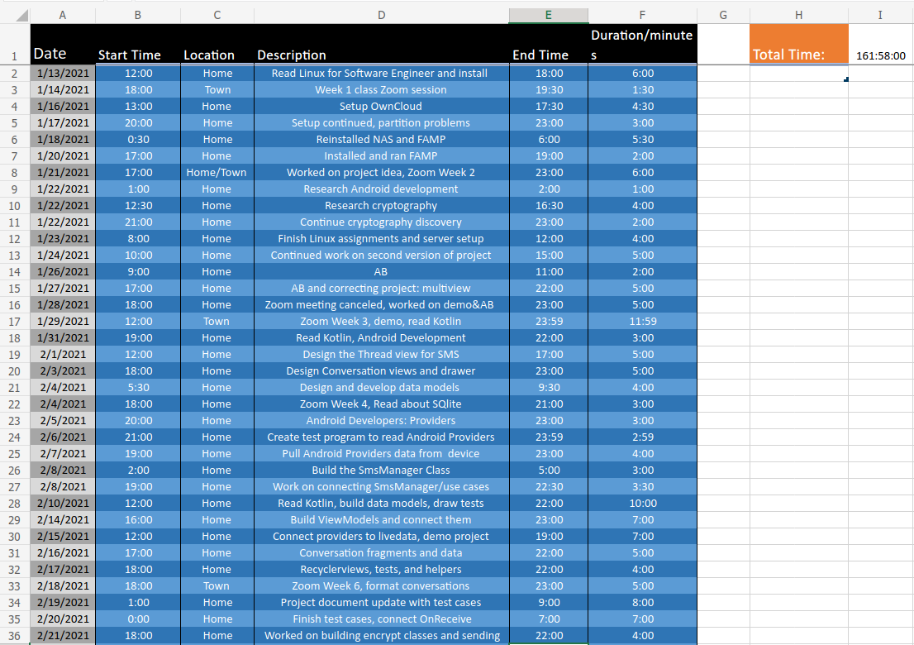

Week 7 Status

Week 8 Status

