Encrypt SMS
College of Computer & Information Sciences
Lucas Olson
Regis University
1/16/21
Version 1.11

Table of Contents
Revision History 5
Project GitHub Link: 5
Abstract 6
Application Description 7
Use Cases 8
Use Case Diagram 8
Fully Dressed Use Cases 9
Read/Send SMS. 9
Encrypt/Decrypt SMS. 9
Packaging. 10
Test Cases 11
Send SMS. 11
Read SMS. 11
Package SMS. 12
Encrypt SMS. 12
Design Goals 13
Architecture 13
Encryption Structure 14
1+1 Architecture 15
Logical View 15
Scenarios 16
Practicum II Plan 17
Common Good 17
Week 1 Status 19
Documentation Progress 19
Development Progress 19
Week 2 Status 19
Documentation Progress 19
Development Progress 19
Week 3 Status 19
Documentation Progress 19
Development Progress 19
Week 4 Status 19
Documentation Progress 20
Development Progress 20
Week 5 Status 22
Documentation Progress 22
Development Progress 22
Week 5 Work Log 23
Week 6 Status 23
Documentation Progress 23
Development Progress 23
Week 6 Work Log 24
Week 7 Status 24
Documentation Progress 24
Development Progress 24
Week 8 Status 25
Documentation Progress 25
Development Progress 25
Week 9 Status 26
Documentation Progress 26
Development Progress 26
Week 10 Status 26
Documentation Progress 26
Development Progress 27
Week 11 Status 27
Documentation Progress 27
Development Progress 27
MSSE 692 Annotated Bibliography 28

Revision History
Revision | Date | Summary
1.1 | 1/16/21 | Initial document created
1.2 | 1/21/21 | Formal document created with tables, diagrams and structured architecture.
1.3 | 1/29/21 | Name changed, revision history, and multi-view architecture
1.4 | 2/7/21 | Use cases started, week 4 details added with screenshots
1.5 | 2/14/21 | Week 5 details. Test cases added for this week 2/19/21 and Work Log
1.6 | 2/21/21 | Week 6 details with work log
1.7 | 2/28/21 | Week 7 details and work log
1.8 | 3/7/21 | Week 8 details & log, encrypted structure, and AB to the end
1.9 | 3/14/21 | Week 9 reflection, hours, and 8 week plan.
1.10 | 3/21/21 | Week 10 reflection, hours are now in field book
1.11 | 3/28/21 | Week 11 reflection

Project GitHub Link:

Everything in Development Branch
https://github.com/qleseid/EncryptSMS.git

Abstract
The secure short message service (SMS) application will primarily consist of a mobile application initially focused around the Android environment. The encompassing project will also include web software for application management purposes. The premise of the project is to provide a means to encrypt and manage SMS messages while using native SMS transmission protocols. This will allow users to send encrypted messages without depending upon a data connection. Also, users maintain the ability to revoke access to messages sent to recipients.

Application Description
The security of information has always been a top priority throughout human existence. In today's data driven world the need for security has only increased as the threats against data continue to grow. Application developers have been busy creating secure means for users to communicate which is evident by the countless chat applications available for download. These applications have a few inherent flaws: They depend upon a data connection, the user has minimal control over their data and its security, and the users are locked into a specific application design. Encrypt SMS overcomes these limitations by providing a service that will either add an additional capability to native applications or be contained in a standalone application that mirrors SMS application design best practices. This application will use standard mobile SMS protocols as the means to transmit the messages. The user retains ultimate control over their data through locally stored private keys. Only the public keys are shared with authorized recipients.
A website will be deployed for an ease of managing participating contacts with the application. There will be additional protocols developed to facilitate a users ability to use the service without the need for a data connection. Additionally, the application itself will connect to the websites database for seamless contact updates. By having three different contact management avenues, the application will have the ability to reach ever SMS user.

Use Cases
The following use cases will be in prioritized order. The first case will represent the highest priority followed by the next highest priority case and so on. The application will include use cases that deal with managing the application database, integrate into the native system, and authenticate a user profile but are excluded from this list.
- Read/Send SMS
- Encrypt/Decrypt SMS
- Packaging

Use Case Diagram
Figure 1. Use case diagram for Encrypt SMS

Fully Dressed Use Cases

Read/Send SMS.
Primary Actor: User

Assumptions:
User is authenticated and the application is open.
Stakeholders:
User: Needs a container to transport the SMS to/from the UI.
Pre-conditions:
The user has opened or successfully logged into application. User is presented with the main activity. The user can see a list of conversations contained within a RecyclerView. They are provided a drawer style navigation along with buttons to adjust settings and create new conversations.
Post-conditions (Success Guarantee):
A new SMS can be read/sent as if using a native application.
Flow of Events:
- User clicks a conversation from the list.
- A new fragment opens the conversation dialog view. Received SMS can be scrolled and read. An entry form allows for the creation of a new SMS at the bottom of this fragment.
- Upon clicking the SEND button, the application queries the database for encryption details associated with desired contact.
ALT FLOW 3a. No encryption data found.
  - Toast message prompts user to request information or send unsecured.
  - Application request data from contact, or cloud database.
ALT FLOW 3b. Navigate UP clicked.
  - Fragment state is saved and returns to the conversation list view in main activity.
- Successful transmission of SMS in desired format and user was able to read received messages.

Encrypt/Decrypt SMS.
Primary Actor: User

Assumptions:
User is authenticated and the application is open.
Stakeholders:
User: Needs a container to encrypt/decrypt the SMS to/from the UI.
Pre-conditions:
The user has opened or successfully logged into application. User has selected a conversation and is attempting to read/send an SMS. Database contains the required data for securely working with desired contact. User has initiated the sending of a message, or is reading current conversation.
Post-conditions (Success Guarantee):
A new SMS is properly encrypted for transmission, or decrypted for reading.
Flow of Events:
- User has sent an encrypted message.
ALT FLOW 1a. User is reading the conversation
  - If in plain-text, decryption has worked.
- SMS is moved to the security function.
- Recipient’s data is used to create a traffic key to encrypt SMS.
- SMS is moved to the packaging function for transmission.

Packaging.
Primary Actor: User

Assumptions:
User is authenticated, application is open, and an SMS is received by the packaging function.
Stakeholders:
User: Needs SMS to be properly structured to ensure proper interaction with SMS native transmission protocols.
Pre-conditions:
The packaging function has received an SMS payload.
Post-conditions (Success Guarantee):
A properly structured SMS is created and returned.
Flow of Events:
- SMS is received by function.
- Encrypted SMS are delivered to the security function.
ALT FLOW 2a. Encrypted messages for sending arrive from security function.
- Encrypted data is sent to Android API for transmission.
- Decrypted SMS are received back from security function.
- SMS is sent to the UI.

Test Cases

Send SMS.
Test Case #: 1 | Test Case Name: Send SMS | Page: 1 of 1
System: Encrypt SMS | Subsystem: SMS, Phone, Providers
Short Description: Test sending an SMS

Pre-conditions:
The user has the application up and running

Steps | Action | Expected Response | Pass/Fail | Comments
1 | Select a conversation or new button | Conversation view loads
2 | Enter valid phone number | Number is displayed in correct format
3 | Tap message input box | Keyboard is displayed
4 | Enter the message in text box | Keyboard functions and message is displayed
5 | Tap the send button | Message is added to conversation list and status is updated

Read SMS.
Test Case #: 2 | Test Case Name: Read SMS | Page: 1 of 1
System: Encrypt SMS | Subsystem: SMS, Phone, Providers
Short Description: Test reading an SMS

Pre-conditions:
The user has the application up and running

Steps | Action | Expected Response | Pass/Fail | Comments
1 | Select a conversation | Prompt for PIN code
2 | Enter valid PIN | Conversation view loaded with plain-text
3 | ALT: Invalid PIN entry | Conversation view loads with encrypted text

Package SMS.
Test Case #: 3 | Test Case Name: Package SMS | Page: 1 of 1
System: Encrypt SMS | Subsystem: SMS, Phone, Providers, Cryptography
Short Description: Test packaging an SMS in correct sizes after encryption

Pre-conditions:
The user has correctly sent an SMS

Steps | Action | Expected Response | Pass/Fail | Comments
1 | Deliver message to package class | Message format is verified and cleaned
2 | Message size is calculated | New message delivered with correct parts
3 | Each part is encrypted | Encrypted data returned within size limit
4 | Message parts are labeled | Correct parts order returned
5 | SMS package sent for transmission | Delivery intent received with no errors

Encrypt SMS.
Test Case #: 4 | Test Case Name: Encrypt SMS | Page: 1 of 1
System: Encrypt SMS | Subsystem: SMS, Phone, Providers, Cryptography
Short Description: Test the encryption process of an SMS for transmission

Pre-conditions:
The user has correctly sent an SMS and packaging is processing the message

Steps | Action | Expected Response | Pass/Fail | Comments
1 | Deliver message to encryption class | Message format is verified and cleaned
2 | Traffic key is read from database | Key is for correct contact and valid
3 | Encrypted message with key | Encrypted data is returned
4 | Verify encrypted data | Data is correctly encrypted
5 | Deliver message to packaging | Packaging receives message

Design Goals

- Implement a private/public encryption key protocol.
- Create either an Android API for use in an SMS app or a standalone app.
- Build a database to house the public keys.
- Build a web-server to communicate with the database and interface with users.
- Isolate and abstract the encrypt/decrypt process to facilitate seamless security updates.
- Mimic TLS packet protocol for a means of transmitting data.

Architecture
The application architecture itself will follow a 3-Tier/MVVC design. The first tier will be the front-end, or presentation layer for user interactions and management. The second tier will contain the service/business layer where user actions are processed and executed in the business logic. Finally, the last tier will contain the data and its underlying support structure.
The web application will follow a similar N-Tier structure with a front-end website that interacts with a server application at the second level. The server then interacts with the database tier to serve the user with appropriate information. The sever will deploy multiple services to accomplish the redundant user interfaces previously discussed. The web software will only be a secondary means of managing the keys used within the mobile application.

Encryption Structure
The structure of encrypting SMS and starts with the Encryption class. This object houses a function to generate a DiffieHellman private/public key pair. The public key is shared with the desired recipients that want to implement encrypted SMS communication. Once each party has the other’s public key, a key agreement can be generated. This agreement process produces a symmetric traffic key to be used with a AES cipher. This symmetrical cipher is used to encrypt and decrypt all communication between the two parties. Because only public keys are initially shared, the possibility to compromise the traffic key is nearly zero do to the extreme time-frame required to brute-force such a key.
As the application matures, the traffic key will be refreshed periodically depending on the user’s desire. A type of forward secrecy could be implemented for every single message if so desired. Initial thoughts are to do a daily refresh, however, a one time process is exponentially better than the statues quo. Within the class itself, traffic keys will be stored in Androids KeyStore class. This area of the operating system adds another level of security by not allowing the key outside of its class. Many devices are equipped with security hardware that works seamlessly with the KeyStore class for even more security. All this security means someone could compromise the device, but the best they could do is use the KeyStore methods to interact with the system without gaining any knowledge of what the keys are.

1+1 Architecture
The application itself is fairly small and straightforward. Because of the simple nature, the process, physical, and development views have been omitted. The logical view and scenarios are more than adequate to provide the overall structure and function of this application.

Logical View
The initial product under development will be an Android SMS application. This application will use the native SMS transmission protocol and implement an offline encryption service to allow users to send and receive secure messages. The class diagram in Figure 2. will provide the basic logical functionality of the application.
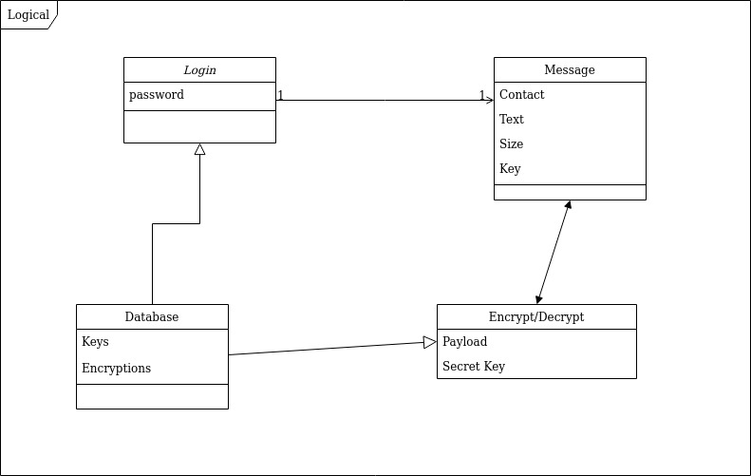Figure 2. Class diagram for logical view.

Scenarios
The following images show the basic look and feel as use cases are enacted by the user. Actual application images were chosen over object scenario diagrams for the added detail that can be afforded.
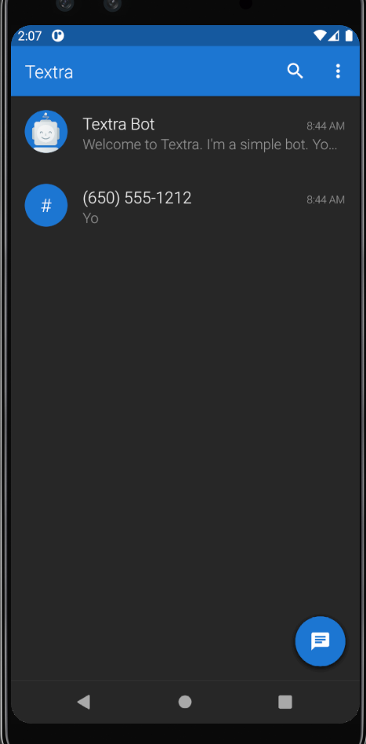
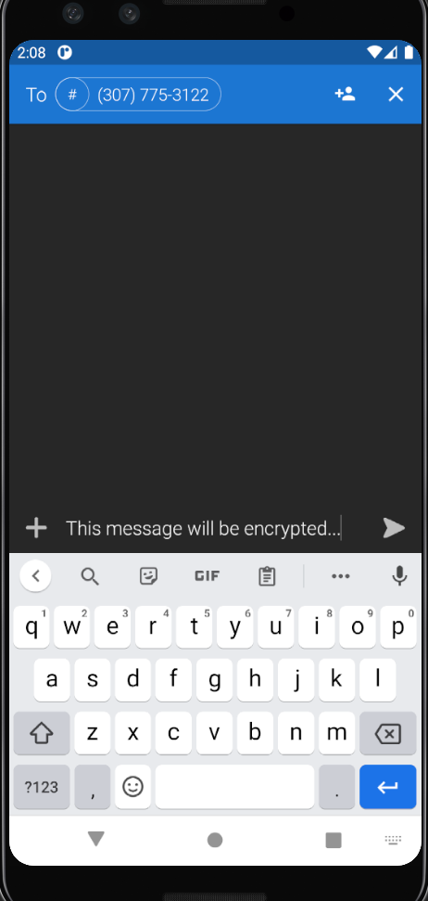

Practicum II Plan
The following plan will be the best estimation of what progress the application will make in the next 8 week.
Week | Summary
1 | - Unit and integration testing  - Encryption storage classes  - Documentation updates
2 | - Encryption key sharing and processing classes  - Input data sterilizing and validation checks  - Jenkins continues testing server
3 | - Finish encryption key sharing and processing classes  - Build a settings activity  - Update Jenkins continues testing server
4 | - Finish the settings activity  - Implement application style customization
5 | - Start solving MMS message handling  - Implement popup notifications  - Implement lock-screen notifications  - Implement Quick-reply
6 | - Continue solving week 5 tasks
7 | - Activate Google Play Store developer account  - Invite people to Beta test the application
8 | - Create public key server  - Fix any reported application bugs

Common Good
The explosion of mobile technology has created more connections to the world in ways unimaginable only a few years ago. Mobile technology systems have placed tremendously powerful devices in the reach of almost everyone around the globe. This was accomplish by abstracting away the complicated systems involved and making them easy to use. The average user needs minimal application knowledge to accomplish their tasks and are often oblivious to the threats surrounding the data they produce and share. Often times there is a tiny minority of people that understands the implications and importance of data security; they bare the burden of creating a change for the common good.
Even though millions of secure applications are used to communicate every day, a large part of textual communication still happens through native SMS routes. The importance of finding a way to secure this avenue hopefully speaks for itself. Additionally, the ability to manage and revoke those secure communications provides another level of security within our culture. Take a moment to reflect, how often do we see text messages displayed completely out of context and the inevitable character damage it causes? The context becomes additional clouded when the time-frame is examined. How many people can truthfully say they are the same person from a decade ago. And should a few short conversations define who we are for the rest of our lives?

Week 1 Status

Documentation Progress
Started the Field-book again in OneNote. Much of this week I’ve already setup on my home system, so this will be a nice review

Development Progress
The project, and what projects we can do is still a mystery. The syllabus doesn’t provide the greatest clarity of what’s to come in the next 4 months. I hope to find out more from the discussion forum.

Week 2 Status

Documentation Progress
Built a brief proposal that wasn’t even close to adequate. This document is the official replacement for it and will be the running document for this project. Still hashing out the project and use cases. I’ve settled on a FAMP stack for the web side of my project and MySQL will mix nicely with SqLite and Android.

Development Progress
No hard development beyond installing server software and building this document.

Week 3 Status

Documentation Progress
Application’s name changed from Secure SMS to Encrypt SMS because previous research had already used that name. This document was graded last week and found to be missing the Multi-view architecture which has been added. It also received a revision history table with brief descriptions because this part of the document will serve great change depth. My presentation idea of serial communication and UART type interfacing was approved during the Zoom call on Friday. I’m not sure how long it will need to be, but I hope to do a live demo with a router.

Development Progress
This week was full of reading sources to build the AB. I’m starting to eliminate encryption protocols that won’t be useful in this project. ECC is looking to be the best choice so far. The application was created late this week in Android Studios. It’s only an empty shell at the moment and will continue to fill it in with functionality as I go.

Week 4 Status

Documentation Progress
The document continues to expand with some good info. There is constant refinement as well to make a more professional document that holds the focus on the application instead of the documentation.

Development Progress
Still working on creating the UI of the application. The pieces are almost there and then connecting the back-end will come shortly after. It looks like I need to learn some sort of Injector function for my application whether it’s Dagger or Hilt. This will add another steep learning curve to the matter but I look forward to the challenge. The UI is coming as seen below, but without data, it isn’t very exciting yet.

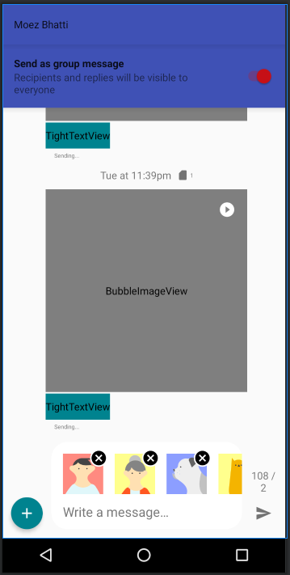
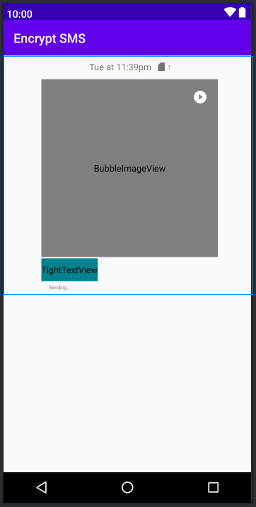

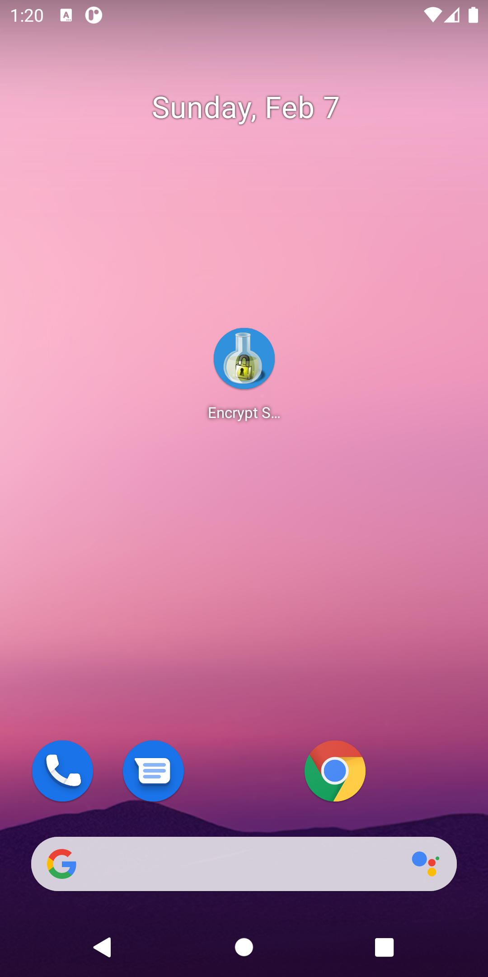
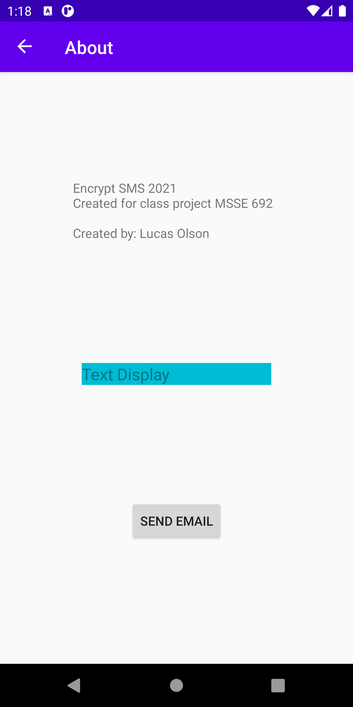
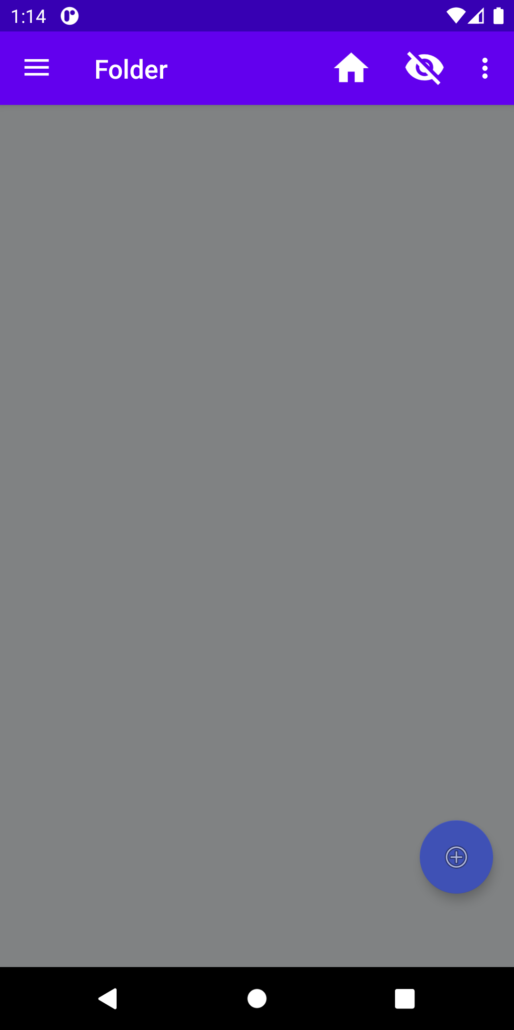
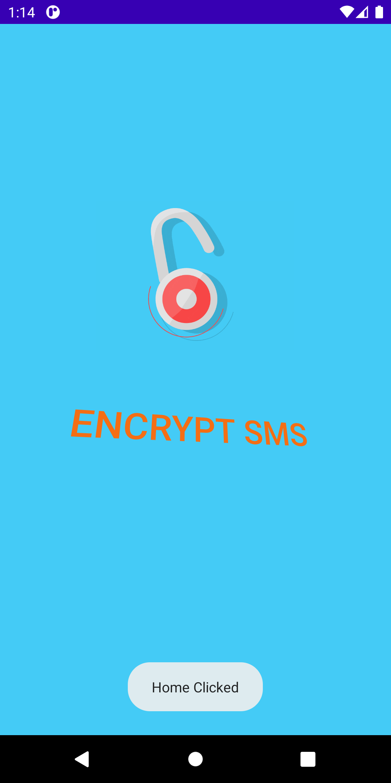

Week 5 Status

Documentation Progress
The addition of my project GitHub link, Testing Use Case which came late, and this weekly update are the changes to the document. My lack of real world experience I think shows in this document, but I believe it’s professionally structured and fits my keep it simple style.

Development Progress
The development progressed well for being sick most of the week. Wednesday through Saturday were completely lost as I spent most of it in bed. I’ve finished the views to a point that will get me progressing towards actually encrypting SMS. Android doesn’t provide great information surrounding SMS and how the system works. Android uses several classes called “providers” that store and manage data which can be used by many system and user applications. This is where native SMS data is stored. Since KitKat, the API became public, but the permissions to access and use the databases are a bit weird. An application can always read the databases with minimal permission, but can’t write to it without being the default application. Getting this default status is another crazy rabbit hole of mystery and pain. The weird part comes when the device receives a message. If there isn’t a default application for that intent, then the system will record the message with the SMS provider. If there is a default application, the intent is delivered to it, and the application has the soul responsibility to record the message with the providers in the correct format. Different apps format the data slightly different and some use their own SMS database with terrible consistency with the provider database. I haven’t identified any missed messages, but updating the seen, read, or sending status doesn’t happen with most.
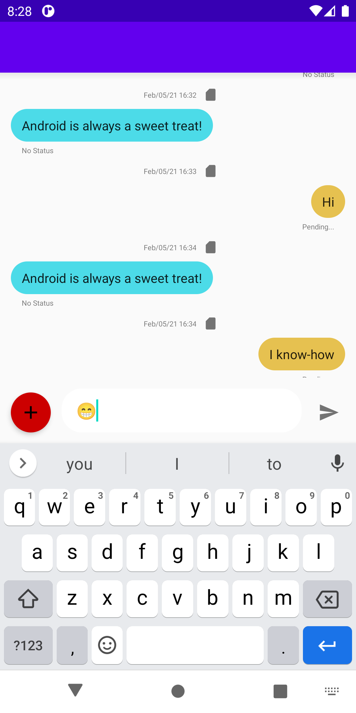
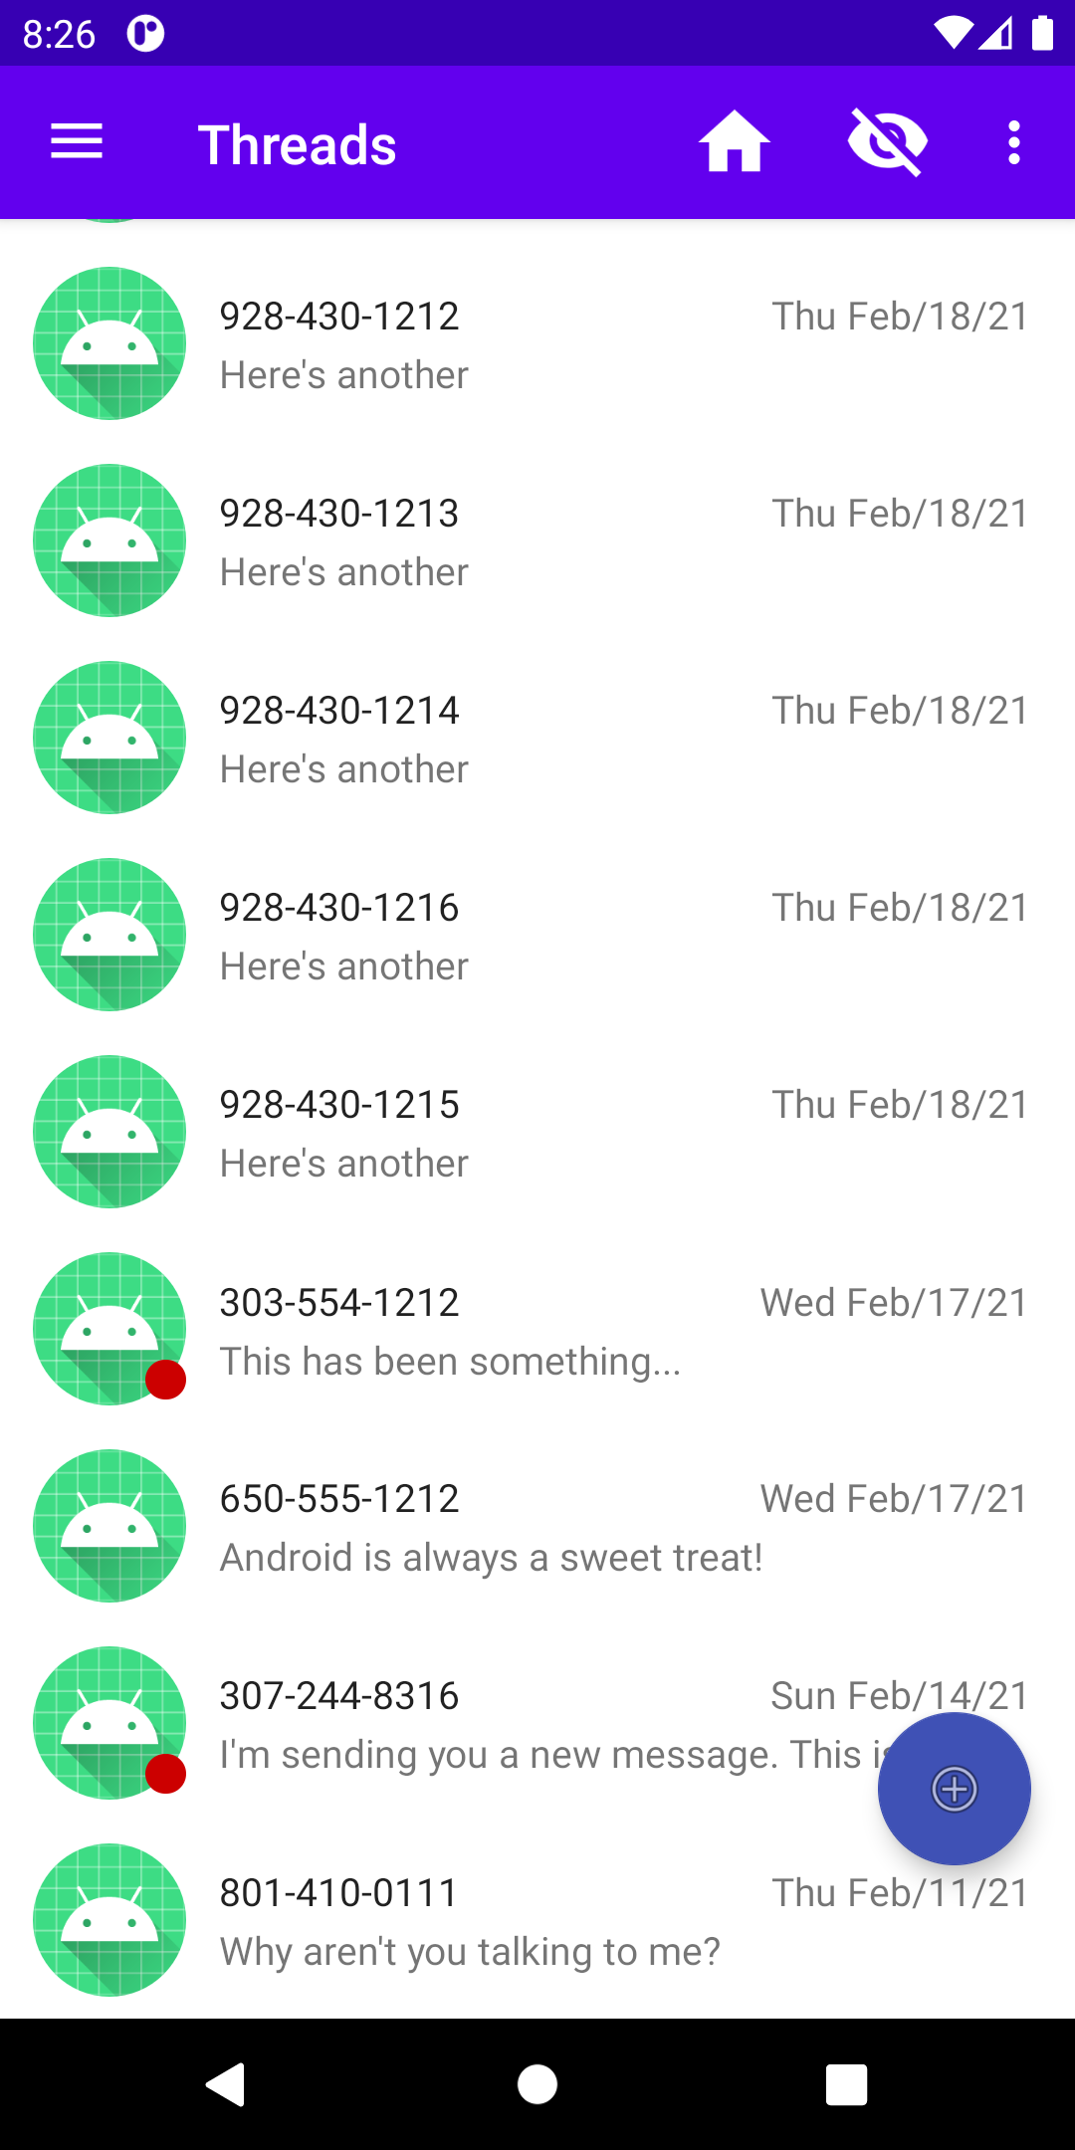

Week 5 Work Log
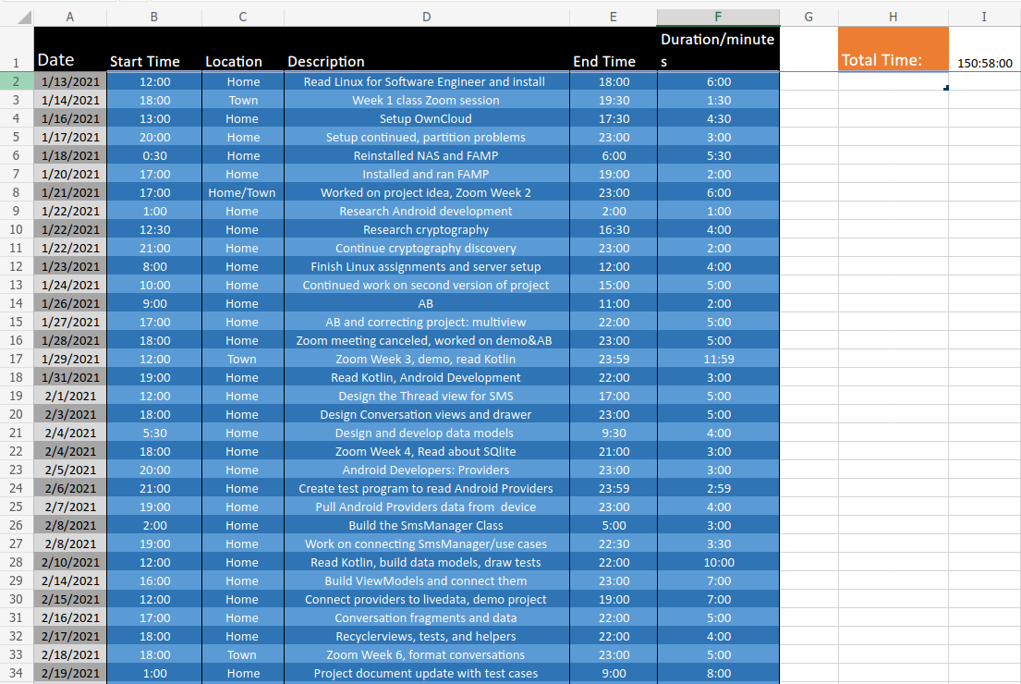

Week 6 Status

Documentation Progress
A week 5 late revision brought most the changes to the document this week. The
only other changes is this section discussing the work of the week. The document itself has been worked to help the internal format which should reduce the need to manually manipulate spacing and alignment issues.

Development Progress
The project is finally getting into the meat of what it’s intended to do. There wasn’t any good base applications to work from at the beginning of this project, so a completely new SMS application had to be made. It’s still missing many features, but has the desired functionality needed to develop encrypting a native SMS. This week will see an application that can send and receive SMS in both plain-text and encrypted format. This initial structure can only handle single text. Once the desired function is running, then a helper class can be injected to handle anything that is multiple messages in length. Every carrier supports a single message with 140 or less characters, this will be the cutoff.

Week 6 Work Log
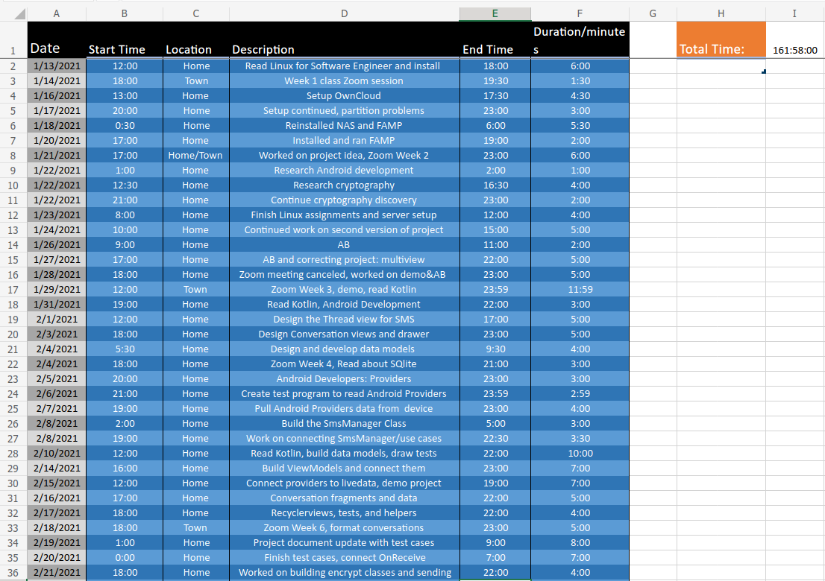

Week 7 Status

Documentation Progress
This week this part of the document has been updated and added Week 8 will see an additional section describing the encryption process of the application. It could have been started this week, but the complete implementation isn’t ready. Omitting it for one more week will keep the document in a cleaner format as its size has grown fairly large.

Development Progress
The goal last week was to get the application in a state where it could send plain-text and encrypted messages. The encryption part was missed last week and this week too. The pieces are ready, but building the supporting features and structure has consumed more time than expected. This week did complete the structures to allow the application to receive text as default along with functional interaction with the Android Providers. The original project was aiming to target Android 17 and up, this was changed to 19 and up.
The significance of the change reduces the application coverage by only 2% and eliminates the complications that are associated with anything below Android 19. Android 19 is the Kit Kat version that saw a significance structure change at the base level. The main focus was application permissions along with standardizing some hidden APIs. The change creates better cohesion, but it isn’t without some cost. Applications must be the default provider before they can have write access to the providers. Android also puts the soul responsibility on the application to handle write functions. If the application isn’t default, then the OS handles the writes. It would be ideal if the default application could override this basic write process to add some customization, but also allow the system to handle it; the stock functions is what’s needed most of the time.
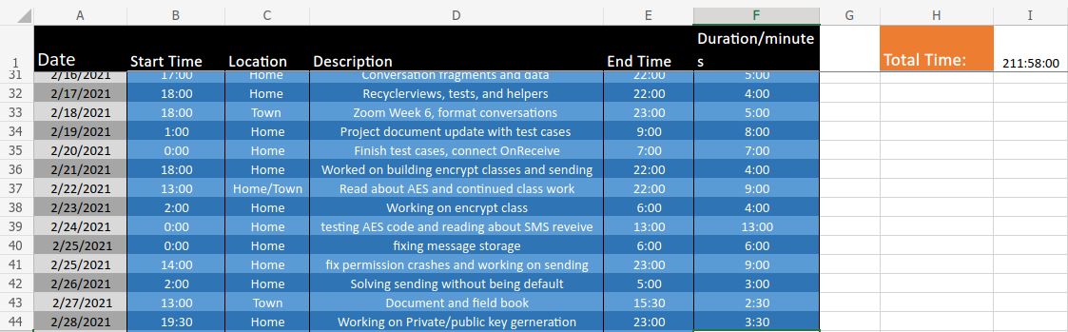

Week 8 Status

Documentation Progress
The document this week rounds out the last 8 weeks of progress by adding details about the encryption process of the application. The addition of this information came late because the overall implementation idea was settled upon early, but actual implementation took time. The Android system offers many cryptographic options but all of them are plagued by trade offs. Most of the issues surrounded getting the right methods to work for the majority of software versions currently in use.

Development Progress
The application is sending and receiving encrypted SMS messages. The encryption process is temporally hard-coded into the application as the functionality is expanded. The encryption process can be toggled on and off to show it’s actually working. Additionally, the underlying processes that interact with the operating system were further refined to create a surprisingly useful application. A majority of time this week was spent reading about unit testing and trying to get some of that running on the system. Unfortunately, unit tests within the Android SDK aren’t normally that useful or worth the time. Most parts of an application are dependent upon an Android library which isn’t supplied by the purely Java testing environment. This means the dependencies must be mocked to get them to run. Mocked tests basically allow you to see method calls, but you inject highly structured data that nearly ensures an already determined outcome. Androids strong point is UI testing with Espresso.
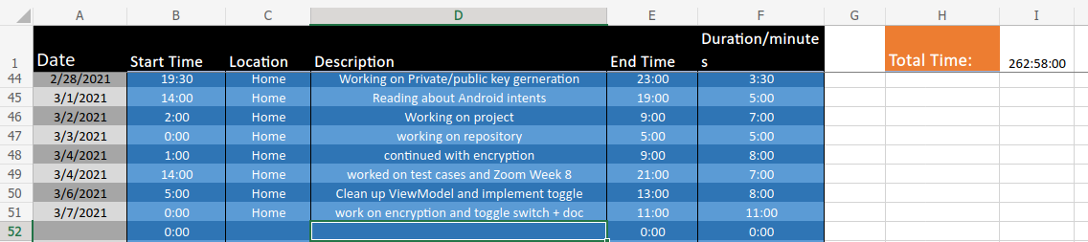

Week 9 Status

Documentation Progress
The document this week is the beginning of MSSE 692 Practicum II. This log is updated with a screenshot of the hours put in this week. A plan for the next 8 weeks has also been added. This plan will remain fluid throughout, but is a close estimation of the desired progress that will be made.

Development Progress
The application is sending and receiving encrypted SMS messages and can now send normal text with a simple slide of a switch. The full implementation of the encryption class is almost finished. Once done, the hard-coded encryption for testing will be replaced. This entire week was mainly focused on catching up unit testing of the application. There are only a few more methods to mock out and write tests for. Classes that need to be mocked for testing can still have real-world issues even if they test perfectly. This is caused by not being able to test the actual Android system through these tests.



Week 10 Status

Documentation Progress
The document saw more work last week than this week with only the AB and this status being updated. The action plan was a good addition, but it does remind me how over ambitious I can be from time to time.

Development Progress
Development of the project continued at a good pace this week. The overall function of the application has improved significantly. It still isn’t ready for Alpha testing, but this next week should be the ticket. There were a few days wasted trying to understand why the key generator was producing identical keys. After three solid days, there wasn’t even a problem beyond the lack of using the encoding method correctly. This is the one time so far that testing was helpful and an issue. On the positive side, my understanding of asynchronous encryption has greatly improved.

Week 11 Status

Documentation Progress
The document saw more work two weeks ago than this week with only the status being updated. The action plan was a good addition, but it does remind me how over ambitious I can be from time to time.

Development Progress
The applications itself moved forward very little this week for two reasons. The first is because most of the week was spent learning and using the Jenkins continuous integration tool with Android applications. I don’t think this is a common tool to use with Android specifically even though Jenkins is used in many Java applications. The second reason is because the initial structure to manage the security keys didn’t work all that great. I’ve designed a new one and have tested it outside of the app with success. This week will see it being implemented and move the application over to using it instead of the static encryption currently in place.
Jenkins itself is a pretty neat tool. I think it was a good choice for CI tools and will serve this application well. It is a bit slow on my server, but it runs autonomously, so no real impact is seen. There is a way to emulate an Android OS in Jenkins, but I might back-burner that for now. The main focus will be to connect Jenkins to my Google Play Store account and Alpha test the application.

MSSE 692 Annotated Bibliography
College of Computer & Information Sciences
Lucas Olson
Regis University
1/25/21

Abstract
This document contains the evaluations of articles, papers and readings from MSSE 692. Each entry contains a summary, assessment and critique of the article. The authors credibility is also evaluated in the assessment of the document.
Keywords: SMS, cryptography, encryption, decryption, SSL, DH, ECC, private/public key, symmetric encryption

Abd Elminaam, D. S., Abdual-Kader, H. M., & Hadhoud, M. M. (2010). Evaluating the performance of symmetric encryption algorithms. International Journal of Network Security, 10(3), 216-222.
The evaluation of symmetric encryption paper discusses the results from their performance tests using various symmetric keys. The paper is looking to identify popular protocols and the effects they will have when used in a mobile environment. This is important because mobile devices are limited by their hardware and battery capacity. Only symmetric protocols are evaluated because asymmetric protocols are computationally intensive and inefficient.
AES, DES, 3DES, RC6, RC2, and Blowfish are the protocols tested within this paper. A substantial amount of data presented was collected from related work previously done with symmetrical protocols. The author’s recreated past work to benchmark their research while adding additional tests of their own. The paper focuses on Base 16/64 differences along with changing data types. It was found that Blowfish provided superior performance in all aspects over other protocols.
Albuja, J. P., & Carrera, E. V. (2009). Trusted SMS communication on mobile devices. 11th Brazilian Workshop on Real-Time and Embedded Systems (pp. 165-170). Pernambuco, Brazil.
This journal entry is somewhat dated but serves as a useful document for understanding the the limitations surrounding mobile devices while performing SMS tasks. The authors identify a need for secure texting and a lack of a standardized framework for developers to use. They propose a framework that allows many variables to meet the demands of different mobile devices. In today’s ecosystem of mobile devices, the Nokia 3500s used in this experiment could be seen as ancient.
This paper takes an interesting approach to building a useful framework for secure messaging. It allows for messages to be digitally signed with hashes and encrypted with a private/public key pair. A Java-based library was produced and tested which included the Bouncy Castle encryption mechanism. The paper concludes that secure SMS can be achieved reasonably with devices that have serious constrains.
Aswatha, A. R., Sasi, S., Santhosh, B., Mehta, D., & Babuprasad, S. (2020). Design and Implementation of Unreliable CFDP Protocol over Elliptic Curve Cryptography. In Smart Intelligent Computing and Applications (pp. 627-638). Singapore: Springer.
Changes in technology with relation to spacecraft have prompted the authors to look at how file transfers are handled and the security implications. The increase in memory size has allowed spacecraft to implement file systems within components that weren’t previously possible. Files are now transferred over space channels with current protocols providing zero security measures.
The paper implements secure file transfer protocols using Elliptic Curve Cryptography (ECC) to produce the required encryption keys. ECC is a strong alternative for public key generation when compared with RSA-based methods. ECC yields correspondingly strong keys that are much smaller than RSAs. A 3072 bit RSA key is comparable to a 256 bit ECC. This type of key production and size is useful with SMS security measures because of the limitation surrounding SMS.
Bojjagani, S., & Sastry, V. N. (2017). A secure end-to-end SMS based mobile banking protocol. International journal of communication systems, 30(15), e3302.
This paper introduces a new mobile banking protocol that is based around SMS. They reference several related works in this are along with the many shortcomings that are associated. The paper contributes a new framework with a formal verification process based on ECC. The new framework is superior to past work because it’s free from all common digital attacks.
With relation to my SMS project, this research is a great source of information on ECC and the many possible attacks associated with SMS. It also provides a modern data set that is closely matched to current mobile device capabilities. The proposed framework is also a great reference to how secure SMS might progress in the near future. This is important because my project could easily find itself working linearly with mobile banking operations.
Bos, J. W., Halderman, J. A., Heninger, N., Moore, J., Naehrig, M., & Wustrow, E. (2014). Elliptic curve cryptography in practice. In International Conference on Financial Cryptography and Data Security (pp. 157-175). Berlin, Heidelberg: Springer.
This paper is review of ECC usage in publicly deployed environments to find unique mistakes and vulnerabilities. Four different areas were looked at: Bitcoin, SSH, TLS, and an Austrian e-ID card system. They found that ECC still isn’t the standard protocol even though it produces sufficient security with small key sizes. Also discovered were significant numbers of weak keys caused by VM duplication and low-entropy key generation. Poor randomness caused several cases of vulnerabilities with some being linked to an Android Java bug.
This research will provide excellent information for my SMS application surrounding ways to properly deploy security measures that involve ECC. My application will involve the Android system, so understanding the previous bugs and ensuring they aren’t reproduced will be vital to my project’s success. Finally, the paper offers a detailed review of the ECC algorithm which can be used to ensure public libraries are accurate.
Braga, A., Neto, R. Z., Vannucci, A., & Hiramatsu, R. (2015). Implementation issues in the construction of an application framework for secure SMS messages on android smartphones. In The Ninth International Conference on Emerging Security Information, Systems and Technologies, SECURWARE.
In this paper, an application framework is constructed around the Android OS to implement a secure SMS service. The framework relies on the use of a specific application to read and send secure messages along with a server to manage user keys. This paper provides a way to structure a secure message and still maintain the small data structure of 140 bytes that SMS are restricted to.
This paper implements the use of short digital signatures which is something I haven’t heard about until now. These signatures are key to maintaining a secure message along with keeping its size small. Investigating and understanding SDSs will be beneficial to my project. Also, this paper provides a substantial list of related work that also provides useful information for me to have a chance at meeting my goals with this project.
Bugbee, L. (2013). U.S. Patent No. 8,503,679. Washington, DC: U.S. Patent and Trademark Office.
The patented process in this document describes a way to use contemporary encryption processes in low bandwidth applications where short message lengths are desirable. The inventor has discovered a process to efficiently use public keys to generate a shared secret that is used to make a traffic key that encrypts the information. All this is done with minimal overhead to the total message size.
This invention is one of the better sources found detailing the process of effectively encrypting a small message and keeping its size small. One of the main goals for my project is to minimize and mitigate the impact to SMS functionality while providing a useful SMS encryption service that isn’t reliant upon a secondary data connection. I also need to be respectful to protected ideas and processes which I believe this patent details.
Hankerson, D., Menezes, A. J., & Vanstone, S. (2006). Guide to elliptic curve cryptography. New York, NY: Springer Science & Business Media.
The following source is an entire book on elliptic curve cryptography. This goes through the entire history, basic arithmetic operations, common protocols, and implementation issues. There is also a great list of software tools along with a few examples.
The use of ECC in my project is turning from hypothetical to becoming a reality. This means having a deep understanding of ECC will be vital. The Android environment comes with many libraries to include ECC encryption, this source will be used to ensure the cryptography has been carried out properly without introducing any of the known issues. The book also provides basic details about other cryptographic algorithms and will be a great source to use to ensure the right tools are being used and there aren’t any missed steps.
Imming, P. C., & van der Raadt, K. (2013). U.S. Patent No. 8,571,218. Washington, DC: U.S. Patent and Trademark Office.
As sources go, a patented idea has some interesting qualities not found in normal research papers. This patent defines the idea of using cryptography to process SMS messages. It relies upon the use of cryptographic pads generated and stored inside the users device. The message indexes a randomly selected pad for message decryption. This system is reliant upon a data connection and outside services beyond the mobile device itself.
The SMS security protocol described in this patent is an interesting approach that hasn’t seen any identifiable uses. The system itself is based upon sound practices but probably finds its limits by using a small set of cryptographic pads to manage secure messages. This could easily be compromised within the mobile environment and wouldn’t serve much use in my project. The referenced list of similar patents does however look to be informative towards my efforts.
Kapoor, V., Abraham, V. S., & Singh, R. (2008). Elliptic curve cryptography. Ubiquity, 2008(May), 1-8.
The authors of this paper are looking at cryptography algorithms and their use in smart-cards. RSA is a popular algorithm that finds usage all over the world. This paper looks at RSA with regard to its size and efficiency. They show how it functions and identify its pluses and minuses. ECC is then contrasted to show how it’s a better cryptography option for constrained environments such as smart-cards.
ECC will inevitably find a place within my project. This paper provides information regarding the few known attacks against ECC. The attacks themselves aren’t based on ECC directly, but upon similar logarithm problems. The beauty here is the fact that avoidance measures have already been designed and can be easily used to avoid these issues.
Lo, J. L. C., Bishop, J., & Eloff, J. H. (2008). SMSSec: An end-to-end protocol for secure SMS. Computers & Security, 27(5-6), 154-167.
SMSSec is a proposed protocol for end-to-end encryption of SMS messages. The second section of this proposal discusses the structure and function of the SMS network. It identifies and addresses the capabilities along with the networks limitations in general. This is important because it’s directly connected to the issues an end-to-end encryption application will face while using this network.
As it applies to my project, this proposal provides only secondary information. What I mean is the network details and issues faced with the infrastructure of SMS itself will be of any use. The actual application itself uses some outdated protocols and compromises its security because of patent infringement issues that weren’t explained. There is some value in the systematic approach they used to develop their protocol that would be foolish to disregard.
Macharla, P. (2017). Android continuous integration: Build-deploy-test automation for Android mobile apps. New York, NY: Springer: Apress.
This book is a great source for CI of Android applications. There is some great testing examples that will be useful for any developer. It does a great job going through the structures needed for testing and integration. Another great and useful part of this book is in the class and object section. The book focuses mostly on Java instead of Kotlin.
A must have for testing and CI work. One of the better sources for developing unit and integration tests. Also a fantastic place to get started with automating many processes involved with developing Android applications. In Java, not Kotlin.
Malla, A., Sahu, P., & Mishra, M. (2018). A novel encryption scheme for secure SMS communication. In Advances in Electronics, Communication and Computing (pp. 467-478). Singapore: Springer.
This paper is an interesting addition to the SMS security world. The novel approach it uses to secure messages is a substitution cipher known as Playfair. The original cipher was developed in 1854 and later popularized by Lord Playfair with a 5 x 5 matrix. This paper looks to use a 9 x 10 matrix that has been modified with several shift and round functions.
The substitution cipher is an interesting approach to securing a message without increasing its overall size. The paper doesn’t do a great job explaining how each party involved would produce the same cipher. The idea of creating a secure message without increasing its size could have beneficial implications with my project, but creating a usable application might prove problematic.
Markovski, S., Kuzmanovska, A., & Simeonovski, M. (2011). A protocol for secure SMS communication for Android OS. In International Conference on ICT Innovations (pp. 171-178). Berlin, Heidelberg: Springer.
Secure SMS in this paper is achieved through using three different layers of encryption within the application and also setting up a secure channel of communication to pass along a secret key. The application they develop is called CryptoSMS and it will function on Android version 2.1 and higher. One of its main features of SMS capture is no longer supported by Android because of security issues. This does not take away from looking at a fully functional application that secured SMS messages.
CryptoSMS follows Android development practices well and implements sound security measures. It discusses an interesting process of protecting the application and its data with a PIN code the user must enter. This is something that will need to be considered for my project. Many people secure the hardware itself but adding the possibility of an addition PIN or code to use this specific application might be a useful feature for many users.
Mazaheri, S. (2020). Cryptographic Primitives that Resist Backdooring and Subversion.
An entire thesis surrounding cryptography, hash functions and subverted implementations. The beginning of the work is to model backdoored hash functions without idealized primitives. They discover that even weak psuedorandomness of hash functions produce robust results against backdooring. The second part of this work is to discuss protecting primitives from attacker substitution which would be hard for users to detect.
Although this thesis is an incredible body of work, its usefulness towards my project will be limited at best. If it does one thing, it reasserts the strength of specific cryptography algorithms and how difficult they would be to attack even for state-sponsored attackers. The thesis does talk about random backdoor oracles which I’ll have to investigate further.
Min, J. H., & Kim, Y. G. (2020). End-to-End Encryption Between Devices on MQTT Protocol Using Elliptic Curve Encryption and Public Key Manager. IJICTDC, 5(2), 18-21.
This paper is focused on securing communication between IoT devices. IoT devices often communicate in plain text which can be problematic. The process detailed in this paper is to implement and verify an end-to-end encryption process between associated IoT devices. Their protocol is referred to as MQTT which uses SSL/TLS to encrypt communications. They use a public key manager within this system to hand key distribution.
ECC is used in this approach of communication security which I find useful. ECC provides secure means with small package overhead on limited mobile systems. The ECC can also be used to generate even more forgiving symmetric keys for data security. The paper’s project is open-source and was developed in the Java language which could be used in my application.
Moskala, M., & Wojda, I. (2017). Android Development with Kotlin. Birmingham, UK: Packt Publishing Ltd.
This book is more of a beginners guide to developing Android applications using the Kotlin language. It does a great job going through the structures and strict typing. Another great and useful part of this book is in the class and object section. Even though Kotlin can mingle with Java, the setup and usage of classes comes with some differences.
Because the book is more for beginners, it’s perfect for me. I don’t have a great deal of experience in this development environment, so getting the foundational structures correct makes things go much smoother. It doesn’t cover any testing scenarios, so other sources will be needed for that. Most books skip testing which I find interesting.
Pereira, G. C., Santos, M. A., De Oliveira, B. T., Simplicio Jr, M. A., Barreto, P. S., Margi, C. B., & Ruggiero, W. V. (2013). SMSCrypto: A lightweight cryptographic framework for secure SMS transmission. Journal of Systems and Software, 86(3), 698-706.
SMSCrypto is another Android based application which finds similar roots to the CryptoSMS application produced a few years before this. The paper itself is focused on performance aspects of securing a message with different protocols. It also looks at using a mobile phone SIM processor to accomplish some of the security tasks. The idea explored because SIM cards are consider near tamper proof when compared against mobile phone memory.
This application is another attempt at a secure SMS application that didn’t seem to catch on. It does rely on a secure server when creating and storing public keys for respective users. The need for additional resources outside of the mobile device itself is exactly what my project is going to avoid. The usefulness of this information will be low for my project.
Riaz, M. N., & Ikram, A. (2018). Development of a secure SMS application using advanced encryption standard (AES) on android platform. IJ Mathematical Sciences and Computing, 2, 34-48.
The authors developed a lightweight and fast SMS securing application that uses the AES algorithm for encryption purposes. The application requires no external connections to function and provides an intuitive user interface. The paper shares no details about how keys are shared between users. The performance aspects of the chosen algorithm are discussed and accompanied by supporting figures.
This body of work is an interesting approach to securing SMS. It is one of the more recent application compared to previous work and it fits better with my goal of having a standalone application not dependent upon external resources. Additional investigation will be needed to understand how keys are shared with each user.
Saxena, N., & Chaudhari, N. S. (2014). SecureSMS: A secure SMS protocol for VAS and other applications. Journal of Systems and Software, 90, 138-150.
The application in this paper is called SecureSMS. It uses a combination of public/private keys to generate symmetric keys that are used to secure messages. The entire system is reliant upon a Certificate Verification authority to verify the authenticity of a message. This part of infrastructure will be on the mobile network provider.
SecureSMS was an unfortunate find for my project because it means I need to change my name. Coming up with an application name might be the hardest part of any project. Finding something that makes sense, is catchy, and hasn’t been used before is problematic. Beyond the name issue, this source will have little use.
Vasic, M. (2017). Mastering Android Development with Kotlin: Deep dive into the world of Android to create robust applications with Kotlin. Birmingham, UK: Packt Publishing Ltd.
This book is more of a intermediate guide to developing Android applications using the Kotlin language. It does a great job going through the structures and strict typing. Another great and useful part of this book is in the class and object section. Even though Kotlin can mingle with Java, the setup and usage of classes comes with some differences.
Because the book is more advanced, it’s perfect for me in the later stages of development. I don’t have a great deal of experience in this development environment, but that is quickly changing and more advanced features are becoming the norm. Developing services and broadcasts is a tricky task, this book is an absolute asset when accomplishing those tasks.
Vijayakumar, P., Ganesh, S. M., Deborah, L. J., & Rawal, B. S. (2018). A new SmartSMS protocol for secure SMS communication in m-health environment. Computers & Electrical Engineering, 65, 265-281.
SmartSMS has been proposed to secure SMS with a focus on the healthcare sector. The use of SMS for communication between doctors and patients is becoming more common and SMS provide zero security measures. Healthcare information is protected by several laws and the need to secure SMS will be vital to protecting people from violations. SmartSMS relies upon a data server that distributes session keys for user interactions.
This paper addresses some of the legal issues that can come with using SMS without implemented security measures. It does lack some detail regarding how the application itself operates in the wild and the performance implications. The system is heavily reliant upon a data server which begs the question why not skip the SMS ecosystem and all its shortcoming. This paper does provide another good example of using AES for symmetrical cryptography.

