**Rochester Institute of Technology**

**SWEN 563/CMPE 663/EEEE 663**

**Project G – Token Ring**

A token ring is a type of computer network topology in which data is transmitted around a closed loop of interconnected devices, with each device receiving and forwarding data to the next device in the ring.

In this project, you will design and implement a token ring communication system. This allows many Nucleo boards to communicate with each other via a dedicated serial interface. Hardware will include multiple Nucleos communicating with each other. You will be able to develop this project independently using a local loopback (so you can talk to yourself), and demonstrate it as a participant in a ring with other students to pass messages around. The connections are defined as follows:

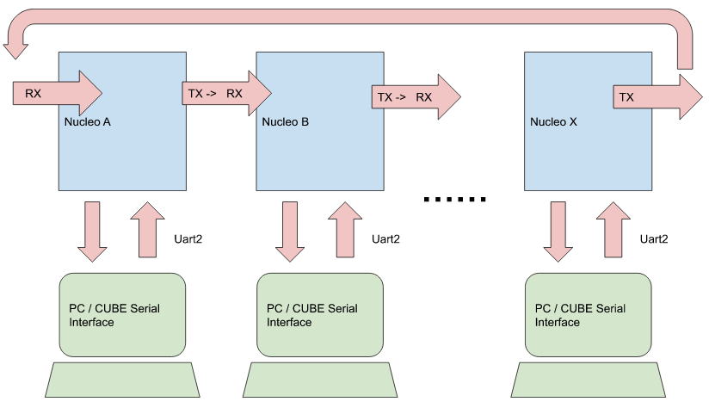

**Problem Statement:**

When the program starts, the user will be asked their name. This name will be verbally shared with other participants in the ring. All names must be unique in the ring.

The following describes the message format

**<Source-ID> <Destination-ID> <command> <parameters> \n**,where

* The Source-ID is the user’s name (e.g. MyName).
* The Destination-ID is the name of the intended recipient (e.g. YourName).
* Command & parameters defined in table below

**MESSAGE**

| **Commands** | **Parameters** | **Meaning** | **On receive** |
| --- | --- | --- | --- |
| msg | Any text string:  “that’s poggers” | Send a freeform text message to a specific recipient | If you are the intended recipient, simply display the message.  SrcName: message |
| led | <n> <on|off> | The addressed node turns LED 1..3 on or off. | If you are the intended recipient, display the message and carry out the action.  SrcName: LED command |
| gen | See P4 | Configure your DAC to the specified output including TYPE=CAP | If you are the intended recipient, display the message and carry out the action.  SrcName: GEN command |
| cap | See P5 | Capture a signal as specified in the command. | If you are the intended recipient, display the message and carry out the action.  SrcName: CAP command |

* You may do this project on your own - but it will be easier to work with a group of people to test all the messages and interactive controls.
* Forward all messages addressed to you. Do not forward any message for which you are the source.
* Parse all messages without regard to case.
* The token ring serial communications is defined as 1200 baud, no parity, 8 bits.

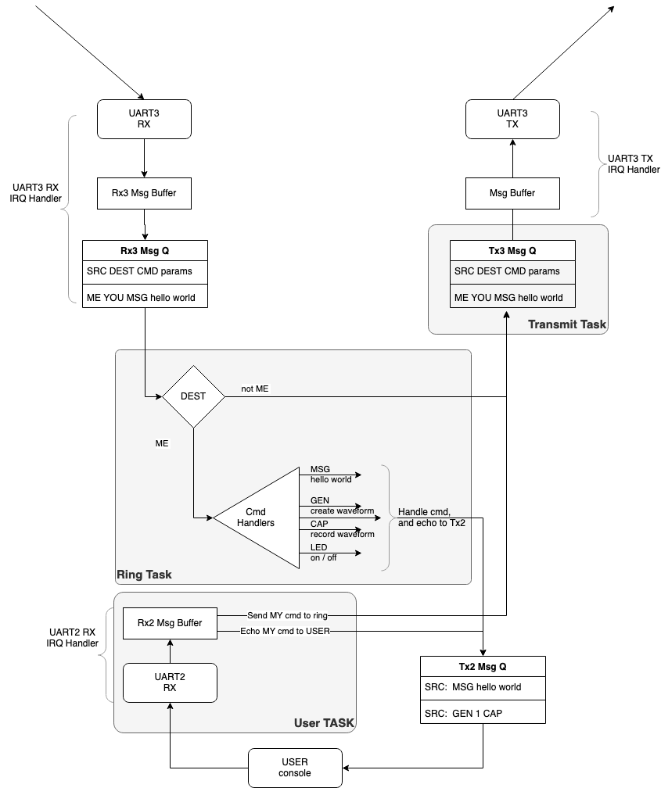

**Report:**

* Explain how your system works. Include a block diagram.
* Explain the architecture you settled on, and what engineering constraints led you to that architecture. Describe and explain the need for and use of interrupts..

In addition to the demonstration of your project, a brief report is required to describe your design. As to the final project report, refer to the Report Specifications for the required content and format.

Be sure to include one run of your output in your report. Please submit your report as either a Word compatible document or a PDF document in the project dropbox. Do not put it inside a zip file or other archive.

Your source code (the .c files you created along with any .h files) must be included in your electronic submission. Files generated by the compiler do not need to be submitted.

**Due Dates:**

Demonstration and collateral reports / code are due prior to the last lab/class.