Requirement Analysis

Nguyễn Quang Linh

# Use case diagram

## General use case diagram

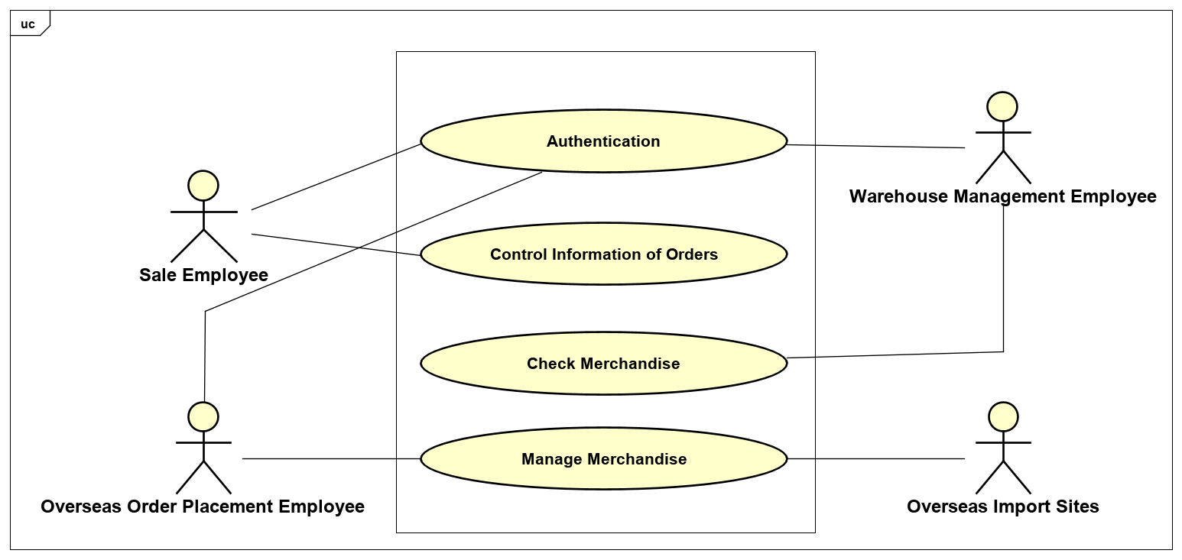

Figure 1: General Usecase Diagram

- Position in usecase:

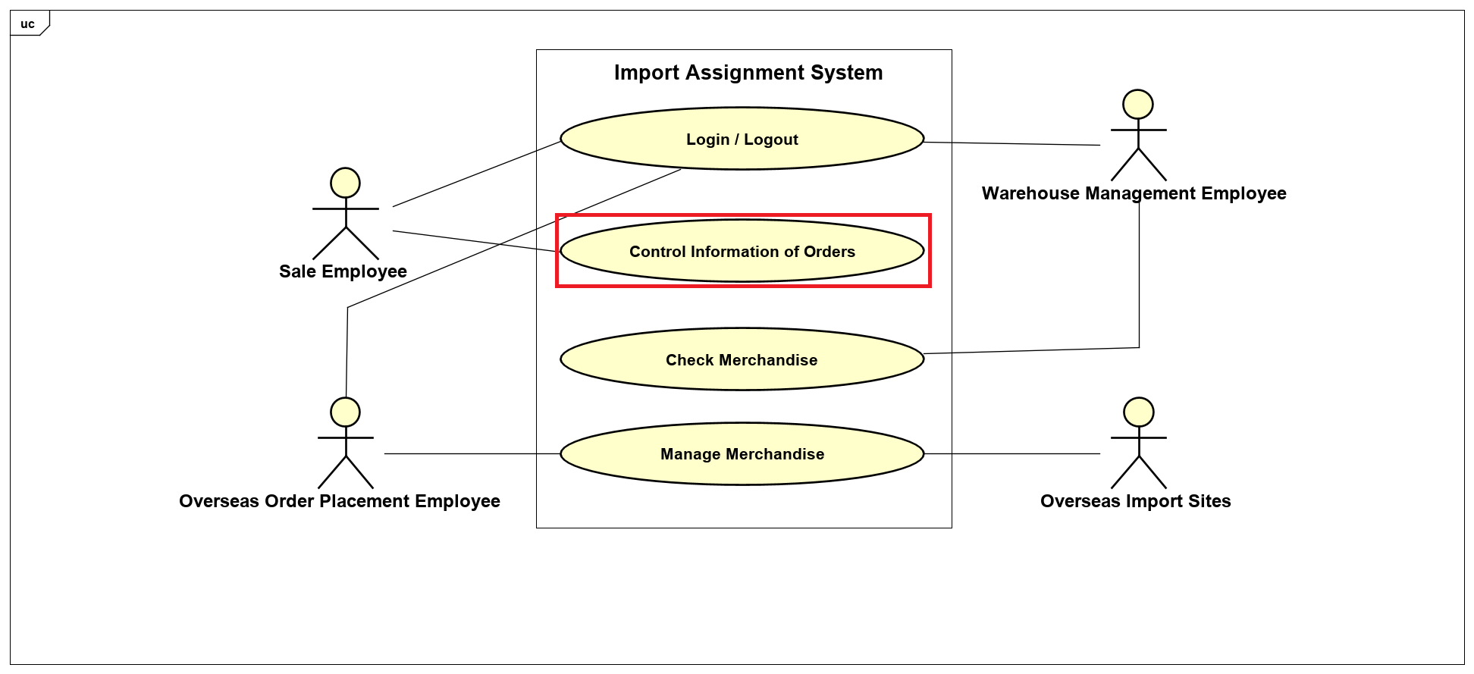

## Use case diagram

# 

Figure 2: Sale employee usecase diagram

# Use case specification

## Use case authentication

|  |  |  |  |
| --- | --- | --- | --- |
| **UC Code** | UC001 | **Use case name** | Authentication |
| **Actor** | Sale employee, Overseas order placement employee, Warehouse management employee | | |
| **Precondition** | Users should have their own accounts | | |
| **Main flow of event** | |  |  |  | | --- | --- | --- | | **#** | **Doer** | **Action** | | **1.** | System | Displays the login page | | **2.** | User | Enter their username and password then selects login button | | **3.** | System | Checks if the account exist or not | | **4.** | System | Checks if the username and password correct or not | | **5.** | System | Checks types of account (sale, overseas order placement or warehouse employee) | | **6.** | System | The system redirects the user to the appropriate home page | | **7.** | User | Select logout button | | **8.** | System | Displays a prompt asking if the user indeed wishes to logout | | | |
| **Alternative flow of event** | |  |  |  | | --- | --- | --- | | **#** | **Doer** | **Action** | | **3a.** | System | Notifies “Account not exist” if the account is not exist and redirect the user to the register page | | **4a.** | System | Notifies “Username or password incorrect” if the username/password is not correct | | **5a.** | System | If the credentials correspond to sale employee/overseas order placement employee/warehouse management employee, then appropriate privileges are granted | | **8a.** | System | If the user confirms, returns the user to the login page, delete their session | | | |
| **Post condition** | None | | |

# 2.2 Use case “Create sale order”

|  |  |  |  |
| --- | --- | --- | --- |
| **UC Code** | UC002 | **Use case name** | Create sale order |
| **Actor** | Sale employee | | |
| **Precondition** | Successful login | | |
| **Main flow of event** | |  |  |  | | --- | --- | --- | | **#** | **Doer** | **Action** | | **1.** | Sale employee | Selects “create order” from the UI | | **2.** | System | Presents a form to fill in | | **3.** | Sale employee | Fills in the information and selects “create” option | | **4.** | System | Checks the validation of the input information (eg: merchandise code) | | **5.** | Sale employee | Enter various orders’ information | | **6.** | System | Checks if the actor selects the exit button before the save button is selected | | **7.** | Sale employee | Selects save button | | **8.** | System | Asks the user’s confirmation, notifies the user that they cannot edit information | | | |
| **Alternative flow of event** | |  |  |  | | --- | --- | --- | | **#** | **Doer** | **Action** | | **4a.** | System | Notifies error if the input information is not correct | | **6a.** | System | Warns the actor that data has not been saved if the actor selects exit button before save button | | **8a.** | System | If the actor selects “Confirm” then saves the order. If the actor selects “Cancel”, return the actor to the form | | | |
| **Post condition** | None | | |

# 2.3 Use case “View sale order”

|  |  |  |  |
| --- | --- | --- | --- |
| **UC Code** | UC003 | **Use case name** | View sale order |
| **Actor** | Sale employee | | |
| **Precondition** | Successful login | | |
| **Main flow of event** | |  |  |  | | --- | --- | --- | | **#** | **Doer** | **Action** | | **1.** | Sale employee | Selects view order button | | **2.** | System | Displays list of orders | | **3.** | Sale employee | Selects view button | | **4.** | System | Displays detailed order | | **5.** | Sale employee | Selects delete button | | **6.** | System | Delete the order | | | |
| **Alternative flow of event** | |  |  |  | | --- | --- | --- | | **#** | **Doer** | **Action** | | **5a.** | System | Confirmation popup | | | |
| **Post condition** |  | | |

# Activity diagram

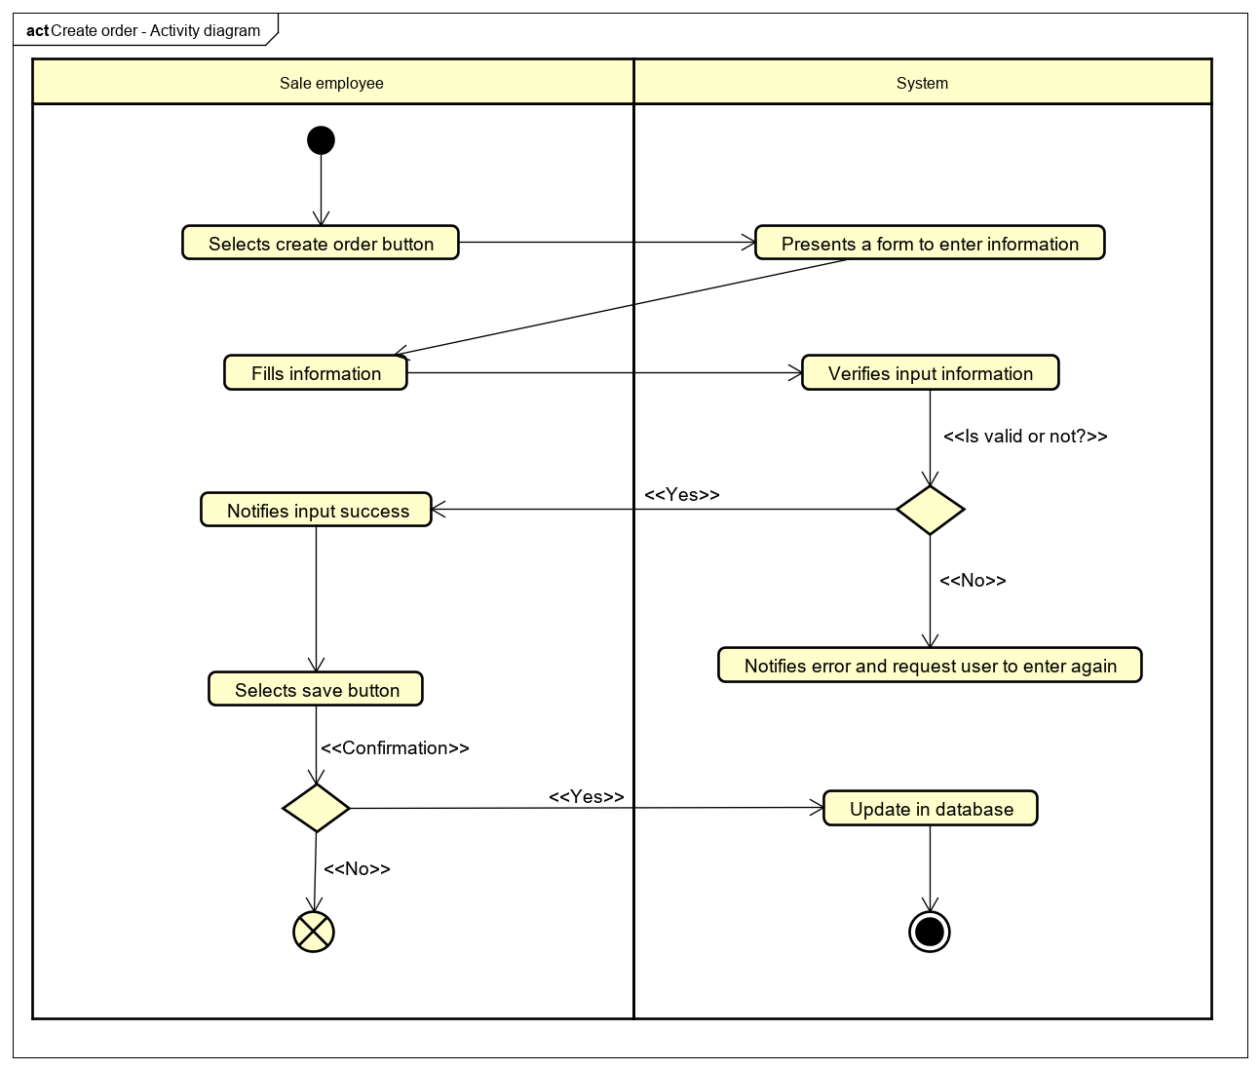

Figure 3: Create order activity diagram

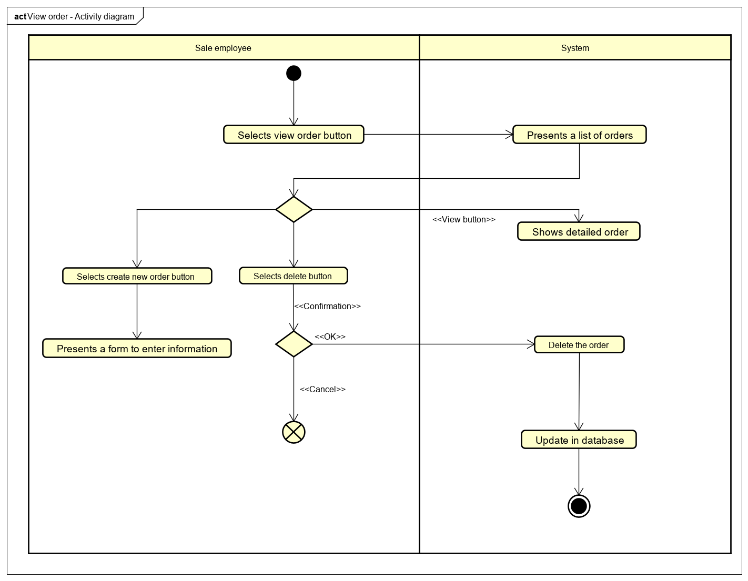

Figure 4: View sale order activity diagram

# Sequence diagram

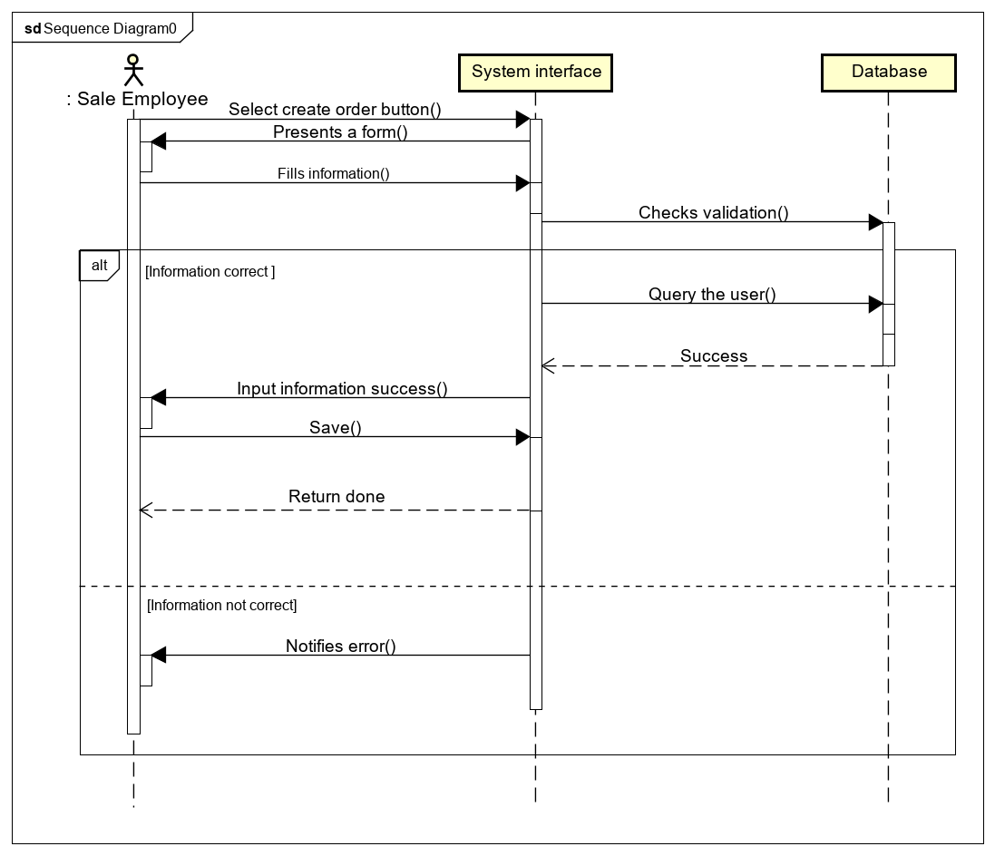

Figure 5: Create sale order

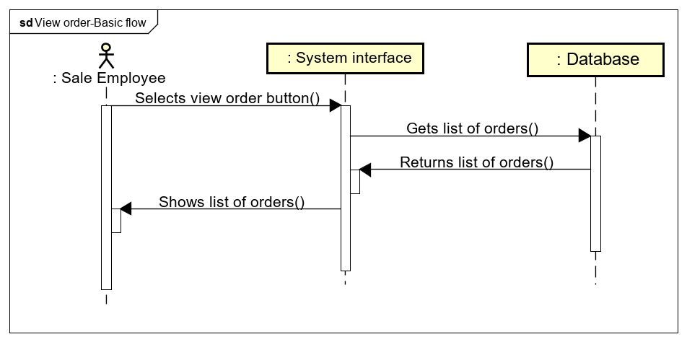

Figure 6: View sale order - Basic flow

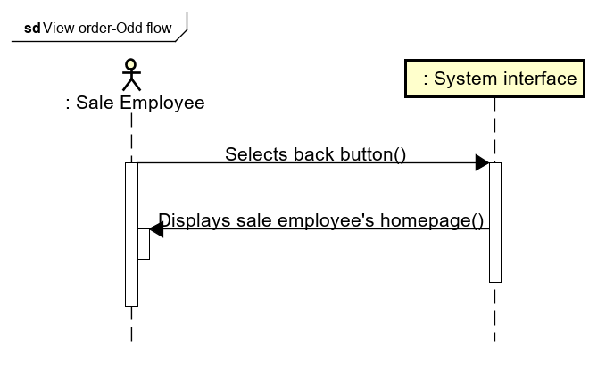

Figure 7: View sale order odd flow

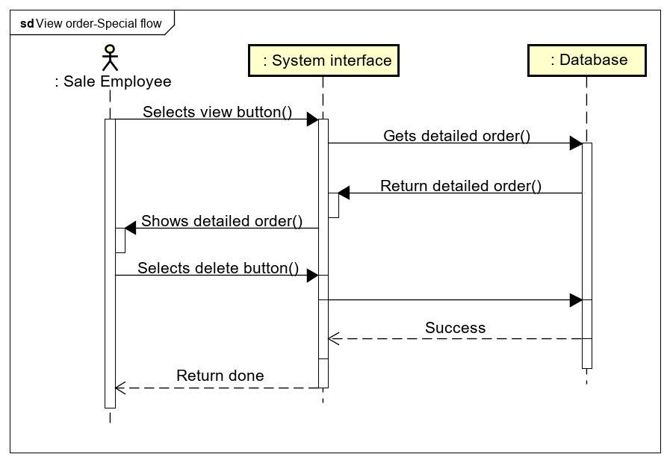

Figure 8: View sale order special flow

# Transition diagram

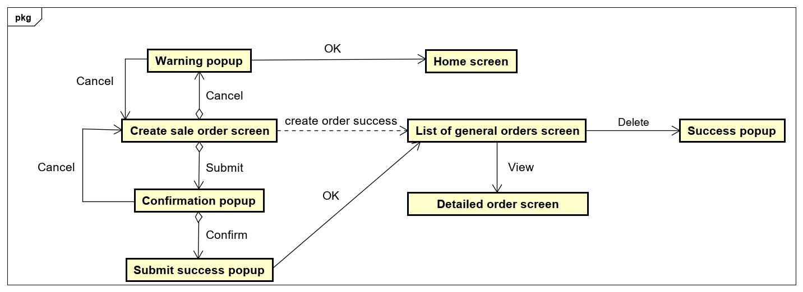

# Class diagram

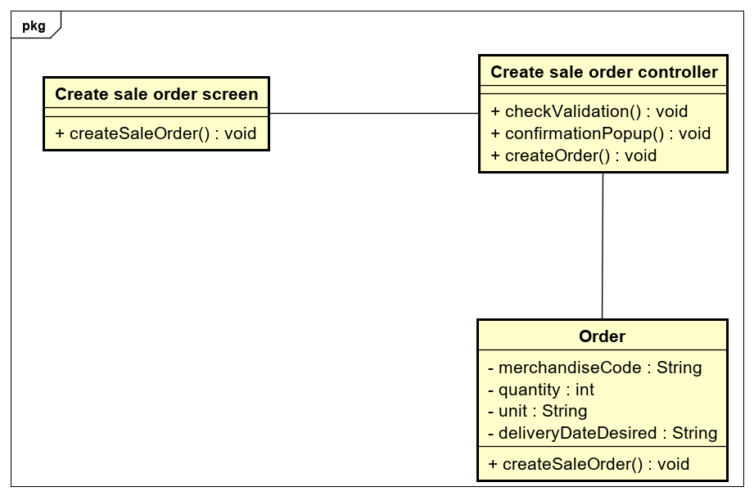

Figure 9: Create order analysis class diagram

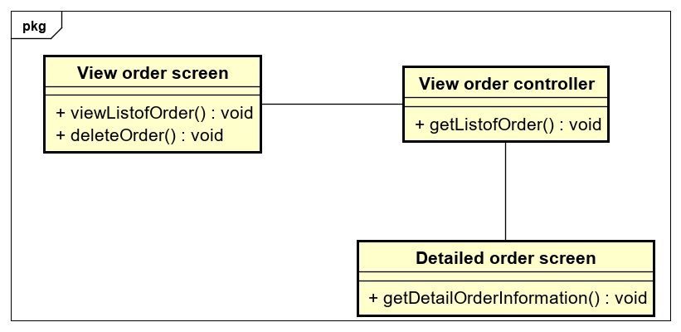

Figure 10: View order analysis class diagram

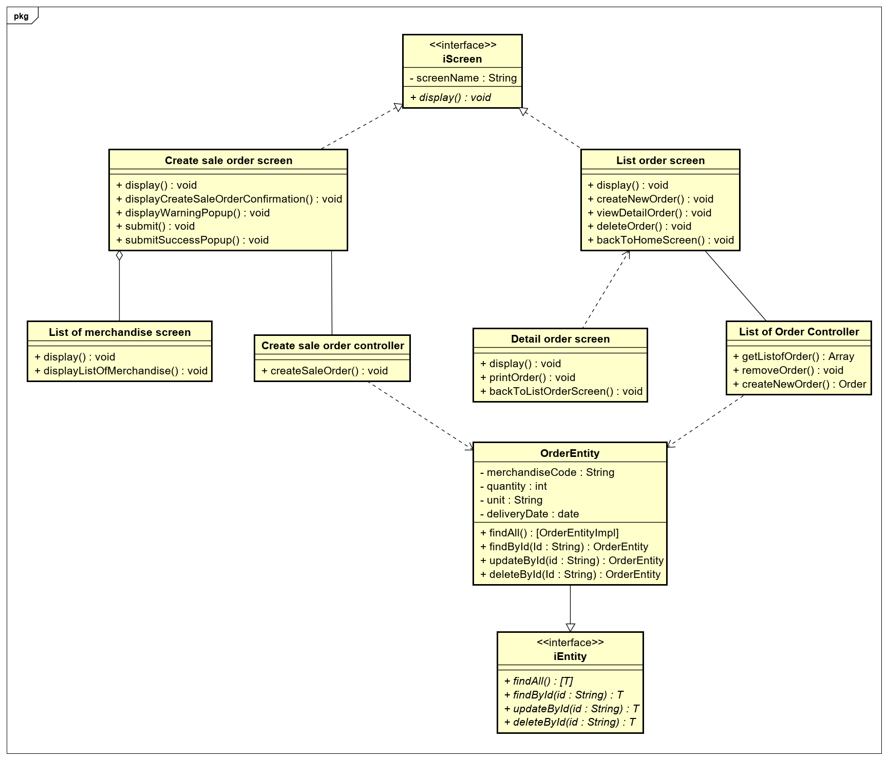

Figure 11: Class design diagram

# User interface

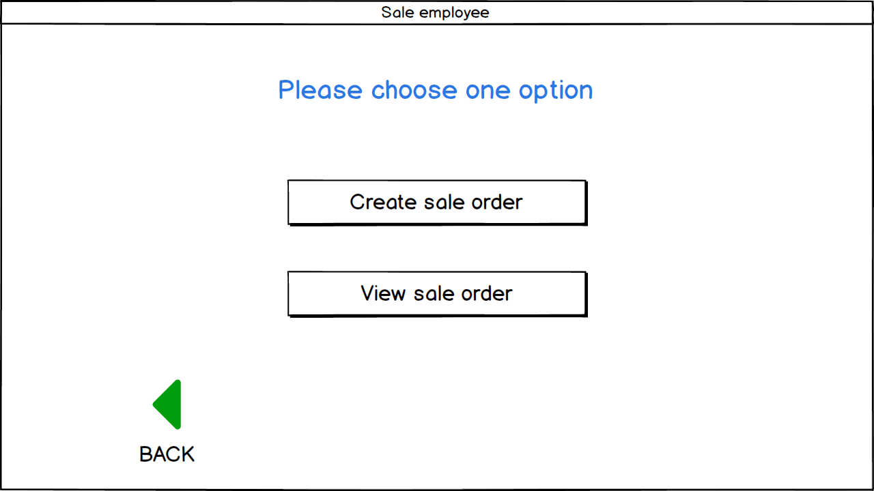

Figure 12: Sale employee account screen

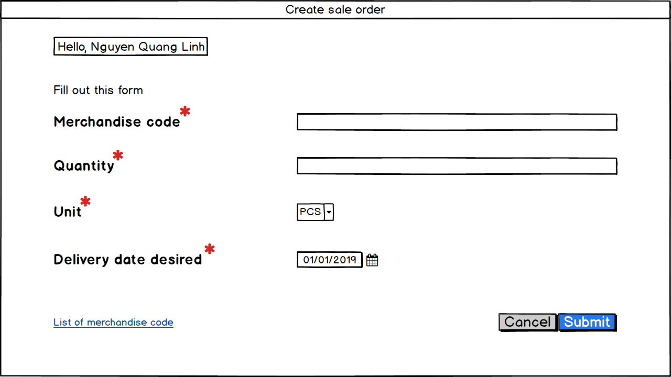

Figure 13: Create sale order screen

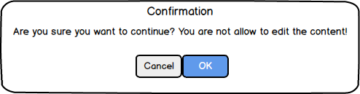

Figure 14: Submit order confirmation popup

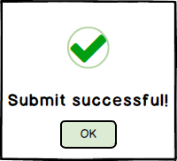

Figure 15: Submit success popup

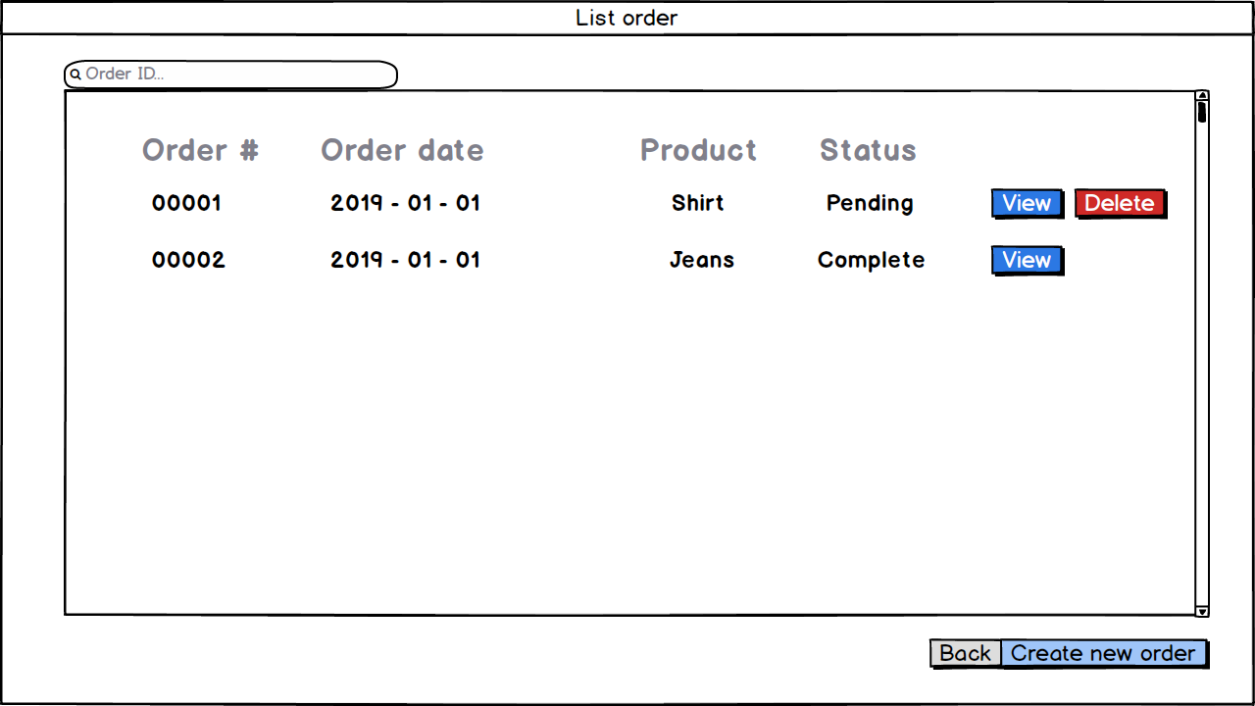

Figure 16: List of orders screen

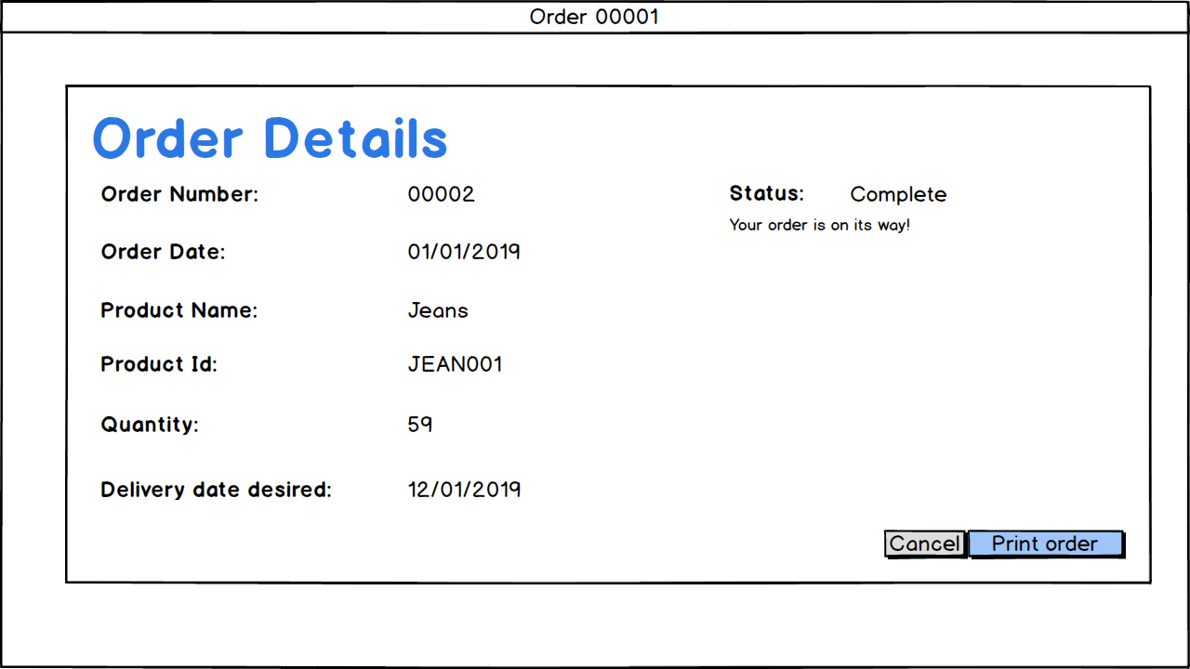

Figure 17: Detailed order screen

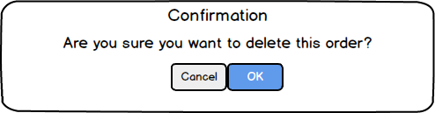

Figure 18: Delete order confirmation