


VANTAGE REPORT
Enter Client Name
Enter D&B DUNS #

Scope of the Report

- History and legal background

- Existing operations

- Banker letter

- Industry overview

- Management background

- Financial statements and analysis

Information Sources

Information given in this report is compiled on the basis of information obtained from the following sources:

- Annual reports

- Information from the website

- Corporate communiqué

- Management discussion

- Media

Methodology

Financial information from the audited annual reports (consolidated and standalone) of (hereinafter referred to as or “the Company”) was studied and analyzed for a five-year period from FY (Financial Year) 2014 to 2019. Also, additional information was also collated from public sources.

Additional clarifications were provided by Sumeer ( CEO) during the management discussion held on 1/28/2020.

Date – 2/1/2020

Contents

COMPANY PROFILE 5
ABOUT THE COMPANY 6
GROUP 9
MANAGEMENT 10
SHAREHOLDING PATTERN 15
BUSINESS OVERVIEW 16
OPERATIONS 17
KEY BUSINESS HIGHLIGHTS 20
FINANCIAL ANALYSIS 27
KEY FINANCIAL HIGHLIGHTS 28
KEY FINANCIAL ELEMENTS AND RATIOS – CONSOLIDATED 29
KEY FINANCIAL ELEMENTS AND RATIOS - STANDALONE 34
PROVISIONAL FINANCIALS (CONSOLIDATED) 40
FREE CASH FLOW ANALYSIS 41
INCREMENTAL CASH FLOW ANALYSIS 44
SENSITIVITY ANALYSIS 46
D&B RATING 47
RATING AND GLOSSARY 48
RATING DRIVERS 49
RATING SENSITIVITY 51
SECTOR OVERVIEW AND DEMAND DRIVERS 52
SECTOR OVERVIEW 53
MACROECONOMIC SUMMARY 56
DEMAND DRIVERS 61
PORTER’S FIVE FORCES MODEL 62
SWOT ANALYSIS 63
STRENGTHS 64
WEAKNESSES 66
OPPORTUNITIES 68
THREATS 70
ANNEXURES 71
FINANCIAL STATEMENTS (CONSOLIDATED) 72
AUDITORS OBSERVATIONS AND CONTINGENT LIABILITIES (CONSOLIDATED) 76
FINANCIAL STATEMENTS (STANDALONE) 82
AUDITORS OBSERVATIONS AND CONTINGENT LIABILITIES (STANDALONE) 86
SUBSIDIARY, STEP DOWN SUBSIDIARY, RELATED PARTIES AND LOCATIONS 96
BANK AND INSURANCE DETAILS 104
AWARDS/CERTIFICATIONS/ISO 105
STANDARD INDUSTRIAL IDENTIFICATION CODES 106
MEDIA ARTICLES 107
GLOSSARY FOR KEY RATIOS 108




Credibility and Risk Reporting

LINE OF BUSINESS



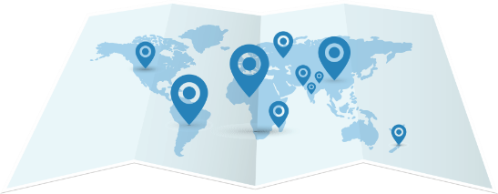



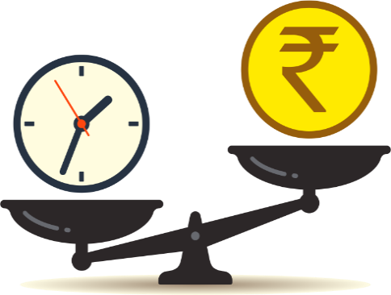

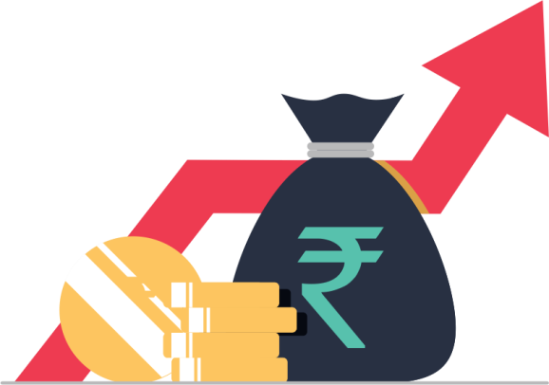
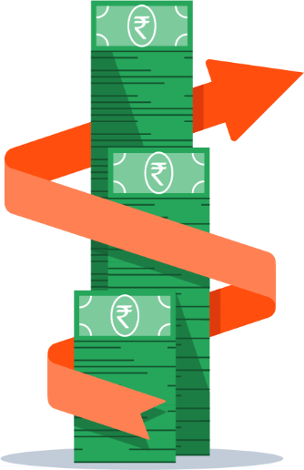
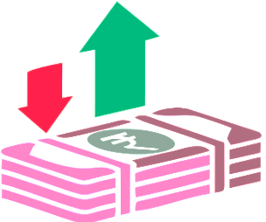
AA A+

MANAGING DIRECTOR

Mr. Bhadresh Shah
VR, IR, BSR,GPR,BPR,SAR

EU, Americas, Asia
D&B RATING

PORTFOLIO

MARKETS COVERED

Note: Key financial elements pertain to consolidated financials of FY 2019
RETURN ON CAPITAL EMPLOYED

TOTAL DEBT EQUITY RATIO

10.2 times
0.45%
INR 45000 thousand

NET PROFIT
0.4%
OPERATING MARGINS
INR 12345 thousand

TANGIBLE NETWORTH

TOTAL REVENUE
INR 5678 thousand



COMPANY PROFILE

ABOUT THE COMPANY

History:

AIA Engineering Limited promoted by Mr. Bhadresh Shah was incorporated on 4th November 1978 .

It as a private limited company under the name “Ahmedabad Induction Alloys Private Limited”. It became a deemed public company with effect from 4th January 1990.

On 11th March 1991, Magotteaux (India) Private Limited was established as a result of a technical and financial collaboration with Magotteaux International S.A., Belgium, and Ahmedabad Induction Alloys Private Limited (AIAPL). AIAPL was merged with Magotteaux (India) Private Limited on 1st April 1991, upon which the name of the former company was changed to “AIA Magotteaux Private Limited” with effect from 11th May 1992. This company became a deemed public company with effect from 30th November 1992.

On account of the termination of technical and financial collaboration with Magotteaux International S.A., Belgium effective 16th March 2000, the name of AIA Magotteaux Limited was changed to AIA Engineering Limited on 2nd May 2000.

The Company became a public limited via initial public offering (IPO) on 14th December 2005. The Company’s shares are listed on BSE Limited (BSE) and The National Stock Exchange of India Limited (NSE).
Line of business:

AIAE manufactures value-added, impact abrasion, and corrosion resistant high chrome mill internals (HCMI). The Company is engaged in the designing, development, manufacturing, installation and servicing high chromium wear, corrosion and abrasion resistant castings which are used in the mining, cement and thermal power industries. It manufactures grinding media, shell liners, diaphragms and vertical spindle mill spare parts (VSMS). Out of the same, grinding media (ring balls) account for over 80% of the total revenue and 20% revenue is derived from other casting products. These components are collectively known as mill internals, which are used for crushing and grinding operations in grinding mills in the cement, power and mining industries. In FY 2019, out of the total revenue - approx. 64% was derived from mining sector and the remaining from non-mining sectors including cement and thermal. Revenue from mining sector has been increasing y-o-y on account of higher scope of penetration of HCMI (59% in FY 2017 to 64% in FY 2019).

Group:

AIAE, through its wholly owned subsidiaries outside India (AIAE and its subsidiaries together known as “AIA group” or the “group”), sells directly to its end customers located in more than 125 countries. These customers are serviced through its wholly owned subsidiaries/branches/representative offices in the USA, Canada, United Kingdom (UK), Brazil, United Arab Emirates (UAE), Australia, South Africa, Philippines, China, Egypt, Chile, Indonesia, Ghana, along with other markets.

Geographical presence:

The Company controls its activities from its corporate office located at Ahmedabad, Gujarat. The Group has about 32 facilities including branch offices based across 4 clusters from Gujarat, Maharashtra, Karnataka and Tamil Nadu.

The Company majorly derives revenue from the international market which contributed 75.83% of the total revenues in FY 2019 whereas the balance 24.17% of the revenue came from the domestic market.

AIA group caters to about 125 countries in the mining segment which includes Brazil, Australia, Canada, the USA, Northern Africa, Far East Asia, Ukraine and Russia amongst others.
Customers and technical collaboration:

The Company’s customers are spread worldwide. It has a customer base of more than 500 with some of its regular customers being Rio Tinto Group, Lafarge Holcim, Newmont Mining Corporation and Vale S.A, Newcrest amongst others. It continuously adds customers and targets to increase wallet share from existing customers.

Furthermore, it has entered into a technical tie-up with EE Mills Solutions LLP, USA (EEMS) for mill linings in Q1 FY 2019. EEMS has special knowledge of optimizing energy efficiency and output of grinding equipment like autogenous mills (AG)/semi-autogenous (SAG) mills/Ball mills in wet & dry grinding industries through re-designing of mill internals viz. Head & shell liners, grate liners, pulp lifters. The Company successfully completed its first trial for SAG mill liners for a large gold mine in Africa under its collaboration with EEMS, USA.

The Company’s manufacturing units are accredited with ISO 9001:2008 certificate.

Source: As provided by the management, annual report 2019 and company website

Capital Market Overview

D & B has its IPO listed in BSE on November 2015. It is one of the member constituent of S & P BSE 200. It is listed as “Other General Industry”.

Market Statistics
Face Value (INR) | 1212
Market Cap (INR in crore) | 12321
Free Float M Cap (INR in crore) | 12345

As on 01/08/2019:

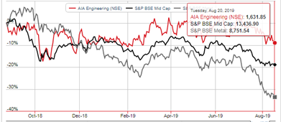

.
Source: BSE and Value research

GROUP

The Company is the flagship company of AIAE group. It has three direct subsidiaries, eight indirect subsidiaries and five related parties.

Subsidiaries:

- Welcast Steels Limited
- Vega Industries (Middle East) FZC
- AIA CSR Foundation

Step-down Subsidiaries:

Vega Industries Limited , UK
Wuxi Vega Trade Co. Ltd
PT .Vega Industries Indonesia
Vega Industries Chile SPA
AIA Ghana Limited
Vega Steel Industries (RSA) Proprietary Ltd
Vega Industries Australia Pty Limited
Related parties:

- AB Tradelink Limited
- Vee Connect Travels Private Limited
- Discus IT Private Limited
- Harsha Engineers Limited
- RNCA & Associates

Source – Annual report 2019

MANAGEMENT

Mr. Bhadresh Kantilal Shah – Managing Director

Mr. Bhadresh Kantilal Shah is the Managing Director of the Company since 11th March, 1991. He has completed his Bachelor of Technology (Metallurgy) from Indian Institute of Technology, Kanpur. He has 46 years of experience in the manufacturing and design of various kinds high chrome castings. He has expertise in handling production, finance, cost and technical administration areas.

Source: As provided by the management
Board of Directors
Mr. Bhadresh Kantilal Shah

DIN – 00058177
Qualification – Bachelor in Technology (Metallurgy)
from Indian Institute of Technology, Kanpur
Designation – Managing Director
Relevant Experience – 48 Years

Other Directorships

Cadila Healthcare Limited
Welcast Steels Limited
Avirat Finance Private Limited
AIA CSR Foundation

Mr. Rajendra Shantilal Shah

DIN – 00061922
Qualification – Bachelor of Mechanical Engineering
Designation – Chairman and Independent – Non-Executive Director

Other Directorships

Welcast Steels Limited
Dishman Carbogen Amcis Limited
Harsha Engineers Limited
Harsha Abakus Solar Private Limited
Harsha Engineers (India) Private Limited
Harsha Renewable Energy Private Limited

Mr. Sundararajan Srikumar

DIN – 01025579
Qualification – Master of Technology (Industrial Engineering)
Post Graduate Diploma in Management from AIMA
Doctor of Philosophy
Designation – Non Independent - Non-Executive Director

Other Directorships

Powertec Infrastructure Holdings Private Limited
Powertec Engineering Private Limited

Director Details

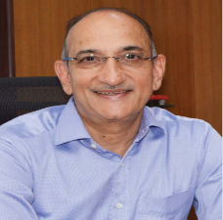

Mr. Rajan Ramkrishna Harivallabhdas

DIN – 00014265
Qualification – Bachelor of Commerce from Gujarat University
Master of Business Administration from United States of America
Designation – Independent Director
Relevant Experience – 31 years

Other Directorships

Polyex Minerals Private Limited
Polyon Textiles Private Limited
Apara Chemtech Private Limited*
Ebony Construction Private Limited
Engineering And Agencies Private Limited
Essenar Investments Private Limited
Shri Arya Investment Private Limited
Ansumalini Investment Private Limited
* Under Process of Striking Off

Mr. Yashwant Manubhai Patel

DIN – 02103312
Qualification – Bachelor of Science (Chemistry)
Designation – Whole-Time Director

Other Directorships

Twiga Investments Private Limited
Knight Bridge Investments Private Limited
AIA CSR Foundation

Mrs. Khushali Samip Solanki

DIN – 07008918
Qualification – Diploma in Hotel Management
Designation – Non-Executive - Non-Independent Director

Other Directorships

Little Place Ventures LLP
Welcast Steels Limited

Mrs. Bhumika Shyamal Shodhan

DIN – 02099400
Qualification – Bachelor of Commerce
Master of Business Administration from USA
Diploma in Fashion Designing
Designation – Non-Executive - Non-Independent Director

Other Directorships

S N B Fashions Private Limited

Mr. Sanjay Shaileshbhai Majmudar

DIN – 00091305
Qualification – Bachelor of Commerce
Chartered Accountant and Associate Company Secretary
Designation – Independent Director

Other Directorships

Aarvee Denims And Exports Limited
Welcast Steels Limited
Dishman Carbogen Amcis Limited
Ashima Limited
M & B Engineering Limited

Mr. Dileep Chinubhai Choksi

DIN – 00016322
Qualification – Bachelor of Commerce
Cost and Works Accountants of India
Chartered Accountant
Bachelor of Law
Designation – Independent Director
Relevant Experience – 38 Years

Other Directorships

Arvind Limited
Lupin Limited
Swaraj Engines Limited
ICICI Prudential Life Insurance Company Limited
Hexaware Technologies Limited
Tata Housing Development Company Limited
Gujarat International Finance Tec-City Company Limited
Miramac Properties Private Limited
Universal Trusteeship Services Limited
UTPL Corporate Trustees Private Limited

Mrs. Janaki Udayanbhai Shah

DIN – 00343343
Qualification – Bachelor of Arts (Economics)
Designation – Additional Director – Independent
Relevant Experience – 20 Years

Other Directorships

Shri Murli Packing And Trading LLP
On-Line Services LLP

Source: Ministry of Corporate Affairs (MCA) and as provided by the management

SHAREHOLDING PATTERN

Total Number of Shareholders : 17,726

Source: BSE Website



BUSINESS OVERVIEW

OPERATIONS

The Company is engaged in the designing, development, manufacture and installation of high chromium wear, corrosion and abrasion resistant castings which are used in the cement, mining and thermal power industries. The Company manufactures grinding media, shell liners, and diaphragms. These components are collectively known as mill internals, which are used for crushing and grinding operations in grinding mills in the cement, power and mining industries. As informed, the products are tailor made as per the customer’s specifications and have an average lead time of 3-4 months.

AIAE employs alloy-casting process for manufacture of the products, which entails designing and choosing high chrome alloy composition in relation to the end application. The casting process is followed by precision heat treatment process to impart the required end properties. The Company produces a specific range of high chrome mill internals which are used as wear parts in the cement, mining, utility and aggregate industries.

The various products manufactured as per the end use application are listed below: -

- Mining

AIAE provides wear components for mining applications. The wear components are used for all types of mineral i.e. iron, gold, lead/zinc, bauxite, copper and phosphates, etc.

- Tube Mill Applications

- Grinding Media – In grinding media, components provided are for crushing and grinding of mineral. Different alloys are recommended depending on ore type and mill particulars. AIAE can help select optimum alloy for specific application ranging from chromium 10% to 32% and hardness ranging from 58 to 69 RC. It also provides technical services like mill audit, marked ball test, ore breakability test and initial ball charge & make up recommendation.

- Inlet/Outlet Head Liners - Inlet/Outlet Head Liners are made for specific components in mining application with the minimum maintenance cost. The advantage of the inlet/outlet head liners are maximum mill availability, minimum maintenance cost, reduction in grinding media & shell liners wear rate and minimizing the replacement time and cost. AIAE can help select suitable alloy for specific application ranging from chromium 10% to 27% and hardness ranging from 52 to 66 RC.

- Shell Liners – The Company manufactures shell liners for ball mills of different stage i.e. single stage, primary, secondary, regrind stage, etc. The advantage of shell liner is optimum lifting action of the balls, optimum expansion of the ball charge, minimize the dead zone of the ball charge, significant reduction of the wear rates of the ball and the liners and minimum operating cost due to longer lifetime and no breakage of the liner plates. AIAE can help select appropriate alloy for specific application ranging from chromium 10% to 27% and hardness ranging from 48 to 61 RC.

- Diaphragm – Along with grinding media and shell liners, the efficient diaphragm is beneficial for improvement of the productivity. AIAE has developed intermediate, discharge, drying chamber and dopple rotator diaphragms which offer maximum useful working life of the components.

- Tube Mill Internals Inlet/Outlet Head Liners

- Inlet/Outlet Head Liners - Inlet/Outlet head liners are made for specific components in mining application with the minimum maintenance cost. The advantage of the inlet/outlet head liners are maximum mill availability, minimum maintenance cost, reduction in grinding media & shell liners wear rate and minimizing the replacement time and cost. AIAE can help select suitable alloy for specific application ranging from chromium 10% to 27% and hardness ranging from 52 to 66 RC.

- Shell Liners - The Company manufactures shell liners for different profiles with hump and without hump depending on wear and drilling pattern. It provides shell liner as the specific profile of the rod mill application which is ranging from 16 to 27% chromium and hardness ranging from 53 to 61RC.

The Company derived over 60% of revenue from mining segment in FY 2019.

- Cement

- Tube Mill Internals – Under tube mill internals, the Company supplies grinding media, shell liners (bolted and boltless), diaphragm (partition wall, discharge diaphragms, drying chamber diaphragms and dopple rotator diaphragms), and provides mill audits along with other services like ball charge management and installation supervision.

- Vertical mill parts – The Company manufactures grinding rolls for vertical mills used by the cement industry.

- High Resistant Chrome Steel (HRCS) Casting – The Company supplies castings for pre heaters, kilns and coolers used in cement manufacturing. The cast segments are designed to go through the cyclone manhole and the segments can be casted in a variety of grades, sizes and thickness according to working conditions for the individual cyclone.

- Crusher Parts – The Company provides wear parts for crushers in cement manufacture.

- Power

AIAE manufactures wear components for thermal power generation plant. The Company provides critical parts for the power plant for reduction of cost of fuel and downtime and maintenance costs.

- Tube Mill Applications

The improved wear parts increase mill efficiency in power generation. This provides the advantage of increased working life for mills, reduced maintenance requirements, improvement in the consistency of supply, improvement in the quality of processed fuel.

- Grinding Media – In power generation, fuel plays an important role. Grinding media helps in reducing cost and improve the efficiency which results into better performance. The advantage of this grinding media are less interruptions of milling operations, improved mill efficiency and reduced overall processing costs.

- Shell Liners – The shell liners are designed in semi boltless designs with the knowledge of milling circuit and mill working condition of specific requirements of production/power consumption. As informed, each liner passes through rigorous quality control test to meet stringent acceptance norms.

- Vertical Mill Application

These parts improve efficiency and cost savings. This improves the alloy composition of grinding rolls for the following mills:

- Monoblock rolls for Loesche and Polysius mills
- Segmented rolls for Atox and Polysius mills
- Segmented tables for Loesche, Polysius and Atox mills
- Grinding rings and Hollow balls for E mills
- Rolls and table segments of Raymond/CE mills

- High Performance Milling System (HPMS) – This concept was developed by the Company for refurbishment of bowl mills, through a Global philosophy of design, supply and services for improvement in life of wear parts and performance optimization which consist of centrifugally cast inserted grinding rolls in high chrome / sinter cast metallurgy, compatible bullring segments in high chrome / sinter cast metallurgy and airport ring assembly / rotary vane wheel.

- Services – The Company provides supervision of installation and commissioning services and technical services for mill optimization in power generation sector.

Source: As provided by the management, Company website and Annual report 2019

KEY BUSINESS HIGHLIGHTS

One of the largest high chrome casting producer in the world by installed capacity (390,000 MT per annum)

Capex incurred to add incremental grinding media capacity coupled with plans to increase the installed capacity to 490,000 MT by 2021
Increasing revenue share and volumes from the mining industry (accounted for 64% revenue in FY 2019)

Diversified presence across geographies (over 125 countries) and reputed customer profile with continual additions to customer base in the international market (export revenue share increasing y-o-y from 66% in FY 2016 to 76% in FY 2019)

Technical tie-up EE Mills Solutions LLP, USA (EEMS) to facilitate re-designing of mill internals; the Company successfully completed its first trial for SAG mill liners for a large gold mine in Africa

Majority business derived from the international market (consolidated)
Exports

United States of America
Far East
Europe
Middle East
United Kingdom
People's Republic of China
Australia
Germany
Taiwan
South Korea
Japan
Italy

Imports
Russia
United States of America
South Korea
People's Republic of China
South Africa
Europe
Taiwan
United Kingdom

Credit terms

LOCAL TERMS
Open Account – 60 days

EXPORT TERMS

Letter of Credit – 60 days

Purchasing Terms

LOCAL TERMS
Open Account – 30 days

IMPORTS TERMS
Letter of Credit

Fact Sheet

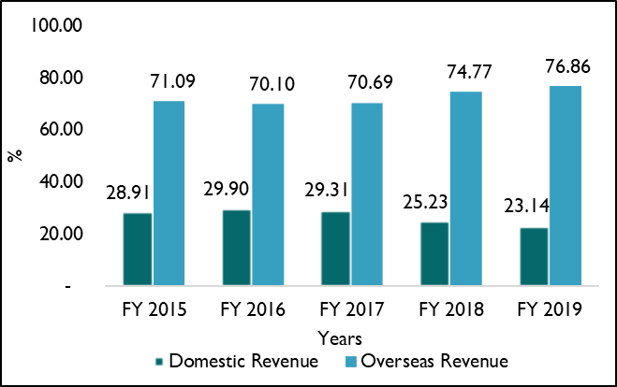

Revenue from overseas markets constituted a major portion of its total revenue during the period under review. In FY 2019, the Company derived 76.86% of its total revenue (consolidated) from the overseas market and 23.14% from the domestic market.

Source: Annual Report 2019

Volume details:

Source: As provided by the management

Geographical penetration and clientele base

Amongst the international market, the following countries contributed to majority of the revenue – United States of America, Far East, Europe, Middle East, United Kingdom, People's Republic of China,Australia, Germany, Taiwan, South Korea, Japan, Italy.

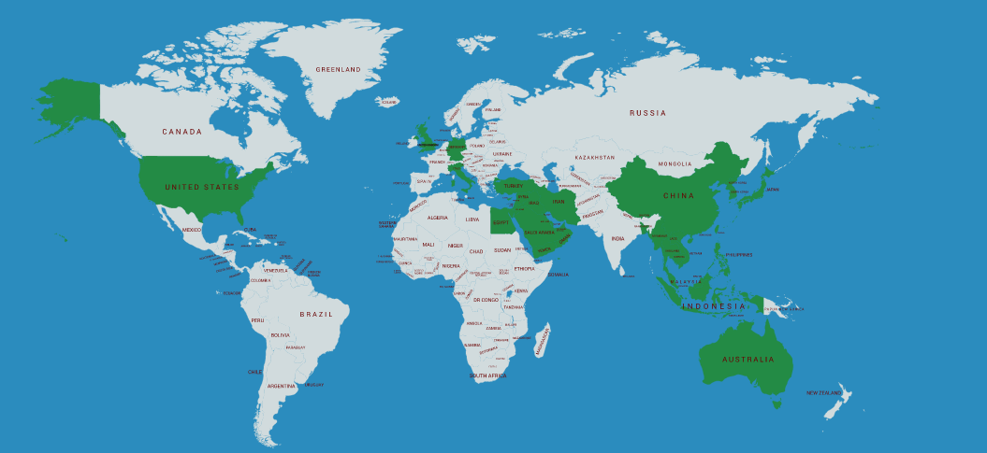

Note: This world map has been reproduced by D&B-India from https://mapchart.net/world.html, a public domain webpage, for representing the geographical spread of the Subject Entity’s business / operations. Nothing herein should be construed to mean any opinion, view or belief of D&B-India with respect to any physical or political borders of any country. D&B-India has represented this world map on ‘as is’, ‘as available’ basis from the said link and does not intend to represent anything except for territorial spread of the Subject Entity’s business / operations.

Clientele

The Company maintains around 500 customers.

Major customer types

- Cement Industry
- Mining Industry
- Thermal Power Industry

Major Customers

Some of its regular customers include Rio Tinto Group, Lafarge Holcim, Newmont Mining Corporation, and Vale S.A, Barrick Group amongst others. It has been associated with mining customers for the last five years (since it started catering to the segment) and has been associated with cement customers for more than a decade. As informed, more than 90% of the Company’s revenue is generated from repeat business (owing to nature of product which is largely a consumable for the customers).

As informed, the Company majorly receives long term contracts (3 to 5 years) from the mining customers, and in cement industry, contracts are order based. It exports to about 125 countries world-wide having a customer base of more than 500 customers. Pricing is adjusted quarterly for changes in raw material, power, labor and foreign exchange rate variation.

Source: As provided by the management

Sourcing and inventory management

Major suppliers

Source: As provided by the management

Manufacturing capacity:

The Company owns several manufacturing units which are located across 4 clusters in Gujarat, Maharashtra, Karnataka and Tamil Nadu. Its total installed capacity is approx. 390,000 MT per annum including commissioning of additional 50,000 MT per annum in FY 2019 for grinding media. It further plans to add 50,000 MT in grinding media (brownfield project) and another 50,000 MT of mill liners (greenfield project). The cumulative capacity is likely to be 490,000 MT per annum by FY 2021.
Raw material procurement:
AIAE procures raw materials (majorly steel scrap and ferrochrome) from the domestic market. Prices of raw materials are determined by demand and supply in the global market.
Competition:
As informed, the Company faces competition from the Belgium player, Magotteaux in the high chrome casting industry. Also, it faces competition in the mining segment from the manufacturers which are into production of forged wear components. However, the Company was able to garner major market share in the high chrome industry through its designing capabilities, worldwide distribution network, direct sales and service support around the world. As informed, it takes around 1-2 years for a successful order from a new customer. During this time, the technicians are engaged with the customer to work on the alloy metallurgy suitable to the customer’s operating environment thus enabling customized solutions. Continuous supply of quality products has resulted in repeat orders for the Company.
Foreign exchange hedging policy:
The Company derives about 76% of its revenues from the international market, which exposes it to foreign currency exchange rate fluctuation risk. However, as informed, the Company completely hedges its order book position by entering into forward contracts. It exports to more than 125 countries worldwide and mostly trades in US dollars. Further, while entering into contract with customer in mining industry, pricing is adjusted to cover changes in raw material cost, labor cost, power cost and foreign exchange rate during tenor the contract.
Future expansion:
As on August 2019, the Company’s current capacity stood at 390,000 MT of high chrome mill internals. The Company is in midst of expanding this capacity to 490,000 MT by brownfield expansion at its existing plant in GIDC Kerala, near Ahmedabad for grinding media and greenfield expansion of 50,000 MT for mill internals.
The incremental capex is likely to be commissioned by FY 2021. The investment would be approx. INR 500 crore and will be funded in phased manner through internal accruals.

Source: Annual Report, Company website and as provided by the management

Corporate Social Responsibility

- Average net profit of the Company for last three financial years – INR 5,317,947 thousand
- Prescribed CSR Expenditure (two percent. of the amount above) - INR 106,359 thousand
- Details of CSR spent during the financial year.
- Total amount spent - INR 105,026 thousand
- Amount unspent, if any - INR 1,333 thousand

Manner in which the amount spent during FY 2019:

Source: Annual Report 2019



FINANCIAL ANALYSIS
Intensive working capital operations stemming from high collection and inventory holding

Comfortable capital structure with strong interest coverage indicator. Expected capex of approx. INR 500 crore by 2021 to be funded through internal accruals keeping the gearing intact

Healthy liquidity position with substantial liquid investments and cash accruals

Volatile ferro chrome prices & exchange rate movement coupled with penetration in newer markets & addition of customers have impacted margins; however, despite the decline, EBITDA margins are within the targeted 20-22% range
Cyclicity in the end-user industries and ferro chrome prices impacts revenue growth; however, there has been y-o-y increase in volumes

KEY FINANCIAL HIGHLIGHTS

KEY FINANCIAL ELEMENTS AND RATIOS – CONSOLIDATED

Amount in INR thousand

Financial Movements - Consolidated

Revenue: Barring dip in FY 2016, witnessed continual growth at a CAGR of around 20% between FY 2016-19

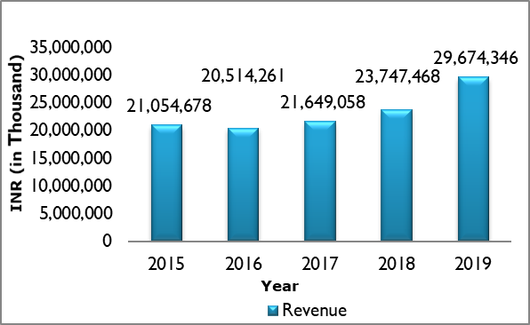
- The Company’s revenue improved during the review period except FY 2016. As informed, the dip in revenues was on account of sluggish economic conditions as well as softening of commodity pricing in mining industry (which is the major revenue contributor segment) leading to sales price reduction.
- The growth was relatively muted at 6% in FY 2017 and picked up to around 10% in FY 2018. Cement industry remained flattish and volatility in ferro chrome prices impacted the sales price, however there was continual volume growth which resulted in an increase in growth rate.
- Further, it increased sharply by ~25% in FY 2019 on account of increased penetration in newer markets such as Latin America, addition of customers and increase in wallet share from few existing customers.
- The volume sales of the Company grew at CAGR of 10.98% in the past three years ended FY 2019 (from 214,477 MT in FY 2017 to 265,174 MT in FY 2019). With additional capacities to be commissioned in FY 2020, it projects sales of 280,000 MT in the current fiscal.

Profitability: Pressure on margins owing to volatile material cost, freight cost, and exchange rate fluctuation

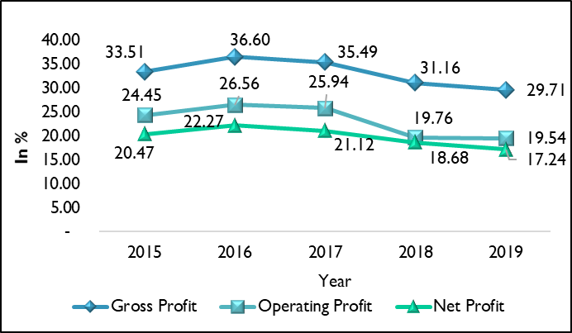
- The gross margins of the Company were impacted by volatile ferro chrome and steel prices and relatively lower sales realization on account of penetration in new markets coupled with addition to new customers (including new contracts from existing customers especially for mines in other regions).
- However, the Company maintains that it targets EBITDA margins of 20-22%. EBITDA margins despite facing pressure over the years, stood at 22.20% in FY 2019.
- Operating margins moved in tandem with the gross level margins.
- Net profit margins moved in line with operating margins while being supported by non-operating income from profit on sale of investment and forex income, however, this was largely netted off by tax provision expense.

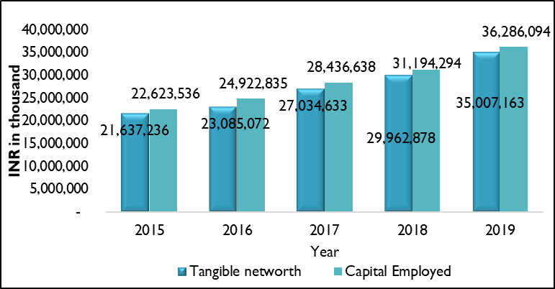
Tangible networth and capital employed

- The tangible networth of the Company improved y-o-y during the review period owing to accretions to reserves.
- The capital employed by the Company increased during the review period on the back of an increase in tangible networth. Total borrowings increased sharply in FY 2016 and then witnessed declining trend till FY 2018 followed by a minor increase in FY 2019. This increase in FY 2019 was on account of term loan from Citibank which is to repaid in single bullet payment by FY 2021.

Elongated working capital cycle

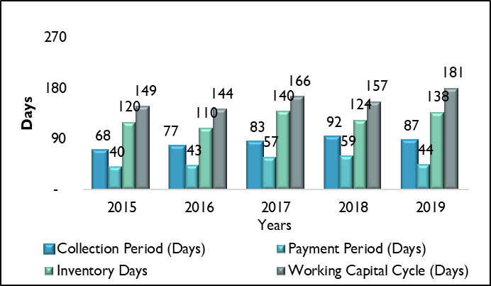
- The Company has an elongated working capital owing to high collection cycle and high inventory period. Working capital cycle stood at its peak at 181 days during the review period.
- Working capital was mainly funded through internal accruals and minimal advances from customers. In order to mitigate the challenge of raw materials (scrap), AIAE maintains minimum 2 months’ stock (since during the monsoons mining of bentonite and sand is risky). The Company similarly stocks ferro chrome and maintains a high inventory of spares to ensure zero down time. This resulted in high inventory period which stood at138 days in FY 2019.

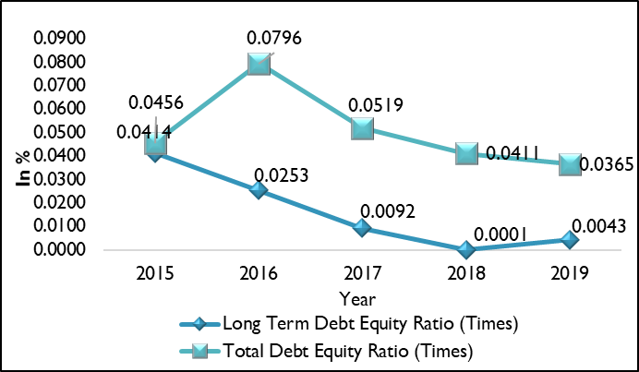
Leverage: Underleveraged capital structure marked by minimal reliance on working capital debt

- The gearing of the Company remained below unity throughout the review period on account of minimal debt.
- Accordingly, the interest coverage stood strong at over 100 times.

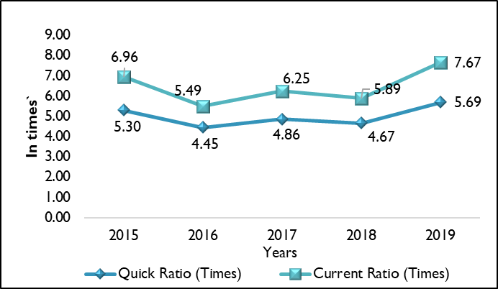
Liquidity: Healthy liquidity position

- Liquidity position of the Company stood healthy backed by substantial cash accruals.
- This was further supported by adequate cash balance and liquid investments which cumulatively stood at INR 13,599,095 thousand in FY 2019.

Refer to annexure for details

KEY FINANCIAL ELEMENTS AND RATIOS - STANDALONE

Amount in INR thousand

Financial Movements - Standalone

Revenue: Barring dip in FY 2016, witnessed continual growth at a CAGR of around 11% between FY 2016-19

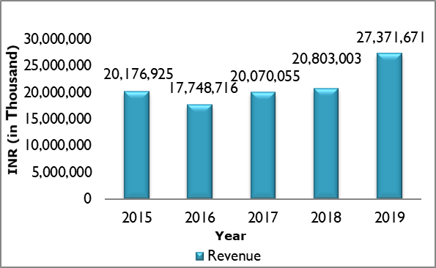
- The Company’s revenue improved during the review period except FY 2016. As informed, the dip in revenues was on account of sluggish economic conditions as well as softening of commodity pricing in mining industry (which is the major revenue contributor segment) leading to sales price reduction.
- It remained sluggish in FY 2018 with a growth of approx. 3%. Cement industry remained flattish and volatility in ferro chrome prices impacted the sales price.
- It increased in FY 2019 on account of increased penetration in newer markets such as Latin America, addition of customers and increase in wallet share from few existing customers.

Profitability: Pressure on margins owing to volatile material cost, freight, and exchange rate fluctuation

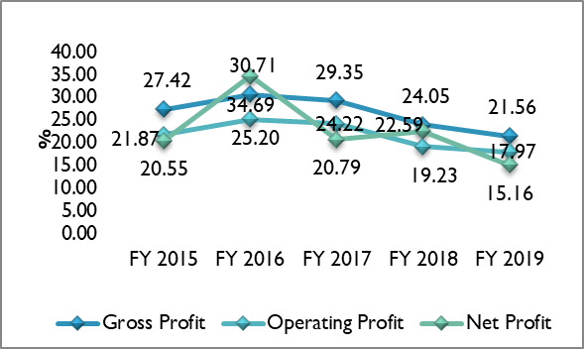
- The gross margins of the Company were impacted by volatile ferro chrome and steel prices and relatively lower sales realization on account of penetration in new markets coupled with addition to new customers (including new contracts from existing customers especially for mines in other regions).
- However, the Company maintains that it targets EBITDA margins of 20-22%.
- Operating margins moved in tandem with the gross level margins.
- Net margins were erratic on account of uneven dividend income coupled with profit from sale of investments and foreign exchange rate movement. Dividend income is majorly from Vega Industries (Middle East) F.Z.C. (wholly owned subsidiary acting as distributor) and has been varying from being nil to 14-15% of revenue during the review period. It stood high at INR 114 crore in FY 2018 aiding the net profit margins during that period, however, stood nil in FY 2019. This coupled with uneven tax provisioning expense as percentage of revenue results in high variation in the net margins.
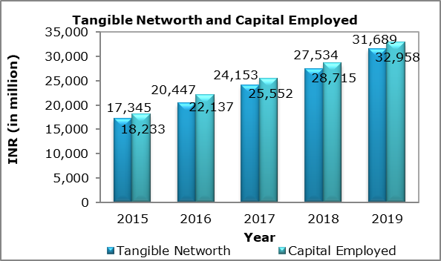
Tangible networth and capital employed

- The tangible networth of the Company improved y-o-y during the review period owing to accretions to reserves.
- The capital employed by the Company increased during the review period on the back of an increase in tangible networth. Total borrowings increased sharply in FY 2016 and then witnessed declining trend till FY 2018 followed by a minor increase in FY 2019. This increase in FY 2019 was on account of term loan from Citibank which is to repaid in single bullet payment by FY 2021.

Elongated working capital cycle
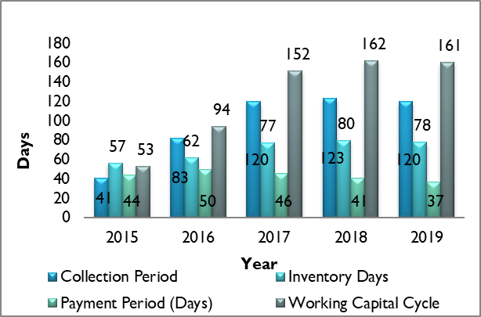
- FY 2017 to FY 2019 witnessed elongated working capital owing to large collection cycle and high inventory period. Working capital cycle depicted an increase in the past three years and stood above 150 days.
- Working capital was mainly funded through internal accruals and minimal advances from customers. In order to mitigate the challenge of raw materials (scrap), AIAE maintains minimum 2 months’ stock (since during the monsoons mining of bentonite and sand is risky). The Company similarly stocks ferro chrome and maintains a high inventory of spares to ensure zero down time. This resulted in high inventory period which stood at 78 days in FY 2019.

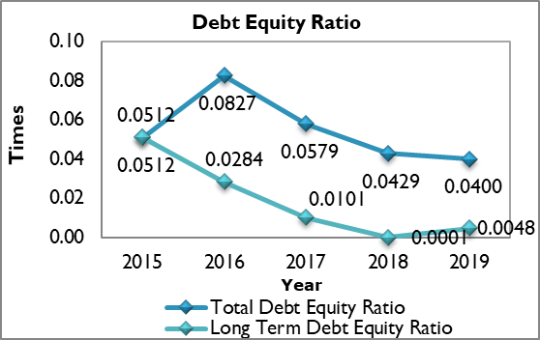
Leverage: Underleveraged capital structure marked by minimal reliance on working capital debt

- The gearing of the Company remained below unity throughout the review period on account of minimal debt.
- Accordingly, the interest coverage stood strong at over 100 times.

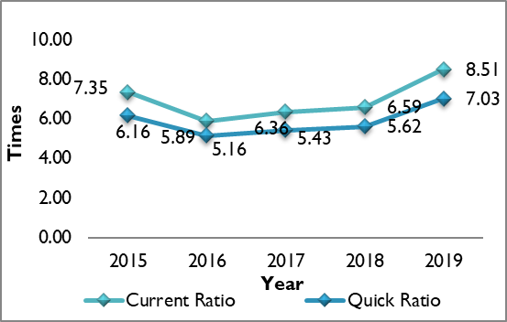
Liquidity: Healthy liquidity position

- Liquidity position of the Company stood healthy backed by substantial cash accruals.
- This was further supported by adequate cash balance and liquid investments which cumilatively stood at INR 10,784,624 thousand in FY 2019.

Refer to annexure for details

Cost Structure of the Company as a percentage of Total Cost

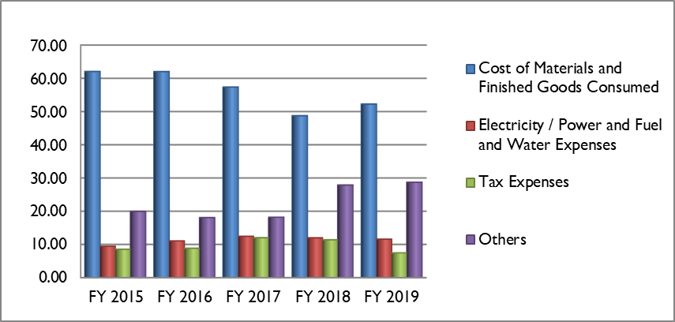

Raw materials cost accounted for approx. 56% on an average of the total revenue of the Company followed by power and fuel expense which accounted for another 11% of total revenue.

PROVISIONAL FINANCIALS (CONSOLIDATED)

Amount in INR thousand

Source: Company website

FREE CASH FLOW ANALYSIS

Amount in INR thousand

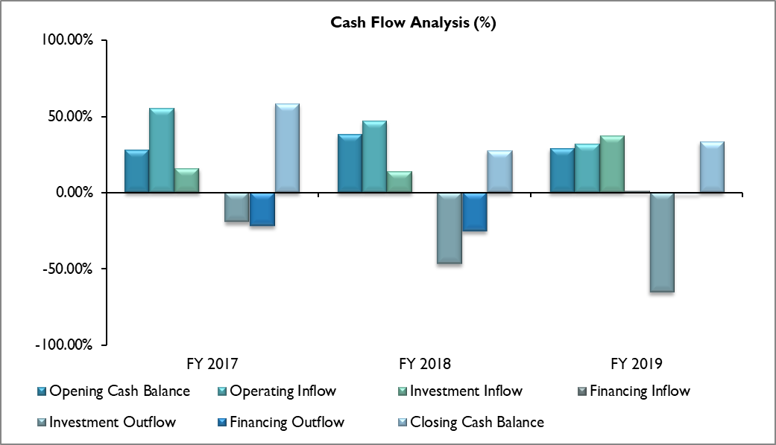

FREE CASH FLOW TO THE FIRM (FCFF)

FCFF indicates the amount of cash generated by the Group after meeting its operating expenses, taxes, changes in its net working capital requirements, capital expenditure and investing requirements. This indicates cash available with the Company for distribution among investors (both debt holders and equity holders). Free cash flow is important because it allows the Group to pursue opportunities that enhance shareholder’s value.

INR in thousand

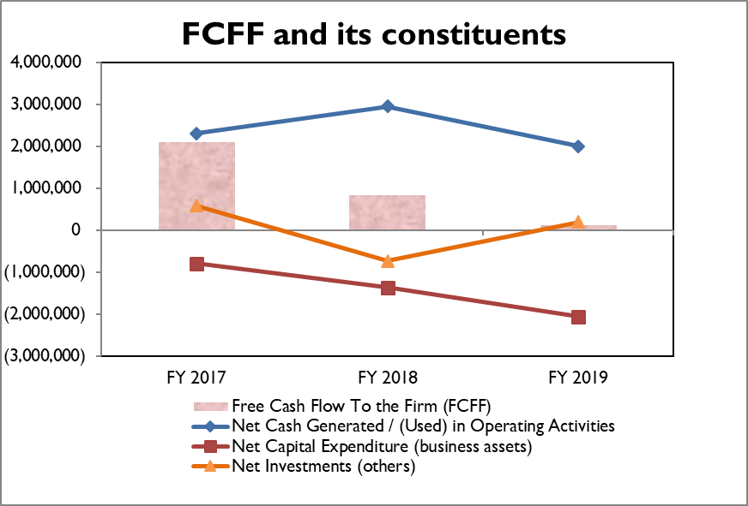

Key Observations

FCFF of the Group increased in FY 2018 on account of decrease in operating cash flows coupled with incremental capex undertaken for purchase of fixed assets and other investments. It further declined due to decrease in operating cash flows coupled with incremental investments towards purchase of fixed assets.

FREE CASH FLOW TO EQUITY (FCFE)

FCFE indicates the cash available to the equity shareholders’ (including the preference shareholders) post reinvestments, capex and repayment of debt obligations. FCFE is a measure of capital usage and used to determine the value of the Company.

INR in thousand
Tax rate assumed at 30%

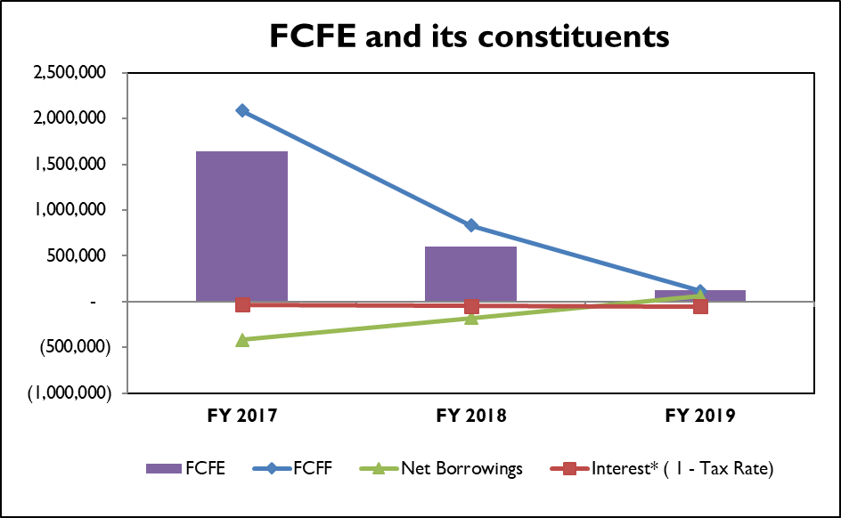

Key Observations

FCFE of the Group witnessed a declining trend from FY 2017-19 on account of decline in FCFF coupled with net repayment of borrowings in FY 2017 and FY 2018.

INCREMENTAL CASH FLOW ANALYSIS

The following tables provide information about the incremental cash availability / (requirement) for future three years in case the Company is able to bring about modifications in its collection period, payable period and inventory holding days.

- The estimated period has been calculated on the basis of an average of the receivable, payable and inventory days for the last three years.

- The cost of goods sold for the future period has been calculated as a percentage of revenue. This percentage has been calculated as an average of cost of goods sold as a percentage of revenue for the period under study. The cost per day has then been multiplied by the number of inventory days to arrive at the amount locked in inventory.

- The cost of purchases for the future period has also been calculated as a percentage of revenue. This percentage has been calculated as average of purchases as a percentage of revenue for the period under study. The cost per day has then been multiplied by the number of payable days to arrive at the amount payable to creditors.

- Future revenue has been calculated assuming a CAGR of 7%.

- Incremental cash availability / (requirement) have been calculated as the difference between the cash flow as per the estimated days and the respective scenario.

- The number of days as mentioned under estimated days, pessimistic scenario and optimistic scenario are applicable for all three future years.

Note: The data along with the different scenarios is only estimation.

Impact of Optimistic Scenario
Amount in INR thousand

Impact of Pessimistic Scenario
Amount in INR thousand

SENSITIVITY ANALYSIS

For the purpose of undertaking sensitivity analysis, we have considered the impact of movement in certain key factors, on the profitability of the Company, which are mentioned as below:

- Revenue
- Raw material cost

We have considered the below mentioned independent scenarios to measure sensitivity of the above factors on some of the key financial elements of the Company. In each of these scenarios, all other factors have been kept constant.

SCENARIOS Text

The results of the analysis are as follows and all the results have been compared with the base case scenario:

Note: Base case scenario is weighted average of financial elements of FY 2017 to FY 2019.

Key Observations

- It can be seen that a decline / increase in revenue (Scenario 2 and 4) or increase / decline in raw material costs (Scenario 1 and 3) has led to fluctuation in margins at all the three levels (gross, operating and net) as compared to the base ratios. The profit margins are more susceptible to adverse/favorable movement in raw material costs which contributed to over 50% of the total revenue in FY 2019. Hence, the ability of the Company to control the raw material costs remains important.



D&B RATING

RATING AND GLOSSARY
D&B Rating : 5A1
Condition : Strong

D&B Indicative Risk Rating consists of two parts, the Financial Strength and the Composite Appraisal / Condition. Financial Strength is an indication of the tangible networth (that is, the shareholder's funds less any intangible assets). The Composite Appraisal / Condition is linked to the level of risk and is an overall evaluation of credit worthiness. It takes into account the financial condition and several factors such as trade reference history, legal structure, management experience and any adverse listings.

D&B Indicative Risk Rating of 5A implies that the Company has a tangible networth of INR 645,950,000 and above as per latest available audited financial statements. Composite appraisal 1 indicates that the overall status of the Company is Strong.

RATING DRIVERS

Strong market position in the high chrome mill internal (HCMI) industry : AIAE manufactures grinding media, liners and diaphragms which are collectively known as mill internals, used for crushing operations in the cement, power utility, mining and aggregate industry. As informed, the Company is the second largest high chrome casting producer in the world second only to Belgium based Magotteaux. As informed, over the years, AIAE has created a competitive advantage for itself in the product that it supplies to the customers through high and consistent quality of products, uninterrupted supplies, undertaking mill audits, custom made products, undertaking installation services. This has helped AIAE build strong relations with customers, thus, securing repeat orders from them. AIAE caters primarily to iron, platinum, gold and copper mines, and approx. 76% of its revenue comes from exports to over 125 countries. The demand primarily emanates from a strong replacements as well as increased demand in the mining industry. Moreover. continuous capacity additions over the last few years have made the Company a dominant player in the segment with significant market share. Its current capacity stands at 390,000 MT per annum and plans to add another 100,000 MT by FY 2021. The blended capacity utilization stands at approx. 85%. Post the completion of capex, the Company is likely to emerge the largest high-chrome player in the world by capacity. The Company has constantly gained market share through its cost leadership, strong distributional capabilities, repeat orders from customers with wide product offering that has positioned AIAE as a strong player in the segment.

Well diversified customer base across geographies and sectors: The Company majorly caters to mining and cement sector and has a large clientele base of more than 500 regular customers. It supplies to over 125 countries world-wide with direct sales to the customers. The marketing is through subsidiaries located overseas in Middle East, UK, USA, South Africa, China and Indonesia. It has floated another subsidiary in Australia to penetrate in that market. Some of its regular customers include Rio Tinto Group, Lafarge Holcim, Newmont Mining Corporation, Barrick Group and Vale S.A. Long term contracts are entered into with the mining customers.The Company’s strategy has been to increase its revenues from its existing customers along with adding new clients in different geographies. As informed, it has recently added Latin American countries like Chile, Peru, Ecuador, etc. to its geographic spread. Also, it has a well-diversified clientele, with sales to mining, cement, power and aggregate industries. In the international market, the Company sells its products under its own brand “Vega”. Further, within mining (which formed over 64% of the total revenues in FY 2019); the Company caters for different mineral ores like iron, platinum, gold and copper. Thus, any sluggishness in the demand of one ore is not expected to materially impact the AIAE’s overall revenue growth. The Company is expected to continue to benefit from its wide customer base located globally.

Healthy financial risk profile: Revenue of the Company depicted continual growth during FY 2016-19 marked by a CAGR of 20.27%. Earlier in FY 2016 there was a slight de-growth, due to sluggish economic conditions, and downswing in commodity prices affecting the mining industry as a whole. Nonetheless, healthy order book (INR 593 crores as on 1st July 2019) and expansion of capacities augurs well for the growth of the Company over the medium term. Furthermore, the capital structure of the Company stood comfortable with debt equity ratio of 0.04 times in FY 2019 on the back of healthy accretion to reserves coupled with minimal borrowings. Moreover, as a conservative leverage policy adopted by the Company, capital expenditure over the medium term would also be funded through internal accruals keeping the leverage low. Robust debt protection metric enables the Company to procure additional funds in case of any business exigencies or fund incremental capex. Low leverage also resulted in strong interest coverage indicator throughout the review period. Additionally, the liquidity of the Company also remained healthy with the net cash and cash equivalents (including current investments) standing high at approx. INR 13,599,095 thousand as at 31st March 2019. Though the Company has large working capital requirements in the form of high inventory holding period and receivables, it was able to manage it efficiently, as majority is funded through internal accruals with low reliance on the external borrowing.

Limited pricing flexibility coupled with volatility in prices of raw materials puts pressure on maintaining profitability: The Company’s main raw materials comprise steel scraps and ferro chrome prices of which are volatile in nature. The domestic prices of these commodities (viz. steel & alloys) follow the international trends which in the long run are influenced by global demand and supply factors that are beyond the control of the Company. Raw material costs constitute on an average approx. 48% of the total revenue. Though, the Company has a long standing presence and due to its strong operating efficiencies are able to price its products at competitive rates, it is not able to fully pass on the raw material price increase to the customers due to focus on penetration in newer markets and drive up volumes. This is evident with the gross profitability being negatively impacted by y-o-y increase in material cost as a percentage of revenue. Gross profit margins declined y-o-y between FY 2016-19. Also, ability of the Company to optimally utilize the incremental additions to capacities is critical to sustain margins. Though considerable volatility in input prices mainly ferro chrome and increase in shipping rates on account of major consolidation in the shipping industry resulted in contraction of margins, the same still remains comfortable and within the management’s target of 20-22% at EBITDA level. As informed, the Company enters into long term contracts with most of its customers (largely in mining contracts) wherein purchase order is raised from time to time and price revision if required are adjusted on a quarterly basis (basis changes in cost of power, material, labor and foreign exchange rate variation) which helps it to maintain margins on contracts with existing customers.

Working capital intensive operations: The Company’s operations are working capital intensive primarily emanating from high inventory and collection period. The inventory days ranged from 110-140 days (138 days in FY 2019) and collection period hovered around 68-92 days (87 days in FY 2019). This led to an increase in the working capital cycle to 181 days in FY 2019 thereby straining the working capital requirement of the Company. AIAE maintains minimum 2 months’ stock of scrap and ferro chrome along with high inventory of spares to ensure zero down time. The majority of the finished good inventory maintained is at the warehouses in its principal offices (subsidiaries) overseas. The same is required to supply products on just in time (JIT) to the customer’s sites worldwide. Also, credit allowed to the customer is 70-90 days which as informed, is realized in time. Collection days also increased sharply in FY 2017 (at standalone levels) owing to change in the collection policy from subsidiary companies. As informed, ECGC (export insurance provider) has intimated AIAE’s subsidiary Vega Industries to make payments to AIAE only after it received payment from the end consumer, as a consequence of which the collection days of AIAE on standalone basis increased sharply. High working capital requirement to some extent is offset by payables which have fluctuated between 40-59 days. Nevertheless, the Company has been managing its high working capital requirements through its internal accruals. Also, it has significant undrawn bank limits from Citibank at its disposal to fund any working capital gap.

RATING SENSITIVITY

Ability of the Company to sustain its margins as it continues to increase its scale of operations and targets volume growth

The Company has a huge capital expenditure plans over the next two years (until FY 2021) to increase its installed capacity for grinding media as well as for mill liners. The utilization of the additional capacities would help the Company to increase its topline going forward. However, the Company continues to face pressure on its bottom line on account of volatile material cost and relatively lower sales realization due to penetration in newer markets. As a result, material cost as a percentage of revenue increased throughout the review period resulting in y-o-y declining margins at all levels in the past four years (FY 2016-19). Hence, ability of the Company to sustain its margins while it continues to increase its volume growth remains critical.

As informed, increase in the capacity for mill liners backed up by technical collaboration with EEMS will likely result in a high margin-accretive product mix and facilitate customer additions. This is likely to aid both the topline and bottomline growth in the medium term.

Ability of the Company to ramp up its operations on the back of significant increase in its facility

The Company is undertaking capital expenditure to increase its capacity, set up a greenfield facility to manufacture mill linings and investing in wind mills. The ability of the Company to effectively utilize the additional capacity being created will remain crucial to improve its topline and return indicators going ahead.

Ability of the Company to reduce working capital intensity

The collection days increased sharply since FY 2017 (at standalone levels) owing to change in the collection policy from subsidiary companies and increasing working capital intensity. They stood at around 120 days (at standalone level) in the past three years. Although the Company has minimal working capital debt utilization, its ability to reduce the high working capital intensity stemming from its receivable days remains critical.

Negative impact due to ongoing arbitral proceedings

Magotteaux International S.A. Belgium (earlier JV partner) initiated arbitral proceedings against the Company and its managing director Mr. Bhadresh K Shah before the International Chamber of Commerce London (ICC) and has claimed the reliefs of injunction and damages inter alia alleging infringement of its patent by AIA in relation to its Sintercast product and breach of the Settlement Deed in relation to its Sintercast product. According to Magotteaux in its request for initiating Arbitration the amount in controversy in the arbitral dispute is approximately USD 60 million (approx. INR 415 crore or 12% of the tangible worth as on 31st March 2019) including costs and damages. AIA is confident of defending the matter and accordingly has not made any provisions against the contingent liability. However, the extent any adverse financial or non-financial impact of an unfavorable judgement remains a key rating sensitivity factor to be monitored.

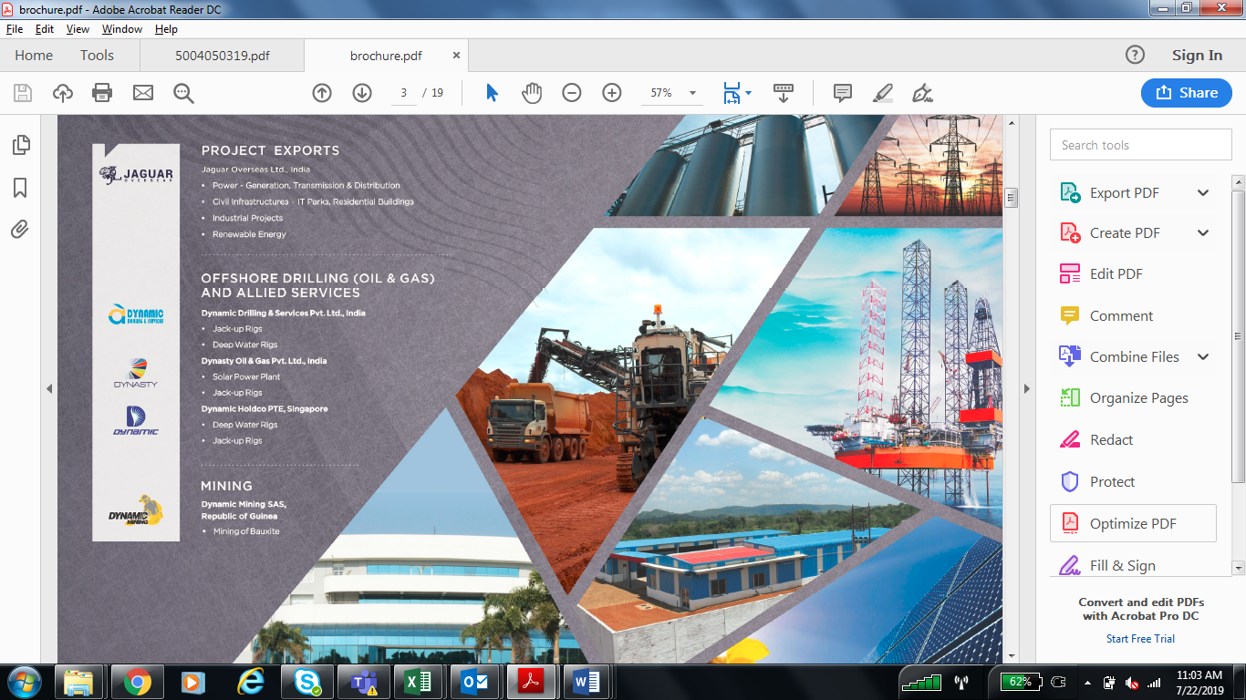

SECTOR OVERVIEW AND DEMAND DRIVERS

SECTOR OVERVIEW

Industry Profile

India was ranked as the second largest casting producers globally as per 51st World Casting Census published by Modern Castings USA in December 2017. Foundry industry that involves casting of a metal, is one of the key sector supporting significantly to the overall manufacturing activity. It is one of the preferred process to manufacture metal products with complex design. Casting process involves pouring the molten metal through a die-cast of the desired shape. On cooling, the die cast is removed, and the solidified metal takes its shape. Depending upon the type of metal and nature of product multiple die casting methods are used.

The different variety of casting alloys and their adaptability offers the choice of most prudent materials to satisfy the requirements of a particular application. Each and every combination has specific physical and mechanical attributes, and its own particular casting properties, machinability, weldability, corrosion protection, temperature treatment properties and different qualities.

Capital Goods industries are the major consumers of castings products. Cast metal products find applications in Tractor, Railways, Machine tools, Automobile, Defence, Earth Moving, Textile, Aerospace, Wind turbile Generators, Cement, Electrical, Power machinery, Sanitary, Pipe Fittings, Pumps, Valves etc.
Casting process can be performed on steel & steel alloys, aluminum metal as well as ferrous & non-ferrous metals (where Grey iron castings account for ~ 70% of total castings produced). Few large players in this industry also specializes in manufacturing of High Chromium consumable wear parts (mill internals) which are used for Crushing and Grinding equipment primarily in the Cement, Mining, Thermal Power and Aggregate Industries. Therefore, level of infrastructure development in these industries is basic drivers of to the requirement of wear parts in these industries.

Production Scenario

Global casting production is estimated to be nearly 110 million tons per annum in 2018, with China alone accounting for nearly 45% of the total production volume. Production of casting in India is estimated to be 12.7 million tons per annum, in FY 2019 while the production capacity is estimated at 15 million tons per annum. According to The Institute of Indian Foundryman, the annual turnover in Indian foundry industry is estimated at USD 19 Billion.
Grey Cast Iron dominates Indian foundry sector, accounting for nearly 66% of casting manufactured in India. Grey Cast Iron is the most widely manufactured casting product in the world, with common applications ranging from automotive components, machinery bases, wind turbine housing, and weights & counter-weights, among others.

Regulatory Scenario

Metal working industry is loosely regulated with minimal operational restrictions for private players. There is no control over production / export / pricing and FDI is allowed under automatic route. The sector benefits by the government’s pro industrial policies that is likely to push industrial growth and create demand for casting products. “Make in India” initiative by the government, which aims to strengthen industrial sector in the country, would have a positive impact on cast metal component manufacturers.

Indian Government, in July 2017, imposed a definitive anti-dumping duty on castings used in wind turbines imported from China. The duty has been imposed for a period of five years, with the rate of anti-dumping duty ranging from 6.27% to 35.92% of the landed value.

Demand Drivers

Automobile sector is the largest consumer of castings in India, accounting for approximately 32% of the total consumption. Industrial machinery, agriculture machinery, pumps & compressors, and pipes & fitting sector together accounts for nearly 25% of the total consumption. Other application sectors include earth moving equipments, diesel engines, machine tools, electrical equipments, railways, power, and valves.

With automobile industry consuming the highest volume of casting, the demand scenario in casting industry is directly linked to the automobile sector. Indian automobile industry is currently during a slowdown, with demand growing by slowest rate in over a decade. High GST rates, distress in agriculture sector, stagnant wages, business uncertainty, and liquidity constraints have impacted demand. This has forced automobile manufacturers in the country to cut down on production, leading to lower demand for input materials including casting. The revival in casting industry is thus dependent largely on rebound in automobile industry.

Capital goods & engineering industry (comprising of manufacturing of components ranging from industrial machinery to electrical equipment to valves) also consumes considerable volume of casting. Thus an expansion in industrial production directly transforms into higher demand for castings. However industrial production in India has been contracting for past few months, due to contraction in manufacturing, capital goods and consumer durables. Factory output has declined to multi year lows while other macro industrial indicators like power generation increased by a slow rate. The overall industrial scenario is pessimistic and manufacturers across sectors are cutting back on production as well as shelving expansion plans. This has severally impacted the offtake of casting by the manufacturing sector.

Thus, it could be commented that the foundry industry in India is currently in a dire scenario with demand contracting.

Long Term Outlook

However, the long-term outlook for the casting industry appears to be favorable. Indian Government is actively taking steps to increase the share of manufacturing to GDP from the current level of below 15% to 25% by 2022. Supportive policies are designed across capital goods and engineering industry, to beef up capacity and increase production. Since casting is an integral part of both capital goods and engineering industry, the focus on manufacturing would directly result in higher demand for casting.

Government Initiatives and announcement favoring Capital Good Industry

Indian capital goods sector was de-licensed following the industrial reforms of 1991, leading to an influx of private players. Additionally, relaxation in investments, especially foreign investment (100% FDI allowed in the sector) as well as participation of foreign investments too improvement the capital flow as well as technology level in this sector. These measures have led to a scenario wherein large domestic private players and Indian arm of multinational companies compete to achieve greater market share. Government intervention is limited to those industries which are of strategic nature.

National Capital Goods Policy

The key objective of the policy approved by the Union Government in 2016 is to increase the production of capital goods in India, as well as generate employment opportunities. The policy envisages increase in domestic production of capital goods from INR 230,000 crore in FY 2015 to INR 750,000 crore in FY 2025. On the job creation front, the policy aims to increase the workforce from approximately 8.4 million (direct & indirect employment) to 40 million by FY 2025.

With casting products forming an integral part of the capital goods industry, programs and policy measures formulated & implemented under the National Capital Goods Policy would help in improving domestic manufacturing infrastructure in the sector. Further, the Technology Acquisition Fund Programme (TAFP) envisaged under the capital goods policy would help in improving the manufacturing technology in the sector.

Export Import

The annual value of casting products exported from India is estimated to be INR 80 Bn in FY 2019, increasing by a CAGR of nearly 4% during the last five years. USA is the largest export market for Indian casting industry. In FY 2019 the value of castings exported to the US accounted for nearly 25% of the total value of casting exports. Apart from the US, Indian casting industry has also managed to penetrate the markets of developed economies in the Europe.

Meanwhile the value of casting products imported to India reached INR 10.7 Bn in FY 2019, increasing by a CAGR of nearly 19% during the time period FY 2014-19. China is the largest exporter of castings to India.

Competitive scenario

Metal casting is a fragmented sector and comprises of about 5000 units out of which 90% can be classified as MSMEs. Smaller scale manufacturing units are present in low-value generic products with a simpler design. Since pricing is a major distinguishing factor among these basic metal cast products the level of price-based competition is intense. Lower price combined with declining demand saw most of these smaller companies operating in thin profit margins. In India, the foundry is found to be present in the cluster which includes Jalandhar, Ludhiana, Agra, Batala, Pune, Kolhapur, Sholapur, Rajkot, Mumbai, Ahemdabad, Belgaum, Coimbatore, Chennai, Hyderabad, Howrah, Kolkata, Indore, Chennai, Ahemdabad, Faridabad, Gurgaon etc
Each cluster is known for catering the need of some specific end-user industry. These include the Coimbatore cluster for pump-sets castings, the Kolhapur and the Belgaum clusters for automotive castings and the Rajkot cluster for diesel engine castings etc.

Also, more than 1500 units have International Quality Accreditation. Few large foundaries are equipped with modern technology and are globally competitive. These companies cater to high-end product segments, mostly value-added metal products in auto components and industrial machinery. Product quality plays a vital role in shaping the competition in this high-value product segment.

Aurangabad Electricals Ltd., Bhagwati Autocast Ltd., Carnation Industries Ltd., Godawri Spherocast Ltd., Hindusthan Malleable & Forgings Ltd., Indu Engineering & Textiles Ltd., Nelcast Ltd., Porwal Auto Components Ltd., Sakthi Auto Ancillary Pvt. Ltd., United Foundries Pvt. Ltd., Universal Autofoundry Ltd. are few companies engaged metal casting.

Few major players engaged in manufacturing of heavy cast material for consumable wear parts include Ador Welding Ltd, AIA Engineering Ltd, and ESAB India Limited, amongst other.

MACROECONOMIC SUMMARY
[A] Global Economy

[A] Global Economy

The momentum in global growth continued to moderate towards the end of 2018 and is expected to decelerate in 2019 amidst increasing headwinds from weak global manufacturing activity, global trade and growing world-wide political uncertainty. The slowdown in 2018 has been witnessed majorly in the manufacturing sector with global merchandise trade slowing down sharply. Service sector activity has also moderated recently. High and rising political and policy uncertainty such as Brexit, heightened trade concerns and signs of weaker growth in China will continue to weigh upon global economic activity in 2019. Global trade is expected to weaken more significantly going ahead and global inflationary pressures are also expected to remain contained. Development in individual countries are as follows

Euro Area - The real GDP growth remained subdued in the Q4 2018. The manufacturing sector continues to remain weak led by slowdown in external demand and also owing to some country and sector-specific factors. The risks to growth outlook are still tilted to the downside, on account of geopolitical issues, protectionism and weakness in emerging markets. Borrowing conditions in the Euro area remains favourable both for firms as well as households. The monetary policy measures continue to support access to financing, in particular for MSMEs. The new series of quarterly targeted longer-term refinancing operations (TLTROs) is expected to support credit demand.

USA – The economic activity continued to remain robust as the fiscal stimulus, favourable financial conditions and strong labour market supported growth offsetting impact of the trade dispute with China. In 2018, the US achieved an above-trend real GDP growth rate of 2.9% given improvement in personal and government consumption and private domestic investment. While a number of positive conditions supported the growth, a number of mounting negatives are likely to push overall growth to a slower pace in 2019. A weakening real estate market, a close to inverting yield curve and softening business survey information, indicate growth will slow in 2019. Owing to trade and investment under pressure because of the threat of trade wars and sanctions, China’s deceleration, and political uncertainties in big European economies, the Federal Reserve seems to be holding back on interest rate increases, however, there is an increased likelihood of only one rate hike in 2019.

UK – The heightened political uncertainty owing to Brexit fallout continues to weigh on growth. The short-term outlook is subject to considerable uncertainty as a result of the forthcoming votes on the EU withdrawal agreement in parliament. The consumer confidence remains in the negative zone, despite improving labour market conditions and robust wage growth. Import demand remained almost stagnant during the first three quarters of 2018. Investment activity also remained weak with investment in plant and machinery falling in 12 out of the last 15 quarters.

JAPAN – Following the natural disaster induced contraction in growth in Q3 2018, growth strengthened in Q4 2018 supported by domestic demand. Going ahead, the growth will be supported by strong demand for investment, accommodative monetary policy stance and strong labour market. In October 2019, there will be an increase in the consumption tax, however, fiscal measures are being taken by the government to cushion the impact. Inflation is likely to remain below the Bank of Japan’s 2% target over the medium term.
Emerging economies - Growth in Emerging Market Economies (EMEs) also weakened in late 2018. In China there has been a loss of growth momentum in recent months and this trend is likely to continue in the early part of 2019. In order to protect the economy from a sharper slowdown, the Chinese government has announced a number of fiscal and monetary policy measures. Russia, Brazil and South Africa remained impacted both domestic and external demand.

[B] Indian Economy

[B.1] Core Outlook

- India will ultimately benefit from a multi-year period of digitization of transactions, tax base expansion and financial deepening.

- India's 264 million strong population of 15-25 year-olds will provide a powerful demographic dividend in the next decade.

- High business costs reflect chronic supply-side problems and can outweigh the advantages of an early-stage market, while infrastructure plans still lag requirements.

- Two-thirds of Indians depend on farm income, making India vulnerable to monsoonal disruption from climate change and El Nino episodes.

- Labour-intensive industries are failing to grow and absorb new workers rapidly.

[B.2] Key Development

[B.2.a] Credit Environment Outlook

- The RBI reduced the policy repo rate back to back by a cumulative 50 basis points from 6.50% to 6.0% during its Feb and Apr 2019 monetary policy meeting and changed the policy stance from calibrated tightening to neutral in Feb 19.

- Bank credit to industry grew by 5.2% in Jan 19, highest since Mar 16. Export credit, which has been contracting since Apr 17, contracted further by 45.5% in Jan 19.

- The RBI relaxed trade credit norms for imports of capital and non-capital goods. Under the revised trade credit (TC) policy, TCs up to US$ 150 million or equivalent per import transaction can be availed now from the earlier limit of US$ 20 million for oil and gas refining & marketing, airline and shipping companies under the automatic route. For other sectors, an amount up to US$ 50 million or equivalent per import transaction can be availed.

- With a view to facilitating flow of credit to well-rated NBFCs, the RBI decided that rated exposures of banks to all NBFCs, excluding Core Investment Companies (CICs), would be risk-weighted as per the ratings assigned by the accredited rating agencies, in a manner similar to that for corporates. Exposures to CICs will continue to be risk-weighted at 100%.

[B.2.b] Supply Environment Outlook

- The government has lowered the basic duty on import of Crude Palm Oil and RBD Palmolein from ASEAN countries, providing deeper tariff concessions to Malaysia. With this, the effective duty difference between CPO & RBO Palmolein stands reduced from 10% to 5%, resulting in sharp increase in import of RBD Palmolein which nearly doubled to 241,101 tons in Feb 2019.

- US’s decision to remove 90 products from the list of duty-free provisions under the Generalized System of Preferences (GSP) effective Nov 1, 2018, is expected to impact at least 50 goods exported by India, mostly exported by MSMEs under the handloom and agriculture sector. Further, the US announced that it intends to terminate India’s designation as beneficial countries under the Generalized System of Preferences (GSP) program.

- India’s new e-commerce policy which bars retailers from selling products from companies in which they have an equity interest and prevents them from holding 25% of their inventory from a single vendor underscores the risk foreign companies face in India and the restructuring of operations they would have to undergo.

[B.2.c] Market Environment Outlook

- The RBI announced a separate scheme called ‘Voluntary Retention Route’ (VRR) to encourage Foreign Portfolio Investors (FPIs) to undertake long-term investments in Indian debt markets. The aggregate investment limit shall be Rs 40,000 crores for VRR-Govt and Rs 35,000 crores for VRR-Corp and the minimum retention period shall be three years.

- Net FDI inflows for Apr-Dec FY19 stood at US$ 33.5 billion, only 7% lower compared to last year inflows.

[B.2.d] Political Environment Outlook

- A stable government at the Centre indicates continued policy thrust

- Cross-border tension with Pakistan continued.

[B.3] Short Term Outlook

The current domestic growth rate seems to have become sluggish as it has moderated sharply from the levels it was expected to grow at the beginning of the year. Given the headwinds in the global economy and domestic structural bottlenecks, the concerns are thus two pronged: whether the sluggishness would worsen or whether the current growth rate will be maintained. The current slowdown in GDP (Q4 2018) is particularly led by the sharp moderation in the government and private sector consumption. In the short term the risks remain accentuated as the concerns on global front are growing while domestically, slower pick up across sectors and investment indicate that the slowdown is becoming more apparent. The concerns could prolong beyond the short term if the rural economy does not gather strength, the issues in some of strategically important sectors such as telecom, power and real estate are not resolved, the stressed assets in the banking sector are not cleaned, tax mobilization through GST decline and buoyancy does not return to consumer confidence.
Expect prospects for economic growth to become clearer after the new government at the Centre announces its mandate/strategy to boost the growth momentum. Smaller companies have been battered by burdensome new tax regulations for the GST, controls on bank lending and higher lending rates for working capital. The impaired loans will remain concentrated in manufacturing industries and upstream sectors, despite the gradual improvement in the quality of banks' loan portfolios.

[B.4] Long-Term Economic Potential

The past two years, incremental reform measures have gained traction in infrastructure, financial inclusion and energy; each offering low-hanging fruit to improve productivity and realize India’s long-term growth potential. Various efforts are being made to unshackle business from decades-old red tape; for example, passage of the new bankruptcy code aims to address the exit problem that has long-tormented the economy and forestalled innovation. The series of stringent measures in 2016, including demonetization, along with the implementation in 2017 of the Goods and Services Tax (GST) should eventually change the face of the Indian economy and will enhance the efficiency of the internal goods and services market, increasing the tax base and improving tax compliance. The initiatives related to industrial relations, employees’ provident funds, wages and small factories are also expected to be pushed further by the government. India’s openness (its trade as a percentage of GDP) has increased from 19.4% in fiscal 1990/91 to 41.0% in 2017/18. However, the country has still not deployed its potential comparative advantage in labor-intensive industries, and there is still a risk that the development of industrial supply chains globally could pass it by. India has removed several major hurdles inhibiting the inflow of capital and has further plans for liberalizing FDI policy.
India’s population is predicted to rise to 1.5 billion by 2030 and the labour force to more than 1.0 billion. India will be one of the most youthful nations in the world in 2020, with an average age of 29. The demographic dividend will be an advantage for India, helping to increase savings provided the country’s youth receives education, skill training, and enough employment opportunities.

[B.5] MARKET POTENTIAL

India’s potential as a market and investment destination lies in its young population, a market of more than 1 billion consumers, and increasing purchasing power. However, currently, the consumption demand remains subdued. While the subdued agricultural prices have entailed low demand in the rural sector, the urban demand is being clamped down by a host of factors. Low corporate profitability in FY18 (lowest since FY03) which indicates lower rise in salaries and wages, weak consumer confidence on current economic situation (RBI survey) and unfavorable external scenario has weighed on urban demand.

The US’s decision to remove 90 products from the list of duty-free provisions under the Generalized System of Preferences (GSP) effective Nov 1, 2018, is expected to impact at least 50 goods exported by India, mostly exported by MSMEs under the handloom and agriculture sector. Further, US announced that it intends to terminate India’s designation as beneficial countries under the Generalized System of Preferences (GSP) program. With India’s position as a beneficiary country under GSP in jeopardy, there is a risk to exports worth US$5.6 bn (India exported goods worth US$ 5.6 bn in 2017 under the GSP programme).

The distress in some of the strategically important sectors such aviation, telecom, power, banking and recently real estate has weighed down industrial activity and raised caution. The Indian aviation sector is currently in the midst of a crisis. Almost a fifth of the banking sector’s exposure to the power sector is stressed. The RBI’s circular that stipulated that default of even a single day in payment of interest/principal would trigger formulation of resolution plan had created distress amongst private players and would have added to the NPA levels in the banking system However, the Supreme court’s stay on the RBI’s 12 February circular will save stressed power firms from immediate liquidation. In FY18, the banking sector witnessed losses for the first time since FY93, (till data was available). The losses continued through the first half of FY19 as well. The auto sector has witnessed de-growth in revenues for the past couple of months. However, the government’s push for infrastructure has led to some traction in the steel and cement sector in the recent past. The recent slew of initiatives by the government to propel the activity in the real estate sector might yield results in the near term. The sector has been in doldrums followed by the slowdown in the supply of funds followed by the liquidity crisis in the NBFC sector, increase in the requirement of funds to develop a project after the implementation of RERA, rising inventories and debt levels.

Effective April 1, 2019, corporate governance standards will be increased for the Indian listed companies, with the SEBI bringing about changes in the listing regulations and prevention of insider trading regulations. The growing number of whistleblowers and increase in settlement orders passed by SEBI in the past three fiscal years, have ensured that the existing companies and those entering the market will have to follow higher standards of corporate governance.

[B.6] FOREX AND TRANSFER RISK

Though the rupee is expected to retain its strength in the short term on the back of FII inflows, it is unlikely to appreciate significantly given that domestic economic fundamentals remain largely unchanged and uncertainty prevails as India is headed for general election starting April 2019. Moreover, the RBI’s plans to hold a US$ 5 bn foreign exchange swap auction for a three-year tenor for liquidity injection will cap gains in the rupee. The rise in global crude oil prices will also curb the rupee appreciation. The anticipation of pause in the rate hike cycle, with only one hike expected in 2019 coupled with dovish stance adopted by the other major central banks will ease pressure on rupee in 2019. FIIs continued to strengthen in Q1 2019 on the back of a recovery in the rupee, easing of tensions between India and Pakistan as well as indications from major central banks towards extending the existing liquidity support. With the return of foreign institutional investment flows, FX reserves also increased to US$ 407 bn as on March 22, 2019. With accretion of FX reserves, import cover remains in safe territory at close to 11 months as on Feb 2019.
In order to further improve the ease of doing business the RBI has rationalized the extant framework for ECB and Rupee denominated bond. The current four-tiered ECB structure have been merged into two as “Foreign Currency denominated ECB” and “Rupee Denominated ECB”. The RBI has also expanded the scope of eligible borrowers by allowing entities that are eligible to receive foreign direct investment to borrow through external commercial borrowings (ECBs) route. Under the new framework, the RBI has also allowed a uniform borrowing limit replacing the existing sector wise limits. All eligible borrowers can now raise ECBs up to US$ 750 million or equivalent per financial year under the automatic route. The revised norms also include provisions which allows various new lenders in the ECB space and thereby increase the lending options while at the same time strengthening the Anti-Money Laundering/Combating the Financing of Terrorism (AML/CFT). The RBI also allowed bidders under the Insolvency and Bankruptcy Code to raise fund abroad to pay the debt. However, such funds cannot be raised from the foreign branches of Indian banks.

Due to the revision in treaties with Mauritius and Singapore, India will now impose tax on capital gains on inflows from these two countries effective April 1, 2019. The protocol is likely to have an adverse effect on various market participants and investors operating out of Mauritius and Singapore such as P-Note issuers, FPIs, private equity funds and holding companies and impact the inbound investment activity in India. Thus, investors will be gearing up for changes in doing business with India.

In a bid to support the importers of capital and non-capital goods for sectors such as oil and gas refining & marketing, airline and shipping companies, the RBI has relaxed the trade credit norms and reduced the cost of overseas loans. As per the revised Trade Credit (TC) policy, up to US$ 150 million or equivalent per import transaction can be availed by the sectors from overseas supplier, bank, financial institution and other permitted recognised lenders from the earlier limit of US$ 20 million under the automatic route, without prior approval from the RBI. For other sectors, trade credit up to US$ 50 million or equivalent per import transaction can be availed. The all-inclusive cost (all-in-cost) for overseas loans has been reduced to benchmark rate plus 250 basis points from the earlier 350 bps.

DEMAND DRIVERS

 | Large replacement market in the mining industry  Growth prospects are primarily emanating out of the large annual replacement market of 2.5 to 3 million tons in the mining industry of which high chrome mill internal accounts for just 15% of the demand.
 | Positive outlook for mill liners market  Global mill liner sales reached 7 million units in 2018, with an estimated ~4% yearly rise in volumes by the end 2019. Majority of gains are underpinned by the demand within cement industry, followed by that from the mining industry. To satisfy the global requirement, substantial investments have been made in the mining industry, in prominent regions, including Canada, Latin America, Australia, Asia, and Central Europe, among others. The Company also plans greenfield investment of 50,000 MT towards mill lining by FY 2021.
 | Favorable government policies like Make in India to increase industrial demand  “Make in India” initiative by the government, which aims to strengthen industrial sector in the country, would have a positive impact on cast metal component manufacturers. Further, metal working industry is loosely regulated with minimal operational restrictions for private players. There is no control over production / export / pricing and FDI is allowed under automatic route.
 | Collaboration with foreign players  In order to strengthen their core competence while looking for opportunities to expand their operations in global market, technical collaborations provide breakthrough through exchanging technical know-how and allow penetration in different markets

PORTER’S FIVE FORCES MODEL

 |  | Competitive Rivalry (Medium)
- With the capex plan, the Company is on the verge of becoming the largest (High chrome mill internals) HCMI player globally
- Cheap labor and production cost provides competitive advantage to Indian manufacturers
- Presence of large number of unorganized players which cater to small-mid size customers
- Strong technical capabilities and engineer network
 | Threat of New Entrants (Low) |  |  |  | Threat of Substitute Products (Medium)
- High capital requirements  - Sticky nature of contracts  - Product quality and efficiency is critical for entry which requires strong metallurgical experience and knowledge  - Deep understanding of the customer’s process makes it difficult for new players to claim existing market  - Long gestation period in terms of new customer win |  |  |  | - Slow technological upgradation and modernization  - Chrome mills superior to other casting products

 | Bargaining Power of Supplier (Low) |  |  | Bargaining Power of Customer (Medium)
- Prices of raw materials determined by global demand and supply factors  - Large number of suppliers for key raw materials  - Product differentiation is low |  |  | - Switching cost of a customer is high  - Technology intensive product  - For smaller customers and base products – large unorganized sector adds to the bargaining strength

SWOT ANALYSIS


STRENGTHS

Strong market position in the high chrome mill internal (HCMI) industry

Incorporated in 1978, AIAE manufactures grinding media, liners and diaphragms which are collectively known as mill internals, used for crushing operations in the cement, power utility, mining and aggregate industry. As informed, the Company is the second largest high chrome casting producer in the world second only to Belgium based Magotteaux, which was its JV partner till FY 2001. As informed, over the years, AIAE has created a competitive advantage for itself in the product that it supplies to the customers through high and consistent quality of products, uninterrupted supplies, undertaking mill audits, custom made products, undertaking installation services.

This has helped AIAE build strong relations with customers, thus, securing repeat orders from them. AIAE caters primarily to iron, platinum, gold and copper mines, and approx. 76% of its revenue comes from exports to over 125 countries. The demand primarily emanates from a strong replacements as well as increased demand in the mining industry. As informed, almost entire revenue comes from replacement market (as the product is used more as a consumable/spares by the customers) for the Company. Also, it has a wide product portfolio, manufacturing more than 100 different sizes of products which are customized as per technical specifications received from the client.

Continuous capacity additions over the last few years have made the Company a dominant player in the segment with significant market share. As informed, the Company put up additional 50,000 MT of grinding media in Q1 FY 2020 and accordingly has a cumulative capacity of 390,000 MT. It is now in the midst of expanding this capacity to 490,000 MT by brownfield expansion of 50,000 MT at its existing plant in GIDC Kerala, near Ahmedabad for grinding media and greenfield expansion of 50,000 MT for mill internals. The blended capacity utilization stands at approx. 85% and the incremental capex is likely to be commissioned by FY 2021. Post the completion of capex, the Company is likely to emerge the largest high-chrome player in the world by capacity.

AIAE inherited technical expertise in high chrome metallurgy from Magotteaux, Inc., Belgium its erstwhile JV partner with whom it was associated for nine years. This has helped strengthen its product engineering capabilities. Also, the Company is able offer its products at competitive rates as it enjoys a cost advantage vis-à-vis its other global peers, due to its presence in relatively low-cost location (all units in India).

Furthermore, it has entered into a technical tie-up with EE Mills Solutions LLP, USA (EEMS) for mill linings in Q1 FY 2019. EEMS has special knowledge of optimizing energy efficiency and output of grinding equipment like AG/SAG/Ball Mills in wet & dry grinding industries through re-designing of mill internals viz. head & shell liners, grate liners, pulp lifters. The Company successfully completed its first trial for SAG mill liners for a large gold mine in Africa under its collaboration with EEMS, USA. This will aid its revenue growth through customer additions along with higher wallet share from existing customers.

Thus, the Company has constantly gained market share through its cost leadership, strong distributional capabilities, repeat orders from customers with wide product offering that has positioned AIAE as a strong player in the segment.

Well diversified customer base across geographies and sectors

The Company majorly caters to mining and cement sector and has a large clientele base of more than 500 regular customers. It supplies to over 125 countries world-wide with direct sales to the customers. The marketing is through subsidiaries located overseas in Middle East, UK, USA, South Africa, China and Indonesia. It has floated another subsidiary in Australia to penetrate in that market.

Some of its regular customers include Rio Tinto Group, Lafarge Holcim, Newmont Mining Corporation, Barrick Group and Vale S.A. Long term contracts are entered into with the mining customers.

The Company’s strategy has been to increase its revenues from its existing customers along with adding new clients in different geographies. As informed, it has recently added Latin American countries like Chile, Peru, Ecuador, etc. to its geographic spread. Also, it has a well-diversified clientele, with sales to mining, cement, power and aggregate industries. In the international market, the Company sells its products under its own brand “Vega”. Further, within mining (which formed over 64% of the total revenues in FY 2019); the Company caters for different mineral ores like iron, platinum, gold and copper. Thus, any sluggishness in the demand of one ore is not expected to materially impact the AIAE’s overall revenue growth. The Company is expected to continue to benefit from its wide customer base located globally.

Healthy financial risk profile

Revenue of the Company depicted continual growth during FY 2016-19 marked by a CAGR of 20.27%. Earlier in FY 2016 there was a slight de-growth, due to sluggish economic conditions, and downswing in commodity prices affecting the mining industry as a whole. Nonetheless, healthy order book (INR 593 crores as on 1st July 2019) and expansion of capacities augurs well for the growth of the Company over the medium term.

Furthermore, the capital structure of the Company stood comfortable with debt equity ratio of 0.04 times in FY 2019 on the back of healthy accretion to reserves coupled with minimal borrowings. Moreover, as a conservative leverage policy adopted by the Company, capital expenditure over the medium term would also be funded through internal accruals keeping the leverage low. Robust debt protection metric enables the Company to procure additional funds in case of any business exigencies or fund incremental capex. Low leverage also resulted in strong interest coverage indicator throughout the review period.

Consolidated:

Additionally, the liquidity of the Company also remained healthy with the net cash and cash equivalents (including current investments) standing high at approx. INR 13,599,095 thousand as at 31st March 2019. Though the Company has large working capital requirements in the form of high inventory holding period and receivables, it was able to manage it efficiently, as majority is funded through internal accruals with low reliance on the external borrowing.


WEAKNESSES

Limited pricing flexibility coupled with volatility in prices of raw materials puts pressure on maintaining profitability

The Company’s main raw materials comprise steel scraps and ferro chrome prices of which are volatile in nature. The domestic prices of these commodities (viz. steel & alloys) follow the international trends which in the long run are influenced by global demand and supply factors that are beyond the control of the Company. Raw material costs constitute on an average approx. 48% of the total revenue. Though, the Company has a long standing presence and due to its strong operating efficiencies are able to price its products at competitive rates, it is not able to fully pass on the raw material price increase to the customers due to focus on penetration in newer markets and drive up volumes. This is evident with the gross profitability being negatively impacted by y-o-y increase in material cost as a percentage of revenue. Also, ability of the Company to optimally utilize the incremental additions to capacities is critical to sustain margins.

Though considerable volatility in input prices mainly ferro chrome and increase in shipping rates on account of major consolidation in the shipping industry resulted in contraction of margins, the same still remains comfortable and within the management’s target of 20-22% at EBITDA level.

Consolidated:

As informed, the Company enters into long term contracts with most of its customers (largely in mining contracts) wherein purchase order is raised from time to time and price revision if required are adjusted on a quarterly basis (basis changes in cost of power, material, labor and foreign exchange rate variation) which helps it to maintain margins on contracts with existing customers.

Working capital intensive operations

The Company’s operations are working capital intensive primarily emanating from high inventory and collection period. The inventory days ranged from 110-140 days (138 days in FY 2019) and collection period hovered around 68-92 days (87 days in FY 2019). This led to an increase in the working capital cycle to 181 days in FY 2019 thereby straining the working capital requirement of the Company. AIAE maintains minimum 2 months’ stock of scrap and ferro chrome along with high inventory of spares to ensure zero down time. The majority of the finished good inventory maintained is at the warehouses in its principal offices (subsidiaries) overseas. The same is required to supply products on just in time (JIT) to the customer’s sites worldwide. Also, credit allowed to the customer is 70-90 days which as informed, is realized in time. Collection days also increased sharply in FY 2017 (at standalone levels) owing to change in the collection policy from subsidiary companies. As informed, ECGC (export insurance provider) has intimated AIAE’s subsidiary Vega Industries to make payments to AIAE only after it received payment from the end consumer, as a consequence of which the collection days of AIAE on standalone basis increased sharply.
High working capital requirement to some extent is offset by payables which have fluctuated between 40-59 days. Nevertheless, the Company has been managing its high working capital requirements through its internal accruals. Also, it has significant undrawn bank limits from Citibank at its disposal to fund any working capital gap.

OPPORTUNITIES


Positive outlook for mill liners market

Global mill liner sales reached 7 million units in 2018, with an estimated ~4% yearly rise in volumes by the end 2019. Majority of the gains are underpinned by the demand within cement industry, followed by that from the mining industry. The cement consumption will continue to be driven by significantly increasing construction activities in emerging countries throughout the Asia Pacific and MENA regions. The Chinese market will be continuing its dominancy in cement production followed by India. The upsurge in cement production is likely to boost the demand for milling operation, which in turn create healthy growth opportunities for global mill liners market. To satisfy the global requirement, substantial investments have been made in the mining industry, in prominent regions, including Canada, Latin America, Australia, Asia, and Central Europe, among others. The Company also plans greenfield investment towards 50,000 MT mill lining by FY 2021.

Strong conversion growth in the mining industry

Mill internals supplied by the Company are used by mining, power and cement industries in crushing and grinding process. Due to their better efficiency and longer life, user industries are shifting to chrome cast products (as compared to forged products). As informed, the growth is primarily emanating out of the large replacement demand in the mining industry. High chrome mill internals are fast replacing the traditional forged internals used in the mining sector, given that these offers less than half the wear rate of forged products and also consume fewer inputs (although are offered at premium prices), leading to cost savings to the customer. As informed, the Company sees mining industry as immense potential for growth as grinding media consumption is 10 times higher in mining than cement due to higher wear rates. As informed, the Company is currently catering to the requirements of the four major ore types-iron, platinum, gold and copper, emphasizing mainly on the replacement market. Also, the Company offers the complete range of high chrome consumables to the mining industry, which includes grinding media as well as mining liners (along with diaphragm). Thus, the Company is likely to benefit from the strong replacement demand arising in the mining industry. The focus of the management would be on the mining segment as there is higher scope for demand led growth. Over the years, the share of revenue from mining sector has been gradually increasing and AIA continues to add new customers within this segment going ahead.

Enhanced capacities and technical collaboration expected to drive revenue growth

The Company planned a large capex to add about 150,000 MT of grinding media and mill liners in the near to medium term. In Q1 FY 2020, it commissioned a 50,000 MT of grinding media unit to take its cumulative installed capacity at 390,000 MT. It is now in the midst of expanding this capacity to 490,000 MT by brownfield expansion of 50,000 MT at its existing plant in GIDC Kerala, near Ahmedabad for grinding media and greenfield expansion of 50,000 MT for mill internals. At present, the blended capacity utilization stands at approx. 85% and the incremental capex is likely to be commissioned by FY 2021. The expansion undertaken is to cater to the large annual replacement market in the mining industry.

Furthermore, it has entered into a technical tie-up with EE Mills Solutions LLP, USA (EEMS) for mill linings in Q1 FY 2019. EEMS has special knowledge of optimizing energy efficiency and output of grinding equipment like AG/SAG/Ball Mills in wet & dry grinding industries through re-designing of mill internals viz. head & shell liners, grate liners, pulp lifters. The Company successfully completed its first trial for SAG mill liners for a large gold mine in Africa under its collaboration with EEMS, USA. This will aid its revenue growth through customer additions along with higher wallet share from existing customers. AIAE has proposed to set up a dedicated plant to manufacture these products.

Moreover, to help reduce the cost and also mitigate risks against an increase in power cost, the Company plans to continue to invest in wind mills to reduce its power consumption cost. As informed, the enhanced capacities and the above mentioned technical agreement are expected to trigger the Company’s revenue growth further and will emerge as the top high-chrome player in the world by capacity post-expansion. The cost optimization strategies will also help the Company improve its bottom line over the near to medium term.


THREATS

Susceptibility to fluctuations in the foreign currency exchange rates

The Company derives about 76% of its revenues from overseas market while it incurs a large part of its cost in INR, exposing it to foreign exchange risk. Movements in exchange rates are influenced by various macro factors like demand/ supply of the foreign currency, domestic inflation, deterioration in the financial condition of other economies relative to U.S.A, Brexit etc. Most of these factors are hard to predict leading to volatility in exchange rates.

Moreover, off lately there has been sharp fluctuations in movement of dollar as against other currencies on account of uncertainty of trade war between US-China and other countries. Movements of commodities like gold is inverse to dollar rate movements which results in vagaries in demand from customers or unfavorable pricing environments. As informed, the Company follows a prudent hedging policy and keeps its short term foreign exchange receivables fully hedged. Outstanding foreign currency forward contracts (sales contract, as on 5th August 2019 stand at USD 27.50 million, ZAR 44.00 million & option contracts of USD 13.00 million for receivables due in August to November 2019.

Though the Company tries to mitigate its risk via forward contracts, the fact that there could be a variation in the cash flows being projected/hedged by the Company and that actually received by it coupled with the variation in the timing of receipt of those cash flows, exposes the Company to the risk of incurring losses on such forward contracts, especially when the exchange rates are quite volatile. As informed, the Company while raising purchase orders as per its long term contracts, it quotes at current traded rate and re-visits the pricing on a quarterly basis which minimizes its risk to some extent.

Arbitral proceedings raised against the Company

On 23rd May 2017 AIA Engineering informed the stock exchanges that Magotteaux International S.A. Belgium has initiated arbitral proceedings against the Company and its Managing Director Mr. Bhadresh K Shah before the International Chamber of Commerce London (ICC) and has claimed the reliefs of injunction and damages inter alia alleging infringement of its patent by AIA Engineering in relation to its sintercast product and breach of the settlement deed in relation to its sintercast product. According to Magotteaux in its request for initiating Arbitration, the amount in controversy in the arbitral dispute is approximately USD 60 million including costs and damages. AIA Engineering said it disputes this request and denies the allegations made therein and is confident of successfully defending the matter in accordance with law. Accordingly, there have not been provisions in the balance sheet for the same.

Moreover, in August 2019, the ICC has dismissed petition on grounds of jurisdiction. At this point, the course potential for Magotteaux would be to go to the British courts for appeal. However, in an event of crystallization of the above mentioned liability, the cash flows of the Company would be impacted severely.



ANNEXURES

FINANCIAL STATEMENTS (CONSOLIDATED)

Five Year Balance Sheet

(Amount in INR thousand)

(Amount in INR thousand)

Five Year Profit and Loss Account

Amount in INR thousand

Five Year Cash Flow Statement

Amount in INR thousand
Note: Closing balance of FY 2016 not matching with opening balance of FY 2017 owing to reclassification.

AUDITORS OBSERVATIONS AND CONTINGENT LIABILITIES (CONSOLIDATED)

Auditors’ observations for the year ended 31st March 2015:

The disputed statutory dues aggregating to INR 516,321 thousand, that have not been deposited on account of disputed statutory matters pending before appropriate authorities are as under:

Source: Annual reports

Contingent Liabilities as on 31st March 2019

Contingent Liabilities as on 31st March 2018

Contingent Liabilities as on 31st March 2017

Contingent Liabilities as on 31st March 2016

Contingent Liabilities as on 31st March 2015

Source: Annual reports

FINANCIAL STATEMENTS (STANDALONE)

Five Year Balance Sheet

(Amount in INR thousand)

(Amount in INR thousand)

Five Year Profit and Loss Account

Amount in INR thousand

Note: Extra-ordinary item pertains to other comprehensive income of items that will not be reclassified to statement of profit and loss

Five Year Cash Flow Statement

Amount in INR thousand
Note: Closing balance of FY 2016 not matching with opening balance of FY 2017 owing to reclassification.

AUDITORS OBSERVATIONS AND CONTINGENT LIABILITIES (STANDALONE)

Auditors’ observations for the year ended 31st March 2019:

The disputed statutory dues amounting to INR 1,707,106 thousand, that have not been deposited on account of disputed statutory matters pending before appropriate authorities are as under:
Amount in INR thousand

Auditors’ observations for the year ended 31st March 2018:

The disputed statutory dues aggregating to INR 1,719,054 thousand, that have not been deposited on account of disputed statutory matters pending before appropriate authorities are as under:
Amount in INR thousand

Auditors’ observations for the year ended 31st March 2017:

The disputed statutory dues aggregating to INR 1,394,726 thousand, that have not been deposited on account of disputed statutory matters pending before appropriate authorities are as under

Amount in INR thousand

Auditors’ observations for the year ended 31st March 2016:

The disputed statutory dues aggregating to INR 324,122 thousand, that have not been deposited on account of disputed statutory matters pending before appropriate authorities are as under:

Amount in INR thousand

Source: Annual reports

Contingent Liabilities as on 31st March 2019

Contingent Liabilities as on 31st March 2018

Contingent Liabilities as on 31st March 2017

Contingent Liabilities as on 31st March 2016

Contingent Liabilities as on 31st March 2015

Source: Annual reports

CORPORATE PARENT LINKAGE

AIA Engineering Limited

Related parties
Step down Subsidiaries
Subsidiaries

AIA CSR Foundation

Vega Industries (Middle East) FZC

Welcast Steels Limited

Vega Industries Limited (USA and UK)

AB Tradelink Limited

Wuxi Vega Trade Co. Ltd

Vega Industries Australia Pty Limited
AIA Ghana Limited
Vega Steel Industries (RSA) Proprietary Ltd

Vega Industries Chile SPA
PT .Vega Industries Indonesia

Vee Connect Travels Private Limited

Discus IT Private Limited

Harsha Engineers Limited

RNCA & Associates

- Subsidiaries
- Step down Subsidiaries
- Related Parties

SUBSIDIARY, STEP DOWN SUBSIDIARY, RELATED PARTIES AND LOCATIONS

Subsidiary Company

Key financials of subsidiary companies for FY 2019
Amount in INR thousand

Source: Annual report 2019

Step Down Subsidiary Companies

* Wholly owned subsidiaries of Vega Industries (Middle East) F.Z.C., U.A.E.
** Wholly owned subsidiary of Vega Industries Limited, U.K.
## Subsidiary of Vega Industries (Middle East) F.Z.C., U.A.E.
# 99% of shares are held by Vega Industries (Middle East) F.Z.C., U.A.E. and balance 1% is held by AIA Engineering Limited.

Key financials of Step down Subsidiary Companies

Amount in INR thousand

Source: Annual report 2019

Related parties

Source: Annual report 2019 and as provided by management

Locations

Source: As provided by the management and company website

BANK AND INSURANCE DETAILS

The Company has banking relationship with following banks:

- HSBC Bank Limited
- Axis Bank Limited
- State Bank of India
- IDBI Bank Limited
- Citi Bank N.A
Source: As provided by the management and annual report 2019

Bank Details

NAME : Citibank N.A

BRANCH : Commercial Bank Branch

ADDRESS : FIFC, 9th Floor
Plot No. C-54 & C-55, G-Block
Bandra Kurla Complex
Mumbai-400 098
Maharashtra
India

The Company has the following facilities from Citibank as on 22nd August 2019:

(Amount in INR thousand)

Insurance Details

The Company has taken insurance coverage on its assets from Tata AIG General Insurance Company Limited and The New India Assurance Company Limited.

Note: Physical copies have not been verified by us
Source: As provided by the management

AWARDS/CERTIFICATIONS/ISO

The Company received following membership:

- Gujarat Chamber of Commerce and Industry
- The Federation of Indian Chambers of Commerce and Industry
- The Confederation of Indian Industry
- Institute of Indian Foundry Men
- Indian Institute of Materials Management

Source: Annual report 2019

Memberships

STANDARD INDUSTRIAL IDENTIFICATION CODES

3369-9902

Manufactures castings, except die-castings, precision

3599-9910

Manufactures grinding castings for the trade

3443-0601

Manufactures liners, industrial: metal plate

3531-0700

Manufactures crushers, grinders, and similar equipment

3541-0300

Manufactures milling machines

SIC Codes

MEDIA ARTICLES
Heading: AIA Engineering Limited

Date: 6th August 2019

AIA Engineering Ltd had earlier announced regarding ICC arbitration invoked by Magotteaux International SA, Belgium (Magotteaux) against Mr. Bhadresh K Shah and the Company, alleging breach of Settlement Agreement and infringement of patent concerning Company's Sintercast products.

Pursuant to oral hearing on jurisdictional issues conducted by the Tribunal on 29-31 August 2018, the tribunal has passed an award on 2nd August 2019 deciding that it does not have jurisdiction to hear the dispute, thereby dismissing claims of Magotteaux (patent infringement and damages) against the Company and Bhadresh K Shah.

The aggrieved party has right to appeal the tribunal's decision in English Courts.

Source: www.equitybulls.com

Heading: AIA Engineering Limited

Date: 23rd May 2017

AIA Engineering informed the stock exchanges that Magotteaux International S.A. Belgium has initiated arbitral proceedings against the company and its managing director Mr. Bhadresh K Shah before the International Chamber of Commerce London (ICC) and has claimed the reliefs of injunction and damages inter alia alleging infringement of its patent by AIA Engineering in relation to its Sintercast product and breach of the Settlement Deed in relation to its Sintercast product. According to Magotteaux in its request for initiating Arbitration the amount in controversy in the arbitral dispute is approximately USD 60 million including costs and damages. AIA Engineering said it disputes this request and denies the allegations made therein and is confident of successfully defending the matter in accordance with law.

Source: www.businessstandard.com

GLOSSARY FOR KEY RATIOS

KEY FINANCIAL RATIOS | FORMULAE
GROWTH RATIOS
Revenue Growth (%) | % change in revenue in the current year over the previous year
Net Profit Growth (%) | % change in net profit in the current year over the previous year
PROFITABILITY RATIOS
Gross Profit Margin (%) | (Net Revenue- Direct Expenditure/ Net Revenue )*100
Operating Profit Margin (%) | (Operating Profit / Net Revenue)*100
Net Profit Margin (%) | (Net Profit after Tax/ Net Revenue) *100
Return on Tangible Networth (%) | (Net Profit after Tax/ Tangible Networth)*100
Return on Average Tangible Networth (%) | (Net Profit After Tax/ Average Tangible Networth) *100
Return on Capital Employed (%) | (Earnings before Interest and Tax/ Capital Employed ) *100
Return on Average Capital Employed (%) | (Earnings before Interest and Tax/ Average Capital Employed) *100
Return on Fixed Assets (%) | (Net Profit after Tax/ Fixed Assets) *100
Return on Total Assets (%) | (Net Profit after Tax/ (Current Assets + Other Tangible Assets))* 100
LIQUIDITY RATIOS
Quick Ratio (Times) | (Current Assets-Inventory- Prepaid Expenses -Unbilled revenue) / Current Liabilities
Current Ratio (Times) | Current Assets/ Current Liabilities
TURNOVER RATIOS
Inventory Turnover Ratio (Times) | (Direct Expenditure - Repairs & Maintenance- Plant & Machinery) / Total Inventory
Fixed Assets Turnover Ratio (Times) | Net Revenue/ Fixed Assets
SOLVENCY RATIOS
Long Term Debt Equity Ratio (Times) | Long Term Loans/ Tangible Networth
Total Debt Equity Ratio (Times) | Total borrowings (Long term + Short term)/ Tangible Networth
Total Liabilities to Tangible Networth (%) | {(Current Liabilities + Non-Current Liabilities) / Tangible Networth )}*100
Interest Coverage Ratio (Times) | Earnings before Interest and Tax/ Interest Expenditure
EFFICIENCY RATIOS
Payment Period (Days) | Accounts Payable/ Total Purchases * 365
Average Payment Period (Days) | Average Accounts Payable / Total Purchases * 365
Collection Period (Days) | Accounts Receivable / Net Revenue *365
Average Collection Period (Days) | Average Accounts Receivable/ Net Revenue *365
WORKING CAPITAL RATIOS
Current Liabilities to Tangible Networth (%) | Current Liabilities/ Tangible Networth *100
Working Capital Turnover Ratio (Times) | Net Revenue/ (Current Assets - Current Liabilities)
Inventory Days | 365/ Inventory Turnover Ratio
Working Capital Cycle | Collection Period (days) + Inventory Holding (Days) - Payment Period (Days)

OTHER KEY FINANCIALTERMS
Direct Expenditure | Cost of material consumed or traded, salaries & wages, freight inward, job work charges, royalties/technical fees and other expenses directly related to manufacturing / rendering of services.
Operating Profit | Measure of profit or loss earned / incurred after charging all direct expenses plus indirect expenses from revenue and other operating income pertaining to core business activities. Taken as EBIT – non operating income.
Net Profit | Measure of net profit or loss earned / incurred after considering all incomes and expenses including interest expenditure and taxes.
Working Capital | Current Assets- Current Liabilities
Tangible Networth | Working Capital + Other Tangible assets- Non-Current Liabilities
Capital Employed | Tangible Networth + (Long term borrowings + Short term borrowings) + Minority Interests
Total Borrowings | Long Term (secured & Unsecured) Loans + Short Term (Secured & Unsecured) Loans

COPYRIGHT (2019) WITH DUN & BRADSTREET.
This report may not be reproduced in whole or in part in any form or manner whatsoever.
All rights reserved

Disclaimer

This material is confidential and proprietary to Dun & Bradstreet and AIA Engineering Limited and may not be copied or otherwise reproduced, repackaged further, transmitted, transferred, disseminated, redistributed or resold or stored for subsequent use for any such purpose in whole or in part in any form or any manner or by any means whatsoever by any person without express authorization of Dun & Bradstreet Information Services India Private Limited (hereinafter referred to as ‘D&B’) or the General Counsel of Dun & Bradstreet.

All information contained herein is obtained by D&B from sources believed by it to be accurate and reliable. Although reasonable care has been taken to ensure that the information herein is true, such information is provided ‘as is’ without any warranty of any kind and D&B in particular makes no representation or warranty express or implied as to the accuracy timeliness or completeness of any such information. All information contained herein must be construed solely as statements of opinion and D&B shall not be liable for any loss incurred by users from any use of this report or its contents.

D&B's information and opinion should not be the only criterion when making business decisions on subject of report. Data in this report should be considered as an additional factor together with others in order to reach a decision.

In the course of its work survey D&B may have received information from the “Subject Company’’ being rated or graded besides the fact that the report may also contain data/information available in the public domain or that made available through secondary sources.

