1. configure maven

<http://maven.apache.org/>

1. change jre to jdk  
   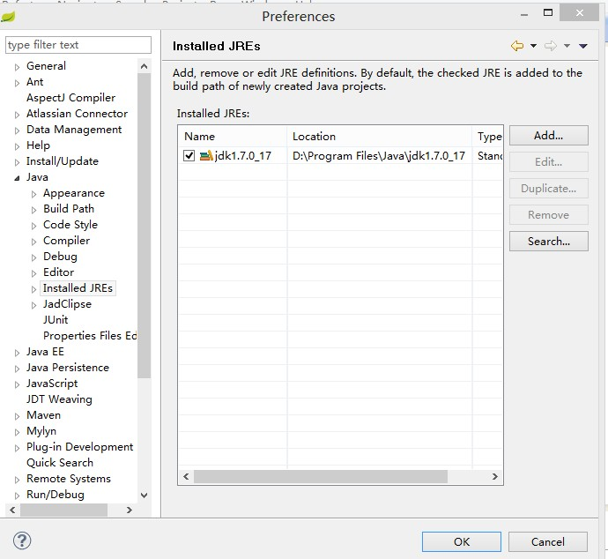
2. agileEAP run maven install

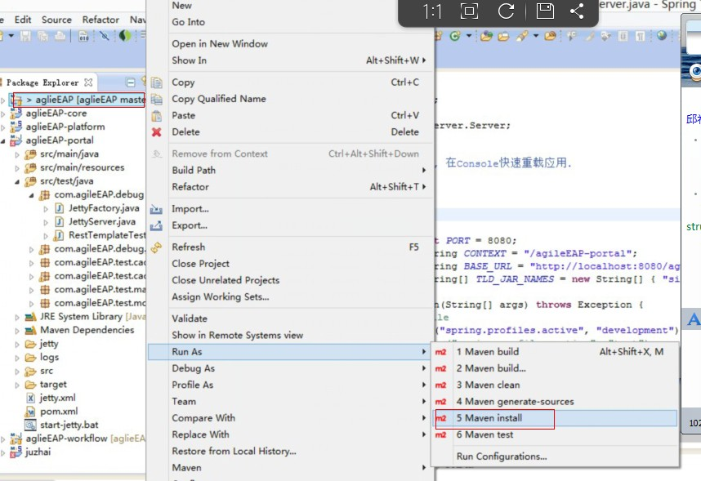

1. configure build path to jdk

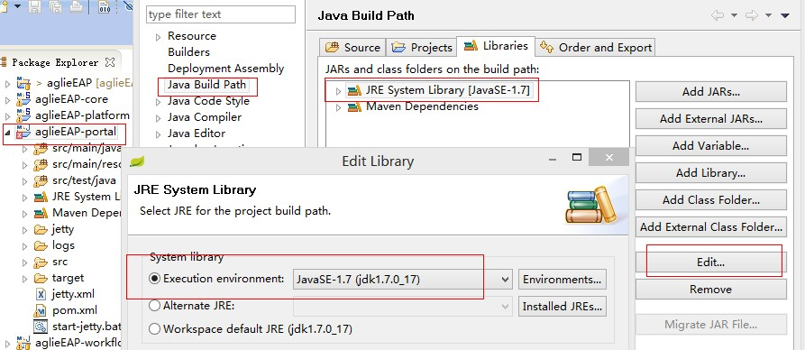

1. import database script to mysql (path: aglieEAP\document\db\agileeap_mysql.sql)
2. configure datasource

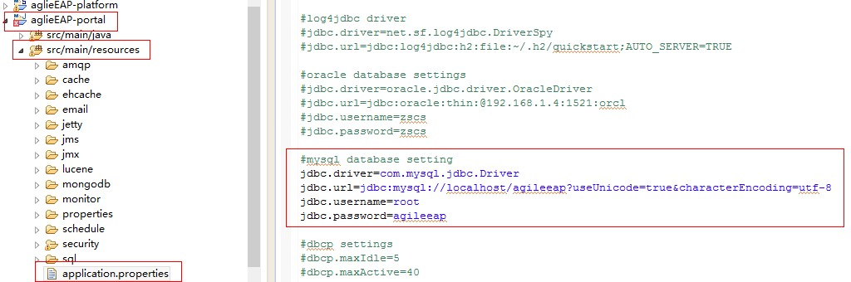

1. run JettyServer

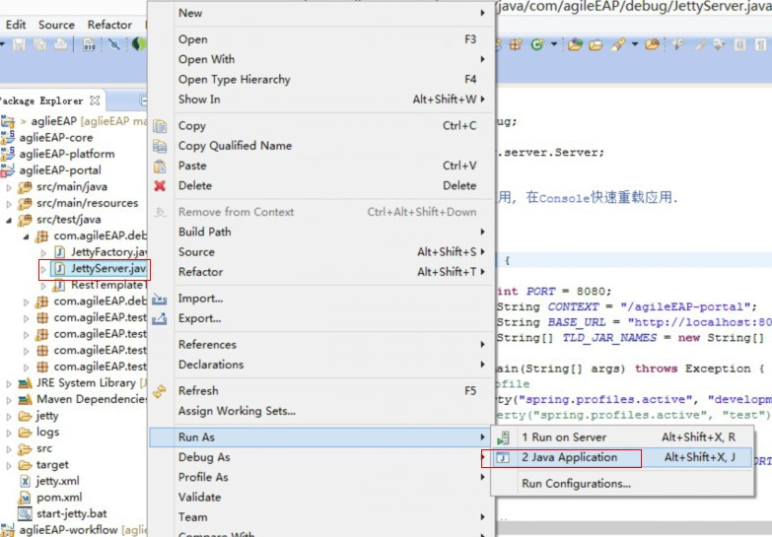

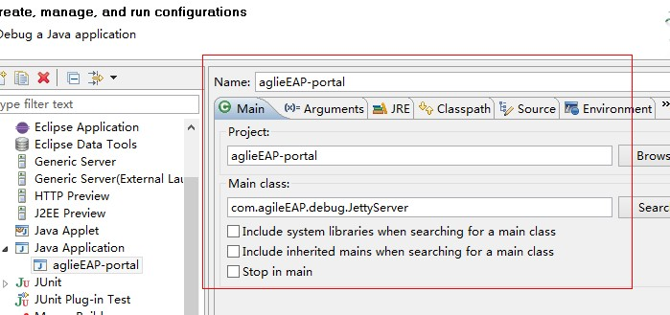

1. login <http://localhost:8080/agileEAP-portal>

account:admin

password:admin

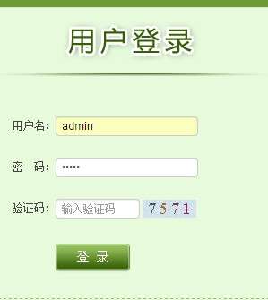

1. you will login system successful