目录
目录 1
步骤 6
该看 7
实验例子 10
不明白的地方 11
0. 前言 11
1. achitecture 11
runtime and DVM 13
secure 13
2. big man 15
init 15
Servicemanager 15
ProcessState, Bpbinder, IPCThreadState 16
zygote 17
core service & sdk service 17
core service 17
例子 20
Sdk service 21
ActivityManagerService 22
WindowManagerService 23
3. Process and thread 24
process 24
Kill a process 25
process’s importance 26
IPC-inter process communicate 27
IBinder & Binder 27
Stub & proxy 28
AIDL 28
service call back client 30
Local service binding 31
The thread, consider thread-safe 31
Thread 31
Main thread 31
Not the main thread 32
Handler, Looper, HandlerThread 32
AsyncTask 34
ActivityManagerService 34
4. Prepare 35
AndroidManifest.xml 35
Context 35
5. Component 36
5.1. Activity 37
View 37
Layout 37
Declare your layout 37
two step process in layout 38
other attr in layout.xml 40
id 40
Pixels 40
padding and margining 41
Layout example 41
FrameLayout 42
LinearLayout 42
RelativeLayout 43
Tablelayout 43
LayoutInflater 44
重用 44
tools 44
Respond to UI Event 44
Touch 45
Focus 46
Building custom view 46
the approach 47
expose your view 47
Draw the view 47
Adapter & AdapterView 49
Adapter 49
getView() 49
当数据发生改变时 50
Baseadpater 50
CursorAdapter 50
ArrayAdapter 51
Baseexpandablelistadapter和CursortreeAdapter 52
ApdaterView 52
事件响应 52
ListView 52
Spinner 53
ListActivity 53
AutoCompleteTextView 53
Expandablelistview 54
Gallery 54
一些方法 54
Task 54
The controls beyond the basis 55
Some widget and other useful 57
Menu 57
添加menuItem 57
事件响应 57
OptionMenu 58
ContextMenu 58
a simple model for extending your existing functionality 58
Dialog 60
AlertDialog 61
RadioGroup 61
Checkbox 61
ProgressBar 61
ActivityGroup 62
WebView 62
Linkify 62
RatingBar 62
Tab 63
Time widget 63
DatePicker, TimePicker, DatePickerDialog, TimerPickerDialog 63
AnalogClock, DigitalClock 64
Gallery 64
ImageView 64
ScrollView 65
Slidingdrawer 65
Surfaceview 65
PagerAdapter 65
5.2. Service 65
Intentservice 66
5.3. Content provider & data storage 66
Application 67
SharedPreference 67
framework 68
file 69
Fileobserver 70
SDcard 70
mount和unmount 71
mediascannerconnection 71
Parse 71
SQLitedatabase 72
SQLiteOpenHelper 74
Cursor 75
及时通知 76
Tool 76
ContentProvider 77
ContentReslover 78
Create a ContentProvider 79
content: URI field(_data field) 80
ContentObserver及时通知 81
内置表 82
contacts 82
MediaStore 83
sms 83
ContentProviderOperation 83
5.4. BroadcastReceiver 83
Some notification 83
Toast 83
Notification & NotificationManager 84
Dialog 84
6. Activate the component 85
Intent 85
Decoupling-message driven programming pattern 85
its part 85
Component name 85
Action 86
Category 86
data 86
Extra 87
Intent resolution/IntentFilter 87
PendingIntent 89
To activity 89
To Service 90
To content provider 91
To Broadcast receiver 91
7. Shutdown the component 92
To activity 92
To service 92
To content provider 93
To broadcast receiver 93
8. Lifecycle of component 93
Activity 94
Saving state 95
Service 96
Broadcast receiver 97
Content provider 97
9. Resources 98
The types 98
R.java 102
Android内置属性 103
Access Resource 103
providing alternative resources 103
handle runtime changes 104
alias resources 105
10. HAL 105
11. Network 105
The basic concept 105
port 105
Get the network info 105
Socket 106
http 106
HttpURLConnection 106
HttpClient 106
WebKit 108
12. telephoney 108
Call 108
Sms 109
Email 109
通讯录 110
13. media 110
MediaPlayer 110
MediaRecorder 111
Support types 112
14. device 112
PowerManager.WakeLock 112
15. other topic 112
search 112
SearchManager 112
configuration 112
Activity 112
Search client activity 112
Searchable activity 113
Suggestion 113
PackageManager 114
ActivityManager 114
WindowManager 114
system service 115
windowmanager和display 115
configuration 115
time 116
Instrumentation 116
AlarmManager 116
Inputmethodmanager 116
Location 116
widget 117
16. Programe topic 117
The package: apk 117
jni 118
引入第三方类库 118
Eclipse中修改项目的packagename 118
Tools 118
DDMS 118
AAPT & DX 119
ADB 119
The other 119
debug 119
junit 119
logcat 120
Android-specific package 120
模拟器配置 120
如何部署到手机 121
如何让apk具有root权限 121
修改android框架 121
获取android的属性 121
获取额外的类 122
执行linux命令 122
反编译 122
root手机 122
Developer 122
Code 122
community 122
Market 122

步骤
Google android doc：至少要看完what is android, application fundamentals, intents and intent filters
Begin android2：至少要看到Alerting Users via Notifications（包含此chapter）
Google samples
Professional android2
Android核心分析：国内在blog上写的，非常的牛B：http://blog.csdn.net/maxleng/archive/2010/04/15/5490770.aspx。让我理解到专注是什么样的概念
其他参考资料：
Unlocking android
Professional android

该看
other
如何成为高手，p26

big content
Contact和media数据库
电话，短信，设置
下载源码，编译源码
Expendable list
123建议内容
Apache库，对于一般的Web Service，Http通讯以及Xml解析操作。
SQLite数据库，作为一个在Linux上跨平台很好的轻量级数据库，和db4o一样的简单好用，可以很好兼容Symbian^3和iPhone 3以后的操作系统。
Telephony、Sms和Bluetooth的开发，常规的应用程序应该处理好来电时程序的情况，以及挂机时恢复状态，尤其是游戏不能因为一个电话导致之后玩家的进度出现问题，对于蓝牙这些近距离传输方式也有一定的开发点。
android学习笔记之概述.mht的作者的文章
进程与线程.mht的作者的文章
中国移动MM平台中推出了3类计划，包含文档、教程

Google doc
App widget
未细看：
Application resource-localization, resource type
Data storage-data backup
Graphics-on a surface view
2d graphics-ninepatchdrawble
3d with opengl
audio and video
Playing JET content
App widget
----
1中的
1
RPC，参见详细的介绍，
2
Advanced topics
Declare layout中的Layout Position
Handling events中的touch mode和之后
Intents and intents filters中的data tests 到 common cases

Android123
Android开发
开发FAQ

Google samples
.view.CustomView1
未细看：
Notifications samples中的几个
.app.SearchInvoke
PreferencesFromCode到最后
Voice Recognition Samples
OS PACKAGE SAMPLES
ANIMATION PACKAGE SAMPLES
.view.InternalSelectionScroll
Tablayout
.view.List9
其中介绍了WindowManager的用法，例如，添加一个view
AbsListView.OnScrollListener
ExpandableList1-3
.view.ImageSwitcher1
.view.TextSwitcher1
Animation相关
.view.InternalSelectionFocus
GRAPHICS SAMPLES

36技
P139

professional2
p117-the active lifetime
p179
p145
p221
未细看：
Ch3
ch5和之前
p190-creating custom link strings及其子内容

begin android2
p307，308
未细看：
ch6后两大节
ch7.6
ch8.5
ch9.6-ch9.8
ch10
ch12
ch13.3-ch13.5
ch15.5
ch19
ch20.6
ch21.6
ch24.3, ch24.5
ch25.1
ch32
ch33
ch35和之后

unlocking android
p207
未细看：
p37之前
ch1.2和之前
ch2.1和ch2.2，除了ch2.2.2
ch2.4
ch3.2.6
ch3.3.5
ch4.4.6
ch5.2.5
ch5.4（因为看了google-doc）
ch6.1
ch6.2
ch6.4.3（未细看）
ch6.5
ch7.1和之后
ch8.2和之后

professional1
p160
未细看：
ch3.外部资源
Ch4, create new views
Ch4, create menu
Ch5, introducing linkify
Ch5, p148, select a contract example

重新看google的第一章
该文档中值得合并的内容进行整理
bo2中google doc没有阐述的地方进行查看
bo2的第一章好好的看一下，有时间做好笔记

该去学习的内容：
书中的四个组件的详细说明
Doc中的intents and intent filters之后
Intents and intent filters中的intent objects
2.1
Declaring Layout中params

***********************************************************

传智播客ppt

hello android2
anroid basic-ch3.9

大话android

Ophone
未细看：
ch3.7

SDK开发大全
195-ch5.12
未细看：
3.15
3.20
3.21
4.2, 4.5, 4.6, 4.10, 4.11和之后
5.6, 5.10

实验例子
- 做例子来读取通讯录，采用rawcontact和contactcontract.data的形式
- 对于singleTask和singleInstance，由一个activity.startActivity，且新的activity的affinity遵从task的，看看是否有异常
- 创建一个含有_data field的数据库
- 验证例子，为了context。Contentprovider中会用getContext来创建数据库，判断contentprovider.getcontext.getcontentresolver和client.getcontentresolver是否相同；数据库是在哪个apk中创建的
- 其他线程可以操纵诸如activity等comp吗？猜想：不行
- 针对于：View.onKeyListener中的onKey返回boolean：True if the listener has consumed the event, false otherwise.
编写editview，看如果返回true，那么连续的按键是否不可被keylistener捕获（可以将editview中的内容在textview上进行展示）；后搜索上句，完成笔记
- adb命令补充
- 针对于b大全2-p254，说，只有运行了该Activity，才会进行注册一个broadcastreceiver，在此，做一个例子。启动模拟器，而不启动该activity。发出broadcast，看是否会激活那个receiver，如果激活的话（说明：并不是需要运行activity才完成receiver的注册），在其中展示一个toast，因为toast是需要context，而context可以理解为一个屏幕，而toast要显示，必需一个屏幕，看toast显示有异常没，如果没有异常，对context进行屏幕的说明
- spinner的drop down view，并对笔记进行完善
- 启动了一个activity，然后home，看该activity的生命周期方法如onpause和onrestore和onsave被调用了没？
并完成lifecycle of activity中的saving state笔记
- google doc
请完成contentprovider的一个例子（gettype何时被调用），并实现监听器例子（参见：create a contentprovide中的即时通知）
两个activity切换，back时，会重新生成一个activity吗，即是oncreate会调用吗？
将android工程进行分类
根据Adapter的List的改变，不用显式调用函数，看AdapterView是否自动更新
- 怎么通过adb查看当前用户，查看所有用户
- cata_default做一个例子，当有多个都是default时，该怎么样

不明白的地方
参见google doc中，view的绘制
两个数据库：contact, media

前言
在开始之前，请大声的说这样的话：“服务”和“内容”。
当没有游戏新作的时候，XBOX很难卖出去。Inter开发了自己的linux系统，当更多的嵌入式设备都基于这样一种系统，软件之下的硬件的核心：凌动处理器才有出路。
当10万个应用程序可以满足你的任何要求，iphone也许会找到一个买家。
优秀的硬件；健壮的系统架构；还有，美妙的应用程序，共同编制了美好的前景。在这一层层的依赖之中，用户看到的是程序（尽管，它展现在无法被击破的核心之上），他找到了满足他要求的产品，一切的一切，才会拥有回报。

achitecture
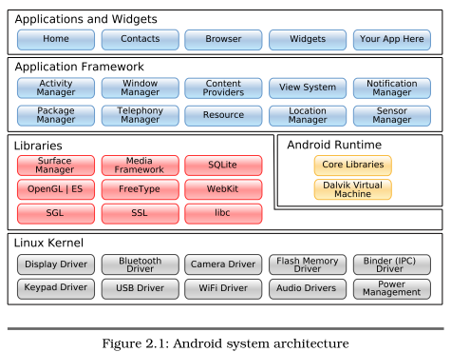
android的组成：AP+AP框架+C lib+HAL框架+HAL Stub
框架的使命：既提供API供外界使用，但是保持对外界的约束
差异化：
android的免费赠送，直接受惠的是硬件厂商
但如果硬件的差异化如果无法传递给上层的AP，那么用户便感觉不到，则硬件需要让android开源，以谋求部分控制点
此外自己当一个小强龙，从下而上提供：驱动，c lib，Java sub framework，以此让更多的开发者开发AP来体现硬件差异，即是软硬结合，如图
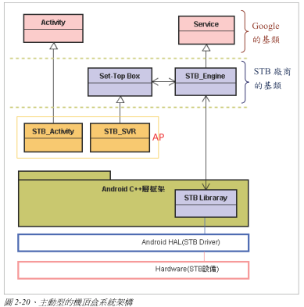
逻辑的调用顺序：AP-JNI-C lib-HAL-driver
参见：
google doc-what is android-application framework
b-professional ch1.introducing the development framework & ch2.android development tools
android的系统优势.mht

runtime and DVM
runtime包含了core library（基础的Java类库）和DVM
Memory and process management of each application is handled exclusively by the runtime, not by the application itself.
The runtime is executed in the Dalvik virtual machine（每一个dvm实例都是一个独立的进程空间）, and the Dalvik VM relies on the Linux kernel for underlying functionality such as threading and low-level memory management.
Dalvik has been written so that a device can run multiple VMs efficiently. The Dalvik VM executes files in the Dalvik Executable (.dex) format (dx tool transform .class into .dex) which is optimized for minimal memory footprint.
DVM提供JNI和threading

secure
参见：
Google doc-frameworks topic-security and permissions
Security and Permissions.mht（为上述资料的翻译）
三类安全限制：
- By default, every application runs in its own Linux process, with its own instance of the Dalvik virtual machine. The hardware forbids one process from accessing another process’s memory.
- Furthermore, every application is assigned a specific Linux user ID（一个app被当成了一个user，该ID是在安装过程中由系统指定的，并且在程序卸载之前保持不变）. By setting proper permissions, user’s file（只能位于data/data/[PACKAGE_NAME]/下）cannot be read or written by other applications(nor by the end user of the phone).
Linux文件权限：
[d][rwx][rwx][rwx]
文件类型，user权限，group权限，other权限
说明：上述两点是通过linux user机制来完成的。
sharedUserId: By default, each package（其标示了一个应用程序） gets its own unique user-id. By setting sharedUserId on two or more packages, each of these packages will be given a single shared user ID, so the two packages are then treated as being the same applicationson, and they can for example run in the same process and have the same file access permission.
Note that for them to actually get the same user ID, they must also be signed with the same signature.
- In addition, access to certain critical operations are restricted
Ask for permission: to access some features, you must specifically ask for permission to use them in AndroidManifest.xml.
For example, to monitor incoming SMS messages, you would specify this in the manifest file:
<uses-permission android:name="android.permission.RECEIVE_SMS"/>自己要访问什么
The permissions you include will be presented to the user before installation commences
有多少种permission参见Manifest.permission
Android can restrict access to entire parts of the system. Using <permission> （允许外部访问什么）in AndroidManifest.xml.
Enforce permission: Activities, services, and intent receivers can declare an attribute named android:permission. Content providers offer two distinct attributes: readPermission and writePermission.
参见：google doc-framework topics-security and permissions- Declaring and Enforcing Permissions中的enforce部分
Other applications will then need to include a uses-permission tag in their manifests (and have it granted) before they can use these protected components. And without permissions,
Activities cannot be started without the permission.
Services cannot be started, stopped, or bound to an activity without the permission.
Intent receivers ignore messages sent via sendBroadcast() unless the x`sender has the permission.
一个例子：
activity1中，android:permission=”com.ql.activity.activity1”
activity2中，uses-permission android:name="com.ql.activity.activity1"
签名：
参见：
http://www.android123.com.cn/androidkaifa/173.html
http://www.android123.com.cn/androidkaifa/272.html
All Android applications (.apk files) must be signed with a certificate whose private key is held by their developer. The certificate does not need to be signed by a certificate authority(CA): it is perfectly allowable, and typical, for Android applications to use self-signed certificates.
This certificate identifies the author of the application. The certificate is used only to establish trust relationships between applications, not for wholesale control over whether an application can be installed.
The most significant ways that signatures impact security is by determining who can access signature-based permissions and who can share user IDs.
Grant permission过程：
At application install time, permissions requested by the application are granted to it by the package installer, based on checks against the signatures of the applications declaring those permissions and/or interaction with the user. No checks with the user are done while an application is running: it either was granted a particular permission when installed, and can use that feature as desired, or the permission was not granted and any attempt to use the feature will fail without prompting the user.
说明：请让用户来修改setting.secure中的设置，而不要让程序来修改，即使申请了permission

big man

init
init是一个可执行程序，是系统运行后的第一个用户空间的程序，它以守护进程的方式运行
期间，会解析init.rc来启动servicemanager,zygote,mediaserver

Servicemanager
参见：百度文库-认识android的servicemanager
Servicemanager is a native process.
core service经由servicemanager加入到binder driver中，client通过servicemanager.getservice获得core service的stub.proxy
java层与servicemanager交互：采用stub-proxy，stub是servicemanagernative，proxy是servicemanagerproxy
ServiceManagerProxy sServiceManager = ServiceManagerNative.asInterface(BinderInternal.getContextObject());
BinderInternal.getContxtObject()是一个native函数，它做了
1. 呼叫底層的ProcesState服務在自己的進程裡，誕生一個BpBinder物件，成為C++層的分身。
2. 然後呼叫JavaObjectForIBinder()來誕生Java層的分身：BinderProxy類別的物件
说明：具体图示，参见：core service中的第2，3图
---
client通过ContextObject作为Binder来获得ServiceManager代理，后通过该代理操纵ServiceManager
ServiceManager.getService返回了一个service的IBinder（同时创建了c++空间的BpBinder），然后我们可以根据这个IBinder来创建代理
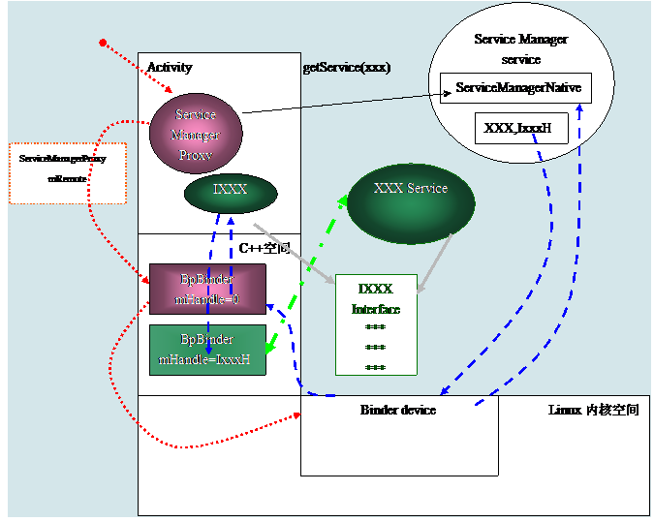

ProcessState, Bpbinder, IPCThreadState
如果另一個進程裡的C++ Client想與ServiceManager互動時，就會透過更底層的ProcesState服務在自己的進程裡，誕生一個BpBinder物件，作為BinderDriver的分身(即Proxy物件)。讓C++ Client能透過BpBinder而與Binder Driver互動，進而跨進程地與ServiceManager溝通，所以BpBinder也間接地扮演ServiceManager的分身的角色
ProcessState是一個singleton類別，此物件負責打開Binder Driver(/dev/binder驅動)，準備讓其進程裡的程式能與Binder Driver進行溝通。
例如，它在其進程(於此，稱為client進程)裡誕生BpBinder物件，此BpBinder物件的執行緒(Thread)透過Binder Driver而轉接(relayto)到IPC thread去執行另一個進程((於此，稱為service進程)裡的服務(例如ServiceManager service)。
而IPCThreadState負責透過Binder Driver而進行跨進程的實際資料讀寫動作。
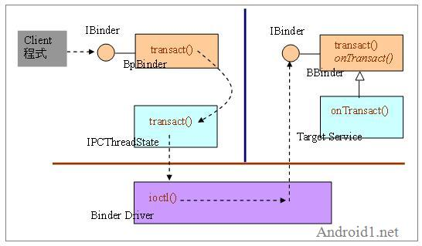

zygote
顾名思义，孵化器。你的应用程序的进程由其孵化出来
参见：Talking about Android process.mht
zygote is a native application process, it start Android Java VM Runtime and a special process named system_server
Your JAVA process is forked by zygote
system_server is a JAVA process, it starts the core Android services, e.g. ActivityManager, WindowManager, PackageManager etc.

core service & sdk service
说明：无论是哪种service，client均通过ipc来与service交互，参见：ipc- ibinder & binder和stub & proxy

core service
core service的主要工作就是和hal stub交互，即是和硬件打交道，每个service运行在一个独立的进程中
执行init.rc的过程中产生对象，或者，由SystemServer产生对象，经由servicemanager将对象的引用放入到binder driver
可由java或c编写
分为android service和native service。
如何区分native service和android service？关键是看jni的c部分和hal的交互是否“在同一进程中，还是走了IPC”
同一进程中：android service
如sensorservice
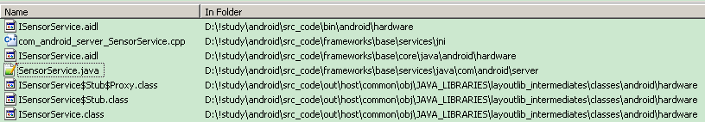
其中sensorservice.java继承stub，
systemserver将sensorservice实例化，并通过servicemanager加入到binderdriver中（参见：SystemServer.java）
com_android_server_SensorService.cpp为jni的c部分，同时调用了hal
sensormanager.java充当了ipc的client proxy
jollen的moloid
不同进程中：native service
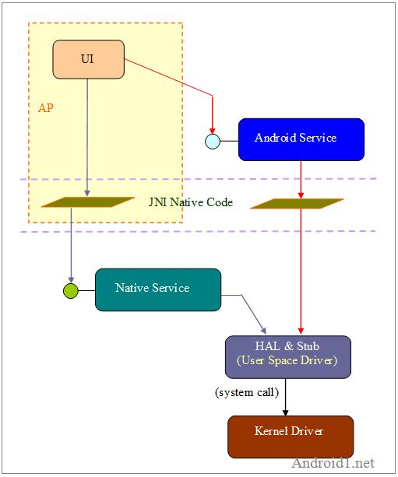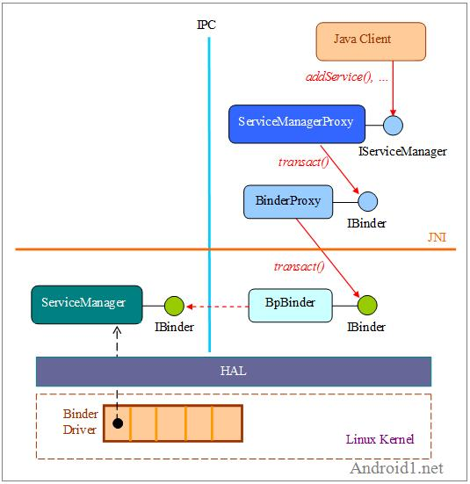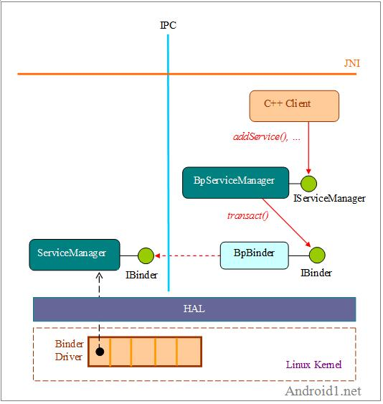

例子
例子1，参见：高-在云端-ch10（010_开发Android的C++核心服务.pdf）
SQR参见p5
jni参见p8, p10
bpsqrs参见p14
bnsqrs参见p17
sqrservice参见p18
其和servicemanager的对应关系为：
 | Client-binder | Client-proxy | Server-binder | Server-stub | Server-stub子类
Servicemanager | Bpinterface<iservicemanager> | bpservicemanager | Bninterface<iservicemanager> | Bnservicemanager | Bservicemanager
sqrs | Bpinterface<isqrs> | Bpsqrs | Bninterface<isqrs> | Bnsqrs | Sqrservice

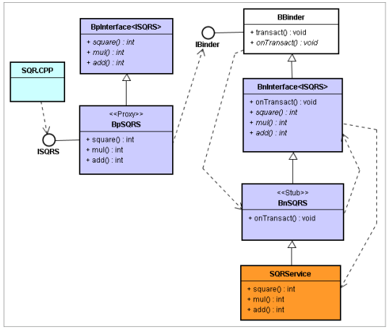
例子2，参见：http://www.android1.net/Topic.aspx?BoardID=21&TopicID=990
写c++ addservice的.h和.cpp，其继承bbinder
通过make命令产生.so，并将该so拷贝到system/bin下
写一个类实例化类addservice，通过servicemanager的iservicemanager（defaultServiceManager(),其是一个sp<IServiceManager>）添加到binder driver上：iservice.addservice(new addservice)，并将编译后的bin放入system/bin下
c client-add通过bpbinder（defaultServiceManager().getservice，其是一个sp<IBinder>）来和addservice进行交互
bpbinder.transact最终会调用addservice.ontransact（其执行在service所在进程的线程池分配的一个线程上）
为add制作jni

Sdk service
是由android的service类编写，并不会开机启动，也不会加入到binder driver中，而是由activitymanagerservice来管理
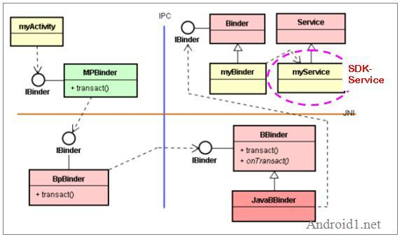
说明：其中MPBinder通过BinderProxy jni来与BpBinder交互

ActivityManagerService
ActivityManager: This controls the life cycle of applications and maintains a common “backstack” for user navigation.
主要管理Activity, service的加载、卸载，应用的创建等
当在一个应用程序中调用StartActivity时，应用就通过IPC机制向System_Service请求启动新的Activity，System_Service首先会查找，这个Activity是否已经被创建，如果没有,查找这个Activity所在的应用程序是否已经起来，如果没有就先启动应用。然后向此应用发送launchActivity消息创建Activity。
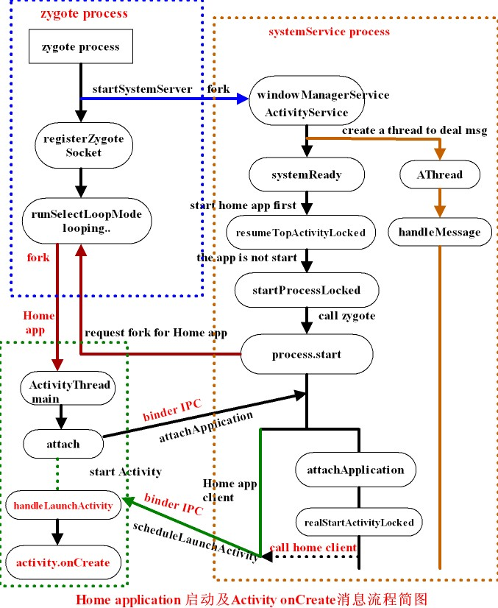

WindowManagerService
WindowManager: 管理所有的窗口程序
主要管理窗体的加载，事件的分发。
启动每个Activity系统都会创建一个viewRoot用于保存所有的view,通过viewRoot将窗体加载到WindowManagerService并创建窗体的客户端，当服务程序接收到按键事件后，就会查找当前窗体是否是焦点控件，如果是的话就会将窗体事件通过客户端IPC传递到相应的应用程序，如果在焦点View中有注册接收KeyEvent的消息则事件就在该view中得到处理。
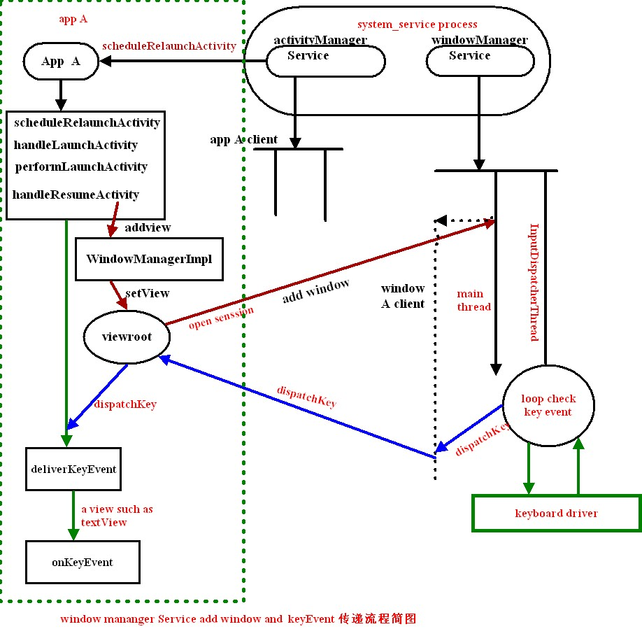

Process and thread

process
- Android starts the process when the first of an application's components needs to be run, and shuts down the process when it's no longer needed and system resources are required by other applications.
- in Androidmanifest.xml file, <application>, <activity>, <service>, <receiver>, <provider> element all has a process attribute to be set, so that different apps’ components can run in the same process — provided that the applications share the same Linux user ID and are signed by the same authorities
使用情形：
If you have multiple applications that need to store data among one another, but you also want that data to not be accessible outside that group of applications, you may want to set the permissions to private and share the UID to allow access.
将经常和某个Service组件进行通信的组件，放入同一个进程，因为与Service通信是个密集操作，走的是RPC，开销不小，通过配置，可以变成进程内的直接引用，消耗颇小
说明：
同一个package中的component可以运行在不同的进程中，如果如此，那么你应该想到两个不同的内存空间：如comp1和comp2运行在不同的进程上，但它们同属一个包，都可以访问一个第三方类C，类C有个public static，当comp1不停的在改变那个static，但comp2却捕捉不到这种改变，因为，不同的内存空间。同一套代码，两个空间
当你的package中有一个类（无论是否为comp），其有一个static变量，你改变了它的值，然后退出程序，而此时，process未消亡，那么，再启动程序，再读该static的值时，其为新值
通过activitymanager.getrunningappprocesses来获得正在运行的process信息
一些方法：
Process.myPid();
Process.killProcess(int pid)

Kill a process
The Android system tries to maintain an application process for as long as possible（参见：DDMS中，当你关闭了一个app，但它的process还没有被消灭）, but eventually it will need to kill old processes when memory runs low(and application components running in this process are consequently destroyed).
To determine which processes to keep and which to kill, Android places each process into an "importance hierarchy".
- An process’s priority is equal to its highest piority component.
- if process A has a dependency on a component(for example, Service which is bound to a comp in process A, ContentProvider) supplied by process B, process B will have at least as high a priority as the application A.
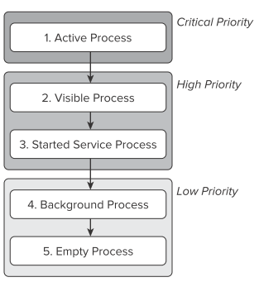

process’s importance
参见：b-professional-ch3-understanding…和android-doc-application fundamentals-Processes and lifecycles
use “adb(Android Debug Bridge) shell dumpsys activity”, and this command will output a lot of information about all the running processes,
- foreground process
This process has application components interacting with the user.
- It hosts an activity that the user is interacting with (the Activity object's onResume() method has been called).
- It hosts a service that's bound to the activity that the user is interacting with.
- It hosts a Service object that's executing one of its lifecycle callbacks (onCreate(), onStart(), or onDestroy()).
- It hosts a BroadcastReceiver object that's executing its onReceive() method.
- visible process
- It hosts an activity that is not in the foreground, but is still visible to the user (its onPause() method has been called).
This may occur, for example, if the foreground activity is a dialog that allows the previous activity to be seen behind it.
- It hosts a service that's bound to a visible activity.
- service process
- It hosts a running service that has been started with the startService() method and that service does not fall into either of the two higher categories.
Because a process running a service is ranked higher than one with background activities, an activity that initiates a long-running operation might do well to start a service for that operation, rather than simply spawn a thread — particularly if the operation will likely outlast the activity. Examples of this are playing music in the background and uploading a picture taken by the camera to a web site. Using a service guarantees that the operation will have at least "service process" priority, regardless of what happens to the activity.
- background process
- It hosts an activity that's not currently visible to the user (the Activity object's onStop() has been called)
Usually there are many background processes running, so they are kept in an LRU (least recently used) list to ensure that the process with the activity that was most recently seen by the user is the last to be killed.
- empty process
- doesn't hold any active application components.
The only reason to keep such a process around is as a cache to improve startup time the next time a component needs to run in it
提高service的process的优先级：
默认情况下，service是background service
调用service.startForground，使其变为forground service
而调用service.stopForground，使其变为background service，

IPC-inter process communicate
Since each application runs in its own process, so how would this happen:
You have the code in one process (for example, in an Activity) that needs to call methods on an object in another process (for example, a Service), so you need to pass objects between processes.
On the Android platform, one process can not normally access the memory of another process. So to talk, they need to decompose their objects into primitives that the operating system can understand, and "marshall"（猜想：marshal排队）the object across that boundary for you (transmitting it from the local process and address space to the remote process and address space, and reassembling and reenacting the call there)

IBinder & Binder
参见：google-doc-IBinder
Android中ipc的本质是ibinder和binder
核心机制：
Ibinder只提供了一个核心的方法：transact
service端有一个ibinder
当client和service处于同一个进程中时，client可以找到service的ibinder，并直接拿它来用
当client和service不在同一个进程中时，client通过bindservice得到一个ibinder，通过ibinder.transact(int code, Parcel data, Parcel reply, int flags)来与service通信，即是service的ibinder.transact会被调用。但对于IPC来说，ibinder.transact要做很多工作，但在各式各样的service端实现逻辑之上，却额外有一些通用的东西，将这些东西抽取出来放入binder.transact以复用整体流程（binder是ibinder的子类），而提供binder.ontransact以让service端简洁的实现各自的核心逻辑（一个钩子，IOC），那么服务端的ibinder一般都继承binder
-----
Android的Binder更多考虑了数据交换的便捷，并且只是解决本机的进程间的通讯
- IBinder.transact(int code, Parcel data, Parcel reply, int flags) matched by Binder.onTransact(int code, Parcel data, Parcel reply, int flags). These methods allow you to send a call to an IBinder object and receive a call coming in to a Binder object, respectively. This transaction API is synchronous, such that a call to transact() does not return until the target has returned from Binder.onTransact();
- The data sent through transact() is a Parcel, a generic buffer of data that also maintains some meta-data about its contents. The meta data is used to manage IBinder object references in the buffer, so that those references can be maintained as the buffer moves across processes.
你可以用parcel.obatin获得一个新的对象
在一个函数中，你先往parcel中写东西，然后，读这个parcel，是读不出东西的；但是通过parcel传给另外一个comp时，却可以读出内容
当你往parcel中按int,string的顺序写，但是却以string,int的顺序读，会出错的
- The system maintains a pool of transaction threads in each process that it runs in. These threads are used to dispatch all IPCs coming in from other processes.
For example, when an IPC is made from process A to process B,
the calling thread in A blocks in IBinder.transact() as it sends the transaction to process B.
The next available pool thread in B receives the incoming transaction, calls Binder.onTransact() on the target object, and replies with the result Parcel.
Upon receiving its result, the thread in process A returns to allow its execution to continue. In effect, other processes appear to use as additional threads that you did not create executing in your own process.

Stub & proxy
开发者不应该看到ibinder和binder，因为那是java端太底层的东西（在c++端，还存在着bpbinder和bbinder等着你），开发者在乎的是service端的核心逻辑要如何实现。他会说：定义一个接口，我完成了它的实现。
但是对于ipc来说，开发者的核心逻辑的调用必须要经过ontransact
client更不应该看到ibinder和binder，它们只知道：嘿，我知道我在进行一个远程调用，而且我知道开发者给我提供了一个接口和那个接口的一个对象，那么，我开始调用了
但是对于ipc来说，client必须要通过ibinder.transact来开始调用
那么，所有的一切都明了了，client和服务器端都需要代理：stub.proxy和stub
stub.proxy
client要调用函数了，我必须将它转化为ibinder.transact，刚好，client已经将ibinder给我了
好的，给我了实参，我将把它们放入到parcel中
我知道client调用的方法的名字，将它放入到code中
OK，完成了，调用ibinder.transact(int code, Parcel data, Parcel reply, int flags)
等等，为了让client看起来在使用开发者给他提供的那个接口，我必须要假装实现了那个接口
stub
我知道某个家伙在调用transact，所以我将调用ontransact
我知道他提供了哪些参数（parcel data），我也知道他想调用开发者提供的哪个方法（code）
我将调用那个方法，并将方法的返回值写入到parcel reply中
OK，完成了
等等，我必须要在service.onbind中返回，所以我必须继承binder（不原始实现ibinder了）；而我需要调用开发者的接口，那么我需要开发者接口的一个对象（采用组合的形式），或者，我声称实现了开发者的接口，让开发者来继承我以填充他的接口实现（继承的方式，这也就是当前android采用的方式）

AIDL
AIDL (Android Interface Definition Language) is an IDL(interface definition language) language used to generate code that enables two processes on an Android-powered device to talk using IPC
通过AIDL，android帮助我们生成了stub和proxy，而留给我们做的，只是完成service端的核心逻辑
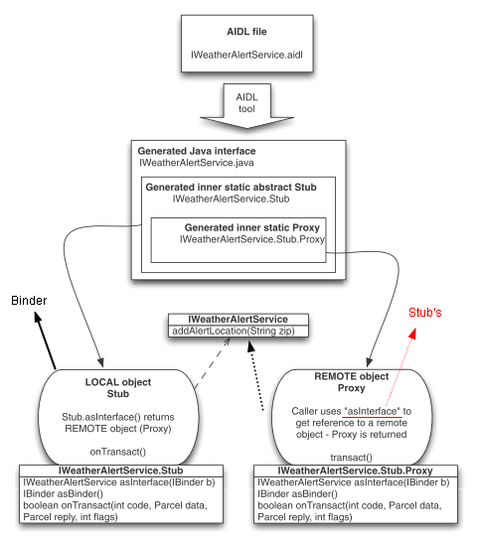
Follow these steps to implement an IPC service using AIDL.
参见：ipc.rar，google-doc-developing-tools-aidl
- Create your .aidl file - This file defines an interface (YourInterface.aidl) that defines the methods and fields available to a client.
- Add the .aidl file to your makefile - (the ADT Plugin for Eclipse manages this for you).
The AIDL compiler(in the tools/ directory) creates an interface in the Java programming language from your AIDL file
这一个interface本身继承iinterface
如果你想让YourInterface.class的所在包为com.ql.rs，那么可以在src下建立相应的目录，并在该目录下编写YourInterface.aidl
Stub class represents the local side of your remotable interface. Stub.asInterface(IBinder binder) method returns a remote version of your interface type - Proxy.
Proxy is used to wire up the plumbing. Client can use it to invoke remove methods
- Implement your interface methods - You must create a class that extends YourInterface.Stub and implements the methods you declared in your .aidl file.
- Expose your interface to clients - If you're writing a service, you should extend Service and override Service.onBind(Intent) to return an instance of the class mentioned in step3.
- bind to the service
过程
- 服务器端
YourService exntends Service
Onbind中，return一个YourInterface.Stub的实现类，猜想：作为local object
- Client端
Context.bindService (Intent service, ServiceConnection conn, int flags)
ServiceConnection.onServiceConnected(ComponentName className, IBinder service)
该方法会在“main thread”中被调用中，而service中的binder的方法是在“bind线程池的线程中”被调用
YourInterface interface = YourInterface.Stub.asInterface(service);
猜想：返回的这个对象是YourInterface.Stub.Proxy，作为remote object
至此，你能根据interface这个对象来操纵local object了（尽管它们在不同的process中）（pass objects between processes），隐约的，你操控了这个service
ServiceConnection.onServiceDisconnected(ComponentName className)中
This is called when the connection with the service has been unexpectedly disconnected -- that is, its process crashed.
说明：
ipc的method中可以包含输入和返回参数，参数类型参见google doc-developing-tools-aidl-create an .aidl file

service call back client
参见：google samples-.app.RemoteServiceBinding
client和service建立了一条连接，client通过ipc控制了service，那么service有可能需要通知client某些信息，如：每一百ms，service将修改某些关键参数，然后通知client该参数。那么此刻，必须通过一种机制来完成这种更新：
方法1：
//注册client提供的callback
//当client bindservice后，client通过ipc间接调用该函数，该函数最终发生在service端
//该RemoteCallbackList对象存在于service端，而E是一个IInterface的对象，该对象存在于client端，通过ipc的方式传递给service，则该对象相对于service来说，是一个remote
RemoteCallbackList.register(E callback)
RemoteCallbackList.unregister(E callback)
//取出client提供的callback，调用E的方法，以完成对client的通知
RemoteCallbackList.beginBroadcast()
E RemoteCallbackList.getBroadcastItem(int index)
RemoteCallbackList.finishBroadcast()
//disable this callback list, and remove all the registered callbacks
RemoteCallbackList.kill()
方法2：通过单纯的binder机制
在transact中，parcel.writestrongbinder，此后原service得到一个ibinder，其可以作为new client来和原client进行交互
方法3：service.aidl中的方法包含了client提供的iinterface类型的参数
参见：service-client give a ipc

Local service binding
如果service与client在同一个process中，而client又想获得service的引用，那么client可以采用Context.bindService (Intent service, ServiceConnection conn, int flags)，而service的onBind中应该返回一个IBinder，那么service提供Binder的子类，且在该子类中提供诸如getService来返回service实例，而后client在ServiceConnection.onserviceconnected中通过ibinder.getservice来获取该实例

The thread, consider thread-safe
The system maintains a separate pool of transaction threads in each process to dispatch all incoming IPC calls
When a call on a method implemented in an IBinder object（Ibinder的实现者） originates in the same process as the Ibinder, the method is executed in the caller's thread.
However, when the call originates in another process（即是ibinder的client属于其他process）, the method is executed in a thread chosen from a pool of threads that Android maintains in the same process as the IBinder; it's not executed in the main thread of the process（非“ibinder的process的mainthread，即是：service所在的process的mainthread”）. For example, whereas a service's onBind() method would be called from the main thread of the service's process, methods implemented in the object that onBind() returns (for example, a Stub subclass that implements RPC methods) would be called from threads in the pool.
Since services can have more than one client, more than one pool thread can engage the same IBinder method at the same time. IBinder methods must, therefore, be implemented to be thread-safe.
Similarly, a content provider can receive data requests that originate in other processes. Although the ContentResolver and ContentProvider classes hide the details of how the interprocess communication is managed, ContentProvider methods that respond to those requests — the methods query(), insert(), delete(), update(), and getType() — are called from a pool of threads in the content provider's process, not the main thread of the process. Since these methods may be called from any number of threads at the same time, they too must be implemented to be thread-safe.

Thread
每个process诞生时，都会产生一个main thread以及looper（message queue），每当主线程运作完毕时，looper就开始运作，即是循环分发其mq上的消息到对应的handler上

Main thread
All Components run in the main thread of the application process.
Thread[main, 5, main]
它负责把事件分派到相应的控件，包括屏幕绘图事件。
用户与Andriod控件的交互在此线程内
该线程上的操作最多不能超过5s，否则会ANR(application not responding)
注意：You cannot modify any part of the UI from a background thread. That must be done on the UI thread. This generally means that there will need to be some coordination between background threads doing the work and the UI thread showing the results of that work.
Activity.runOnUiThread() works similar to the post() methods on Handler and View, in that it queues up a Runnable to run on the UI thread,
if you are not on the UI thread right now.
If you are already on the UI thread, it invokes the Runnable immediately.

Not the main thread
No component（即使是service） should perform long or blocking operations (such as networking operations or computation loops) when called by the system, since this will block any other components also in the process.
另一种解释是：
The Android platform monitors the responsiveness of applications and kills those that are considered nonresponsive.
An Application Not Responding (ANR) event is defined as no response to a user input for five seconds. (A user touches the screen, or presses a key, or the like, and your application must respond). So does this mean your code always has to complete within five seconds? No, of course not, but the main UI thread does have to respond within that time frame（在5秒钟内必须完成响应，否则会被认为是nonresponsive）
Runnable：大部分时间runnable是为thread而生，但是，你可以在任意线程中调用runnable.run，此时run所在的线程规则符合一般的函数调用所处线程规则

Handler, Looper, HandlerThread
Looper for running a message loop within a thread（即是：分发消息）(this thread maintains a messagequeue which contains Message or Runnable objects that are sent via the Handler, by send.. method and post.. method),
Looper和thread关联的方式：在thread的run中，looper.prepare，而looper.loop使得消息（而消息是通过与looper关联的handler分发）进行分发
一旦looper.loop()，那么loop()得不到返回
Handler for processing messages or runnables in the message queue（红色为猜想）
Each Handler instance is associated with a single thread and that thread's message queue
参见Handler的构造函数，其和looper是关联的，进而和looper的thread关联
handler()等同于handler(looper.mylooper)
Handler will deliver messages and runnables to that message queue and execute them as they come out of the message queue.
this allows you to queue and schedule tasks to be run on different threads
其handlemsg在该与其关联的thread上进行的
当有两个handler同时和一个thread进行关联，那么handler1发送的msg最终会deliver到handler1而不是handler2处处理
当你通过handler发送msg时，使用handler.obtainmsg从message pool中取出一个msg
当你通过looper来创建handler，那么在关联的thread.run()中，必须looper.prepare()，而你想让通过handler分发的msg得到处理，那么必须looper.loop()
HandlerThread for setting up a thread with a message loop.
说明：
handlerthread只是为了方便。当使用上述来建立looper和handler，那么handlerthread是不需要使用的
一个例子
When a process is created for your application, its main thread is dedicated to running a message queue（猜想：main thread是一个HandlerThread）. Getting tasks into a separate thread, then getting results back to the main thread is where the Handler, and related classes, come into play.
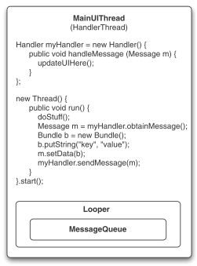
说明：
上例中，handleMessage因为位于mainthread中，而mainthread创建了Activity的页面结构，所以updateUIHere（其中，更新了view的属性值）才允许被调用。
本质上，在执行完生命周期方法后，ui thread开始放入loop。如果你在ui thread中执行了一个永远不会跳出的方法，那么，其他诸如刷新窗口等事件就得不到处理，因为要遵守队列的FIFO。
一些方法：
Handler.postDelayed(Runnable)隔多少时间后，运行这个task
Handler.removeCallbacks()移除这个任务
一个例子：
//建立一个新的线程，并开启
HandlerThread thread = new HandlerThread("ServiceStartArguments");
//注意一定要start
thread.start();
Looper looper = thread.getLooper();
//MyHandler继承自Handler
MyHandler handler = new MyHandler(looper);
参见：my/test26

AsyncTask
Android will handle all of the chores of doing work on the UI thread versus on a background thread. Moreover, Android itself allocates and removes that background thread.
AsyncTask<Params, Progress, Result>
void onPreExecute() is called, from the UI thread, before the background thread executes doInBackground()
Result doInBackground(Params... params) will be called on a background thread.
In:The type of information that is needed to process the task (e.g., URLs to download)
Out: The type of information that is passed when the task is completed to the post-task code
void onProgressUpdate(Progress... values) is called, from the UI thread, to update ui
In:
The type of information that is passed within the task to indicate progress
the data published by doInBackground() via publishProgress().
void onPostExecute(Result result) is called, from the UI thread, after doInBackground() completes.
In: the value returned by doInBackground()
启动：excute

ActivityManagerService
在ActivityManagerService中，有两类数据结构最为醒目，一个是ArrayList，另一个是HashMap。ActivityManagerService有大量的ArrayList，每一个组件，会有多个ArrayList来分状态存放。调度工作，往往就是从一个ArrayList里面拿出来，找个方法调一调，然后扔到另一个ArrayList里面去，当这个组件没对应的ArrayList放着的时候，说明它离死不远了。HashMap，是因为有组件是需要用名字或Intent信息做定位的，比如Content Provider，它的查找，都是依据Uri，有了HashMap，一切都顺理成章了。
ActivityManagerService用一些名曰xxxRecord的数据结构，来表达各个存活的组件。于是就有了，HistoryRecord（保存Activity信息的，之所以叫History，是相对Task栈而言的...），ServiceRecord，BroadcastRecord，ContentProviderRecord，TaskRecord，ProcessRecord，等等。
值得注意的，是TaskRecord，我们一直再说，Task栈这样的概念，其实，真实的底层，并不会在TaskRecord中，维系一个Activity的栈。在ActivityManagerService中，各个任务task的Activity，都以HistoryRecord的形式，集中存放在一个ArrayList中，每个HistoryRecord，会存放它所在TaskRecord的引用（猜想：不止一个）。当有一个Activity，执行完成，从概念上的Task栈中退出，Android是通过从当前HistoryRecord位置往前扫描同一个TaskRecord的HistoryRecord来完成的（猜想：HR会问：自身的下一个activity是否在task上，如果在，使其成为焦点，如果不在，通过引用task找到下一个HR，将其当前的activity设为焦点）。这个设计，使得上层很多看上去逻辑很复杂的Task体系，在实现变得很统一而简明，值得称道。
ProcessRecord，是整个进程托管实现的核心，它存放有运行在这个进程上，所有组件的信息，根据这些信息，系统有一整套的算法来决议如何处置这个进程，如果对回收算法感兴趣，可以从ActivityManagerService的trimApplications函数入手来看。

Prepare

AndroidManifest.xml
参见google-doc-“the androidmanifest.xml file”
it ties all of the details together for an Android application.
It declare all the information that should be bundled into the Android package (.apk).
- the application's components
- any libraries the application needs to be linked against (besides the default Android library)
- any permissions the application expects to be granted.
参见Manifest.permission类
- Any permissions the other app needs to access the components of this app
Activities, services, and content providers that are not declared in the manifest are not visible to the system and are consequently never run.
However, broadcast receivers can either be declared in the manifest, or they can be created dynamically in code (as BroadcastReceiver objects) and registered with the system by calling Context.registerReceiver(BroadcastReceiver, IntentFilter). And use Context.unregisterReceiver(BroadcastReceiver) to unreigster

Context
Interface to global information about an application environment.
On Android, a Context is used for many operations but mostly to load and access resources
It allows access to application-specific resources and classes, as well as up-calls for application-level operations such as launching activities, broadcasting and receiving intents, etc.
说明：你可以通过createPackageContext (String packageName, int flags)来获得另外一个context
- 分类
  - 对应于app的context
参见：application
  - 对应于Activity
对一个程序来说，Activity可以销毁几次，那么属于Activity的context就会销毁多次
- context涵盖了多个process
猜想：当intent激起了另一个进程中的component，context涵盖了多个process。只有application的入口activity被激起，才标志着一个context
例1：
client通过contentresolver访问contentprovider，client和provider在两个process中，
contentprovider的process中，进行通知是这样的：getContext.getContentResolver.notify(…)，
在client的activity中，进行注册监听器是这样的：getContentResolver.registerContentObserver(…)
而client能够收到通知，那么说明两个contentresolver是一致，则context涵盖多个process
例2：
我有一个broadcastreceiver来监听短信的到来，设，此时已开启了其他的一个程序b（如：开始桌面程序）
当收到短信时，我将展示一个toast，而toast是需要一个画布的，但是此时我并没有那张画布，但是程序b有，则利用b的画布，到最后，短信来了，我看到了那个toast
说明：针对于Activity，context是张Canvas画布，参见b范例大全p54
- 不同的context对象
你有两个activity，它们各自的context并不是一样的。
例如：当你在B的oncreatedialog中使用A.getapplicationcontext进行了alterdialog.builder，那么该dialog在某种情况下是不显示的。
- Context和activity
api规范上要求我们：当你需要传入一个context时，不要传入一个activity，因为这样会导致不必要的内存没有得到释放（参见：google doc-resource-avoiding memory leaks），但是，在google-api demo中（参见：类似于dialogsample），还是使用activity而不是activity.getapplicationcontext/getbasecontext来传入。

Component
Activity, Service, BroadcastReciever, ContentProvider
这是基于组件的编程模型
A central feature of Android is that one application can make use of elements of other applications (provided those applications permit it). For example, if your application needs to display a scrolling list of images and another application has developed a suitable scroller and made it available to others, you can call upon that scroller to do the work, rather than develop your own. Your application doesn't incorporate the code of the other application or link to it. Rather, it simply starts up that piece of the other application when the need arises.
For this to work, the system must be able to start an application process when any part of it is needed, and instantiate the Java objects for that part.

Activity
An application might consist of some activities, and each activity is independent of the others.
Each Activity displays a UI and responds to system- and user-initiated events.

View
The visual content of the window is provided by a hierarchy of views, each view controls a particular rectangular space within the window,
负责：该区域的渲染（是否可见，是否可以获得焦点等）, and views are where the activity's interaction with the user takes place.
A View object is a data structure whose properties store the content for a specific rectangular area of the screen and the layout parameters.
The View class serves as the base for subclasses called "widgets," which offer fully implemented UI objects, like text fields and buttons.
The ViewGroup class serves as the base for subclasses called "layouts," which offer different kinds of layout architecture, like linear, tabular and relative. ViewGroup is the subclass of View class
In order to attach the view hierarchy tree to the screen for rendering, your Activity must call the setContentView() method and pass a reference to the root node object,
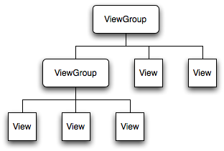

Layout

Declare your layout
Two ways:
- Declare UI elements in XML. Android provides a straightforward XML vocabulary that corresponds to the View classes and subclasses, such as those for widgets and layouts.
Using layout resources decouples your presentation layer from the application logic, providing the flexibility to change the presentation without changing code.
the XML vocabulary for declaring UI elements closely follows the structure and naming of the classes and methods, where element names correspond to class names and attribute names correspond to methods.
说明：查看同一个layout.xml是否适应于其他的分辨率
在adt自带的layout编辑器中，选择device-custom，则
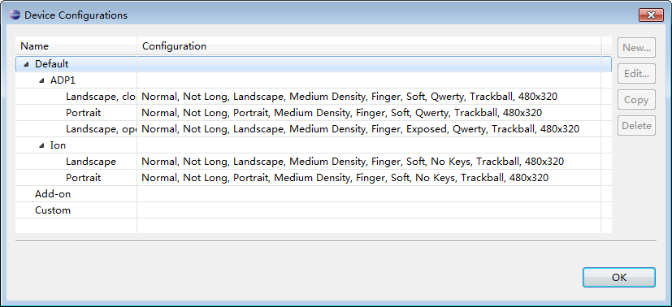
其中configuration中列出了具体的模拟器参数，进而进行选择，以进行查看
- Instantiate layout elements at runtime. Your application can create View and ViewGroup objects (and manipulate their properties) programmatically.

two step process in layout
参见：R.styleable类，其中提供了android内置的几个layout.xml
以LinearLayout和LinearLayout.LayoutParams为例，参见xml attr，分别对应了android:和android:layout_属性
则在layout.xml中的LinearLayout元素中，可以定义android:属性，其指明了我应该怎样布局我的孩子
则在layout.xml中的LinearLayout元素的子元素中，可以定义anroid:layout_属性，其指明了我针对于父亲的布局信息，以此为父亲布局提供部分依据
在程序中：childView.setLayoutParams
之下为具体过程：
Layout takes place in a two-step process: first measurements are taken(measure pass), using the LayoutParams, then items are placed on the screen(layout pass).
猜想：
上述两个process的目的为：递归丈量child view的width和height（measure，得到measured width/height），然后position the child view（layout，得到width/height）
上述思想和mypainter不谋而合，嘎嘎
- The measuring pass is implemented in measure(int widthMeasureSpec, int heightMeasureSpec) and is a top-down traversal of the View tree.
Each View pushes dimension specifications down the tree during the recursion. 而后，parentview将使用这些measureSpec（在layout.xml中，child指定layout_width/layout_height，parent据此来产生int的measureSpec）来调用childview.measure（measure将会调用onmeasure），最后根据childview的measuredwidth与measuredheight和一些其他的因素，来最终确定自己的mw和mh（均是实际的像素值，通过setMeasuredDimension(int, int)来保存）
参见：
MyViewGroup（实现了一行行的排列当一行满时，自动放入下一行）
MyViewMeasureSpec
b-professional2-p136
当我需要丈量以得到mw和mh时，我需要复写onMeasure(int, int)
measureSpec:
It is encoded with View.MeasureSpec which contains size constraint and mode constrain
Mode
UNSPECIFIED: The parent has not imposed any constraint on the child. It can be whatever size it wants.
EXACTLY: The parent has determined an specific size for the child. The child is going to be given those bounds regardless of how big it wants to be
当孩子是的layout_width/layout_height是fill parent时，或者，为具体的px时，父亲将其对应的measurespec传入孩子
AT_MOST: The child can be as large as it wants up to the specified size.
当孩子是wrap，或者父亲是wrap，而孩子是fill时
说明：
设你定义了一个view，在layout.xml中定义了layout_width/layout_height，在某个时刻，该view的measure方法将被父亲调用（当父亲需要丈量自身的w/h时）父亲根据该view的要求，创建了measureSpec，调用该view的measure方法，进而onmeasure方法
在该view的onmeasure方法中，
你可以完全忽略该measureSpec
对于标准控件来说，标准控件将严格按照父亲给予自己的指令，measure出自己占用了多少空间
Layout_width/layout_height:
如果是wrap_content，父亲将给出的measureSpec：mode为AT_MOST，size为“考虑之前孩子所占空间”后的最大剩余空间
如果是fill_parent，父亲将给出的measureSpec：mode为EXACTLY，size为“考虑之前孩子所占空间”后的最大剩余空间
如果是具体的px值，父亲将给出的measureSpec：mode为EXACTLY，size为该具体的px值
说明：
当父亲的layout_w/h是wrap_content，而孩子的layout_w/h是fill_parent时，孩子的layout_w/h本质上是wrap_content
一种情况：设父亲一个有n个孩子，在布置了i个孩子后，父亲也许会发现：已经没有后续的空间（可见区域）为后续的孩子了
说明：The base View class presents a distinctly empty 100-pixel-by-100-pixel square
- The layout pass happens in layout(int, int, int, int) and is also top-down.
During this pass each parent is responsible for positioning all of its children using the sizes computed in the measure pass.
当我想要丈量我的孩子时，我需要复写onlayout，并在其中调用childview.layout（说明：layout将会调用onlayout）
说明：即便一个view为invisible，其也被 measure和layout
总说明：
view的onMeasure和onLayout会被调用两次
第1次onMeasure：view的measured dimension有值，dimension无值
第1次onLayout：view的measured dimension有值，dimension有值
第2次onMeasure：view的measured dimension有值，dimension有值
第2次onLayout：view的measured dimension有值，dimension有值
参见：my/myViewGroup，activity依赖的layout是：group4.xml
---
layoutparams相关方法：
view.getlayoutparams：获得该view对应的layoutparams
viewgroup.updateviewlayout：更新孩子view的layoutparams

other attr in layout.xml

id
Any View object may have an integer ID associated with it, to uniquely identify the View within the tree. And this ID should be unique
When the application is compiled, this ID is referenced as an integer, but the ID is typically assigned in the layout XML file as a string, in the id attribute. The syntax for an ID, inside an XML tag is: android:id = "@+id/my_button"
@：参见R.java
+：它是一个新的资源，应该被加入到R.java.id中
你也许会看到android:id = "@android:id/empty" 或者是 “@android:id/list”
说明：前面少了+，但多了“android:”，因为empty是android内置的id，你必须要在前面加上android包名，且默认是隐藏的。参见：google-doc中R.id

Pixels
参见：google-sdk-available resource types
• px (pixels): Dots on the screen.
• in (inches): Size as measured by a ruler. It is based on the actual size of the screen.
• mm (millimeters): Size as measured by a ruler. It is based on the actual size of the screen.
• pt (points): 1/72 of an inch. It is based on the actual size of the screen.
• dp (density-independent pixels): An abstract unit based on the density of the screen. On a display with 160 dots per inch, 1dp = 1px.
• dip: Synonym for dp, used more often in Google examples.
• sp (scale-independent pixels): Similar to dp but also scaled by the user’s font size preference.
建议：To make your interface scalable to any current and future type of display,
- you always use the sp unit for text sizes and the dip unit for everything else.
- You should also consider using vector graphics instead of bitmaps

padding and margining
- Padding
The padding is expressed in pixels for the left, top, right and bottom parts of the view.
Padding can be used to offset the content of the view by a specific amount of pixels. For instance, a left padding of 2 will push the view's content by 2 pixels to the right of the left edge.
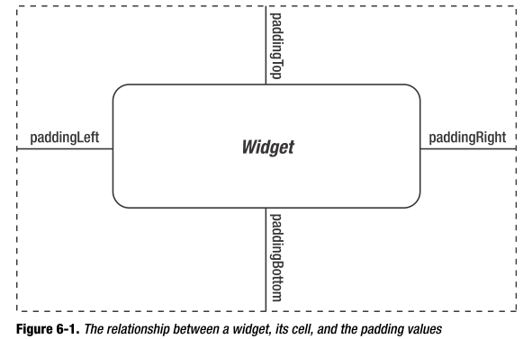
- Margining
If you apply a custom background to a widget (e.g., via the android:background attribute), the background will be behind both the widget and the padding area.
To avoid this, rather than using padding, you can establish margins, which add whitespace without extending the intrinsic size of the widget.
You can set margins via android:layout_marginTop and related attributes.
说明：
padding是作为view的额外区域而存在，如同样是wrap_content的button，当设置了padding后，其按钮区域会明显的变大
而margining用以指明view之间的额外间隔，其并不属于view的区域

Layout example

FrameLayout
All child elements of the FrameLayout are pinned to the top left corner of the screen
Subsequent child views will simply be drawn over previous ones
- Margin问题
设它有一个孩子view，你在layout.xml中设置孩子view的android:layout_marginLeft，你会发现，这没有效果
解决：
建立一个LinearLayout(wrap_content,wrap_content)，是其成为孩子view的父亲，其成为framelayout的孩子
在孩子view中，设置android:layout_marginLeft的同时，也设置android:layout_gravity
参见：my/framelayout

LinearLayout
- orientation
之下为两个RadioButton，在一个RadioGroup，当设置RadioGroup的orientation为LinearLayout.HORIZONTAL时，效果为
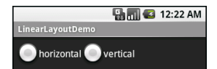
当设置orientation为LinearLayout.VERTICAL时，效果为
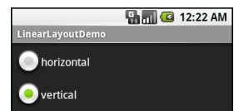
- gravity和layout_gravity
gravity表明了：在我自身的小空间里（此时，已经计算好了view的dimension），对于widget：我应该怎样绘制我自己；对于layout：怎么绘制我的孩子
之下为三个RadioButton，在一个RadioGroup（其width为fill_parent，height为wrap_content），当设置RadioGroup的gravity为Gravity.LEFT时，效果为

当设置gravity为Gravity.CENTER_HORIZONTAL时，效果为

当设置gravity为Gravity.RIGHT时，效果为

Layout_gravity表明了：在布置我时，请parent根据自身布局的同时，尽量满足我的要求
参见：gravity_layout_gravity.xml
如果linearlayout的朝向是水平，那么孩子的layout_gravity的居中要求只能是：垂直
如果linearlayout的朝向是垂直，那么孩子的layout_gravity的居中要求只能是：水平
参见：my/linearlayout
- layout_weight
Indicates how much of the extra space（额外空间） in the LinearLayout will be allocated to the view associated with these LayoutParams
Specify 0 if the view should not be stretched. Otherwise the extra pixels will be pro-rated among all views whose weight is greater than 0.
当我的孩子设置了该属性，那么我的额外的空间（当我布置完所有的孩子后，我的所剩空间）将按比例分配到该孩子上，则，其最终成为孩子的空间

RelativeLayout
- Layout_toLeftOf, _toRightOf, _above, _below
- Layout_alignLeft, _alignRight, _alignTop, _alignBottom, _alignBaseLine
alignBaseLine和alignTop的区别： ，其中TextView参照EditView
Layout_alignParentLeft, _alignParentRight, _alignParentTop, _alignParentBottom
- Layout_ centerHorizontal, _centerVertical, _centerInParent
说明：
我将画view A，那么该view A可能使用诸如Layout_toLeftOf等引用view B，而view B又Layout_toRightOf来引用view A，此时，引用关系构成了一个环circle，会抛出异常。
但是，如果a采用..of的方式引用b，而b采用align的方式引用a，则不构成一个环
当view1在view2的下方，Android从自上而下绘制view，当绘制到view2，发现屏幕已经被占满，而relativelayout又没有scrollbar（通过成为scrollview的孩子的方式），那么view1将不再绘制
参见：my/test27

Tablelayout
参见：movie_info_tab_file_detail.xml
如果你知道有一列的内容很长，需要换行，那么android:shrinkColumns="index(从0开始)"

LayoutInflater
“inflation” means the act of converting an XML layout specification into the actual tree of View objects the XML represents.
LayoutInflater li;
li = (LayoutInflater)getContext().getSystemService(Context.LAYOUT_INFLATER_SERVICE);
或者，li = (LayoutInflater) LayoutInflater.from(Context);
// public View inflate (int resource, ViewGroup root, boolean attachToRoot)，
Whether the root view of the inflated xml should be attached to the root parameter? If false, root parameter is only used to create the correct subclass of LayoutParams for the root view of the inflated xml.
li.inflate(R.layout.mylayout, this, true);
// Get references to the child controls.
EditText editText = (EditText)findViewById(R.id.editText);
说明：每次inflate返回的是不同的对象，而findviewbyid返回的是同一个对象

重用
在layout.xml中请使用include来重用其他xml吧

tools
droiddraw提供了拖拉的布局功能，开源
http://code.google.com/p/droiddraw/

Respond to UI Event
猜想：
按键的处理线程也是maint thread of the process hosting the app
activity本身实现一些诸如KeyEvent.Callback等事件回调接口，提供了onbackpressed等方法来处理back按键
设linearlayout中包含button，当设置linearlayout的clickable为true，但是button的为false，则单击按键时，按键事件由linearlayout捕获
下述观点可能错误，按键一开始由activity捕获，后分发下去
那么当当前没有焦点view时，activity会捕捉按键；否则，按键处理一开始会委托给View.onKeyListener，如果返回false，那么会进一步委托给activity。参见：my/test2
There are two ways:
- Define an event listener and register it with the View.
The View class contains a collection of nested interfaces named On<something>Listener, each with a callback method called On<something>(). For example, View.OnClickListener (for handling "clicks" on a View), So if you want your View to be notified when it is "clicked" (such as when a button is selected), implement OnClickListener and define its onClick() callback method (where you perform the action upon click), and register it to the View with setOnClickListener().
View.onKeyListener中的onKey返回boolean：True if the listener has consumed the event, false otherwise.则，如，你点击了back，如果返回为true，则系统对back键的处理-销毁activity将不会得到执行；反之，如果为false，那么销毁就会继续
根据keyevent.getaction来判断是按下action_down、抬起action_up等事件
根据keyevent.getkeycode来判断是哪个按键在参与事件，如keycode_dpad_center, keycode_enter
说明：你可以为诸如layout.xml中的button设置android:onclick属性
- Override an existing callback method for the View.
This is what you should do when you've implemented your own View class and want to listen for specific events that occur within it.
Example events you can handle include when the screen is touched (onTouchEvent()), when the trackball is moved (onTrackballEvent()), or when a key on the device is pressed (onKeyDown()，键值由KeyEvent.KEYCODE_表示).
This allows you to define the default behavior for each event inside your custom View and determine whether the event should be passed on to some other child View（由方法的返回值true or false决定）.
注意：
- onKey()- key events are always delivered starting from the top of the View hierarchy, and then down, until they reach the appropriate destination in focus。
按键事件的处理顺序：listener, handler, activity。当其一的callback返回为true，则后续callback不再被调用。
layout可以响应key事件，只要其focusable和focusableintouchmode都为true，但是这样的话，其孩子就永远得不到焦点
UI此刻必须具有焦点，否则，其listener.onkey将不会得到调用
参见：my/test2
- onTouch() - This returns a boolean to indicate whether your listener consumes this event. The important thing is that this event can have multiple actions that follow each other. So, if you return false when the down action event is received, you indicate that you have not consumed the event and are also not interested in subsequent actions from this event. Thus, you will not be called for any other actions within the event, such as a fingure gesture, or the eventual up action event.
参见：touch
- 如果5秒内没有响应用户输入事件，则认为程序无响应，会抛出异常
参见：Android事件处理.mht

Touch
传递机制：
当ontouch返回false，则对后续事件不再感兴趣，如gesture和touch up，传递后续touch事件给帮手
有哪些帮手可供选择：onlongclick, onclick, father.ontouch
当只有帮手onlongclick，那么ontouch执行完，点击保持一段时间后，跳入onlongclick，因为onlongclick需要touch up事件被处理，那么ontouch会继续处理后续gesture和touch up事件
当只有帮手onclick，那么需要跳入到onclick，但是onclick需要touch up事件被处理，那么ontouch会继续处理后续gesture和touch up事件
当touch up事件处理完，会判断在move的过程中是否超出了view的有效区域，如果没有超出，跳入onclick
当有onclick和onlongclick时，当onlongclick返回false，则touch up事件处理后，跳入onclick
当只有帮手father.ontouch，那么ontouch执行完，跳入father.ontouch
当有on...click和father.ontouch时，father.ontouch不起作用
当ontouch返回true，则对后续事件感兴趣，其忽略帮手
------------------
listview的情况
child.ontouch简略为ontouch，
当ontouch返回false，则对后续事件不再感兴趣，如gesture和touch up，传递后续touch事件给帮手
有哪些帮手可供选择：onlongclick, onclick, father.ontouch(onitemlongclick, onitemclick)
onitemlongclick, onitemclick均是father的，其由father.ontouch跳入，但又不完全是(见下情况)
当onlongclick返回false，则onitemlongclick为其帮手
说明：viewgroup含有onintercepttouchevent，详情参见：onInterceptTouchEvent和onTouchEvent调用时序
实现view的拖动效果：
你可以实现一个ontouchlistener来监听view的当前位置：通过motionevent.getrawx和getrawy
然后你可以拿着(x,y)来更新view的位置，但是..一旦view被加入到一个layout中，那么其位置就是由layout来决定（根据一定的算法得到，而不让用户费心）
则
viewA是你要拖动的对象，它之前位于layoutA下，那么你定义一个framelayout，其中包含了layoutA和absolutelayout
当你拖动viewA时，设置其为隐藏，为该view制作一个copy（如将该viewA变成bitmap，将该bitmap作为src来新建一个imageview），后将copy放入absolutelayout中
根据rawx和rawy来更新copy的layout_x和layout_y（absolutelayout.layoutparams.x和y），并重设copy.layoutparams
一个例子：参见：testMyDrawer-copy need more than a xml文件夹

Focus
告诉我，view，你是否具有焦点：android:focusable android:focuableInTouchMode XML attribute to the View
告诉我，view，你的下一个焦点在哪里：Overrides with the following XML attributes in the layout file: nextFocusDown, nextFocusLeft, nextFocusRight, and nextFocusUp.
现在，强制将焦点转移到一个view上：view.requestfocus
获得activity的当前焦点view：activity.getCurrentFocus();

Building custom view
参见：google doc-framework topics-building custom componentsf

the approach
- Modifying an existing view type
- compound components
- Fully Customized views
参见：
Google sample-.view.CustomView1, .view.InternalSelectionScroll
My/test23
如何获得系统attr的值和自定义attr的值
typedarray和attributeset的用法

expose your view
- 外部可以直接引用该类
- through a layout.xml，
如果MyView不是内部类，则可用com.ql.MyView代替TextView了
否则，则采用该形式：<view class=”com.ql.SomeClass$MyView” />

Draw the view
参见：google doc-framework topics-graphics-2d graphics
- 关键类
Bitmap为画布/绘制载体，为存储颜色信息的二维数组
获得bitmap对象：
BitmapFactory.decodeByteArray
BitmapFactory.decodeFile
BitmapFactory.decodeResource
BitmapFactory.decodeStream
来将byte array, file, resource, inputstream转化为Bitmap对象
它是canvas的载体，即是：canvas所绘制的所有东西都将被画到bitmap上；此外，还可以将该bitmap再绘制到其他canvas上：canvas.drawbitmap
回收：当你使用完了bitmap后，需要回收
if(bitmapObject.isRecycled()==false) //如果没有回收
bitmapObject.recycle();
Matrix对rotate, scale等进行封装，借助于此，使用Bitmap.createBitmap可以产生新的bitmap
Canvas是一个画布，其载体由构造函数Canvas(Bitmap)中的Bitmap来指定
构造例子：
Bitmap b = Bitmap.createBitmap(100, 100, Bitmap.Config.ARGB_8888);
Canvas c = new Canvas(b);
它负责绘制，拥有绘制的方法，并负责transform（可以在transform之前save，然后变换之后restore）
绘制方法参数往往包含了坐标，说明：这些坐标都是相对的（不是绝对的），即是：相对于canvas对应的view
Drawtext将绘制字符串，将依据paint的baseline，即是以左上角的y+distance above baseline来绘制。参见：google demo-labelview
Once your onDraw() is complete, the Android framework will use your Canvas to draw a Bitmap handled by the system
获取方式：
对于view，使用ondraw的参数canvas
对于surfaceview，使用surfaceview.lockcanvas
Drawable is a general abstraction for "something that can be drawn on the canvas”, 方式：draw(Canvas)
Paint负责管理画笔
Rect和RectF类管理坐标
- View的绘制控制
When an Activity receives focus, it will be requested to draw its layout.
Drawing begins with the root node of the layout. Components are drawn to the screen in the order they are found in the layout tree: parents first, then children (parents end up behind children, if they overlap in positioning).
View group is responsible for requesting each of its children to be drawn (with the child.draw() method) and each View is responsible for drawing itself.
View.onDraw(Canvas) will be called by the Android framework to request that your View draw itself
更新：Each time that your application is prepared to be drawn, you must request your View be invalidated by calling invalidate(). In order to request an invalidate from a thread other than your main Activity's thread, you must call postInvalidate().
参见b-professional2-p128，
注意：例子中在构造一个listview的itemview
猜想：从b-professional2的例子中可以看到，当viewgroup-listview为child view-textview指定好了position和width/height后，canvas.draw…便针对于该区域，参见p129-onDraw
- 其他
- 复制view
用ui thread来调用view的dispatchdraw，该方法需要一个canvas作为参数，那么用bitmap来构造此canvas，那么到最后，view的内容被绘制到该bitmap上，则该bitmap代表了view的内容
- 方法调用顺序
针对于view：onfinishinflate-onmeasure-onlayout-ondraw-dispatchdraw
针对于viewgroup：onfinishinflate-onmeasure-onlayout-dispathdraw
说明：
Viewgroup不含有ondraw
在viewgroup的onlayout中，只有调用孩子view.layout时，孩子view才会绘制
针对于activity，activity.setcontentview中时，view.onfinishinflate被调用，后activity.setcontentview返回，activity.onresume后才会调用view.onmeasure
- 图片缩放
BitmapFactory.Options options = new BitmapFactory.Options();
options.inSampleSize = 2;//图片宽高都为原来的二分之一，即图片为原来的四分之一
Bitmap bitmap = BitmapFactory.decodeStream(xx,xx,options);
- Manager
Viewmanager和windowmanager用来显示

Adapter & AdapterView

Adapter
Android’s adapters are responsible for providing the roster of data for a selection widget, as well as for returning a View which is representing the row for the supplied position in the adapter data to be displayed inside the selection widget(AdapterView).
setAdapter的调用形式：
AdapterView.setAdapter
AutoCompleteTextView.setAdapter
ListActivity.setListAdapter

getView()
getView (int position, View convertView, ViewGroup parent)：你将参照array[position]这一原始数据来构建一个item view
注意：我提供了一个数组，那么需要考虑：
- 数组中的元素是协助展示的最终数据吗？如果不是，请在Adapter.getItem(position)中构造
- 数组中的第i个元素要协助展示第i个view吗？如果不是，请在Adapter.getItemId(position)中构造
- 第i个view可以转换到第j个view吗？如果可以，
那么这两个view对应同一个view type（一个view type对应一个view层次性，例如viewI的层次性为LinearLayout-TextView_ImageView，则viewJ的层次性也必为LinearLayout-TextView_ImageView），则在构造第j个view时，我可能将传入该view type的第k个view
时机：一个屏幕上最多可包含m个view，但总共有m+n个view，当拖动下拉条，要展示第m个view时（从第0个开始），则根据Adapter.getItemViewType(int position)（其值区间为[0, Adapter.getViewTypeCount()-1]）来决定是否应该传入convertview。
说明：因为屏幕上只允许存在m个view，我之前已经构造了m个，但此刻，前x个已经不需要了，因为它们已经无法显示在屏幕上了，那么我有可能拿这前x个来构造后x个应该显示的view（注意：当一版面可以显示k个item view，那么你不可以用同一个view来构造k个item，而必须使用k个对象）
此刻，请重新指定convertView以及孩子view的属性，设unit view的root为linearlayout，孩子为textview和imageview，那么重新利用convertview所涉及的最关键的操作是：重新textview.settext(text)和imageview.setimageresource(rid)，那么将text和rid分别保存在两个集合中，如textlist和ridlist。
接下来，我知道新的unit view中的textview和imageview需要哪些属性值，但是我如何发现textview和imageview：当convertview不为null时，我肯定知道它是一个linearlayout类型，当进行强制转换后，是否要findviewbyid？你可能会问，find操作之前已经做过了，现在应该避免重复操作，而且，一旦重复，伴随着unitview的个数的巨大，巨大的性能浪费将产生。
是的，我们应该避免重新findviewbyid，那么我们要将textview和imageview与convertview进行关联，一种做法是：新建一个类wrapperview，继承自linearlayout，将textview和imageview作为其成员变量保存起来，而convertview就是一个wrapperview，如果需要textview，那么直接取wrpperview的成员变量就可以了
一个规范例子：参见
Google sample-List14//采用了另外一种做法，但是思想相同
Adapter.getView.rar
my/test4
后续工作：
对registerDataSetObserver进行说明
再看baseadapter中的abstract方法
再看“应用程序揭秘”中的游戏编程，其中涉及了怎么绘制一个自定义的view

当数据发生改变时
参见：my/test3
当adapter.add或者remove元素时，adapterview自动更新
当adpater内部的数据包（如：array, list）发生改变时，需要adapter.notifyDataSetChanged()以重新getView，注意：请确保该方法在ui thread中被调用;
一个例子：
当你有100个图片item要展示，item view中包含了imageview，一开始imageview显示着默认图片，你在后台对该图片的缩略图进行加载，加载完成后notify。那么，由于加载速度很快，你应该在每次加载10个后进行通知，而不是每加载一个通知一次；在通知的时候，你应该判断加载的数据是否在listview.getfirstvisibleposition和listview.getlastvisibleposition之间，和，展示的图片是否已经不是默认图了

Baseadpater
当你要自己实现一个adapter时，继承baseadpater是最好的选择。其中，最关键的需要复写的方法是：getview和getcount
当getcount为0时，adpaterview将使用emptyview，否则，调用getview

CursorAdapter
SimpleCursorAdapter (Context context, int layout, Cursor c, String[] from, int[] to)
参数说明
From为列名
To为layout中的对应于from的view的id
getView, newView, bindView:
The getView() method inspects the supplied View to recycle. If it is null, getView() calls newView(), then bindView(). If it is not null, getView() just calls bindView().
If you are extending CursorAdapter, which is used for displaying results of a database or content provider query, you should override newView() and bindView(), instead of getView().
一个例子：
public View newView(Context context, Cursor cursor,
ViewGroup parent) {
LayoutInflater inflater=context.getLayoutInflater();
View row=inflater.inflate(R.layout.row, null);
ViewWrapper wrapper=new ViewWrapper(row);

row.setTag(wrapper);

return(row);
}

public void bindView(View row, Context context, Cursor cursor) {
ViewWrapper wrapper=(ViewWrapper)row.getTag();

// actual logic to populate row from Cursor goes here
}
当table内容发生改变时，必须调用cursor.requery重新查询，如实行者为contentprovider。
This, in turn, will update any SimpleCursorAdapter you may have wrapping the Cursor,
and that will update any selection widgets (e.g., ListView) you have using this adapter.
一些方法：
adapter.getItem(position)返回的是一个cursor。参见：b大全2-p333
runQueryOnBackgroundThread (CharSequence constraint)
Runs a query with the specified constraint. This query is requested by the filter attached to this adapter.
猜想：如AutoCompleteTextView中的adapter采用cursoradapter，那么在输入关键字时，会调用该方法，而该方法会返回一个cursor，根据该cursor，cursoradapter组装item view
参见：b开发2-ch5.9

ArrayAdapter
context | The current context.
textViewResourceId | The resource ID for a layout file containing a TextView to use when instantiating views.  猜想：它指示了item的展示
objects | The objects to represent in the ListView.  String[] or List  猜想：每个元素对应一个item
new ArrayAdapter<String>(this, android.R.layout.simple_list_item_1, new String[]{"this", "is", "a", "really", "silly", "list"});
By default, the ArrayAdapter invokes toString() on the objects, and simply turns those strings into TextView objects

Baseexpandablelistadapter和CursortreeAdapter
参见：expandablelistview

ApdaterView

事件响应
item被select或被单击：
参见：my/test
AdapterView.setOnItemClickListener处理：鼠标单击
AdapterView.setOnItemSelectedListener处理：上下方向键单击/鼠标滑过
当选中了一项，后在其他地方单击使该项变为不选中，则onNothingSelected被调用
说明：鼠标的拖动并不是上述监听器监听的事件
AbsListView.OnScrollListener
public void onScroll (AbsListView view, int firstVisibleItem, int visibleItemCount, int totalItemCount)
当在滑动的时候调用
public void onScrollStateChanged(AbsListView view, int scrollState);
当滑动状态发生改变的时候调用，滑动状态为：SCROLL_STATE_IDLE（静止）, SCROLL_STATE_TOUCH_SCROLL（用手拖动中）, SCROLL_STATE_FLING（拖动后松手后的滑行）
参见：metadataAndroidClient（情形：一个gridview要展示很多image，在滑动的过程中，显示默认图标，滑动停止时，展示item对应的图标）

ListView
ListView.setChoiceMode()
ListView.CHOICE_MODE_SINGLE
android.R.layout.simple_list_item_single_choice
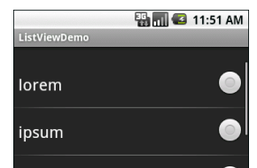
CHOICE_MODE_MULTIPLE
android.R.layout.simple_list_item_multiple_choice
ListView.getCheckedItemPositions()
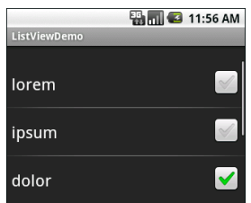

Spinner
Pressing the center button on the D-pad pops up a selection dialog box from which the user can choose an item
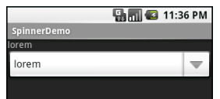
ArrayAdapter.setDropDownViewResource for drop-down view
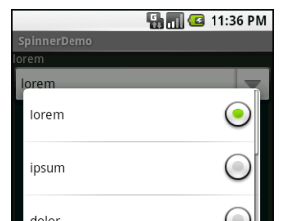

ListActivity
ListActivity本身绑定了一个ListView
如果不为ListActivity设置mainLayout.xml，则使用默认，意味着可以不重写onCreate，并setContentView
但，如果要为其指定mainLayout.xml，则必须在该xml中包含ListView，且id为@android:id/list

AutoCompleteTextView
AutoCompleteTextView.addTextChangedListener(TextWatcher{
onTextChanged
当AutoCompleteTextView的text发生改变时，通知
beforeTextChanged
afterTextChanged
});
android:completionThreshold=3，意味着当用户输入3个字符时，才会出现候选，效果如图：
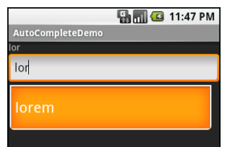

Expandablelistview
其和listview的思想大同小异，其区别为
- 其拥有group和child概念，
- 其对应的adapter需继承自baseexpandablelistadapter，该adpater中针对于group和child均有getcount和getview等一套方法
- 而其涉及了数据库时，对应的adapter为cursortreeadapter，其思想也和cursoradapter大同小异，区别为：在构造函数中的cursor用以获取group数据，其也作为getchildrencursor的参数以获取child的cursor。对于一般应用，你也许会考虑使用simplecursortreeadapter

Gallery
其和listview的思想大同小异，其区别为
其对应的adapter为spinneradapter，而你可以使用baseadapter，因为其继承了它
其3d效果，参见：
My/gallery3D
my/di_movie_android
Android控件Gallery3D效果.htm

一些方法
View.setVisibility()，供选参数：View.VISIBLE, View.GONE, View.INVISIBLE

Task
参见
ActivityManagerService中的HistoryRecord
Google doc-application fundamentals-activities and tasks
b-professional-p92-activity stack
A task is a stack of activities objects（猜想：a stack which contains activity objects for back user action，或者，for finish()）（当一个root activity启动时，对应该activity的affinity的task如果不存在将被产生），task是root activity的，该activity是老大
To the user, it will seem as if the map viewer(a part component of other app) is part of the same application as your activity, even though it's defined in another application and runs in that application's process. Android maintains this user experience by keeping both activities in the same task
The root activity in the stack is the one that began the task — typically, it's an activity the user selected in the application launcher（"android.intent.action.MAIN" launchs the task, and “android.intent.category.LAUNCHER” gives the user the chance to return to that task at any time after it has been launched（如按HOME后，可以从launcher栏再重新启动）），或者，你通过了一个含有new task的flag的intent来启动了一个activity，也即是产生了一个新的task
When context starts a activity, this new activity is pushed on the stack of the target task（栈顶）; it becomes the running activity, and can response to the user.
The previous activity remains in the stack. When the user presses the BACK key, the current activity is popped（猜想：该activity被遗弃了，它被销毁了） from the stack, and the previous one resumes as the running activity. Activities in the stack are never rearranged, only pushed and popped
All the activities in a task move together as a unit. The entire task (the entire activity stack) can be brought to the foreground or sent to the background
Tasks的顺序性：你可能启动了多个task，先启动task1，再task2，再task3。当你此刻在task3，那么你一直在back，则，当task3被清空时，task2会呈现在你面前（并不呈现home），最终，task1呈现了
当你长按home时，出现了一些程序，那么它们代表的是一个个的task
Value of the task – root activity’s affinity
Values for the task as a whole are set in the root activity, that value is read from the affinity set for the task's root activity.
If this attribute is not set, the activity inherits the affinity set for the application (<application> element's taskAffinity attribute).
The name of the default affinity for an application is the package name set by the <manifest> element.
A task can have more than one instance of the same Activity: different entry
The stack contains objects, so if a task has more than one instance of the same Activity subclass open — multiple map viewers, for example — the stack has a separate entry for each instance.
一些技巧：
通过ActivityManager.getRunningTasks来获得ActivityManager.RunningTaskInfo
通过ActivityManager.getRunningServices来获得当前ActivityManager.RunningServiceInfo

The controls beyond the basis
参见：
google doc-applications fundaments-activities and tasks
google doc-framework topics-the androidmanifest.xml-activity
b-ophone-p58
The association of activities with tasks, and the behavior of an activity within a task, is controlled by the interaction between flags set in the Intent object that started the activity and attributes set in the activity's <activity> element in the manifest
猜想：Context.startActivitytask的过程：
task中存放着activity，而activity本身为context，当一个context.startActivity时，
- 往往会根据context找到源task（猜想：如果context由非activity的component获得时，将会找不到源task，此时Intent必须含有new task flag），因为此task往往会成为目标task-被激起的activity被存入该task中，成为栈顶；
- android会寻找已经安装的activity
- 根据intent的属性和androidmanifest.xml，来决定activity是否应该被实例化，该被放入哪一个task的栈顶中（singleTask的activity可能会因为无法被放入栈顶而完全忽略该intent，但是却使singleTask的task处于foreground）
In this regard, the principal Intent flags are（参见：My/intentflag）:
- FLAG_ACTIVITY_NEW_TASK
当intent被添加了此属性，那么activity将会被放入与<activity>的affinity属性相同的task中，如果不存在，新建该task
- FLAG_ACTIVITY_CLEAR_TOP
If an Intent object includes the FLAG_ACTIVITY_CLEAR_TOP flag, and the target task already has an instance of the type of activity that should handle the intent in its stack, all activities above that instance are cleared away so that it stands at the top of the stack and can respond to the intent.
- FLAG_ACTIVITY_RESET_TASK_IF_NEEDED
- FLAG_ACTIVITY_SINGLE_TOP
一个例子：
在你的脑海里，有abcd四个activity，你想着在d后退的时候，跳转到a，而不是c，那么：
在start(b)时，intent的flag为：FLAG_ACTIVITY_CLEAR_WHEN_TASK_RESET
在start(d)时，intent的flag为：FLAG_ACTIVITY_NEW_TASK|FLAG_ACTIVITY_RESET_TASK_IF_NEEDED
要清除task中的所有activity：在api level 11中，FLAG_ACTIVITY_CLEAR_TASK
--
The principal <activity> attributes are:
- taskAffinity
activity.affinity最终和task.affinity“类似”，要么相同，要么activity.affinity被忽略
- allowTaskReparenting
Whether or not the activity can move from task A that started it to task B it has an affinity for when task B is next brought to the front
For example, if an e-mail message contains a link to a web page, clicking the link brings up an activity that can display the page. That activity is defined by the browser application, but is launched as part of the e-mail task. If it's reparented to the browser task, it will be shown when the browser next comes to the front, and will be absent when the e-mail task again comes forward.
- launchMode
An instruction on how the activity should be launched
Every time there's new intent for a "standard" activity, a new instance of the class is created to respond to that intent.无论activity是否存在，甚至位于栈顶
singleTop和standard非常类似，只是if the target task already has an existing instance of the activity at the top of its stack, that instance will receive the new intent (in an onNewIntent() call); a new instance is not created
A "singleTask" activity is at the root of the activity stack, and other activities (necessarily "standard" and "singleTop" activities) can be launched into the same task. Moreover, the device can hold only one instance of the activity at a time
A " singleInstance" activity is at the root of the activity stack, but other activities (necessarily "standard" and "singleTop" activities) can not be launched into the same task. Moreover, the device can hold only one instance of the activity at a time
以下描述了task“被用户leave（如，用户在launch栏处又开启了一个app），而后点击home，再在launch栏又一次启动”的清理情形
默认方式是：If the user leaves a task for a long time, the system clears the task of all activities except the root activity.
- clearTaskOnLaunch
Whether or not all activities will be removed from the task, except for the root activity
This attribute is meaningful only for the root activity of a task，也即是只有root activity设置该属性才能影响该task
- alwaysRetainTaskState
Whether or not the state of the task that the activity is in will always be maintained by the system
This attribute is meaningful only for the root activity of a task，也即是只有root activity设置该属性才能影响该task
- finishOnTaskLaunch
Whether or not an existing instance of the activity should be shut down (finished)
- noHistory
Whether or not the activity should be removed from the activity stack and finished (its finish() method called) when the user navigates away from it and it's no longer visible on screen
问题：
abc四个activity，存在两个task，根分别是a和c，a启动了b，intent flag为FLAG_ACTIVITY_NEW_TASK，b放入了c的task中。此时，当用户点返回，用户看到的是a还是c。猜想：b和c已经是一组了，b返回，c展示

Some widget and other useful

Menu

添加menuItem
在onCreate…Menu()方法中来完成：
- Menu.add (int groupId, int itemId, int order, int titleRes)
- 通过res/menu/mymenu.xml，new MenuInflater(getApplication()).inflate(menuResourceId, menu instance in);
参见：
Google samples-.app.MenuInflateFromXml
menu.xml
此外，还可以添加子菜单addSubMenu (int groupId, int itemId, int order, int titleRes)

事件响应
对于optionmenu，activity.onOptionsItemSelected(MenuItem item)，参见 b-sdk-p68
对于contextmenu：activity.onContextItemSelected(MenuItem item)
当ContextMenu和ListView连用时，AdapterContextMenuInfo info = (AdapterContextMenuInfo) menuitem.getMenuInfo();
This provides information about the currently selected item，如info.position代表listview中选中的item的位置，info.targetview代表listview中选中的view
类似的，当与expandablelistview连用时，该info为expandablelistmenuinfo。
根据info.packedposition，listview.getpackedpositiontype能得到点击的是child还是group；诸如listview.getpackedpositiongroup能得到点击针对于group的位置
对于optionmenu和contextmenu：menuItem.setOnMenuItemClickListener
猜想：你可以在oncreate..menu的时候来通过这种方式来设置响应，从而不需要再设置activity.on…ItemSelected

OptionMenu
The options menu is triggered by pressing the hardware Menu button on the device.
Optionmenu被认为是activity的
当它被初次创建时（它只会被创建一次），onCreateOptionsMenu()被调用
onPrepareOptionsMenu() is called just before displaying the menu each time it is requested.


ContextMenu
当长按一个View时，系统会弹出一个漂浮的菜单列表
Contextmenu不认为是view的，而是activity的
但是Menu是和activity中的view联系在一起的：View.setOnCreateContextMenuListener或者Activity.registerForContextMenu(View)
onCreateContextMenu(ContextMenu, View, ContextMenuInfo) will be called for each time the context menu is requested, and context menus are discarded after they are used or dismissed.
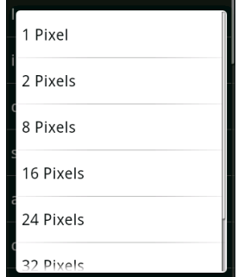

a simple model for extending your existing functionality
Android lets future packages provide new functionality for existing applications, using Intent Filters to populate menus dynamically at run time.即是：将一些component（如之前编写好的activity）变成现有application的menu item，使其extend the app’s functionality.
The Menu.addIntentOptions method lets you specify an Intent that describes the data that is acted upon by this menu. Android resolves this Intent and returns every action speciﬁed in the Intent Filters that matches the speciﬁed data. A new Menu Item is created for each, with the text populated from the matching Intent Filters’ labels.
The intent:
The Intent is being used to ﬁnd actions, so don’t assign it one;
it should only specify the data on which to perform actions.
You should also specify the category of the action, either CATEGORY_ALTERNATIVE or CATEGORY_SELECTED_ALTERNATIVE in androidmanifest.xml
Generally, this will be handled within your Activity’s onCreateOptionsMenu or onCreateContextMenu handlers.
一个例子：
@Override
public boolean onCreateOptionsMenu(Menu menu) {
super.onCreateOptionsMenu(menu);
// Create the intent used to resolve which actions should appear in the menu.
Intent intent = new Intent();
intent.setData(MoonBaseProvider.CONTENT_URI);
intent.addCategory(Intent.CATEGORY_SELECTED_ALTERNATIVE);
// Normal menu options to let you set a group and ID
// values for the menu items you’re adding.
int menuGroup = 0;
int menuItemId = 0;
int menuItemOrder = Menu.NONE;
// Provide the name of the component that’s calling the action -- generally the current Activity.
ComponentName caller = getComponentName();
// Define intents that should be added first.
Intent[] specificIntents = null;
// The menu items created from the previous Intents will populate this array.
MenuItem[] outSpecificItems = null;
// Set any optional flags.
int flags = Menu.FLAG_APPEND_TO_GROUP;
// Populate the menu
menu.addIntentOptions(menuGroup,
menuItemId,
menuItemOrder,
caller,
specificIntents,
intent,
flags,
outSpecificItems);
return true;
}
而一个已有的零件：
<activity android:name=”.NostromoController”>
<intent-filter android:label=”Nuke From Orbit”>
<action android:name=”com.pad.nostromo.NUKE_FROM_ORBIT”/>
<data android:mimeType=”vnd.moonbase.cursor.item/*”/>
<category android:name=”android.intent.category.ALTERNATIVE”/>
<category android:name=”android.intent.category.SELECTED_ALTERNATIVE”/>
</intent-filter>
</activity>

Dialog
参见：AlertDialogSamples.java
当activity管理着一个dialog时，如像activity管理menu一样
呈现：
activity.showDialog，注意：仅当dialog被初次创建时，activity.onCreateDialog被调用（期间，创建一个dialog对象），即是：该dialog被缓存，而不是重复创造
或者，产生一个dialog对象，后dialog.show()
产生dialog对象：使用AlertDialog.Builder(Context)，说明：该context必须是当前显示的activity，而非package中的其他comp。参见：AlertDialogSamples.java
隐藏：activity.dismissDialog，或者，Dialog.dismiss
every time your dialog is dismissed, the state of the Dialog object is retained by the Activity.
为dialog设置ondismisslistener，来指出：当dialog消失的时候怎么办
其他listener：设置oncancellistener，指的是：当dialog取消（取消按钮或者back按键）的时候怎么办
删除：activity.removeDialog
If you decide that you will no longer need this object or it's important that the state is cleared, then you should call removeDialog(int). This will remove any internal references to the object and if the dialog is showing, it will dismiss it.
Android提供了四类dialog，参见google doc-frameworktopics-user interface-creating dialogs
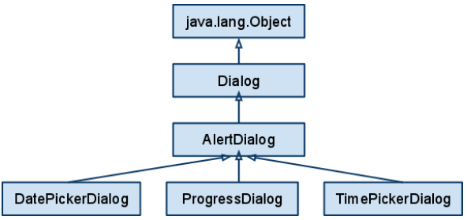

AlertDialog
参见：google samples-.app.AlertDialogSamples
new AlertDialog.Builder().setTitle().setMessage().
setPositiveButton(int resId, DialogInterface.OnClickListener).setNegativeButton().
setItems(int resArrayId, DialogInterface.OnClickListener).
其中：DialogInterface.OnClickListener(){onClick(DialogInterface dialog, int whichItem)}
show()
为AleterDialolg设置自定义的layout, setView()

RadioGroup
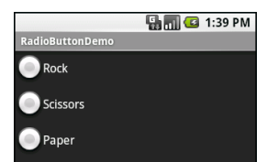
setOnCheckedChangeListener：单击radiobutton的回调
可以使用配置文件将RadioButton放入RadioGroup中

Checkbox
setOnCheckedChangeListener
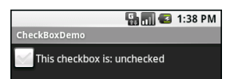
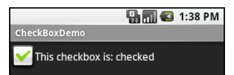

ProgressBar
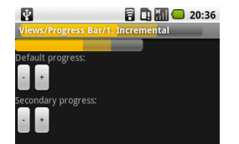
Intermediate（中间的）和indeterminate（不明确的）
参见b-ophone-p92

ActivityGroup
Activitygroup使得：ui由多个activity组成
场景：
1. tab的构造：一个tab的content是一个activity
2. 一个layout的某个view并不是固定的，它可以是：view1，或，view2，或，viewn。
那么，你可以构建几个layout.xml，
在一个activity.java中编写这几个layout.xml的按键响应，且控制转换
或者，你可以将viewi对应activityi的content view，在多个activity.java中编写按键逻辑，然后将这些activity加入，且控制转换
说明：android保证，这些activity不会被重复构造，且，每个activity对应的content view的view对象只有一个
参见：my/localactivitymanager

WebView
loadUrl(httpurl);
loadData(httpdata, “utf-8”);

Linkify
Linkify is a helper class that automagically creates hyperlinks within TextView (and TextView derived) classes through RegEx pattern matching.
Text that matches a specified RegEx pattern will be converted into a clickable hyperlink that implicitly fires startActivity(new Intent(Intent.ACTION_VIEW, uri)), using the matched text as the target URI.
Linkify.addLinks(myTextView,Linkify.WEB_URLS | Linkify.EMAIL_ADDRESSES | Linkify.PHONE_NUMBERS);
当myTextView中的内容是电话时，则此时，会产生一个连接，单击该连接，则会产生Intent来调用电话程序，同理对于email和web url
另一种方法：
可以在AndroidManifest.xml中，为myTextView设置autoLink属性，值为web | phone | email，或者，all

RatingBar
setOnRatingBarChangeListener()

Tab
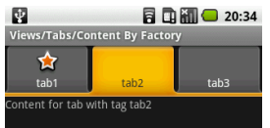
TabHost is the overarching container for the tab buttons and tab contents.
TabWidget implements the row of tab buttons, which contain text labels and, optionally, icons.
FrameLayout is the container for the tab contents. Each tab content is a child of the FrameLayout.
这往往只体现在layout.xml中
TabSpec
一个例子：TabHost.addTab(host.newTabSpec(tag).setIndicator(label, getResources().getDrawable(iconId)).setContent(viewId));
A tab can have either a View or an Activity as its contents. If you want to use an Activity as the content of a tab, you provide an Intent that will launch the desired Activity; Android’s tab-management framework will then pour the Activity’s UI into the tab, however, You cannot host other applications’ activities in your tabs; only your own activities are allowed, for security reasons.
如：tabHost.addTab(tabHost.newTabSpec("tab1").setIndicator("list").setContent(new Intent(this, List1.class)));
一个例子：参见：Tab.rar
参见：my/metadataclient, my/musicRecommendationAndroidClient, my/movieRecommendationAndroidClient

Time widget

DatePicker, TimePicker, DatePickerDialog, TimerPickerDialog
- Listener
OnDateChangedListener, OnDateSetListener
OnTimeChangedListener, OnTimeSetListener
- Calendar
Calendar dateAndTime=Calendar.getInstance();
dateAndTime.set(Calendar.YEAR, year);
dateAndTime.set(Calendar.MONTH, monthOfYear);
dateAndTime.set(Calendar.DAY_OF_MONTH, dayOfMonth);
dateAndTime.set(Calendar.HOUR_OF_DAY, hourOfDay);
dateAndTime.set(Calendar.MINUTE, minute);
- DateFormat
java.text.DateFormat fmtDateAndTime=new SimpleDateFormat("yyyy-MM-dd")
fmtDateAndTime.format(dateAndTime.getTime())
- diaolog效果
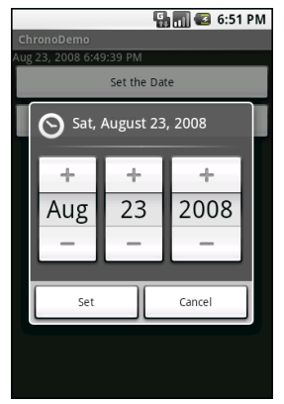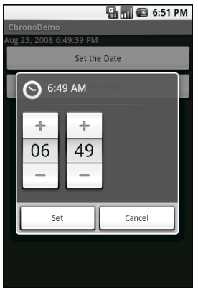

AnalogClock, DigitalClock
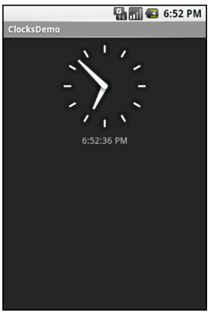

Gallery
本身也是一个AdapterView，参见：google samples-.view.Gallery1

ImageView
ImageView.setImageResource(int resId);
参见：
google samples-.view.Grid2
.view.ImageView1

ScrollView
当往LinearLayout中添加大量的view时，将LinearLayout放入ScrollView中，可以添加滚动条，样式由android:scrollbars决定
如果需要添加水平的滚动，请使用horillzonscrollview

Slidingdrawer
其分为handler和content两个view，在layout.xml中设置，参见：testMyDrawer-copy need more than a xml
当要点击/拖动某一区域drawer才有反应时，复写onintercepttouchevent：
当在指定区域时，返回super...
当不在时，返回true（此时会传递至ontouchevent）

Surfaceview
surfaceview是一个view
默认情况下，给其一整屏来进行绘制，可以对其父的width和height进行设置，从而限制其大小
参见：
My/surfaceView
http://blog.csdn.net/hellogv/article/details/5985090
绘制：
在surfaceview对应的canvas上面
步骤：
获取canvas：SurfaceView.getHolder().lockCanvas(XX)
使用canvas/paint等进行绘制
SurfaceView.getHolder().unlockCanvasAndPost(XX)
说明：该步骤可以在任何线程上调用
Vs View:
- 使用场景
View：被动绘制
Surfaceview：主动绘制，适用于频繁刷新屏幕
- 更新
当你更新了view的内容（复写view.ondraw方法，使用view.ondraw提供的canvas），你需要在ui线程上调用view.invalidate
当你更新了surface view的内容（在任何线程上，使用surfaceviewholder.lockcanvas提供的canvas，并最后，surefaceviewholder.unlockCanvasAndPost），你不需要调用invalidate

PagerAdapter
ViewPager多页面滑动切换
参见：my/viewpager

Service
Two purposes:
- performing a background task.
A service doesn't have a visual user interface, but rather runs in the background for an indefinite period of time
- enabling IBinder/Binder-based IPC（参见Process and thread-IPC）
It's possible for the client to connect(ServiceConnection) to/bind to an ongoing service (and start the service if it's not already running)（注意：client和service可以在不同的process中）. While connected, the client can communicate with the service through an interface that the service exposes，即是：你可以控制service了
获得系统的服务：Context.getSystemService
获得正在运行的service：ActivityManager的方法List<ActivityManager.RunningServiceInfo> getRunningServices()
who can be the client of Service:
Services can be used by any application component that hangs around for a reasonable period of time.
This includes activities, content providers, and other services.
Notably, it does not include pure broadcast receivers (i.e., intent receivers that are not part of an activity), since those will get garbage collected immediately after each instance processes one incoming Intent.

Intentservice
其是service的一种，排队intent，其处理在一个非UI thread的thread上进行

Content provider & data storage
参见：google doc-framework topics-data storage
there are typically only a few ways to persist the data: in memory structures, the filesystem, databases, and network services.
And Android:
- includes a SharedPreferences object and preferences system that allows you to store simple key-value pairs within applications.
can share data between apps only if the correct permissions are set and each application knows the context/path.
参见unlock-p175-ch5.4
但是google doc却说：ContentProvider is the only way to share data across applications; there's no common storage area that all Android packages can access.
- provides access to the filesystem,
can share data between apps only if the correct permissions are set and each application knows the context/path.
参见unlock-p175-ch5.4
但是google doc却说：ContentProvider is the only way to share data across applications; there's no common storage area that all Android packages can access.
- provides access to the res/raw and res/xml, 参见Externalizing Resources
be accessible only to the process that own it
- has support for a local relational database through SQLite,
be accessible only to the process that own it
- includes its own construct that allows applications to share data through a clever URI-based approach called a ContentProvider

Application
We can store some user information in Application, so we can reference this object again in other activities in the same app to retrieve the information we are storing here
它是一个全局的context：
当app的进程没有杀死，该context将会一直存在，而不会被重复创建
它是个，针对于同一个程序的，全局的，资源存储器
还记得之前的程序中，总是建立一个mycontext的类，现在可以：用一个自定义的Application，来代替，mycontext
参见：my/applicationContext
用途：
- Maintain application state
- Transfer objects between application components
- Manage and maintain resources used by several application components
创建时机：
when your application process is created.
Manifest.xml：
<application android:icon="@drawable/icon"
android:name="MyApplication">
[... Manifest nodes such as Activity ...]
</application>
获取：
activity.getapplication

SharedPreference
它的载体是一个文件，本质上也归依于file system，内容样式参见：sharedpreferencefile.xml
载体文件位于/data/data/[PACKAGE_NAME]/shared_prefs下
The savable primitive data type: booleans, floats, ints, longs, and strings
例子：
SharedPreference pref = Context.getSharedPreferences(String name, int accessmode)
accessmode can be one of private(Context.MODE_PRIVATE), world readable, world writable, or a combination.
the three sets of rwx represent read, write, and/or execute permissions for user who create this xml file(by default, each app has it own user id, so the user is identified by this id), group which user belong to, and other
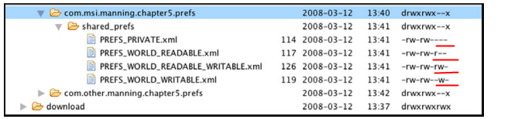
getPreferences(mode)：文件名为：当包名为com.ql.test4，而类完整类名为com.ql.test4.app.Test，则文件名为：app.Test
appB try to get the SharedPreference which appA create
appAContext = createPackageContext("appA.packageName[如com.ql.test7]",Context.CONTEXT_IGNORE_SECURITY);
appAContext.getSharedPreferences(name, Context.MODE_PRIVAT[因为该sp是属于appA，当该sp不存在时，本质上不会被创建，所以该mode没有任何作用])
注意：当appB要对sp进行某些读写操作时，sp必须具有对应的权限
参见：my/test7, my/test8
Editor e = pref.edit();
// With the Editor you can set/get String, boolean, float, int, and long types as key-value pairs
e.putString(String key, String value);
// persist the memory map to the preferences backing file.
e.commit();

framework
参见：
Google sample-.app.PreferencesFromXml
my/test9
正如名字所描述，You can describe your application(the package)’s preferences（选项） in an XML file stored in your project’s res/xml/ directory
Given that, Android can present a pleasant UI for manipulating those preferences （PreferenceActivity.addPreferencesFromResource(rid)，rid.xml的主要作用是定义样式，如是一个text还是一个radio，并指定该组件对应于preference的key名。其后，通过用户操作和默认值来最终影响preference的key值）, which are then stored in the SharedPreferences which you get back from getDefaultSharedPreferences()（说明：文件名为yourpackagename_perferences.xml，其样式参见：preferences-framework.xml）
注意：
there is no explicit save or commit button or menu.当用户进行修改时，any changes就立刻被persisted。可以通过观察xml来验证。
一个package中有多个activity，而每个activity都有可能针对于同一个default shared preference进行操作，而其途径是通过定义了选项外观的xml。Preference中的key随着外观xml的组件对应的key的增加而增加（并不是被覆盖）

file
Android has a filesystem that is based on Linux and supports mode-based permissions.
So you can create and read files from within your applications or other apps by provided the right authorities（参见SharedPerference图）
文件位于data/data/[PACKAGE_NAME]/files/下（说明：可通过 context.getFilesDir().getPath()+"/" 获得）
对文件的操作的关键是：是用流
FileOutputStream = Context.openFileOutput(filename, mode);
Filename有两种形式：
“fileName.postfix”
"/data/data/[PACKAGE_NAME]/files/fileName.postfix，说明：使用此形式可以用于解决：读写其他应用的文件
四类mode:
Context.MODE_PRIVATE = 0
Context.MODE_APPEND = 32768 //说明：默认情况下，写入文件的数据会覆盖原有数据，如果你只是想追加新内容，那么用此mode
//当通过fileoutputstream的构造函数而非context来创建写入流时，当append为true时，写入的新数据也不会覆盖原有内容
Context.MODE_WORLD_READABLE = 1
Context.MODE_WORLD_WRITEABLE = 2
你也可以改变文件的permission： File.setWritable
FileOutputStream.write(“content”);
FileOutputStream.flush();
FileOutputStream.close();
打开工作目录并试图创建：ContextWrapper.getFirDir，路径为/files/
注意：
当你准备打开文件a的输出流时，请确保…/files文件夹存在，可以不考虑文件a是否存在
/a/b代表的不一定是文件，而/a/b/代表的不一定是目录；本质上，它们是相同的
当/a/b以文件的形式存在时，通过编程，你将创建不了路径为/a/b的目录
Push & pull：
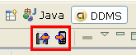
Along with creating files from within your application, you can push and pull files to the platform, using the adb
如，adb push filePath/filename.postfix /data/data/[PACKAGE_NAME]/files/filename.postfix
而cache文件位于data/data/[PACKAGE_NAME]/cache/下
ContextWrapper.getCacheDir获得工作缓冲目录，路径为/cache/
When the device is low on internal storage space, Android may delete these cache files to recover space
When the user uninstalls your application, these files are removed

Fileobserver
参见：google-doc-FileObserver
FileObserver可以监视某一路径下（参见构造函数中的path）文件系统的改变情况
参见其三个方法，你可以调用onEvent来判断事件的类别，其用FileObserver.CREATE等表示，如：文件新增，文件删除，文件剪切from，文件剪切to等
onevent的所在线程并不是main thread(ui thread)
注意：
fileobserver监听不到：插拔sdcard，mount/unmount
当fileobserver是一个局部变量时，当函数返回时，fileobserver会自动调用stopwatch
参见：my/metadataandroidplatform

SDcard
SD: Secure Digital flash memory card
In order to work with an SD card image in the Android Emulator, you will first need to use the mksdcard tool(in the tools directory of the SDK) to set up your SD image file. Then, you will need to start the emulator with the -sdcard <path_to_file> option in order to have the SD image mounted.
创建存储卡：
Mksdcard -l sdcard 512M c:/sdcard/sdcard.img
在eclipse中创建avd时，也可以附带着创建存储卡
启动：
Emulator -avd myavd -sdcard c:/sdcard/sdcard.img
或者，在eclipse的run configuration中
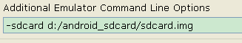
-sdcard d:/android_sdcard/sdcard.img
说明：当将媒体文件拷贝进sdcard后，先dev tool-media scanner，后图片库，来展示媒体
判断存储卡的状态：
Environment.getExternalStorageState
如果是Environment.MEDIA_MOUNTED，则存在，可读可写
如果是Environment.MEDIA_MOUNTED_READ_ONLY，则存在，只可读
如果是Environment.MEDIA_REMOVED，则不存在
获得存储卡的文件路径
Environment.getExternalStorageDirectory().getAbsolutePath();//如果是模拟器，为/sdcard；如果是真机，为/mnt/sdcard
获得存储卡的空间使用情况
new StatFs(Environment.getExternalStorageDirectory().getPath());
/* Block的size */
long blockSize = statFs.getBlockSize();
/* 总Block数量 */
long totalBlocks = statFs.getBlockCount();
/* 已使用的Block数量 */
long availableBlocks = statFs.getAvailableBlocks();
permission：
<!-- 在SDCard中创建与删除文件权限 -->
<uses-permission android:name="android.permission.MOUNT_UNMOUNT_FILESYSTEMS"/>
<!-- 往SDCard写入数据权限 -->
<uses-permission android:name="android.permission.WRITE_EXTERNAL_STORAGE"/>

mount和unmount
- 当mount手机时：
当手机通过usb连接到主机，mount手机，此时可以通过电脑来向手机拷贝东西，
但是程序此刻已经认为sdcard不存在了；诸如contacts等数据库会发生改变，程序查询不到该数据库的任何记录，如果此刻该数据库的contentresolver注册了contentobserver，那么其会收到通知
- 当unmount手机时：
会自动扫描sdcard

mediascannerconnection
编程来扫描卡，从而更新media数据库：你可以通过mediascannerconnection建立一条连接，然后connect，便开始扫描sdcard；而连接状态的改变（诸如连接被建立），会通知MediaScannerConnection.MediaScannerConnectionClient

Parse
在Android平台上可以使用Simple API for XML(SAX) 、Document Object Model(DOM)和Android附带的XmlPullParser解析XML文件
参见：传智播客ppt-p28~p33
- SAX
SAX解析XML文档为事件驱动。当解析器发现元素开始、元素结束，文本、文档的开始或者结束时，发送事件，在程序中编写响应这些事件的代码，其特点如下：
优点：不用事先调入整个文档，占用资源少。尤其在嵌入式环境中，极力推荐采用SAX进行解析XML文档。
缺点：不像DOM一样将文档长期驻留在内存，数据不是持久的，事件过后，如没有保存数据，那么数据就会丢失。
使用场合：机器性能有限，尤其是在嵌入式环境，如Android，极力推荐采用SAX进行解析XML文档。
一个例子：
事件处理的顺序，处理时间的位置：一般在DefaultHandler.startDocument()初始化工作，在endDocument()中收尾的处理工作；startElement()—characters()—endDocument()是一个XML节点读取的过程，startElement()用来初始判断，characters()获取节点的字符数据，endDocument()将数据写入数据结构。
SAXParserFactory factory = SAXParserFactory.newInstance();
SAXParser parser = factory.newSAXParser();
XMLReader xmlreader = parser.getXMLReader();
URL rrl = new URL(urlstring);
InputSource is = new InputSource(url.openStream());
Xmlreader.setContentHanlder(YourHandler);
Xmlreader.parse(is);
- dom
如果使用DocumentBuilder，参见：begin android2/code/Files/static
DOM(文档对象模型)，为XML文档的解析定义了一组接口，解析器读入整个文档，然后构造一个驻留内存的树结构，然后代码就可以使用DOM接口来操组整个树结构，其他点如下：
优点：整个文档树都在内存当中，便于操作；支持删除、修改、重新排列等多功能。
缺点：将整个文档调入内存（经常包含大量无用的节点），浪费时间和空间。
使用场合：一旦解析了文档还需要多次访问这些数据，而且资源比较充足（如内存、CPU等）。
- XmlPullParser
XmlPullParser parser = Resource.getXml(xmlResourceID)（参见：unlock-p164）
Event type: START_TAG, TEXT, END_TAG, END_DOCUMENT
重要方法：parser.getEventType(), parser.next()

SQLitedatabase
Sqlite is a “small” relational database.
参见
语法：http://www.sqlite.org/lang.html
the type sqlite supports: http://www.sqlite.org/datatype3.html
支持 NULL、INTEGER、REAL（浮点数字）、TEXT(字符串文本)和BLOB(二进制对象)数据类型，虽然它支持的类型虽然只有五种，但实际上sqlite3也接受varchar(n)、char(n)、decimal(p,s) 等数据类型，只不过在运算或保存时会转成对应的五种数据类型
SQLite最大的特点是你可以保存任何类型的数据到任何字段中，无论这列声明的数据类型是什么。例如：可以在Integer字段中存放字符串，或者在布尔型字段中存放浮点数，或者在字符型字段中存放日期型值。 但有一种情况例外：定义为INTEGER PRIMARY KEY的字段只能存储64位整数， 当向这种字段中保存除整数以外的数据时，将会产生错误。 另外， SQLite 在解析CREATE TABLE 语句时，会忽略 CREATE TABLE 语句中跟在字段名后面的数据类型信息，如下面语句会忽略 name字段的类型信息：
CREATE TABLE person (personid integer primary key autoincrement, name varchar(20))
sqlite tool: http://www.sqlite.org/sqlite.html
The Definitive Guide to SQLite by Michael Owens (Apress, 2006)
文件位于/data/data/[PACKAGE_NAME]/database/下
但本质上不归依于file system
Each database is accessible only to the process that created it，可以参见对应文件的访问权限.
If you need to pass data across processes, you can use AIDL/Binder or create a ContentProvider,
but you can’t use a database directly across the process/package boundary.
SQLiteDatabase is used to open/close（尽管你也可以在SQLiteOpenHelper中做） database connections, begin a transaction, IDUQ（增删改查）, create a database（openOrCreateDatabase+dbObj.execSQL(createTabStatement)尽管你也可以在SQLiteOpenHelper中做）, and so on.
说明：
type checking isn’t necessary when assigning or extracting values from each column within a row.
请尽量少用sql语句，如：你有100个sms的_id，你要根据_id来查询address，然后根据address来查到contacts的display name，那么不要为每个sms的_id来使用2条sql语句，这样你将访问2*100次数据库，你应该使用in(..)来为100个_id构建仅仅的2条sql语句，从而访问数据库2次
一些方法
execSQL()
works for any SQL that does not return results
可以执行insert、delete、update和CREATE TABLE之类有更改行为的SQL语句
如：execSQL("insert into person(name, age) values(?,?)", new Object[]{"传智播客", 4});
该方法的好处是：
当insert的内容含有单引号时，组拼出来的SQL语句就会存在语法错误。要解决这个问题需要对单引号进行转义，也就是把单引号转换成两个单引号。有些时候insert的内容往往还包含像“ & ”这些特殊SQL符号，为保证组拼好的SQL语句语法正确，必须对SQL语句中的这些特殊SQL符号都进行转义，显然，对每条SQL语句都做这样的处理工作是比较烦琐的。SQLiteDatabase类提供了一个重载后的execSQL(String sql, Object[] bindArgs)方法，使用这个方法可以解决前面提到的问题，因为这个方法支持使用占位符参数(?)
此外，此方法的第二个参数是bindargument，则意味着当执行insert语句时，你可以一次插入多条记录。
注意：
当干一件事情只需要i条sql时，避免使用i+n条sql语句
对于android，sql语句的最大长度为19032个字符
rawQuery()
可以执行select语句
如：db.rawQuery("select * from person where name like ? and age=?", new String[]{"%传智%", "4"});
SQLiteStatement
SQLiteStatement = SQLiteDatabase.compileStatement("UPDATE Books SET file_id = ?, encoding = ?, language = ?, title = ? WHERE book_id = ?");
SQLiteStatement.bindLong(1, fileId);
SQLiteStatement.bindString(2, encoding);
SQLiteStatement.bindString(3, language);
SQLiteStatement.bindString(4, title);
SQLiteStatement.bindLong(5, bookId);
SQLiteStatement.execute();
insert (String table, String nullColumnHack, ContentValues values)
insert格式：insert into 表名(字段列表) values(值列表)
insert a ContentValue，而CotentValue是一个hashmap，key为列名（String类型），value为列值（XXX类型）
如果表的key为_id，且是autoincrement，那么ContentValue中不应该包含对应了_id的元素，参见：b大全2-p172
nullColumnHack用于：当ContentValues为null或者元素个数为0时，Insert()方法必然要添加一条除了主键之外其它字段为Null值的记录，如：insert into person(name) values(NULL)，倘若不给定字段名，insert语句就成了这样：insert into person() values()
其会返回rowid，注意：和主键id没有关系
query(String table, String[] columns, String selection, String[] selectionArgs, String groupBy, String having, String orderBy)
select子句格式：select * from 表名 where 条件子句 group by 分组字句 having ... order by 排序子句
update()
update格式：insert into 表名(字段列表) values(值列表)
delete()
delete格式：delete from 表名 where 条件子句
close()方法将close the database object（将关闭该数据库连接）
rawQuery() to invoke a SELECT statement directly.
SQLiteQueryBuilder
事务：
一个例子：
db.beginTransaction();//开始事务
try {
db.execSQL("insert into person(name, age) values(?,?)", new Object[]{"传智播客", 4});
db.execSQL("update person set name=? where personid=?", new Object[]{"传智", 1});
db.setTransactionSuccessful();//调用此方法会在执行到endTransaction() 时提交当前事务，如果不调用此方法会回滚事务
} finally {
db.endTransaction();//由事务的标志决定是提交事务，还是回滚事务
}
将数据库随apk一起发布：将db加入到apk中，后通过程序将其拷贝到…/databases下

SQLiteOpenHelper
you can use it to create, upgrad, and open, close databases（建立一个数据库连接）
构造函数：public SQLiteOpenHelper (Context context, String name, SQLiteDatabase.CursorFactory factory, int version)
name is the database file’s name, version指明了该数据库的版本
则在构造函数中，构建了database file
get…ableDatabase()将试图获得一个数据库连接，
搜索database file，如果该数据库还没有被创建，则onCreate被调用。
onCreate is called when the database is created for the first time. This is where the creation of tables and the initial population of the tables should happen.
表创建范例：create table table_name (_id integer primary key autoincrement, field_name field_type);
搜索database file，如果该数据库的版本低于构造函数中的version，则onUpgrade被调用。
onUpgrade is called when the database needs to be upgraded. The implementation should use this method to drop tables, add tables, or do anything else it needs to upgrade to the new schema version.
一个例子：
myDatabase.execSQL("ALTER TABLE Tags RENAME TO Tags_Obsolete");
myDatabase.execSQL("CREATE TABLE Tags(" + "tag_id INTEGER PRIMARY KEY,"
+ "name TEXT NOT NULL,"
+ "parent_id INTEGER REFERENCES Tags(tag_id),"
+ "CONSTRAINT Tags_Unique UNIQUE (name, parent_id))");
myDatabase.execSQL("INSERT INTO Tags (tag_id,name,parent_id) SELECT tag_id,name,parent FROM Tags_Obsolete");
myDatabase.execSQL("DROP TABLE Tags_Obsolete");
close()方法将close any open database object（将关闭该数据库的所有连接）

Cursor
Cursor object can be used to iterate backward or forward through the result set.
It is an interface, and SQLiteCursor can iterate over data stored in an SQLite database, while MatrixCursor is for data not stored in a database
对于数据库，Cursor = SQLiteDatabase.query ()
或者，Cursor = ContentResolver.query (Uri uri, String[] projection, String selection, String[] selectionArgs, String sortOrder)
The table
The returned column
如People._ID, People._COUNT, People.NAME, People.NUMBER
而Peolple implements BaseColumns, PeopleColumns, PhoneColumns
The where
The ? value
The sort order
What the result set looks like:
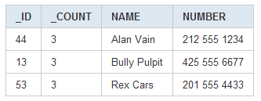
一些方法
moveTo..SomePosition()
遍历：
While(cur.moveToNext()){
cur.get…(cur.getColumnIndexOrThrow(some column));
}
Close() releases the cursor’s resources
startManagingCursor allows the activity to take care of managing the given Cursor's lifecycle for you based on the activity's lifecycle.
That is, when the activity is stopped it will automatically call deactivate() on the given Cursor, and when it is later restarted it will call requery() for you. When the activity is destroyed, all managed Cursors will be closed automatically.
When you’ve finished with the Cursor, call stopManagingCursor
CursorFactory is responsible for creating new cursors via its newCursor() implementation

及时通知
cursor提供了registerDataSetObserver方法
说明：使用起来存在困惑
参见：my/datasourceListener

Tool
- sqlite expert
- sqlite developer
- sqlite3 tool
参见：sqlite tool: http://www.sqlite.org/sqlite.html
it is in adb shell
you can use this tool to manipulate, dump, restore, and otherwise work with your database file
一个例子：
cd [ANDROID_HOME]/tools
adb shell
cd /data/data/com.msi.manning.chapter4/databases
sqlite3 w_alert.db
sqlite>.table //列出所有的table，其中可以中表sqlite_master中查看当前数据库一共有多少表
sqlite>select * from mytable
sqlite>.exit
- sqlite manager
it is an extension for firefox
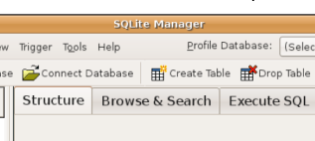
乱码问题：
sqlite数据库以utf-8编码，所以，当你编码向数据库中插入数据时，必须保证域值为utf-8编码

ContentProvider
参见google doc-framework topics-content provider. 尽管ContentProvider is not the only way to share data across applications（如：当file的permission被设定，other app还是可以访问该file），但是该方式是被推荐的
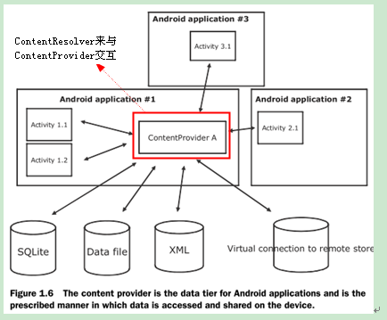
Contentprovider顾名思义，是一个内容提供者，它负责对外提供内容，应该向客户隐藏内容访问的一切细节（说明：也许你的全部内容由几个表来表示，但是客户不知道也不应该知道，那么在provider.insert/update等操作中，你也许会同时操作几个表来完成向客户提供的服务，就如同使用RawContacts.CONTENT_URI插入数据时，实际上rawcontact和contacts表均被插入数据。而contentprovider并不是和intent联系，而是uri，android底层需要提供一种机制来根据uri（也即是authority part）找到合适的provider，而后provider负责所有的响应，所以客户不用关心CONTENT_URI和表之间的对应关系，也不用关心provider有多少内部类、内部类的CONTENT_URI的更广阔的含义，因为它应该为客户透明，因为CONTENT_URI只是为了找到provider，并为provider的insert/update等逻辑服务）
在内部，内容can be stored in the file system, in an SQLite database, or in any other manner that makes sense. However, Content providers expose their data as some simple tables on a database model
---
之下为以前的论断
However, Content providers expose their data as some simple tables（猜想：抽象的或真实的。Properties are to content providers as columns are to databases.） on a database model（一种简单情况的猜想，之下的所有附加论述也均以简单为前提，一个“table”由CONTENT_URI来标示[也被称为base uri]，and the authority part identifies ContentProvider，猜想：对应着一个database。如：Contacts contentprovider由content://contacts标示，其中的一个表由content://contacts/people标示[其中/people标示了data type path]，so the Contacts content provider may serve up other data using other base Uri values[因为people位于contacts的下一级，则contacts很可能拥有多个下级]）. where each row is a record（每个row由一个numeric _ID field来标示[也被称为instance identifier]，其对应的uri为content://${CONTENT_URI}/${_ID}）
---
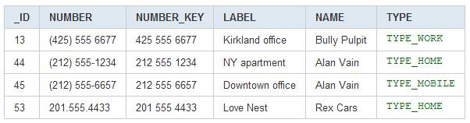
By acquire the proper permissions(which is set in ContentProvider’s AndroidManifest.xml attribute), other app can query, add, update, and delete the data which this content provider take care of.

ContentReslover
Despite ContentProvider provides some operations such as IDUQ, however, other applications do not call these methods directly. Because directly sharing files or databases is discouraged on the Android platform and is further enforced by the Linux security system, which prevents ad hoc file access from one application space to another without explicitly granted permissions.
Typically, there's just a single instance of each type of ContentProvider. But it can communicate with multiple ContentResolver objects in different applications and processes. Different apps can use their ContentResolvers to communicate with ContentProvider, because this approach negates Linux process/security hurdles as well as keeps all data access normalized through the ContentProvider
而ContentProvider是一个抽象类，增删改查这些操作都是抽象的
当ContentResolver发出一个请求时，系统检查给定的URI的权限并传递请求给ContentProvider注册。内容提供者能理解URI想要的东西。UriMatcher 类用于帮助解析URIs
一些方法：
获得contentreslover：Context.getContentResolver
Activity.managedQuery causes the activity to manage the life cycle of the Cursor. A managed Cursor handles all of the niceties, such as unloading itself when the activity pauses, and requerying itself when the activity restarts
如果你有一堆contentvalues需要插入，那么使用bulkinsert

Create a ContentProvider
Steps:
- implementing six abstract methods declared in the ContentProvider class:
query()
insert()
update()
delete()
getType()
Android uses both the content Uri and the MIME type as ways to identify content on the device.
一个例子：
For a single record: vnd.android.cursor.item/vnd.yourcompanyname.yourtable
For multiple records: vnd.android.cursor.dir/vnd.yourcompanyname.yourtable
猜想：
至此，你定义了一个ContentProvider可以处理的content type
当你要启动一个activity时，intent中，action指定，uri为content://，但是没有指定type；在manifest.xml的intent-filter中，action, data mimetype均指定，则根据“test匹配”，intent中的uri必需根据contentprovider.gettype获取到type。则，这可算getType()的一种应用。
该观点可能错误：如果不在getType中体现ContentProvider可以处理的类型，那么它的增删改查操作等将不能进行
试想一下：authority为content://com.ql.study，而url为content://com.ql.study/java/mobile/android，那么android会认为ContentProvider可以处理几种类型呢？三种吗：java, mobile, android，还是一种java/mobile/android，声明被处理的类型吧
说明：
Because these ContentProvider methods can be called from various ContentResolver objects in different processes and threads, they must be implemented in a thread-safe manner.
As a courtesy, you might also want to call ContentResolver.notifyChange() to notify listeners when there are modifications to the data
onCreate()
该方法中，你应该构建你的“table”中的数据了。
when onCreate() is called, this is
the first time ever for the content provider,
the first time for a new release of a content provider that was upgraded in place,
or just a normal startup.
- Define a public static final Uri named CONTENT_URI. You must define a unique string for this value.
说明：建议在一个内部类中定义，该类实现了BaseColumns，如Contacts.People
If the provider has subtables, also define CONTENT_URI constants for each of the subtables. These URIs should all have the same authority (since that identifies the content provider), and be distinguished only by their paths
- Define the column names that the content provider will return to clients.
说明：建议在一个内部类中定义，该类实现了BaseColumns，如Contacts.People
Be sure to include an integer column named "_id" (with the constant _ID) for the IDs of the records.
If you're using the SQLite database, the _ID field should be the following type: INTEGER PRIMARY KEY AUTOINCREMENT
- declare in AndroidManifest.xml
name and authority(it should be the lowercase of the full-qualified class name to ensure uniqueness)
permission (read and/or write data)
Set the multiprocess attribute to "true" if data does not need to be synchronized between multiple running versions of the content provider. This permits an instance of the provider to be created in each client process, eliminating the need to perform IPC.

content: URI field(_data field)
You can place small amounts of binary data into a table by calling the version of ContentValues.put() that takes a byte array.
However, if you are exposing byte data that's too big to put in the table itself — such as a large bitmap file —
The field that exposes the data to clients should actually contain a content: URI string.
The record should also have another field, named “_data” field that lists the exact file path on the device for that file（例如，参见：MediaStore.MediaColumns.DATA，它是数据库中的DATA STREAM类型，参见：my/test11/Test1）
The client will call ContentResolver.openInputStream() on the user-facing field holding the URI for the item. The ContentResolver will request the "_data" field for that record, and because it has higher permissions than a client, it should be able to access that file directly and return a read wrapper for the file to the client.
类似的，if the table entry is a content: URI, you should never try to open and read the file directly (for one thing, permissions problems can make this fail). Instead, you should call ContentResolver.openInputStream() to get an InputStream object that you can use to read the data.
如：
MediaStore content provider, the main provider that dispenses image, audio, and video data, employs a special convention:
The same URI that is used with query() or managedQuery() to get meta-information about the binary data (such as, the caption of a photograph or the date it was taken) is used with openInputStream() to get the data itself.
URI说明：当你查询出了一条记录，那么该记录对应的URI
The same URI that is used with insert() to put meta-information into a MediaStore record is used with openOutputStream() to place the binary data there.
URI说明：当你插入出了一条记录，那么该记录对应的URI
一个例子：
Intent intent = new Intent();
intent.setType("image/*");
intent.setAction(Intent.ACTION_GET_CONTENT);
startActivityForResult(intent, 1);
会打开手机的媒体库，并且展示的只是图片，选择一个图片
在onActivityResult(int requestCode, int resultCode, Intent data)中：
BitmapFactory.decodeStream(getContentResolver().openInputStream(data.getData));
可以看到data.getData为诸如此形式：content://media/external/images/media/1，content://media/external/images/media/2
一个例子：
String[] projection = { MediaStore.Images.Media.DATA };
// content://media/external/images/media
Cursor cursor = managedQuery(MediaStore.Images.Media.EXTERNAL_CONTENT_URI, projection, null, null, null);
while (cursor.moveToNext())
{
// file name为诸如此形式：/sdcard/somePic.jpeg
String filename = cursor.getString(0);
}

ContentObserver及时通知
- ContentResolver.registerContentObserver(Uri uri, boolean notifyForDescendents, ContentObserver observer)
Register an observer class that gets callbacks when data identified by a given content URI changes.
其为观察者，而subject为contentresolver，需要contentresolver.notifyChange后，才会得到通知
notifyForDescendents：其表明了监视的范围，如，当uri是content://sms，但notifyForDescendents为false时，当插入一个短信，且contentresolver.notify了，该observer还是不会得到通知
contentobserver构造函数中有一个Handler，参见文档，contentobserver.onChange() will happen on the provider Handler.猜想：该方法中可以进行ui操作
- ContentResolver.notifyChange(Uri uri, ContentObserver observer)
Notify registered observers that a row was updated.
参数说明：observer that initiated the change. In many cases, the latter will be null; a non-null value simply means that the observer that initiated the change will not be notified of its own changes.
说明：当删除内置数据库contact中的一个人时，注册在data.content_uri的contentobserver会被通知一次；但是当添加一个人时，会通知两次
- Cursor.setNotificationUri(ContentResolver cr, Uri uri)
Register to watch a content URI for changes. The listener attached to cr will be notified.
说明：不知如何使用

内置表
参见：
google doc-android.provider包
九重天的chinaunix博客-native content providers list
如Contacts.People，含有CONTENT_URI（则，其对应一个“表”）；此外，实现了诸如BaseColumns、Contacts.PeopleColumns（其本身定义了一堆列名）

contacts
Contact information is stored in a three-tier data model
A row in the ContactsContract.Data table can store any kind of personal data, such as a phone number or email addresses.
Each row of the data table is typically used to store a single piece of contact information (such as a phone number or a email address) and its associated metadata (such as whether it is a work or home number).
What kind of the piece of data:
ContactsContract.Data is a generic table that can hold any kind of contact data. The kind of data stored in a given row is specified by the row's MIMETYPE value, which determines the meaning of the generic columns DATA1 through DATA15. For example, if MIMETYPE is ContactsContract.CommonDataKinds.Phone.CONTENT_ITEM_TYPE, then the column DATA1 stores the phone number
CONTENT_URI: The content:// style URI for all data records of the CONTENT_ITEM_TYPE MIME type, combined with the associated raw contact and aggregate contact data. 如：content://com.android.contacts/data/phones
A row in the ContactsContract.RawContacts table represents a set of data describing a person and associated with a single account
A row in the ContactsContract.Contacts table represents an aggregate of one or more RawContacts presumably describing the same person
说明：在contact2.db中，表data有外键raw_contact_id，表rawcontact有外键cotact_id，则可看出表之间为m:1关系
如何读取contacts中的信息，参见：
How to read contacts on Android 2_0.mht
Google sample-ContactManager
编程插入一个contact：
请使用contentresolver向ContactsContract.RawContacts插入记录，其contentvalues可以为一个单纯构造后的对象
后得到rawcontactid，那么使用该id和mimetype向ContactsContract.Data插入记录，其Uri可以为Data.CONTENT_URI
而contact表会自动生成记录，注意：自行更改ContactsContract.Contacts会抛出异常
其他的表：
calllog对应CallLog.Calls类，其db为contact2.db，

MediaStore
Media包含：video, audio, image
说明：当你编程来向mediastore插入音/视频时，请提供_data的值，否则，会抛出异常

sms
其uri为content://sms
当代码实现拷贝一个手机的sms到另一手机，关键是sms数据库的读取和写入，注意不要写入刚读取的thread_id

ContentProviderOperation
如果想知道它的具体使用，参见：google doc-NickName中的样例
说明：其不行完成一次插入多个值的操作

BroadcastReceiver
A broadcast receiver is a component that does nothing but receive and react to broadcast announcements.
It is a Intent broadcast consumers
This exposes the event-driven programming model between applications.
To Register the receiver, you can
- In androidmenifest.xml
- Context.registerReceiver(BroadcastReceiver receiver, IntentFilter filter)
说明：比较上述两种方式：
第一种，注册的监听器不能被取消注册，除非被卸载
第二种，注册的监听器可以被取消注册，如在Activity.onPause中

Some notification

Toast
Toast.makeText().show()

Notification & NotificationManager
notification is persistent and stays in a notification area（状态栏） until the user deletes it.
用手指按住状态栏并下拉，可以看到notification列表
参见：google doc api
一个例子：
Notification的一些属性
icon, // the icon for the status bar
tickerText, // the text to display in the ticker，在状态栏上，icon右边的文字，不久后消失
when, // the timestamp for the notification
// 之下用于setLatestEventInfo中，when the notification is clicked, we are to display this
context, // the application context
contentTitle, //在notification列表中的信息标题
contentText, //在notification列表中的信息内容
pIntent // 当用户单击该notification时，PendingIntent对应的intent被激起
NotificationManager nm = (NotificationManager)getSystemService(Context.NOTIFICATION_SERVICE)
nm.notify(id, Notification);
若id不同，则状态栏上会添加多个notification；否则，新的替换掉旧的
nm.cancel(id);
在状态栏取消掉对应该id的notification

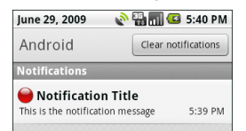
一些方法：
// after a 100ms delay, vibrate for 250ms, pause for 100 ms and then vibrate for 500ms.
notif.vibrate = new long[] { 100, 250, 100, 500 };
说明：在非主线程上可以调用notificationmanager的方法，参见：google-apidemo-servicestartargument.java

Dialog
参见：part of activity-dialog

Activate the component

Intent
An Intent in Android describes what you want to do or what the event being broadcast.

Decoupling-message driven programming pattern
A central feature of Android is that one application can make use of elements of other applications (provided those applications permit it). Intents provide a mechanism for message passing within and between applications.
Using Intents to propagate actions — even within the same application — is a fundamental Android design principle. It encourages the decoupling of components, to allow the seamless replacement of application elements.
采用message driven这种机制，使得耦合性降到最低：
我需要你，但是我不依赖你的接口，我只依赖于第三方，那个永远都不变的东西：intent和intent filter
Intent本质上也是inter process communication的一种表现，因为可以在其中存入extra（Bundle）
你可以访问哪些积木：manifest.xml中的acitivity元素含有exported属性。当在manifest.xml中，activity没有intent-filter时，意味着默认情况下外部package不能访问该activity，因为要启动该activity，必须知道它的componentname，而外部package是不知道的；而当含有intent-filter时，表明外部package可以访问该activity

its part
It contains
the information of interest to the component that receives the intent (such as the action to be taken and the data to act on), and
the informations of interest to the Android system (such as the category of component that should handle the intent and instructions on how to launch a target activity).
Principally, it can contain the following:
参见
Google doc-Intent类
b-professional-p144-…
b-professional-p159-Native Android Broadcast Actions
b-unlock-p137

Component name
The qualified name of the component that should handle the intent.
It is a ComponentName object — a combination of the fully qualified class name of the target component (for example "com.example.project.app.FreneticActivity") and the package name set in the manifest file of the application where the component resides (for example, "com.example.project").
This might be appropriate if the target intent is in your application. It definitely is not recommended for sending intents to other applications.
说明：当该属性被设置后，其他属于就可被认为可选
注意：当service位于其他包中，当我使用包含了componentname的intent来访问该service时，该service必须在其所在包的manifest.xml中配置android:export=true。参见：google doc-security and permission-declaring and enforcing permission-enforcing permission in androidmanifest.xml-service部分

Action
It specifies the name of action being serviced — or, in the case of broadcast intents, the action that took place and is being reported.
内置的action参见：Intent, b-profess2-p177

Category
A string containing additional information about the kind of component that should handle the intent.
A category helps classify the action.
It specifies under which circumstances the action should be serviced.
内置的category参见：Intent, b-profess2-p179
Intent.CATEGORY_DEFAULT：参见：my/test20
当自己定义intent filter时，需要包含default category
对于action为非MAIN得，不需设置category为DEFAULT，否则抛出异常
当两个component都设置为default时（无论其是否在同一个app中），系统会弹出选择框，以供选择
在intent-filter中设置android:priority的数值大一些，那么消息就只被该filter对应的comp拦截

data
The URI(scheme, host, port, path)(not the real data) of the data to be acted on and the MIME type of that data
It specifies the matches for data your component can act on.
注意：data是uri，并不是实实在在的数据
  - Uri样式
scheme://host:port/path（host and port together constitute the URI authority或者叫namespace）
示例：content://com.example.project:200/folder/subfolder/etc
注意：/folder/subfolder/etc为path，注意前面的/
说明：针对于ContentResolver，scheme有android.resource, content, file的形式，参见：google-doc-ContentResolver

一些方法：
Uri uri = Uri.parse("scheme://host:port/path")
Uri.withAppendedPath()
UriMatcher.addURI(String authority, String path, int code)
ContentUris.withAppendedId(Uri, id)
ContentUris.parseId(Uri)
  - Mime type样式
<type android:value=”vnd.android.cursor.dir/*”/>
this above would match any Android cursor.
另外一种格式为：
contenttype/postfix
image/*, audio/*, video/*, */*, plain/text
参见：b大全2-p193
一个例子：当你打开media时，无论是vedio, audio, image哪种类型，其action均为Intent.ACTION_VIEW，data仅为uri，而不用设置mimetype
一个例子：action为Intent.ACTION_GET_CONTENT, type为image/*，则启动手机媒体库，供用户选择图片
一个例子：new Intent(Intent.ACTION_VIEW, Uri.parse("geo:"+_lat+","+_lon))
一个例子：
Intent it = new Intent(Intent.ACTION_VIEW);
it.putExtra("sms_body", "The SMS text");
it.setType("vnd.android.cursor.dir/mms-sms");
startActivity(it);
一个例子：
File f;
intent.setAction(android.content.Intent.ACTION_VIEW);
intent.setDataAndType(Uri.fromFile(f), getMIMEType(f));
startActivity(intent);
说明：与之上的例子做比较，action相同，只是data mimetype不同

Extra
Key-value pairs for additional information that should be delivered to the component handling the intent
上述数据可以由Intent.putExtra(key, value)来携带，但本质，均被归一至Intent.putExtras(Bundle)
some actions are paired with particular extras

Intent resolution/IntentFilter
Activities, services, and broadcast receivers are activated by asynchronous messages called intents. And android system must find the activity or service to perform the requested action or the set of broadcast receivers to respond to the broadcast announcement.
通过不同的机制，参见下面的4个to，保证了同一个intent只能被传递给一类component.
Intent解析，是由ActivityManagerService来负责的。其实，它是一个很名不副实的类，因为虽然名为Activity的Manager Service，但它管辖的范围，不只是Activity，还有其他三类组件，和它们所在的进程。
- Explicit intents
Explicit intents designate the target component by its component name field.
说明：当设置了component后，你还可以设置诸如action等属性，但是其已经不再走intent resolution过程
- Implicit intents and intent filter
An IntentFilter is a declaration of capability and interest in offering assistance to those in need. It describes the action it performs and the data upon which it can be performed.
Intent resolution, or dispatching, takes place at runtime(late binding), as opposed to when the application is compiled
If Its component name field is null, 通过比较“intent与component’s intent filter”的action, category, data，来判断component是否该响应该action
The PackageManager has a set of query...() methods that return all components that can accept a particular intent, and a similar series of resolve...() methods that determine the best component to respond to an intent
intent filters are generally not set up in Java code, but in the application's manifest file (AndroidManifest.xml) as <intent-filter> elements.
The one exception would be filters for broadcast receivers that are registered dynamically by calling Context.registerReceiver(); they are directly created as IntentFilter objects.
Component can have none or more intent filters. If a component does not have any intent filters, it can receive only explicit intents，否则，必须filter之一必须要匹配intent。
If more than one component is resolved from this process, they are ordered in terms of priority, with an optional tag that can be added to the Intent Filter node. The highest ranking component is then returned.
一个方法：intent.createchoose
匹配规则：
参见：
google doc-intent and intent filters-如action tests等
b-profess2-p180
  - 一个filter可能含有多个action，但是一个intent只有一个action，只要intent.action匹配其中之一，action test通过
If the filter fails to list any actions, there is nothing for an intent to match, so no intent can get through the filter.
On the other hand, an Intent object that doesn't specify an action automatically passes the test — as long as the filter contains at least one action.
  - 一个filter可能含有多个category，但是一个intent也含有多个category，只有intent的每个category匹配其中之一，category test通过
In principle, therefore, an Intent object with no categories should always pass this test, regardless of what's in the filter. That's mostly true.
However, with one exception, Android treats all implicit intents passed to startActivity() as if they contained at least one category: "android.intent.category.DEFAULT" (the CATEGORY_DEFAULT constant). Therefore, activities that are willing to receive implicit intents must include "android.intent.category.DEFAULT" in their intent filters.
However, Filters with "android.intent.action.MAIN" and "android.intent.category.LAUNCHER" settings are the exception. They mark activities that begin new tasks and that are represented on the launcher screen. They can include "android.intent.category.DEFAULT" in the list of categories whenever they like.
  - 一个filter可能含有多个data，但是一个intent只有一个data，只要intent.data匹配其中之一（data的每个part必须完全匹配，如果filter没有指定mimetype，则默认为匹配），date test通过
参见google-doc-Intents and Intent Filters-data test
例子1：
<activity android:name=”.EarthquakeDamageViewer” android:label=”View Damage”>
<intent-filter>
<action android:name=”com.paad.earthquake.intent.action.SHOW_DAMAGE”/>
<category android:name=”android.intent.category.DEFAULT”/>
<category android:name=”android.intent.category.ALTERNATIVE_SELECTED”/>
<data android:mimeType=”vnd.earthquake.cursor.item/*”/>
</intent-filter>
</activity>
例子2（使用指定的浏览器来访问）：
String url = "www.baidu.com";
Intent intent = new Intent();
intent.setAction("android.intent.action.VIEW");
Uri content_uri_browsers = Uri.parse(url);
intent.setData(content_uri_browsers);
intent.setClassName("com.android.browser", "com.android.browser.BrowserActivity");
说明：
如果去掉intent.setClassName，则系统让你选择浏览器
如果去掉intent.setAction，浏览器将跳到主页，而不是指定的url
之下的内容参见android-doc中的intent and intent filter

PendingIntent
A Pending Intent is commonly used to package an Intent that will be fired in response to a future event,
such as a widget View being clicked or a Notification being selected from the notification panel.
When used, Pending Intents execute the packaged Intent with the same permissions and identity as if you had executed them yourself, within your own application.
PendingIntent.get…将会Returns an existing or new PendingIntent matching the given parameters. May return null only if FLAG_NO_CREATE has been supplied.
参见bophone-p8
当用户激发了一个动作时，PendingIntent中的intent会被激发，可能会start一个activity，如下例：
Notification.setLatestEventInfo(Context context, CharSequence contentTitle, CharSequence contentText, PendingIntent contentIntent)
contentIntent | The intent to launch when the user clicks the expanded notification
它实现了Parcelable，还记得Parcelable吗？在IPC中，要在进程间传递自定义类型，该类型需要实现Parcelable

To activity
An activity is launched (or given something new to do) by passing an Intent object to Context.startActivity(Intent) or Activity.startActivityForResult().
The responding activity can look at the initial intent that caused it to be launched by calling its getIntent() method. Android calls the activity's onNewIntent() method to pass this activity any subsequent intents.
One activity often starts the next one. If it expects a result back from the activity it's starting, it calls Activity.startActivityForResult() instead of startActivity(). For example, if activity1 starts an activity(activity2) that lets the user pick a photo, it might expect to be returned the chosen photo. The result is returned in an Intent object that's passed to the calling activity1's onActivityResult(int requestCode, int resultCode, Intent data) method. （何时调用该方法:The ActivityResult is propagated back to whoever launched you via onActivityResult(), when finish is called, or when the sub-activity closed）
注意：在startActivityForResult(Intent intent, int requestCode)中，
- you also pass in a request code. This value will be used later to uniquely identify the sub-Activity that has returned a result.
- When your sub-Activity is ready to close, call setResult(requestCode, resultIntent) before finish to return a result to the calling Activity.
The Intent returned as a result can include a URI to a piece of content (such as the contact, phone number, or media ﬁ le) and a collection of Extras used to return additional information.

To Service
参见：shutdown the component-to service
- A service is started (or new instructions are given to an ongoing service) by passing an Intent object to Context.startService().
Android calls the service's onStart() method and passes it the Intent object.
说明：在android1.5，onstart已经过时，采用onstartcommand来代替
Onstartcommand主要用于：
- 当onstartcommand没有返回时，service所在进程被kill掉（如显式process.kill）了，该进程再重新开启时，service该怎么办：重新实例化，并自动调用onstartcommand
- 当onstartcommand返回后，在被显式的kill掉（如stopservice,stopself）之前，service所在进程被kill掉（如显式process.kill）了，该进程再重新开启时，service该怎么办：根据返回的参数不同，而进行处理。
如，当onstartcommand返回start_stick时，当进程重新启动时，service会被重新创建，并调用onstartcommand，并传入null的intent。其，旨在表明：要避免service重建且onstartcommand重调，请在service做完自己的事情后，显式关闭吧
通过Onstartcommand中的参数flag，与，诸如start_stick进行，与操作，来表明onstartcommand的本次调用来源于哪种情景
第一次调用onstartcommand时，flag为0
当onstartcommand未返回，而进程被杀掉，再次onstartcommand中的flag为0
- 当onstartcommand返回，被显式的kill掉（如stopservice,stopself）了，而service所在进程又被kill掉（如显式process.kill）了，该进程再重新开启时，service什么也不用做
参见：
google-doc-service.java
google搜索：doc for the return value of the service.onstartcommand
参数说明：startid用于表明该service当前有多少个客户
- Similarly, if the service allows others to bind it, an intent can be passed to Context. bindService (Intent service, ServiceConnection conn, int flags) to establish an ongoing connection(ServiceConnection) between the calling component and a target service.(If the service is not already running, bindService() can optionally start it.)，那时，你就可以控制service了
The service receives the Intent object in an onBind() call.
一个例子：
You can bind to a service that was started with startService(). For example, a background music service could be started by calling startService() with an Intent object that identifies the music to play. Only later, possibly when the user wants to exercise some control over the player or get information about the current song, would an activity establish a connection to the service by calling bindService().
参见IPC
- using onBind in the same app
The simple act of binding itself can be useful in situations where the service and its clients are all in the same application—the local service scenario：
在MyService的onBind中，我返回一个Binder的子类，该子类提供getService，其中返回MyService.this，则MyService的client可以获得MyService的实例，进而client可以调用MyService的方法
注意: In a remote service scenario, this would not work, because the limitations of IPC prevent us from passing services between processes
说明：当service拥有多个客户时，只会产生一个service的实例，既是oncreate只会被调用一次，而onstart或者onbind会多次被调用

To content provider
Content providers are activated when they're targeted by a request from a ContentResolver, and has no relationship with intent

To Broadcast receiver
An application can initiate a broadcast by passing an Intent object to methods like Context.sendBroadcast()（所有的接收者都能接收）, Context.sendOrderedBroadcast()（一次传递给一个接收者）, and Context.sendStickyBroadcast() in any of their variations. 参见：unlock android-p136-ch4.2.1
Another important aspect with Intent broadcasts is how permissions are handled.
When you broadcast an Intent, you can optionally specify a permission. Permissions are String declarations that can be used when making a broadcast that require receivers to declare the same permission.
Android delivers the intent to all interested broadcast receivers by calling their onReceive() method.注意：如果该方法10秒内还没有执行完，怎认为程序不响应，抛出异常。

Shutdown the component
android provide you with some methods to shut down / destroy the component, but note this:
Components might be shut down by the system when they are no longer being used or when Android must reclaim memory for more active components.
下面展示的是非极限情况下的手动shut down，这种情况下，component将被优雅的清理，and don’t forget to clean up the resource in the corresponding lifecycle method

To activity
An activity can be shut down by calling its finish() method.
One activity can shut down another activity (one it started with startActivityForResult()) by calling finishActivity().
注意：在task中，当用户点击了back，该activity被销毁

To service
- Once started（猜想：service的启动方式是start，而非bind）, a Service runs until it is explicitly stopped
A service can be stopped by calling its stopSelf() or stopSelfResult() method, or by calling Context.stopService().
- If a Service is bound by calling Context.bindService, and now, if there are no other bound clients to the service, Android will automaticly shut down the service as well, hence, we do not need to call stopService() ourselves.
一个例子：
参见：my/test15和test16
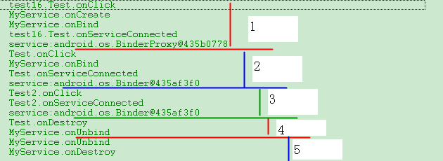
情景：test15有两个activity：Test和Test2，test16有一个activity：Test
1：先进入test16，点击button连接（bind）service
2：按Home，进入test15，点击button连接service
3：进入test15.Test2，点击button连接service
4：退出test15
5：进入test16，退出test16
说明：
对于不同的程序（只在乎是不同的package，而不论是同一个package但不同的process。该解释同样使用于下文），service会被重复onBind，且返回的ServiceConnection.onServiceConnected.Ibender不同。参见1和2
对于同一个程序，service不会被重复onBind（此不同于Context.startService，因为onStart永远会被调用），但onserviceconnected会被调用多次，但返回的ServiceConnection.onServiceConnected.Ibender均相同（但，通过该ibinder进行的每一次调用后，service端均在新线程上执行）。参见2和3
当activity退出时（无论是通过back还是finish），将会自动将unbind已经连接的service connection。参见4和5
当一个service没有bound client时，service被销毁
stopservice和unbindservice：当你start了一个service，后bind。当stop后，该service并不会被销毁，因为有bind client（当再unbind后，service被销毁，因为此刻已经没有bind client的了）；同样unbind后，该service也不会被销毁，因为有start client（当再stop后，service被销毁，因为此刻已经没有start client的了）
当有两个client都start了一个service，那么其中一个stop该service，那么该service被销毁

To content provider
A content provider is active only while it's responding to a request from a ContentResolver. So there's no need to explicitly shut down these components.

To broadcast receiver
A broadcast receiver is active only while it's responding to a broadcast message. So there's no need to explicitly shut down these components.
注意：The exception is if the BroadcastReceiver is implemented on some longer-lived component, such as an activity or service. In that case, the intent receiver lives as long as its “host” does (e.g., until the activity is frozen). However, in this case, you cannot declare the intent receiver via AndroidManifest.xml. Instead, you need to call registerReceiver() on your Activity’s onResume() callback to declare interest in an intent, and then call unregisterReceiver() from your Activity’s onPause() when you no longer need those intents.

Lifecycle of component
Application components have a lifecycle — a beginning when Android instantiates them to respond to intents through to an end when the instances are destroyed.
Every component has its own life state, which can tell you the possibility that the process hosting them might be terminated and the instances destroyed（参见Kill a process to reclaim the resource）
Every component has its own lifecycle method which notify you of transitions between states.

Activity
An activity has essentially three states:
- It is active or running when it is in the foreground of the screen (at the top of the activity stack for the current task). This is the activity that is the focus for the user's actions.
- It is paused if it has lost focus but is still visible to the user. That is, another activity lies on top of it and that activity either is transparent or doesn't cover the full screen, so some of the paused activity can show through. A paused activity is completely alive (it maintains all state and member information and remains attached to the window manager), but can be killed by the system in extreme low memory situations.
- It is stopped if it is completely obscured by another activity. It still retains all state and member information. However, it is no longer visible to the user so its window is hidden and it will often be killed by the system when memory is needed elsewhere.
Seven lifecycle hooks such as onCreate…, and these methods define three nested loops
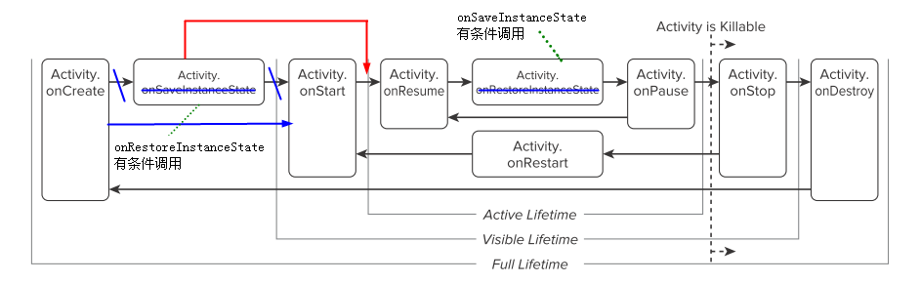
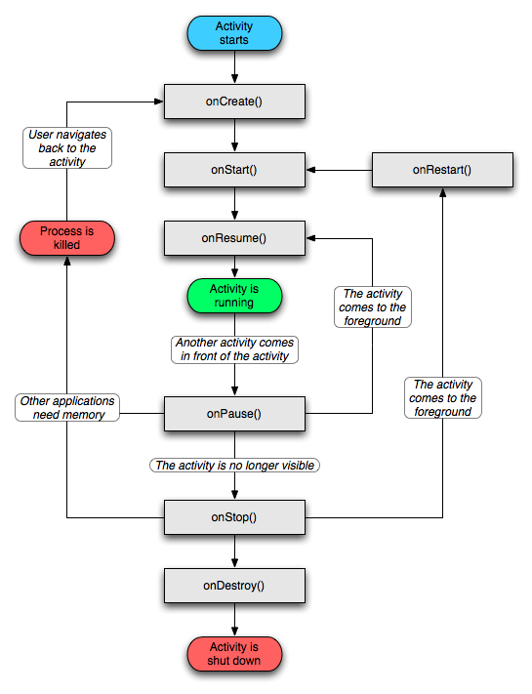
一个例子：
当从activity01切换到activity02，所调用的生命周期方法为
1oncreate, 1onstart, 1onresume, 1onpause, 2oncreate, 2onstart, 2onresume, 1onstop, 1ondestroy
说明：onresume执行之后，界面才得以展示

Saving state
To capture that state before the activity is killed by the system(not by the user action, such as pressing the BACK key), you can implement an onSaveInstanceState() method for the activity (Android calls this method before onPause() is called) （在默认的状态下，系统控件都会自己保存相关的状态信息，比如TextView会保存当前的Text信息，则这不需要我们担心）. It passes the method a Bundle object where you can record the dynamic state of the activity as name-value pairs. Android会将其持久化为磁盘上。
When the activity is being re-initialized from a previously saved state, the Bundle（从磁盘上反序列化） is passed both to onCreate() and onRestoreInstanceState() that's called after onStart(), so that either or both of them can recreate the captured state.
注意：onSaveInstanceState() and onRestoreInstanceState() are not lifecycle methods. 当处于某种时机时，它们才被调用。
一种情形：
当启动一个程序，再按HOME时，activity会变为stop，而此时，会调用onSaveInstanceState，但是此时用户通过launch栏再启动该应用，并不会调用onRestoreInstanceState
同样，当程序被用户关闭，再启动时，onCreate中的Bundle为空，也不会调用onRestoreInstanceState
猜想：android明白系统（而非用户）终止了哪些程序，当该程序对应的activity再次需要实例化时，android才会restore state
一种情形：
参见：handle runtime changes

Service
Three different lifetime:
- The entire lifetime: onCreate - onDestroy
- the active lifetime: onStart(this method is called only for services started by startService())
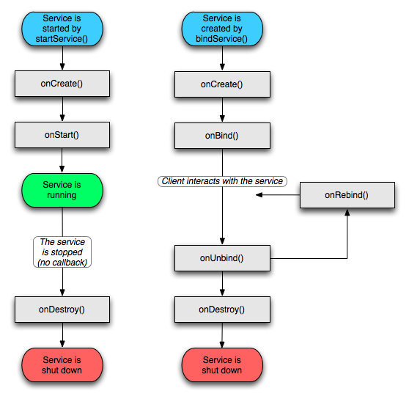
If a Service is bound by calling Context.bindService, it will run as long as possible until the connection is unbound

Broadcast receiver
When a broadcast message arrives for the receiver, Android calls its onReceive() method and passes it the Intent object containing the message.
The broadcast receiver is considered to be active only while it is executing this method. When onReceive() returns, it is inactive, and process that invoked the receiver are no longer needed and may be killed by the system
And, onReceive handler must complete within five seconds or the Force Close dialog will be displayed.
说明：我在receiver中声明了一个int变量，在onreceive中开启了一个线程，该线程每隔5s会更新那个int，重复20次。结果为：一切正常，并没有抛出什么错误

Content provider
A content provider is active only while it's responding to a request from a ContentResolver.

Resources
参见：google doc-framework topics-application resources

The types
参见：
google doc-framework topics-application resources-providing resources-grouping resource types
google doc-framework topics-application resources-resource types，即是：R一共有多少个内部类
■ assets - 包含应用系统需要使用到的诸如mp3、视频类的文件
getAssets().open("read_asset.txt");//.txt位于asset/下
说明：本质上，android不认为assets为资源，因为其下的东西在R.java中没有被分配id
■ res/anim —XML representations of frame-by-frame animations
参见：
google doc-framework topics-application resources-animation
google doc-framework topics-application resources-resource types-animation
b-大全2-p90
三类：property/view/drawable animation
          - property animation:
3.0及以上支持
animate any property of any object (Views and non-Views)
the object itself is actually modified
对应class：animator.class
          - view animation:
alpha, rotate, scale, translate
only animate View objects, but the actual View itself is not modified
对应class：animation.class, AnimationSet.class（其子animation同时发生，其属性将自用/忽略、覆盖/传递给子animation，参见android doc）
样式，参见：google doc-framework topics-application resources-resource types-animation-Tween animation
启动：
ImageView image = (ImageView) findViewById(R.id.image);
Animation hyperspaceJump = AnimationUtils.loadAnimation(this, R.anim.hyperspace_jump);
image.startAnimation(hyperspaceJump);
            - ui响应区域
你可以设置fillafter为true，以使得animation完成后，使view停留在最后位置，但是，即便如此，view的ui响应区域仍然是动画开始前的那个。解决：更新响应区域：自定义view，复写getHitRect方法
            - shareInterpolator
如果你的anim.xml中要使用set，那么，请根据情况，设置shareInterpolator为false，因为：
该值默认为true，而set是含有一个默认的interpolator，则：shareInterpolator为false导致了：set的孩子，如translate中虽然设置了interpolator，但没有任何的效果
            - 动画原点
设set中有2个animation，第一个animation中android:fillAfter为true，则第二个animation参照原点为：当第一个animation执行完的终点
设view要依次执行2个set，每个set的第一个animation的参考原点为：view在original_layout.xml中的位置
            - offsetstart和duration
在startAnimation后，要等待offsetstart个ms，再执行长度为duration的动画
            - rotate
设在set中包含2个animation，设fillafter为true，第一个是rotate，当第一个执行完
如果第二个是rotate，那么采用旋转之后的坐标系
如果第二个不是rotate，那么不采用旋转之后的坐标
参见：my/rotate
            - 前一个动画的残留
当你已经执行了一个animation，如将view从位置1移动到位置2
那么，在你执行后续的动画之前，请确保该动画的起始位置在：前一次动画的终结位置
否则，在执行后续动画时，你将看到上一次动画的残留view
参见：my/animation/TestUnrecover
          - drawable animation:
本质上是一个drawable
对应class：animationdrawable.class
样式，参见：google doc-framework topics-application resources-resource types-animation-Frame animation
启动：
ImageView rocketImage = (ImageView) findViewById(R.id.rocket_image);
rocketImage.setBackgroundResource(R.drawable.rocket_thrust);
rocketAnimation = (AnimationDrawable) rocketImage.getBackground();
rocketAnimation.start();//该start方法可以被调用在任何线程上，通过验证在android2.1u1
区域：我有一个view，它是viewgroup的孩子，那么：view的动画的活动区间不得超过viewgroup的可见区间
Viewflipper也是一种animation，一次只能显示一个view
■ res/drawable —.png, .9.png, and .jpg images
它是不被编译成为binary, but may be automatically optimized with lossless image compression by the aapt tool
读取drawable图片的byte：在该文件夹下的文件大部分都是png图片，那么怎样读取该图片的数据：bitmap.compress
得到bitmap：参见bitmap，或者，((bitmapdrawable)Resource.getdrawable(rid)).getbitmap()
State list
其根据不同的状态设置了一组drawable
参见：google doc-application resources-resource types-drawable-state list
shape可以使用在selector上，参见：android123-android控件美化shape你会用吗
■ res/layout —XML representations of View objects
resources in the res/layout directory don’t have to be layouts. There you can define a single TextView in a layout file
■ res/values —XML representations of strings, colors, styles(and theme)（style用于view，而theme用于application）, dimensions, and arrays
根元素是resource
for string
需用\进行转义的字符串：? ’ \
特殊字符串：&: &amp;，<: &lt;，>: &gt;，\’: &apos;，\”: &quot;
format:
String result=String.format(“&lt;b&gt;%1$s&lt;/b&gt;”, “you &amp; me”;
此result为<b>you & me</b>
说明：%1$s的意思为：第一个参数，且参数类型为string；则%n$x代表了第n个参数，类型为x
yourTextView.setText(Html.fromHtml(result));
而Html.fromHtml()将会产生一个android.text.Spanned对象
--
//注意：其为getText而非getString。当getString时，文字的格式将被忽略
CharSequence str = getText(R.string.styled_text);// Plain, <b>bold</b>, <i>italic</i>, <b><i>bold-italic</i></b>
TextView tv = (TextView) findViewById(R.id.text);
tv.setText(str);
for color, #RGB, #ARGB, #RRGGBB, #AARRGGBB，参见：Color类
State list
其根据不同的状态设置了一组color
参见：google doc-application resources-resource types-color state list
for style, and theme(one type of style)
R.styleable中定义了一个view中可以出现哪些属性，也即是这个view有哪一些可定制的样式
R.style中定义了一个view中对应于该属性允许赋哪些值
styles refer to a set of attributes applied to a single View element,
themes refer to a set of attributes being applied to an entire Activity or application.
When a style is applied as a theme, every View in the Activity or application will apply each style property that it supports
自定义style：
style中包含了一部分属性，如android:textColor，则在构造某一个view时，会调用View(Context context, AttributeSet attrs)，则针对于上述情况，view.setTextColor将被调用。即是：style中封装了一部分针对于外观的属性设置，是对该部分设置的封装。
可定义declare-styleable，其中包含了属性名，猜想：在构造函数View(Context context, AttributeSet attrs)中可以为styleable中的属性赋值
一个例子：
//属性值被保存在TypedArray中
TypedArray a = context.obtainStyledAttributes(attrs, R.styleable.LabelView);
//text为你自定义的属性名
CharSequence s = a.getString(R.styleable.LabelView_text);
然后就可以利用该s了，如setText()
参见：
style.xml
google doc-framework topics-applying styles and themes
google.samples-.view.CustomView1
my/test23
例子
<TextView style="@style/mystyle" />
或者，另一种形式：style=”android:attr/spinnerDropDownItemStyle”
<application android:theme="@style/mytheme"/>
<activity android:theme="@style/mytheme"/>
for attrs,
R.attr定义了可以出现在.xml中的元素的属性，涵盖了R.styleable
格式：
目前Android系统内置的格式类型有integer比如ProgressBar的进度值，float比如RatingBar的值可能是3.5颗星，boolean比如ToggleButton的是否勾选，string比如TextView的text属性，当然除了我们常见的基础类型外，Android的属性还有特殊的比如color是用于颜色属性的，可以识别为#FF0000等类型，当然还有dimension的尺寸类型，比如23dip，15px，18sp的长度单位，还有一种特殊的为reference，一般用于引用@+id/cwj @drawable/xxx这样的类型。
参见：
google samples-attrs.xml
■ res/xml —User-defined XML files (that are also compiled into a binary form)
■ res/raw —Arbitrary (which has only meaning to your app, but not to android) and uncompiled files that can be added
使用流来读取数据：InputStream = Resources.openRawResource(rawResourceID)（参见unlock-p163）
获得文件的大小：Resources.openRawResourceFd(myResourceId).getLength();
说明：
- 除了上述文件夹外，android不支持在res下建立其他文件夹
- the resource are compiled into an efficient binary type, except that are already binary and the raw type, which is not compiled
- except res/raw/, all the other types of xml are parsed for you, either by the Android packaging system or by the Android system on the device or emulator.则，你再使用它们的时候可以不用再自行解析（parse）了

R.java
对所有的资源进行全局索引
Resources are precompiled into a special class known as the R class.说明：R is generated by the aapt tool when your project is compiled
The R class is made up of static inner classes (one for each resource type)
The hex numbers are just integers that the Android resource manager uses to load the real data, the strings, and the other assets that are compiled into your package.
The value of these variables is a reference to the corresponding resource’s location in the resource table(which is contained in a special file the aapt tool creates)( The resource table is represented within your application as an instance of the Resources class), not an instance of the resource itself.
It is important that you never modify this file directly, as it automatically regenerates every time a resource is modified,它不应该通过用户编辑的方式被定义，应该通过编辑yourlayout.xml等资源的方式被定义（之后，会自动生成R.layout.yourlayout类）

Android内置属性
参见：
google doc中的R的内部类，如：对于内置的layout，外部引用格式为：@android:layout/，参见R.layout
内置style源码：
http://android.git.kernel.org/?p=platform/frameworks/base.git;a=blob;f=core/res/res/values/styles.xml;h=d7b654e49809cb97a35682754b1394af5c8bc88b;hb=HEAD
内置theme源码：
http://android.git.kernel.org/?p=platform/frameworks/base.git;a=blob;f=core/res/res/values/themes.xml;h=6b3d7407d1c895a3c297e60d5beac98e2d34c271;hb=HEAD
android源码（http://source.android.com），如：对于layout，参见frameworks/base/core/res/res/layout

Access Resource
获得resource
Resources myResources = getResources();
- 你可能会在.xml中看到@string/hello（说明：它的更广泛的形式是：@[<package_name>:]<resource_type>/<resource_name>），它的意思是：把R.string.hello（说明：它的更广泛的形式是：[<package_name>.]R.<resource_type>.<resource_name>）的值给我please
android自带的资源对应的package为”android”
- 你可能会在.xml中看到?android:windowNoTitle，它的意思是：把android:windowNoTitle的值给我please
A style attribute resource value allows you to reference the value of an attribute in the current-applied theme.
This attribute reference can only be used in style resources and XML attributes
它的更广泛的形式是：?[<package_name>:][<resource_type>/]<resource_name>
对于上例来说，其完整的形式为?android:attr/windowNoTitle

providing alternative resources
以<resources_name>-<config_qualifier>-…-<config_qualifier>的形式来provide different resource values for specific device configuration.
如：value-en
有多少configuration类别参见：google-sdk-application resources-providing resources-Providing Alternative Resources-table2
注意：是强调顺序的
At runtime, Android automatically detects the current device configuration and loads the appropriate resources
参见：
google-sdk-application resources-providing resources-Providing Alternative Resources
professional android2-Creating Resources for Different Languages and Hardware-p105
http://www.loc.gov/standards/iso639-2/php/code_list.php
手动更改配置：
Resource res=getResource();
Configuration conf=res.getConfiguration();
Conf.locale=
DisplayMetrics dm=res.getDisplayMetrics();
Res.updateConfiguration(conf, dm);

handle runtime changes
Some device configurations can change during runtime (such as screen orientation, keyboard availability, and language). When such a change occurs, Android restarts the running Activity (onDestroy() is called, followed by onCreate()). The restart behavior is designed to help your application adapt to new configurations by automatically reloading your application with alternative resources.
To properly handle a restart, it is important that your Activity restores its previous state through the normal Activity lifecycle, in which Android calls onSaveInstanceState() before it destroys your Activity so that you can save data about the application state. You can then restore the state during onCreate() or onRestoreInstanceState().
一个问题：However, you might encounter a situation in which restarting your application and restoring significant amounts of data can be costly and create a poor user experience
Solutions:
- Retaining an Object During a Configuration Change
Android calls onRetainNonConfigurationInstance() between onStop() and onDestroy() when it shuts down your Activity due to a configuration change. In your implementation of onRetainNonConfigurationInstance(), you can return any Object that you need in order to efficiently restore your state after the configuration change(by using getLastNonConfigurationInstance()).
- Handling the Configuration Change Yourself
If your application doesn't need to update resources during a specific configuration change and you have a performance limitation that requires you to avoid the Activity restart, then you can declare that your Activity handles the configuration change itself, which means:
when one of these configurations change, your activity is not restarted, instead, the Activity receives a call to onConfigurationChanged (Configuration newConfig)
Note: 当该方法被调用，Resource加载了合适的alternative resource，但是没有将其应用到widget上，需要手动来完成。参见：my/test28
How to: 如<activity android:name=".MyActivity" android:configChanges="orientation|keyboardHidden" />
configChanges可以取哪些值，参见：Configuration.java中的成员变量

alias resources
你的程序中有一些alternative resources，当你发现有一个资源适应于alternative A和B（但而不是全部），那么，你可以将该资源放入默认文件夹，而在A, B中建立一个alias。猜想：实际上不建alias也可以，当扫描定位到alternative文件夹，当发现没有资源时，会到默认文件夹中去寻找。
参见：google-sdk-application resources-providing resources-Providing Alternative Resources-Creating alias resources

HAL
Hal: hardware abstract layer
参见：jollen的ppt和mokoid源码
位于c库和linux kernel之间，为了硬件厂商不公开驱动源码
hw_module_t是基类，提供open，驱动开发者编写子类

Network
In terms of the data network, Android provides access in several ways: mobile Internet Protocol (IP) networks, Wi-Fi, and Bluetooth
The package in android: java.net, org.apache.http.client, android.net

The basic concept
Data is sent between connected devices with particular addresses, the addressed device is called node.
Protocols are a predefined and agreed-upon set of rules for communication.

port
In order to handle many client requests, often for different purposes, coming in nearly simultaneously to a single IP address, modern server operating systems use the concept of ports. Ports are not physical; they are simply a representation of a particular area of the computer’s memory.
Every computer with an IP address also supports a range of thousands of ports to enable multiple “conversations” to happen at the same time.

Get the network info
ConnectivityManager cMgr = (ConnectivityManager) getSystemService(Context.CONNECTIVITY_SERVICE);
NetworkInfo netInfo = cMgr.getActiveNetworkInfo();

Socket
和普通的ServerSocket/Socket编程一样

http
代理的设置，参见：Android上如何正确实现程序的联网，事关WIFI CMWAP CMNET 7dot9's Laputa.htm
如何让模拟器通过代理联网：emulator -avd youravdname -http-proxy proxy_address:proxy_port -debug-proxy

HttpURLConnection
参见：
HttpURLConnection.ppt
如何成为android高手-p4
俺要虎虎生威博客
手机自身的IP是10.0.2.2
client打开os写（注意设置content-length头信息），后打开is读
server打开is读，后打开os写

HttpClient
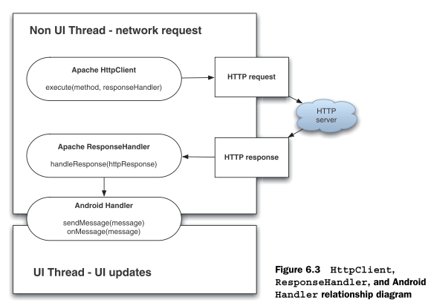
参见：D:\学习\JAVA\资料\android\!unlocking android\uad\ch6\NetworkExplorer\src\com\msi\manning\network\data\HTTPRequestHelper.java
根据上图编程allows the HTTP call to be made in an asynchronous manner—we don’t have to block and wait the entire time between when the request is fired and when it completes
本质上，这种编程的关键点是Handler，HttpClient.excute的执行线程由用户来指定，那么我们指定在一个new thread上。到http任务完成，将关键参数放入消息队列中，Looper检测消息队列，最后handler在messagequeue对应的thread上处理消息。
疑问：handlerResponse在哪个线程上执行。猜想：从图上可知为excute方法所在的线程
一个例子：
DefaultHttpClient client = new DefaultHttpClient();
HttpGet httpMethod = new HttpGet(serveraddress);
//该方法本身返回HttpResponse，则除了在handleResponse中对response做处理，还能在此做处理
//猜想：该方法是阻塞的
HttpResponse = client.execute(httpMethod, new ResponseHandler<String>() {
public String handleResponse(HttpResponse response) {
// when the response happens close the notification and update UI
StatusLine status = response.getStatusLine();
Log.d(Constants.LOGTAG, " " + ApacheHTTPSimple.CLASSTAG + " statusCode - " + status.getStatusCode());
Log.d(Constants.LOGTAG, " " + ApacheHTTPSimple.CLASSTAG + " statusReasonPhrase - "
+ status.getReasonPhrase());
HttpEntity entity = response.getEntity();
String result = null;
try {
//或者result = StringUtils.inputStreamToString(entity.getContent());
result = EntityUtils.toString(entity);

//send message to update ui
Message message = handler.obtainMessage();
Bundle bundle = new Bundle();
bundle.putString("RESPONSE", result);
message.setData(bundle);
handler.sendMessage(message);
} catch (IOException e) {
Log.e(Constants.LOGTAG, " " + ApacheHTTPSimple.CLASSTAG, e);
}
return result;
}
});
设置证书：HttpClient.getCredentialsProvider().setCredentials
设置request header：
client.addRequestInterceptor(new HttpRequestInterceptor() {
public void process( final HttpRequest request, final HttpContext context) throws HttpException, IOException {
for (String key : sendHeaders.keySet()) {
if (!request.containsHeader(key)) {
request.addHeader(key, sendHeaders.get(key));
}
}
}
});

WebKit

telephoney
TelephonyManager is not related to making calls but rather is used to
retrieve all kinds of telephony-related data, such as the state of the voice network, the device’s own phone number, and Subscriber Identity Module (SIM) card details.
getsystemService(TELEPHONY_SERVICE)
PhoneStateListener can alert you when call or phone network states change.
TelephonyManager.listen(phoneListener, PhoneStateListener.LISTEN_CALL_STATE);

Call
Intent
action:
ACTION_DIAL
This will not actually dial the phone; rather, it activates the dialer activity
ACTION_CALL
uri: tel:123…
监听器：
PhoneStateListener.onCallStateChanged(int state, String incomingNumber)可以监听电话的状态
注册监听器：TelephonyManager.listen(PhoneStateListener, PhoneStateListener.LISTEN_CALL_STATE);
参见：b大全2-p270
TelephonyManager = getSystemService(Context.TELEPHONY_SERVICE);
getCallState
CALL_STATE_IDLE (phone not in use),
CALL_STATE_RINGING (call requested but still being connected)
CALL_STATE_OFFHOOK (call in progress).
TelephonyManager.listen(PhoneStateListener, PhoneStateListener.LISTEN_CALL_STATE);
<uses-permission android:name="android.permission.READ_PHONE_STATE"/>
getSubscriberId
Find out the SIM ID (IMSI)
getPhoneType
GSM

Sms
内置的发信程序：
Action
SmsManager
获得smsmanager
SmsManager.getDefault
发送短信：
sendTextMessage (String destinationAddress, String scAddress, String text, PendingIntent sentIntent, PendingIntent deliveryIntent)
sendDataMessage (String destinationAddress, String scAddress, short destinationPort, byte[] data, PendingIntent sentIntent, PendingIntent deliveryIntent)
参数示例：
PendingIntent sentIntent = PendingIntent.getBroadcast(getApplicationContext(), 0, new Intent(“SMS_SEND_ACTIOIN”), 0);
PendingIntent deliveryIntent = PendingIntent.getBroadcast(getApplicationContext(), 0, new Intent(“SMS_DELIVERED_ACTION”), 0);
上述两个intent分别表示短信发送出以及短信送达到收件人时的broadcast
发送结果：
Actvitiy.RESULT_OK
SmsManager.RESULT_ERROR_GENERIC_FAILURE
接收短信：
注册了android.provider.Telephony.SMS_RECEIVED的BroadcastReceiver可以监测到发送来的短信
intent.getExtras().get(“pdus”)返回的是Object[]，每个元素为byte[]
然后根据每个byte[]，SmsMessage.createFromPdu()创建SmsMessage
此后，message.getMessageBody，message.getOriginatingAddress
用DDMS来模拟打电话和发短信以验证程序的正确性
Permission：
<uses-permission android:name="android.permission.RECEIVE_SMS"/><!-- 接收短信权限 -->
<uses-permission android:name="android.permission.SEND_SMS"/><!-- 发送短信权限 -->
参见：eoeandroid-“thread-39876-1-3”的发送短信和彩信的intent

Email
Intent inte:
action: Intent.ACTION_SEND
uri: tel:123…
extra: 发件人地址，收件人地址，内容等（参见：b-sdk-p167）
一个例子：
Intent mEmailIntent = new Intent(android.content.Intent .ACTION_SEND);
mEmailIntent.setType("plain/text");
/*设定E-mail收件人的信箱*/
mEmailIntent.putExtra(android.content.Intent.EXTRA_EMAIL, String[]{..});
/*设定E-mail的标题*/
mEmailIntent.putExtra(android.content.Intent.EXTRA_SUBJECT, String);
/*设定E-mail的内容*/
mEmailIntent.putExtra(android.content.Intent.EXTRA_TEXT, String);
/*显示发信中*/
startActivity(Intent.createChooser(mEmailIntent, getResources().getString(R.string.str_message)));

通讯录
- 其对应的ContentProvider：
在通讯录中，一个人可以有多组号码（组：家庭号码，工作号码）
ContactsContract.Contacts.CONTENT_URI
ContactsContract.Contacts._ID
ContactsContract.Contacts.DISPLAY_NAME（显示在通讯录中的名字）
ContactsContract.CommonDataKinds.Phone.CONTENT_URI
ContactsContract.CommonDataKinds.Phone.CONTACT_ID（其对应ContactsContract.Contacts._ID）
ContactsContract.CommonDataKinds.Phone.NUMBER
ContactsContract.CommonDataKinds.Phone.TYPE（其为整数值，对应的String由
ContactsContract.CommonDataKinds.Phone.getTypeLabelResource()获得）
- Android内置程序
startForActivityResult(new Intent(Intent.ACTION_PICK, Uri.parse(“content://contacts/people”)))
后在onActivityResult中通过intent.getData获得uri，进而获得cursor

media
android内置了mediastore，其包含了audio, video, image，且分internal和external
当你要打开一个多媒体，那么你可以使用这样一个intent，其action为action_view，
data为content://…/{id}
或者，uri为file://...，type为如image/*

MediaPlayer
Android lets you play audio and video from several types of data sources. You can play audio or video
from media files stored in the application's resources (raw resources),
MediaPlayer.create(context, R.raw.sound_file_1);
from standalone files in the filesystem,
or from a data stream arriving over a network connection.
MediaPlayer mp = new MediaPlayer();
mp.setDataSource(PATH_TO_FILE-OR-HTTP_URL);
参见：google samples-.media.MediaPlayerDemo
实际调用过程：
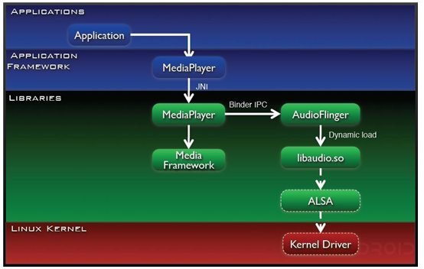
一些方法：
create(Context, resourceId)或者setDataSource( file path 如 "/sdcard/bb.mp3" );
reset
Prepare
Start
pause
stop
release
监听器：
OnCompletionListener
OnErrorListener
OnBufferingUpdateListener
OnPreparedListener
说明：
播放视频时，需要一个SurfaceView充当holder
MediaPlayer.setDisplay(holder);

MediaRecorder
The platform also lets you record audio and video, where supported by the mobile device hardware. To record audio or video, use the MediaRecorder class.
参见：google doc-audio and video-Example: Audio Capture Setup and Start

Support types
参见：google doc-appendix-supported media formats

device

PowerManager.WakeLock
This class lets you say that you need to have the device on
myWakeLock.acquire();
myWakeLock.release();

other topic

search
参见：
google doc-framework topics-search
google sample-SearchableDictionary

SearchManager
SearchManager manages the life of the Android search dialog, handles the rendering of the search dialog, display all search suggestions below the search dialog, send your application the search query when executed by the user.

configuration
The searchable configuration is an XML file that defines several settings for the Android search dialog in your application. This file is traditionally named searchable.xml and must be saved in the res/xml/ project directory.

Activity

Search client activity
<application ... >
<activity android:name=".SearchClient" >
<meta-data android:name="android.app.default_searchable" android:value=".MySearchableActivity" />
</activity>
…
</application>
Invoke search:
- setDefaultKeyMode(DEFAULT_KEYS_SEARCH_LOCAL).//当当前焦点组件对某一个按键没有反应时，该按键将激起什么操作
- 单击search按键
- 如果接下来，你想激起屏幕上端的搜索组件，那么调用startSearch(String initialQuery, boolean selectInitialQuery, Bundle appSearchData, boolean globalSearch)，但该方法只能在onSearchRequested中被调用，所以，，，
Put query string and extra app data: Query string由程序传递，不用自行制定；而App data放入bundle extra中
- 单击屏幕上端的搜索组件的搜索按钮，会激起一个intent，其action为intent.action_search，并包含了query string和extra data等信息

Searchable activity
This is the Activity that receives the search query then searches your data and displays the search
When the user executes a search, the Search Manager will use a specially-formed Intent to pass the search query to the Activity that you've declared to handle searches
一个例子：
<application ... >
<activity android:name=".MySearchableActivity" >
<intent-filter>
<action android:name="android.intent.action.SEARCH" />
</intent-filter>
<meta-data android:name="android.app.searchable" android:resource="@xml/searchable"/>
</activity>
...
</application>
Search step:
- receiving the query string and app data
intent.getStringExtra(SearchManager.QUERY);
intent.getBundleExtra(SearchManager.APP_DATA)
- searching your data
- presenting the results

Suggestion
作用：你在之前的搜索过程键入了abcd，当你再次搜索时，键入a时，将会出现提醒
修改searchable.xml，android:searchSuggestAuthority="someAuthority"，则用户在键入query字符时，将请求authority为指定值的contentprovider的特定数据（通过query()的方式，其中的uri为content://${someAuthority}/${SearchManager.SUGGEST_URI_PATH_QUERY}/${query}）；该provider中需要包含_id, SearchManager.SUGGEST_COLUMN_TEXT_1等列，而query中返回的cursor由MatrixCursor(列名数组).addRow(列值数组)产生
当要单击suggestion中的某一个item时，将会向searchable activity发送一个intent，其action在configuration中定义：android:searchSuggestIntentAction。如果要设置该intent的data，那么请在provider中包含SearchManager.SUGGEST_COLUMN_INTENT_DATA列，并在返回的cursor中包含对应的值，而在searchable activity中，可以通过getIntent().getDataString()获得该data

PackageManager
PackageManager is design to retrieve various kinds of information related to the application packages that are currently installed on the device
- 获得包的信息：getApplication().getPackageManager().getPackageInfo()
- 获取可以在launcher栏启动的activity
Intent mainIntent = new Intent(Intent.ACTION_MAIN, null);
mainIntent.addCategory(Intent.CATEGORY_LAUNCHER);
List<ResolveInfo> mApps = getPackageManager().queryIntentActivities(mainIntent, 0);
/*
- Packageinfo is overall information about the contents of a package. This corresponds to all of the information collected from AndroidManifest.xml.
- applicationinfo corresponds to information collected from the AndroidManifest.xml's <application> tag.
- ResolveInfo is information that is returned from resolving an intent against an IntentFilter（该intent由packagemanager指定）. 你可以通过它来获得activityinfo, serviceinfo等
- activityinfo is information you can retrieve about a particular application activity or receiver. This corresponds to information collected from the AndroidManifest.xml's <activity> and <receiver> tags. 一个activity由包名和完全限定类名来表示
*/
ResolveInfo info = mApps.get(position);
info.activityInfo.packageName返回包名
info.activityInfo.name返回full qulified name
info.activityInfo.loadIcon(getPackageManager())返回一个Drawable的icon
info.activityInfo.loadLabel(getPackageManager())返回标签
- 获取所有安装包的信息：getinstalledpackage，后通过packageinfo.activities获得activityinfo，进而得到其他
注意：该方法的flag应包含get_activity，则packageinfo.activities才不为空

ActivityManager
Interact with the overall activities（还包含service信息） running in the system，猜想：通过它，可以获得任何运行中的component的信息

WindowManager
一个场景：
我有一个activity，它的布局的root并非framelayout，而此刻，我需要将一个view加入到activity上，且居中显示，要求：不要修改layout.xml
方法：利用windowmanager.layoutparams来设置居中，用windowmanager.addview来加入该view
参见：my/windowmanagerlp

system service
通过Context.getSystemService(String serviceDesc)来获得特定的服务对象，参见：b大全2-p272

windowmanager和display
整个Android的窗口机制是基于WindowManager，这个接口可以添加view到屏幕，也可以从屏幕删除view。它面向的对象一端是屏幕，另一端就是View，直接忽略我们以前的Activity或者Dialog之类的东东。其实我们的Activity或者Diolog底层的实现也是通过WindowManager，这个WindowManager是全局的，整个系统就是这个唯一的东东。它是显示View的最底层了。
一个例子：
WindowManager mWm = (WindowManager)getSystemService(Context.WINDOW_SERVICE);
Button view = new Button(this);
view.setText("window manager test!");
WindowManager.LayoutParams mParams = new WindowManager.LayoutParams();
mWm.addView(view, mParams);
--
获得display：Activity.getWindow().getWindowManager().getDefaultDisplay()
获得width和height：Display.getWidth, getHeight
设置屏幕方向：Activity.setRequestOrientation(ActivityInfo.SCREEN_ORIENTATION_PORTRAIT)
或者，
DisplayMetrics dm = new DisplayMetrics();
getWindowManager().getDefaultDisplay().getMetrics(dm);
手机分辨率为：dm.widthPixels, dm.heightPixels,
--
全屏：Activity.getWindow().setFlags(WindowManager.LayoutParams.FLAG_FULLSCREEN, true/false);
无标题：
requestWindowFeature(Window.FEATURE_NO_TITLE);
或者采用style.xml中的形式，查询R.attr，可以发现其有属性windownotitle
设置属性：
window.setfeatureint

configuration
当系统设置发生改变时（键盘隐藏或者打开，屏幕方向更改），会产生事件，对应的处理方法为Activity.onConfigurationChanged
获得诸如蓝牙、无线网络的设置状态：System.getString(getContentResolver(), System.BLUETOOTH_ON)
如果返回为1，则意味打开

time
Calendar
获得实例
Calendar.getInstance();
设置时间
c.setTimeInMillis(System.currentTimeMillis());
获得unit
int mHour = c.get(Calendar.HOUR_OF_DAY);
int Minute = c.get(Calendar.MINUTE);

Instrumentation
好像是用来做测试的，参见：google samples-.app.LocalSample

AlarmManager
获取：AlarmManager am = (AlarmManager) getSystemService(ALARM_SERVICE);
一些方法：
public void set (int type, long triggerAtTime, PendingIntent operation)
public void setRepeating (int type, long triggerAtTime, long interval, PendingIntent operation)
public void cancel (PendingIntent operation)
一个例子：30秒后将启动该PendingIntent
Calendar calendar = Calendar.getInstance();
calendar.setTimeInMillis(System.currentTimeMillis());
calendar.add(Calendar.SECOND, 30);
AlarmManager am = (AlarmManager) getSystemService(ALARM_SERVICE);
am.set(AlarmManager.RTC_WAKEUP, calendar.getTimeInMillis(), some PendingIntent);
关闭一个repeat alarm：alarmmanager.cancel(pendingintent)
参见：google-apidemo-alarmcontroller

Inputmethodmanager
隐藏输入法（隐藏键盘）：
InputMethodManager imm = (InputMethodManager) getSystemService(INPUT_METHOD_SERVICE);
View view1 = ContentBrowser.this.getCurrentFocus();
if (view1 != null) {
imm.hideSoftInputFromWindow(view1.getWindowToken(), 0);
}

Location
关于通过gps，wifi/基站获取位置，参见：location文件夹
当你的gps一开始可用，你得到了你的位置，而现在gps又不可用了，那么getlastknownlocation还会有返回值，只是该值对应于上一次

widget
App Widgets are miniature application views that can be embedded in other applications (such as the Home screen) and receive periodic updates
An application component that is able to hold other App Widgets is called an App Widget host.

Programe topic

The package: apk
Android applications are written in the Java programming language.
The apk file is the vehicle for distributing the application and installing it on mobile devices; it is the file users download to their devices. All the code in a single .apk file is considered to be one application.
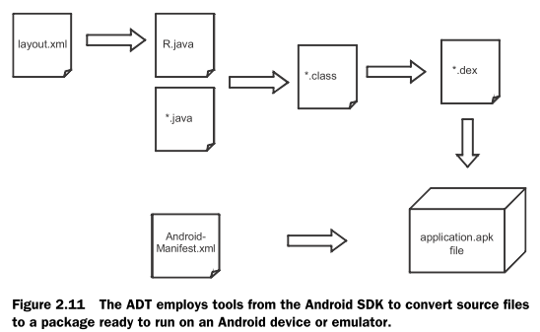
说明：
图中的.xml还包含了诸如strings.xml等
aapt(android asset packaging tool)负责将所有需要的资源打入apk包：
converted xml files(binary form)（转换过程由aapt完成）
a compiled binary form as resource of the non-layout resources including the Drawables and Values（如.png，它们已经被压缩过了，所以不再被aapt压缩）
the dex file（由dx将.class转换成.dex）
Resources.arsc
它是整个文件的资源表（参见b-ophone-p41）
META-INF
如果apk被签名，该文件夹便存在（参见b-ophone-p42）
The apk name:
在eclipse中，新建一个android项目，会让你填写包名，如com.ql，那么最后打成的包为com.ql.apk
在DDMS的file explorer中，data/app中可以看到com.ql.apk，可以将其导出；而在data/data中将会看到com.ql文件夹，其中用来存在应用程序的私有文件（如reference文件、db文件）
注意：你可以建立两个项目a和b，但是当它们在新建时的包名相同时，如均为com.ql，那么可能会产生问题：
当运行a再运行b，那么a中的组件会被覆盖，猜想：a的androidmanifest.xml会被覆盖。那么其他程序再让a的组件来捕获特定的intent，就成为枉然
当使用eclipse时，bin下存在着你的apk

jni
参见：jni文件夹
JNI由DVM提供，通过jni，android framework与底层c++ library进行交互
当包含了so的程序安装到手机上后，so被自动拷贝到data/data/packagename/lib下

引入第三方类库
步骤：
设置classpath
将第三方jar放入到当前项目的一个文件夹中（如lib），然后右键该文件夹-Bulid path-Use as source folder
猜想：之下步骤可能不需要，因为就算放入libs中，安装后，jar也不会出现在data/data/packagename/lib下
和res同级，建立libs，将jar放入
如何导出类到jar：选择一个工程，export，java-jar file
说明：当你引入了第三方类库，那么最后生成的classes.dex中包含了该类库的.class（可以通过反编译工具来查看）

Eclipse中修改项目的packagename
右键该项目，android tool-change package name
这只会改变package name在manifest.xml中的表示，并不会改变项目中的包结构

Tools

DDMS
Dalvik Debug Monitoring Service
参见：unlocking android p64-ch2.2.2
It contains
- Thread, heap, file managment
- Emulator control
  - Data and voice network control
- logging
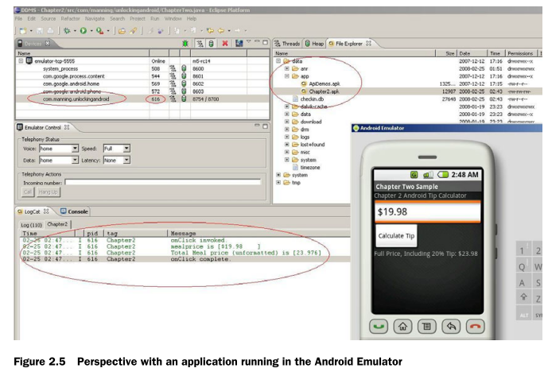

AAPT & DX
参见the package: .apk

ADB
参见：google doc-developing-tools-adb
ADB Android Debug Bridge
A client-server application that provides a link to a running emulator. It lets you copy files, install compiled application packages (.apk), and run shell commands.
如：
打开一个模拟器：进入tools下，emulator –data emulator_name
安装一个程序：adb install (apk在PC上的路径/)*.apk
将apk文件上传到了模拟器自带操作系统的data/app目录下了

The other
参见b-professional2-p78

debug
please use the eclipse debug perspective

junit
参见：junit文件夹

logcat
Calling static methods of the android.util.Log class adds entries to the log.
Entries in the log may be viewed via the LogCat view of the DDMS Perspective
在logcat中建立自己的过滤器，设定tag
Log class has different levels, including
Verbose
Debug
Information
Warning
Error
命令行使用：adb logcat -s myAndroid:D。则输出hag为myAndroid的且级别在debug之上（包含debug）的日志
参数参见：logcat参数.txt
连真机打印日志：
手机安装驱动；设置-应用程序-开发-打开debug模式；将手机连至主机
eclipse-run configurate-不选择auto；运行程序；选择合适的真机emulator
打开ddms，选择合适的emulator，在logcat区域查看
说明：
日志还有其十分重要的用途：比如，你可以拦截activitymanager的日志，来获取用户都开启哪些程序（因为程序是通过intent来开启的，甚至还可以获取intent.data）。其对应的linux命令是：logcat –s ActivityManager:I
你的程序需要权限：<uses-permission android:name="android.permission.READ_LOGS" />
当你使用编程的方式获得logcat的输出，那么请确保：
logcat会缓存将之前的日志信息，那么请先清空之前的logcat内容，再进行读取
Runtime.getRuntime().exec("logcat -c");
Process p = Runtime.getRuntime().exec("logcat -s PVPlayer:D");

Android-specific package
■ android.app—Android application model access
■ android.content—Accessing and publishing data in Android
■ android.net—Contains the Uri class, used for accessing various content
■ android.graphics—Graphics primitives
■ android.opengl—OpenGL classes
■ android.os—System-level access to the Android environment
■ android.provider—ContentProvider-related classes
■ android.telephony—Telephony capability access
■ android.text—Text layout
■ android.util—Collection of utilities for text manipulation, including XML
■ android.view—UI elements
■ android.webkit—Browser functionality
■ android.widget—More UI elements

模拟器配置
更改语言：settings菜单项-locale
修改大小：
出现错误：emulator: ERROR: system image file too large for device's hardware configuration (74 MB > 72 MB).
则修改C:\Documents and Settings\luqi\.android\avd\yourAvdName.avd\config.ini，添加disk.systemPartition.size=96MB
ERROR: the user data image is used by another emulator. aborting
删除C:\Documents and Settings\luqi\.android\avd\yourAvdName.avd下的以.lock结尾的文件夹
查看android自带的模拟器的配置：
参见\android-sdk-windows\platforms\android-2.2_r02\skins\WVGA800\layout
如device元素指明了分辨率为480*800

如何部署到手机
- 将手机连上主机，adb install apk的绝对路径名
- 猜想：将apk导出
- 手机安装usb驱动
手机和android相连
在eclipse中run,参见实例大全v2-p19

如何让apk具有root权限
参见：sign文件夹
- 在manifest.xml中卫manifest元素添加sharduserid=”android.uid.system”
- 编译为apk
- 运行sign.bat

修改android框架
参见：
source.android.com
其中讲述了如何获取源码，how to build an android-compatible device
修改android框架代码.mht
怎样使用eclipse来开发android源码.mht
Android源码获取方法.mht

获取android的属性
可以通过之下几个途径
- system.getproperties获得properties，后properties.propertyNames可以获得属性名，后system.getproperty
- 读取文件系统的default.prop, system/build.prop,system/default.prop, data/local.prop；使用build类
- 读取proc/cupinfo, proc/meminfo
- packagemanager.hassystemfeature来判断是否支持某些特性
- display和displaymetrics的某些方法来获得诸如width等屏幕属性
- hardware.camera和hardware.camera.size来获取摄像头属性

获取额外的类
导入sdk/platform/android2.x/data下唯一的jar放入classpath，诸如systemproperties的类就可以用了

执行linux命令
runtime.exec来执行linux命令，通过返回的process调用getoutputstream来读取结果
一个例子：
Process p = Runtime.getRuntime().exec(your_cmd);

反编译
参见：反编译文件夹

root手机
1-click root
http://forum.xda-developers.com/showthread.php?t=747598
SuperOneClick
http://forum.xda-developers.com/showthread.php?t=803682

Developer

Code
android-sdk-windows\docs\resources\samples\index.html
http://code.google.com/p/apps-for-android/
源码：http://android.git.kernel.org/?p=platform/frameworks/base.git;a=tree;hb=HEAD

community
Ophone
www.ophoneesdn.com
mobile market
参见b-ophone-p7

Market
Android market

