Shared SDG Labels Don’t Mean Shared Framing — Embedding-Based Register-Topic Decomposition of Research-Policy Divergence Across the SDGs
Table of Contents

Abstract
Shared SDG labels do not mean research and policy frame a goal similarly. This paper contributes a measurement framework that separates research-policy divergence into two dimensions: coverage (which SDGs each corpus prioritises) and within-SDG semantic framing (how differently the same SDG is discussed). Framing is composed of topic (substantive content) and register (communicative conventions).
The paper embeds 62,173 SDG-labelled, 3,105,144 research, and 40,597 policy text segments with a frozen Sentence-BERT encoder. Labelled segments are used to train a single-label logistic regression classifier to score research and policy text segments. The study then trains an SDG-stratified research-policy LR classifier to subtract the linear directions that separate research and policy from the original semantic space using Iterative Nullspace Projection (INLP, Ravfogel et al. (2020)). What remains is called the adjusted semantic space, which arguably contains the substantive topic. Texts are re-scored in this adjusted space. The difference between the raw and adjusted embeddings is called the register component.
For each SDG in each corpus, coverage is its share within the corpus and semantic centroid is the mean value of the embeddings labelled that SDG. For each SDG, coverage gap is the coverage difference between the two corpora and raw semantic gap is the cosine distance between research and policy centroids. Adjusted and register semantic centroids and gaps are recalculated using the respective values. Correlation tests between H1a) absolute coverage gap, H1b) signed coverage gap, H1c) research coverage, H1d) policy coverage and within-SDG semantic gaps (raw, adjusted, register) are calculated with two-sided Monte Carlo permutation p-values (100,000 resamples).
The SDG classifier achieves macro-F1 = 0.816 on a held-out test set and reproduces research-side’s high coverage of SDGs 3, 4, 11, 16 established by prior findings. Policy-side ranking (top SDGs: 13, 16, and 17) is established here for the first time. The raw coverage-semantic correlation is null ($ρ=−0.012$, p = 0.959). However, decomposition hints at a cancellation: the adjusted semantic gap is positively associated with coverage ($ρ=0.544$, p = 0.025) while the register component is negatively associated ($ρ=−0.390$, p = 0.120). Policy coverage is the strongest directional predictor of the adjusted semantic gap ($ρ=+0.589$, p = 0.015), while research coverage shows no consistent signal ($ρ=+0.267$, p = 0.295).
Those results are generally stable across encoders, classifier family, retrieval strategy, segment cap, and policy-source family. To conclude, coverage and framing should be measured and reported as separate axes of divergence. Shared labels are insufficient evidence of shared framing.
Keywords: research-policy alignment; Sustainable Development Goals; semantic similarity; transformer embeddings; measurement protocol; bibliometrics.
Data and code availability. The analysis code and the frozen, processed outputs are version-controlled at https://github.com/qmanhbeo/dissertation-bham.

Introduction
Research-policy alignment is often inferred from whether scientific and policy texts address the same topics (Bornmann, Haunschild, and Marx 2016), but shared coverage does not mean comparable framing. Research and policy rarely even co-occur on a topic to begin with: only 1.2% of 191,276 climate-change publications carry at least one policy-document mention (Bornmann, Haunschild, and Marx 2016), and even where research and policy communities share terminology, they diverge in term salience and focal concerns (Toney-Wails, Curlee, and Probasco 2024). A paper and a policy document can both be labelled the same SDG while emphasising different problems, actors, and interventions. Legislative agendas, ESG disclosures, and funding decisions increasingly treat SDG tags as evidence of alignment (Heilinger, Kempt, and Nagel 2024; Heras-Saizarbitoria, Urbieta, and Boiral 2022) while this assumption is empirically unfounded.
Existing methods for mapping research to the Sustainable Development Goals (SDGs) operate mainly at the level of lexical or bibliometric correspondence: keyword dictionaries, Boolean queries, or citation and mention counts (Armitage, Lorenz, and Mikki 2020; Kashnitsky et al. 2024). Broader AI-SDG assessments compound this, resting on expert opinion or publication counts rather than on the texts themselves (Vinuesa et al. 2020). They measure whether a text is about a SDG instead of how it frames it.
Coverage gaps like this are not AI-specific: in conservation science, 59% of policy-prioritised topics appear in fewer than 15 papers (McCarthy et al. 2026). Framing gaps are not AI-specific either: corporate AI research concentrates on pre-deployment problems, leaving the deployment-impact space policy must address (Strauss et al. 2025), and global AI metrics emphasise technical/economic performance where policy stresses ethical/social dimensions (Sioumalas-Christodoulou and Tympas 2025).
This paper proposes that research-policy alignment has at least two separable dimensions: coverage divergence (which SDGs each corpus prioritises) and semantic framing divergence (how differently they discuss the same SDG). Its contribution is a measurement framework. Applied to the AI-SDG scientific and policy literature, this framework advances its mapping from Level 1 (lexical correspondence) to Level 2 (observed textual-semantic proximity in embedding space; Section 2.3). A novel SDG-stratified INLP adaptation separates register from topic.
The central research question is: To what extent do academic AI-for-sustainability research and policy discourse differ in SDG coverage and semantic framing across the 17 SDGs, and how are these two dimensions related?

Literature Review

Previous AI-SDG Bibliometrics
Existing assessments of AI and the SDGs rest on expert views or publication counts rather than on the texts themselves (Vinuesa et al. 2020). Broader SDG scientometrics and the AI-specific inventories converge on one robust finding: SDG 3 (Good Health) and SDG 7 (Affordable and Clean Energy) are the most addressed goals in the AI-specific studies, followed by SDG 4 (Quality Education), SDG 13 (Climate Action), SDG 11 (Sustainable Cities and Communities), and SDG 16 (Peace, Justice and Strong Institutions). The evidence base spans a citation-based corpus of roughly 25,000 publications on the Millennium and Sustainable Development Goals (Bautista-Puig et al. 2021), 20,511 AI publications (2001–2020) (Singh et al. 2024), 1,288 big-data and AI publications (Nedungadi et al. 2024), 792 AI-and-SDG research articles (Gohr et al. 2025), and 108 AI-for-social-good projects (Cowls et al. 2021). Still, none of these studies measures within-SDG semantic framing.
SDG publication mapping depends on the methods used. Armitage, Lorenz, and Mikki (2020) shows that what counts as SDG-relevant depends on interpretive choices about queries, labels, and databases. Kashnitsky et al. (2024) reach the same caution from a broader comparison of Boolean, machine-learning, and hybrid mapping systems, finding no single best approach and no single “golden” validation set. The dependence persists in AI-based mapping: keyword baselines still omit publications that never state an SDG keyword explicitly, so the reported corpus boundary remains query-dependent (Yin et al. 2025). The embedding-based approach used in this paper reduces some vocabulary-level brittleness of keyword dictionaries, but its results are still conditional on corpus construction, which centroids are used, and model choice.
The SDGs themselves are interdependent by design but no operational framework specifies how (Nilsson, Griggs, and Visbeck 2016), with the exception of SDG 17. Le Blanc (2015), in a network analysis of the proposed SDGs, treats SDG 17 (Partnerships for the Goals) as the dedicated goal for cross-cutting means of implementation: finance, trade, technology transfer, and capacity building, excluding it from cross-goal mapping because its targets are implementation infrastructure rather than substantive domains. The Griggs et al. (2017) guide likewise describes SDG 17 as the main enabler of the whole framework. Unlike every other SDG, whose discourse more likely centres on a shared substantive topic, SDG 17 policy discourse concerns coordinating and resourcing implementation itself, a conceptual space that AI research doesn’t generally occupy. Single-SDG assignment used in this paper is therefore a simplifying assumption.

Research-Policy Alignment in AI and Sustainability
A growing literature documents structural tensions between what AI research produces and what sustainability policy requires. Corporate AI research concentrates on pre-deployment technical problems, creating a gap between research priorities and the deployment impacts governance must address (Strauss et al. 2025). Global AI metrics emphasise technical and economic performance when policy discourse stresses ethical and social dimensions aligned with SDG concerns (Sioumalas-Christodoulou and Tympas 2025). Research and policy communities can share trustworthy-AI terminology while differing in term salience and focal concerns (Toney-Wails, Curlee, and Probasco 2024). The pattern extends beyond AI: in conservation science, 59% of policy-prioritised research topics appear in fewer than 15 papers (McCarthy et al. 2026).
Adjacent scientometric work measures research-policy connection through policy-document mentions rather than semantic framing and still finds only 1.2% of 191,276 climate-change publications have at least one policy mention (Bornmann, Haunschild, and Marx 2016).
Theory explains why such divergence is the default rather than a failure. Knowledge systems support action when they produce information that is simultaneously salient, credible, and legitimate (Cash et al. 2003). Because these are properties of how information is framed and packaged rather than of which topics it covers, they motivate measuring framing alongside coverage instead of only topical presence. The epistemic-communities framework explains why shared framing matters for policy coordination under uncertainty: expert communities influence policy by articulating cause effect relationships and framing issues for collective debate (Haas 1992). Haas’s concept is broader than semantic proximity, involving shared normative and causal beliefs, validity criteria, and a common policy enterprise. The present study therefore does not operationalise an epistemic community directly, but measures only the weaker condition of observed semantic proximity. Semantic proximity cannot show the existence, strength, or influence of an expert community (Cross 2013).
The benchmark itself is not neutral. The SDG framework is a politically negotiated instrument with documented limitations: goals can create incentives to over-focus on target achievement (Fukuda-Parr 2016), summit documents remain state-centric and avoid causal responsibility (Bexell and Jönsson 2017), and Goal 8’s 3% annual growth target is empirically incompatible with the resource-use and emissions goals (Hickel 2019). Reported SDG engagement is frequently superficial, so reported alignment should not be conflated with substantive commitment (Heilinger, Kempt, and Nagel 2024; Heras-Saizarbitoria, Urbieta, and Boiral 2022). To the extent that research follows Mode 1 knowledge production (problems set within academic disciplines) rather than Mode 2 (problems arising in contexts of application) (Gibbons et al. 1994), divergence is not uniformly problematic: where research explores possibilities that policy discourse has not yet absorbed, distance may reflect productive exploration rather than failure of alignment.

A Three-Level Framework of Research-Policy Alignment
This paper proposes that research-policy alignment be understood as a three-level construct rather than a binary property of shared labels:
Level 1: lexical or bibliometric correspondence. The dominant mode of existing SDG-mapping work: assigning texts to goals through keyword dictionaries, Boolean queries, or citation and mention counts (Armitage, Lorenz, and Mikki 2020; Kashnitsky et al. 2024). This level is criticized: shared vocabulary does not guarantee shared meaning (Bornmann, Haunschild, and Marx 2016), and keyword methods are brittle to vocabulary and database choices (Armitage, Lorenz, and Mikki 2020).
Level 2: observed textual-semantic proximity in embedding space. Sentence embeddings locate texts in a shared semantic space where proximity reflects distributional patterns of co-occurrence (Harris 1954; Reimers and Gurevych 2019), and encoder-based SDG association has been benchmarked as a strong baseline (Gjorgjevikj et al. 2025). This level detects divergence that keyword methods miss. It also makes divergence structurally visible: observed proximity decomposes into separable components (coverage versus framing, and topic versus register within framing), and because the decomposition operates on the texts themselves, its findings can be reproduced and tested, not just judged (Section 3.8). The present study is positioned at this level, and the limits of that measurement are developed in Section 2.4 below.
Level 3: substantive comparison of implied problems, actors, and interventions. Whether the two discourses address the same problems, involve the same actors, and propose the same interventions (Cash et al. 2003; Guston 2001; Haas 1992). Because this requires interpreting causal beliefs, legitimacy, and institutional mechanism (Caplan 1979; Haas 1992), it lies beyond unsupervised text analysis and is left to qualitative follow-up.
Advancing from Level 1 to Level 2 is the study’s main methodological contribution; Level 3 is not addressed. Figure 1 illustrates this decomposition.
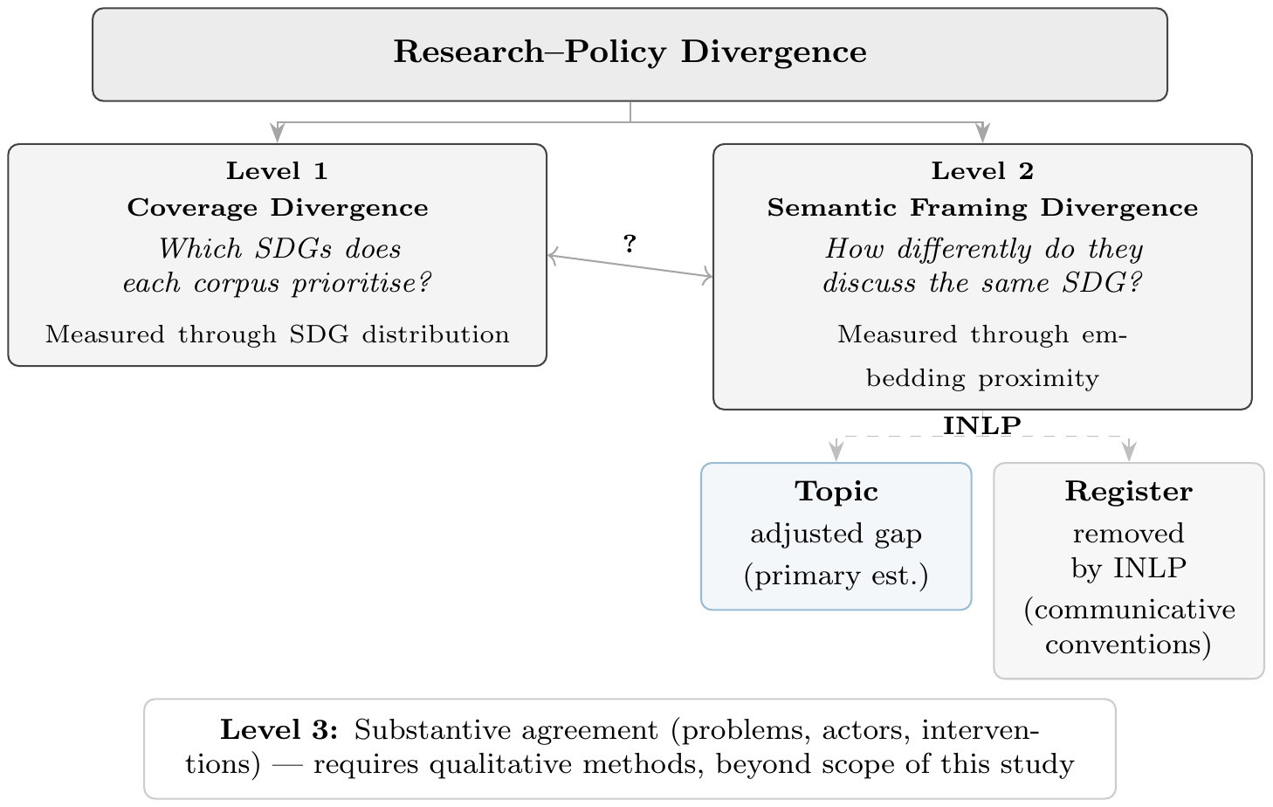
Conceptual framework: research–policy divergence separated into coverage and semantic framing dimensions, positioned within the three-level alignment construct.

Semantic Methods: Rationale and Cautions
The distributional hypothesis, that meaning can be described through patterns of linguistic co-occurrence (Harris 1954), motivates the use of Sentence-BERT (Reimers and Gurevych 2019) and related transformer encoders for large-scale semantic comparison. However, using them to compare research abstracts and policy documents is new and not yet directly benchmarked. The distance is descriptive rather than causal.
Gjorgjevikj et al. (2025) benchmarked sentence encoders specifically for SDG association tasks, finding that general-purpose models from the sentence-transformers family perform among the strongest as baselines, and that domain-specific fine-tuning further improves predictive performance while reducing sensitivity to description length. Rodriguez, Spirling, and Stewart (2023)’s conText framework provides a computational-social-science precedent for comparing meaning across contexts, adopting a narrow, structuralist view of meaning as distributional co-occurrence and making no causal claims about human understanding. This study follows that same descriptive premise: semantic proximity is a distributional measurement rather than evidence of substantive framing alignment. The implication is that embedding distance mixes topic, register, and contextual convention into a single number: distributional representations are not topic-only, since language models inherently encode varieties of language including register (Grieve et al. 2025), and stylistic variation is demonstrably present in distributional vector spaces (Niu and Carpuat 2017). This motivates the decomposition into these components (Section 3.8).
McCarthy et al. (2026) supply a closer empirical precedent, showing with a multi-target SciBERT classifier that research-policy coverage gaps are measurable with transformer encoders outside the AI-SDG setting. This study extends that logic from a single conservation domain to all 17 SDGs, and from coverage to within-SDG semantic framing.
An older corpus-linguistic tradition adds a further caution. Biber’s multidimensional (MD) analysis identifies six co-varying dimensions of linguistic variation across 23 spoken and written genres, derived from factor analysis of 67 linguistic features (Biber 1988). Each dimension captures a continuum of co-occurring linguistic features rather than a binary speech/writing split (Biber 1988; Biber and Conrad 2009). Register is therefore a multi-layered property: two texts can differ on some dimensions and converge on others. INLP removes a linear slice of the embedding space. What it isolates is the largest single direction of writing-style difference; it is not claimed to capture every aspect of register, which is multi-dimensional. For the present study this matters because research abstracts and policy documents may differ not only in substantive topic, but also in abstraction, modality, institutional stance, and rhetorical function. Embedding distance is therefore treated as observed textual-semantic proximity rather than a clean measure of topic alone.

Research Gap and Hypotheses
The literature reviewed above has not produced: (i) a systematic comparison of how academic AI-for-sustainability research and policy discourse differ in SDG coverage and within-SDG semantic framing. Existing work measures research coverage, citation patterns, or policy-document uptake, but does not compare the two corpora directly on these dimensions; or (ii) an examination of how coverage gaps and semantic gaps are related. This framework is diagnostic. It maps where observed divergence is, without classifying whether any given gap reflects productive or problematic disconnection. The latter would require qualitative follow-up beyond the scope of embedding analysis.
The research question is operationalised by four sub-hypotheses, each correlating a distinct coverage predictor with the within-SDG semantic gap across the 17 SDGs:
- H1a (motivating hypothesis): the coverage gap is positively associated with the semantic gap;
- H1b: research–policy dominance $↔$ semantic gap;
- H1c: research coverage $↔$ semantic gap;
- H1d: policy coverage $↔$ semantic gap.
H1b–H1d are signed tests of directional components: with dominance defined as research share minus policy share, the sign of each association locates which community’s framing norms drive the linkage, per the epistemic-communities direction-of-dominance argument. The operationalization of these tests, Pearson $r$ and Spearman $ρ$ between each predictor and semantic-gap scores including the $n=17$ scope conditions, is described in Section 3.9.
These contributions and hypotheses are motivated by the theoretical frameworks reviewed in Section 2.2. The two-communities theory holds that researchers and policymakers occupy separate worlds with different values, reward systems, and languages (Caplan 1979). If these communities also develop different topical priorities, as the empirical record of research-policy divergence suggests (Strauss et al. 2025; McCarthy et al. 2026), then coverage divergence and semantic divergence should co-occur: SDGs where one community dominates attention should also show divergent framing, because the community shaping the discussion brings its own communicative norms. The epistemic-communities framework further distinguishes the direction of dominance: where research prioritises a given SDG, the framing should reflect academic norms of knowledge production; where policy prioritises it, the framing should reflect institutional norms of coordination (Haas 1992). H1a tests for general coverage-semantic relationships. H1b–H1d decompose the coverage-semantic relationship into these directional components.

Methodology
This study uses publicly available text data and requires no ethical approval.

Token-Aware Segmentation
All source documents are segmented at sentence boundaries using the embedding model’s (Section 3.2) own tokenizer to enforce a hard token budget, guaranteeing that every segment fits within the encoder’s context window. The procedure applies identically to research abstracts, policy documents, and reference corpora: NLTK sentence-boundary detection is followed by greedy accumulation of sentences up to a token budget of max_seq_length $−$ 10 (for the canonical MPNet encoder: 384 $−$ 10 = 374 tokens). Segments falling below 20 words are discarded. A single sentence exceeding the token budget is kept whole because mid-sentence splitting is not permissible.
For the research–policy comparison this design has two consequences. First, research abstracts (mean $∼$200 words) mostly fit within the 374-token budget, but 17.18% exceed it and split into multiple segments; the research-side text unit is therefore the abstract, whose segments are aggregated to a single document vector before assignment, not the individual segment. Second, policy documents of variable length are split into multiple segments of comparable size to research abstracts, making the two corpora directly comparable in embedding space. The per-document segment cap of $K=50$ applied in the semantic-gap analysis (Section 3.7) is a separate, additional restraint on document-level dominance within a single SDG cluster. It does not affect the segmentation itself.

Embedding Model and Normalisation
All texts were encoded with all-mpnet-base-v2 (Sentence-Transformers 2021b; Reimers and Gurevych 2019) from the sentence-transformers library, producing 768-dimensional dense vectors. Embeddings were L2-normalised to unit vectors so that cosine similarity equals their dot product.
No fine-tuning is used. The embeddings are frozen (fixed, not retrained). A linear classifier on frozen embeddings, well-known as linear probing, is the standard way to test what a representation already captures (Alain and Bengio 2018; Conneau et al. 2018). Both the SDG classifier (Section 3.5) and the INLP step (Section 3.8) are linear operations on this fixed space. Freezing also keeps the two corpora in one shared space. Retraining on the SDG data (which skews toward policy words) would distort that space.
Encoder choice is a primary robustness axis: gap rankings are re-computed under two alternative encoders, all-MiniLM-L6-v2 (Sentence-Transformers 2021a) (384-dimensional) and SciBERT (Beltagy, Lo, and Cohan 2019) (768-dimensional). Encoder-robustness checks use the same reference (Section 3.5) and policy corpora (Section 3.4), but only 100,000 research abstracts sampled randomly from the full research-abstract corpus (Section 3.3) to save computation. This is motivated by the finding that the semantic gap (Section 3.7) becomes stable compared to the full-corpus value within 100 random re-samples at around the size of 50,000 abstracts (Appendix 11). This sample size is also adequately larger than existing SDG-classification works (Section 2.1).

Research Corpus
The research corpus consists of 2,536,771 research abstracts retrieved from the OpenAlex API (Priem, Piwowar, and Orr 2022), covering publications between 2018 and 2025. The 2018 start reflects the post-AlexNet emergence of deep learning as AI research’s dominant approach (Krizhevsky, Sutskever, and Hinton 2012), combined with an expected research-uptake lag following the SDGs’ 2015 adoption.
Retrieval combined OpenAlex’s native SDG work filter with four high-precision AI search terms (artificial intelligence, machine learning, deep learning, neural network), giving 68 queries (17 SDGs $×$ 4 terms). The term set draws on established practice for delimiting AI corpora (Hellwig, Huggett, and Siebert 2019; OECD 2024), capturing AI-related work without trying to catch every AI term. Because this study measures semantic alignment between research and policy rather than counting publications, the search favours precision over recall: each term must clearly mark AI work, accepting that some papers are missed, to keep non-AI papers out of the embedding space. This contrasts with recall-oriented AI corpora built from hundreds of field-specific keywords across hundreds of thousands of documents (Hellwig, Huggett, and Siebert 2019) or field-of-study membership (OECD 2024; Priem, Piwowar, and Orr 2022; Wang et al. 2020); Schoeberl, Toney, and Dunham (2023) reach the same precision-over-recall conclusion for AI-research identification, finding results sensitive to retrieval method and favouring supervised classification. Those specific ‘learning’ terms likely inflate what gets counted as SDG4 (Education). This is examined in Appendix 8.1.
A direct test re-ran retrieval using field-of-study membership for the same two AI fields/concepts of “AI” and “ML” (OECD 2024) and re-scored the resulting 100,000-paper corpus through its own segmentation (Section 3.1) and classifier (Section 3.5), but reuses the register-adjusted space from the main research corpus (Section 3.8), assuming research-policy register directions are unchanged in the same semantic space, regardless of how the corpus was retrieved. Coverage (Section 3.6) and semantic-gap (Section 3.7) rankings are stable under this alternative strategy. Results are reported mainly in Section 4.4. For diagnostics of detailed differences between the two retrieval strategies, see Appendix 7. This test also found that concept-based retrieval (over keyword-based) helps with the SDG4-inflation issue (Table 6, Appendix 7). A redo of the analysis using this retrieval method is recommended, but left for future follow-ups.
Importantly, the robustness check applies no SDG filter at retrieval time and is therefore a pure AI/ML corpus with SDG labels assigned post hoc by the classifier, not a corpus independently verified as SDG-relevant. This is documented transparently instead of fixed, due to time constraints.
After deduplication and removal of records lacking usable abstracts and the 20-word minimum, the research corpus survives as abstracts, tokenised into segments for embedding (record and segment counts in Table 1). The corpus is predominantly English (99.5%) but no hard language filter is applied. The main results reproduce under subsampling from 50,000 papers (Appendix 11), two orders of magnitude larger than the non-English share. No balancing by SDG or citation count is applied.

Policy Corpus
The policy corpus contains text segments from three collections, representing distinct source documents (segment and document counts per collection in Table 1). It should be read as mixed international institutional SDG policy discourse rather than every AI-sustainability policy that exists:
- Curated AI and SDG policy documents: UN, OECD, EU, UK, and AU AI governance frameworks; IPCC assessment reports; SDSN sustainable development reports; and national AI strategies.
- SDGi Voluntary National Review and Voluntary Local Review corpus (SDGi 2024): National and local self-assessments submitted to the UN High-Level Political Forum.
- UN General Debate Corpus (Jankin, Baturo, and Dasandi 2024): SDG-relevant passages from General Debate speeches, sessions 70–80 (2015–2024); paragraph-level keyword filtering precedes segmentation, so only SDG-relevant passages enter the pipeline, which is why its segment count is far fewer than the full corpus of speeches.
An important asymmetry follows: the research corpus is a tight intersection of AI and SDG content while the policy corpus (Section 3.4) is a broader union covering institutional SDG discourse and AI governance. The curated sub-corpus is the more relevant reference for AI-governance-specific interpretation; Appendix 14.7 reports a source-family sensitivity check.

Supervised Reference Classifier
The canonical instrument is a supervised classifier trained on pooled single-label reference data from five independent annotated corpora. Corpus sizes at each pipeline stage—raw, preprocessed + de-duplicated, segmented, and single-label—are reported in Table 1:
- OSDG Community Dataset (Pukelis et al. 2022) (no SDG17): crowdsourced excerpts validated by multiple volunteers.
- SDG Classification Benchmark (SDG Classification Expert Group 2025) (expert-verified): expert-annotated snippets with consensus resolution.
- IISD SDG Knowledge Hub (Wulff, Meier, and Mata 2023): multi-label journalism and policy commentary on 2030 Agenda implementation.
- SDGi Corpus (SDGi 2024): government Voluntary National and Local Reviews (VNRs/LRs).
- Aurora dataset (Vanderfeesten, Spielberg, and Gunes 2020) (expert-validated): academic abstracts validated by domain researchers.
Corpus provenance: record counts at each pipeline stage (Raw, Prep, Seg, Lab; definitions below).
Corpus | Raw | Prep | Seg | Lab
OSDG Community Dataset | 43,025 | 30,532 | 30,532 | 30,532 (no SDG17)
SDG Classification Benchmark | 1,251 | 281 | 281 | 281
IISD SDG Knowledge Hub | 9,172 | 9,171 | 26,959 | 6,122
SDGi Corpus | 5,880 | 4,225 | 21,346 | 20,267
Aurora dataset | 5,619 | 4,022 | 4,975 | 4,971
Research corpus (OpenAlex) | 2,763,579 | 2,536,771 | 3,105,144 | —
Policy corpus (3 collections) | 6,368 | 6,367 | 40,597 | —
Column definitions. Raw: original source size before any pipeline processing. Prep (Preprocessed + Deduped): cleaned, de-duplicated records that survive the 20-word minimum and proceed to embedding; equivalently, the number of documents (abstracts for research, records for reference and policy) that yield at least one segment. Seg (Segments): post-segmentation segment count. Lab (Single-label): count that feeds the classifier; not applicable (—) for the unlabelled research and policy corpora. OSDG and the Benchmark bypass segmentation, so Seg = Lab.
OSDG alone contributes about 49% of labelled texts and draws on UN-adjacent documents, so the reference data remain weighted toward policy vocabulary. OSDG and the Benchmark bypass segmentation due to having short texts; the Knowledge Hub, SDGi, and Aurora are segmented before pooling.
The pooled reference data were split into training and held-out test sets by stratified document-grouped splitting (pool size and split are reported in Table 1), keeping all texts from the same source document in one fold to enforce strict separation between training and evaluation. The champion LR ($C=3.0$, L2 penalty, class_weight=None, solver lbfgs) was selected by 5-fold GroupKFold cross-validation (Hastie, Tibshirani, and Friedman 2009) on the training pool. The grid-search protocol, hyperparameter rationale, and the MLP robustness comparison are reported in Appendix 12.
The validation task does not evaluate a rejection option for non-SDG texts. This is acceptable because the research corpus is first restricted to an OpenAlex AI-and-SDG universe, so the classifier answers a relative question among the 17 SDGs. This restriction does not hold for the concept-retrieved robustness corpus (Section 3.3), which applies no SDG filter at retrieval; the classifier still forces an argmax assignment there despite the corpus not being pre-restricted to SDG-relevant text. Section 5.5 discusses this limitation.
Each text is assigned to its highest-probability SDG (argmax), traceable to 768 signed coefficients per class with no hidden layers, no dropout, and no random-seed sensitivity. Macro-F1, the unweighted mean of per-SDG scores, is the primary validation metric (See results in Section 4.1).
Because the classifier is trained on pooled reference data that are themselves policy-adjacent, the scoring instrument behaves differently on the two corpora. Policy segments receive systematically higher LR predicted probabilities than research abstracts (mean 0.749 vs 0.627). The gap has two causes the data cannot separate: a genre artefact (the reference data skew toward policy vocabulary) or a substantive difference (policy texts address SDG implementation more directly). Either way, hard argmax assignment depends only on each text’s within-corpus probability ranking across the 17 SDGs, not on absolute probability levels. As a result, the asymmetry threatens the findings only if it shifts SDGs unevenly within a corpus rather than uniformly. This study does not test whether the shift is uniform across SDGs, so the possibility that it reorders within-corpus rankings for some goals cannot be ruled out. This is left for future work due to time constraints.
Two supervised model families were considered: logistic regression, which exposes interpretable per-dimension coefficients, and a multi-layer perceptron (MLP) were compared. Random forests and gradient boosting were excluded because the embedding space is already a learned representation, so bagged trees add ensemble complexity without a mechanism for improvement or per-dimension interpretability.
The LR grid searched $C∈\{0.1,1,2,3,5,10,30,100\}$ with an L2 penalty and class_weight $∈$ {None, balanced}. The MLP grid swept $n_{\text{layers}}∈\{2,3,4,6\}×\text{hidden_size}∈\{256,384\}×\text{lr}∈\{3e−4,1e−3\}$ with weight_decay=0, dropout=0.3, AdamW, and early stopping.
For robustness, a zero-shot nearest centroid assignment method (hereafter ZS) was also considered. This method builds the reference SDG centroids by aggregating the labelled reference texts, and unlabelled texts are assigned to the nearest SDG centroid in the embedding space.
Finally, the model of choice is LR because MLP shows negligible performance improvement compared to the lost interpretability. Grid search and test results are reported in Section 4.1.

Coverage Gap Analysis
For each corpus item, the predicted SDG is the LR argmax (hard assignment, Section 3.5); the coverage profile is the proportion of analysis units assigned to each SDG (an abstract for research, a source document for policy).
The policy corpus is not a flat set of documents: its 40,597 segments are grouped into 6,367 source documents of very different lengths (Section 3.4). A segment-weighted profile would let a handful of long reports dominate the count, so the analysis instead computes a document-weighted profile in which every source document counts equally regardless of length, following the standard centroid formulation in which each document contributes one length-normalised unit vector (Manning, Raghavan, and Schütze 2008). Concretely: segment vectors are averaged per document, hard-assigned to the top SDG, and the coverage profile counts documents (not segments) per SDG. The research corpus uses the same logic at the paper level: each of the 2,536,771 abstracts is represented by the mean of its segments, hard-assigned as a single document unit, so the research-side text unit is the abstract and the two corpora are weighted identically.
The coverage gap for SDG $j$ is defined as:
$${\text{CoverageGap}}_{j}=\left|{\text{ResearchCoverage}}_{j}−{\text{PolicyCoverage}}_{j}\right|$$
The signed version of the same quantity is:
$${\text{SignedCoverageGap}}_{j}={\text{ResearchCoverage}}_{j}−{\text{PolicyCoverage}}_{j}$$
A positive value means research dominates SDG $j$. A negative value means policy dominates.

Semantic Gap Analysis
The semantic gap measures within-SDG divergence: given that both corpora have texts assigned to SDG $j$, how differently do they discuss it?
For each SDG $j$ the analysis collects all assigned research papers and all assigned policy segments (capped at 50 per source document to bound single-document influence. For example, SDSN reports alone contribute up to 3,179 segments otherwise). The two corpora are aggregated at different text units here by design, unlike the coverage profile (Section 3.6), which weights both corpora at the document level. Research abstracts are single-topic by genre convention, so each of the 2,536,771 abstracts contributes exactly one unit vector, the L2-renormalised mean of its segment embeddings, and a 33-segment abstract and a single-segment abstract carry equal weight: the research centroid $c_{j}^{\text{res}}$ is the L2-normalised mean of these paper-level unit vectors assigned to SDG $j$. Policy sources, by contrast, are long, deliberately excerpted institutional texts (UNGDC speeches, SDGi VNRs) whose passages are topically distinct and may span several SDGs. Weighting each source document equally would collapse that within-document variation into a single point. The policy centroid $c_{j}^{\text{pol}}$ is therefore the L2-normalised mean of the (capped) segment embeddings assigned to SDG $j$, sampling the topical content of each passage rather than treating each report as one undifferentiated unit. Underlying both choices is the same rule: the coverage profile counts documents, so both corpora are aggregated to the document level; the semantic gap averages text content, so each corpus is aggregated at its natural authorship unit: the abstract for research and the passage for policy.
The semantic gap for each SDG is then defined as:
$${\text{SemanticGap}}_{j}=1−\left(c_{j}^{\text{res}}⋅c_{j}^{\text{pol}}\right)$$
A gap of 0 indicates perfectly overlapping semantic directions; a gap approaching 1 indicates orthogonal framing. Cosine similarity between centroids is the standard method for document-level semantic comparison in embedding space (Brück and Pouly 2019; Babićc et al. 2020). Centroid cosine distance collapses each embedding cloud to its mean direction.
Appendix 10 shows the adjusted-gap ranking correlates moderately with most full-distribution alternatives ($ρ=0.44$–$0.69$), while Gaussian-2-Wasserstein, squared MMD, Sinkhorn, C2ST, and Grassmann show weak or negative agreement ($ρ≤0.26$), confirming the centroid estimate captures a dominant signal while distribution shape also carries signal. An alternative reading is that weak agreement from five independent distribution-aware measures reflects a real limitation of the mean-direction centroid rather than a merely complementary signal; the present study cannot distinguish between these readings and reports both distribution-aware and centroid results (Appendix 10) so readers can judge for themselves. However, further analysis with those distance measures is left for future work.
The per-document segment cap of $K=50$ (seeded, reproducible) bounds a single document’s contribution to at most 50 segments, mitigating the influence of very long reports on the policy centroid; sensitivity at $K=20$ and no cap is reported in Table [tab:cross-sensitivity-robustness], Appendix 14.

Register Adjustment via Iterative Nullspace Projection (INLP)
The semantic gap is not a clean measure of substantive disagreement. Research and policy texts differ in both topic (what they discuss) and register (how they are written – audience, purpose, style). Embedding distance mixes the two. INLP (Ravfogel et al. 2020) is used in this paper to roughly split the gap into an adjusted semantic gap (topic) and a register component (See results in Section 4.3).

Objective.
INLP learns directions that, when subtracted from the embeddings, erase the research–policy difference. After $K$ iterations nothing about corpus identity remains linearly predictable. Projecting out the directions that carry the most corpus signal is the gentlest way to do this.

SDG-stratified procedure.
Vanilla INLP removes a binary attribute (e.g. gender). The present adaptation must remove register, a corpus-level property tangled with SDG topic in the raw embeddings. The key modification is SDG stratification: at each iteration, equal numbers of research and policy embeddings are drawn from each of the 17 SDGs, so the classifier cannot use topic as a stand-in for register. The procedure proceeds as follows at each iteration $k=1,…,K$:
- Stratified sample. Draw $n_{\text{target}}$ texts per SDG per corpus (global-minimum rule: $n_{\text{target}}=\min_{j}min\left(\left|X_{j}^{\text{res}}\right|,\left|X_{j}^{\text{pol}}\right|\right)$; under the frozen snapshot, $n_{\text{target}}=1123​$ for MPNet). Form the 34-class stratification key $z_{\text{strat}}=2×\text{sdg_labels}+y$, ensuring balanced corpus $×$ topic combinations.
- Project existing directions. Subtract from each sample embedding the components along all previously learned directions: x=x−j<k​gj⋅x gj.
- Train classifier. Fit L2-regularised logistic regression to predict corpus identity $y$ from the projected embeddings $\tilde{x}$. The hyperparameters are fixed defaults, not validated, because the objective is to recover a decodable direction, not to maximise classification accuracy. This means the quality of any single iteration’s direction is not individually verified; only the aggregate stopping criterion (held-out accuracy $≤0.5$ across all $K$ iterations) guards against a degenerate or noisy direction being retained. A per-iteration validation pass is not performed and is left for future refinement. Split 15% held-out, stratified by $z_{\text{strat}}$.
- Extract direction. Normalise the weight vector: $g_{k}=w_{k}/∥w_{k}∥$. Orthogonalise against all prior directions: gk←gk−j<k​gk⋅gj gj. If $∥g_{k}∥<{10}^{−8}$ (direction collapse), stop.
- Stopping criterion. Stop if held-out accuracy $≤0.5$ (the majority-class baseline for balanced binary classification). Otherwise append $g_{k}$ and continue.
All three encoder tracks converge within 40–79 iterations (Appendix 13.1). The final adjusted embedding is $x′=x−\sum_{k=1}^{K}{\left(g_{k}⋅x\right)} g_{k}$, and the adjusted gap uses centroids computed on these projected embeddings.
Identification argument. The stratification design is the critical structural precondition: because every iteration trains on equal numbers of research and policy embeddings from each SDG, no linear direction can simultaneously encode SDG topic and corpus identity. What remains linearly decodable is the corpus-level register difference: modality, audience conventions, institutional stance, and structural patterns. The removed subspace is interpreted as register in the sense of Biber and Conrad (2009): a variety associated with a particular situation of use, including communicative purpose, audience, and production circumstances. Stratification controls for SDG topic, but not for other differences such as publication period or author background. The removed component is therefore best read as register-like, not as pure register. This interpretation is evaluated against independent linguistic markers in Appendix 13.2. The validation finds 1) substantial reduction of the corpus-level signal but not its complete elimination and 2) SDG classifier accuracy remains unchanged, meaning topic (and hence coverage) is not significantly affected by INLP register adjustment.
With the projector learned, the semantic-gap analysis of Section 3.7 is recomputed twice: once on the adjusted embeddings and once on the removed component ($x−x′$), yielding respectively the within-SDG adjusted gap and the register component.

Coverage–Semantic Interaction
The test works as follows. Pearson $r$ and Spearman rank correlation $ρ$ are computed between each coverage predictor (coverage gap, research–policy dominance, research coverage, policy coverage) and the within-SDG semantic-gap scores across the 17 SDGs; SDG 4 is treated as artefact-affected (Section 3.3) and examined separately (Appendix 8.1).
There might be criticism that $n=17$ is poor statistical power. However, the 17 SDGs are the whole framework, not a sample. Finer-grained units (the framework defines 169 targets) would raise the observation count, but no labelled target-level reference data exist. That is left for future work when data is available.
The only randomness comes from measurement (classifier, corpus build, embeddings). All $p$-values are two-sided Monte Carlo permutation tests (100,000 resamples, fixed seed); they test the null of no association given the measured values, so no sample-size power argument is needed (Berk, Western, and Weiss 1995; Abadie et al. 2020).
With only 17 units, a single goal can sway the result, so the associations are checked with a leave-one-out analysis (Section 4.4) and across configurations (Section 4.5).
Raw, adjusted, and register-component correlations come from one decomposition (register = raw $−$ adjusted). They move together, so the claim is about their combined pattern, not three separate tests. This reasoning covers the raw/adjusted/register triad specifically; it does not extend to the four H1a–H1d hypotheses or the $∼$24 robustness configurations reported elsewhere, which are interpreted collectively for consistency of sign and magnitude rather than treated as a formally corrected multiple-testing family. All three are reported for every configuration. Because the decomposition is fixed in advance and the three numbers inform each other, no multiple-comparison correction is applied.
A supplementary pooled-regression analysis combines all 24 configurations into a single panel (Appendix 15).
Figure 2 summarises the end-to-end methodology.
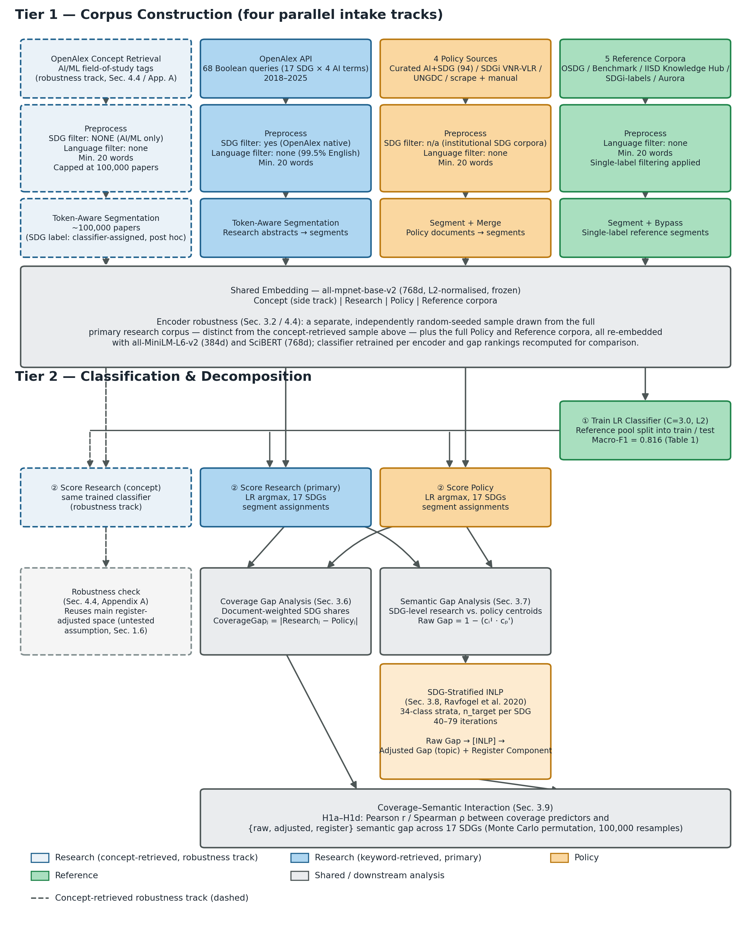
End-to-end methodology pipeline: four parallel corpus-construction tracks (keyword-retrieved research, concept-retrieved research robustness track, policy, and reference) feeding a shared embedding, classification, and register–topic decomposition stage.

Results
This section reports validation, coverage gaps, semantic gaps, H1 tests, and robustness without interpretation.

Supervised Reference Classifier Grid Search and Performance
Grid search over architecture depth, hidden size, and learning rate showed negligible performance variance across the MLP configurations (CV macro-F1 = 0.815–0.819), and LR is flat within $∼$0.001 for C $∈\{1,3,5\}$, suggesting that LR/MLP choice is not a major binding constraint for the classifier’s power (Table 2).
Model selection ranking: 5-fold GroupKFold cross-validated macro-F1.
Rank | Config | CV macro-F1
1 | MLP 3L/256h, lr=0.0003 (best) | 0.8192 $±$ 0.0032
2 | MLP 2L/256h, lr=0.0003 | 0.8184 $±$ 0.0030
3 | MLP 6L/384h, lr=0.0003 | 0.8183 $±$ 0.0023
4–16 | MLP (remaining 13 configurations) | 0.8151–0.8183
17 | LR C=3.0, cw=None (chosen) | 0.8101 $±$ 0.0020
18 | LR C=2.0, cw=None | 0.8098 $±$ 0.0018
19 | LR C=5.0, cw=None | 0.8097 $±$ 0.0017
20–32 | LR (remaining 13 configurations) | 0.7904–0.8087
Notes: Top three configurations per family are shown individually; the remaining configurations are collapsed to their CV macro-F1 range. LR (C=3.0, L2, class_weight=None) is the chosen champion (rank 17).
LR (C=3.0, L2, class_weight=None) was chosen over the highest-scoring MLP despite a 0.0091 macro-F1 gap: LR requires one free parameter (C) and no hidden layers, dropout, learning-rate tuning, or early stopping, and it provides 768 signed coefficients per SDG class, each directly attributable to a specific semantic dimension, whereas MLP’s hidden layers diffuse this information across non-linear transformations. For this study’s purpose – building an interpretable supervised reference to compare corpora, not a classifier built to label single documents – LR is chosen for transparency, not superior accuracy.
The chosen classifier was evaluated on the held-out test set (n=9,338, document-grouped to prevent source leakage). It reaches macro-F1 = 0.816 and micro-F1 = 0.8306, far above the 1/17 random baseline (0.059). Per-class F1 values from the test set are reported in Table 3.
LR, MLP, and zero-shot (nearest-centroid) test-set F1 scores (n=9,338).
SDG | n (test) | LR test F1 | MLP test F1 | ZS test F1
1 (No Poverty) | 473 | 0.737 | 0.758 | 0.671
2 (Zero Hunger) | 416 | 0.830 | 0.829 | 0.792
3 (Good Health) | 848 | 0.903 | 0.909 | 0.871
4 (Education) | 734 | 0.889 | 0.899 | 0.878
5 (Gender Equality) | 816 | 0.881 | 0.882 | 0.833
6 (Clean Water) | 552 | 0.879 | 0.877 | 0.849
7 (Clean Energy) | 602 | 0.861 | 0.862 | 0.845
8 (Decent Work) | 398 | 0.716 | 0.718 | 0.631
9 (Innovation) | 526 | 0.770 | 0.787 | 0.694
10 (Reduced Ineq.) | 423 | 0.610 | 0.644 | 0.485
11 (Sust. Cities) | 451 | 0.762 | 0.786 | 0.690
12 (Consumption) | 330 | 0.783 | 0.775 | 0.720
13 (Climate) | 564 | 0.831 | 0.845 | 0.778
14 (Life Below Water) | 327 | 0.892 | 0.895 | 0.864
15 (Life on Land) | 545 | 0.865 | 0.864 | 0.836
16 (Peace & Justice) | 798 | 0.879 | 0.896 | 0.806
17 (Partnerships) | 535 | 0.788 | 0.814 | 0.671
Macro-F1 (SDGs 1–17) | – | 0.816 | 0.826 | 0.760
Micro-F1 (SDGs 1–17) | – | 0.831 | 0.840 | 0.774
Notes: All three methods are evaluated on the same held-out pooled test set (all reference sources, document-grouped). The n (test) column reports the per-SDG gold-label count in the test split (single-label, summing to n=9,338), identical for every classifier. LR (C=3.0, L2) is the chosen classifier; MLP (3-layer/256-hidden) and zero-shot (raw nearest-centroid on SDG centroids) F1s are shown for comparison, with commentary deferred to Appendix 12.
Per-class F1 ranges from 0.610 (SDG 10) to 0.903 (SDG 3); most goals score between 0.76 and 0.89. The weakest classes (SDGs 10 and 8) are consistent with their semantic breadth suggested by Kashnitsky et al. (2024) (Appendix 8.2, Figure 7).
Despite OSDG (49% of training data) having zero SDG17 examples (Section 3.5), performance doesn’t degrade (Table above, Appendix 8.2), which suggests the other four sources (SDGi, Aurora, Benchmark, IISD Hub) carry enough SDG17 signal to compensate.
MLP and nearest-centroid F1s are also reported here but comments are deferred to Appendix 12. One thing that can be concluded is that nearest-centroid assignment is too simple for the linearity of separation between SDGs in the 768d embedding space, while MLP is too unnecessarily complex without significant added benefit.

Coverage and Coverage Gap
Figure 3 presents the document-weighted policy coverage profile alongside the research coverage profile.
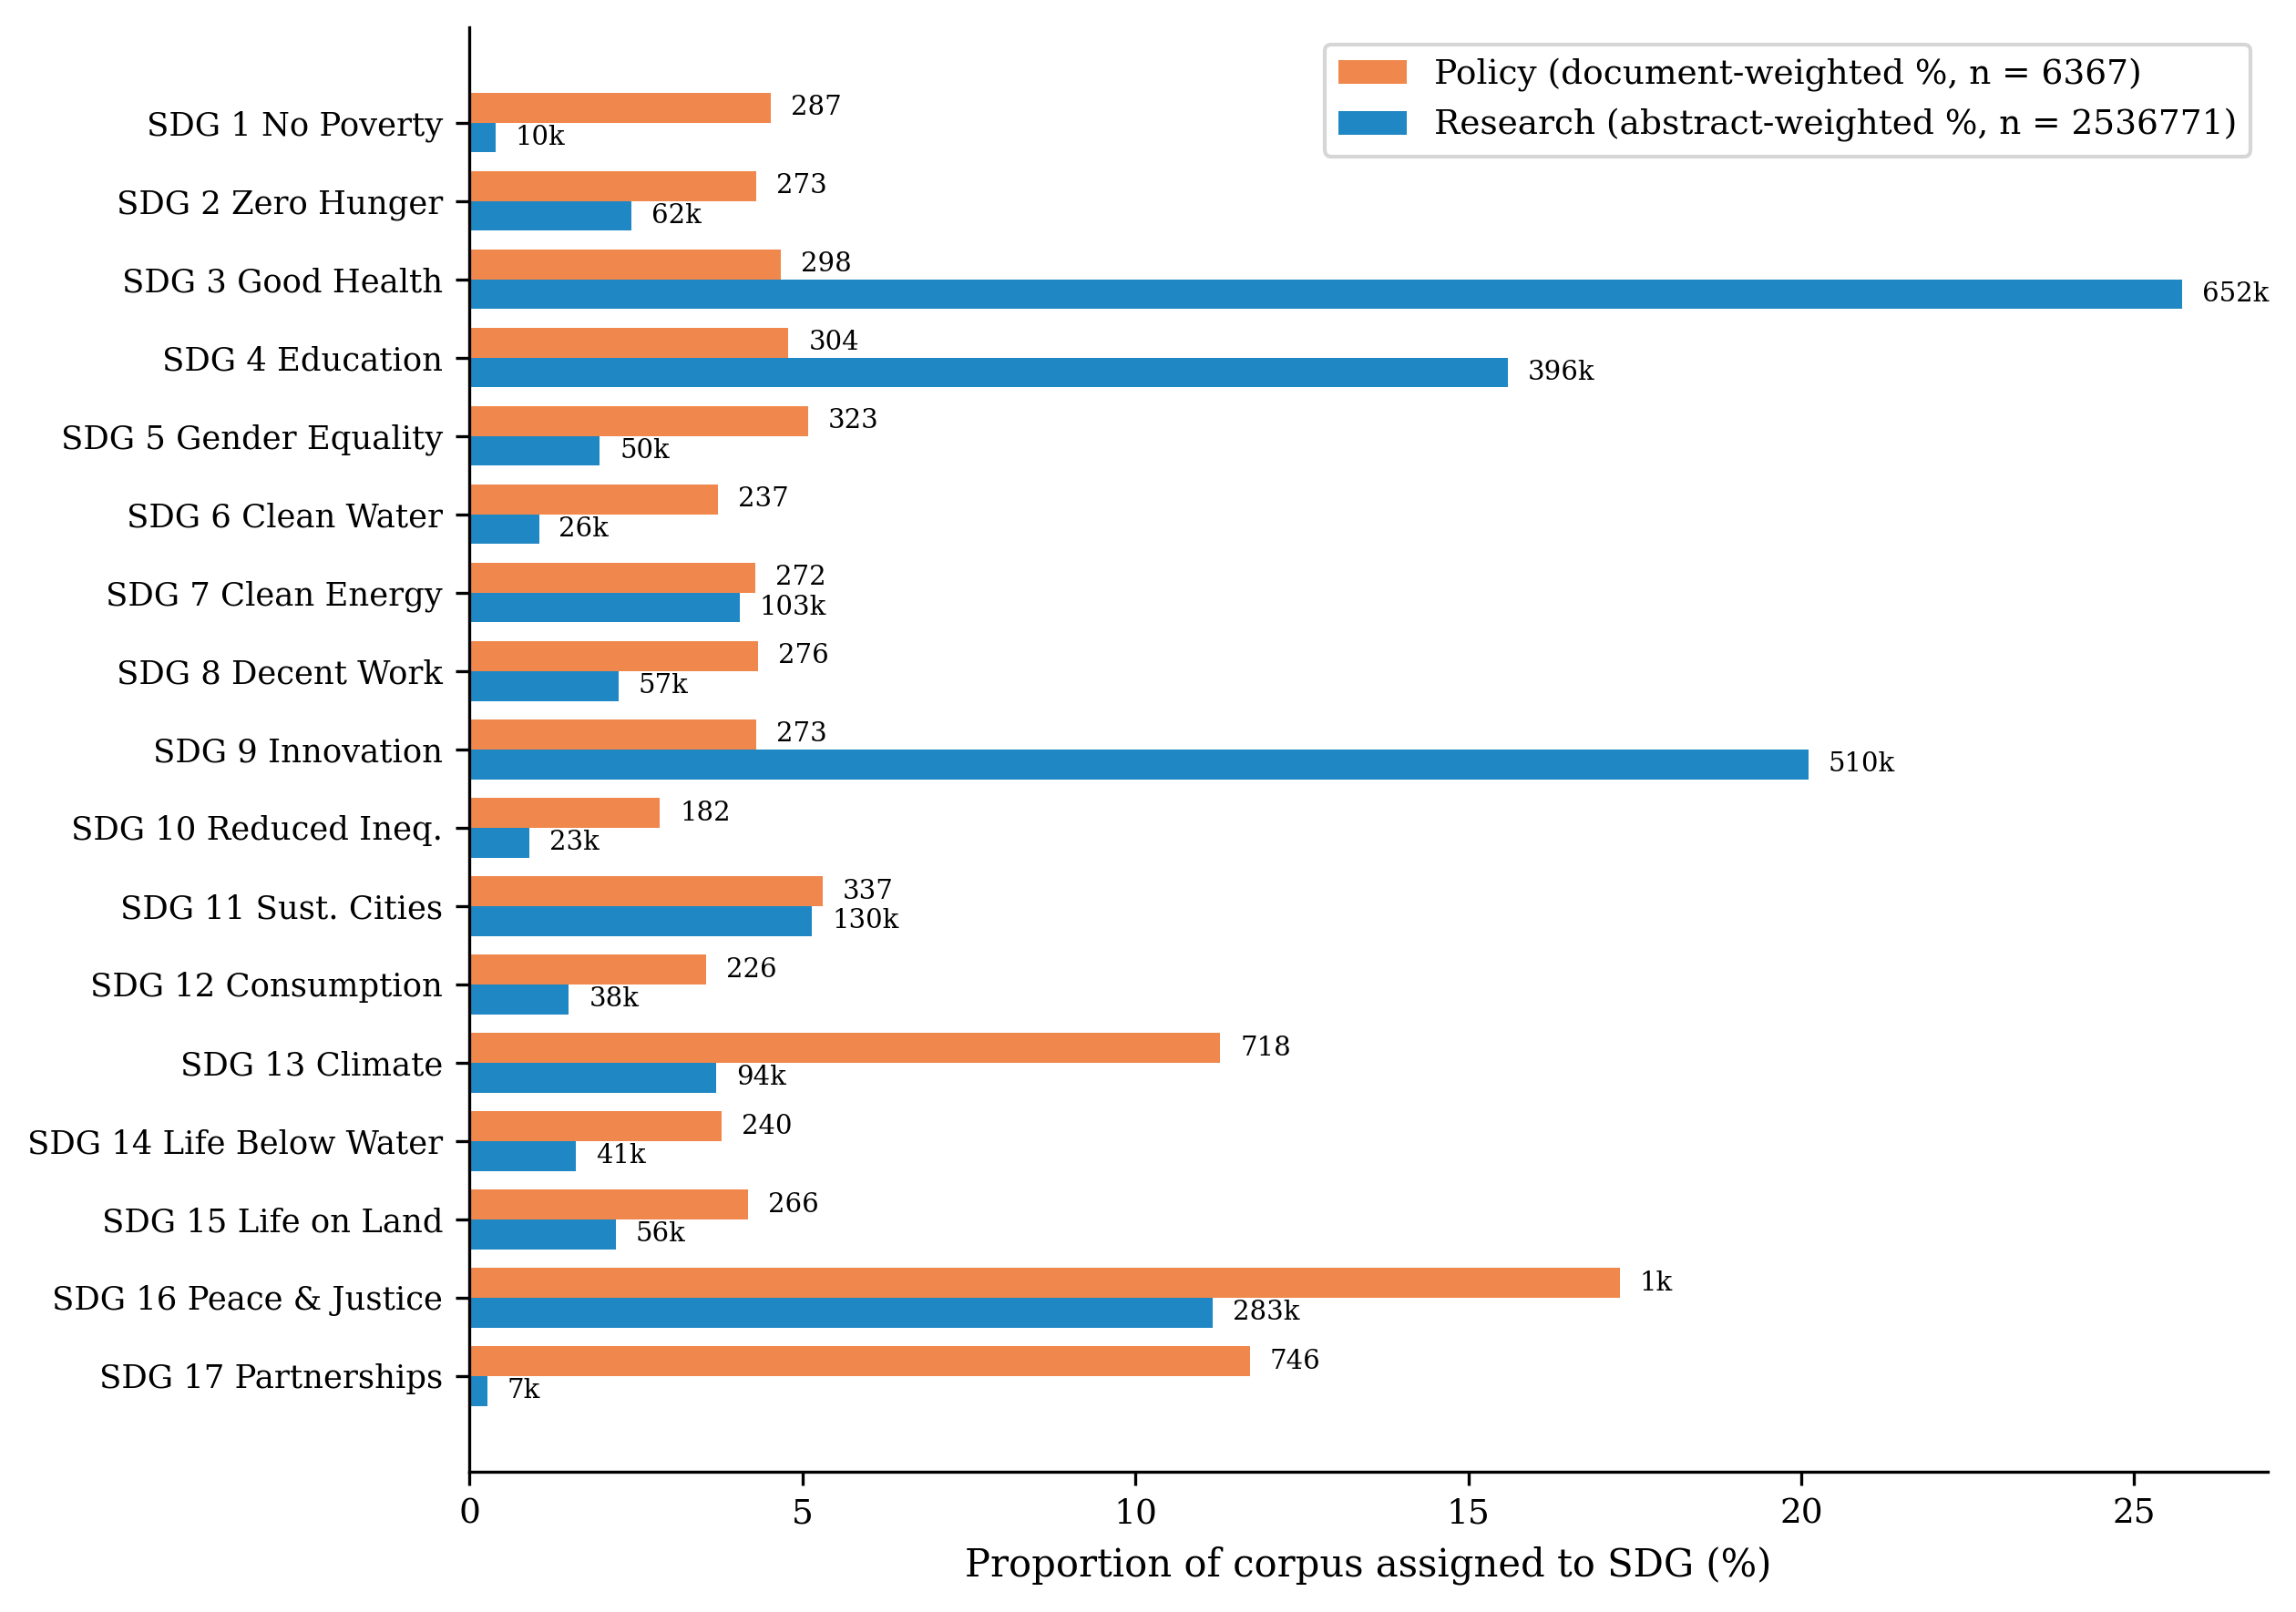
Coverage profiles by SDG. SDG 4 is flagged as artefact-affected due to ML-learning vocabulary overlap with education corpora (Appendix 8.1).
Policy corpus. Three SDGs dominate the document-weighted profile of the full policy corpus: SDG 16 (Peace, Justice and Strong Institutions, 17.3%), SDG 17 (Partnerships for the Goals, 11.7%), and SDG 13 (Climate Action, 11.3%), accounting for 40.3% of policy documents. This ordering is consistent with the literature review’s account of SDG 17 as the cross-cutting means-of-implementation goal (Section 2) (Le Blanc 2015; Griggs et al. 2017). The author thinks the top ranking SDGs make intuitive sense. However, Appendix 14.7 shows this full-corpus profile is source-family sensitive: the curated AI/SDG sub-corpus is much more innovation-heavy, the UNGDC family is more climate-, partnerships-, and governance-oriented, and the SDGi family is comparatively flat, with SDG 11-style institutional review language at its top.
Research corpus. The largest research shares are SDG 3 (Good Health, 25.7%), SDG 9 (Innovation, 20.1%), and SDG 4 (Quality Education, 15.6%), followed by SDG 16 and SDG 11 at 11.2% and 5.1% respectively. SDG 7 (Affordable and Clean Energy), co-dominant in several prior inventories, ranks sixth here (4.1%) rather than in the leading tier. The SDG 3 lead corroborates the literature review, where it is the one goal every major AI and sustainability bibliometric study finds dominant (Section 2.1). The leading coverage of SDGs 4, 11, and 16 also align largely with previous literature (Section 2.1). However, SDG 4 is likely inflated by the corpus retrieval strategy (Section 3.1) and SDG 9’s lead is likely inflated by this study focusing on AI-related papers. Also, the research-side near-absence of SDG 17 (0.3%) and SDG 1 (0.4%) matches Gohr et al. (2025)’s finding that SDG 1, SDG 5, and SDG 17 are severely underrepresented in the AI–SDG literature.
Largest coverage mismatches. The five largest absolute coverage gaps are SDG 3 (21.0), SDG 9 (15.8), SDG 17 (11.4), SDG 4 (10.8), and SDG 13 (7.6). The largest single-goal imbalance is SDG 3 (research 25.7% vs. policy 4.7%): research concentrates on technically tractable health applications while policy underweights the goal. The most extreme policy-over-research imbalances are SDG 17 (policy 11.7% vs. research 0.3%) and SDG 13 (11.3% vs. 3.7%): policy frames partnerships and climate as cross-cutting coordination challenges, while research, specifically AI research, engages them far less. SDG 16 is policy’s top theme (17.3%) but research does engage it (11.2%, fourth-highest research share), so it is not a “barely-touches” case.

Register Adjustment and Semantic Gap
Register adjustment converges after 62 iterations for the MPNet embedding space. Detailed data on the iterations until convergence, also for MiniLM and SciBERT spaces, is reported in Appendix 13.1. Figure 4 shows the combined embedding space and the geometric effect of INLP register adjustment: the raw space (left) separates research and policy clouds, while the adjusted space (right) shows no major separation between them. It might not be clear from the rough visualisation in the PCA maps, but while the adjusted space removes mostly research-policy differences, it retains the separability between SDGs fully (Appendix 13.2).
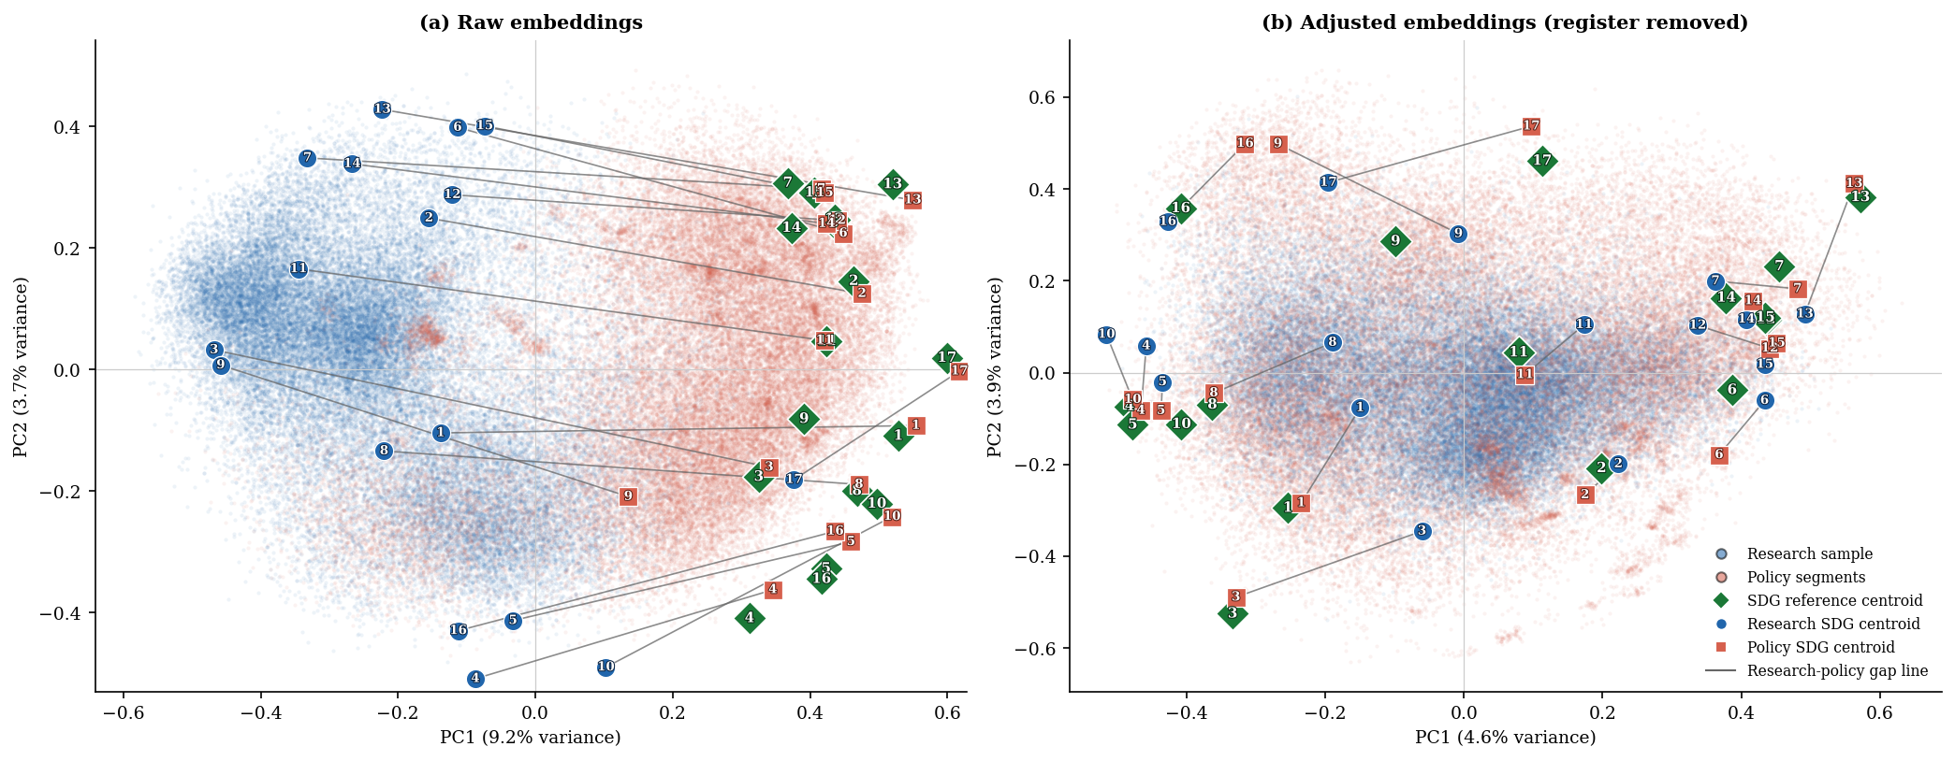
PCA before/after INLP register removal (MPNet).
Figure 5 shows the within-SDG semantic gap for all 17 SDGs, sorted by the adjusted (topic) gap after register removal. The adjusted gap ranges from 0.326 (SDG 17, widest) to 0.084 (SDG 15, narrowest), a span of 0.241 cosine units. The raw gap (naive baseline) ranges from 0.494 (SDG 3, widest) to 0.177 (SDG 17, narrowest), a span of 0.317. The adjusted ranking is stable when the segment cap is 20 per document or removed (Table [tab:cross-sensitivity-robustness]), so the result does not depend on the sampling parameter. A second sampling concern is corpus asymmetry: research (2,536,771 abstracts) outweighs policy (6,367 documents) by roughly 398:1 in document units. This study therefore re-derived the ranking on random research draws comparable in size to the policy corpus: across 100 independent 50,000-paper draws it reproduces the full-corpus ordering at Spearman $ρ=0.986​$ (SD 0.009), so the research-side over-representation does not drive which SDGs show large versus small gaps (Appendix 11).
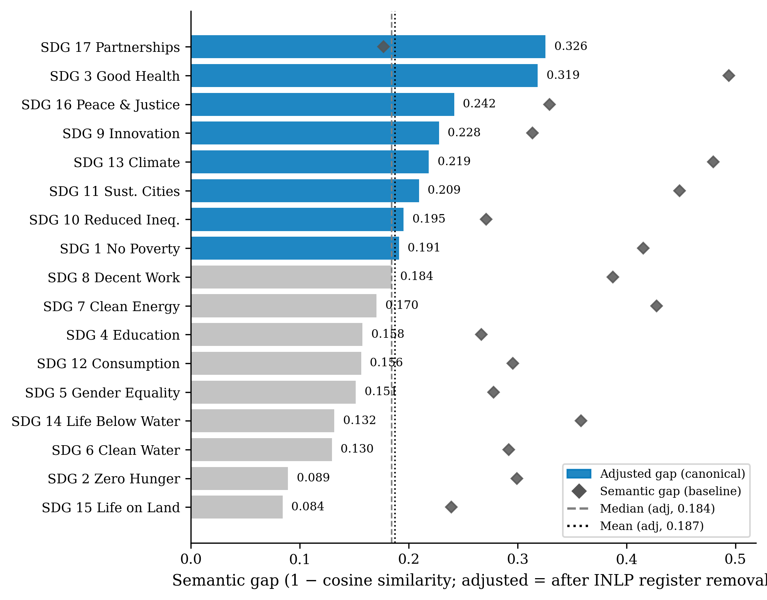
Within-SDG semantic gap by SDG, sorted by the adjusted (topic) gap after register removal.
Largest semantic gaps (adjusted). SDGs 17, 3, 16, 9, and 13 show the widest adjusted gaps. Under the raw gap, the ordering shifts: SDG 3 (0.494) leads. The register decomposition confirms that register uniformly inflates the raw gap, except for SDG 17 where register increases apparent similarity.
Smallest semantic gaps (adjusted). SDG 15 (Life on Land, 0.084), SDG 2 (Zero Hunger, 0.089), SDG 6 (Clean Water, 0.130), SDG 14 (Life Below Water, 0.132), and SDG 5 (Gender Equality, 0.151) show the narrowest adjusted gaps. A narrow gap does not mean balanced attention: SDG 9 is still research-dominant, and SDG 4 carries the learning-vocabulary concern (Appendix 8.1). Appendix 9 lists the most distinctive research- and policy-side terms for high- and low-gap cases.
Table 4 consolidates the per-SDG inputs that the interaction tests below draw on. It reports two families of values: the semantic-gap family (raw, adjusted, and register component; Figs 5 and 6) and the coverage-predictor family (absolute coverage gap, signed dominance, research share, and policy share; Fig. 3). Signed dominance is research share minus policy share (percentage points); absolute coverage gap is $\left|\text{research}−\text{policy}\right|$ (percentage points); the register component is raw minus adjusted gap. Reading this table first lets the rank correlations in Section 4.4 be traced back to concrete per-SDG numbers.
Reference values for the semantic-gap and coverage-predictor families (per SDG). Semantic gaps from Figs 5 and 6; coverage predictors from Fig. 3. Cov. = $\left|\text{research}−\text{policy}\right|$ (pp). Signed dom. = research share $−$ policy share (pp). Reg. Comp. = raw $−$ adjusted.
SDG | Description | Semantic gaps |  |  | Coverage predictors
3-5 (lr)6-9 |  | Raw | Adj. | Reg. | Cov. | SDom | Res % | Pol %
1 | No Poverty | 0.415 | 0.191 | +0.224 | 4.1 | -4.1 | 0.4 | 4.5
2 | Zero Hunger | 0.299 | 0.089 | +0.210 | 1.9 | -1.9 | 2.4 | 4.3
3 | Good Health | 0.494 | 0.319 | +0.176 | 21.0 | +21.0 | 25.7 | 4.7
4 | Education | 0.267 | 0.158 | +0.109 | 10.8 | +10.8 | 15.6 | 4.8
5 | Gender Equality | 0.278 | 0.151 | +0.126 | 3.1 | -3.1 | 2.0 | 5.1
6 | Clean Water | 0.292 | 0.130 | +0.162 | 2.7 | -2.7 | 1.0 | 3.7
7 | Clean Energy | 0.428 | 0.170 | +0.257 | 0.2 | -0.2 | 4.1 | 4.3
8 | Decent Work | 0.387 | 0.184 | +0.203 | 2.1 | -2.1 | 2.2 | 4.3
9 | Innovation | 0.314 | 0.228 | +0.086 | 15.8 | +15.8 | 20.1 | 4.3
10 | Reduced Ineq. | 0.271 | 0.195 | +0.076 | 2.0 | -2.0 | 0.9 | 2.9
11 | Sust. Cities | 0.449 | 0.209 | +0.239 | 0.2 | -0.2 | 5.1 | 5.3
12 | Consumption | 0.296 | 0.156 | +0.139 | 2.1 | -2.1 | 1.5 | 3.5
13 | Climate | 0.480 | 0.219 | +0.261 | 7.6 | -7.6 | 3.7 | 11.3
14 | Life Below Water | 0.358 | 0.132 | +0.227 | 2.2 | -2.2 | 1.6 | 3.8
15 | Life on Land | 0.239 | 0.084 | +0.155 | 2.0 | -2.0 | 2.2 | 4.2
16 | Peace & Justice | 0.329 | 0.242 | +0.087 | 6.1 | -6.1 | 11.2 | 17.3
17 | Partnerships | 0.177 | 0.326 | -0.149 | 11.4 | -11.4 | 0.3 | 11.7
Mean | — | 0.340 | 0.187 | +0.152 | 5.6 | +0.0 | 5.9 | 5.9
Notes: Raw gap is the reference semantic-gap estimate; Adj. gap is after INLP register removal (primary estimate; evaluated in Appendix 13.2); Reg. Comp. = raw $−$ adjusted. Coverage predictors are document-weighted research/policy shares; Signed dom. = research % $−$ policy % (pp). These are the per-SDG inputs to the Section 4.4 tests.

Coverage–Semantic Interaction: Results
Table 5 reports H1a–H1d rank correlations between coverage predictors and the within-SDG semantic gap across all encoder–classifier configs. Columns show Spearman $ρ$ against the raw gap, adjusted gap, and register component. The per-SDG values underlying these correlations are consolidated in Table 4.
Predictors are research coverage, policy coverage, absolute coverage gap, and signed dominance. MLP configs reuse their encoder’s INLP matrix; Concept rows use the concept-retrieved research corpus (Appendix 7).
H1a–H1d coverage-predictor vs semantic-gap rank correlations (Spearman $ρ$) across encoder–classifier configs.
 | Semantic Gap | Adj. gap | Reg. Comp.
H1a. Coverage gap $↔$ Semantic gap
MPNet LR | -0.012 | +0.544$​^{*}$ | -0.390
MPNet MLP | -0.135 | +0.336 | -0.370
MPNet ZS | -0.299 | +0.203 | -0.449$​^{†}$
MiniLM LR | -0.243 | +0.397 | -0.463$​^{†}$
MiniLM MLP | -0.042 | +0.505$​^{*}$ | -0.272
SciBERT LR | -0.130 | +0.221 | -0.267
SciBERT MLP | -0.333 | -0.034 | -0.120
Concept LR | +0.108 | +0.434$​^{†}$ | -0.194
Concept MLP | -0.017 | +0.181 | -0.140
H1b. Research–policy dominance $↔$ Semantic gap
MPNet LR | +0.159 | -0.059 | +0.029
MPNet MLP | +0.020 | -0.118 | -0.034
MPNet ZS | -0.005 | -0.336 | +0.360
MiniLM LR | +0.404 | -0.020 | +0.429$​^{†}$
MiniLM MLP | +0.319 | -0.066 | +0.348
SciBERT LR | +0.549$​^{*}$ | -0.118 | +0.547$​^{*}$
SciBERT MLP | +0.336 | -0.429$​^{†}$ | +0.529$​^{*}$
Concept LR | +0.051 | -0.029 | -0.260
Concept MLP | -0.174 | +0.093 | -0.199
H1c. Research coverage $↔$ Semantic gap
MPNet LR | +0.449$​^{†}$ | +0.267 | +0.145
MPNet MLP | +0.262 | +0.098 | +0.088
MPNet ZS | -0.100 | -0.328 | +0.314
MiniLM LR | +0.444$​^{†}$ | +0.262 | +0.331
MiniLM MLP | +0.373 | +0.275 | +0.279
SciBERT LR | +0.605$​^{*}$ | +0.466$​^{†}$ | +0.020
SciBERT MLP | -0.005 | -0.196 | +0.225
Concept LR | +0.221 | +0.017 | -0.076
Concept MLP | -0.098 | -0.010 | -0.127
H1d. Policy coverage $↔$ Semantic gap
MPNet LR | +0.212 | +0.589$​^{*}$ | -0.009
MPNet MLP | +0.175 | +0.428$​^{†}$ | -0.007
MPNet ZS | -0.094 | +0.240 | -0.321
MiniLM LR | -0.015 | +0.449$​^{†}$ | -0.159
MiniLM MLP | +0.083 | +0.456$​^{†}$ | -0.093
SciBERT LR | -0.100 | +0.605$​^{*}$ | -0.686$​^{**}$
SciBERT MLP | -0.172 | +0.395 | -0.395
Concept LR | +0.369 | +0.510$​^{*}$ | +0.178
Concept MLP | +0.256 | +0.258 | +0.082
Notes: Raw gap = naive semantic-gap estimate; Adj. gap = after INLP register removal (primary estimate; evaluated in Appendix 13.2); Register = raw $−$ adjusted. Each correlation is between two rank vectors (ranks 1–17 across the 17 SDGs); Spearman $ρ$ is the Pearson correlation of these ranks, testing monotonic association. $​^{***}p<.001$, $​^{**}p<.01$, $​^{*}p<.05$, $​^{†}p<.10$.
H1a is null on the raw gap ($ρ=−0.012$, $p=0.959$; Table 5, MPNet LR). The raw gap masks a register–topic decomposition: the register component ($ρ=−0.390$) cancels the topic signal ($ρ=0.544$). After register removal, the adjusted gap is positively associated with the coverage gap (positive in 8/9 configs). The directional decomposition shows an asymmetric pattern: H1d (policy coverage) is positive in 9/9 configurations, significant at $p<0.05$ for MPNet LR ($ρ=+0.589$), SciBERT LR ($ρ=+0.605$), and Concept LR ($ρ=+0.510$), while H1b (signed dominance) and H1c (research coverage) show no consistent adjusted-direction signal. The linkage between coverage and framing operates through the policy side: where policy heavily covers an SDG, topic divergence is wider.
The adjusted association is marginal: under a conservative familywise view of the three linked statistics, $p=0.025$ would not survive a correction, so it is read as pattern-consistent evidence for the cancellation rather than a confirmatory test, with the weight carried by the cross-configuration and cross-encoder consistency above (Section 4.5).
A metric-sensitivity check repeats this grid with Pearson $r$ on the raw magnitudes instead of Spearman $ρ$ (Appendix 14.6); the adjusted-gap association is unchanged in sign under the metric switch for the signal-bearing hypotheses (H1a, H1d); the few sign changes are confined to insignificant configs in the null H1b/H1c, confirming the rank-based reporting is not driving the result.
The SDG 4 lexical artefact (Appendix 8.1) does not drive this result. A leave-one-out check with SDG 4 removed leaves the raw coverage-gap correlation null ($ρ=0.088$, $p=0.744$) and preserves the positive register-adjusted coverage-gap association ($ρ=0.597$, $p=0.016$), so the artefact props up neither the raw null nor the adjusted association.
The corpus asymmetry does not manufacture this null. Because the research corpus is the AI $∩$ SDG intersection while the policy corpus pools AI-specific and broad institutional SDG discourse, this study re-ran the interaction test with the policy side restricted to the curated AI/SDG family, a symmetric AI/SDG-vs-AI/SDG comparison that matches the research corpus’s scope. The cancellation pattern holds: research share remains uncorrelated with the gap ($ρ=−0.06$, $p=0.833$), and the coverage-gap correlation does not reach significance either ($ρ=−0.22$, $p=0.386$; Table [tab:policy-source-family-h25], Appendix 14.7).
Figure 6 shows the within-SDG semantic gap against each coverage predictor, one point per SDG; open grey markers are the raw baseline, solid blue the adjusted (canonical) gap. The raw and adjusted gaps share the same vertical scale across all four panels. Panel (a) is the H1a test (absolute coverage gap): large coverage gaps span the full range of adjusted semantic gaps, so no single SDG drives the weak H1a association. The directional panels show the asymmetry: H1b (signed dominance) and H1c (research coverage) show no consistent adjusted-direction trend, while H1d (policy coverage) rises with the adjusted gap, confirming that the coverage–framing linkage operates through the policy side.
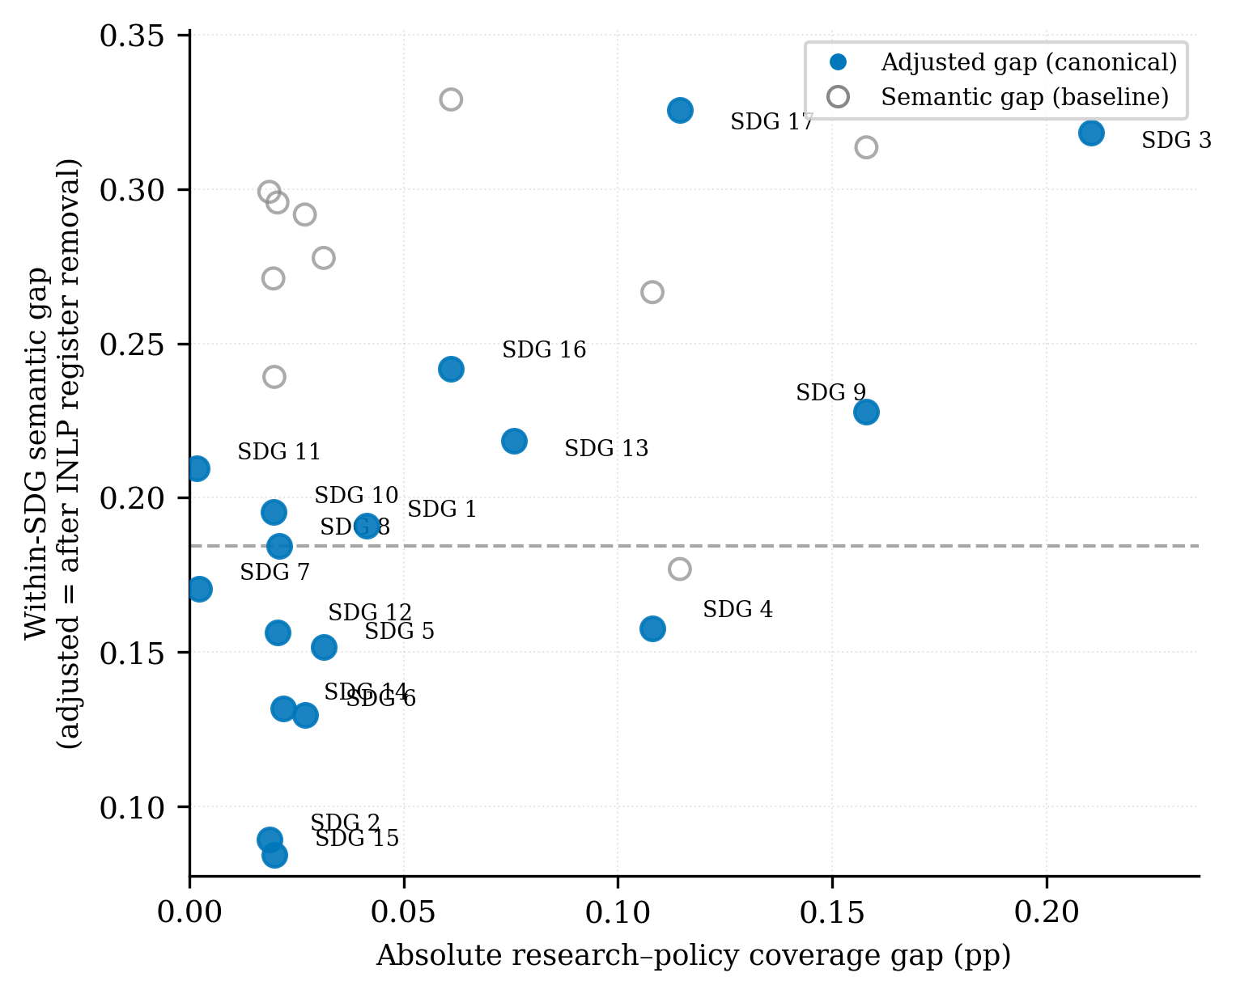  H1a: absolute coverage gap | 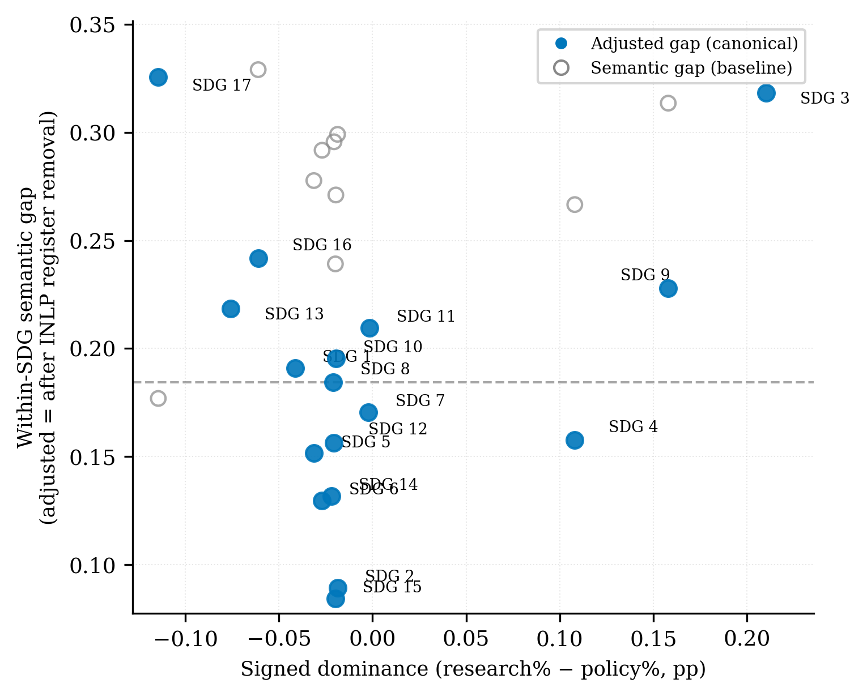  H1b: signed dominance (research% $−$ policy%) | 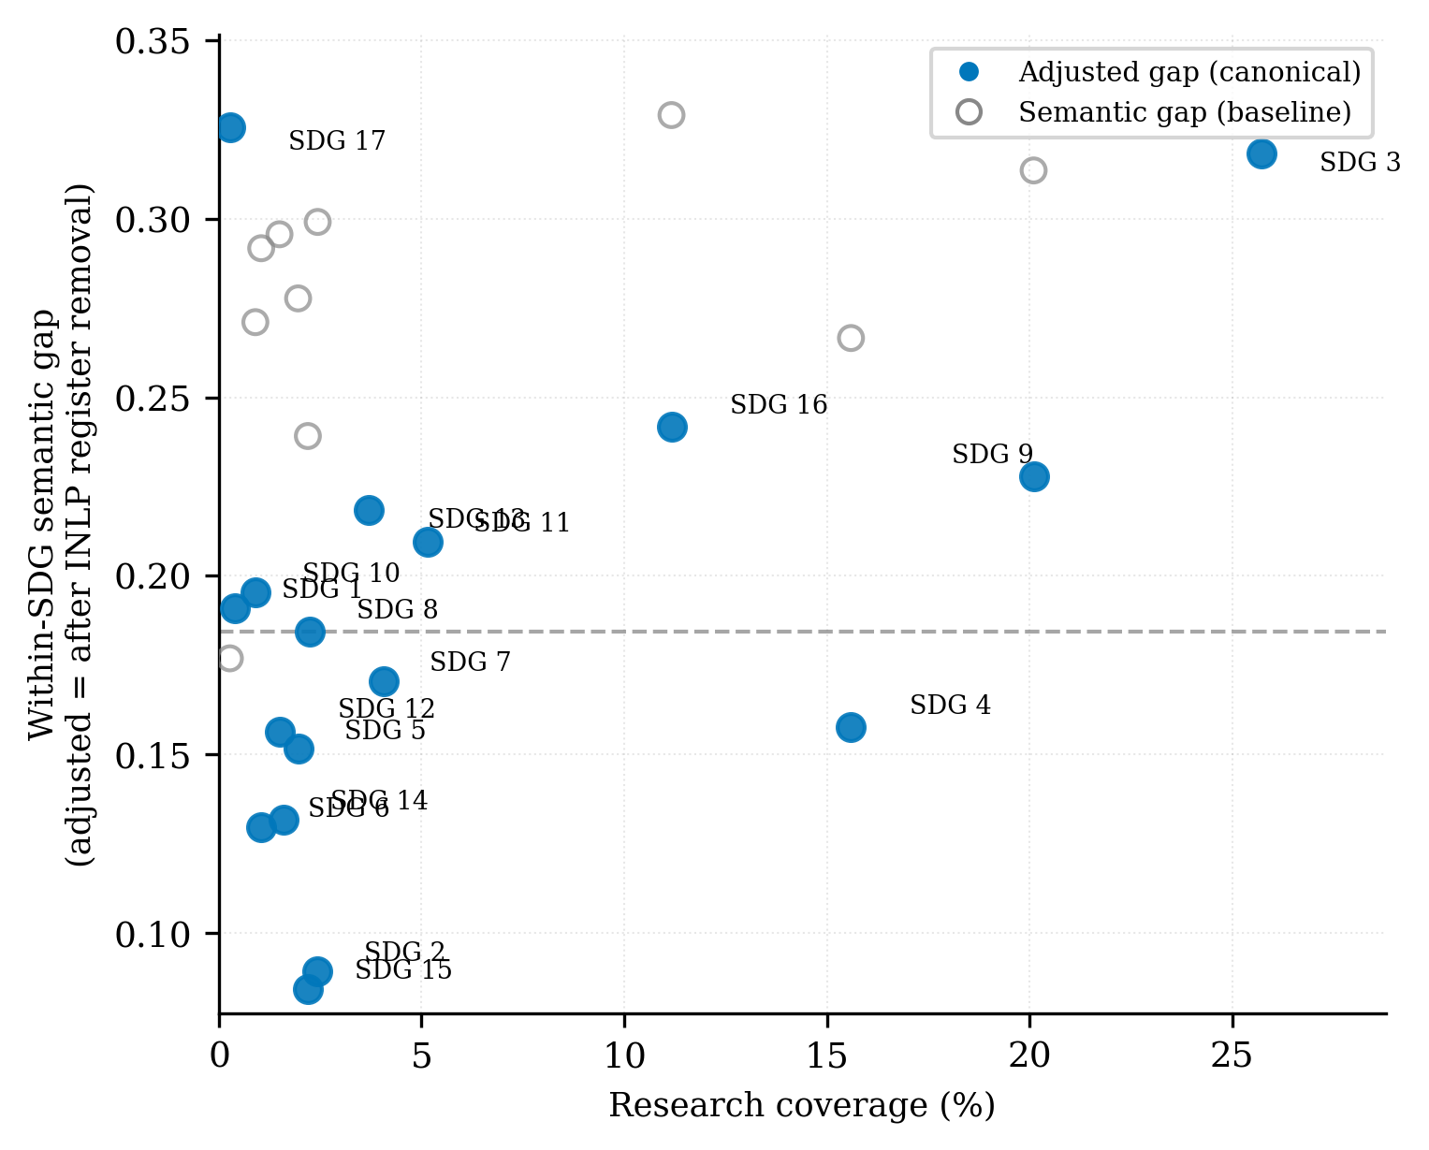  H1c: research coverage (%) | 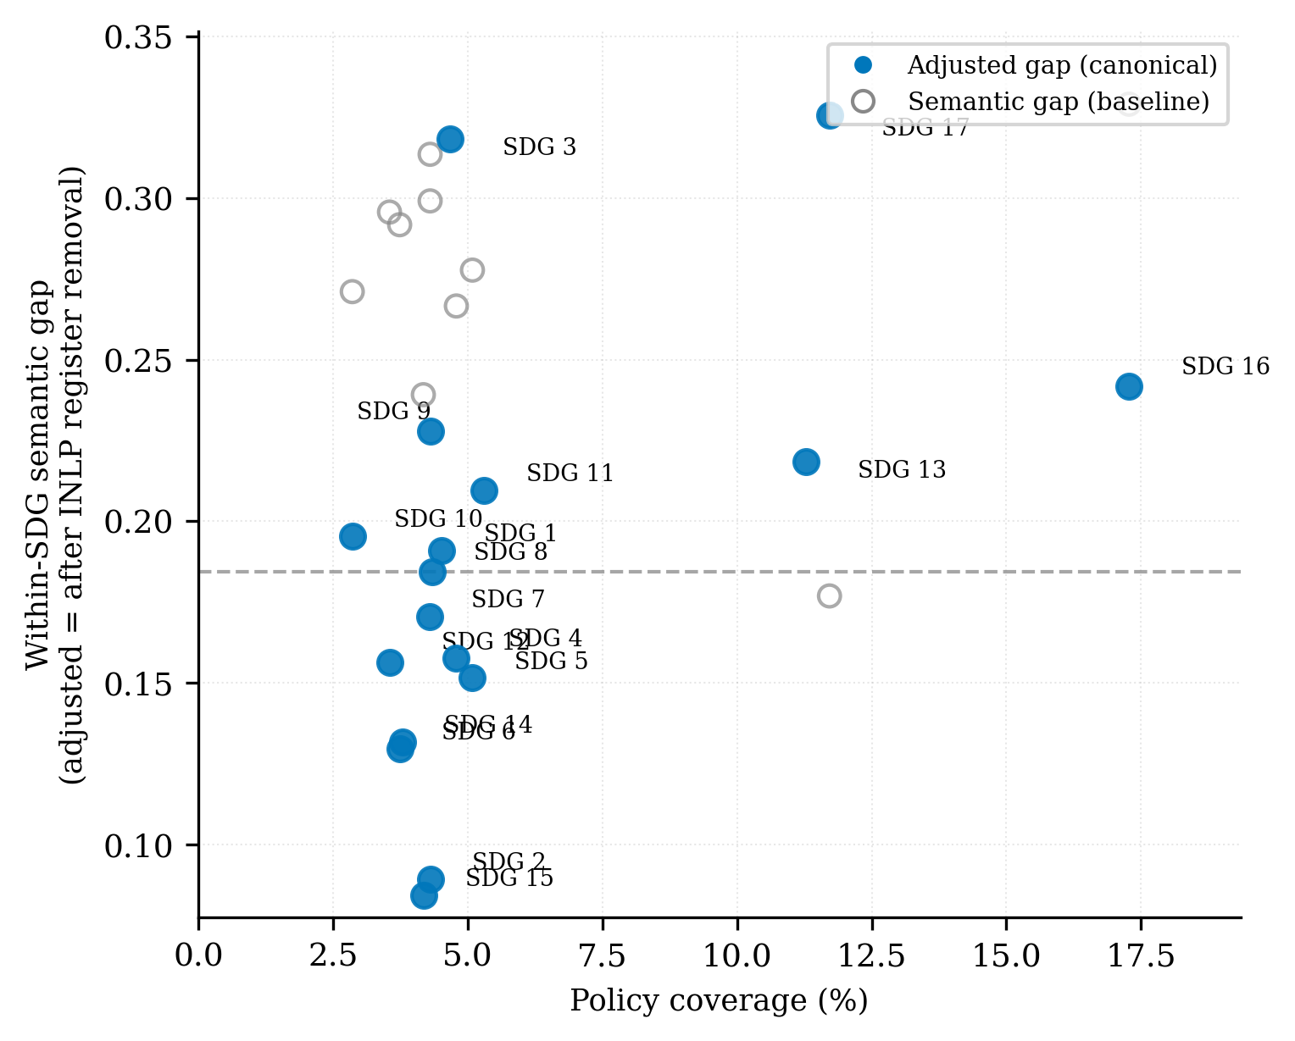  H1d: policy coverage (%)
Coverage predictor vs within-SDG semantic gap, one point per SDG. Solid blue = adjusted gap (canonical, after INLP register removal); open grey = raw baseline. (a) absolute coverage gap; (b) signed dominance; (c) research coverage; (d) policy coverage.

Robustness of the Gap Rankings
Register removal is validated against independent linguistic markers (Appendix 13.2); the adjusted gap is the primary estimate.
Cross-sensitivity (policy source, segment cap, retrieval). Under MPNet–LR, the semantic-gap ranking is stable across segment cap and retrieval in the adjusted panel ($ρ≥0.65$; Table [tab:cross-sensitivity-robustness]) and across policy source, segment cap, and retrieval in the raw panel ($ρ≥0.65$; Table [tab:cross-sensitivity-robustness-raw]). The same holds for coverage (Table [tab:cross-sensitivity-coverage]).
Encoder sensitivity. Coverage-gap ranks are stable across encoders (MPNet–LR vs. SciBERT–LR $ρ=0.93$; vs. MiniLM–LR $ρ=0.89$; Table [tab:encoder-sensitivity-coverage]). Semantic-gap magnitude is encoder-dependent (SciBERT: 0.04 vs. MPNet: 0.34) because scientific pretraining fuses the genres (Beltagy, Lo, and Cohan 2019), but the divergence conclusion holds (Table [tab:encoder-sensitivity-semantic]). Under the raw gap, SDG 3 leads for MPNet–LR and SciBERT–LR while SDG 13 leads for MiniLM–LR; SDG 17 trails in all three (rank 16 or 17).
Classifier sensitivity. LR and MLP show varied agreement (MPNet LR vs. MLP $ρ=0.85$; Table [tab:encoder-sensitivity-semantic]). Under the raw gap, SDG 17 is the most classifier-sensitive goal, sitting at rank 17 under LR but rank 8 under zero-shot.
Distance-functional robustness. Most distribution-aware metrics correlate only moderately with the adjusted semantic gap (sliced Wasserstein $ρ=0.525$, Chamfer $ρ=0.485$), while Gaussian-2-Wasserstein and squared MMD are weaker ($ρ≈0.24$–$0.26$) and C2ST and Grassmann show negative agreement ($ρ=−0.164​$ and $−0.243​$; Appendix 10). The adjusted gap is primarily a mean-direction finding; shape carries a related but distinct signal.
Synthesis. Two conclusions survive: SDG 15 is robustly least-divergent (rank 17 across configs); SDG 17 is most classifier-sensitive and most divergent under the adjusted gap, while SDG 3 leads under the raw gap for MPNet–LR. The cancellation replicates across all configs and policy-source families. Pooled OLS confirms the adjusted association (Appendix 15).

Discussion
The headline result is a cancellation: the raw correlation is null because register and topic offset ($ρ=0.544$ vs. $ρ=−0.390$; Table 5).

Semantic cancellation effect
Three potential confounds could be ruled out before the cancellation can be interpreted substantively.
Independence of classification and measurement. The LR classifier and the embedding space are separate tools: classification uses softmax probabilities; semantic measurement uses cosine distance between L2-normalised centroids. The most plausible confounder would be the INLP register-adjustment step systematically adjusting less for low-coverage SDGs and more for high-coverage ones, which could manufacture rather than show the adjusted-gap correlation. This is structurally precluded, not merely mitigated, by the stratification design (Section 3.8): at every iteration, INLP draws an equal, globally fixed number of research and policy embeddings per SDG (n_target = 1123 for MPNet), regardless of that SDG’s actual coverage share in either corpus. Because the classifier that learns each removed direction never sees coverage-proportional samples, coverage cannot leak into which direction gets learned or removed.
Cross-configuration replication. The cancellation replicates across most configs (Table 5): signs are stable for all encoder–classifier combinations under the primary keyword-retrieved corpus. The exception is the concept-retrieved track, where H1a’s raw-gap sign flips against all other configurations (Concept LR: +0.108, vs. negative or near-zero elsewhere) — consistent with the retrieval-related instability discussed in Section 5.5. Excluding that track, the pattern does not appear to be a quirk of a specific encoder space, classifier, or methodological choice (segmentation, segment-capping for long documents).
SciBERT compression validates the register interpretation. SciBERT compresses the raw gap from 0.34 to 0.04 (88% reduction) while preserving coverage ($ρ=0.93$; Table [tab:encoder-sensitivity-coverage]). Scientific pretraining (Beltagy, Lo, and Cohan 2019) fuses the registers because both use scientific conventions, exactly what the decomposition predicts.

Two communities, two dimensions
If the cancellation is real, it calls for a theoretical explanation. The two-communities theory (Caplan 1979) provides one. Caplan characterises social scientists and policy makers as living in “separate worlds with different and often conflicting values, different reward systems, and different languages” (Caplan 1979, 459). The gap, he argues, “necessarily involves value and ideological dimensions as well as technical ones” (Caplan 1979, 461). If the two communities are genuinely distinct knowledge cultures, then a near-zero raw correlation is expected, not puzzling: the two corpora develop different topical priorities (producing coverage divergence) and different communicative norms (producing register divergence), and the two effects operate in opposite directions on the semantic gap. Caplan himself warned that “it does not follow… that an alliance of social scientists and policy makers is the panacea” (Caplan 1979, 461). The raw null is the expected result of two distinct knowledge cultures coexisting without deep integration.
The adjusted association also shows that coverage and framing are separable dimensions, not a single “alignment” property. As shown in Results (Section 4.3), SDGs 9 and 17 illustrate this: SDG 9 has the second-largest coverage gap but a moderate semantic gap, while SDG 17 has moderate coverage but the widest adjusted gap. A single alignment score would conflate these two genuinely different patterns. This separability is the paper’s core empirical contribution to the SDG-mapping literature, which has treated coverage as the primary output (Armitage, Lorenz, and Mikki 2020; Kashnitsky et al. 2024). The framework demonstrates that coverage and framing should be reported as independent axes.
The positive adjusted correlation ($ρ=+0.544$, read as pattern-consistent rather than confirmatory evidence — Section 5.1) is consistent with the two dimensions being linked through topic: where one community dominates a given SDG’s coverage, the framing tends to diverge. The epistemic-communities framework (Haas 1992) makes this reading clearer. Haas argues that “before states can agree on whether and how to deal collectively with a specific problem, they must reach some consensus about the nature and scope of the problem…” (Haas 1992, 29). Where research dominates coverage (SDGs 3, 9), the framing reflects academic norms of knowledge production: “problems set and solved in a context governed by the, largely academic, interests of a specific community” (Gibbons et al. 1994, 3). Where policy dominates (SDGs 13, 16, 17), the framing reflects institutional norms of coordination: “knowledge carried out in a context of application” (Gibbons et al. 1994, 3). The coverage-semantic linkage is the empirical manifestation of two communities framing the same goals differently when attention (measured as coverage) diverges between them.
However, Haas also cautions that “given the many examples of different states reacting in different ways to the same consensual evidence provided by specialists, it is unclear how effective consensual knowledge is, as an independent variable, at explaining or predicting state behavior” (Haas 1992, 30). The adjusted association shows that coverage and framing are linked through topic, but it does not show that this linkage produces policy uptake.
The directional decomposition (H1b–H1d) shows an asymmetric structure, as shown in Table 5. H1d (policy coverage) is the strongest consistent predictor, positive in 9 of 9 configurations. The linkage operates through the policy side: where policy heavily covers an SDG, framing divergence is wider, consistent with Haas’s observation that epistemic communities occupy institutional niches (Haas 1992, 30) and with the Mode 1/Mode 2 distinction (Gibbons et al. 1994).
This asymmetry is consistent with Cash et al.’s (Cash et al. 2003) observation that salience, credibility, and legitimacy are “tightly coupled” such that efforts to enhance one “normally incur a cost to the others.” Where policy attention is concentrated (SDGs 13, 16, 17), the institutional framing that drives salience simultaneously distances the discourse from research norms of credibility, widening the adjusted gap. The mechanism is structural, not communicative: where policy dominates an SDG, the Mode 2 framing prevails and the gap widens.

The register decomposition: what the raw gap actually measures
For 16 of 17 SDGs, the register component is positive (+0.076 to +0.261; Table 4), meaning register uniformly inflates the apparent divergence. The implication is clear: any SDG-mapping study that uses raw embedding distances without register adjustment will overestimate semantic divergence. The raw gap is a composite of topic, register, and convention; only the adjusted gap isolates topic.
The exception is SDG 17, where the register component is negative (-0.149): register makes the two communities appear more similar than their topics warrant. Under the raw gap SDG 17 ranks near the bottom (0.177) but after register removal it jumps to the top (0.326). Policy partnership discourse uses institutional language (countries, nations, global) that superficially resembles research vocabulary, but the substance differs: research concerns technical terms (model, method), while policy concerns institutional coordination.
SDG 17 is where framing power operates most invisibly: partnership language sounds like either community, but the coordination logic belongs exclusively to policy. Le Blanc (2015) and Griggs et al. (2017) describe SDG 17 as “implementation infrastructure rather than substantive domains”; the register inversion confirms this empirically.
The register decomposition also shows what the embedding instrument actually measures. Embedding distance is a composite signal of topic and register (Harris 1954). SDG stratification works because the 17 goals span many topics, so a direction separating research from policy cannot also encode any one SDG topic. The method assumes topic and register can be pulled apart; where they cannot (e.g., clinical notes vs biomedical literature), some topic would leak into the removed component.

Level 0: Institutional Commensurability
The three-level framework (Section 2.3) assumes that research and policy discourse are already commensurable categories, comparable once retrieved and embedded. Constructing the corpora exposes a prior condition that framework does not capture. The research corpus is a tight intersection of AI and SDG content (2,536,771 abstracts); the curated AI-and-SDG policy family is 94 documents. This is not merely a sampling limitation to be corrected with more time (Section 5.5). It is evidence that “AI and the SDGs” is not yet an established organising category in institutional policy discourse the way it already is in academic research. Policy documents overwhelmingly discuss AI governance and SDG implementation as separate agendas; the joint category the research corpus takes for granted barely exists on the policy side to be sampled.
This claim should be read carefully: “level” in this framework is reference-relative, not absolute. The paper’s core Level 1/Level 2 analysis (Sections 2.3 and 4) takes “AI-and-SDG” as an already-commensurable category and measures coverage and framing within it. The observation above applies the identical logic one category outward — treating general SDG discourse as the commensurable category and asking whether AI coverage within it is itself established on the policy side. It is not, in the formal sense of this paper’s Level 1 analysis, a measurement: no general-SDG coverage statistic was collected for either corpus, and the argument is inferred from the difficulty of assembling a symmetric AI-and-SDG policy corpus rather than from a coverage figure analogous to Section 4’s. What follows should therefore be read as a plausible extension of the framework’s logic, motivating future work, not as a Level-1-style finding in its own right.
This asymmetry maps onto the Mode 1/Mode 2 distinction (Gibbons et al. 1994) one level up from where it is usually applied. Mode 1 knowledge production allows a research community to define and pursue a novel cross-cutting category — “AI for the SDGs” — as an internal disciplinary move, requiring no external validation. Institutional policy discourse, operating closer to Mode 2’s context of application, adopts new organising categories only once they are demanded by a concrete problem, negotiation, or mandate. Research can outrun policy in category formation before it outruns policy in content. The near-total absence of a comparably sized “AI-and-SDG” policy corpus is therefore not a gap this study failed to fill; it is the gap, observed one level before Level 1 coverage or Level 2 framing can even be measured.
As noted in Section 2.1, SDG 17 is treated in the literature (Le Blanc 2015; Griggs et al. 2017) as implementation infrastructure rather than a substantive domain in its own right, coordinating action across goals rather than constituting one. Applied here one category up (see previous paragraph), the same reading suggests “AI and the SDGs” may currently occupy an analogous pre-domain status in policy discourse — a research-side framing device that institutional discourse has not yet organised itself around. If so, the coverage and semantic gaps measured in this paper (Section 4) describe divergence within a category that, on the policy side, barely exists as a category at all. A future Level 0 measurement — tracking when and whether “AI-and-SDG” stabilises as a policy-organising category, for instance through co-occurrence of AI and SDG terms in institutional agendas over time — would convert this inference into a Level-1-style measurement; the present study only registers the asymmetry it produced.

Limitations
Semantic proximity, not substantive alignment. The study is positioned at Level 2 of a three-level construct (Section 2.3). Level 3 requires qualitative, institutional, and deliberative methods and is left to future work.
Distance metric discards distributional shape. Centroids are mean-direction measures. Under raw embeddings, distribution-aware metrics (sliced Wasserstein, Chamfer) correlated strongly with the semantic gap ($ρ=0.44$–$0.91$), but this agreement was largely a register artifact: the distribution-aware metrics track the register component of the gap, not the adjusted semantic gap (Appendix [sec:distributional-robustness]). After register removal, the adjusted semantic gap is a mean-direction measure, and distribution-aware metrics correlate with it only weakly to moderately (e.g. Gaussian-2-Wasserstein $ρ=0.243$, sliced Wasserstein $ρ=0.525$); they remain an informative full-distribution complement, not a re-ranking. The covariance-shape term accounts for $≈79\%$ of the squared Gaussian-2-Wasserstein distance, and a replicate run under the adjacent seed changes the largest per-SDG gap by at most 0.008 (Appendix [sec:distributional-robustness]).
Unaudited upstream SDG filter. The research corpus depends on OpenAlex’s native SDG-work classification to define the candidate universe before the four AI terms are applied (Section 3.3). This filter’s precision and recall against ground-truth SDG relevance have not been independently audited in this study, and the 2,536,771 abstracts retrieved reflect OpenAlex’s operational definition of SDG-relevant work rather than a validated one. The corpus size is large enough to rule out a sample-size or statistical-power concern, but it does not, on its own, establish that the filter is accurate; auditing it against a manually labelled sample is left for future work.
Retrieval-method dependency. The keyword-retrieved corpus trades recall for precision; Appendix 7 shows that concept-retrieved papers (field-of-study membership) produce closely aligned gap rankings, with a substantially lower SDG 4 share ($−$7.3pp) as the largest deviation between the two profiles. Re-running the full pipeline with concept-retrieved papers as the primary corpus is the most direct path to eliminating this artefact and is left for future work. Additionally, the concept-retrieved robustness check (Appendix 7) reuses the register-adjusted space fitted on the keyword-retrieved corpus rather than re-fitting INLP on the concept-retrieved embeddings, assuming the research-policy register direction is stable across retrieval strategies. This assumption is untested; re-fitting INLP natively on the concept-retrieved corpus is recommended before treating that corpus as a fully independent robustness check.
Concept-retrieved corpus is unfiltered for SDG relevance. Unlike the primary keyword-retrieved corpus, which applies OpenAlex’s SDG work filter before the AI terms, the concept-retrieved robustness corpus (Appendix 7) restricts only to AI/ML field-of-study membership; no SDG filter is applied at retrieval. SDG labels for this corpus are assigned entirely by the trained classifier post hoc, so its agreement with the keyword-retrieved corpus (Table 5) demonstrates stability of coverage-share ranking under a different retrieval strategy, not independent confirmation that the concept corpus itself is SDG-relevant. This concern is consistent with a pattern in Table 5: on H1a’s raw semantic-gap column, the concept-retrieved configuration is the only one whose sign flips against the rest of the encoder–classifier grid (Concept LR: +0.108, vs. seven negatives elsewhere), while the MiniLM and SciBERT tracks — also different encoders — show no comparable sign flip. (H1c’s raw column is mixed across all configs, so no single track uniquely flips there.) This does not prove the unfiltered-retrieval concern causes the instability, but it is the pattern that concern would predict, and MiniLM/SciBERT show no comparable instability despite also being different encoders. Time constraints prevented applying a comparable SDG filter to this alternative corpus; doing so is recommended before treating it as a fully independent validation. Follow-up works should either apply OpenAlex’s SDG filter for consistency and audit it independently for validation, or not apply OpenAlex’s SDG filter and allow for baseline non-SDG classification (Section 3.5).
Register adjustment is partial. INLP removes a linear subspace that captures the dominant corpus-level register difference, but register is multi-layered (Biber 1988). The register interpretation rests on a structural argument (SDG stratification ensures topic cannot leak into the removed direction; Section 3.8) plus partial empirical validation against independent linguistic markers (Appendix 13.2). The validation finds substantial reduction of the corpus-level signal but not its complete elimination.
Per-SDG assignment is approximate. The hard argmax treats SDG discourse as cleanly separable, but the PCA space (Figure 4) shows real-world SDG discourse is fuzzy. SDG 4 is artefact-affected by the machine-learning/education “learning” overlap; its rank is read conditional on Appendix 8.1. Leave-one-out of SDG 4 preserves the adjusted association ($ρ=0.597$, $p=0.016$). Future work with multi-class SDG classification is recommended.
Cross-sectional design. The study observes one period (2018–2025) against a similarly timed policy corpus; it cannot assess whether alignment is improving or deteriorating, or whether specific events (e.g., the EU AI Act 2024, IPCC AR6 2022) (European Union 2024; IPCC 2022) shifted research framing.

Contribution and Implications
The primary contribution of this paper is the measurement framework, not the specific AI–SDG findings. The framework advances AI–SDG mapping from Level 1 (lexical correspondence) to Level 2 (observed semantic proximity), with explicit marking of Level 3 boundaries (Section 2.3). The cross-sensitivity transparency (Table [tab:cross-sensitivity-robustness]) is a reusable template: instead of reporting a single gap ranking, it shows how stable every ranking position is across the measurement choices. The SDG-stratified INLP adaptation — training the corpus classifier on balanced topic–corpus strata so that no linear direction can encode both topic and register — is a methodological contribution applicable to any cross-corpus comparison where topic and register are confounded. The protocol is portable to any research-policy interface that shares a category system and embeds both sides in a common semantic space.
The AI–SDG findings are a first application to be checked against a larger, more diverse policy corpus, not settled results. The findings reported here, the cancellation, the SDG 17 inversion, and the positive adjusted association, are properties of this specific pair of corpora at this moment in time.
Beyond the measurement advance, the results carry a direct implication for how SDG engagement is read. The paper’s premise, that shared coverage is not shared framing, is common sense, and the results confirm it: coverage and framing are separable, with only a modest, hedged correlation between them. Coverage, the Level 1 metric existing studies report, captures only a weak form of salience; it does not address credibility or legitimacy (Cash et al. 2003). The adjusted gap is a Level 2 metric that begins to measure framing compatibility. The high-gap SDGs (17, 3, 16, 9, 13) are candidates for boundary-organising practices (Guston 2001): policy synthesis briefs, joint workshops, or funder-required summaries. Cash et al. (Cash et al. 2003) caution that translation alone cannot resolve the tradeoffs among salience, credibility, and legitimacy. Existing SDG-mapping studies report only coverage (Armitage, Lorenz, and Mikki 2020); this paper shows coverage and framing are separable dimensions (Section 4.3).

Conclusion
The Introduction asked whether shared SDG labels between academic AI research and institutional policy discourse indicate genuine alignment. Not without examining framing. This paper demonstrated that coverage divergence (which SDGs each community prioritises) and within-SDG semantic framing divergence (how differently they discuss the same goal) are separable dimensions that can diverge independently. The raw correlation between the two dimensions is near-zero (Spearman $ρ=−0.012$), but this masks a register-topic cancellation: after INLP register removal, the adjusted semantic gap is positively associated with the coverage gap ($ρ=0.544$, $p=0.025$). The linkage is asymmetric: policy coverage is the strongest directional predictor of framing divergence (positive in 9/9 configurations), while research coverage shows no consistent signal. Where policy attention concentrates, Mode 2 knowledge production (Gibbons et al. 1994) shapes the discourse in contexts of application, producing framings that are structurally further from research norms; this is the expected consequence of two distinct knowledge cultures producing different framings of the same goals (Caplan 1979; Cash et al. 2003).
The takeaway for practice is that an SDG label is not evidence of alignment: a tag records that a text is about a goal, not that it frames the goal the way another community does. The register decomposition shows embedding distance, like keyword matching, is a composite signal inflated by genre for 16 of 17 SDGs, with SDG 17 the stark exception where institutional vocabulary masks the deepest topic divergence. Because funders and policymakers read SDG counts as proof of engagement (Heilinger, Kempt, and Nagel 2024; Heras-Saizarbitoria, Urbieta, and Boiral 2022), the two-dimensional reading developed here — coverage alongside framing, with the register component made explicit — is needed to interpret that engagement correctly.
The framework is the paper’s primary contribution, advancing AI–SDG mapping from Level 1 (lexical correspondence) to Level 2 (observed semantic proximity) with explicit marking of Level 3 boundaries (Section 5.5), and portable to any research-policy interface that shares a category system (Section 5.5). The asymmetric corpus construction itself is diagnostic: the difficulty of building a symmetric AI-SDG policy corpus reflects that “AI and the SDGs” is not yet an established organising category in policy discourse the way it already is in research — an inferred, not measured, institutional gap (Section 5.4). Level 3, whether the divergences documented here reflect productive exploration, institutional failure, or simply different knowledge cultures pursuing different mandates, requires qualitative, institutional, and deliberative methods that lie beyond the scope of embedding analysis.

Concept-based Research Retrieval
This section reports results of using the concept-retrieved research corpus. This test uses field-of-study membership for the same two AI fields, mirroring the OECD.AI definition (OECD 2024), and re-scored the resulting corpus through the identical pipeline (segmentation, Section 3.1; classifier, Section 3.5). No SDG filter was applied at retrieval; see Section 5.5 for this limitation. Concept retrieval used OpenAlex concept tags for Artificial Intelligence and Machine Learning, capped at 100,000 papers total. This scale sits within the variance plateau established in Appendix 11 (coverage-profile standard deviation 0.001 and mean within-SDG semantic gap 0.342, within 0.002 of the full-corpus estimate of 0.340 at 50,000 papers) and exceeds every corpus size used in prior SDG classification and mapping benchmarks: the OSDG community dataset (30,532 texts) (Pukelis et al. 2022), the SDG benchmark encoder evaluation corpus (35,001 excerpts) (Gjorgjevikj et al. 2025), the SDGi corpus (20,267 segments) (SDGi 2024), the Aurora expert-validated set (4,971 texts) (Vanderfeesten, Spielberg, and Gunes 2020), and the (Kashnitsky et al. 2024) benchmark (6,000 papers)—while remaining far smaller than the full 3,105,144-segment research corpus, making it a computationally tractable substrate for OpenAlex concept tagging.
Table 6 compares SDG coverage shares between the keyword-retrieved and concept-retrieved corpora. The two profiles are closely aligned (Spearman $ρ=0.948$, Kendall $τ=0.868$); the largest deviations are SDG 4 ($−$7.3pp, the known ML-vocabulary artefact, Appendix 8.1) and SDG 9 ($+5.8$pp). Within-SDG coverage-gap and semantic-gap rankings are also stable against the keyword baseline (coverage-gap rank $ρ=0.87$; semantic-gap rank $ρ=0.81$, Table [tab:cross-sensitivity-robustness]). The main findings are therefore reported as robust to query-term choice, while both corpora remain conditional on their respective retrieval strategies.
SDG coverage-share comparison: keyword-retrieved versus concept-retrieved (AI/ML field-of-study) research corpus.
SDG | Keyword % | Concept % | $Δ$
1 | 0.4 | 0.7 | +0.3
2 | 2.4 | 1.8 | -0.6
3 | 25.7 | 25.7 | -0.0
4 | 15.6 | 8.3 | -7.3
5 | 2.0 | 1.7 | -0.2
6 | 1.0 | 0.8 | -0.2
7 | 4.1 | 4.7 | +0.6
8 | 2.2 | 2.3 | +0.1
9 | 20.1 | 25.9 | +5.8
10 | 0.9 | 0.8 | -0.1
11 | 5.1 | 8.0 | +2.9
12 | 1.5 | 2.7 | +1.2
13 | 3.7 | 4.2 | +0.5
14 | 1.6 | 1.3 | -0.3
15 | 2.2 | 2.1 | -0.1
16 | 11.2 | 8.8 | -2.4
17 | 0.3 | 0.2 | -0.0
Spearman $ρ$ = 0.948; Kendall $τ$ = 0.868
Notes: $Δ$ is concept minus keyword share in percentage points.
Table 7 reproduces the per-SDG reference values (Section 4.4) for the concept-retrieved corpus: the semantic-gap family (raw, adjusted, register component) and the coverage-predictor family (coverage gap, signed dominance, research share, policy share). Signed dominance = research share $−$ policy share (pp); coverage gap = $\left|\text{research}−\text{policy}\right|$ (pp). These are the per-SDG inputs behind the Concept rows in the interaction grid (Table 5) and the cross-sensitivity tables.
Concept-retrieved corpus — per-SDG reference values (semantic-gap and coverage-predictor families).
SDG | Description | Semantic gaps |  |  | Coverage predictors
3-5 (lr)6-9 |  | Raw | Adj. | Reg. | Cov. | SDom | Res % | Pol %
1 | No Poverty | 0.827 | 0.440 | +0.387 | 3.9 | -3.9 | 0.7 | 4.5
2 | Zero Hunger | 0.428 | 0.137 | +0.291 | 2.5 | -2.5 | 1.8 | 4.3
3 | Good Health | 0.663 | 0.454 | +0.209 | 21.0 | +21.0 | 25.7 | 4.7
4 | Education | 0.402 | 0.224 | +0.178 | 3.5 | +3.5 | 8.3 | 4.8
5 | Gender Equality | 0.575 | 0.333 | +0.241 | 3.3 | -3.3 | 1.7 | 5.1
6 | Clean Water | 0.384 | 0.180 | +0.204 | 2.9 | -2.9 | 0.8 | 3.7
7 | Clean Energy | 0.514 | 0.242 | +0.272 | 0.4 | +0.4 | 4.7 | 4.3
8 | Decent Work | 0.625 | 0.363 | +0.262 | 2.0 | -2.0 | 2.3 | 4.3
9 | Innovation | 0.421 | 0.330 | +0.092 | 21.6 | +21.6 | 25.9 | 4.3
10 | Reduced Ineq. | 0.458 | 0.312 | +0.146 | 2.1 | -2.1 | 0.8 | 2.9
11 | Sust. Cities | 0.693 | 0.458 | +0.236 | 2.7 | +2.7 | 8.0 | 5.3
12 | Consumption | 0.400 | 0.280 | +0.120 | 0.9 | -0.9 | 2.7 | 3.5
13 | Climate | 0.598 | 0.266 | +0.332 | 7.1 | -7.1 | 4.2 | 11.3
14 | Life Below Water | 0.504 | 0.253 | +0.251 | 2.5 | -2.5 | 1.3 | 3.8
15 | Life on Land | 0.346 | 0.139 | +0.207 | 2.1 | -2.1 | 2.1 | 4.2
16 | Peace & Justice | 0.541 | 0.327 | +0.214 | 8.5 | -8.5 | 8.8 | 17.3
17 | Partnerships | 0.312 | 0.521 | -0.210 | 11.5 | -11.5 | 0.2 | 11.7
Mean | — | 0.511 | 0.309 | +0.202 | 5.8 | +0.0 | 5.9 | 5.9
Notes: Same structure as Table 4. Signed dom. = research % $−$ policy % (pp); Reg. Comp. = raw $−$ adjusted. The concept-retrieved corpus reuses the MPNet register-adjusted space (Section 3.8).

Diagnostics for Reference Classifier

SDG 4 Lexical Artefact Audit: The ML ‘Learning’ Overlap
SDG 4 is the only goal audited because it is the only one carrying an a priori lexical-overlap concern: “learning” is shared ML and education vocabulary, and prior AI–SDG inventories place SDG 4 outside the leading tier of SDG 3 and SDG 7 (Singh et al. 2024; Cowls et al. 2021; Nedungadi et al. 2024), so its third-place research share here is suspect on independent grounds. The audit does not relabel records; it tests whether the concern is empirically plausible. Table [tab:sdg4-lexical-audit] therefore compares the lexical composition of SDG 4-assigned research with a matched non-SDG4 sample and with SDG 9, using only two transparent keyword groups: ML-learning and education-specific vocabulary.
The result (Table [tab:sdg4-lexical-audit]) is a negative test of the false-positive hypothesis: education-specific vocabulary alone covers 44.4% of SDG 4-assigned records and overlaps ML vocabulary in a further 23.8%, while only 11.8% are ML-only. The comparison sets are inverted, with ML-only vocabulary dominating the non-SDG4 sample and the SDG 9 set (50.3% and 61.5%). The SDG 4 signal is therefore not the same technical language that drives SDG 9; but the 23.8% “both” share (versus 2.6% and 2.9% elsewhere) shows the two vocabularies do overlap materially within the SDG 4-assigned set.
The main analysis therefore retains the canonical LR argmax assignment but continues to treat SDG 4 as artefact-affected. The most accurate reading is a learning-related assignment whose interpretation is blurred by lexical overlap: neither “clean education” nor “pure ML artefact.”
Notes: The audit only checks whether SDG 4-assigned research is disproportionately dominated by machine-learning vocabulary, education vocabulary, or both.

Centroid Similarity
This subsection reports the pairwise cosine-similarity heatmap (Figure 7) for the 17 canonical SDG centroids. The centroids are the per-SDG mean training embeddings (L2-normalised) used by the LR classifier.
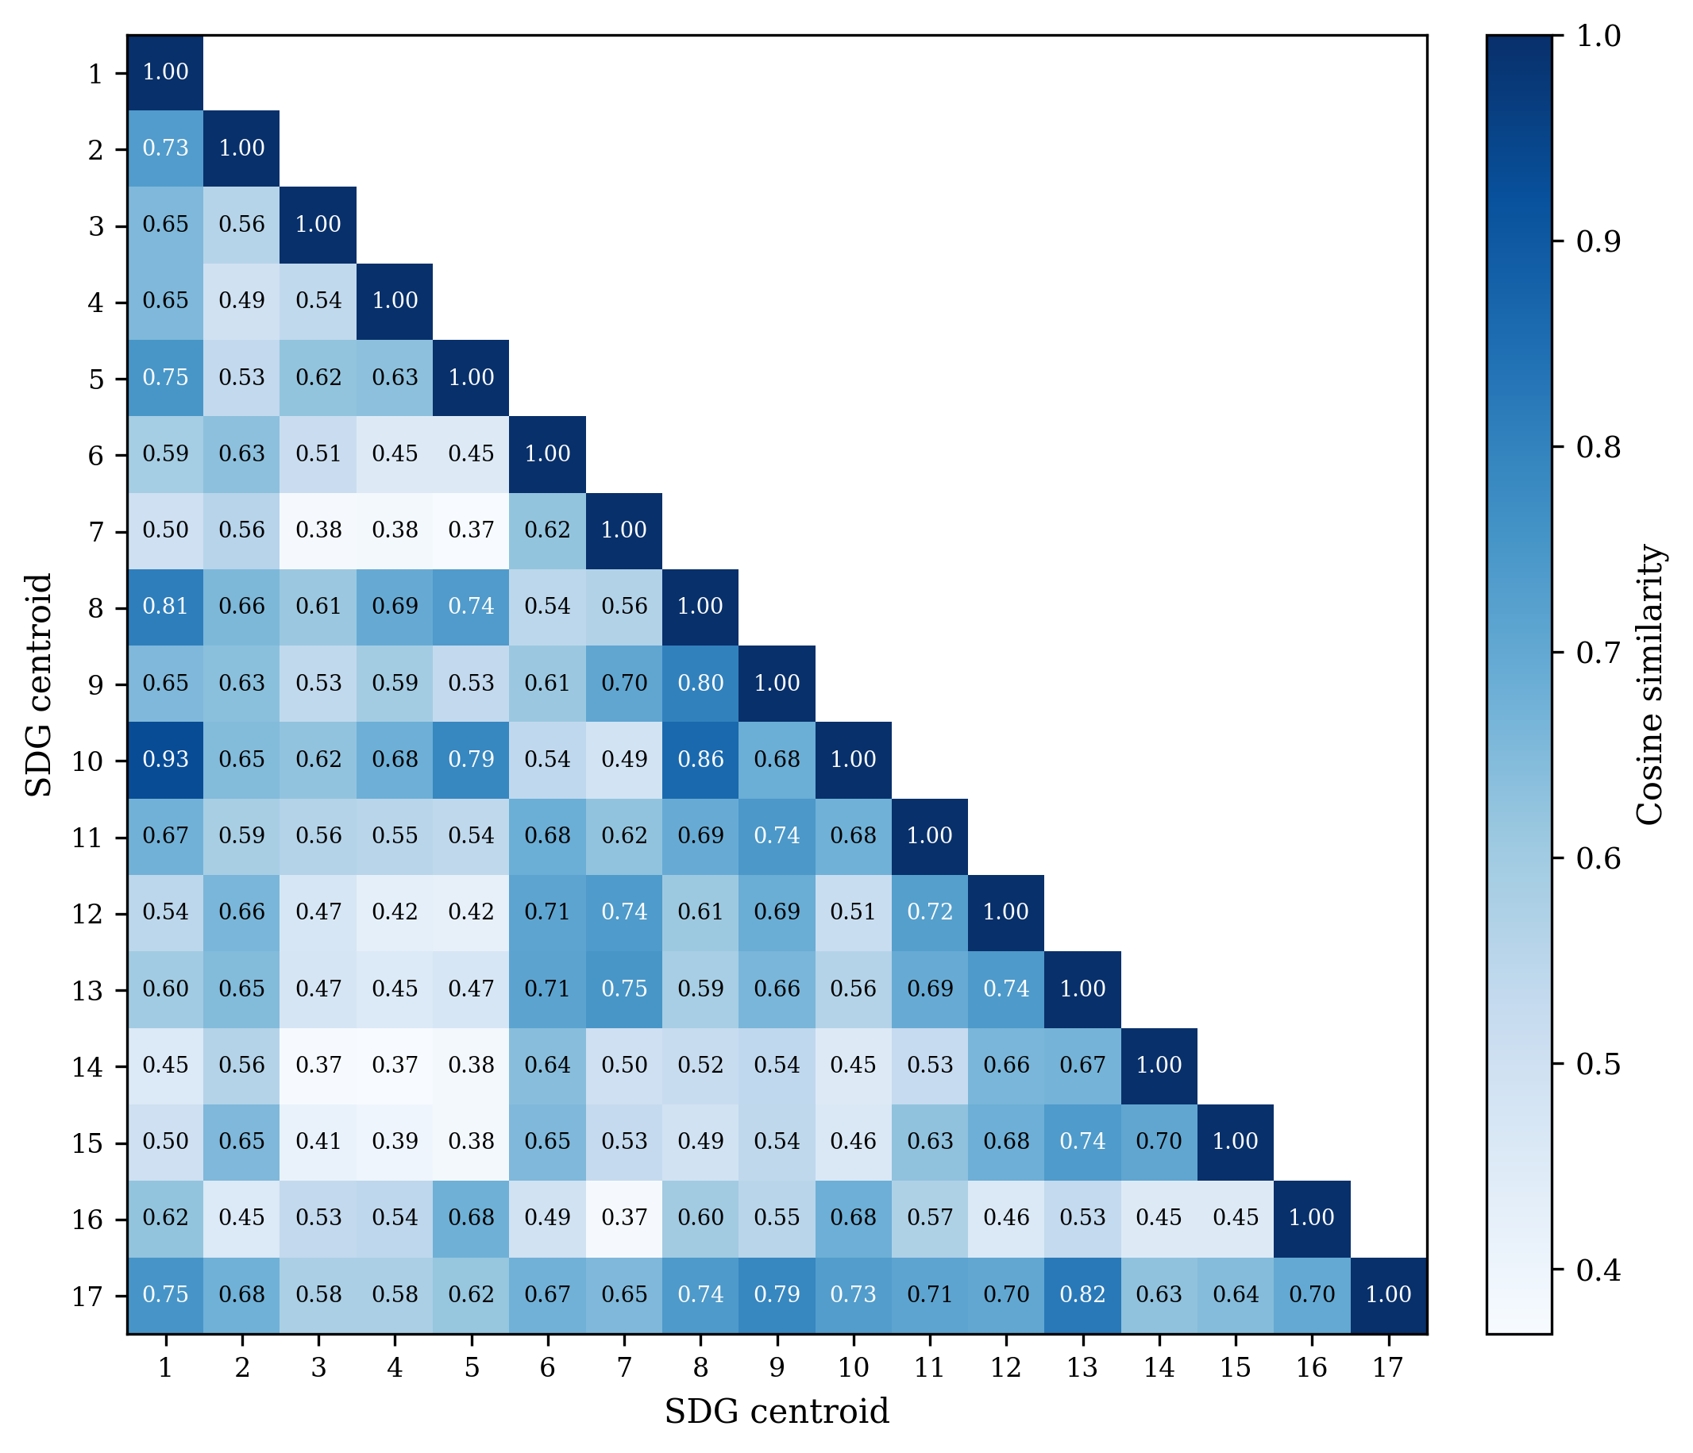
Pairwise cosine similarity between canonical SDG centroids (lower triangle). SDG 13 and SDG 17 sit close together (cosine 0.821), as do SDGs 1, 8, and 10.
Figure 7 shows the full 17$×$17 similarity grid. Reading the grid, three observations stand out. First, the diagonal dominates: most centroids are far more similar to themselves than to any neighbour, which is why the supervised LR classifier (Table 3) can build on this well-separated base to reach 0.816. Second, a small set of off-diagonal cells is elevated: SDG 11’s centroid neighbours SDG 9 (cosine 0.744), SDG 8 lies near SDGs 1 and 10 (cosine 0.808 and 0.862), and SDGs 1 and 10 are themselves the closest off-diagonal pair (cosine 0.931) – these are the proximities that make the SDG 10 and SDG 8 scores in Section 4.1 indicative rather than exact. Third, SDG 17 is the clear outlier: its row and column are the flattest, and its nearest neighbour is SDG 13 (cosine 0.821), reflecting the overlap between climate and partnership discourse noted in Section 4.1.

Lexical Illustration of the Semantic Gap
Table [tab:semantic-gap-text-interpretability-full] lists the TF-IDF terms most distinctive of the research and policy sides for each SDG. Generic ML methodology vocabulary, such as model, learning, and neural, is excluded because these terms reflect the search strategy rather than SDG-specific framing.
The contrasts echo the embedding patterns. The widest-gap SDGs (3, 13, 11, 7, 1, 8, 14; raw gap $≥0.358$) consistently oppose technical measurement vocabulary, detection, images, yield, regression, against institutional or welfare terms, climate, emissions, health, employment. SDG 13 clarifies the pattern most sharply: research terms centre on crop monitoring and soil science while policy terms address national emissions commitments. Lower-gap SDGs (17, 15, 4, 10, 5, 6, 2; raw gap $≤0.299$) show narrower lexical divergence, such as the shared technology-infrastructure frame of SDG 9 or the social-media-partnership overlap of SDG 17. A further observation cuts across both groups: agricultural-AI vocabulary (crop, soil, agricultural) appears on the research side of nine unrelated SDGs, reflecting a strong agri-tech skew in the AI-for-SDG literature rather than alignment with each goal’s policy domain.
Notes: Terms are TF-IDF-weighted unigrams and bigrams from deterministic samples of research and policy texts assigned to each SDG.

Distance-Functional Robustness Table

Table [tab:distributional-gap] reports the per-SDG research–policy gap under the full battery of distribution-aware metrics, together with the primary semantic gap. Part 1 covers the full-corpus exact metrics (sliced Wasserstein, Chamfer, Hausdorff, Gaussian-2-Wasserstein, Grassmann, linear MMD); part 2 covers the sampled metrics (exact EMD, Sinkhorn, energy, squared RBF MMD, C2ST AUC) plus the sampled semantic gap. The final row of each part reports Spearman $ρ$ between each metric’s ranking and the primary (adjusted) ranking.
Why the raw robustness result does not carry over. Under raw embeddings the distribution-aware metrics appeared to preserve the semantic gap ranking ($ρ=0.44$–$0.91$), an agreement driven by the shared register component rather than by topic. Decomposing the raw gap into adjusted semantic gap $+$ register component, the register component has larger variance than the raw gap itself (variance ratio $1.210$) and correlates $ρ=0.748$ with the raw gap while correlating $ρ=−0.235$ with the adjusted semantic gap. The distribution-aware metrics therefore tracked register, agreeing with the raw semantic gap but diverging from the adjusted one. After INLP removes register, the metrics instead track topic-space shape: most correlate moderately with the adjusted semantic gap ($ρ=0.44$–$0.69$; sliced Wasserstein $ρ=0.525$, exact EMD $ρ=0.694$), Gaussian-2-Wasserstein and squared MMD are weaker ($ρ≈0.24$–$0.26$), and Sinkhorn, C2ST, and Grassmann show near-zero or negative agreement ($ρ=0.047​$, $−0.164​$, $−0.243​$), and they elevate SDGs 12 and 1 at the margin. The adjusted semantic gap is a mean-direction estimate, and the distribution-aware distances are a complementary full-distribution view. The covariance-shape term of the Gaussian-2-Wasserstein distance accounts for $≈79\%$ of the squared distance on average, and a replicate run under the adjacent seed changes the largest per-SDG gap by at most $0.008$.
The H1 decomposition is not an artefact of the centroid estimate. Table 8 re-runs the H1a–H1d correlation grid with the distribution-aware semantic gaps (adjusted embeddings) in place of the centroid gap; predictors and test are identical to Table 5. The positive coverage–framing association replicates under the mean-complementary family: sliced Wasserstein ($ρ=0.554$, $p=0.022$), linear MMD ($ρ=0.603$, $p=0.012$), and energy distance ($ρ=0.537$, $p=0.027$) reproduce the adjusted association at magnitudes close to the centroid estimate ($ρ=0.544$, $p=0.025$), with squared RBF MMD directionally consistent ($ρ=0.473$, $p=0.056$). The distributional view also shows a difference the mean-direction estimate misses: H1c (research coverage) is positively associated with the sliced-Wasserstein ($ρ=0.539$, $p=0.028$), energy-distance ($ρ=0.532$, $p=0.030$), and squared RBF MMD ($ρ=0.551$, $p=0.024$) gaps even though it is null on the centroid gap, suggesting research-heavy goals show wider distributional shape divergence without a wider mean-direction gap. The association is not uniform across the battery: exact EMD and Chamfer agree moderately with the centroid ranking (Table [tab:distributional-gap], final row) yet show no H1a association, and every metric whose ranking agreement is weak or negative is null as well, with one exception: Sinkhorn’s H1d is significantly negative ($ρ=−0.505$, $p=0.041$), an outlier consistent with its near-zero ranking agreement. Excluding SDG 4 leaves every conclusion unchanged (full $n=16$ grid in the analysis JSON).
H1a–H1d coverage-predictor vs semantic-gap Spearman correlations under distribution-aware semantic gaps (adjusted embeddings). Distributional gaps replace the centroid gap as the outcome vector; predictors and test are identical to Table 5.
 | H1a | H1b | H1c | H1d
 | Cov. gap | Dominance | Research cov. | Policy cov.
Sliced Wasserstein | +0.554$​^{*}$ | +0.061 | +0.539$​^{*}$ | +0.397
Linear MMD | +0.603$​^{*}$ | +0.022 | +0.466$​^{†}$ | +0.439$​^{†}$
Energy distance | +0.537$​^{*}$ | +0.074 | +0.532$​^{*}$ | +0.384
Squared RBF MMD | +0.473$​^{†}$ | +0.113 | +0.551$​^{*}$ | +0.296
Exact EMD | +0.304 | +0.147 | +0.167 | +0.217
Chamfer | +0.103 | -0.115 | -0.350 | -0.006
Modified Hausdorff | +0.159 | +0.152 | +0.127 | +0.066
Gaussian-2-Wasserstein | -0.007 | +0.240 | +0.262 | -0.042
Sinkhorn | -0.199 | +0.397 | -0.176 | -0.505$​^{*}$
C2ST AUC | +0.270 | +0.275 | +0.375 | -0.139
Grassmann | -0.186 | +0.034 | +0.012 | -0.228
Notes: Spearman $ρ$ with two-sided Monte Carlo permutation $p$-values (100,000 resamples, seed 42), $n=17$ SDGs; $​^{***}p<0.001$, $​^{**}p<0.01$, $​^{*}p<0.05$, $​^{†}p<0.10$. Excluding SDG 4 ($n=16$) leaves every conclusion unchanged; the full $n=16$ grid is in the analysis JSON (distributional_h1_interaction.json).

Sample-Stability Robustness Check
To test whether the headline findings depend heavily on research-corpus size, this study reran the downstream research-side analysis on repeated random subsamples drawn from the pre-embedded, pre-scored OpenAlex corpus. For each of 11 sampled tiers (from 1,000 to 2,000,000 papers), 100 independent samples were drawn without replacement, the research coverage profile was recomputed, sampled research centroids were rebuilt, the mean within-SDG semantic gap was recalculated, and the policy-text calibration-bias summary was re-estimated. Policy-side quantities were held fixed.
Notes: Mean SD of SDG coverage shares is the unweighted mean of the per-SDG standard deviations in research coverage share across the 100 random draws at each sampled tier. The remaining columns report the mean and draw-to-draw standard deviation of the headline downstream metrics. The full-corpus row is deterministic and therefore has no variance term.
Plain-language guide. The stability ladder shows that the clearest practical plateau appears by roughly 200,000 papers, where the mean semantic gap ($∼$0.340) and policy-text calibration bias ($∼$0.122) already stabilise to within 0.001 of their full-corpus values. From 500,000 papers upward, draw-to-draw dispersion is negligible. The full 3,105,144-segment result is retained as the primary estimate because it uses all available data, yields the tightest values, and enables per-SDG subgroup detail and rank-order precision that the plateau minimum does not guarantee; the substantive conclusions are not artefacts of sample size choice.
Balanced-subset rank stability. The ladder holds the policy side fixed while the research side grows, so the two sides are never size-matched within a tier. Because research (2,536,771 abstracts) outweighs policy (6,367 documents) by about 398:1, this study also tested whether the within-SDG semantic-gap ranking survives when the research side is subsampled to a size comparable to the policy corpus. Across 100 independent draws at the 50,000-paper tier, the gap ranking reproduces the full-corpus ordering at Spearman $ρ=0.986​$ (SD 0.009), already $ρ=0.936​$ at 10,000 papers and $ρ=0.990​$ at 100,000 papers, converging to $ρ=1.000​$ at the full corpus.

Model Selection: Grid Search Protocol and Rationale
Three model families were considered under 5-fold GroupKFold cross-validation (document-level grouping, not random splits) on the pooled training data (n=52,835); the held-out test set (n=9,338) was never touched during any grid search. Logistic regression, which exposes interpretable per-dimension coefficients, and a multi-layer perceptron (MLP) were compared; random forests and gradient boosting were excluded because the embedding space is already a learned representation, so bagged trees add ensemble complexity without a mechanism for improvement or per-dimension interpretability.
The LR grid searched C $∈\{0.1,1,2,3,5,10,30,100\}$ with an L2 penalty and class_weight $∈\{\text{None},\text{balanced}\}$; the MLP grid swept n_layers $∈\{2,3,4,6\}$ $×$ hidden_size $∈\{256,384\}$ $×$ lr $∈\{3e−4,1e−3\}$ with weight_decay=0, dropout=0.3, AdamW, and early stopping. Grid search over architecture depth, hidden size, and learning rate showed negligible performance variance across the MLP configurations (CV macro-$F_{1}$ = 0.815–0.819), and LR is flat within $∼$0.001 for C $∈\{1,3,5\}$, confirming that architecture is not a binding constraint (Table 2).
Champion: LR (C=3.0, L2). LR (C=3.0, L2, class_weight=None) was chosen over the highest-scoring MLP despite a 0.0091 macro-$F_{1}$ gap: LR requires one free parameter (C) and no hidden layers, dropout, learning-rate tuning, or early stopping, and it provides 768 signed coefficients per SDG class, each directly attributable to a specific semantic dimension, whereas MLP’s hidden layers diffuse this information across non-linear transformations. For this study’s purpose – building an interpretable supervised reference to compare corpora, not a classifier built to label single documents – LR is chosen for transparency, not superior accuracy. The MLP test macro-$F_{1}$ (0.826) cited in Section 4.1 is a single held-out evaluation of the champion MLP retrained on the full training pool (n=52,835), distinct from the CV mean of 0.8192 $±$ 0.0032 above. The full candidate ranking is reproduced in Table 9.
Held-out test performance (Table 3) quantifies the cost of each simplification. The champion MLP reaches macro-F1 0.826 and micro-F1 0.8396, only 1.0 and 0.9 points above LR (0.816 / 0.831) with a near-identical per-SDG ordering (Spearman $ρ=0.98$), so its extra capacity yields negligible accuracy and the interpretability-first choice of LR is justified. The zero-shot nearest-centroid baseline is weaker – macro-F1 0.760 and micro-F1 0.7743, 5.6 points below LR – because it has no trained decision boundary, only the unweighted mean of reference embeddings, and the penalty is concentrated on the goals hardest to separate for all methods (SDG 10: 0.485 vs 0.610; SDG 17: 0.671). ZS still recovers the same broad ranking ($ρ=0.93$ vs LR) and far exceeds the 1/17 random baseline, so it remains a usable unsupervised sanity check rather than a competitive classifier.
Model selection ranking (full): 5-fold GroupKFold cross-validated macro-F1 across all 32 candidates (16 MLP + 16 LR).
Rank | Config | CV macro-F1
1 | MLP 3L/256h, lr=0.0003 (best) | 0.8192 $±$ 0.0032
2 | MLP 2L/256h, lr=0.0003 | 0.8184 $±$ 0.0030
3 | MLP 6L/384h, lr=0.0003 | 0.8183 $±$ 0.0023
4 | MLP 2L/384h, lr=0.0003 | 0.8183 $±$ 0.0022
5 | MLP 4L/256h, lr=0.001 | 0.8181 $±$ 0.0017
6 | MLP 2L/256h, lr=0.001 | 0.8180 $±$ 0.0038
7 | MLP 3L/384h, lr=0.0003 | 0.8176 $±$ 0.0015
8 | MLP 4L/384h, lr=0.0003 | 0.8175 $±$ 0.0017
9 | MLP 4L/256h, lr=0.0003 | 0.8169 $±$ 0.0024
10 | MLP 6L/256h, lr=0.0003 | 0.8168 $±$ 0.0026
11 | MLP 3L/256h, lr=0.001 | 0.8165 $±$ 0.0030
12 | MLP 2L/384h, lr=0.001 | 0.8162 $±$ 0.0053
13 | MLP 6L/384h, lr=0.001 | 0.8156 $±$ 0.0039
14 | MLP 6L/256h, lr=0.001 | 0.8153 $±$ 0.0027
15 | MLP 4L/384h, lr=0.001 | 0.8151 $±$ 0.0024
16 | MLP 3L/384h, lr=0.001 | 0.8151 $±$ 0.0015
17 | LR C=3.0, cw=None (chosen) | 0.8101 $±$ 0.0020
18 | LR C=2.0, cw=None | 0.8098 $±$ 0.0018
19 | LR C=5.0, cw=None | 0.8097 $±$ 0.0017
20 | LR C=1.0, cw=None | 0.8087 $±$ 0.0025
21 | LR C=3.0, cw=balanced | 0.8079 $±$ 0.0014
22 | LR C=2.0, cw=balanced | 0.8077 $±$ 0.0016
23 | LR C=10.0, cw=None | 0.8075 $±$ 0.0020
24 | LR C=5.0, cw=balanced | 0.8073 $±$ 0.0017
25 | LR C=1.0, cw=balanced | 0.8069 $±$ 0.0026
26 | LR C=10.0, cw=balanced | 0.8063 $±$ 0.0013
27 | LR C=30.0, cw=None | 0.8039 $±$ 0.0023
28 | LR C=30.0, cw=balanced | 0.8022 $±$ 0.0016
29 | LR C=100.0, cw=None | 0.7967 $±$ 0.0010
30 | LR C=100.0, cw=balanced | 0.7942 $±$ 0.0017
31 | LR C=0.1, cw=balanced | 0.7919 $±$ 0.0032
32 | LR C=0.1, cw=None | 0.7904 $±$ 0.0032

Register Removal: Convergence and Validation

Convergence
The full INLP procedure and identification argument are given in Methodology (Section 3.8). This appendix reports the convergence behaviour of the procedure and the construct validation of the component it removes. The adjusted results are the primary decomposition, not sensitivity diagnostics.

Convergence results.
INLP removal converges fast. Held-out accuracy falls from 0.978 at iteration 1 to 0.498 by iteration 62, and the mean gap shrinks by 41% before flattening. Almost all of that happens in the first 15 directions: the gap’s correlation with the raw (un-removed) gap drops from 0.995 to about 0.352 and stays there. Table 10 shows the per-iteration path for all three encoders.
The decomposition identifies the SDG 17 inversion discussed in Results (Section 4.3) and Table 4: the register component is positive for all SDGs except SDG 17 (range: +0.076 to +0.261, smallest SDG 10, largest SDG 13), the only negative value, where register increases the apparent research–policy similarity of the partnership goal.

Cross-config replication.
The same iterative procedure was run on the MiniLM and SciBERT encoder tracks (the latter two on the S1 subset, by design); all three reach the $≤0.5$ stopping threshold. Held-out register-classification accuracy falls from 0.965–0.978 at iteration 1 to 0.491–0.498 at convergence, and all three compress sharply in the first 15 iterations (to 0.539–0.685) before plateauing at the majority-class baseline. The iteration count required to reach the threshold differs across encoders, but the qualitative convergence, a rapid early drop followed by a plateau, is identical, confirming that the stopping behaviour reported above is a property of the INLP procedure rather than of the MPNet embedding space.
Stratified iterative register-removal diagnostic across the three encoder tracks.
 | MPNet |  |  | MiniLM |  |  | SciBERT
2-4 (lr)5-7 (lr)8-10 It. | acc | gap | p vs raw | acc | gap | p vs raw | acc | gap | p vs raw
1 | 0.978 | 0.315 | 0.995 | 0.965 | 0.312 | 0.988 | 0.973 | 0.014 | 0.877
2 | 0.938 | 0.303 | 0.985 | 0.913 | 0.285 | 0.976 | 0.872 | 0.011 | 0.792
3 | 0.895 | 0.290 | 0.983 | 0.852 | 0.265 | 0.951 | 0.755 | 0.011 | 0.748
4 | 0.864 | 0.282 | 0.980 | 0.796 | 0.248 | 0.922 | 0.691 | 0.010 | 0.757
5 | 0.831 | 0.279 | 0.973 | 0.763 | 0.234 | 0.882 | 0.634 | 0.010 | 0.738
10 | 0.747 | 0.237 | 0.708 | 0.633 | 0.188 | 0.532 | 0.581 | 0.011 | 0.667
15 | 0.685 | 0.206 | 0.444 | 0.584 | 0.173 | 0.392 | 0.539 | 0.012 | 0.608
20 | 0.593 | 0.195 | 0.365 | 0.545 | 0.167 | 0.382 | 0.582 | 0.014 | 0.588
30 | 0.558 | 0.188 | 0.390 | 0.500 | 0.162 | 0.336 | 0.634 | 0.023 | 0.515
40 | 0.535 | 0.186 | 0.355 | 0.498 | 0.161 | 0.328 | 0.596 | 0.032 | 0.463
50 | 0.523 | 0.187 | 0.338 | — | — | — | 0.581 | 0.034 | 0.485
60 | 0.512 | 0.187 | 0.338 | — | — | — | 0.562 | 0.036 | 0.483
62 | 0.498 | 0.187 | 0.338 | — | — | — | — | — | —
70 | — | — | — | — | — | — | 0.552 | 0.038 | 0.500
79 | — | — | — | — | — | — | 0.491 | 0.041 | 0.471
Notes: acc = held-out accuracy on a stratified 15% test split after projecting out the first $k$ learned directions. gap = average within-SDG semantic gap after $k$ removals. p vs raw = Spearman rank correlation of the gap vector at iteration $k$ versus the raw (iteration 0, un-projected) gap vector; reported per encoder track. Cells marked — indicate an iteration not shown for that track.

Construct Validation

Purpose and Validation Question
Section 3.8 establishes what INLP removes, a corpus-separable linear component, but not what that component is. This subsection evaluates the register interpretation empirically, using an independent surface-linguistic register score computed from the segment texts, following Biber-style register features (Biber 1988).
The validation can establish three things: whether the adjustment removes a large corpus-separable component; whether the removal is accompanied by evidence that SDG (topic) structure is being destroyed; and whether apparent residual register signals survive controlled samples. It cannot establish that the removed subspace is identical to the measured linguistic register features, and the register score used here is a small set of surface indicators; the validation is single-encoder and sample-limited.

Register Operationalisation and Sample Construction
What the test checks. The main analysis removes a writing-style (register) component with INLP and reads the remaining gap as topic. The appendix checks that reading with independent, surface-level style measurements. Two questions are asked: (1) does removal actually weaken the research–policy distinction? (2) does removal destroy topic? The short answer is yes to (1) and no to (2); whether the removed part is truly register is not proven (see the conclusion).
Sample construction. All results use the canonical MPNet track, 408 segments per sample (12 per SDG per corpus, seed 42), and the same frozen projection matrix $G$ as the main analysis. A small set of long flagship reports (the SDSN Sustainable Development Reports 2024 and 2025, the UNDP Human Development Report 2021/22, the WHO report on ethics and governance of AI for health, the EU AI Act, and two UN SDG progress reports) contribute 25 segments across 15 of the 17 SDGs, often as near-duplicates of the same document. These segments are style outliers (mean sentence length 276.9 words vs. 35.6 for the remaining units; nominalisation rate 20.0 vs. 38.8) and, because segments of one document sit close in embedding space, can create fake pooled correlations. The main test therefore uses a one-segment-per-document design (global deduplication by source document; 408 distinct parents, no multi-parent units), which caps each flagship document at one segment and replaces excluded segments with other policy segments from the same SDG, drawn mostly from shorter national and thematic monitoring reports. The two designs differ in makeup, which the Limitations return to. Table [tab:register-sample-design] summarises both.
Notes: The one-per-parent sample is a rebuild, not a subset of the original sample: excluded flagship segments are replaced by shorter national and thematic monitoring reports, so the two samples differ in composition. Each sample holds 12 segments per SDG per corpus.
Register score. Each sampled segment is lower-cased and tokenised. Six surface features are counted and, except sentence length, expressed per 1,000 words:
- Hedge rate: occurrences of may, might, could, suggests, appears, potentially, likely.
- Deontic-modality rate: must, shall, should, will.
- First-person rate: first-person pronouns (I, we, our, us, me, my and variants).
- Nominalisation rate: words ending in -tion, -ment, -ness.
- Passive-voice frequency: a be-form (am/is/are/was/were/be/been/being) immediately followed by a past participle, allowing one intervening adverb; detected by part-of-speech tagging.
- Mean sentence length: words per sentence (sentence-split).
The register score is the first principal component (PC1) of the six standardised features; it is oriented so that it correlates positively with sentence length, but this is only a sign convention and the score does not rest on any single feature.
This manual score is the study’s independent, human-readable register benchmark. It is not used in the main analysis, which relies on INLP’s removed embedding subspace; it is the yardstick against which INLP removal is validated in G.2.3–G.2.5. There it emerges that the manual score tracks INLP removal only weakly: its correlation with the amount of embedding removed is $ρ≈0.10$ on the original sample and not significant on the cleaner one-per-parent sample, and a classifier built from the six features alone separates research from policy at about chance. The manual score therefore captures only a small, unstable part of what INLP removes – which is why the register reading is offered as plausible but unproven.
Corpus feature contrasts. Table [tab:register-feature-contrasts] shows all six features: policy uses markedly more deontic language and research hedges and passivises more, both stable across samples; first-person and nominalisation rates are about balanced, with the flagship segments the outliers on both. Mean sentence length is the one feature whose direction is not robust – its apparent policy lead is driven by the flagship documents and reverses once they are set aside, so it is treated as composition-sensitive rather than load-bearing.
Notes: Policy and Research are corpus-mean feature values on the original sample. Mega-doc = mean among the 25 flagship segments; Rest = mean among the remaining units. Rates are per 1,000 words except mean sentence length (words). Load-bearing? marks features used as stable corpus-style signals; sentence length is flagged composition-sensitive.

Corpus Discrimination Before and After INLP
A 5-fold logistic-regression classifier separates research from policy segments almost perfectly on raw embeddings (accuracy 0.909 on the original sample; 0.944 on the one-per-parent sample; Table [tab:register-validation-accuracy]). After register removal the accuracy falls to 0.505 on the original sample and 0.603 on the one-per-parent sample – a large share of the corpus-linear signal is gone, though not all – and the canonical one-per-parent value stays clearly above chance. Confidence intervals and $p$-values are in the table.
A per-SDG-deduplicated variant of the sample (dominated by the 25 flagship policy segments) yields an adjusted accuracy of 0.505, indistinguishable from chance; excluding those segments raises it to 0.574 (difference +0.098, 95% CI [0.025, 0.169]), confirming that flagship clustering drives the original-sample result. The canonical one-per-parent estimate (0.603) is the primary result; residual above-chance separation after removal is not a method failure, since INLP’s stopping rule converges on its own training distribution while the validation classifier is re-estimated from scratch.
The register-only rows of Table [tab:register-validation-accuracy] bound the interpretation. A classifier trained on the six surface features alone reaches only 0.456 on the original sample and 0.544 on the one-per-parent sample, barely above chance in the latter case. The linguistic markers therefore capture only a part of the corpus distinction. This is consistent with the register reading (the corpora do differ in register-like surface ways), but it also delimits it: the removed embedding component is far broader than these six surface features, so the validation cannot claim that the removed subspace is exhausted by, or identical to, the measured features.

Topic Preservation
If the adjustment removed topic, 17-way SDG selectivity, how well the SDG of a segment can be predicted from its embedding, would fall. It does not (Table [tab:register-validation-selectivity]): on the original per-SDG-dedup sample (draw 1), LR cross-validated accuracy is 0.691 on raw and 0.672 on adjusted embeddings, and kNN 0.554 and 0.578 (chance 0.059). The change is small and of mixed sign, so there is no evidence that topic structure is systematically removed; the analysis does not claim perfect preservation, and it was run on the original sample only, not re-estimated on the one-per-parent rebuild. Topic remains linearly decodable after register removal, as the identification argument anticipates.

Residual Register Diagnostics and Robustness Investigation
The register score used here is the independent surface-linguistic score defined in G.2.2. Does any register survive removal? Two faint traces appear on the messy sample but both vanish or reverse on the cleaner one-per-parent sample, so they reflect flagship-document clustering, not real residual register. Specifically, on the messy sample the manual score correlates weakly with the amount removed (+0.102, within-research +0.212, within-policy +0.191), and correlates more strongly with SDG-centroid distance in adjusted than raw space (+0.126 $→$ +0.247). On the clean sample both correlations disappear or go negative (+0.092; centroid -0.212 $→$ -0.197). A within-SDG trace (-0.197) and the draw-stability check (seeds 43–45, sign-flipping, only 0/17 SDGs significant) confirm it is draw-level noise, not structure.

Validation Conclusion
The validation supports the following claims.
- The adjustment removes a substantial corpus-level component: corpus-discrimination accuracy falls from near-perfect on raw embeddings to moderately above chance after removal, on both the original and one-per-parent samples (Table [tab:register-validation-accuracy]).
- The removed component is not strongly attributable to SDG topic loss: 17-way SDG selectivity is essentially unchanged (Table [tab:register-validation-selectivity]).
- Apparent residual register signals were explained by sampling and document-clustering effects rather than by stable residual structure: the initial removed-magnitude and centroid-distance associations vanished or reversed on the controlled sample, and the one surviving within-SDG trace was draw-unstable.
- The remaining evidence provides partial empirical support for the register reading: the corpora differ in register-like surface features in stable directions, and the adjustment removes corpus-separable signal while leaving topic structure intact, but a measured correspondence between the removed component and the six features was not established, and residual corpus-linear signal remains.
The register interpretation is therefore consistent with the validation evidence rather than confirmed by it; the main text describes it as resting on partial, not complete, empirical support.

Limitations
The validation is bounded in ways that should be read alongside the main text. First, the register score is one choice among several: an alternative a-priori “institutional” combination gave null or reversed results, and the score’s sign is a convention, not a substantive prior. Second, each sample contains only 408 segments (12 per SDG per corpus), and the per-SDG tests within the draw-stability stage have $n=12$ policy units each, so the 0-of-17 significant per-SDG result is not evidence of absence at the per-SDG level. Third, the draw-stability check was applied to the within-SDG trace only; the corpus-level accuracies in Table [tab:register-validation-accuracy] were not re-estimated on fresh draws. Fourth, the one-per-parent sample is a rebuild, not a subset of the original sample, and the excluded flagship documents are replaced by shorter national and thematic monitoring reports, so the two-sample comparison is partly compositional. Fifth, the validation is MPNet-canonical only. Sixth, the residual corpus-linear signal that survives adjustment is not characterised further; its exact linguistic content remains open, part of why the empirical support is partial rather than complete.
Notes: Pooled accuracy = proportion of correct predictions across the five test folds. Wilson 95% CI and one-sided binomial test against 0.5 on the pooled proportion. In the one-per-parent sample each segment comes from a distinct source document, so no test segment shares a source document with its training folds; in the original per-SDG-dedup sample, segments of the same flagship document can straddle folds, so the original-sample rows carry a mild grouped-similarity caveat. Mega-policy excluded = original sample minus the 25 policy segments contributed by the 7 multi-segment documents.
Notes: Five-fold stratified cross-validated accuracy of logistic regression ($C=10$) and $k$-nearest-neighbour classification ($k=5$) (Cover and Hart 1967) in predicting the SDG of each segment from raw and adjusted embeddings; chance = 1/17. If the adjustment removed topic, these accuracies would fall.

Supplementary Cross-Method Data

Cross-Method Coverage and Semantic Gap Values
Tables [tab:app-cross-method-covgap] and [tab:app-cross-method-semgap] report the raw coverage gap and semantic gap values for each SDG across seven encoder–classifier combinations, with an additional concept-retrieval LR column for comparison against the keyword-retrieved research corpus baseline (Appendix 7). While Tables [tab:cross-sensitivity-robustness] and [tab:cross-sensitivity-coverage] rank these values to compare cross-method stability, the tables below show the unrounded gap magnitudes, allowing the rank separation to be interpreted in absolute terms. Coverage gap is document-weighted (Assumption A19); semantic gap policy centroids use a 50-segment-per-document cap. The zero-shot nearest-centroid method is reported for the canonical MPNet encoder only (Appendix 14.5).

Rank Robustness: Cross-Sensitivity and Encoder Sensitivity
Tables [tab:cross-sensitivity-robustness] (adjusted) and [tab:cross-sensitivity-robustness-raw] (raw) report each SDG’s semantic-gap rank under the canonical MPNet–LR configuration and its alternatives: segment cap (20, none) and concept-based retrieval (LR, MLP) in both panels, with policy source family (curated AI/SDG, SDGi, UNGDC, full) added in the raw panel. Tables [tab:encoder-sensitivity-semantic], [tab:encoder-sensitivity-semantic-raw], and [tab:encoder-sensitivity-coverage] report the within-SDG gap rankings under MPNet, MiniLM, and SciBERT for each classifier. The adjusted (register-removed) ranking is reported separately from the raw (naive) ranking, with the tested dimension nested inside each table.
Adjusted (register-removed, canonical).
Notes: Each cell reports the within-SDG semantic-gap rank ($1=\text{largest gap}$, $17=\text{smallest gap}$). The Canon column is the canonical MPNet—LR ranking. Segment-cap columns compare cap 20 and no cap. The Retrieval column replaces keyword retrieval with concept-based (AI/ML field-of-study) retrieval. Rank Corr ($ρ$) is the Spearman correlation of each column’s SDG gap ranks against the Canon column.
Raw (naive baseline, un-adjusted).
Notes: Each cell reports the within-SDG semantic-gap rank ($1=\text{largest gap}$, $17=\text{smallest gap}$). The Canon column is the canonical MPNet—LR ranking. Policy-source columns compare the keyword-retrieved research profile against each policy-source family. Segment-cap columns compare cap 20 and no cap. The Retrieval column replaces keyword retrieval with concept-based (AI/ML field-of-study) retrieval. Rank Corr ($ρ$) is the Spearman correlation of each column’s SDG gap ranks against the Canon column.

Encoder Sensitivity
The semantic-gap ranking is moderately preserved across the three encoders on the adjusted (register-removed) gap (MPNet–LR vs. SciBERT–LR Spearman $ρ=0.54$; MPNet–LR vs. MiniLM–LR $ρ≈0.63$), and the coverage-gap ranking is highly stable (MPNet–LR vs. SciBERT–LR $ρ=0.93$). MiniLM and SciBERT are scored on a deterministic 100,000-paper subset (seed 42) of the canonical segmented corpus, so the architecture comparison isolates encoder choice from corpus scale. Under the raw gap, SDG 3 leads for MPNet–LR and SciBERT–LR while SDG 13 leads for MiniLM–LR; SDG 17 trails in all three (rank 16 or 17). The scientific-domain SciBERT compresses the magnitudes but does not change which goals diverge most. Classifier sensitivity within MPNet on the adjusted gap: the three classifiers, LR, zero-shot nearest-centroid, and the MLP robustness check, show varied agreement (MPNet LR vs. MLP $ρ=0.85$, LR vs. zero-shot $ρ=0.60$); under the raw gap, SDG 17 is the most classifier-sensitive goal, sitting at rank 17 under LR but rank 8 under zero-shot. The LR baseline is the canonical reference, with MLP and zero-shot as uncertainty bounds.
Adjusted (register-removed, canonical).
Notes: Each cell reports the within-SDG semantic-gap rank ($1=\text{largest gap}$, $17=\text{smallest gap}$) under that encoder and assignment method. MPNet (768-d) is the canonical general-purpose encoder; MiniLM (384-d) is a smaller general-purpose encoder; SciBERT (768-d) is a scientific-domain encoder. MPNet and SciBERT share dimensionality (768-d), isolating architecture/domain from the dimensionality drop that confounds the MPNet–MiniLM pair (Section 14.3). LR = logistic regression; MLP = 4-layer/384-hidden network; Zero-shot = nearest-centroid on SDG reference centroids, reported for the canonical MPNet encoder only (scoped to a single supervised-vs-nearest-centroid comparison, Appendix 14.5). Rank Corr ($ρ$) is the Spearman correlation of each column’s SDG gap ranks against the canonical adjusted MPNet-LR column.
Raw (naive baseline, un-adjusted).
Notes: Each cell reports the within-SDG semantic-gap rank ($1=\text{largest gap}$, $17=\text{smallest gap}$) under that encoder and assignment method. MPNet (768-d) is the canonical general-purpose encoder; MiniLM (384-d) is a smaller general-purpose encoder; SciBERT (768-d) is a scientific-domain encoder. MPNet and SciBERT share dimensionality (768-d), isolating architecture/domain from the dimensionality drop that confounds the MPNet–MiniLM pair (Section 14.3). LR = logistic regression; MLP = 4-layer/384-hidden network; Zero-shot = nearest-centroid on SDG reference centroids, reported for the canonical MPNet encoder only (scoped to a single supervised-vs-nearest-centroid comparison, Appendix 14.5). Rank Corr ($ρ$) is the Spearman correlation of each column’s SDG gap ranks against the canonical raw MPNet-LR column.
Notes: Each cell reports the within-SDG coverage-gap rank ($1=\text{largest gap}$, $17=\text{smallest gap}$) under that encoder and assignment method. MPNet (768-d) is the canonical general-purpose encoder; MiniLM (384-d) is a smaller general-purpose encoder; SciBERT (768-d) is a scientific-domain encoder. MPNet and SciBERT share dimensionality (768-d), isolating architecture/domain from the dimensionality drop that confounds the MPNet–MiniLM pair (Section 14.3). LR = canonical supervised logistic regression; MLP = 4-layer/384-hidden network; Zero-shot = nearest-centroid on SDG reference centroids, reported for the canonical MPNet encoder only. Coverage gap is document-weighted (Assumption A19) for all methods. Rank Corr ($ρ$) is the Spearman correlation of each column’s SDG coverage-gap ranks against the canonical MPNet-LR column.
Notes: Each cell reports the within-SDG coverage-gap rank ($1=\text{largest gap}$, $17=\text{smallest gap}$). The Canon column is the canonical MPNet—LR ranking. Coverage gap = $\left|\text{research proportion}−\text{policy proportion}\right|$ per SDG, using document-weighted policy proportions (Assumption A19). Policy-source columns compare the keyword-retrieved research profile against each policy-source family. The Retrieval column replaces keyword retrieval with concept-based (AI/ML field-of-study) retrieval. The Segment-cap axis is omitted: coverage gap is segment-cap-independent. Rank Corr ($ρ$) is the Spearman correlation of each column’s SDG coverage-gap ranks against the canonical column.

Per-Track Reference Value Tables
The consolidated per-SDG reference table from Section 4.4 is reproduced below for the MiniLM and SciBERT encoder tracks (each scored on the deterministic 100,000-paper subset, isolating encoder choice from corpus scale). Column structure matches Table 4: a semantic-gap family (raw, adjusted, register component) and a coverage-predictor family (coverage gap, signed dominance, research share, policy share). Signed dominance = research share $−$ policy share (pp); coverage gap = $\left|\text{research}−\text{policy}\right|$ (pp).
MiniLM track — per-SDG reference values (semantic-gap and coverage-predictor families).
SDG | Description | Semantic gaps |  |  | Coverage predictors
3-5 (lr)6-9 |  | Raw | Adj. | Reg. | Cov. | SDom | Res % | Pol %
1 | No Poverty | 0.222 | 0.176 | +0.046 | 4.1 | -4.1 | 0.3 | 4.4
2 | Zero Hunger | 0.297 | 0.077 | +0.220 | 2.1 | -2.1 | 2.3 | 4.4
3 | Good Health | 0.495 | 0.238 | +0.257 | 22.0 | +22.0 | 26.9 | 4.9
4 | Education | 0.291 | 0.178 | +0.113 | 8.9 | +8.9 | 13.8 | 4.9
5 | Gender Equality | 0.470 | 0.272 | +0.198 | 1.7 | -1.7 | 3.3 | 5.1
6 | Clean Water | 0.298 | 0.101 | +0.198 | 2.3 | -2.3 | 1.4 | 3.7
7 | Clean Energy | 0.430 | 0.127 | +0.302 | 1.0 | +1.0 | 5.3 | 4.3
8 | Decent Work | 0.336 | 0.129 | +0.207 | 2.3 | -2.3 | 2.0 | 4.2
9 | Innovation | 0.350 | 0.142 | +0.208 | 12.5 | +12.5 | 16.9 | 4.4
10 | Reduced Ineq. | 0.485 | 0.207 | +0.278 | 1.1 | -1.1 | 1.8 | 2.9
11 | Sust. Cities | 0.397 | 0.119 | +0.278 | 1.6 | -1.6 | 3.7 | 5.3
12 | Consumption | 0.391 | 0.147 | +0.245 | 1.6 | -1.6 | 1.9 | 3.5
13 | Climate | 0.541 | 0.187 | +0.354 | 5.1 | -5.1 | 5.6 | 10.7
14 | Life Below Water | 0.330 | 0.111 | +0.218 | 2.2 | -2.2 | 1.4 | 3.6
15 | Life on Land | 0.345 | 0.112 | +0.233 | 0.1 | -0.1 | 4.1 | 4.2
16 | Peace & Justice | 0.322 | 0.220 | +0.101 | 11.2 | -11.2 | 8.7 | 19.9
17 | Partnerships | 0.241 | 0.190 | +0.052 | 8.9 | -8.9 | 0.6 | 9.5
Mean | — | 0.367 | 0.161 | +0.206 | 5.2 | +0.0 | 5.9 | 5.9
Notes: Same structure as Table 4. Signed dom. = research % $−$ policy % (pp); Reg. Comp. = raw $−$ adjusted.
SciBERT track — per-SDG reference values (semantic-gap and coverage-predictor families).
SDG | Description | Semantic gaps |  |  | Coverage predictors
3-5 (lr)6-9 |  | Raw | Adj. | Reg. | Cov. | SDom | Res % | Pol %
1 | No Poverty | 0.032 | 0.025 | +0.007 | 5.1 | -5.1 | 0.1 | 5.3
2 | Zero Hunger | 0.037 | 0.020 | +0.017 | 2.6 | -2.6 | 1.3 | 3.9
3 | Good Health | 0.056 | 0.044 | +0.012 | 22.3 | +22.3 | 27.0 | 4.8
4 | Education | 0.044 | 0.039 | +0.004 | 12.8 | +12.8 | 17.7 | 4.9
5 | Gender Equality | 0.041 | 0.063 | -0.022 | 3.9 | -3.9 | 1.5 | 5.4
6 | Clean Water | 0.045 | 0.028 | +0.017 | 2.5 | -2.5 | 1.1 | 3.6
7 | Clean Energy | 0.052 | 0.042 | +0.010 | 0.6 | -0.6 | 3.5 | 4.2
8 | Decent Work | 0.033 | 0.030 | +0.004 | 3.7 | -3.7 | 0.8 | 4.5
9 | Innovation | 0.045 | 0.035 | +0.010 | 17.6 | +17.6 | 21.4 | 3.8
10 | Reduced Ineq. | 0.047 | 0.043 | +0.004 | 1.6 | -1.6 | 0.8 | 2.4
11 | Sust. Cities | 0.052 | 0.054 | -0.001 | 1.8 | -1.8 | 4.1 | 5.9
12 | Consumption | 0.039 | 0.024 | +0.014 | 2.5 | -2.5 | 1.1 | 3.5
13 | Climate | 0.053 | 0.056 | -0.003 | 5.9 | -5.9 | 4.0 | 9.9
14 | Life Below Water | 0.044 | 0.039 | +0.005 | 2.8 | -2.8 | 0.9 | 3.7
15 | Life on Land | 0.044 | 0.032 | +0.012 | 1.3 | -1.3 | 2.8 | 4.1
16 | Peace & Justice | 0.040 | 0.078 | -0.037 | 9.1 | -9.1 | 11.6 | 20.7
17 | Partnerships | 0.023 | 0.041 | -0.019 | 9.1 | -9.1 | 0.2 | 9.3
Mean | — | 0.043 | 0.041 | +0.002 | 6.2 | +0.0 | 5.9 | 5.9
Notes: Same structure as Table 4. Signed dom. = research % $−$ policy % (pp); Reg. Comp. = raw $−$ adjusted.
Notes: Coverage gap = $\left|\text{research proportion}−\text{policy proportion}\right|$ per SDG in percentage points, using document-weighted policy proportions (Assumption A19) for all methods.
Notes: Semantic gap = $1−cos\left(r_{\text{SDG}},p_{\text{SDG}}\right)$ where $r_{\text{SDG}}$ and $p_{\text{SDG}}$ are the research and policy centroids; policy centroids use a 50-segment-per-document cap. All values are cosine units. This is a values table reporting the raw (naive) semantic gap; the adjusted (register-removed) ranking is shown in the rank-robustness tables (Section 14.2).

Assignment-Method Comparison: Supervised vs. Nearest-Centroid
The zero-shot nearest-centroid method is used in this study for one purpose only: a single comparison between the canonical supervised classifier (LR, with the MLP as robustness) and an assignment rule with no trained decision boundary. Table [tab:app-assignment-method-comparison] reports how often the two classifiers agree, per SDG and overall, for the research corpus (segment level) and the policy corpus (segment level), together with the LR-versus-zero-shot semantic-gap rank delta per SDG.
Notes: Agree % is the share of LR-assigned texts that the zero-shot rule also assigns to the same SDG. Semantic-gap ranks are $1=\text{largest gap}$ on the raw (naive, unadjusted) gap; $\left|Δ\right|$ is the absolute rank difference between the two classifiers. Classifier agreement is computed over all texts (research: each segment; policy: each segment), without the 50-segment-per-document cap, which applies only to centroid building. The zero-shot rule assigns each text to the SDG with the highest cosine similarity to the train-split reference centroids ($s_{k}$); the LR rule uses the trained classifier’s argmax. MLP agreement against zero-shot is reported for both corpora: research MLP-vs-ZS agreement is computed from the persisted per-shard research scores and shown as the overall Res MLP % (59.5%), alongside the policy MLP-vs-ZS rates.
The comparison confirms that the two classifiers agree on the majority of assignments: the overall LR-versus-zero-shot agreement rate is 67.3% over the 3,105,144 research segments and 81.5% over policy segments (Table [tab:app-assignment-method-comparison]). Agreement is not uniform across SDGs, and the disagreements are concentrated where the reference centroids are least separated, in line with Appendix 8.2. SDG 17, whose reference centroid is the flattest and most isolated in that analysis, is also the most classifier-sensitive goal here: it shows the largest rank delta between the two semantic-gap rankings ($\left|Δ\right|=9$) and one of the lowest per-SDG classifier agreement rates on the research side (26.1%, second only to SDG 10 at 23.6%). SDG 8, whose supervised rank is also heavily classifier-dependent (rank 6 under LR, rank 14 under zero-shot), shows one of the largest rank deltas ($\left|Δ\right|=8$, tied with SDG 9). The zero-shot rule, having no supervised decision boundary, anchors partnership and inequality discourse less sharply than the LR classifier. The MLP robustness check agrees with the zero-shot rule at 76.3% of policy segments, close to the LR-versus-zero-shot rate, and at 59.5% of research segments overall.

Raw-Value Correlation: Metric-Sensitivity Companion
Table 13 repeats the H1a–H1d grid of Table 5 with one change: cells report Pearson $r$ on the raw coverage and gap magnitudes instead of Spearman $ρ$ on their ranks; the grid, predictors, and columns are identical. The four H1 hypotheses are co-equal and each probes a distinct coverage-structure prediction. Under both metrics the adjusted-gap association is stable across the supervised tracks for H1a and H1d (the hypotheses with a detectable signal: positive in 8/9 and 9/9 configs respectively under Pearson) and remains null for H1b and H1c (no consistent signal under either metric – itself informative: coverage divergence tracks the gap and policy share, not dominance or raw research share). The zero-shot config, already scoped as an uncertainty bound, is stable on the adjusted gap. SciBERT is designated a lower-trust robustness encoder (its scientific pretraining compresses gap magnitudes, $0.04​$ against $0.34​$, Section 14.3).
Possible causes of the SciBERT divergence. Possible causes range from small-$n$ estimation noise to SciBERT’s compressed gap magnitudes and lower assignment fidelity; none is established, and the divergence does not threaten the conclusion, which rests on the supervised tracks where the signal is large ($+0.70$) and stable across metrics. The raw-value specification therefore confirms, rather than threatens, the rank-based result.
Pearson $r$ on the raw coverage and semantic-gap magnitudes (not ranked).
 | Raw gap | Adj. gap | Register
H1a. Coverage gap $↔$ Semantic gap
MPNet LR | +0.102 | +0.694$​^{**}$ | -0.382
MPNet MLP | -0.069 | +0.441$​^{†}$ | -0.404
MPNet ZS | -0.171 | +0.230 | -0.333
MiniLM LR | +0.068 | +0.474$​^{†}$ | -0.226
MiniLM MLP | +0.333 | +0.611$​^{**}$ | -0.093
SciBERT LR | +0.129 | +0.152 | -0.080
SciBERT MLP | -0.108 | -0.189 | +0.138
Concept LR | +0.030 | +0.445$​^{†}$ | -0.357
Concept MLP | -0.092 | +0.196 | -0.310
H1b. Policy–research dominance $↔$ Semantic gap
MPNet LR | +0.274 | +0.196 | +0.115
MPNet MLP | +0.050 | +0.090 | -0.014
MPNet ZS | -0.152 | -0.227 | +0.033
MiniLM LR | +0.293 | +0.119 | +0.240
MiniLM MLP | +0.353 | +0.150 | +0.260
SciBERT LR | +0.460$​^{†}$ | -0.156 | +0.420$​^{†}$
SciBERT MLP | +0.194 | -0.358 | +0.484$​^{*}$
Concept LR | +0.117 | +0.120 | +0.021
Concept MLP | -0.060 | +0.046 | -0.119
H1c. Research coverage $↔$ Semantic gap
MPNet LR | +0.288 | +0.464$​^{†}$ | -0.055
MPNet MLP | +0.032 | +0.308 | -0.197
MPNet ZS | -0.191 | -0.117 | -0.087
MiniLM LR | +0.302 | +0.355 | +0.101
MiniLM MLP | +0.429$​^{†}$ | +0.438$​^{†}$ | +0.132
SciBERT LR | +0.419$​^{†}$ | +0.208 | +0.029
SciBERT MLP | +0.029 | -0.234 | +0.262
Concept LR | +0.134 | +0.262 | -0.085
Concept MLP | -0.074 | +0.113 | -0.205
H1d. Policy coverage $↔$ Semantic gap
MPNet LR | -0.018 | +0.501$​^{*}$ | -0.359
MPNet MLP | -0.045 | +0.418$​^{†}$ | -0.361
MPNet ZS | -0.052 | +0.258 | -0.244
MiniLM LR | -0.041 | +0.381 | -0.284
MiniLM MLP | +0.064 | +0.466$​^{*}$ | -0.269
SciBERT LR | -0.138 | +0.728$​^{**}$ | -0.813$​^{***}$
SciBERT MLP | -0.344 | +0.287 | -0.492$​^{*}$
Concept LR | +0.009 | +0.269 | -0.225
Concept MLP | -0.017 | +0.130 | -0.154
Notes: Same H1a–H1d grid and column layout as Table 5; significance stars use the two-sided Monte Carlo permutation $p$-value ($​^{***} p<0.001$, $​^{**} p<0.01$, $​^{*} p<0.05$, $​^{†} p<0.10$). Identical inputs and configuration grid to Table 5; only the correlation function changes from Spearman $ρ$ (ranks) to Pearson $r$ (raw magnitudes). ZS is MPNet-only per manuscript scope.

Detailed Policy Profiles by Source Family
The full policy corpus combines a curated AI/SDG sub-corpus, SDGi VNR/VLR reports, and UN General Debate speeches. These are all policy-facing texts, but they are not interchangeable genres. The family split reported in Table [tab:policy-source-family] therefore asks a narrow question: whether the full-corpus policy profile is broadly stable across source families or whether it is strongly shaped by corpus composition.
The answer is mixed. The broad international-institutional profile is clearly source-family sensitive. The curated AI/SDG family is much more innovation-oriented, with SDG 9 leading its document-weighted profile, while the UNGDC family is more strongly concentrated on climate, partnerships, and governance, consistent with the UNGD topic distributions reported by Jankin, Baturo, and Dasandi (2024), and the SDGi family is comparatively flat, with SDG 11-style institutional review language at its top. At the same time, the broader full-corpus pattern is not driven by one family alone: both the UNGDC speeches and the full corpus are dominated by the climate–partnerships–governance block, and the within-SDG semantic-gap ordering is broadly preserved across families ($ρ=0.73$–$0.97$).
The implication is interpretive rather than corrective. The full policy corpus should be read as international institutional SDG discourse, not as a universal profile of all AI sustainability policy. The scope of what the policy-side distribution represents is accordingly narrower, but the main diagnostic purpose remains valid.
Notes: For each policy source family, pol.% (n) is the document-weighted policy share (%) with the document count in parentheses; sem. (n) is the within-SDG research–policy semantic gap (naive, unadjusted) with the capped segment count in parentheses. Read across a row to see whether the gap is stable or driven by one family.
Re-running the interaction tests within each policy source family (Table [tab:policy-source-family-h25]) confirms the null is not an artefact of comparing an AI-specific research intersection with a broader policy union: the curated AI/SDG construction reproduces the full-corpus cancellation (Section 4.4), while the SDGi and UNGDC families show positive research-share associations ($ρ=0.60$, $p=0.014$; $ρ=0.42$, $p=0.115$). The full-corpus row of Table [tab:policy-source-family-h25] reproduces the canonical interaction estimates (Section 4.4), confirming the replication is faithful.
Notes: Spearman $ρ$ (with two-sided Monte Carlo permutation $p$, 100,000 resamples, fixed seed) between each coverage predictor and the within-SDG semantic gap across the reliable SDGs ($n$). Research share is the research-corpus proportion per SDG (family-independent); the coverage gap is $\left|\text{research}−\text{policy}\right|$ (percentage points) using the family’s document-weighted policy share. The curated AI/SDG family is the symmetric AI/SDG-vs-AI/SDG control matching the research corpus’s AI $∩$ SDG scope.

Pooled Regression: Coverage Predictors and the Semantic Gap
This appendix pools all 24 encoder–retrieval–method–cap configurations into a single panel ($N=408$) and regresses the within-SDG semantic gap on coverage predictors using OLS with cluster-robust standard errors by SDG (17 clusters). The dependent variable is the rank of the semantic gap within each configuration (1–17 per config, ties averaged); predictors are expressed in percentage points (0–100). Table [tab:k1-specification-grid] reports the full 23-specification grid across core regressions (Panel A), robustness checks (Panel B), interaction terms (Panel C), and alternative functional forms (Panel D).
The adjusted semantic gap is positively associated with the coverage gap ($b=+0.18$, $p=0.069$; Panel A, column 1); the coefficient is marginally significant at conventional thresholds but is confirmed by the supervised-only subsample ($p=0.040$), the MPNet-only subsample ($p=0.003$), and the raw-DV specification in cosine units ($p=0.007$). The raw gap and the register component show no detectable association with any coverage predictor, consistent with the cancellation pattern reported in Section 4.4. Policy coverage (the share of policy documents assigned to a given SDG) is a stronger predictor of the adjusted gap ($b=+0.41$, $p=0.003$), capturing how concentrated policy attention is on each goal. The coverage-gap-by-encoder interaction (Panel C) shows that the effect is strongest for MPNet and reverses for SciBERT, suggesting that domain-specialised pretraining compresses the adjusted semantic gap regardless of coverage structure.

Declaration of AI Use
This declaration is made in accordance with the University of Birmingham Code of Practice on Academic Integrity 2024–25 (Appendix A). AI tools were used only as aids to the author’s own work: every idea, argument, research question, analysis design, result, and interpretation in this dissertation is the author’s own. AI-generated suggestions and code were reviewed, tested, and independently verified by the author before inclusion, and no AI-generated text or analysis was submitted as the author’s work without the author’s full authorship and oversight. This declaration lists the ways AI tools were used; uses not listed (e.g., code debugging, plotting, LaTeX troubleshooting, literature summarisation) were subject to the same oversight and verification.
Declaration of AI use.
Activity | AI tool(s) | How output was used
Researching and refining ideas | ChatGPT, MiniMax / DeepSeek (via OpenCode), GPT (via Codex) | Used to explore and stress-test ideas and to check data/code availability for feasibility. All adopted ideas, arguments, and conclusions are the author’s own and were independently evaluated; the final research design was presented to and approved by the supervisor.
Information retrieval / background research | Gemini, MiniMax / DeepSeek (via OpenCode), GPT (via Codex) | AI tools read the manuscript for context and recommended papers to investigate further. All cited sources were independently verified against the original publications.
Drafting an outline / organising thoughts | MiniMax / DeepSeek (via OpenCode), GPT (via Codex) | AI coding agents generated code scaffolding that the author reviewed, unit-tested, and directed; all analytical decisions, results, and interpretation are the author’s own.
Refining research questions | ChatGPT, MiniMax / DeepSeek (via OpenCode), GPT (via Codex) | Used to explore alternative framings and to confirm the questions were answerable with the available data and models. The author retained full control over the final formulation, and the research questions were presented to and approved by the supervisor.
Checking spelling and grammar | ChatGPT, Gemini, Claude (web/mobile), MiniMax / DeepSeek (via OpenCode), GPT (via Codex) | Used for spelling, punctuation, grammar, and syntax checking, and for formatting/ordering of references and cross-references. All suggestions were accepted or rejected by the author; AI was not used to alter or develop the ideas or arguments presented.
Abadie, Alberto, Susan Athey, Guido W. Imbens, and Jeffrey M. Wooldridge. 2020. “Sampling-Based Versus Design-Based Uncertainty in Regression Analysis.” Econometrica 88 (1): 265–96. https://doi.org/10.3982/ECTA12675.
Alain, Guillaume, and Yoshua Bengio. 2018. “Understanding Intermediate Layers Using Linear Classifier Probes.” https://arxiv.org/abs/1610.01644.
Armitage, Caroline S., Madeleine Lorenz, and Susanne Mikki. 2020. “Mapping Scholarly Publications Related to the Sustainable Development Goals: Do Independent Bibliometric Approaches Get the Same Results?” Quantitative Science Studies 1 (3): 1092–1108. https://doi.org/10.1162/qss_a_00071.
Babićc, Filippe, Enrique Guerra, Martinćić-Ipśić, and Meśtrovićc. 2020. “A Comparison of Approaches for Measuring the Semantic Similarity of Short Texts Based on Word Embeddings.” Journal of Information and Organizational Sciences 44 (2): 231–46. https://doi.org/10.31341/jios.44.2.2.
Bautista-Puig, Núria, Ana Marta Aleixo, Susana Leal, Ulisses Azeiteiro, and Rodrigo Costas. 2021. “Unveiling the Research Landscape of Sustainable Development Goals and Their Inclusion in Higher Education Institutions and Research Centers: Major Trends in 2000–2017.” Frontiers in Sustainability 2: 620743. https://doi.org/10.3389/frsus.2021.620743.
Beltagy, Iz, Kyle Lo, and Arman Cohan. 2019. “SciBERT: A Pretrained Language Model for Scientific Text.” arXiv Preprint arXiv:1903.10676. https://doi.org/10.48550/arXiv.1903.10676.
Berk, Richard A., Bruce Western, and Robert E. Weiss. 1995. “Statistical Inference for Apparent Populations.” Sociological Methodology 25: 421–58. https://doi.org/10.2307/271073.
Bexell, Magdalena, and Kristina Jönsson. 2017. “Responsibility and the United Nations’ Sustainable Development Goals.” Forum for Development Studies 44 (1): 13–29. https://doi.org/10.1080/08039410.2016.1252424.
Biber, Douglas. 1988. Variation Across Speech and Writing. Cambridge: Cambridge University Press.
Biber, Douglas, and Susan Conrad. 2009. Register, Genre, and Style. Cambridge: Cambridge University Press.
Bornmann, Lutz, Robin Haunschild, and Werner Marx. 2016. “Policy Documents as Sources for Measuring Societal Impact: How Often Is Climate Change Research Mentioned in Policy-Related Documents?” Scientometrics 109 (3): 1477–95. https://doi.org/10.1007/s11192-016-2115-y.
Brück, Tim vor der, and Marc Pouly. 2019. “Text Similarity Estimation Based on Word Embeddings and Matrix Norms for Targeted Marketing.” In Proceedings of the North American Chapter of the Association for Computational Linguistics: Human Language Technologies (NAACL-HLT), 1827–36. https://doi.org/10.18653/v1/N19-1181.
Caplan, Nathan. 1979. “The Two-Communities Theory and Knowledge Utilization.” American Behavioral Scientist 22 (3): 459–70. https://doi.org/10.1177/000276427902200308.
Cash, David W., William C. Clark, Frank Alcock, Nancy M. Dickson, Noelle Eckley, David H. Guston, Jill Jäger, and Ronald B. Mitchell. 2003. “Knowledge Systems for Sustainable Development.” Proceedings of the National Academy of Sciences 100 (14): 8086–91. https://doi.org/10.1073/pnas.1231332100.
Conneau, Alexis, German Kruszewski, Guillaume Lample, Loïc Barrault, and Marco Baroni. 2018. “What You Can Cram into a Single Vector: Probing Sentence Embeddings for Linguistic Properties.” https://arxiv.org/abs/1805.01070.
Cover, T. M., and P. E. Hart. 1967. “Nearest Neighbor Pattern Classification.” IEEE Transactions on Information Theory 13 (1): 21–27. https://doi.org/10.1109/TIT.1967.1053964.
Cowls, Josh, Andreas Tsamados, Mariarosaria Taddeo, and Luciano Floridi. 2021. “A Definition, Benchmark and Database of AI for Social Good Initiatives.” Nature Machine Intelligence 3 (2): 111–15. https://doi.org/10.1038/s42256-021-00296-0.
Cross, Mai’a K. Davis. 2013. “Rethinking Epistemic Communities Twenty Years Later.” Review of International Studies 39 (1): 137–60. https://doi.org/10.1017/S0260210512000034.
European Union. 2024. “Regulation (EU) 2024/1689 of the European Parliament and of the Council Laying down Harmonised Rules on Artificial Intelligence (Artificial Intelligence Act).” European Union. https://eur-lex.europa.eu/legal-content/EN/TXT/?uri=CELEX:32024R1689.
Fukuda-Parr, Sakiko. 2016. “From the Millennium Development Goals to the Sustainable Development Goals: Shifts in Purpose, Concept, and Politics of Global Goal Setting for Development.” Gender & Development 24 (1): 43–52. https://doi.org/10.1080/13552074.2016.1145895.
Gibbons, Michael, Camille Limoges, Helga Nowotny, Simon Schwartzman, Peter Scott, and Martin Trow. 1994. The New Production of Knowledge: The Dynamics of Science and Research in Contemporary Societies. London: SAGE Publications.
Gjorgjevikj, Ana, Kostadin Mishev, Dimitar Trajanov, and Ljupco Kocarev. 2025. “Benchmarking Sentence Encoders in Associating Indicators with Sustainable Development Goals and Targets.” IEEE Access 13: 141434–60. https://doi.org/10.1109/ACCESS.2025.3595894.
Gohr, C., G. Rodríguez, S. Belomestnykh, D. Berg-Moelleken, N. Chauhan, J.-O. Engler, L. V. von Heydebreck, et al. 2025. “Artificial Intelligence in Sustainable Development Research.” Nature Sustainability 8: 970–78. https://doi.org/10.1038/s41893-025-01598-6.
Grieve, Jack, Sara Bartl, Matteo Fuoli, Jason Grafmiller, Weihang Huang, Alejandro Jawerbaum, Akira Murakami, Marcus Perlman, Dafne Roemling, and Bodo Winter. 2025. “The Sociolinguistic Foundations of Language Modeling.” Frontiers in Artificial Intelligence 7: 1472411. https://doi.org/10.3389/frai.2024.1472411.
Griggs, D. J., M. Nilsson, A. Stevance, and D. McCollum, eds. 2017. A Guide to SDG Interactions: From Science to Implementation. International Council for Science. https://doi.org/10.24948/2017.01.
Guston, David H. 2001. “Boundary Organizations in Environmental Policy and Science: An Introduction.” Science, Technology, & Human Values 26 (4): 399–408. https://doi.org/10.1177/016224390102600401.
Haas, Peter M. 1992. “Introduction: Epistemic Communities and International Policy Coordination.” International Organization 46 (1): 1–35. https://doi.org/10.1017/S0020818300001442.
Harris, Zellig S. 1954. “Distributional Structure.” WORD 10 (2–3): 146–62. https://doi.org/10.1080/00437956.1954.11659520.
Hastie, Trevor, Robert Tibshirani, and Jerome Friedman. 2009. The Elements of Statistical Learning. 2nd ed. Springer. https://doi.org/10.1007/978-0-387-84858-7.
Heilinger, Jan-Christoph, Hendrik Kempt, and Saskia K. Nagel. 2024. “Beware of Sustainable AI! Uses and Abuses of a Worthy Goal.” AI and Ethics 4 (2): 201–12. https://doi.org/10.1007/s43681-023-00259-8.
Hellwig, Joerg, Sarah Huggett, and Mark Siebert. 2019. Artificial Intelligence: How Knowledge Is Created, Transferred, and Used. Elsevier.
Heras-Saizarbitoria, Iñaki, Laida Urbieta, and Olivier Boiral. 2022. “Organizations’ Engagement with Sustainable Development Goals: From Cherry-Picking to SDG-Washing?” Corporate Social Responsibility and Environmental Management 29 (2): 316–28. https://doi.org/10.1002/csr.2202.
Hickel, Jason. 2019. “The Contradiction of the Sustainable Development Goals: Growth Versus Ecology on a Finite Planet.” Sustainable Development 27 (5): 873–84. https://doi.org/10.1002/sd.1947.
IPCC. 2022. “Climate Change 2022: Impacts, Adaptation and Vulnerability. Contribution of Working Group II to the Sixth Assessment Report.” Intergovernmental Panel on Climate Change. https://www.ipcc.ch/report/ar6/wg2/.
Jankin, Slava, Alexander Baturo, and Niheer Dasandi. 2024. “Words to Unite Nations: The Complete United Nations General Debate Corpus, 1946–Present.” Journal of Peace Research 62 (4): 1339–51. https://doi.org/10.1177/00223433241275335.
Kashnitsky, Yury, Guillaume Roberge, Jingwen Mu, Kevin Kang, Weiwei Wang, Maurice Vanderfeesten, Maxime Rivest, et al. 2024. “Evaluating Approaches to Identifying Research Supporting the United Nations Sustainable Development Goals.” Quantitative Science Studies 5 (2): 408–25. https://doi.org/10.1162/qss_a_00304.
Krizhevsky, Alex, Ilya Sutskever, and Geoffrey E Hinton. 2012. “ImageNet Classification with Deep Convolutional Neural Networks.” In Advances in Neural Information Processing Systems, edited by F. Pereira, C. J. Burges, L. Bottou, and K. Weinberger. Vol. 25. Curran Associates, Inc. https://proceedings.neurips.cc/paper_files/paper/2012/file/c399862d3b9d6b76c8436e924a68c45b-Paper.pdf.
Le Blanc, David. 2015. “Towards Integration at Last? The Sustainable Development Goals as a Network of Targets.” Sustainable Development 23 (3): 176–87. https://doi.org/10.1002/sd.1582.
Manning, Christopher D., Prabhakar Raghavan, and Hinrich Schütze. 2008. Introduction to Information Retrieval. Cambridge University Press. https://nlp.stanford.edu/IR-book/.
McCarthy, Chris, Cassandra Brooks, Troy Sternberg, Kyle Shaney, and Buho Hoshino. 2026. “AI-Assisted Multi-Target Classification for Research-Policy Alignment in Conservation Science.” Ecological Informatics 94: 103669. https://doi.org/10.1016/j.ecoinf.2026.103669.
Nedungadi, Prema, Sreejith Surendran, Kai-Yu Tang, and Raghu Raman. 2024. “Big Data and AI Algorithms for Sustainable Development Goals: A Topic Modeling Analysis.” IEEE Access 12: 188519–41. https://doi.org/10.1109/ACCESS.2024.3516500.
Nilsson, Måns, D. J. Griggs, and Martin Visbeck. 2016. “Policy: Map the Interactions Between Sustainable Development Goals.” Nature 534 (7607): 320–22. https://doi.org/10.1038/534320a.
Niu, Xing, and Marine Carpuat. 2017. “Discovering Stylistic Variations in Distributional Vector Space Models via Lexical Paraphrases.” In Proceedings of the Workshop on Stylistic Variation, edited by Julian Brooke, Thamar Solorio, and Moshe Koppel, 20–27. Copenhagen, Denmark: Association for Computational Linguistics. https://doi.org/10.18653/v1/W17-4903.
OECD. 2024. “OECD.AI: Partner Data and Methodological Note.” https://oecd.ai/en/partner-data-methodological-note.
Priem, Jason, Heather Piwowar, and Richard Orr. 2022. “OpenAlex: A Fully-Open Index of the World’s Scholarly Works.” https://doi.org/10.48550/arXiv.2205.01833.
Pukelis, Lukas, Núria Bautista-Puig, Gustė Statulevičiūtė, Vilius Stančiauskas, Gokhan Dikmener, and Dina Akylbekova. 2022. “OSDG 2.0: A Multilingual Tool for Classifying Text Data by UN Sustainable Development Goals (SDGs).” arXiv Preprint. https://doi.org/10.48550/arXiv.2211.11252.
Ravfogel, Shauli, Yanai Elazar, Hila Gonen, Michael Twiton, and Yoav Goldberg. 2020. “Null It Out: Guarding Protected Attributes by Iterative Nullspace Projection.” In Proceedings of the 58th Annual Meeting of the Association for Computational Linguistics, 7237–56. Association for Computational Linguistics. https://doi.org/10.18653/v1/2020.acl-main.647.
Reimers, Nils, and Iryna Gurevych. 2019. “Sentence-BERT: Sentence Embeddings Using Siamese BERT-Networks.” In Proceedings of the 2019 Conference on Empirical Methods in Natural Language Processing, 3982–92. Association for Computational Linguistics. https://doi.org/10.18653/v1/D19-1410.
Rodriguez, Pedro L., Arthur Spirling, and Brandon M. Stewart. 2023. “Embedding Regression: Models for Context-Specific Description and Inference.” American Political Science Review 117 (4): 1255–74. https://doi.org/10.1017/S0003055422001228.
Schoeberl, M., B. Toney, and M. Dunham. 2023. “Identifying AI Research.” Center for Security; Emerging Technology (CSET). https://doi.org/10.51593/20230.
SDG Classification Expert Group. 2025. “SDG Classification Benchmark.” https://github.com/SDGClassification/benchmark.
SDGi. 2024. “SDGi Corpus of Voluntary National and Local Reviews.” https://huggingface.co/datasets/UNDP/sdgi-corpus.
Sentence-Transformers. 2021a. “all-MiniLM-L6-v2: Sentence Embedding Model.” https://huggingface.co/sentence-transformers/all-MiniLM-L6-v2.
———. 2021b. “all-mpnet-base-v2: Sentence Embedding Model.” https://huggingface.co/sentence-transformers/all-mpnet-base-v2.
Singh, Aakash, Anurag Kanaujia, Vivek Kumar Singh, and Ricardo Vinuesa. 2024. “Artificial Intelligence for Sustainable Development Goals: Bibliometric Patterns and Concept Evolution Trajectories.” Sustainable Development 32 (1): 724–54. https://doi.org/10.1002/sd.2706.
Sioumalas-Christodoulou, Konstantinos, and Aristides Tympas. 2025. “AI Metrics and Policymaking: Assumptions and Challenges in the Shaping of AI.” AI & Society 40: 4655–70. https://doi.org/10.1007/s00146-025-02181-5.
Strauss, Ilan, Isobel Moure, Tim O’Reilly, and Sruly Rosenblat. 2025. “Real-World Gaps in AI Governance Research: AI Safety and Reliability in Everyday Deployments.” https://doi.org/10.48550/arXiv.2505.00174.
Toney-Wails, Autumn, Kathleen Curlee, and Emelia Probasco. 2024. “Trust Issues: Discrepancies in Trustworthy AI Keywords Use in Policy and Research.” In Proceedings of the 2024 ACM Conference on Fairness, Accountability, and Transparency (FAccT ’24), 2222–33. Association for Computing Machinery. https://doi.org/10.1145/3630106.3659035.
Vanderfeesten, Maurice, Eike Spielberg, and Yassin Gunes. 2020. “Survey Data of ‘Mapping Research Output to the Sustainable Development Goals (SDGs)’ by Aurora Universities Network (AUR).” https://doi.org/10.5281/zenodo.3798385.
Vinuesa, Ricardo, Hossein Azizpour, Iolanda Leite, Madeline Balaam, Virginia Dignum, Sami Domisch, Anna Felländer, Simone Daniela Langhans, Max Tegmark, and Francesco Fuso Nerini. 2020. “The Role of Artificial Intelligence in Achieving the Sustainable Development Goals.” Nature Communications 11 (1): 233. https://doi.org/10.1038/s41467-019-14108-y.
Wang, Kuansan, Zhihong Shen, Chiyuan Huang, Chieh-Han Wu, Yuxiao Dong, and Anshul Kanakia. 2020. “Microsoft Academic Graph: When Experts Are Not Enough.” Quantitative Science Studies 1 (1): 396–413. https://doi.org/10.1162/qss_a_00021.
Wulff, Dirk U., Dominik S. Meier, and Rui Mata. 2023. “SDG Knowledge Hub Dataset of SDG-Labeled News Articles.” https://doi.org/10.5281/zenodo.7523032.
Yin, Hui, Amir Aryani, Gavin Lambert, Zhuochen Wu, Nakul Nambiar, Marcus White, Luis Salvador-Carulla, et al. 2025. “Leveraging Artificial Intelligence Technology for Mapping Publications to Sustainable Development Goals.” Array 27: 100419. https://doi.org/10.1016/j.array.2025.100419.

SDG 4’s share is partly inflated by machine-learning vocabulary overlap (Appendix 8.1).
The three metrics are: (1) mean SD of SDG coverage shares, how much the topic balance moves across repeated samples; (2) mean semantic gap, how different research and policy language are within the same SDG; (3) policy–research score gap, how much the scoring instrument favours policy text over research text regardless of content.

