#

about the owner

**After a successful 25 year career with several large corporations; where she headed up multi-million dollar health and beauty care divisions. Ms. Palmer has joined forces with DDF- Doctor’s Dermatologic Formula, France Laure, and Permanent Choices to fulfill her life long dream as a business owner.**

**Rhea named her salon El Z’s Faces to honor her late mother- Elzetta, who was her inspiration and role model.**

**Rhea is a community activist, supporting various companies, and non-profit organizations. She is also a loyal fan of the bay area sports teams.**

El Z’s Faces provides a professional, relaxing environment in semi-private rooms. Prior to each treatment, a complimentary analysis is performed to determine skin care regimen.

For your comfort -Wraps, Slippers, Hair protectors, and hot or cold beverages are served.

Permanent make-up & skin care



**“Wake Up Beautiful Everyday”**

A Unisex Salon

2067 B Street

Hayward, CA. 94541

510.537.FACE(3223)

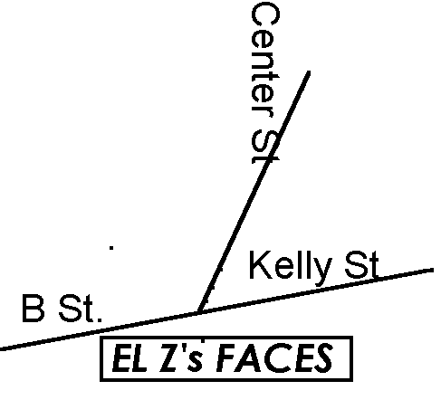About permanent make-up

**Congratulations! You have decided to enhance your beauty with Micropigmentation, also known as Permanent Make-Up, this is a 30 year old cosmetic procedure which places pigment(color) into the dermis layer of the skin. The result is a care free, natural look enhancing the eyebrows, eyes, and lips.**

**Permanent Make-Up will not wash off, smudge or smear. Beneficial for those who are active, vision impaired, allergic to cosmetics, hair loss, or simply desire freedom from make-up.**

**Free consultation includes:**

**- Analysis of skin type**

**- Coloring & facial features**

**A topical numbing solution is applied to minimize discomfort. El Z’s Faces only uses pigment derived rom plant extracts-iron oxide free. All equipment used is disposable.**

**\* permanent make-up:**

**- eye liner  
 - eye brows**

**- beauty mark**

**- areola definition**

**- scar camouflage**

**- lip liner & vermilion (full lips)**

**\* skin treatment overview:**

**- acne treatment**

**- glycolic exfoliation**

**- collagen sheet masks**

**- salicylic resurfacing**

**- razor bump treatment**

**- dermolyse enzyme peel**

**- matrigel skin lightening**

**- deep pore back treatment**

**- express & european facials**

**\* hair removal:**

**- bikini & underarms**

**- full face & half/full leg**

**- eyebrow definition (wax/tweeze)**

**\* eye lashes: (non-permanent)**

**- individual & strip lashes**

**\* products available:**

**- ddf**

**- tend skin**

**- france laure**

**Eyebrows**

Before

Immediately after

7 weeks after