Working with Gulp

As has been mentioned in previous section, Gulp is a JavaScript task runner. It helps with performing repetitive tasks like minification, compilation, unit testing, linting, etc. This is possible thanks to extensive Gulp Plugins library.

Gulp tasks are already set up for you. They are stored inside Cartzilla/gulpfile.js. But in order to have access to them via you Command Line tool you will need to install gulp-cli node package. Gulp CLI stands for Gulp Command Line Interface.To do that type following line in your terminal:

npm install -g gulp-cli\* if you are on Mac make sure to use sudo to install packages globally otherwise you may runt into error.

Gulp CLI commands

* gulp - this main command will fire default gulp task which includes: launching BrowserSync, moving vendor libraries from node\_modules directory to dist folder, javascript minification, sass and pug compilation and lanching watch task. BrowserSync will create dev server and sync your browser with your code editor. Note: to use other separate tasks explained below you will need to open other Terminal window and leave the one with running server intact.
* gulp clean - as the name implies it cleans dist folder from generated (compiled assests like css, js, vendor libs, etc.)
* gulp vendor - moves vendor libraries from node\_modules directory to dist folder. Please check this article explaining how to add new vendor plugin to your project - [Installing Vendor plugins with npm and Gulp](https://demo.createx.studio/cartzilla/docs/install-vendor-plugin.html)
* gulp js - polifill using Babel and then minify and uglify main theme.js file from src folder to dist/js/theme.min.js file which linked to your HTML document. Babel gives you an opportunity to write ES6 javascript and be sure it will be compiled to ES5 js that has a better support across browsers.
* gulp pug - compiles .pug from src/templates folder into HTML in dist folder.
* gulp sass:expanded - compiles .scss files into non-minified CSS (css/theme.css). From src to dist folder.
* gulp sass:minified - compiles .scss files into minified CSS (css/theme.min.css). From src to dist folder.
* gulp watch - launches watch task. It will watch changes of your .scss / .js / .pug files and automatically compile them into .css / .js / .html.

Next steps

Now you when you are equiped with all necessary tools and dev invironment is all set you are ready to dive into Cartzilla customization.

Take some time to familiarize yourself with [Project Structure](https://demo.createx.studio/cartzilla/docs/project-structure.html).

# Project structure

| Folder / File name | Description |
| --- | --- |
| Cartzilla | Folder contains all template source and production files. |
| Cartzilla / src | This folder holds all template source files like .pug, .scss, .js that are then processed (compiled / minified) to dist folder. |
| Cartzilla / dist | Folder contains all template distribution files like .html, .css, .js that have been processed (compiled / minified) from src folder using Node.js and Gulp. |
| Cartzilla / dist / vendor | This folder contains all vendor plugins' .js / .css files. |
| Cartzilla / package.json | File contains meta data about your app or module. Most importantly, it includes the list of dependencies to install from npm when running npm install. |
| Cartzilla / gulpfile.js | Configuration file for Gulp library. It contains all tasks you want to perform with Gulp. Learn more about it from [Working with Gulp](https://demo.createx.studio/cartzilla/docs/working-with-gulp.html) section or [official Gulp documentation](https://github.com/gulpjs/gulp/blob/v4.0.0/docs/API.md). |
| Cartzilla / src / js | This folder contains main theme.js that is processed (compiled / minified) to dist/js/theme.min.js. |
| Cartzilla / src / scss | This folder contains all project sass files that are compiled and minified to styles in dist/css/ folder. |
| Cartzilla / src / templates | This folder contains all pug files that are compiled into HTML in dist, dist/components and dist/docs folders. |

Note: if you do not use Pro Front-End setup with Node.js and Gulp and want directly edit html / css / js files you should be looking into dist folder.

Whether you work with Node.js and Gulp or not you can still take advantage of preprocessors for HTML and CSS.  
In this case you might want to learn [how to use Pug and Sass](https://demo.createx.studio/cartzilla/docs/using-preprocessors.html).

Installing Vendor plugins with npm and Gulp

Follow this 4 easy steps to install 3rd party plugin and use it in your Cartzilla based project:

1. Open your Terminal window and navigate to the root directory of your project (where you package.json file is located).
2. Run npm install <package name> --save. This command does two things: downloads package to node\_modules folder and writes dependency to your package.json file inside dependencies object.
3. Run gulp vendor. This command will clean dist/vendor folder and move all the dpendencies that are listed in package.json file in dependencies object to dist/vendor including your newly downloaded plugins.
4. And last step is to link to plugin's scripts and styles in your document. If you use Pug templates you can link to plugin using array of dependencies. See the screenshot below:

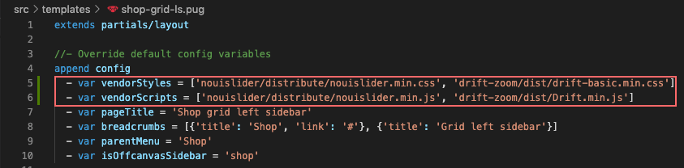

# Using Pug & Sass

Sass (Syntactically Awesome Style Sheets)

Sass is a scripting language that is interpreted or compiled into Cascading Style Sheets (CSS). It is the most mature, stable, and powerful professional grade CSS extension language in the world. Sass gives you the power of variables, mixins, functions, etc.

Pug (former Jade)

Pug is a high performance Node.js Templating Engine. Just like SASS, Pug is a prepocessor and, as such it helps you accomplishing tasks like wrapping away repetitive work by providing features not available in plain HTML like variables, includes, mixins, functions, etc.

## Compiling Sass and Pug

Again, if you are not using Node.js and Gulp setup, don't like command line interface there is another way to work with preprocessors. There is a popular software (GUI) for compiling Sass and Pug called "Prepross". Visit it's website at <https://prepros.io/>. Basic version is completely free and available for Mac and Windows.

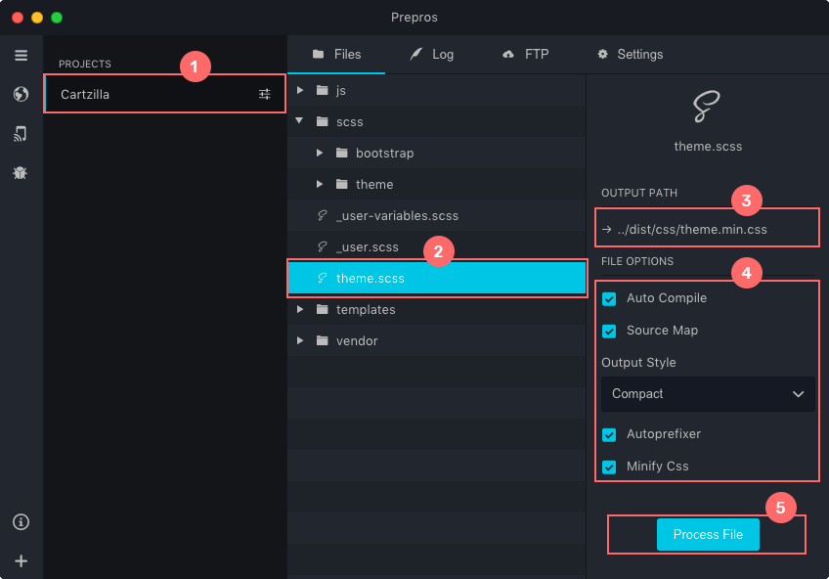

# Browser support

Vendor prefixes are not used inside SCSS instead we use [Autoprefixer](https://github.com/postcss/autoprefixer" \t "_blank) to handle intended browser support via CSS prefixes. After compilation CSS styles are passed through Autoprefixer to add necessary vendor prefixes. As you know vendor prefixes are important to ensure cross-browser compatibility of latest CSS3 features.

## Customize browser support via Autoprefixer settings

Autoprefixer is integral part of Gulp / Node building process. So to customize its settings you need to go to package.json and find "browserslist" array. It's currently set to the Bootstrap's default list of browsers.

Generally it's a good practice to collect some analytics about what Browsers/OSs your visitors use. And then customize Autoprefixer settings based on this data.

For more information about available Browserlist options visit <https://github.com/browserslist/browserslist>.

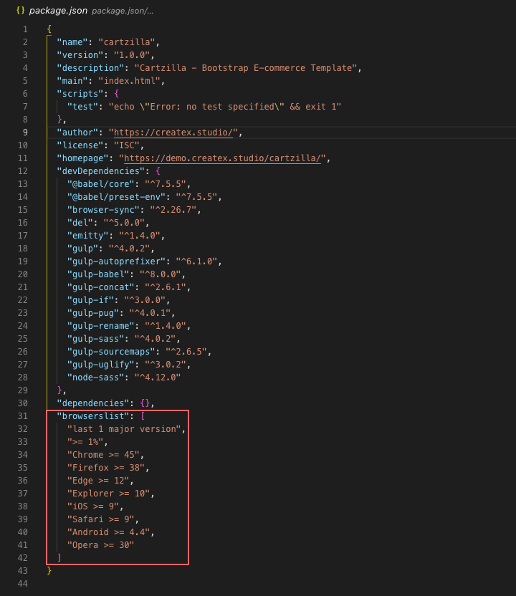

Global colors

There are 2 options to customize Cartzilla global colors:

1. Customize global colors via Sass variables
2. Replace global colors in CSS

Customize global colors via Sass variables

In case you want to create your own color scheme - the fastest and painless way to do that is via Sass variables.

Simply copy necessary variable from Cartzilla/src/scss/theme/helpers/\_variables.scss file and paste to Cartzilla/src/scss/\_user-variables.scss, then compile new theme.min.css file either using Prepros or Gulp. Check [Using Preprocessors](https://demo.createx.studio/cartzilla/docs/using-preprocessors.html) and [Working with Gulp](https://demo.createx.studio/cartzilla/docs/working-with-gulp.html) sections for instructions.

Blelow is the screenshot of the part of Sass variables file responsible for global colors:

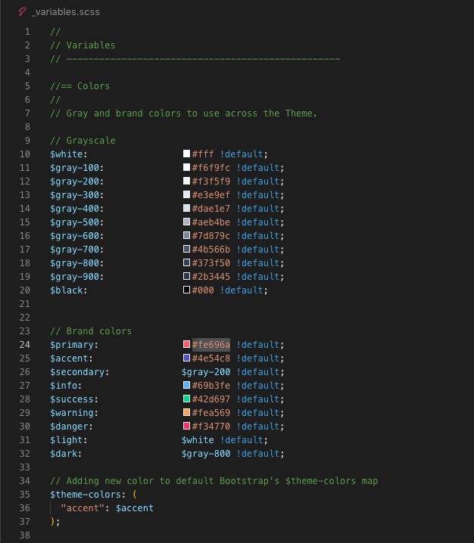

Replace global colors in CSS

This is the hardest way to do things done. I don't recommend it but if you prefer vanilla CSS you can replace all color hex values inside Cartzilla/dist/css/theme.min.css with your own using "find and replace" panel of you code editor. Refer to the image above as a guidance.

# Components

Component - is a snippet of HTML code with assosiated CSS classes and sometimes attached JavaScript functionality that is rendered by the browser as a standalone website element. They can be mixed together to produce more complex components.

Along with all Bootstrap 4 components Cartzilla introduces new elements you can use across website. More than 40 components in total.

[List of all Components as well as their visual reference and code snippets can be found here.](https://demo.createx.studio/cartzilla/components/alerts.html)

[Bootstrap 4 Components and documentation.](https://getbootstrap.com/docs/4.5/components/alerts/)

Below is the image showing how to see code snippet for each component:

# Navbar, Page title and Footer templates (Pug)

You can easily switch between differen pre-built Navbar, Page title and Footer variants using Pug templates.

##### **Navbar**

Here is how to change Navbar and Page title variant inside any page template:

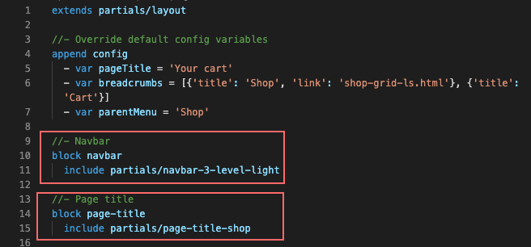

And this is the list of available templates:

* navbar-1-level-light
* navbar-1-level-dark
* navbar-2-level-light
* navbar-2-level-dark
* navbar-3-level-light
* navbar-3-level-dark
* navbar-electro-store
* navbar-marketplace

##### **Footer**

Here is how to change Footer variant inside any page template:

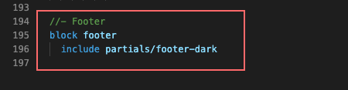

And this is the list of available templates:

* footer-dark
* footer-light
* footer-marketplace

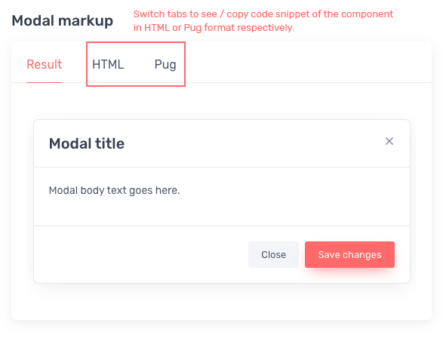

# Utility classes

Bootstrap includes dozens of utilities - classes with a single purpose to reduce the frequency of highly repetitive declarations.

Along with [default Bootstrap 4 utility classes](https://getbootstrap.com/docs/4.5/utilities/borders/) Cartzilla introduces its own. They all live inside Cartzilla/src/scss/theme/\_utilities.scss file.

See part of \_utilities.scss file below:

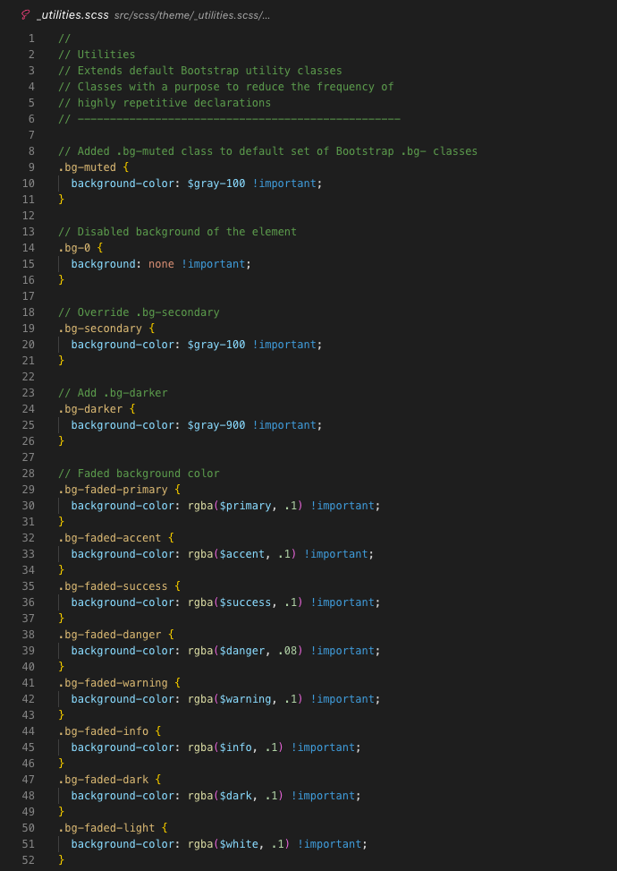

UI icons (Icon font)

Cartzilla includes the collection of vector based font icons to use across the website. See the code example below:

* [HTML](https://demo.createx.studio/cartzilla/docs/ui-icons.html#html)
* [Pug](https://demo.createx.studio/cartzilla/docs/ui-icons.html#pug)
* [Result](https://demo.createx.studio/cartzilla/docs/ui-icons.html#result)

<i class="czi-add-location"></i>

Copy

[You can find the list of all available icons as well as their respective css classes here.](https://demo.createx.studio/cartzilla/components/icon-font.html)

# Mailchimp subscription form

Mailchimp is a marketing automation platform and an email marketing service.

In other words this Mailchimp widget will help you to collect user emails right from you website to run email marketing campaign via Mailchimp web application. Below is the live example of the widget that collects emails for Createx Studio. Switch to HTML or Pug tab to see code example and instructions.

* [Result](https://demo.createx.studio/cartzilla/docs/mailchimp.html#result9)
* [HTML](https://demo.createx.studio/cartzilla/docs/mailchimp.html#html9)
* [Pug](https://demo.createx.studio/cartzilla/docs/mailchimp.html#pug9)

### **Subscribe**

Parte superior do formulário

Subscribe\*



\*Subscribe to our newsletter to receive early discount offers, updates and new products info.

Parte inferior do formulário

# Sources and credits

While making this template we used 3rd party plugins, images, icons, fonts, etc... and want to thank their creators.

## Plugins, Libraries and Frameworks:

* Node.js - <https://nodejs.org/en/>
* Gulp - <https://gulpjs.com/>
* Pug - <https://pugjs.org/api/getting-started.html>
* Sass - <http://sass-lang.com/>
* jQuery - <https://jquery.com/>
* Bootstrap 4 - <https://getbootstrap.com/>
* Smooth Scroll - <https://github.com/cferdinandi/smooth-scroll/>
* Tiny Slider - <https://github.com/ganlanyuan/tiny-slider>
* Lightgallery.js - <https://sachinchoolur.github.io/lightgallery.js/>
* noUiSlider - <https://refreshless.com/nouislider/>
* Simplebar (Custom Scrollbar) - <https://github.com/Grsmto/simplebar>
* Popper.js - <https://popper.js.org/>
* Prism.js - <https://prismjs.com/>
* Interactive Credit Card - <https://github.com/jessepollak/card>
* Drift (Zoom on hover) - <https://github.com/imgix/drift>
* Shuffle.js (Masonry grid) - <https://vestride.github.io/Shuffle/>
* imagesLoaded - <https://imagesloaded.desandro.com/>
* Chartist.js - <https://github.com/gionkunz/chartist-js>

## Google Fonts:

* Rubik - <https://fonts.google.com/specimen/Rubik>

## Font Icons:

* Essential Icons - <https://freeui.design/250-essential-icons-set/>
* Flaticon Icons - <https://www.flaticon.com/>

## Graphic Assets:

### **Homepages**

* <https://www.pexels.com/photo/woman-holding-lollipop-1841349/>
* <https://www.pexels.com/photo/black-woman-wearing-hoodie-jacket-2306109/>
* <https://unsplash.com/photos/_7LbC5J-jw4>
* <https://www.anthonyboyd.graphics/mockups/top-view-ipad-pro-2018-mockup-set-vol-2/>
* <https://www.pixeden.com/psd-mock-up-templates/ui-isometric-psd-devices-pack-vol5>
* <https://unsplash.com/photos/kJ2xdKJZZ9k>
* <https://www.pexels.com/photo/woman-wearing-black-sleeveless-dress-holding-white-headphone-at-daytime-1001850/>
* <https://www.pexels.com/photo/person-holding-silver-iphone-7-887751/>
* <https://www.sketchappsources.com/free-source/4099-flat-iphone-11-pro-mockup-sketch-freebie-resource.html>
* <https://unsplash.com/photos/uTPkovVRhR8>
* <https://unsplash.com/photos/2awzIErSaG0>
* <https://www.pexels.com/photo/man-wearing-gray-sweatshirt-and-headphones-374888/>
* <https://www.freepik.com/free-photo/side-view-photo-girl-listening-music-with-headphones_6819398.htm>
* <https://unsplash.com/photos/CgKpB3iSX5c>
* <https://www.pexels.com/photo/smiling-woman-using-headphones-3394668/>
* <https://www.freepik.com/free-photo/medium-shot-woman-with-headphones-book_5551587.htm>
* <https://www.beatsbydre.com/>
* <https://www.freepik.com/free-photo/portrait-beautiful-family-holding-paper-shopping-bag_6729742.htm>
* <https://www.freepik.com/free-photo/happy-delivery-man-pointing-grocery-bag-hand_6292832.htm>
* <https://www.flaticon.com/packs/grocery-18>

### **Shop catalog**

* <https://www2.hm.com/>
* [https://www.6pm.com](https://www.6pm.com/)
* <https://usa.tommy.com/>

### **Shop categories**

* <https://www.pexels.com/photo/man-wearing-blue-lacoste-polo-shirt-and-silver-colored-analog-watch-1232459/>
* <https://www.pexels.com/photo/woman-in-blue-and-white-striped-top-raising-her-left-hand-1462637/>
* <https://unsplash.com/photos/sF5X5zTVtmc>
* <https://www.freepik.com/free-photo/young-man-sitting-top-rock-looking-view_5223515.htm>

### **Marketplace**

* <https://www.pixeden.com/psd-mock-up-templates/ui-isometric-psd-devices-pack-vol5>
* <https://www.invisionapp.com/inside-design/design-resources/>
* <https://www.anthonyboyd.graphics/mockups/top-view-apple-watch-series-5-mockup/>
* <https://www.pixeden.com/psd-mock-up-templates/psd-hardcover-book-catalog-mockup-2>
* <https://www.pixeden.com/psd-mock-up-templates/psd-project-devices-showcase-vol3>
* <https://www.pixeden.com/psd-mock-up-templates/gravity-psd-devices-ui-mockup-set-v7>
* <https://www.anthonyboyd.graphics/mockups/floating-iphone-11-pro-max-and-ipad-pro-mockup/>
* <https://www.ls.graphics/free/simple-iphone-x-mockups>
* <https://www.pixeden.com/psd-mock-up-templates/ui-psd-iphone-x-monochrome>
* <https://www.mockupdaddy.com/download/free-download-iphone-11-pro-clay-mockup/>
* <https://www.mockupworld.co/free/girl-wearing-printed-t-shirt-mockup/>
* <https://www.flaticon.com/packs/user-interface-7>
* <https://unsplash.com/photos/Zk--Ydz2IAs>
* <https://unsplash.com/photos/e2oAzYuYh3k>
* <https://unsplash.com/photos/Ajcipx1VDXI>

### **Food Delivery**

* <https://unsplash.com/photos/Z5tSnuGuTTw>
* <https://unsplash.com/photos/ICA6PtRBYLw>
* <https://unsplash.com/photos/NzHRSLhc6Cs>
* <https://unsplash.com/photos/J9lD6FS6_cs>
* <https://unsplash.com/photos/JorKKx5rvA0>
* <https://www.pexels.com/photo/delicious-coconut-mousse-cake-with-disposable-cup-of-coffee-4551124/>
* <https://www.pexels.com/photo/top-view-photo-of-assorted-fruits-1171170/>
* <https://www.pexels.com/photo/baking-cheese-cooking-crust-315755/>
* <https://www.pexels.com/photo/noodles-with-meat-and-mint-on-top-2664216/>
* <https://www.pexels.com/photo/delivery-man-wearing-a-face-mask-4393241/>
* <https://www.pexels.com/photo/man-in-white-dress-shirt-wearing-eyeglasses-3814446/>
* <https://www.toptal.com/designers/subtlepatterns/?s=food>
* <https://psdrepo.com/free-psd/recipe-app-free-psd-ui-kit-freebie/>
* <https://freebiesbug.com/psd-freebies/minimal-iphone-x-mockups/>
* <https://www.graphicpear.com/line-minimal-food-icons-vector/>
* <https://unsplash.com/s/photos/burger>
* <https://www.freepngimg.com/food/pizza>

### **Promo banner**

* <https://www.pexels.com/photo/close-up-photo-of-sneakers-2529146/>

### **Blog pages**

* <https://www.pexels.com/photo/adult-cutting-daylight-facial-expression-1153369/>
* <https://www.pexels.com/photo/working-macbook-computer-keyboard-34577/>
* <https://unsplash.com/photos/49mCO5ZRQDk>
* <https://unsplash.com/photos/7YlHU_ZPS34>
* <https://unsplash.com/photos/yK1zLvFkXIQ>

### **People faces**

* <https://unsplash.com/photos/sLGYaQ_stMM>
* <https://unsplash.com/photos/9R-CH7PR150>
* <https://unsplash.com/photos/oJUTLMxMsgE>

### **404 Error page illustration**

* <https://www.shutterstock.com/image-vector/empty-shopping-bag-basket-icon-cute-789717544>

### **Pages**

* <https://www.pexels.com/photo/woman-in-yellow-blouse-and-blue-jeans-taking-selfie-while-sitting-on-car-787472/>

### **Components docs**

* <https://unsplash.com/photos/tvG4WvjgsEY>
* <https://www.pexels.com/photo/photo-of-sneakers-on-white-background-2529148/>
* <https://www.pexels.com/photo/white-and-blue-floral-flap-sling-bag-hanging-on-white-steel-rack-904350/>
* <https://www.pexels.com/photo/woman-wearing-white-blue-and-red-cold-sleeved-mini-dress-and-bag-set-1163194/>
* <https://unsplash.com/photos/fr0J5-GIVyg>
* <https://unsplash.com/photos/w0gF-h1Oq28>
* <https://unsplash.com/photos/sf_1ZDA1YFw>
* <https://www.mockupworld.co/free/girl-wearing-printed-t-shirt-mockup/>
* <https://www.mockupworld.co/free/two-paper-bags-mockup/>
* <https://www.mockupworld.co/free/business-card-branding-mockup-collection/>
* <https://www.mockupworld.co/free/t-shirt-for-men-on-a-white-hanger-mockup/>
* <https://www.mockupworld.co/free/clean-paper-cup-mockup/>
* <https://www.pixeden.com/psd-mock-up-templates/psd-product-manual-mockup>
* <https://www.pixeden.com/psd-mock-up-templates/folded-t-shirt-mockup-template-2>
* <https://www.pixeden.com/psd-mock-up-templates/paperback-psd-book-mockup-vol6>
* <https://unsplash.com/photos/aDZ5YIuedQg>
* <https://www.mockupworld.co/free/t-shirt-for-men-mockup/>
* <https://www.pexels.com/photo/white-headphone-1037992/>

Changelog

v1.4 –  July 13, 2020

* New

Food Delivery Service Demo:

* + Front Page (Homepage). [View demo](https://demo.createx.studio/cartzilla/home-food-delivery.html" \t "_blank)
  + Category Page. [View demo](https://demo.createx.studio/cartzilla/food-delivery-category.html" \t "_blank)
  + Single Item (Restaurant) Page. [View demo](https://demo.createx.studio/cartzilla/food-delivery-single.html" \t "_blank)
  + Cart (Your Order). [View demo](https://demo.createx.studio/cartzilla/food-delivery-cart.html" \t "_blank)
  + Checkout (Address & Payment). [View demo](https://demo.createx.studio/cartzilla/food-delivery-checkout.html" \t "_blank)
* New

Single Post no Sidebar Template  [View demo](https://demo.createx.studio/cartzilla/blog-single.html)

* Updated

Bootstrap to latest stable version 4.5.0

* Updated

All plugins, npm modules and dependencies to latest versions

* Updated

Changed CSS class name of transparent navigation bar from navbar-transparent to navbar-floating. Updated stickyNavbar() function inside theme.js

* Updated

ajaxifySubscribeForm() inside theme.js. Rewrote code from jQuery to vanilla JavaScript

* Updated

Redesigned the structure of PUG templates dependencies: Moved navbar and footer partials from layout.pug to page templates. Now template inheritance works via block keyword. These changes made the compilation process 1.5x faster when you channge something in navbar or footer partials. Plus now you have more flexibility to adjust navigation bars and footers for individual pages.

* Updated

package.json and gulpfile.js files. Now all 3rd party plugins and libraries are installed via npm automatically when you run npn install command (previously manually) and moved from node\_modules to dist folder by Gulp on project init. Read more about how add new vendor plugins to the project in [this article](https://demo.createx.studio/cartzilla/docs/install-vendor-plugin.html)

* Updated

Getting started and components documentation: Fixed components code examples. Updated section: [Navbar / Page title / Footer variants (Pug)](https://demo.createx.studio/cartzilla/docs/navbar-footer.html). Added section: [Installing Vendor plugins with npm and Gulp](https://demo.createx.studio/cartzilla/docs/install-vendor-plugin.html)

* Updated

Sketch file: added new Food Delivery Service demo frontpage mockup

* Fixed

Minor bug fixes and improvements

v1.3 –  February 29, 2020

* New

Grocery Store Demo:

* + Front Page (Homepage). [View demo](https://demo.createx.studio/cartzilla/home-grocery-store.html" \t "_blank)
  + Product Catalog Page. [View demo](https://demo.createx.studio/cartzilla/grocery-catalog.html" \t "_blank)
  + Single Product Page. [View demo](https://demo.createx.studio/cartzilla/grocery-single.html" \t "_blank)
  + Checkout Page Template. [View demo](https://demo.createx.studio/cartzilla/grocery-checkout.html" \t "_blank)
* New

Single Product / Brand Store  [View demo](https://demo.createx.studio/cartzilla/home-single-store.html)

* New

Navbar with Side Menu. See live example on Grocery Store Demo page

* New

Transparent Navbar version. See live example on Single Product/Brand Store Demo page

* New

Javascript behavior when radio buttons behave like tabs by switching linked content. See live example on Single Product/Brand Demo page (Choose your style section)

* New

Added empty state for Cart dropdown. See live example on Single Product/Brand Demo page

* Updated

Replaced Salvattore.js with Shuffle.js and imagesLoaded.js for masonry grid (particularly Blog grid) layouts

* Updated

Color presets (radio buttons) now changing labels dynamically via Javascript. See it in action on Shop Single Product pages v1 and v2

* Updated

Added new icons to Cartzilla icon font

* Updated

Sketch file with new demo page design mockups

* Updated

Security patch: Added rel='noopener' to all links with target='\_blank' attribute. For more info read [this article](https://developers.google.com/web/tools/lighthouse/audits/noopener" \t "_blank)

* Updated

Node modules to latest versions

* Fixed

Handheld Toolbar styles: Removed padding-bottom that equals to Toolbar height from body by default. Now you can add bottom padding to body by applyoing css class toolbar-enabled to body. If you use PUG it applies automatically if var isToolbar = true is added to particular page template or globally enabled via templates/helpers/config.pug. It's done to ensure that you can remove bottom padding from body without editing core theme styles if you don't need Handheld Toolbar.

* Fixed

SCSS maps in theme \_variable.scss. Special thanks to Kevin Ramharak for the fix suggestion

* Fixed

Minor bug fixes and improvements

v1.2 –  December 20, 2019

* New

Added new Toolbar for Handheld devices that is fixed to bottom (similar to iOS) and holds all important buttons like Menu, Cart, Wishlist, Sidebar togglers, etc. This will improve user experience on handheld devices.

* New

Added .gitignore file to the download package that tells git which files (or patterns) it should ignore. Make sure to enable hidden files visibility on your system.

* Updated

Navigation bars (Headers): added tooltips for action buttons. Added separate wishlist button for cases when wishlist is available not only for registered users.

* Updated

404 Error page templates

* Updated

JavaScript plugins to latest versions

* Updated

Node modules to latest versions

* Fixed

Documentation typos and wrong content.

* Fixed

Minor bug fixes and improvements

v1.1 –  November 30, 2019

* New

Digital Products Marketplace Demo:

* + Front Page (Homepage). [View demo](https://demo.createx.studio/cartzilla/home-marketplace.html" \t "_blank)
  + Catalog (Category) page with filters. [View demo](https://demo.createx.studio/cartzilla/marketplace-category.html" \t "_blank)
  + Single Item Page. [View demo](https://demo.createx.studio/cartzilla/marketplace-single.html" \t "_blank)
  + Vendor (Seller) Page. [View demo](https://demo.createx.studio/cartzilla/marketplace-vendor.html" \t "_blank)
  + Cart page template. [View demo](https://demo.createx.studio/cartzilla/marketplace-cart.html" \t "_blank)
  + Checkout page template. [View demo](https://demo.createx.studio/cartzilla/marketplace-checkout.html" \t "_blank)
* New

Marketplace Vendor / User Dashboard:

* + Profile Settings. [View demo](https://demo.createx.studio/cartzilla/dashboard-settings.html" \t "_blank)
  + Purchases. [View demo](https://demo.createx.studio/cartzilla/dashboard-purchases.html" \t "_blank)
  + Favorites. [View demo](https://demo.createx.studio/cartzilla/dashboard-favorites.html" \t "_blank)
  + Sales. [View demo](https://demo.createx.studio/cartzilla/dashboard-sales.html" \t "_blank)
  + Products. [View demo](https://demo.createx.studio/cartzilla/dashboard-products.html" \t "_blank)
  + Add New Product. [View demo](https://demo.createx.studio/cartzilla/dashboard-add-new-product.html" \t "_blank)
  + Payouts. [View demo](https://demo.createx.studio/cartzilla/dashboard-payouts.html" \t "_blank)
* New

Electronics Store Homepage. [View demo](https://demo.createx.studio/cartzilla/home-electronics-store.html" \t "_blank)

* New

Single Product Page v2. [View demo](https://demo.createx.studio/cartzilla/shop-single-v2.html" \t "_blank)

* New

Product Comparison Page (Table). [View demo](https://demo.createx.studio/cartzilla/comparison.html" \t "_blank)

* New

Navbar Versions for: Marketplace and Electronics Store

* New

Footer Version for: Marketplace

* New

Qucik View Popup v2 (for Electronics Store)

* New

404 Error Page Template (Text variant). [View demo](https://demo.createx.studio/cartzilla/404-simple.html" \t "_blank)

* New

Charts Component. [View demo](https://demo.createx.studio/cartzilla/components/charts.html" \t "_blank)

* New

Countdown Timer Component. [View demo](https://demo.createx.studio/cartzilla/components/countdown.html" \t "_blank)

* New

Product Card for Digital (Downloadable) Products

* New

Drag & Drop File Uploader. See updated Forms component page for more details

* Updated

Bootstrap to latest version 4.4.1

* Updated

Homepage Hero Slider. Added Animations to Slider Text Layers

* Updated

Icon Font. Added new Icons to the collection. [See available icons](https://demo.createx.studio/cartzilla/components/icon-font.html" \t "_blank)

* Updated

\_variables.scss Added $path-to-fonts variable. Now it's easier to change theme font via \_user-variables.scss

* Updated

Sketch file. Added new page mockups

* Updated

Documentation and Components

* Fixed

Minor bug fixes and improvements

v1.0 –  October 21, 2019

* Initial release