Converter case study

Jakub Michalski, Dubai College

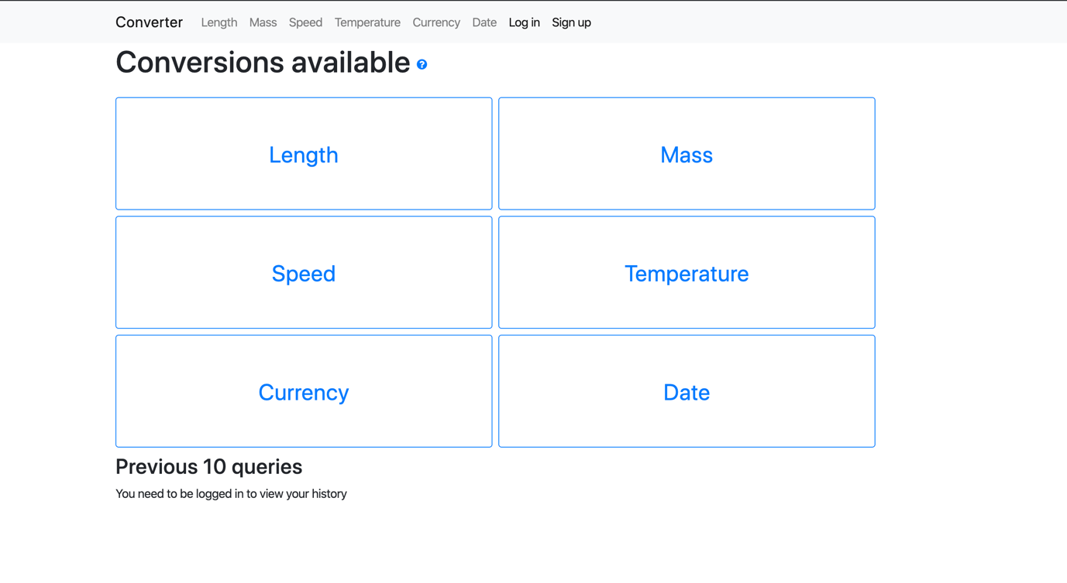

# Usage

## MacOS

1. In the terminal, navigate into the converter_case_study folder (folder containing converter, user_interface, venv_mac folders etc.)
2. Execute ‘source venv_mac/bin/activate’
3. If everything executes successfully, your terminal input should be preceded by ‘venv_mac’, like below



1. Verify that all the necessary modules are installed using ‘pip freeze’, which should produce a list as below

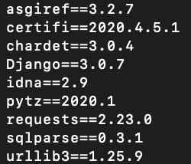

1. Run the server using ‘python3 manage.py runserver’
2. In your browser, navigate to the IP address output in the console, example below

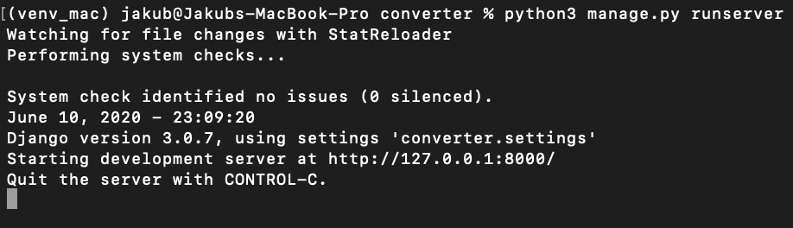

1. The website should load in the browser
2. In case of any errors, please follow the ‘Different operating environment/error’ section

## Windows

1. In cmd, navigate into the converter_case_study folder (folder containing converter, user_interface, venv_mac folders etc.)
2. Execute ‘venv_windows\Scripts\activate’

## Different operating environment/error

1. In the terminal, navigate into the converter_case_study folder (folder containing converter, user_interface, venv_mac folders etc.)