Amilia > WordPress API (A2WP)

TABLE OF CONTENTS
Purpose | p. 2
Functionality Overview | p. 2-3
Authorization | p. 3
Endpoints and URLs | p. 3
Adding Custom Functions | p. 4-6

PURPOSE
A2WP’s main goal is to fetch data from SBVPA’s Amilia account (https://app.amilia.com/Account/en/sbvpa), format the results, and push the product to SB websites.
Within its Azure project, two functions call the class: CreateA2WP and UpdateA2WP. CreateA2WP runs on a timer and grabs all Amilia and WordPress data for the purpose of comparing them; UpdateA2WP runs on an HTTP trigger and grabs the data of one specific Amilia/WordPress post.
If you want to set up A2WP to a new site, first follow the steps in the GitHub readme.

FUNCTIONALITY OVERVIEW
A2WP is a class declared in site > wwwroot > A2WP > a2wp.js
You may see other files in the A2WP directory, like sbvpa-a2wp.js and dreamcenter-a2wp.js. These scripts build out A2WP objects and give them custom functionality.
To make your own object, you should make a separate file like the two I just mentioned. You’ll hopefully never need to edit a2wp.js, but just in case – here’s a brief description of the class’s main functions.
fetchData | Fetches data from Amilia backend and from the specified WP site. If the result returns multiple pages, fetchData collects the header’s pagination info and sends it to fetchMorePages.
postData | Pushes data to the specified URL + endpoint. All this data first needs to be stored in the bodyData parameter as a JSON object.
delete | Takes a URL that has an endpoint + post id and deletes that post. Will also delete the post’s attached thumbnail to reduce the amount of unparented images in WP’s media folder.
checkExists | If running CreateA2WP, checkExists compares all available Amilia data with all current WP posts and sees 1) if Amilia has any new posts WP needs to add, and 2) if WP has any old posts that no longer exist on Amilia.
call | Runs fetchData, checkExists (if necessary), and passes data through custom functions. The custom functions will create an objPost and objDel: call then posts everything in objPost and deletes everything in objDel.

AUTHORIZATION
A2WP needs authorization for both Amilia and WordPress. All passwords and tokens exist in the Azure project > Settings > Environment variables.
To grab Amilia events, A2WP uses the bearer token AUTH_TOKEN.
CreateA2WP and UpdateA2WP use WP Application Passwords to push changes to WP. The two Application Passwords that the API currently use are SBVPA_PASS and DREAMCENTER_PASS.
To generate an Application Password, go the appsadmin account on your WP site, go to profile, and scroll all the way down. It should have the option to generate a password – if not, Wordfence may have disabled that feature by default.

ENDPOINTS AND URLS
https://a2wp.azurewebsites.net/api/UpdateA2WP
https://app.amilia.com/api/V3/en/org/sbvpa/
SBVPA
https://sbvpa.org/wp-json/wp/v2/
GET endpoints: activities?amilia_id&status=publish&per_page=100
POST endpoints: activities, activities/{id}, media

DREAMCENTER
https://dreamcente2dev.wpenginepowered.com/wp-json/wp/v2/
GET endpoints: events?amilia_id&status=publish&per_page=100
POST endpoints: activities, activities/{id}, media
ADDING CUSTOM FUNCTIONS
The purpose of custom functions is to manipulate Amilia data into something viable for posting to WP. Each function must first be declared and then assigned to your A2WP instance; the functions execute in the order they are assigned.
To create your own instance and functions, enter the Azure project and make your way to the Kudu Services from the left menu.
Development Tools > Advanced Tools > Go > Debug console
Now that you’re in the file explorer, go to site > wwwroot > A2WP and hit the plus beside the A2WP to make a new file, which you’ll name (site name)-a2wp.js
Here are some examples of what should be in this file:
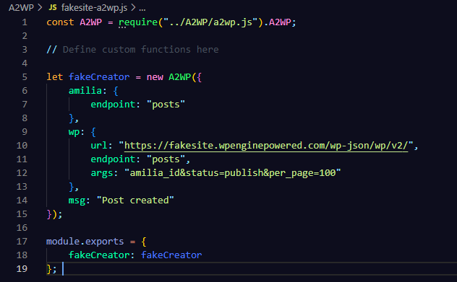
A2WP should always be required at the top of the script because this allows your script to access a2wp.js. Likewise, module.exports should always pass your new A2WP object at the bottom of the script so the rest of the Function App can read it.
The msg variable is not necessary, but it’s encouraged because it prints what’s happening to the log and helps with debugging.
Next, let’s add a function. Say you only want to post free activities to WP. The script would check the price of each available Amilia item and decide whether or not it fits the “free” description.
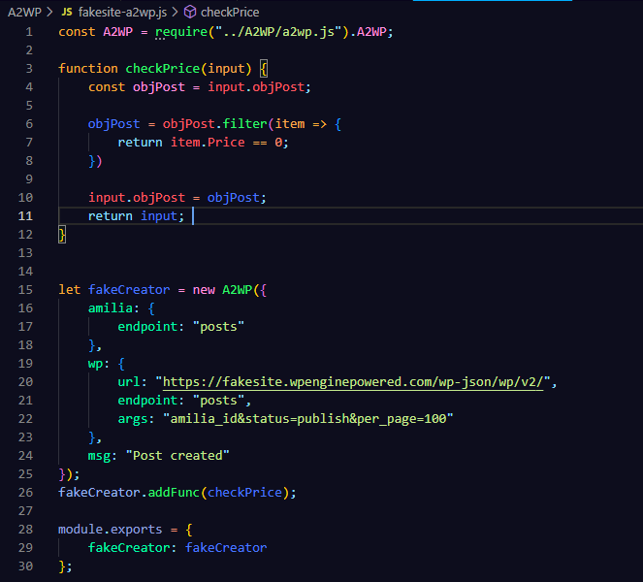
Every custom function must pass input as a parameter and must return input. Input is carried throughout all custom functions. If you want to add more values to input, just write something like input.newVar = “something” and the next function will be able to access it.
objPost and objDel are the first two arrays to exist in input, and even though the class automatically generates content for them, you can also tamper with these values if you want to add/remove items from either array.
Now you’ll need to build the actual content going to WP.
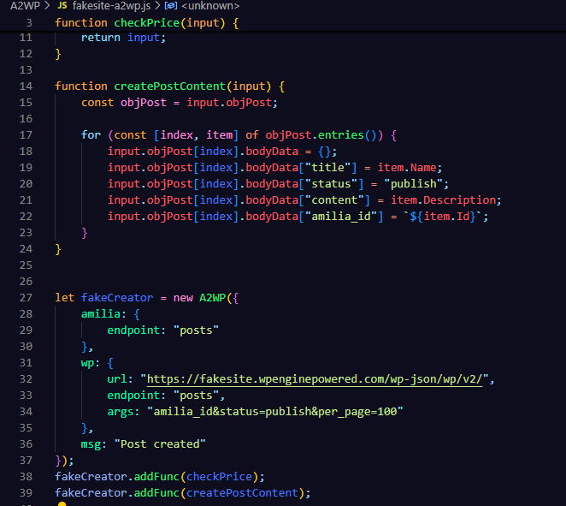
Add all WP attributes to bodyData (title, status, and amilia_id are required).
All your content must be passed in a variable named “bodyData” otherwise it will not carry over.
Finally, call the new object.
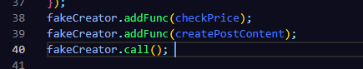

Happy debugging! (Or not, if you’re lucky.)

