|  |  |
| --- | --- |
| Logo_FPT_University_doc | **MINISTRY OF EDUCATION AND TRAINING**  **FPT UNIVERSITY** |

**REPORT DOCUMENT**

***Project***

**COMPUTER SHOP**

**Management System**

***Software Design Specification***

|  |  |
| --- | --- |
| <Group 3rd – SE1310> | |
| **Group Member** | Nguyen Minh Quang – HE130059 |
| Hoang Duc Phong |
| Nguyen Thu Trang |
| Nguyen Duy Nam |
| **Supervisor** | Tran Quy Ban |
| **Ext. Supervisor** |  |
| **Project Code** | Computer Shop Management System |

# Table of Contents

[Table of Contents 2](#_Toc15036314)

[1. ARCHITECTURE DESIGN 3](#_Toc15036315)

[1.1 Choice of Architecture Design 3](#_Toc15036316)

[1.2 Architectural Presentation 4](#_Toc15036317)

[1.2.1 Context Diagram 4](#_Toc15036318)

[1.2.2 Architecture: 4](#_Toc15036319)

[2. DIAGRAM 5](#_Toc15036320)

[2.1.1 Class Diagram 5](#_Toc15036321)

[2.1.2 State Diagram 7](#_Toc15036322)

[2.1.3 Sequence Diagram 8](#_Toc15036323)

# ARCHITECTURE DESIGN

## Context Diagram

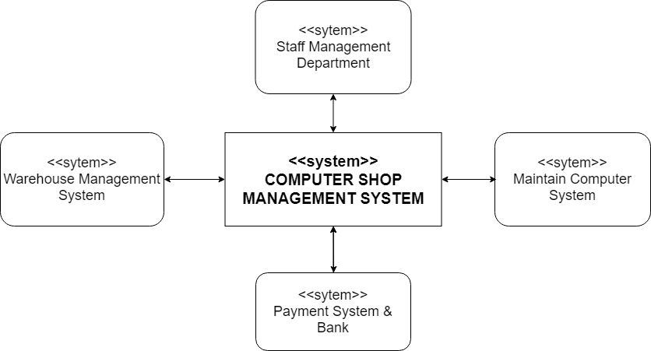

## Architectural Presentation

Our Computer Shop Management System has been deployed on Web and our system is for computer shop so we choosing MVC architecture to development because its advantage.

* **Advantages of MVC**
* **Faster development process:** MVC supports rapid and parallel development. With MVC, one programmer can work on the view while other can work on the controller to create business logic of the web application. The application developed using MVC can be three times faster than application developed using other development patterns.
* **Ability to provide multiple views:** In the MVC Model, you can create multiple views for a model. Code duplication is very limited in MVC because it separates data and business logic from the display.
* **Support for asynchronous technique:** MVC also supports asynchronous technique, which helps developers to develop an application that loads very fast.
* **Modification does not affect the entire model:** Modification does not affect the entire model because model part does not depend on the views part. Therefore, any changes in the Model will not affect the entire architecture.
* **MVC model returns the data without formatting:** MVC pattern returns data without applying any formatting so the same components can be used and called for use with any interface.
* **SEO friendly Development platform:** Using this platform, it is very easy to develop SEO-friendly URLs to generate more visits from a specific application.
* **Disadvantages of MVC**
* Increased complexity
* Inefficiency of data access in view
* Difficulty of using MVC with modern user interface.
* Need multiple programmers
* Knowledge on multiple technologies is required.
* Developer have knowledge of client-side code and html code.

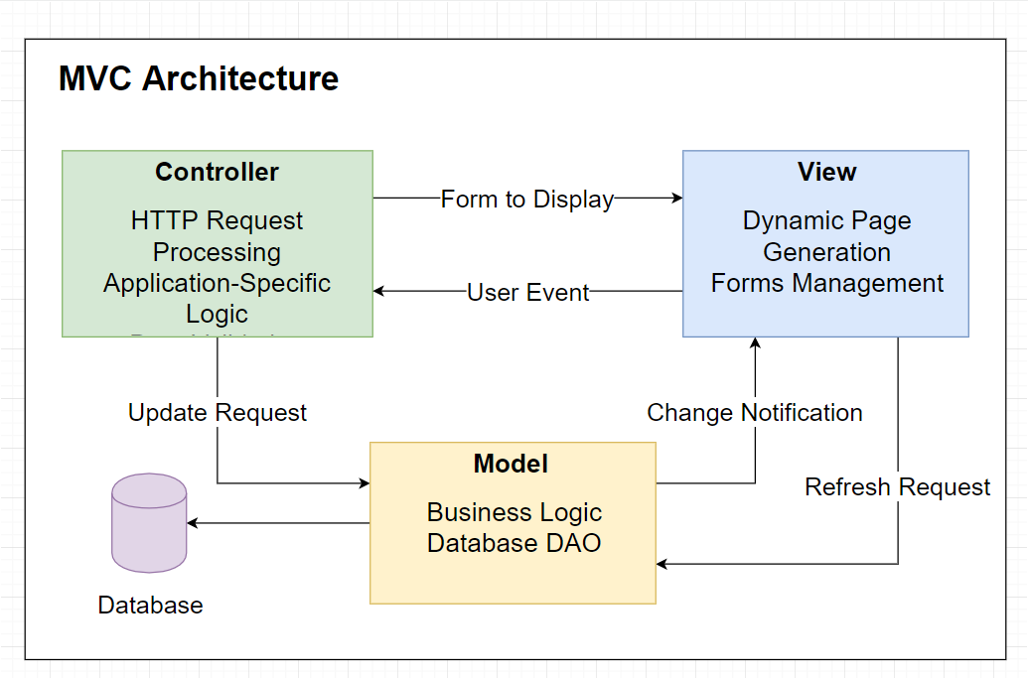

# DIAGRAM

### Class Diagram

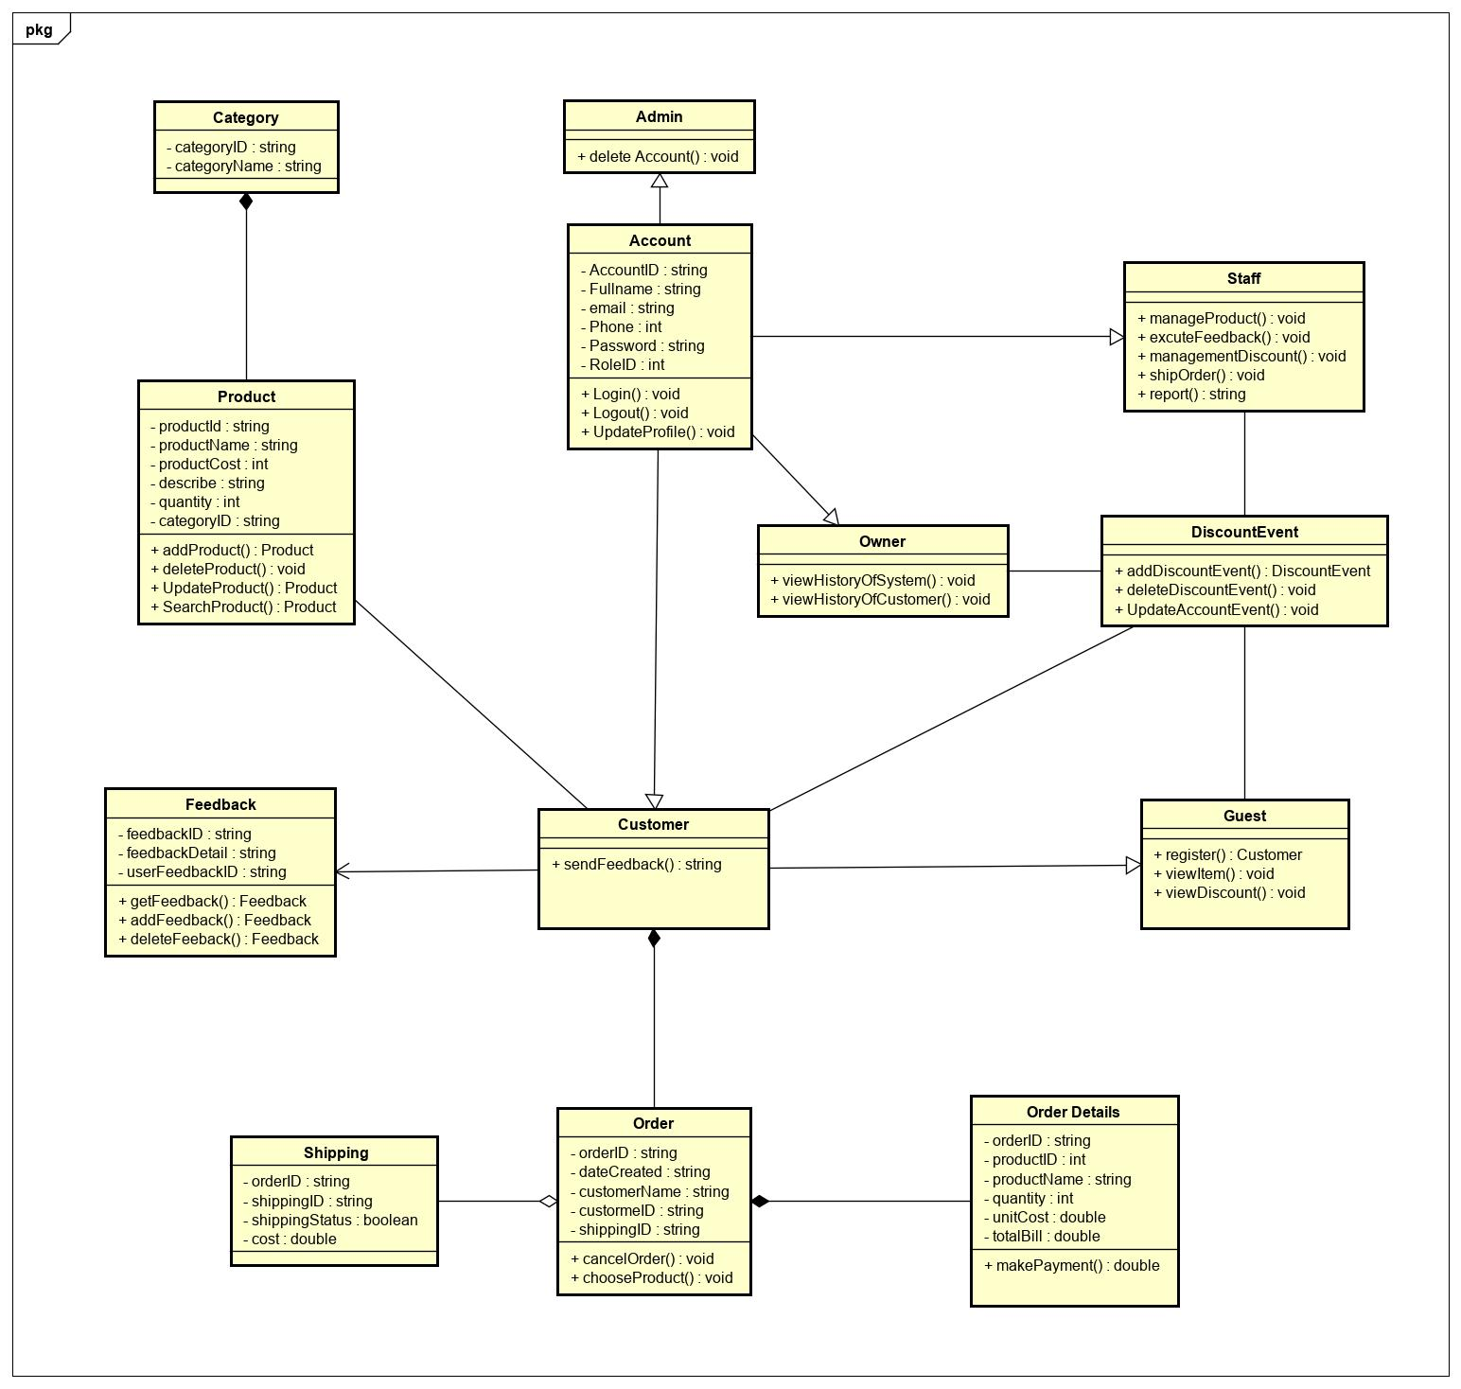

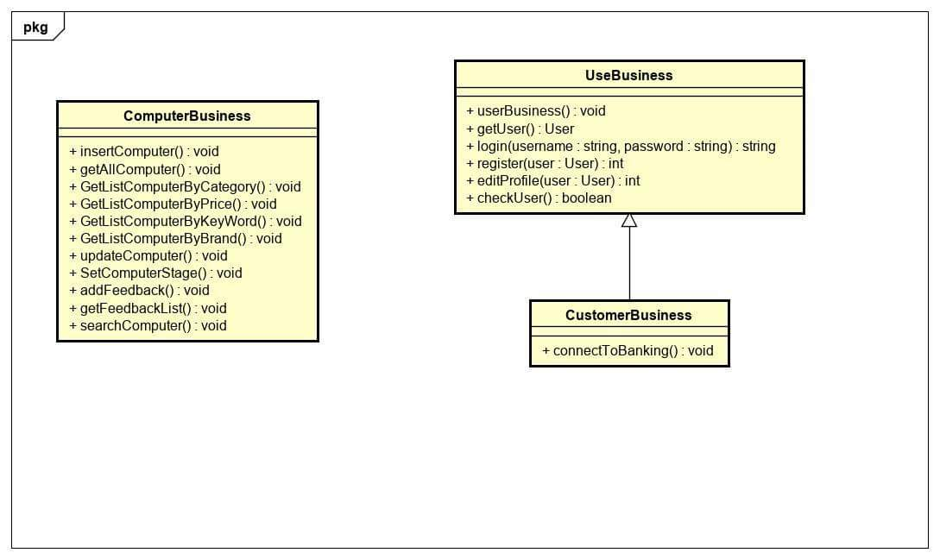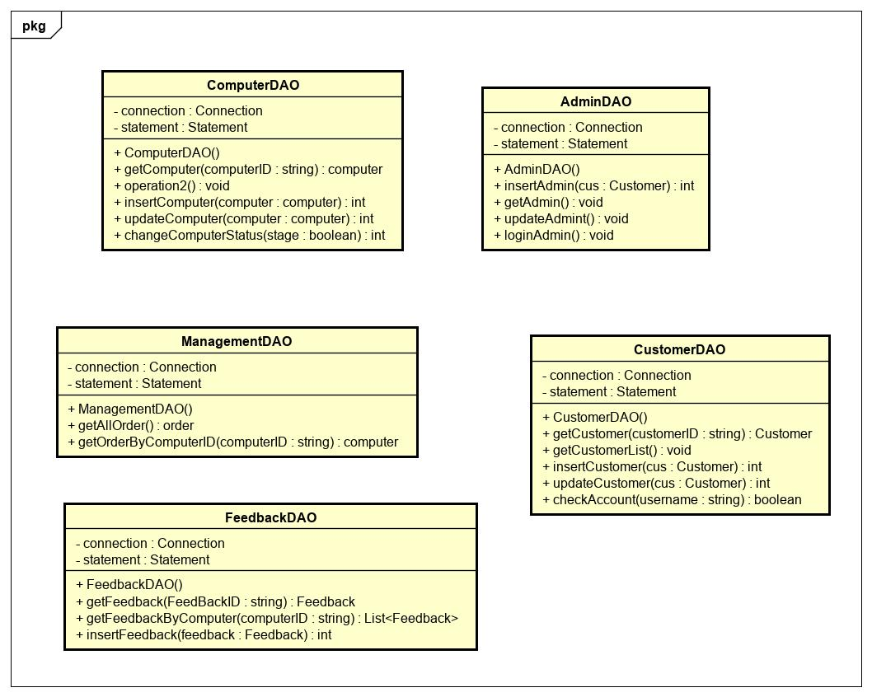

### State Diagram

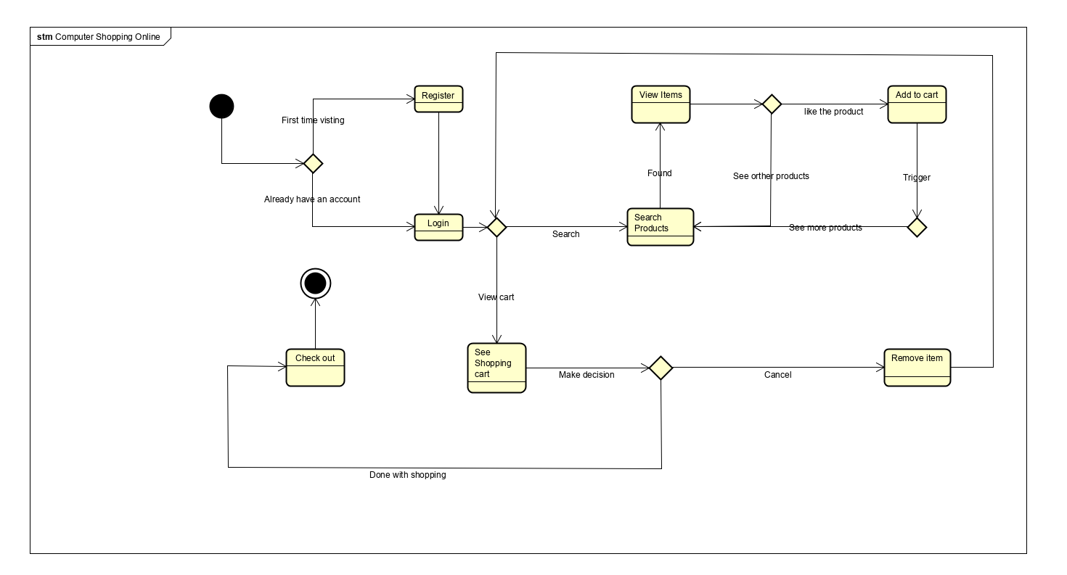

### Sequence Diagram

#### Login

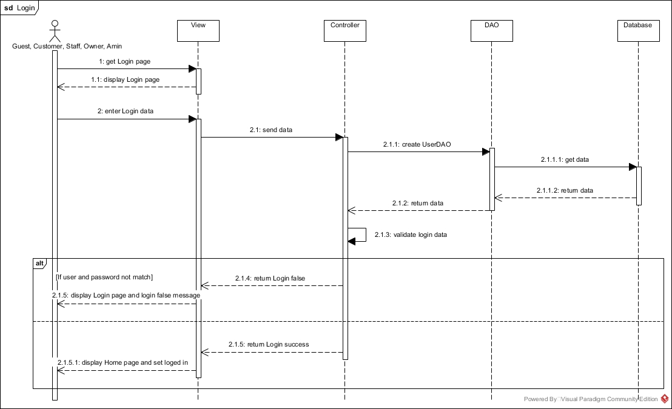

#### Logout

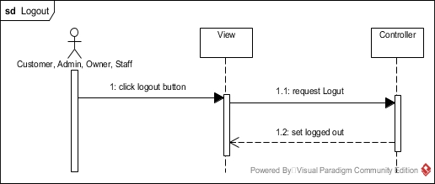

#### Register

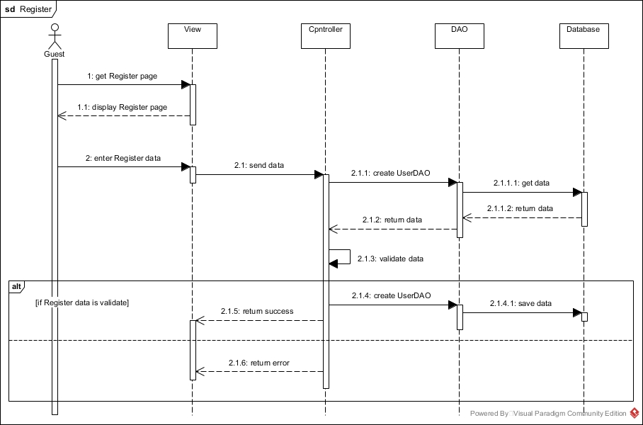

#### Update Profile

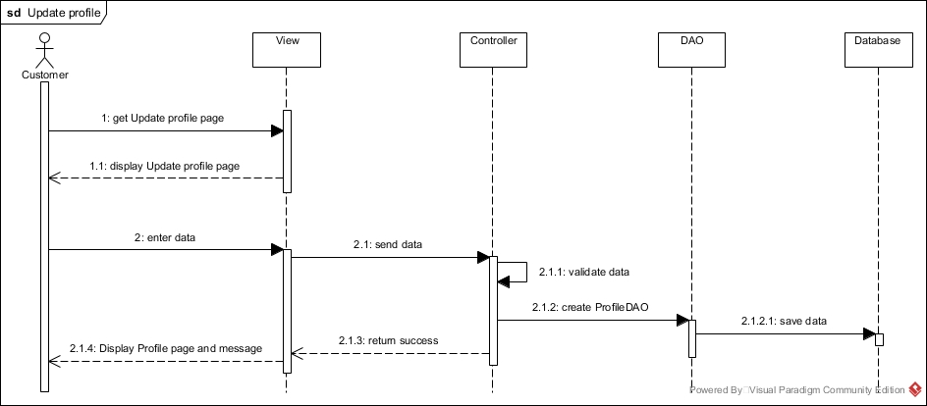

#### Delete Account

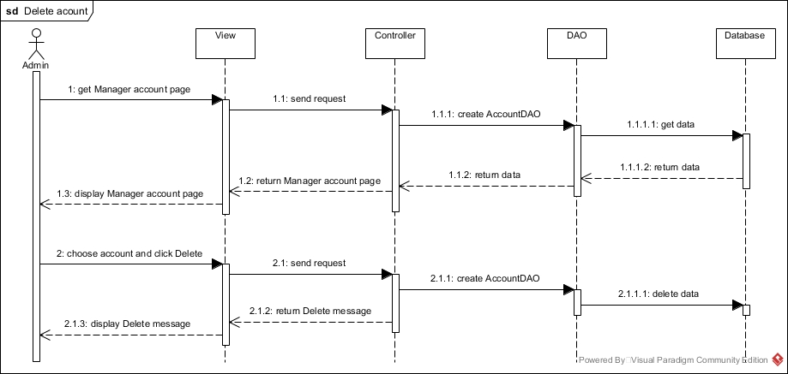

#### Add item

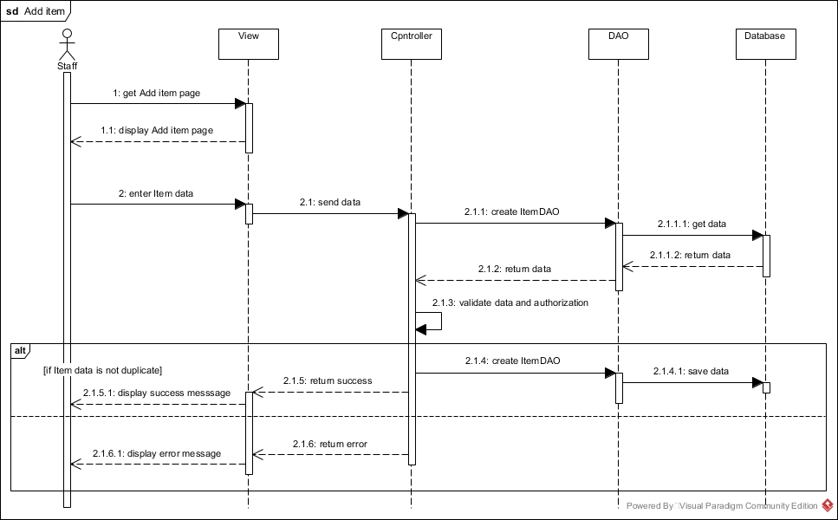

#### Update item

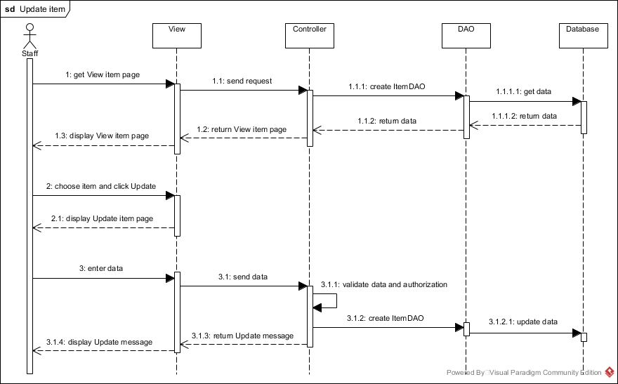

#### Delete item

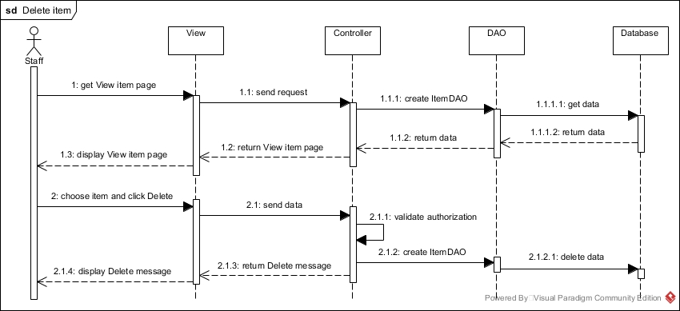

#### View item

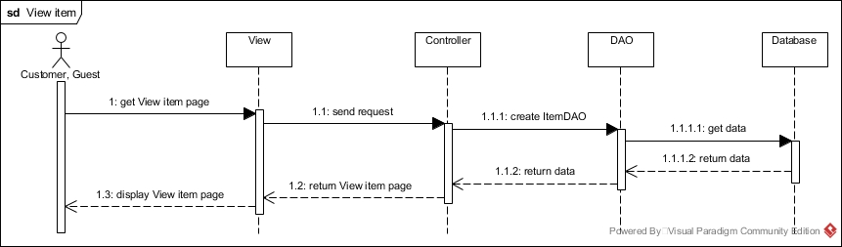

#### Search item

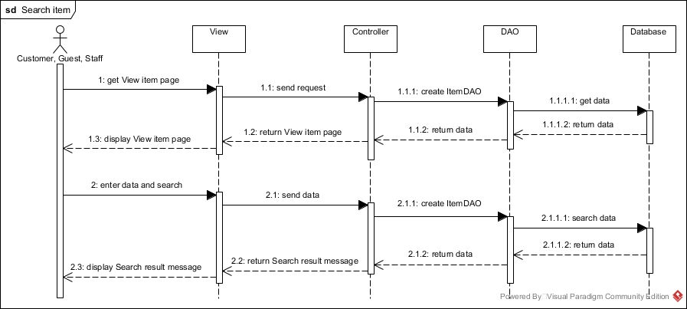

#### Add discount event

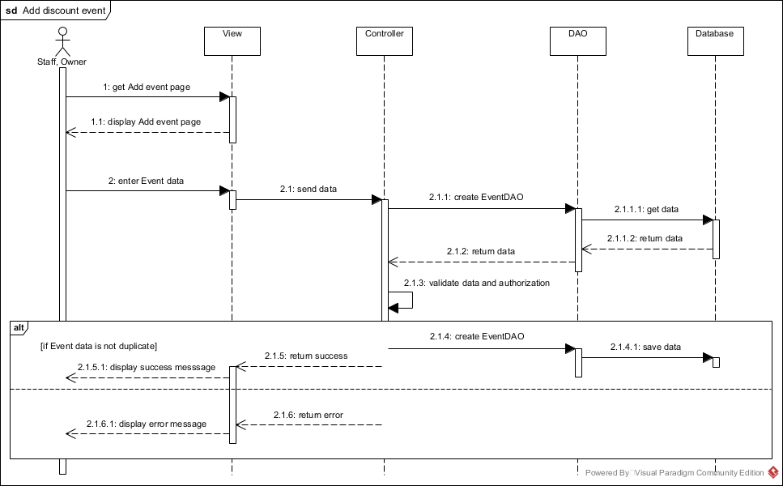

#### Update discount event

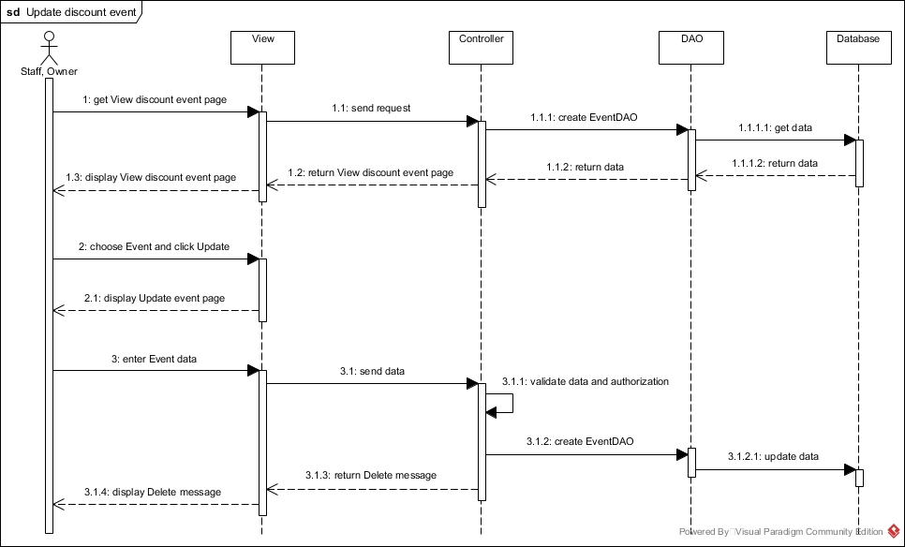

#### Delete discount event

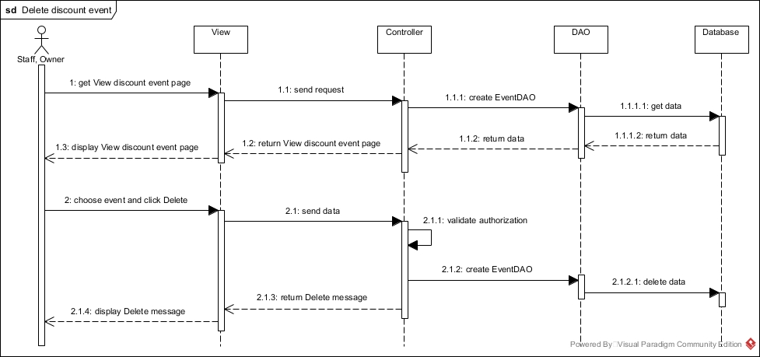

#### View discount event

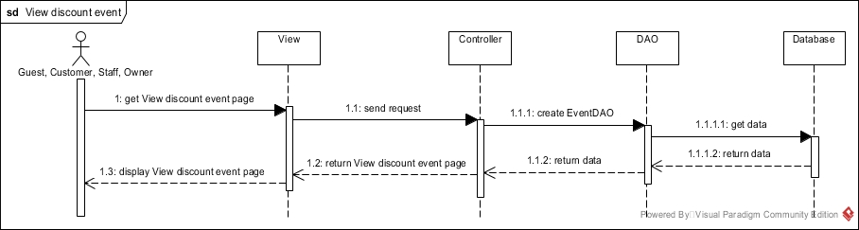

#### Feedback

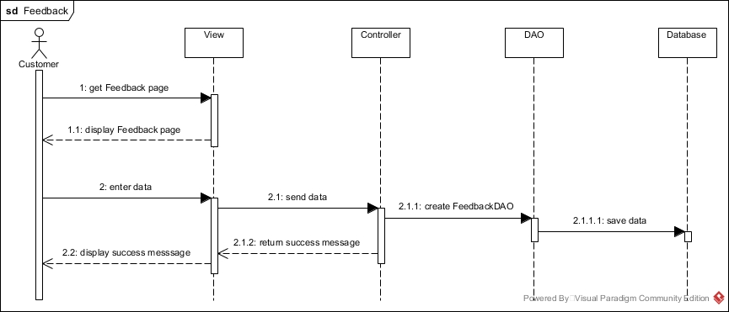

#### Order

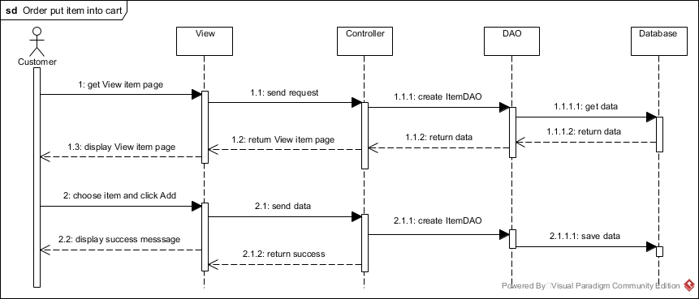

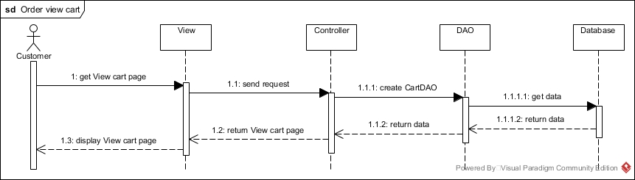

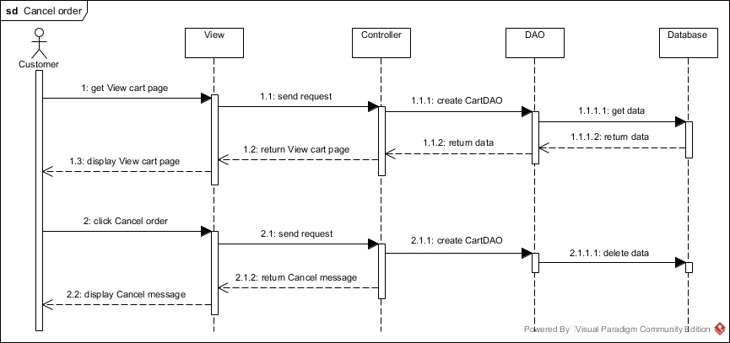

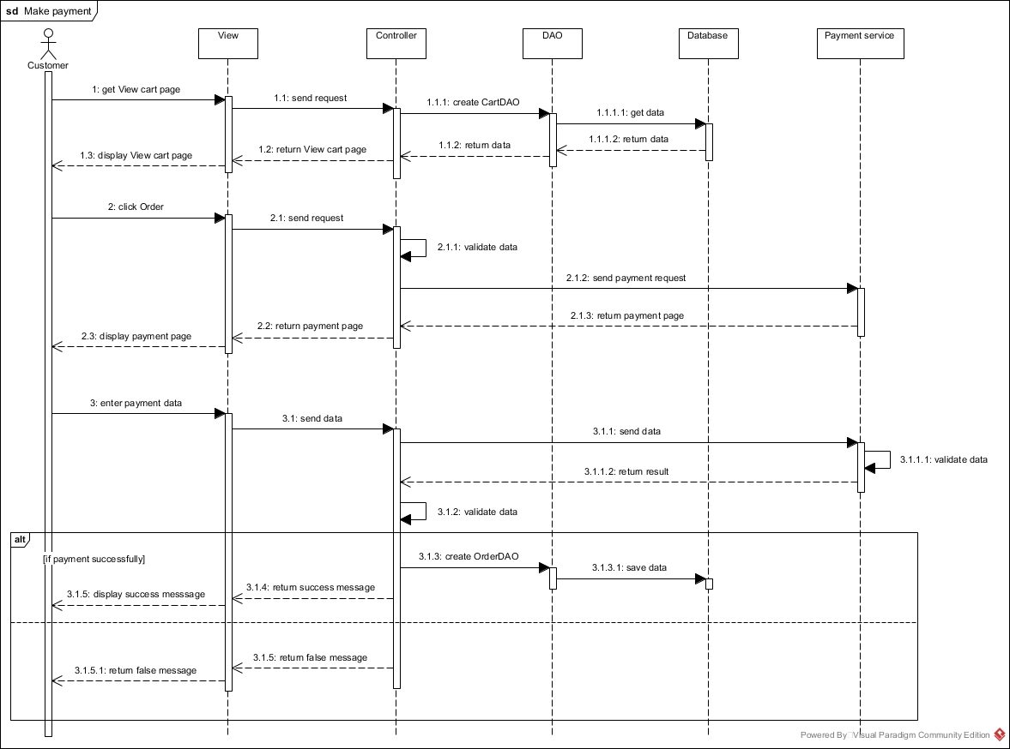

#### Report

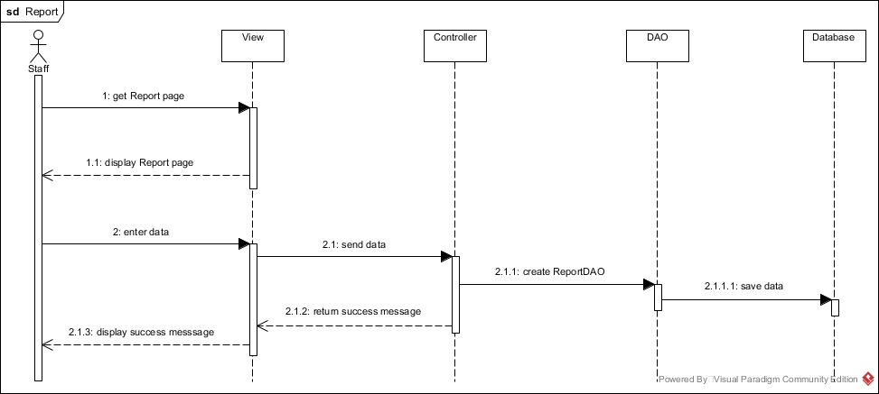

#### View Order History - staff

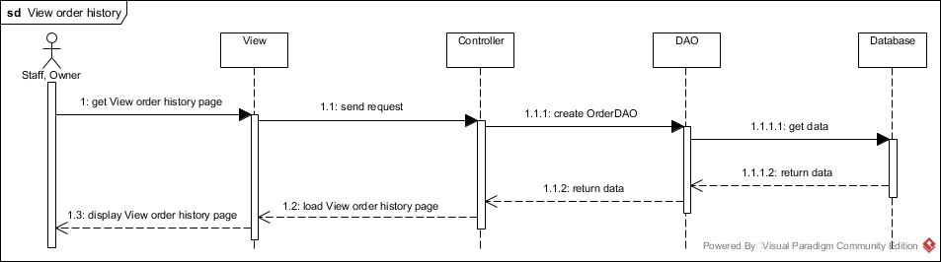

#### View Action History – owner

