|  |  |  |
| --- | --- | --- |
| **LAB221 Assignment** | **Type:** | **Short Assignment** |
| **Code:** | **J2.S.P0115** |
| **LOC:** | **50** |
| **Slot(s):** | **1** |

**Title**

Verify input data

**Background Context**

NA

**Program Specifications**

Use swing library to create a program to verify input data.

Information should be verified:

* Student code: max length is 10, not contains special characters (@, #, $)
* Student name: max length is 30
* Birth Date: in format MM/DD/YYYY
* Phone number: max length is 15, contain numeric characters only (0 – 9)
* Email: max length is 30, contain only one “@” character, do not contain special characters (!, #, $)

***Function details:***

NA

***Expectation of User interface:***

The screen should be as:

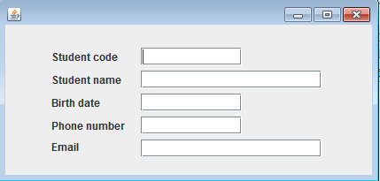

**Guidelines**