|  |  |  |
| --- | --- | --- |
| **LAB221 Assignment** | **Type:** | **Short Assignment** |
| **Code:** | **J2.S.P0016** |
| **LOC:** | **100** |
| **Slot(s):** | **1** |

**Title**

Counter: Swing, thread and Java 2D

**Background Context**

You often see how is clock works, you can make your own clock by using the swing, thread and Java 2D.

In this assignment, we will guide you how to make the clock and how to present a clock as graphic object.

**Program Specifications**

Create an application using Thread, Swing and Java 2D to implement the application. The application should consist of the following classes:

1. **CounterRunnable.java**

This class will calculate the counter and after every second the counter increment by 1, the value of counter will be present as graphic object, like a real clock. This class also calculates the arc and draws an arc inside a circle.

**2. Main.java**

Make a frame look like description below and start the CounterRunnable thread.

***Function details:***

1. Display the GUI like figure (1).
2. When users click on Start button, start your counting (2).

***Expectation of User interface:***

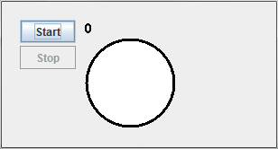*(1) 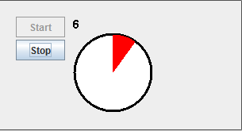(2)*

**Guidelines**

Some things to note about fillArc():

* 0 degrees is at the rightmost point of the oval/circle
* A positive arcAngle means the arc will extend counterclockwise, otherwise, the arc will extend clockwise from the startAngle
* the arc automatically fills the shape that is determined by the width and height
* the color of the Graphics object was set to Color.blue before these drawings were made

|  |  |  |  |  |  |  |  |  |  |  |  |  |  |  |  |  |  |
| --- | --- | --- | --- | --- | --- | --- | --- | --- | --- | --- | --- | --- | --- | --- | --- | --- | --- |
| |  |  | | --- | --- | | the bounding box (black) and circle (red)  drawRect(50,5,100,100); | http://cs.wellesley.edu/~cs111/fall06/labs/lab12/box1.jpg | | fillArc(50,5,100,100,75,40); | http://cs.wellesley.edu/~cs111/fall06/labs/lab12/boxa.gif | | fillArc(50,5,100,100,75,-40); | http://cs.wellesley.edu/~cs111/fall06/labs/lab12/boxb.gif | | fillArc(50,5,100,100,225,90); | http://cs.wellesley.edu/~cs111/fall06/labs/lab12/boxc.gif | | |  |  | | --- | --- | | the bounding rect (black) and oval (red)  drawRect(50,5,100,33); | http://cs.wellesley.edu/~cs111/fall06/labs/lab12/rect1.jpg | | fillArc(50,5,100,33,75,40); | http://cs.wellesley.edu/~cs111/fall06/labs/lab12/recta.gif | | fillArc(50,5,100,33,75,-40); | http://cs.wellesley.edu/~cs111/fall06/labs/lab12/rectb.gif | | fillArc(50,5,33,100,225,90); | http://cs.wellesley.edu/~cs111/fall06/labs/lab12/rectc.gif | |