|  |  |  |
| --- | --- | --- |
| **Lab 221 Assignment** | **Type:** | **Short Assignment** |
| **Code:** | **J2.S.P0104** |
| **LOC:** | **60** |
| **Slot(s):** | **1** |

**Title**

Browse by line in JTable

**Background Context**

NA

**Program Specifications**

Create a program to browse by line on a data collection as table.

***Function details:***

NA

***Expectation of User interface:***

The screen when the program startup should be as:

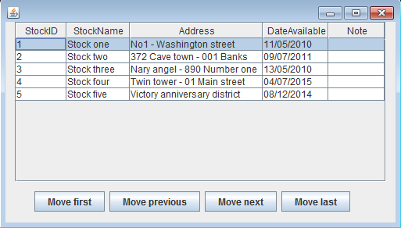

* Click “Move last” button:

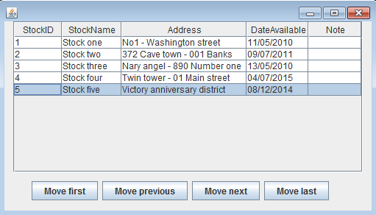

* Click “Move previous” button:

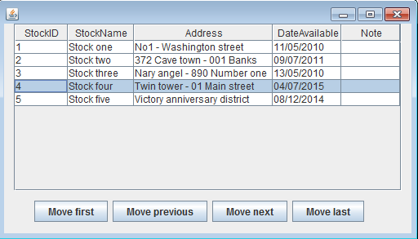

* Click “Move first” button:

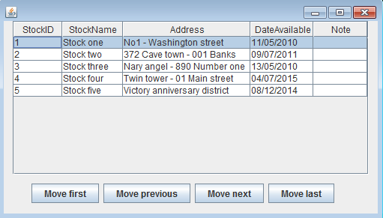

* Click “Move next” button:

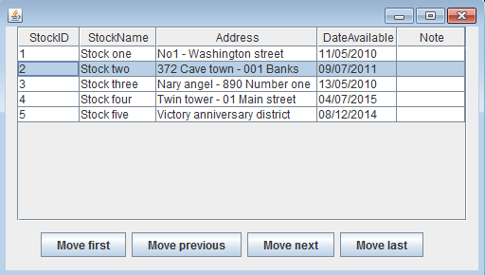

**Guidelines**