|  |  |  |
| --- | --- | --- |
| **LAB221 Assignment** | **Type:** | **Short Assignment** |
| **Code:** | **J2.S.P0121** |
| **LOC:** | **70** |
| **Slot(s):** | **2** |

**Title**

Draw Clock.

**Background Context**

A graphics context provides the capabilities of drawing on the screen. The graphics context maintains states such as the color and font used in drawing, as well as interacting with the underlying operating system to perform the drawing. In Java, custom painting is done via the java.awt.Graphics class, which manages a graphics context, and provides a set of device-independent methods for drawing texts, figures and images on the screen on different platforms.

The java.awt.Graphics is an abstract class, as the actual act of drawing is system-dependent and device-dependent. Each operating platform will provide a subclass of Graphics to perform the actual drawing under the platform, but conform to the specification defined in Graphics.

**Program Specifications**

Design a program that allows display clock.

***Function details:***

1. Program will draw a clock display current time.
2. Clocks will have three hour hand, minute and second.

***Expectation of User interface:***

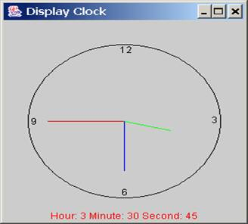

**Guidelines**

**Draw second line:**

Step 1: Calculate angle for second line. There are sixty seconds in one minute, the angle for the second hand is : a = second x (2PI/60).

Step2: Draw second line:

xCenter = 0, yCenter =0.

xEnd = xCenter + handLength x sin(a)

yEnd = yCenter - handLength x cos(a).

**Draw minute, hour are same**

