|  |  |  |
| --- | --- | --- |
| **LAB221 Assignment** | **Type:** | **Short Assignment** |
| **Code:** | **J2.S.P0202** |
| **LOC:** | **30** |
| **Slot(s):** | **2** |

**Title**

Unit Converter

**Background Context**

N/A

**Program Specifications**

Design a program that converts common units of measurement

***Function details:***

* User input value to convert
* Select type of measurement units

***Expectation of User interface:***

The screen when the program startup should be as:

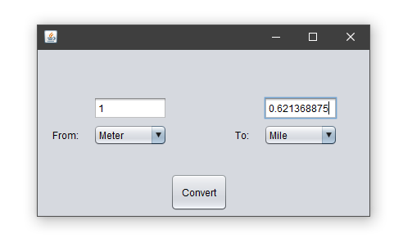

**Guidelines**