|  |  |  |
| --- | --- | --- |
| **LAB221 Assignment** | **Type:** | **Short Assignment** |
| **Code:** | **J2.S.P0204** |
| **LOC:** | **150** |
| **Slot(s):** | **1** |

**Title**

Worker Managerment System

**Background Context**

N/A

**Program Specifications**

Design a program to manager workers.

***Function details:***

* Connect to MS-SQL and get all workers to manager
* Display main screen as GUI
* View Detail
* Update
* Addnew

***Expectation of User interface:***

The screen when the program startup should be as:

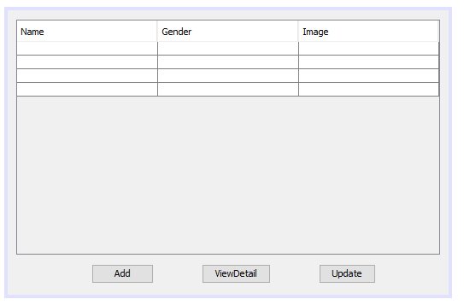

Main Screen

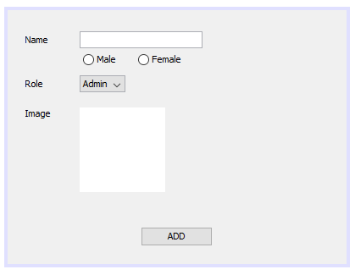

Add Screen

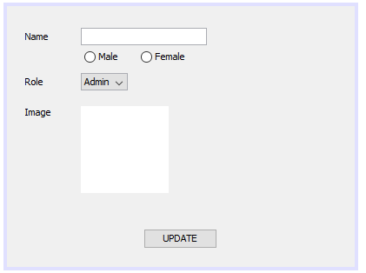

Update Screen