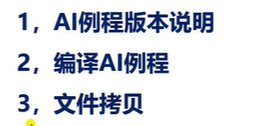



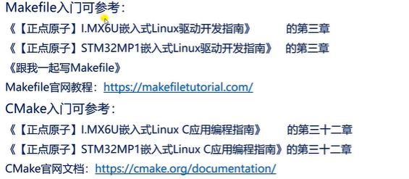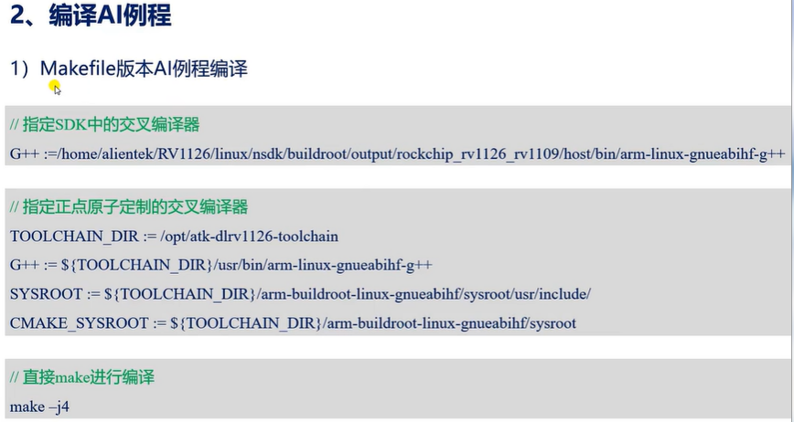

G++ :/opt/atk-dlrk3568-5_10_sdk-toolchain/bin/aarch64-linux-g++