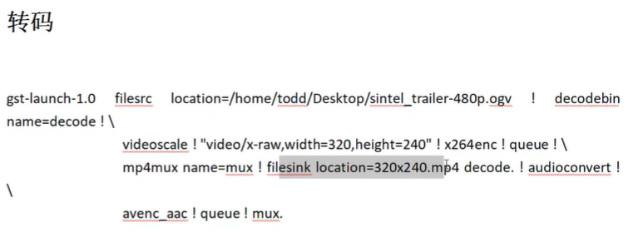

gst-launch-1.0 filesrc location=/home/todd/Desktop/sintel_trailer-480p.ogv ! decodebin name=decode ! videoscale ! "video/x-raw,width=320,height=240" ! x264enc ! queue ! mp4mux name=mux ! filesink location=320x240.mp4 decode. ! audioconvert ! avenc_aac ! queue ! mux.

/*

执行效果：

sudo gst-launch-1.0 filesrc location=/home/alientek/桌面/SampleVideo_720x480_30mb.flv ! decodebin name=decode ! videoscale ! "video/x-raw,width=320,height=240" ! x264enc ! queue ! mp4mux name=mux ! filesink location=320x240.mp4 decode. ! audioconvert ! avenc_aac ! queue ! mux.

decodebin 先解码出来

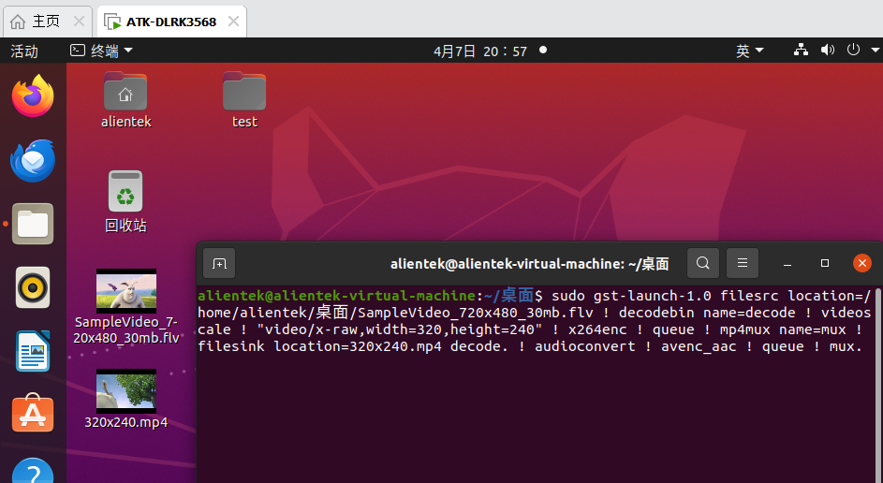

*/

/*

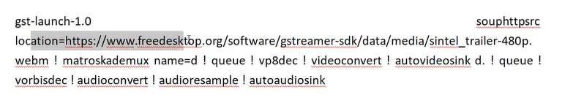

gst-launch-1.0 souphttpsrc location=https://gstreamer.freedesktop.org/media/sintel_trailer-480p.webm ! matroskademux name=d ! queue ! vp8dec ! videoconvert ! autovideosink d. ! queue ! vorbisdec ! audioresample ! autoaudiosink

gst-launch-1.0 souphttpsrc location=https://www.freedesktop.org/software/gstreamer-sdk/data/media/sintel_trailer-480p.webm ! matroskademux name=d ! queue ! vp8dec ! videoconvert ! autovideosink d. ! queue ! vorbisdec ! audioconvert ! audioresample ! autoaudiosink

gst-launch-1.0 souphttpsrc location=https://gstreamer.freedesktop.org/media/sintel_trailer-480p.webm ! matroskademux name=d ! queue ! vp8dec ! videoconvert ! autovideosink d. ! queue ! vorbisdec ! audioconvert ! audioresample ! autoaudiosink



