<https://www.bilibili.com/video/BV14x4y1x7xe?vd_source=ee352c2b480117ef10f914c44b39070b>

/*

alientek@alientek-virtual-machine:/$ gst-launch-1.0 --version

gst-launch-1.0 version 1.16.3

GStreamer 1.16.3

https://launchpad.net/distros/ubuntu/+source/gstreamer1.0

alientek@alientek-virtual-machine:/$

*/

/*

alientek@alientek-virtual-machine:/$ gst-inspect-1.0 --version

gst-inspect-1.0 version 1.16.3

GStreamer 1.16.3

https://launchpad.net/distros/ubuntu/+source/gstreamer1.0

alientek@alientek-virtual-machine:/$

*/

/*

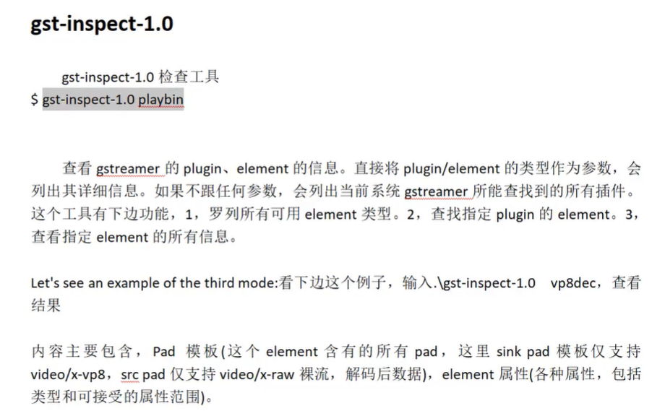

/*

alientek@alientek-virtual-machine:/$ gst-inspect-1.0 playbin

Factory Details:

Rank none (0) //基本信息

Long-name Player Bin 2

Klass Generic/Bin/Player

Description Autoplug and play media from an uri

Author Wim Taymans <wim.taymans@gmail.com>

Plugin Details:

Name playback

Description various playback elements

Filename /usr/lib/x86_64-linux-gnu/gstreamer-1.0/libgstplayback.so

Version 1.16.3

License LGPL

Source module gst-plugins-base

Source release date 2020-10-21

Binary package GStreamer Base Plugins (Ubuntu)

Origin URL https://launchpad.net/distros/ubuntu/+source/gst-plugins-base1.0

GObject

+----GInitiallyUnowned

+----GstObject

*/

/*

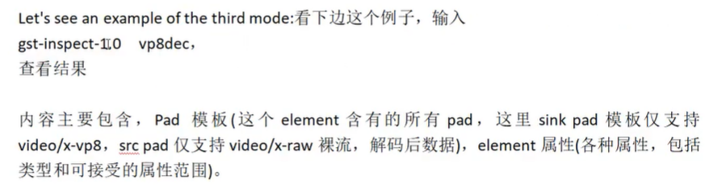

alientek@alientek-virtual-machine:/$ gst-inspect-1.0 vp8dec

Factory Details:

Rank primary (256)

Long-name On2 VP8 Decoder

Klass Codec/Decoder/Video

Description Decode VP8 video streams

Author David Schleef <ds@entropywave.com>, Sebastian Dröge <sebastian.droege@collabora.co.uk>

Plugin Details:

Name vpx

Description VP8 plugin

Filename /usr/lib/x86_64-linux-gnu/gstreamer-1.0/libgstvpx.so

Version 1.16.3

License LGPL

Source module gst-plugins-good

Source release date 2020-10-21

Binary package GStreamer Good Plugins (Ubuntu)

Origin URL https://launchpad.net/distros/ubuntu/+source/gst-plugins-good1.0

GObject

+----GInitiallyUnowned

+----GstObject

*/

/*

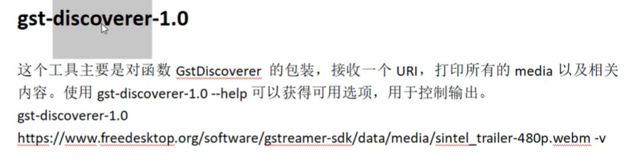

gst-discoverer-1.0 <https://www.freedesktop.org/software/gstreamer-sdk/data/media/sintel_trailer-480p.webm> -V

这个命令就相当于：mediainfo、ffprobe检测媒体文件的媒体信息。

这就是两个小工具：gst-inspact-1.0和gst-discover-1.0

/*

alientek@alientek-virtual-machine:/$ gst-discoverer-1.0 https://www.freedesktop.org/software/gstreamer-sdk/data/media/sintel_trailer-480p.webm -v

Analyzing <https://www.freedesktop.org/software/gstreamer-sdk/data/media/sintel_trailer-480p.webm> //分析

Done discovering <https://www.freedesktop.org/software/gstreamer-sdk/data/media/sintel_trailer-480p.webm> //完成检测

Topology:

container: video/webm //container：容器是video/webm

audio: audio/x-vorbis, channels=(int)2, rate=(int)48000, streamheader=(buffer)< 01766f72626973000000000280bb0000000000008038010000000000b801, 03766f726269731d000000586970682e4f7267206c6962566f726269732049203230303930373039010000001a000000454e434f4445523d66666d706567327468656f72612d302e323401,  >

//上面是流的头

Tags:

容器格式: Matroska

语言代码: en

标题: Audio

应用程序名称: ffmpeg2theora-0.24

编码器: Xiph.Org libVorbis I 20090709

编码器版本: 0

音频编码: Vorbis

名义比特率: 80000

比特率: 80000

Codec: //编解码

audio/x-vorbis, channels=(int)2, rate=(int)48000, streamheader=(buffer)< 01766f72626973000000000280bb0000000000008038010000000000b801, 03766f726269731d000000586970682e4f7267206c6962566f726269732049203230303930373039010000001a000000454e434f4445523d66666d706567327468656f72612d302e323401,  >

Additional info:

None

Stream ID: 49c0757884165711870775ccdbc4bab3576fa15bb3b5c59102fa354546e860fe/002:2408282244873345389

Language: en

Channels: 2 (front-left, front-right)

Sample rate: 48000

Depth: 32 //深度

Bitrate: 80000 //比特率

Max bitrate: 0

video: video/x-vp8, width=(int)854, height=(int)480, framerate=(fraction)0/1 //视频：vp8 宽854 高480 帧率没检测出来：0。

Tags:

视频编码: VP8 video //视频编解码VP8

容器格式: Matroska

Codec:

video/x-vp8, width=(int)854, height=(int)480, framerate=(fraction)0/1

Additional info:

None

Stream ID: 49c0757884165711870775ccdbc4bab3576fa15bb3b5c59102fa354546e860fe/001:3465118714092722455

Width: 854

Height: 480

Depth: 24

Frame rate: 0/1

Pixel aspect ratio: 1/1

Interlaced: false

Bitrate: 0

Max bitrate: 0

Properties:

Duration: 0:00:52.250000000

Seekable: yes

Live: no

Tags:

容器格式: Matroska

语言代码: en

标题: Audio

应用程序名称: ffmpeg2theora-0.24

编码器: Xiph.Org libVorbis I 20090709

编码器版本: 0

音频编码: Vorbis

名义比特率: 80000

比特率: 80000

视频编码: VP8 video

alientek@alientek-virtual-machine:/$

*/

*/

*/