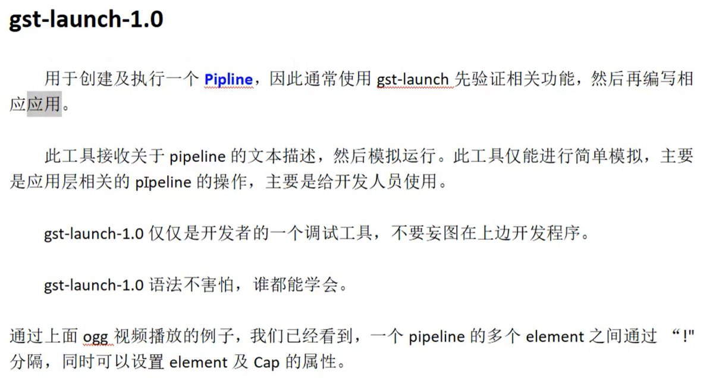

小例子：

gst-launch-1.0 filesrc location=sintel_trailer-480p.ogv ! oggdemux name=demux ! queue ! vorbisdec ! autbaudiosink demux.! queue ! theoradec !videoconvert! Autovideosink

gst-launch-1.0 videotestsrc ! "video/x-raw,width=1280,height=720" ! autovideosink

创建有随机红绿蓝线条的源 然后指定宽高 最后autovideosink进行渲染。

多个Element之间通过！进行分割。

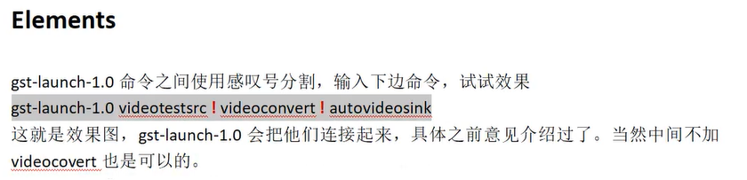

gst-launch-1.0 videotestsrc ! videoconvert ! autovideosink

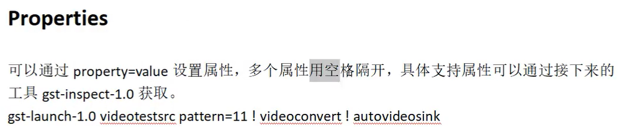

gst-launch-1.0 videotestsrc pattern=11 ! videoconvert ! autovideosink

/*

alientek@alientek-virtual-machine:/$ gst-inspect-1.0 videotestsrc

Factory Details:

Rank none (0)

Long-name Video test source

Klass Source/Video

Description Creates a test video stream

Author David A. Schleef <ds@schleef.org>

Plugin Details:

Name videotestsrc

Description Creates a test video stream

Filename /usr/lib/x86_64-linux-gnu/gstreamer-1.0/libgstvideotestsrc.so

Version 1.16.3

License LGPL

Source module gst-plugins-base

Source release date 2020-10-21

Binary package GStreamer Base Plugins (Ubuntu)

Origin URL https://launchpad.net/distros/ubuntu/+source/gst-plugins-base1.0

GObject

+----GInitiallyUnowned

+----GstObject

+----GstElement

+----GstBaseSrc

+----GstPushSrc

+----GstVideoTestSrc

Pad Templates:

SRC template: 'src'

Availability: Always

Capabilities:

video/x-raw

format: { (string)I420, (string)YV12, (string)YUY2, (string)UYVY, (string)AYUV, (string)VUYA, (string)RGBx, (string)BGRx, (string)xRGB, (string)xBGR, (string)RGBA, (string)BGRA, (string)ARGB, (string)ABGR, (string)RGB, (string)BGR, (string)Y41B, (string)Y42B, (string)YVYU, (string)Y444, (string)v210, (string)v216, (string)Y210, (string)Y410, (string)NV12, (string)NV21, (string)GRAY8, (string)GRAY16_BE, (string)GRAY16_LE, (string)v308, (string)RGB16, (string)BGR16, (string)RGB15, (string)BGR15, (string)UYVP, (string)A420, (string)RGB8P, (string)YUV9, (string)YVU9, (string)IYU1, (string)ARGB64, (string)AYUV64, (string)r210, (string)I420_10BE, (string)I420_10LE, (string)I422_10BE, (string)I422_10LE, (string)Y444_10BE, (string)Y444_10LE, (string)GBR, (string)GBR_10BE, (string)GBR_10LE, (string)NV16, (string)NV24, (string)NV12_64Z32, (string)A420_10BE, (string)A420_10LE, (string)A422_10BE, (string)A422_10LE, (string)A444_10BE, (string)A444_10LE, (string)NV61, (string)P010_10BE, (string)P010_10LE, (string)IYU2, (string)VYUY, (string)GBRA, (string)GBRA_10BE, (string)GBRA_10LE, (string)BGR10A2_LE, (string)GBR_12BE, (string)GBR_12LE, (string)GBRA_12BE, (string)GBRA_12LE, (string)I420_12BE, (string)I420_12LE, (string)I422_12BE, (string)I422_12LE, (string)Y444_12BE, (string)Y444_12LE, (string)GRAY10_LE32, (string)NV12_10LE32, (string)NV16_10LE32, (string)NV12_10LE40 }

width: [ 1, 2147483647 ]

height: [ 1, 2147483647 ]

framerate: [ 0/1, 2147483647/1 ]

multiview-mode: { (string)mono, (string)left, (string)right }

video/x-bayer

format: { (string)bggr, (string)rggb, (string)grbg, (string)gbrg }

width: [ 1, 2147483647 ]

height: [ 1, 2147483647 ]

framerate: [ 0/1, 2147483647/1 ]

multiview-mode: { (string)mono, (string)left, (string)right }

Element has no clocking capabilities.

Element has no URI handling capabilities.

Pads:

SRC: 'src'

Pad Template: 'src'

Element Properties:

animation-mode : For pattern=ball, which counter defines the position of the ball.

flags: 可读, 可写

Enum "GstVideoTestSrcAnimationMode" Default: 0, "frames"

(0): frames - frame count

(1): wall-time - wall clock time

(2): running-time - running time

background-color : Background color to use (big-endian ARGB)

flags: 可读, 可写, 可控制

Unsigned Integer. Range: 0 - 4294967295 Default: 4278190080

blocksize : Size in bytes to read per buffer (-1 = default)

flags: 可读, 可写

Unsigned Integer. Range: 0 - 4294967295 Default: 4096

do-timestamp : Apply current stream time to buffers

flags: 可读, 可写

Boolean. Default: false

flip : For pattern=ball, invert colors every second.

flags: 可读, 可写

Boolean. Default: false

foreground-color : Foreground color to use (big-endian ARGB)

flags: 可读, 可写, 可控制

Unsigned Integer. Range: 0 - 4294967295 Default: 4294967295

horizontal-speed : Scroll image number of pixels per frame (positive is scroll to the left)

flags: 可读, 可写

Integer. Range: -2147483648 - 2147483647 Default: 0

is-live : Whether to act as a live source

flags: 可读, 可写

Boolean. Default: false

k0 : Zoneplate zero order phase, for generating plain fields or phase offsets

flags: 可读, 可写

Integer. Range: -2147483648 - 2147483647 Default: 0

kt : Zoneplate 1st order t phase, for generating phase rotation as a function of time

flags: 可读, 可写

Integer. Range: -2147483648 - 2147483647 Default: 0

kt2 : Zoneplate 2nd order t phase, t*t/256 cycles per picture

flags: 可读, 可写

Integer. Range: -2147483648 - 2147483647 Default: 0

kx : Zoneplate 1st order x phase, for generating constant horizontal frequencies

flags: 可读, 可写

Integer. Range: -2147483648 - 2147483647 Default: 0

kx2 : Zoneplate 2nd order x phase, normalised to kx2/256 cycles per horizontal pixel at width/2 from origin

flags: 可读, 可写

Integer. Range: -2147483648 - 2147483647 Default: 0

kxt : Zoneplate x*t product phase, normalised to kxy/256 cycles per vertical pixel at width/2 from origin

flags: 可读, 可写

Integer. Range: -2147483648 - 2147483647 Default: 0

kxy : Zoneplate x*y product phase

flags: 可读, 可写

Integer. Range: -2147483648 - 2147483647 Default: 0

ky : Zoneplate 1st order y phase, for generating contant vertical frequencies

flags: 可读, 可写

Integer. Range: -2147483648 - 2147483647 Default: 0

ky2 : Zoneplate 2nd order y phase, normailsed to ky2/256 cycles per vertical pixel at height/2 from origin

flags: 可读, 可写

Integer. Range: -2147483648 - 2147483647 Default: 0

kyt : Zoneplate y*t product phase

flags: 可读, 可写

Integer. Range: -2147483648 - 2147483647 Default: 0

motion : For pattern=ball, what motion the ball does

flags: 可读, 可写

Enum "GstVideoTestSrcMotionType" Default: 0, "wavy"

(0): wavy - Ball waves back and forth, up and down

(1): sweep - 1 revolution per second

(2): hsweep - 1/2 revolution per second, then reset to top

name : The name of the object

flags: 可读, 可写

String. Default: "videotestsrc0"

num-buffers : Number of buffers to output before sending EOS (-1 = unlimited)

flags: 可读, 可写

Integer. Range: -1 - 2147483647 Default: -1

parent : The parent of the object

flags: 可读, 可写

Object of type "GstObject"

pattern : Type of test pattern to generate

flags: 可读, 可写

Enum "GstVideoTestSrcPattern" Default: 0, "smpte"

(0): smpte - SMPTE 100% color bars

(1): snow - Random (television snow)

(2): black - 100% Black

(3): white - 100% White

(4): red - Red

(5): green - Green

(6): blue - Blue

(7): checkers-1 - Checkers 1px

(8): checkers-2 - Checkers 2px

(9): checkers-4 - Checkers 4px

(10): checkers-8 - Checkers 8px

(11): circular - Circular

(12): blink - Blink

(13): smpte75 - SMPTE 75% color bars

(14): zone-plate - Zone plate

(15): gamut - Gamut checkers

(16): chroma-zone-plate - Chroma zone plate

(17): solid-color - Solid color

(18): ball - Moving ball

(19): smpte100 - SMPTE 100% color bars

(20): bar - Bar

(21): pinwheel - Pinwheel

(22): spokes - Spokes

(23): gradient - Gradient

(24): colors - Colors

timestamp-offset : An offset added to timestamps set on buffers (in ns)

flags: 可读, 可写

Integer64. Range: 0 - 9223372036854775807 Default: 0

typefind : Run typefind before negotiating (deprecated, non-functional)

flags: 可读, 可写, 已废弃

Boolean. Default: false

xoffset : Zoneplate 2nd order products x offset

flags: 可读, 可写

Integer. Range: -2147483648 - 2147483647 Default: 0

yoffset : Zoneplate 2nd order products y offset

flags: 可读, 可写

Integer. Range: -2147483648 - 2147483647 Default: 0

*/

查询命令：gst-inspect-1.0 videotestsrc 查询videotestsrc这一个命令支持的属性。