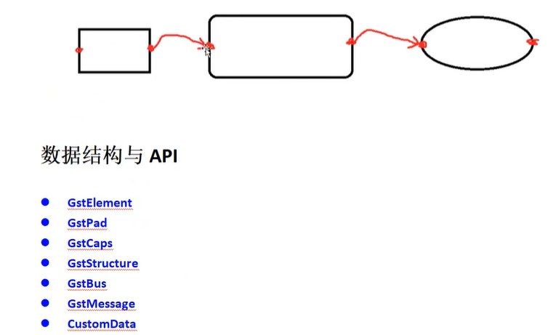

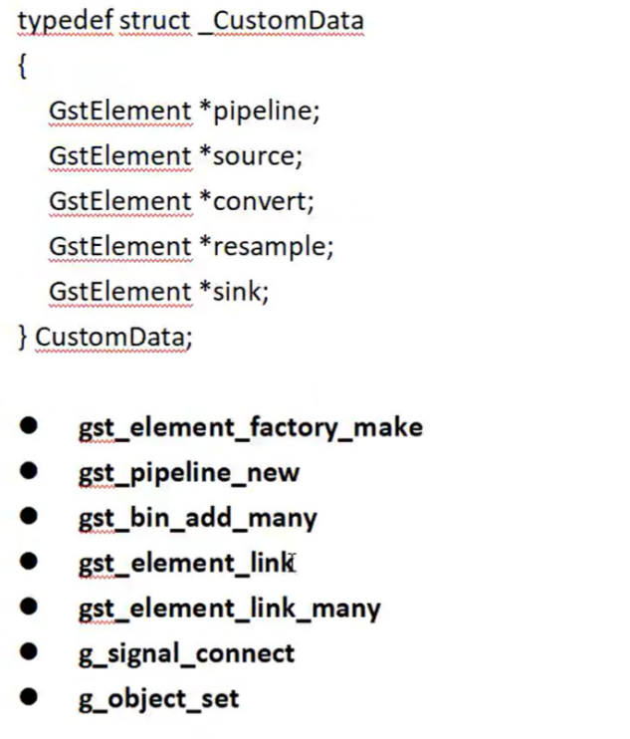

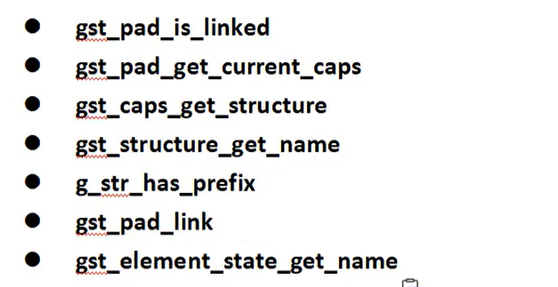

程序运行效果分析：

alientek@alientek-virtual-machine:~/桌面/test/gst/lesson$ ./hello-3

Pipeline state changed from NULL to READY:

========> pad_added_handler :0.

Received new pad 'src_0' from 'source':

It has type 'video/x-raw' which is not raw audio. Ignoring.

========> pad_added_handler :1.

Received new pad 'src_1' from 'source':

Link succeeded (type 'audio/x-raw').

Pipeline state changed from READY to PAUSED:

Pipeline state changed from PAUSED to PLAYING: