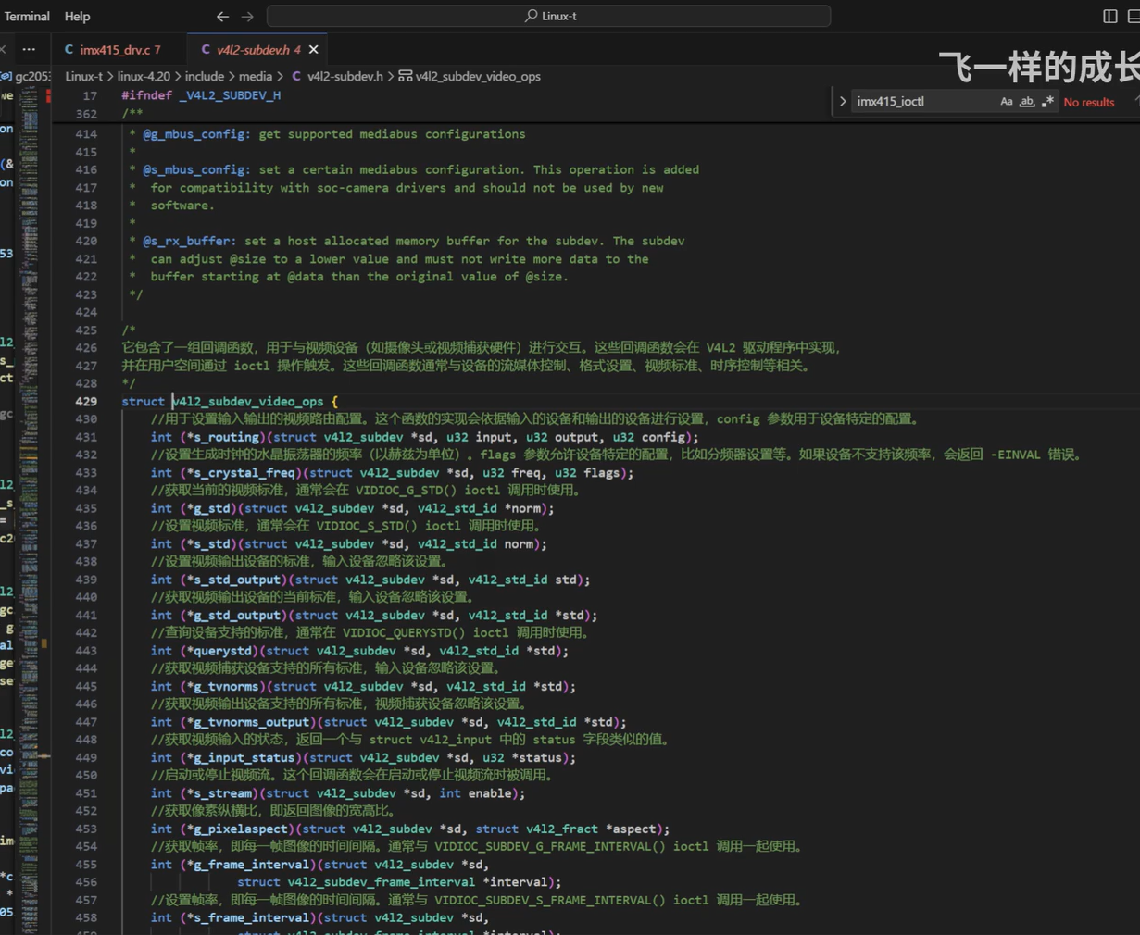

//这些都是系统自带的头文件。

#include <linux/clk.h>

#include <linux/device.h>

#include <linux/delay.h>

#include <linux/gpio/consumer.h>

#include <linux/i2c.h>

#include <linux/module.h>

#include <linux/pm_runtime.h>

#include <linux/of.h>

#include <linux/of_graph.h>

#include <linux/regulator/consumer.h>

#include <linux/sysfs.h>

#include <linux/slab.h>

#include <linux/pinctrl/consumer.h>

#include <linux/version.h>

#include <linux/rk-camera-module.h>

//下面的都是关于media（v4l2）的一些头文件，红色警告不用管

#include <media/v4l2-async.h>

#include <media/media-entity.h>

#include <media/v4l2-common.h>

#include <media/v4l2-ctrls.h>

#include <media/v4l2-device.h>

#include <media/v4l2-event.h>

#include <media/v4l2-fwnode.h>

#include <media/v4l2-image-sizes.h>

#include <media/v4l2-mediabus.h>

#include <media/v4l2-subdev.h>

#define IMX415_NAME "imx415"

#define to_imx415(sd) container_of(sd,struct imx415,subdev)

#define IMX415_FLIP_MIRROR_REG 0x17

#define GC_MIRROR_BIT_MASK BIT(0) //定义GC2053镜像位掩码

#define GC_FLIP_BIT_MASK BIT(1) //定义GC2053翻转位

#define IMX415_REG_CTRL_MODE 0x3E //定义控制模式寄存器地址

#define IMX415_MODE_SW_STANDBY 0x11 //定义软件待机模式

#define IMX415_MODE_STREAMING 0x91 //定义流式传输模式

#define IMX415_LANES 2 //定义通道数

#define REG_NULL 0xFF

//对imx415_write_array形参：寄存器结构体进行定义：

struct regval {

u8 addr; //寄存器地址

u8 val; //寄存器写的值

};

//定义imx415_g_frame_interval所需的imx415_mode

struct imx415_mode {

u32 width; //摄像头图像宽度

u32 height; //摄像头图像高度

struct v4l2_fract max_fps; //摄像头最大帧率

u32 hts_def; //摄像头默认行总时间

u32 vts_def; //摄像头默认场总时间

u32 exp_def; //摄像头默认曝光时间

const struct regval *reg_list; //指向摄像头寄存器列表的指针

u32 hdr_mode; //摄像头 HDR 模式

u32 vc[PAD_MAX]; //摄像头虚拟通道

};

static int imx415_s_power(struct v4l2_subdev *sd, int on)

{

struct imx415 *imx415 = to_imx415(sd);

struct i2c_client *client = imx415->client;

int ret = 0;

mutex_lock(&imx415->mutex);

/* If the power state is not modified - no work to do. */

if (imx415->power_on == !!on)

goto unlock_and_return;

if (on) {

//让sensor处于正常的电源工作状态

ret = pm_runtime_get_sync(&client->dev);//同步获取设备的电源状态，确保设备被唤醒并处于活动状态

if (ret < 0) {

pm_runtime_put_noidle(&client->dev);

goto unlock_and_return;

}

imx415->power_on = true;

} else {

//低功耗状态

pm_runtime_put(&client->dev);

imx415->power_on = false;

}

unlock_and_return:

mutex_unlock(&imx415->mutex);

return ret;

}

/* sensor register write */

static int imx415_write_reg(struct i2c_client *client, u8 reg, u8 val)

{

struct i2c_msg msg;

u8 buf[2];

int ret;

buf[0] = reg & 0xFF;

buf[1] = val;

//传进来的寄存器地址和对应的值val

//怎么发出去呢，也就是说，我的子设备怎么知道呢？就需要I2C总线进行传输。

//对msg结构体进行填充

msg.addr = client->addr;

msg.flags = client->flags;

msg.buf = buf; //要传输的数据

msg.len = sizeof(buf);

//借助i2c_transfer函数，开始进行i2c总线传输数据。

ret = i2c_transfer(client->adapter, &msg, 1);

if (ret >= 0)

return 0;

dev_err(&client->dev,

"gc2053 write reg(0x%x val:0x%x) failed !\n", reg, val);

return ret;

}

static long imx415_ioctl(struct v4l2_subdev *sd, unsigned int cmd, void *arg)

{

struct imx415 *imx415 = to_imx415(sd);

long ret = 0;

struct rkmodule_hdr_cfg *hdr_cfg;

u32 stream = 0;

switch (cmd) {

case RKMODULE_GET_HDR_CFG:

hdr_cfg = (struct rkmodule_hdr_cfg *)arg;

hdr_cfg->esp.mode = HDR_NORMAL_VC;

hdr_cfg->hdr_mode = imx415->cur_mode->hdr_mode;

break;

case RKMODULE_SET_HDR_CFG:

case RKMODULE_SET_CONVERSION_GAIN:

break;

/*

ret = -EINVAL;

dev_err(&imx415->client->dev, "imx415 not support hdr mode\n");

break;

*/

case RKMODULE_GET_MODULE_INFO:

imx415_get_module_inf(imx415, (struct rkmodule_inf *)arg);

break;

case RKMODULE_AWB_CFG:

imx415_set_awb_cfg(imx415,(struct rkmodule_awb_cfg *)arg);

break;

case RKMODULE_LSC_CFG:

imx415_set_lsc_cfg(imx415,(struct rkmodule_lsc_cfg *)arg);

break;

case RKMODULE_SET_QUICK_STREAM:

stream = *((u32 *)arg);

if (stream)

ret = imx415_write_reg(imx415->client, IMX415_REG_CTRL_MODE,

IMX415_MODE_STREAMING);

else

ret = imx415_write_reg(imx415->client, IMX415_REG_CTRL_MODE,

IMX415_MODE_SW_STANDBY);

break;

default:

ret = -ENOTTY;

break;

}

return ret;

}

//对__imx415_start_stream里面的imx415_write_array进行实现

static int imx415_write_array(struct i2c_client *client,const struct regval *regs)

{

int i, ret = 0;

i = 0;

while (regs[i].addr != REG_NULL) { //这一句是对结构体数组的每一个addr成员进行遍历，查看是否为REG_NULL。

//也就是说当地址不是0xFF的时候就往寄存器写数据。

ret = imx415_write_reg(client, regs[i].addr, regs[i].val);

if (ret) {

dev_err(&client->dev, "%s failed !\n", __func__);

break;

}

i++;

}

return ret;

}

//对imx415_set_flip里面的gc2053_read_reg进行实现

static int imx415_read_reg(struct i2c_client *client, u8 reg, u8 *val)

{

struct i2c_msg msg[2];

u8 buf[1];

int ret;

buf[0] = reg & 0xFF;

msg[0].addr = client->addr;

msg[0].flags = client->flags;

msg[0].buf = buf;

msg[0].len = sizeof(buf);

msg[1].addr = client->addr;

msg[1].flags = client->flags | I2C_M_RD;

msg[1].buf = buf;

msg[1].len = 1;

ret = i2c_transfer(client->adapter, msg, 2);

if (ret >= 0) {

*val = buf[0];

return 0;

}

dev_err(&client->dev,

"imx415 read reg(0x%x val:0x%x) failed !\n", reg, *val);

return ret;

}

//实现__imx415_start_stream里面的imx415_set_flip

//设置镜像

static int imx415_set_flip(struct imx415 *imx415, u8 mode)

{

u8 match_reg = 0;

imx415_read_reg(imx415->client, IMX415_FLIP_MIRROR_REG, &match_reg);

if (mode == GC_FLIP_BIT_MASK) {

match_reg |= GC_FLIP_BIT_MASK;

match_reg &= ~GC_MIRROR_BIT_MASK;

} else if (mode == GC_MIRROR_BIT_MASK) {

match_reg |= GC_MIRROR_BIT_MASK;

match_reg &= ~GC_FLIP_BIT_MASK;

} else if (mode == (GC_MIRROR_BIT_MASK |

GC_FLIP_BIT_MASK)) {

match_reg |= GC_FLIP_BIT_MASK;

match_reg |= GC_MIRROR_BIT_MASK;

} else {

match_reg &= ~GC_FLIP_BIT_MASK;

match_reg &= ~GC_MIRROR_BIT_MASK;

}

return imx415_write_reg(imx415->client, IMX415_FLIP_MIRROR_REG, match_reg);

}

//实现imx415_s_stream的start和stop_stream:

//开启和关闭流需要对寄存器进行操作，所以需要写寄存器，同时会有v4l2控制器的处理以及镜像翻转，所以我们在开启流的时候可以做一些操作操作，而这些操作就需要对寄存器进行写操作。

static int __imx415_start_stream(struct imx415 *imx415)

{

int ret;

//首先对imx415 sensor 寄存器 填写值

ret = imx415_write_array(imx415->client, imx415->cur_mode->reg_list);

if (ret)

return ret;

/* In case these controls are set before streaming */

mutex_unlock(&imx415->mutex);

//然后对v4l2控制器做设置操作，

v4l2_ctrl_handler_setup(&imx415->ctrl_handler);

mutex_lock(&imx415->mutex);

//例如作镜像翻转等

ret = imx415_set_flip(imx415, imx415->flip);

if (ret)

return ret;

//最后开启流

return imx415_write_reg(imx415->client, IMX415_REG_CTRL_MODE,IMX415_MODE_STREAMING);

}

static int __imx415_stop_stream(struct imx415 *imx415)

{

return imx415_write_reg(imx415->client, IMX415_REG_CTRL_MODE,

IMX415_MODE_SW_STANDBY);

}

//实现v4l2_subdev_video_ops结构体的imx415_s_stream

static int imx415_s_stream(struct v4l2_subdev *sd, int on)

{

struct imx415 *imx415 = to_imx415(sd);

struct i2c_client *client = imx415->client;

int ret = 0;

mutex_lock(&imx415->mutex); //上锁是因为不能并行操作

on = !!on;

if (on == imx415->streaming)

goto unlock_and_return;

if (on) { //如果on为1就开启流

ret = pm_runtime_get_sync(&client->dev);

if (ret < 0) {

pm_runtime_put_noidle(&client->dev);

goto unlock_and_return;

}

ret = __imx415_start_stream(imx415);

if (ret) {

v4l2_err(sd, "start stream failed while write regs\n");

pm_runtime_put(&client->dev);

goto unlock_and_return;

}

} else {

__imx415_stop_stream(imx415);

pm_runtime_put(&client->dev);

}

imx415->streaming = on;

unlock_and_return:

mutex_unlock(&imx415->mutex);

return 0;

}

//填充imx415_core_ops：

static const struct v4l2_subdev_core_ops imx415_core_ops = {

.s_power = imx415_s_power, //对sensor电源进行操作

.ioctl = imx415_ioctl,

};

//实现v4l2_subdev_video_ops所需的imx415_g_frame_interval帧间隔：

static int imx415_g_frame_interval(struct v4l2_subdev *sd,struct v4l2_subdev_frame_interval *fi)

{

struct imx415 *imx415 = to_imx415(sd);

const struct imx415_mode *mode = imx415->cur_mode;

mutex_lock(&imx415->mutex);

fi->interval = mode->max_fps;

mutex_unlock(&imx415->mutex);

return 0;

}

//实现v4l2_subdev_video_ops所需的imx415_g_mbus_config

//v4l2_mbus_config定义在 include/media/v4l2_mediabus.h文件里。

static int imx415_g_mbus_config(struct v4l2_subdev *sd,struct v4l2_mbus_config *config)

{

#if USE_DVP_INTERFACE

config->type = V4L2_MBUS_PARALLEL;

config->flags = V4L2_MBUS_HSYNC_ACTIVE_HIGH |

V4L2_MBUS_VSYNC_ACTIVE_LOW |

V4L2_MBUS_PCLK_SAMPLE_RISING;

#else

struct imx415 *imx415 = to_imx415(sd);

const struct imx415_mode *mode = imx415->cur_mode;

u32 val = 0;

if (mode->hdr_mode == NO_HDR)

val = 1 << (IMX415_LANES - 1) |

//下面这两个定义在：include/media/v4l2_mediabus.h文件里面

V4L2_MBUS_CSI2_CHANNEL_0 |

V4L2_MBUS_CSI2_CONTINUOUS_CLOCK;

config->type = V4L2_MBUS_CSI2;

config->flags = val;

#endif

return 0;

}

//填充imx415_video_ops

//v4l2_subdev_video_ops结构体定义在：include/media/v4l2_subdev.h文件里面

static const struct v4l2_subdev_video_ops imx415_video_ops = {

.s_stream = imx415_s_stream,

.g_frame_interval = imx415_g_frame_interval,

.g_mbus_config = imx415_g_mbus_config,

};

//填充imx415_pad_ops

static const struct v4l2_subdev_pad_ops imx415_pad_ops = {

.enum_mbus_code = imx415_enum_mbus_code,

.enum_frame_size = imx415_enum_frame_sizes,

.enum_frame_interval = imx415_enum_frame_interval,

.get_format = imx415_get_format, //获取摄像头格式

.set_format = imx415_set_format, //设置摄像头格式

};

static const struct v4l2_subdev_ops imx415_subdev_ops =

{

.core = &imx415_core_ops,

.video = &imx415_video_ops,

.pad = &imx415_pad_ops,

};

//实现imx415_pm_ops：

static const struct dev_pm_ops imx415_pm_ops = {

SET_RUNTIME_PM_OPS(imx415_runtime_suspend,

imx415_runtime_resume, NULL)

};

static int imx415_pm_resume(struct device *dev)

//3.实现prob函数

static int imx415_probe(struct i2c_client *client,const struct i2c_device_id *id)

{

//1.定义相关结构体

struct device *dev = &client->dev;

struct device_node *node = dev->of_node;

struct imx415 *imx415;

struct v4l2_subdev *sd;

int ret;

//2.分配内存为imx415结构体，获取其设备树里面的信息

imx415 = devm_kzalloc(dev,sizeof(*imx415),GFP_KERNEL);

imx415->client = client;

//3.开始解析设备信息。

//解析模块索引值

ret = of_property_read_u32(node,RKMODULE_CAMERA_MODULE_INDEX,&imx415->module_index);

//解析摄像头是前向还是后置。

ret |= of_property_read_string(node, RKMODULE_CAMERA_MODULE_FACING,

&imx415->module_facing);

//解析模块名称

ret |= of_property_read_string(node, RKMODULE_CAMERA_MODULE_NAME,

&imx415->module_name);

//解析镜头名称

ret |= of_property_read_string(node, RKMODULE_CAMERA_LENS_NAME,

&imx415->len_name);

if (ret) {

dev_err(dev,

"could not get module information!\n");

return -EINVAL;

}

imx415->xvclk = devm_clk_get(&client->dev, "xvclk");

if (IS_ERR(imx415->xvclk)) {

dev_err(&client->dev, "Failed to get xvclk\n");

return -EINVAL;

}

imx415->reset_gpio = devm_gpiod_get(dev, "reset", GPIOD_OUT_LOW);

if (IS_ERR(imx415->reset_gpio))

dev_warn(dev, "Failed to get reset-gpios\n");

imx415->pwdn_gpio = devm_gpiod_get(dev, "pwdn", GPIOD_OUT_LOW);

if (IS_ERR(imx415->pwdn_gpio))

dev_info(dev, "Failed to get pwdn-gpios, maybe no used\n");

imx415->power_gpio = devm_gpiod_get(dev, "power", GPIOD_OUT_LOW);

if (IS_ERR(imx415->power_gpio))

dev_warn(dev, "Failed to get power-gpios\n");

ret = imx415_configure_regulators(imx415);

if (ret) {

dev_err(dev, "Failed to get power regulators\n");

return ret;

}

ret = imx415_parse_of_mipi(imx415);

if (ret != 0)

return -EINVAL;

imx415->pinctrl = devm_pinctrl_get(dev);

if (!IS_ERR(imx415->pinctrl)) {

imx415->pins_default =

pinctrl_lookup_state(imx415->pinctrl,

OF_CAMERA_PINCTRL_STATE_DEFAULT);

if (IS_ERR(imx415->pins_default))

dev_err(dev, "could not get default pinstate\n");

imx415->pins_sleep =

pinctrl_lookup_state(imx415->pinctrl,

OF_CAMERA_PINCTRL_STATE_SLEEP);

if (IS_ERR(imx415->pins_sleep))

dev_err(dev, "could not get sleep pinstate\n");

} else {

dev_err(dev, "no pinctrl\n");

}

mutex_init(&imx415->mutex);

sd = &imx415->subdev;

//4. 初始化v4l2_subdev结构体

v4l2_i2c_subdev_init(sd, client, &imx415_subdev_ops);

ret = imx415_initialize_controls(imx415);

if (ret)

goto err_destroy_mutex;

ret = __imx415_power_on(imx415);

if (ret)

goto err_free_handler;

ret = imx415_check_sensor_id(imx415, client);

if (ret)

goto err_power_off;

return 0;

}

//4.

static int imx415_remove(struct i2c_client *client)

{

return 0;

}

//5. 定义匹配表

static const struct i2c_device_id imx415_i2c_driver[] =

{

{"imx415",0},

{ },

};

#if IS_ENABLE(CONFIG_OF)

static const struct of_device_id imx415_of_match[] = {

{.compatible = "fsl,imx415", },

{ },

};

MODULE_DEVICE_TABLE(of, imx415_of_match);

#endif

//1.定义和设置i2c_drv取得结构体

/*

driver：Device driver model driver主要包含驱动名称和与DTS注册设备进行匹配的

of_match_table。当of_match_table中的compatible域 和 dts文件的compatible域匹配时，·probe函数才会被调用

id_table:List of I2C devices supported by this driver如果kernel没有使用of_match_table和

dts注册设备进行进行匹配，则kernel使用该table进行匹配

probe:Callback for device binding

remove:Callback for device unbinding

*/

static struct i2c_driver imx415_i2c_driver = {

.driver = {

.name = IMX415_NAME,

.pm = &imx415_pm_ops,

.of_match_table = of_match_ptr(imx415_of_match),

},

.probe = &imx415_probe,

.remove = &imx415_remove,

.id_table = imx415_match_id,

};

//2.注册imx415_i2c_driver结构体

static int __init sensor_mod_init(void)

{

return i2c_add_driver(&imx415_i2c_driver);

}

static void __exit sensor_mod_exit(void)

{

i2c_del_driver(&imx415_i2c_driver);

}

device_initcall_sync(sensor_mod_init);

module_exit(sensor_mod_exit);

MODULE_DESCRIPTION("IMX415 CMOS Image Sensor driver");

MODULE_LICENSE("GPL v2");

//这就是一个sensor的驱动框架。

总结：

今天主要就是完成了v4l2_subdev_video_ops里面的这三个回调函数。

一个是开启流，获得摄像头镜像

一个是设置帧间隔，设置一帧的时间

最后是配置MIPI相关的总线的类型。

后面再去实现端口号的操作：v4l2_subdev_pad_ops: