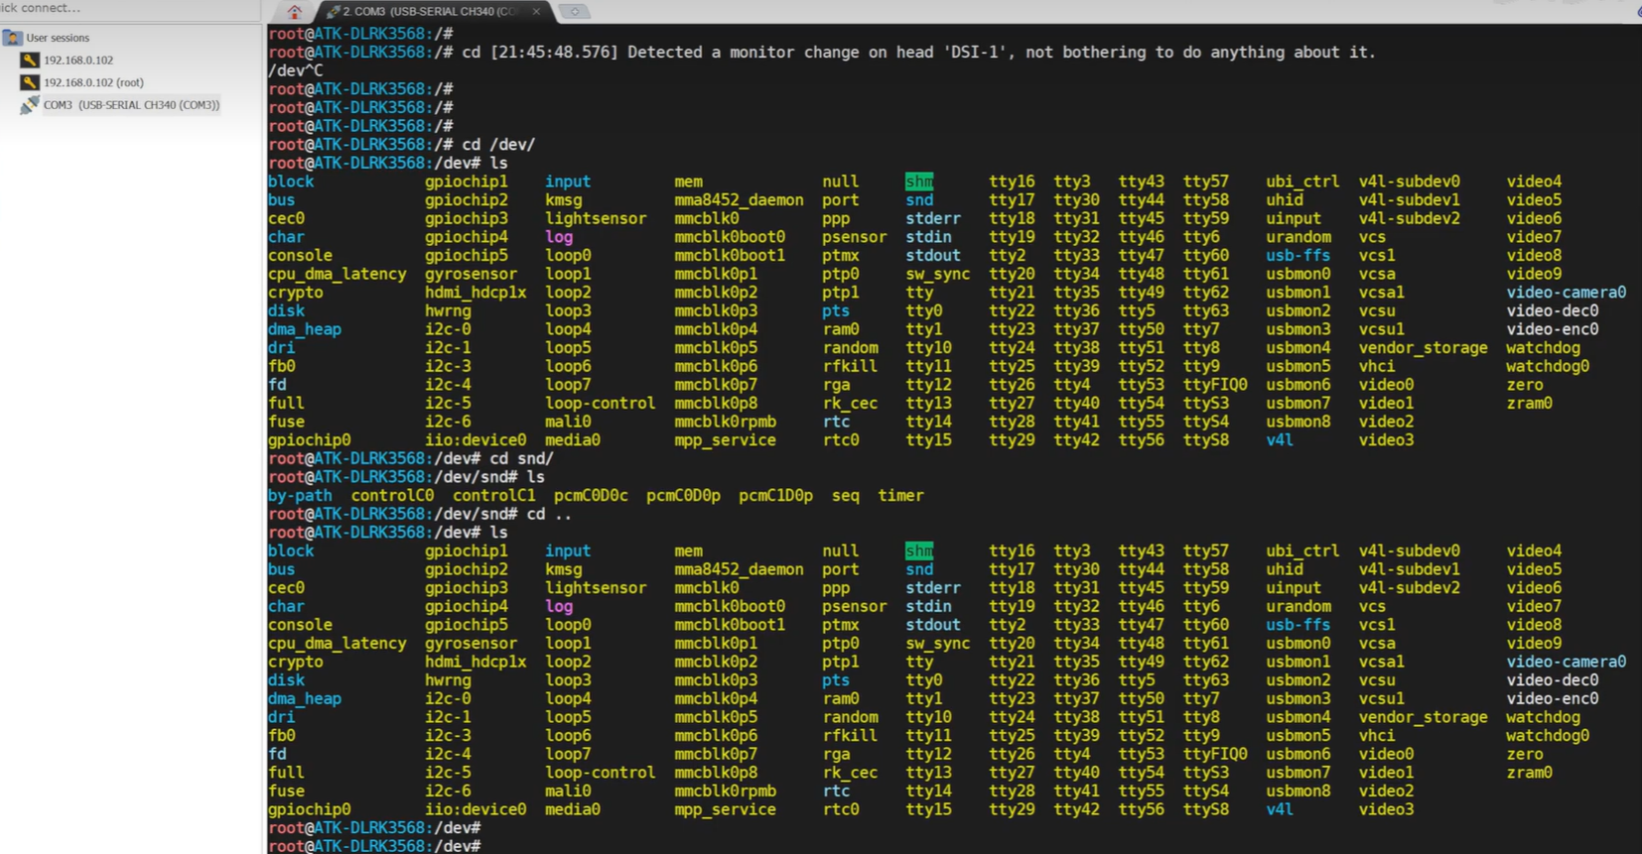

摄像头的主要节点是在dev/:media0、v4l-subdev0~2、video0~9

音频主要是在dev/snd/

插上摄像头之后，如何查看设备是否注册成功？

需要去查看媒体：media0，这个媒体代表的是你驱动里面，也就是设备外设接入了多少个媒体设备（视频、音频相关的）。 执行命令：media-ctl -p -d /dev/media0:

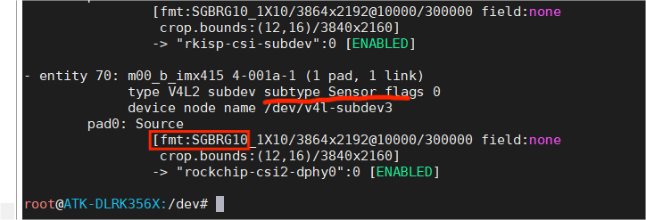

并且sensor的格式是SGBRG10

其格式的设置的代码宏定义位于：include/uapi/linux/media-bus-format.h文件里面：

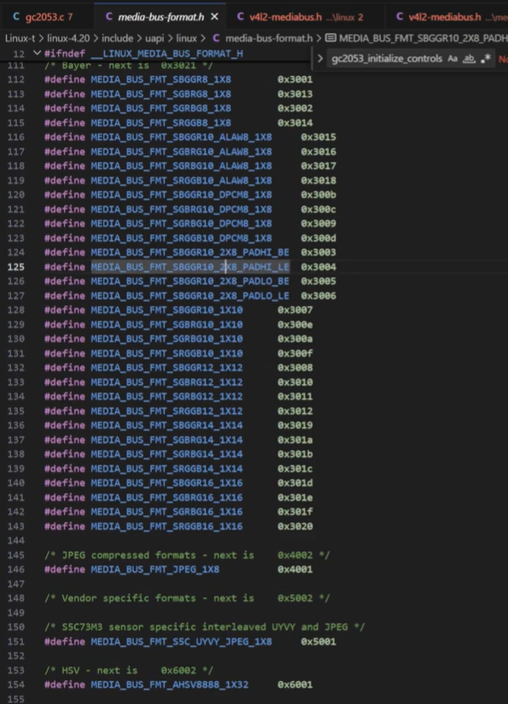

root@ATK-DLRK356X:/# v4l2-c

v4l2-compliance v4l2-ctl

root@ATK-DLRK356X:/# clear

root@ATK-DLRK356X:/# ls

bin home lost+found opt sbin udisk

busybox.fragment init media proc sdcard userdata

data lib misc rockchip_test sys usr

dev lib64 mnt root system var

etc linuxrc oem run tmp vendor

root@ATK-DLRK356X:/# v4l2-c

v4l2-compliance v4l2-ctl

root@ATK-DLRK356X:/# v4l2-ctl --help

General/Common options:

--all display all information available

-C, --get-ctrl <ctrl>[,<ctrl>...]

get the value of the controls [VIDIOC_G_EXT_CTRLS]

-c, --set-ctrl <ctrl>=<val>[,<ctrl>=<val>...]

set the value of the controls [VIDIOC_S_EXT_CTRLS]

-D, --info show driver info [VIDIOC_QUERYCAP]

-d, --device <dev> use device <dev> instead of /dev/video0

if <dev> starts with a digit, then /dev/video<dev> is used

Otherwise if -z was specified earlier, then <dev> is the entity name

or interface ID (if prefixed with 0x) as found in the topology of the

media device with the bus info string as specified by the -z option.

-e, --out-device <dev> use device <dev> for output streams instead of the

default device as set with --device

if <dev> starts with a digit, then /dev/video<dev> is used

Otherwise if -z was specified earlier, then <dev> is the entity name

or interface ID (if prefixed with 0x) as found in the topology of the

media device with the bus info string as specified by the -z option.

-E, --export-device <dev> use device <dev> for exporting DMA buffers

if <dev> starts with a digit, then /dev/video<dev> is used

Otherwise if -z was specified earlier, then <dev> is the entity name

or interface ID (if prefixed with 0x) as found in the topology of the

media device with the bus info string as specified by the -z option.

-z, --media-bus-info <bus-info>

find the media device with the given bus info string. If set, then

-d, -e and -E options can use the entity name or interface ID to refer

to the device nodes.

-h, --help display this help message

--help-all all options

--help-io input/output options

--help-meta metadata format options

--help-misc miscellaneous options

--help-overlay overlay format options

--help-sdr SDR format options

--help-selection crop/selection options

--help-stds standards and other video timings options

--help-streaming streaming options

--help-subdev sub-device options

--help-tuner tuner/modulator options

--help-vbi VBI format options

--help-vidcap video capture format options

--help-vidout vidout output format options

--help-edid edid handling options

-k, --concise be more concise if possible.

-l, --list-ctrls display all controls and their values [VIDIOC_QUERYCTRL]

-L, --list-ctrls-menus

display all controls and their menus [VIDIOC_QUERYMENU]

-r, --subset <ctrl>[,<offset>,<size>]+

the subset of the N-dimensional array to get/set for control <ctrl>,

for every dimension an (<offset>, <size>) tuple is given.

-w, --wrapper use the libv4l2 wrapper library.

--list-devices list all v4l devices. If -z was given, then list just the

devices of the media device with the bus info string as

specified by the -z option.

--log-status log the board status in the kernel log [VIDIOC_LOG_STATUS]

--get-priority query the current access priority [VIDIOC_G_PRIORITY]

--set-priority <prio>

set the new access priority [VIDIOC_S_PRIORITY]

<prio> is 1 (background), 2 (interactive) or 3 (record)

--silent only set the result code, do not print any messages

--sleep <secs> sleep <secs>, call QUERYCAP and close the file handle

--verbose turn on verbose ioctl status reporting

root@ATK-DLRK356X:/# v4l2-ctl --help-streaming

Video Streaming options:

--stream-count <count>

stream <count> buffers. The default is to keep streaming

forever. This count does not include the number of initial

skipped buffers as is passed by --stream-skip.

--stream-skip <count>

skip the first <count> buffers. The default is 0.

--stream-sleep <count>

sleep for 1 second every <count> buffers. If <count> is 0,

then sleep forever right after streaming starts. The default

is -1 (never sleep).

--stream-to <file> stream to this file. The default is to discard the

data. If <file> is '-', then the data is written to stdout

and the --silent option is turned on automatically.

--stream-to-hdr <file> stream to this file. Same as --stream-to, but each

frame is prefixed by a header. Use for compressed data.

--stream-to-host <hostname[:port]>

stream to this host. The default port is 8362.

--stream-lossless always use lossless video compression.

--stream-poll use non-blocking mode and select() to stream.

--stream-buf-caps show capture buffer capabilities

--stream-mmap <count>

capture video using mmap() [VIDIOC_(D)QBUF]

count: the number of buffers to allocate. The default is 3.

--stream-user <count>

capture video using user pointers [VIDIOC_(D)QBUF]

count: the number of buffers to allocate. The default is 3.

--stream-dmabuf capture video using dmabuf [VIDIOC_(D)QBUF]

Requires a corresponding --stream-out-mmap option.

--stream-from <file>

stream from this file. The default is to generate a pattern.

If <file> is '-', then the data is read from stdin.

--stream-from-hdr <file> stream from this file. Same as --stream-from, but each

frame is prefixed by a header. Use for compressed data.

--stream-from-host <hostname[:port]>

stream from this host. The default port is 8362.

--stream-no-query Do not query and set the DV timings or standard before streaming.

--stream-loop loop when the end of the file we are streaming from is reached.

The default is to stop.

--stream-out-pattern <count>

choose output test pattern. The default is 0.

--stream-out-square

show a square in the middle of the output test pattern.

--stream-out-border

show a border around the pillar/letterboxed video.

--stream-out-sav insert an SAV code in every line.

--stream-out-eav insert an EAV code in every line.

--stream-out-pixel-aspect <aspect

select a pixel aspect ratio. The default is to autodetect.

<aspect> can be one of: square, ntsc, pal

--stream-out-video-aspect <aspect

select a video aspect ratio. The default is to use the frame ratio.

<aspect> can be one of: 4x3, 14x9, 16x9, anamorphic

--stream-out-alpha <alpha-value>

value to use for the alpha component, range 0-255. The default is 0.

--stream-out-alpha-red-only

only use the --stream-out-alpha value for the red colors,

for all others use 0.

--stream-out-rgb-lim-range

Encode RGB values as limited [16-235] instead of full range.

--stream-out-hor-speed <speed>

choose speed for horizontal movement. The default is 0,

and the range is [-3...3].

--stream-out-vert-speed <speed>

choose speed for vertical movement. The default is 0,

and the range is [-3...3].

--stream-out-perc-fill <percentage>

percentage of the frame to actually fill. The default is 100%.

--stream-out-buf-caps

show output buffer capabilities

--stream-out-mmap <count>

output video using mmap() [VIDIOC_(D)QBUF]

count: the number of buffers to allocate. The default is 4.

--stream-out-user <count>

output video using user pointers [VIDIOC_(D)QBUF]

count: the number of buffers to allocate. The default is 4.

--stream-out-dmabuf

output video using dmabuf [VIDIOC_(D)QBUF]

Requires a corresponding --stream-mmap option.

--list-patterns list available patterns for use with --stream-pattern.

--list-buffers list all video buffers [VIDIOC_QUERYBUF]

--list-buffers-out list all video output buffers [VIDIOC_QUERYBUF]

--list-buffers-vbi list all VBI buffers [VIDIOC_QUERYBUF]

--list-buffers-vbi-out

list all VBI output buffers [VIDIOC_QUERYBUF]

--list-buffers-sliced-vbi

list all sliced VBI buffers [VIDIOC_QUERYBUF]

--list-buffers-sliced-vbi-out

list all sliced VBI output buffers [VIDIOC_QUERYBUF]

--list-buffers-sdr

list all SDR RX buffers [VIDIOC_QUERYBUF]

--list-buffers-sdr-out

list all SDR TX buffers [VIDIOC_QUERYBUF]

--list-buffers-meta

list all Meta RX buffers [VIDIOC_QUERYBUF]

root@ATK-DLRK356X:/#

root@ATK-DLRK356X:/# v4l2-ctl --help-vidcap

Video Capture Formats options:

--list-formats display supported video formats [VIDIOC_ENUM_FMT]

--list-formats-ext display supported video formats including frame sizes

and intervals

--list-framesizes <f>

list supported framesizes for pixelformat <f>

[VIDIOC_ENUM_FRAMESIZES]

pixelformat is the fourcc value as a string

--list-frameintervals width=<w>,height=<h>,pixelformat=<f>

list supported frame intervals for pixelformat <f> and

the given width and height [VIDIOC_ENUM_FRAMEINTERVALS]

pixelformat is the fourcc value as a string

--list-fields list supported fields for the current format

-V, --get-fmt-video

query the video capture format [VIDIOC_G_FMT]

-v, --set-fmt-video

--try-fmt-video width=<w>,height=<h>,pixelformat=<pf>,field=<f>,colorspace=<c>,

xfer=<xf>,ycbcr=<y>,hsv=<hsv>,quantization=<q>,

premul-alpha,bytesperline=<bpl>,sizeimage=<sz>

set/try the video capture format [VIDIOC_S/TRY_FMT]

pixelformat is either the format index as reported by

--list-formats, or the fourcc value as a string.

The bytesperline and sizeimage options can be used multiple times,

once for each plane.

premul-alpha sets V4L2_PIX_FMT_FLAG_PREMUL_ALPHA.

<f> can be one of the following field layouts:

any, none, top, bottom, interlaced, seq_tb, seq_bt,

alternate, interlaced_tb, interlaced_bt

<c> can be one of the following colorspaces:

smpte170m, smpte240m, rec709, 470m, 470bg, jpeg, srgb,

oprgb, bt2020, dcip3

<xf> can be one of the following transfer functions:

default, 709, srgb, oprgb, smpte240m, smpte2084, dcip3, none

<y> can be one of the following Y'CbCr encodings:

default, 601, 709, xv601, xv709, bt2020, bt2020c, smpte240m

<hsv> can be one of the following HSV encodings:

default, 180, 256

<q> can be one of the following quantization methods:

default, full-range, lim-range

root@ATK-DLRK356X:/#