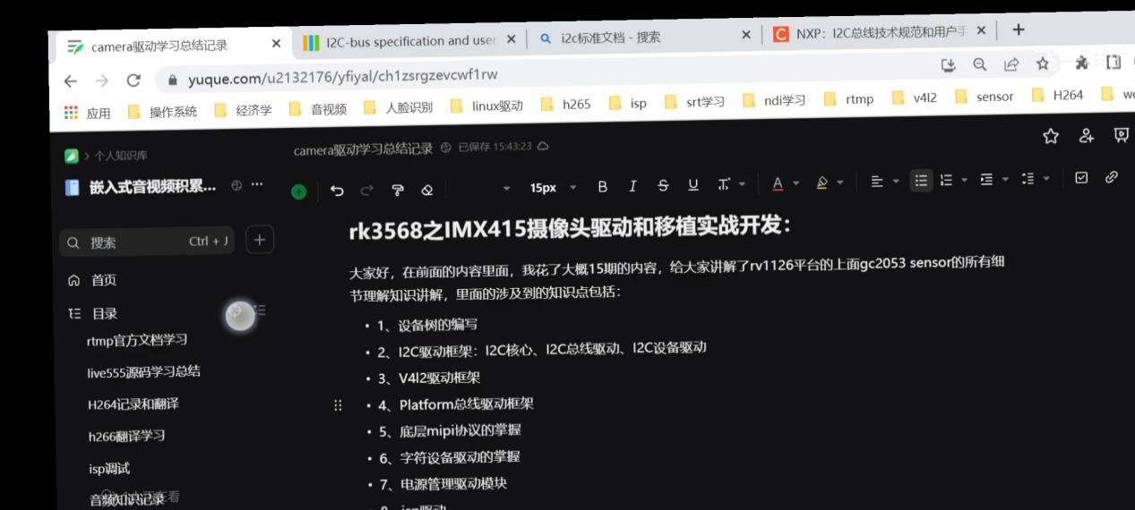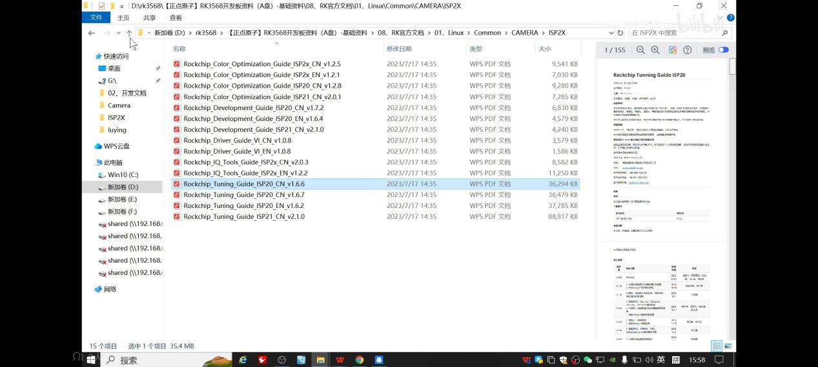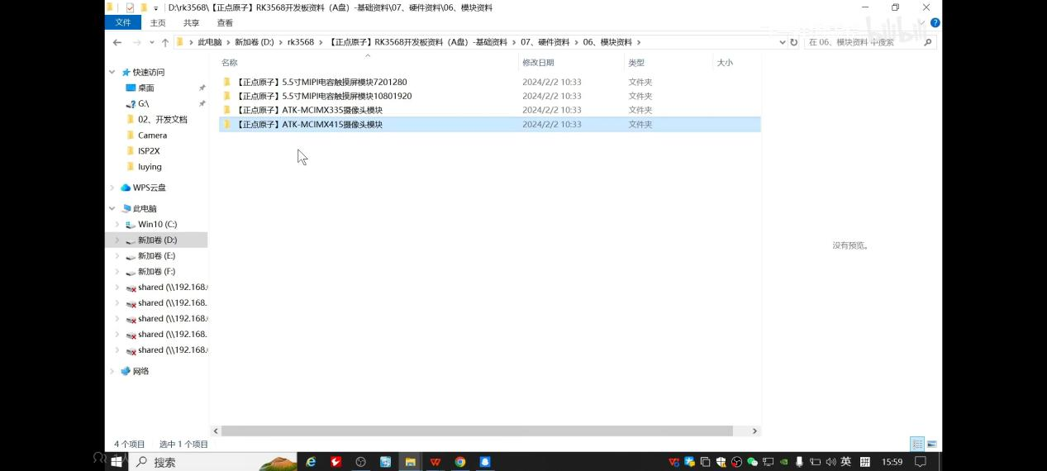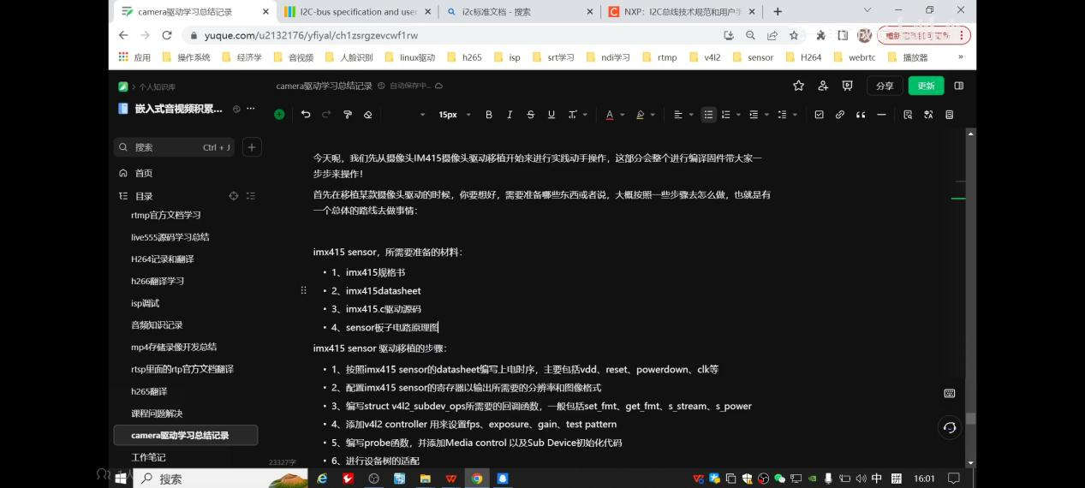

<https://www.bilibili.com/video/BV11M4m1k7aj/?spm_id_from=333.788.player.switch&bvid=BV1kt421K7Zt&vd_source=af21ee908c04895a95a22f7a0c9e0013>

百问网AI音视频开发课程

<https://eai.100ask.net/ELinuxAIBase/DataLayer-DataAcquisition#12-opencv%E5%85%A5%E9%97%A8>

嵌入式AI

<https://zhuanlan.zhihu.com/p/621470492>

Camera | 7.瑞芯微rk3568平台摄像头控制器MIPI-CSI驱动架构梳理

<https://zhuanlan.zhihu.com/p/689575437>

瑞芯微-I2S | 音频驱动调试基本命令和工具-基于rk3568-2

<https://zhuanlan.zhihu.com/p/686029031>

瑞芯微 | I2S-音频基础 -1

<https://zhuanlan.zhihu.com/p/639465797>

基于瑞芯微camera文章汇总pdf分享给大家

<https://zhuanlan.zhihu.com/p/636839218>

Camera | 11.瑞芯微摄像头采集图像颜色偏绿解决笔记

<https://zhuanlan.zhihu.com/p/633715894>

Camera | 10.linux驱动 led架构-基于rk3568

<https://zhuanlan.zhihu.com/p/628722434>

Camera | 9.如何让camera支持闪光灯？-基于rk3568

<https://zhuanlan.zhihu.com/p/623576094>

Camera | 9.让rk3568支持前后置摄像头

<https://zhuanlan.zhihu.com/p/621470492>

Camera | 7.瑞芯微rk3568平台摄像头控制器MIPI-CSI驱动架构梳理

<https://zhuanlan.zhihu.com/p/613738305>

Camera | 6.v4l2拓扑架构

<https://zhuanlan.zhihu.com/p/610873219>

Camera | 5.Linux v4l2架构(基于rk3568)

<https://zhuanlan.zhihu.com/p/606653811>

Camera | 4.瑞芯微平台MIPI摄像头应用程序编写

<https://zhuanlan.zhihu.com/p/604324755>

Camera | 3.瑞芯微平台MIPI摄像头常用调试命令

<https://zhuanlan.zhihu.com/p/599531271>

Camera | 2.MIPI、CSI基础

<https://zhuanlan.zhihu.com/p/597173877>

Camera | 1.Camera基础知识

<https://mp.weixin.qq.com/s?__biz=MzUxMjEyNDgyNw==&mid=2247508019&idx=1&sn=805bfe3c8c21a97e7bdfad74b0ededd7&chksm=f96bd2c7ce1c5bd12fa8a17914d72f87eed0a8e181d5c3bc4337e530555427acfa81890a8f6b&scene=21&token=1941748762&lang=zh_CN#wechat_redirect>

瑞芯微rk356x板子快速上手

<https://mp.weixin.qq.com/s?__biz=MzUxMjEyNDgyNw==&mid=2247509048&idx=1&sn=183000efd21b95ec25e42d486bc51210&chksm=f96bd6ccce1c5fda538c9896770ad8e89c8fb512a6154b98e881c00fb881c323dcb7c87ec1d7&token=1936399008&lang=zh_CN#rd>

瑞芯微 | 摄像头ov13850移植笔记

<https://ldd.100ask.net/zh/13_V4L2/02_1.html>

Linux设备驱动开发教程中心

<https://www.yuque.com/u2132176/yfiyal/ch1zsrgzevcwf1rw#gpfcM>

camera驱动学习总结记录