You have to print all output in the output file specified by main arguments, or you won’t get any score.

Output format for Data Structure Final Project

1. NewBike Class License Mile StationName

Example:

Input : NewBike Lady 00000 0 Hongshulin

Output : New bike is received by Station Hongshulin.

2. JunkIt License

Example:

1. General case.

Input : JunkIt TPI01

Output : Bike TPI01 is deleted from Danshui.

2. If the bike is now being rented.

Input : JunkIt TPI03

Output : Bike TPI03 is now being rented.

3. If the bike doesn't exist.

Input : JunkIt KKK23

Output : Bike KKK23 does not belong to our company.

3. Rent StationName Class

Example:

1. If there is no bike of specific class in the station.

Input : Rent Danshui Lady

Output : No free bike is available.

2. If there exists a bike of specific class in the station.

Input : Rent Danshui Lady

Output : A bike is rented from Danshui.

4. Returns StationName License Mile

Example:

Input : Returns Hongshulin 00A03 190

Output : Rental charge for this bike is 1245.

5. Trans StationName License

Example:

1. General case.

Input : Trans Jingmei 00A09

Output : Bike 00A09 is transferred to Jingmei.

2. If the bike doesn't exist.

Input : Trans Jingmei 0FA09

Output : Bike 0FA09 does not belong to our company.

3. If bike is now being rented.

Input : Trans Jingmei 0AA09

Output : Bike 0AA09 is now being rented.

6. Inquire License output format :

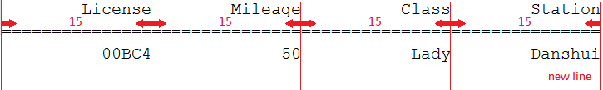

Hint: (c++)

#include<iomanip> //using setw()

std::cout << setw(15) << "License" << setw(15) << "Mileage"<< …….

Example:

1. If the bike does not exist.

Input : Inquire 00BC4

Output : Bike 00BC4 does not belong to our company.

2. General case.

Input : Inquire 00BC4

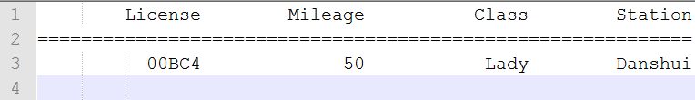Output :

7. StationReport StationName

Print StationName and the following kinds of heaps in it. Each heap is printed from its first node to the last one.

(1)Free Bike Heaps:

Print “Free Bikes” and the heaps from Electric=0 to Hybrid=3. (2)Rented Bike Heap:

Print “Rented Bikes” and then HRent.

Example:

Input : StationReport Danshui

Output :

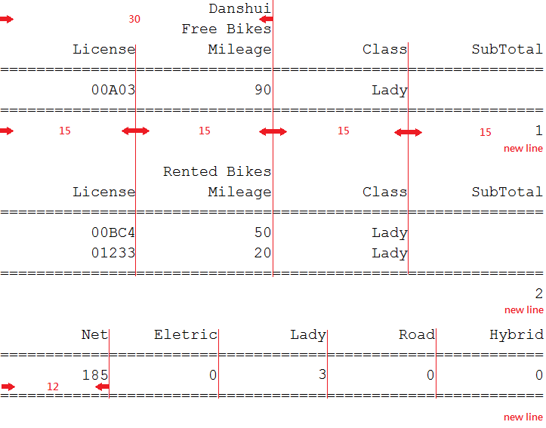

8. UbikeReport

You need to print the data in the order. (1)Free Bikes:

Print the 4 heaps (from Electric=0 to Hybrid=3) of free bikes in each station (from Danshui=0 to Jingmei=11). Each heap is printed from its first node to the last one. (2)Rented Bikes:

Print the heaps (from Electric=0 to Hybrid=3) of rented bikes in each station (from

Danshui=0 to Jingmei=11). The heap is printed from its first node to the last one. Example:

Input : UbikeReport

Output :

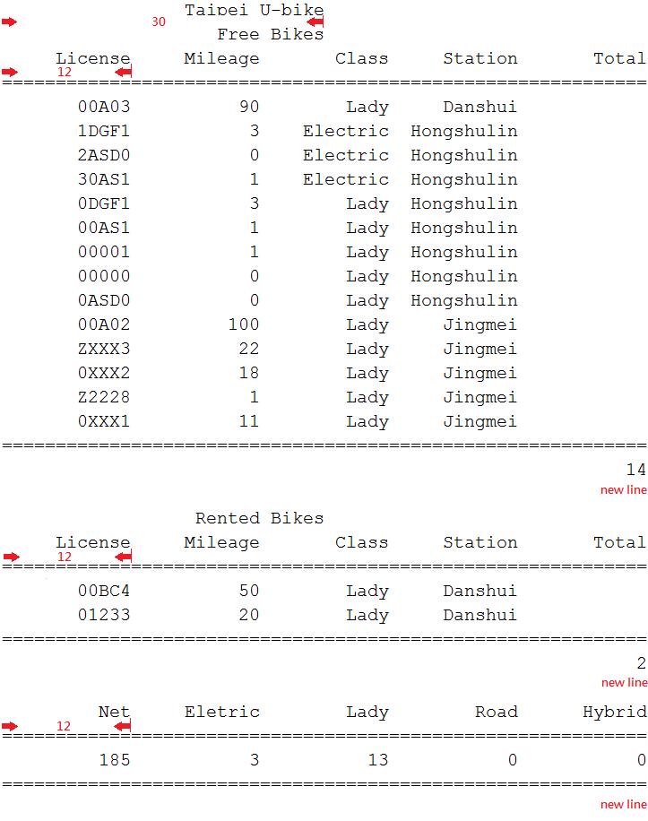

9. NetSearch StationName

(1) Print StationName

(2) 15’=’

(3) Print 4 type class net from Electric=0 to Hybrid=3. (4) 15’=’

(5) Print total net

(6) newline

Example

Input : NetSearch Danshui

Output :

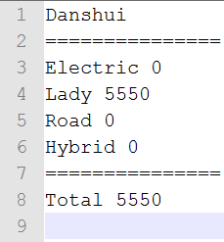

10. BReport

Print the Binary search tree.

The first line is “Binary Search Tree”

The second line is the preorder of the BST.

The third line is the inorder of the BST.

Example:

Input : BReport

Output :

