ULTRASOUND QA MANAGEMENT SYSTEM
Project Specification Document

July 2025
Table of Contents
Project’s context 3
Project’s aims 3
Project’s perimeter 3
Users 4
Functionalities 4
Diagram of use 5
Diagram of class 6
Mock-up 6
Page 1: Index 6
Page 2: Test 6
Page 3: Library 6
Technical constraints 6

Project’s context
St George’s Hospital, Ultrasound Team.
Issue: Compliance with end user quality assurance tests in Radiology is low. Issues with scanners or probes often go unreported. There is a need to simply the process to record test results and report issues to the ultrasound physics team.
Goal: To create a custom application/website that allows end users to access the scanner inventory and input results of standardised tests.

Project’s aims
Specific goals:
- Identify which systems are due for testing
- Make the records of tests easier
- Centralise the data
- Improve the trackability
- Provide a route to report issues to medical physics and monitor status

Project’s perimeter
Included:
- Auto-saving test pages (idk)
- Export history in Excel sheet
- Access to the ultrasound team contact details
- Auto update worklist according to the date and machine test done
- You can update manually list of the machine
- Log the fault automatically
Not included:
- Auto update of new machines

Users
- Radiographers, ultrasound team
- No need to have a training (for the app?)
- Need to have an account (administered by ultrasound team)
- Anyone connected can access all of the machines

Functionalities
Functionality | Description
Worklist | Table with 3 columns: Room, Scanner’s name and due date. The worklist is updated every day and if a machine is done it will be updated. It will show the machine that have to be tested to the maximum 5 days ago.
Outstanding faults table | Table with 4 columns: Room, scanner’s name, progress (Completed Successfully, in progress, not started).
Contact physics | Button clickable. You will open an email window directly with the ultrasound team contact.
View library | Button clickable to go on a page in which you can see all the active machine with a picture and a button results history.
View results history | On the library, if you click on button results history you will upload the Excel Sheet. You can also have a button up on this page to upload the results history of all the machines.
Update scanner parent child | Button clickable on the index page to update the machine’s list from exisiting Equipment database
Exit button | To disconnect from the website.
Test page | If you double click on a machine in the worklist, you will have the test page that include all the probe’s test tables and information about the machine (location, name and due date). A ‘back to dashboard’ button to go back to the index page. A ‘save the result’ button to save the result.
Test table | Probe number, model, serial number.  Visual inspection: pass or fail button  Uniformity: write a comment and button to declare a fault  Depth of reverb: enter a value  Noise level: enter a value
Fault | On the test page, possibility to log another fault with a comment section.
Link | Link to work instructions (SOP) for tests

Diagram of use
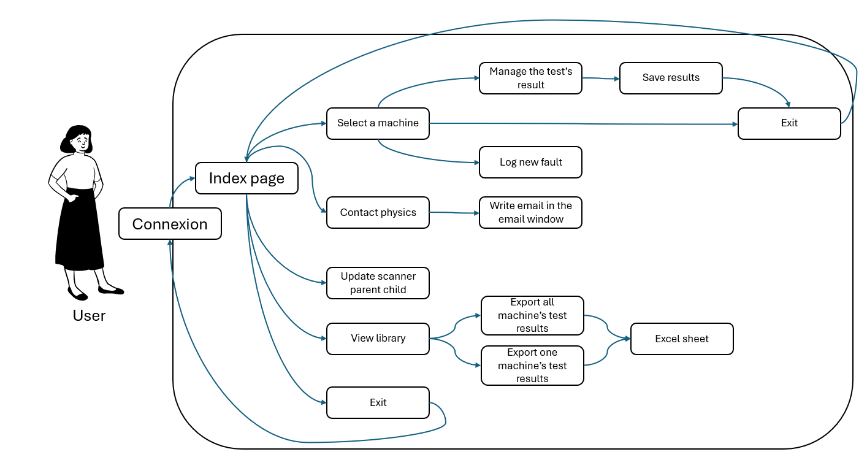

Diagram of class
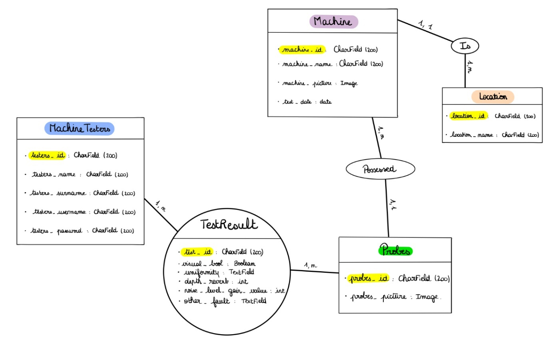
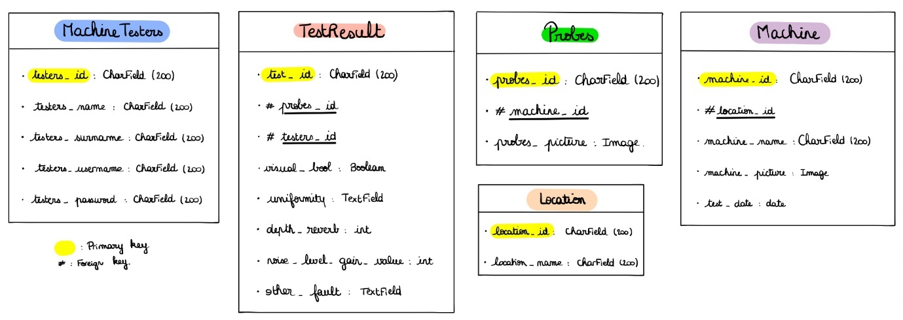

Mock-up

Page 1: Index
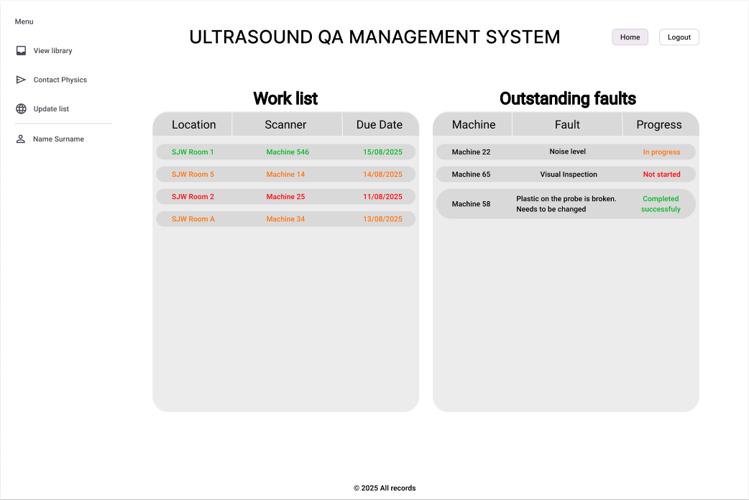

Page 2: Test
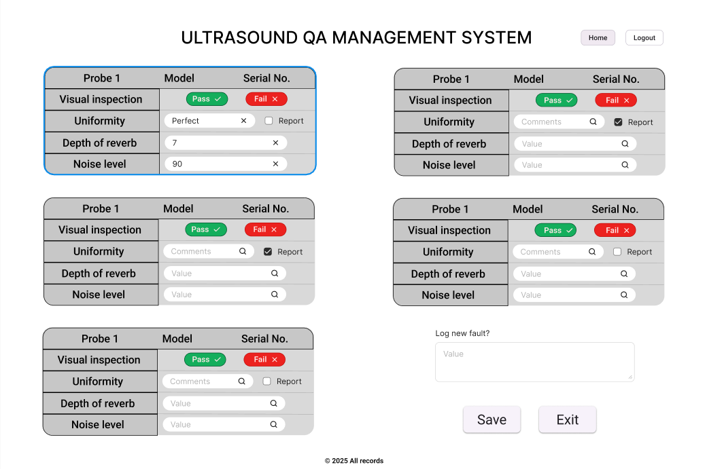

Page 3: Library
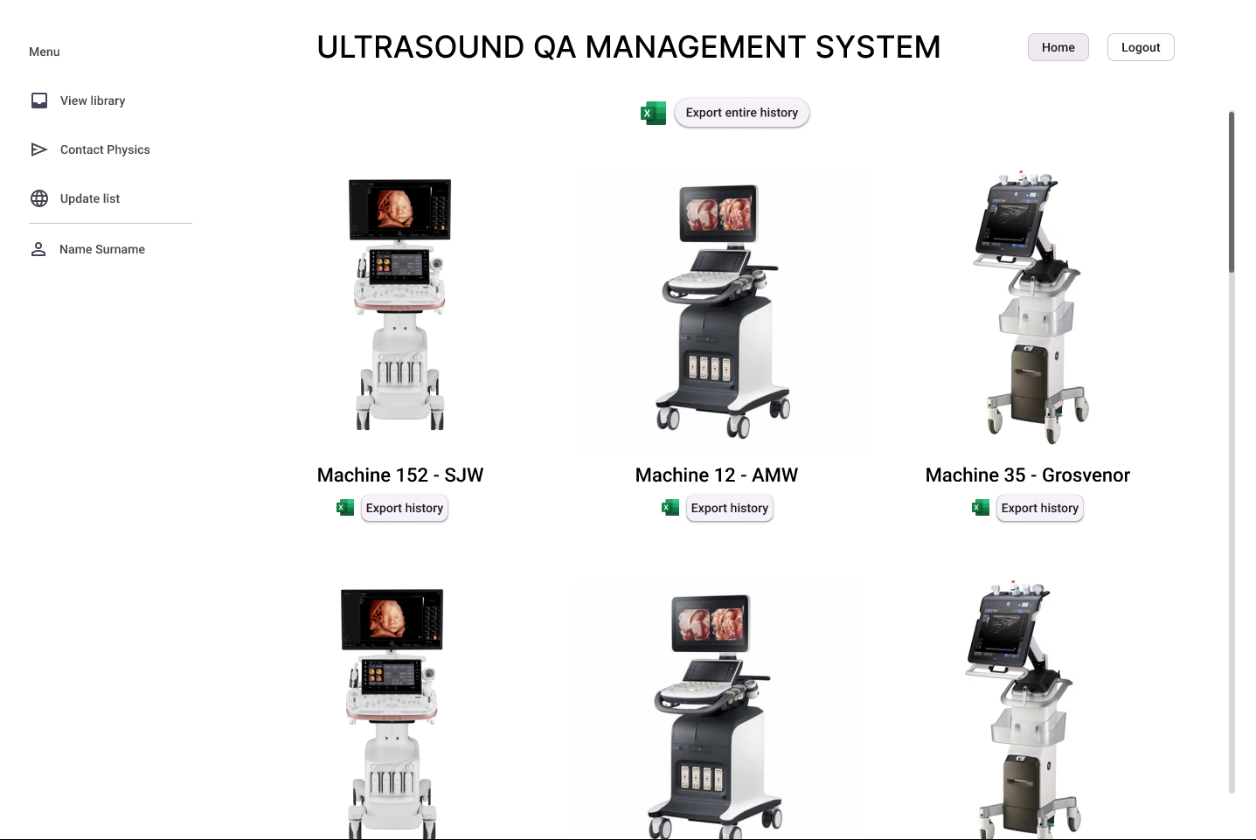

Technical constraints
- Django, e-quip database, SQLite database.
- Hebergement?
- Security?

