1. Client and Topic (25-word minimum):

The following website will follow the path of a home-based business that would be run, If I were able to distribute my product through the workplace.

2. Development Process and Engagement (50-word minimum):

This website will be made for myself, however if this site could assist a client in the long run then I would not object to doing so. The research that will go into this website would be to observe other websites that specialize in providing a service similar to mine. I will have to view the pages these websites have, that'll give me an example of how the site should be presented.

3. Testing (50-word minimum):

I will analyze the speed that it takes getting from one page to another. For other tactics to shoot for, is the responsiveness of the attributes or links within the website. There's this feeling I have that these two aspects will play an appropriate role in my website, before the SEO can be accessed. I plan on utilizing Microsoft Edge as a browser. It's the default browser on my laptop in comparison to internet explorer.

4. Description (100-word minimum):

The goal of my business is to sell breakfast smoothies to people who don't necessarily wake up early enough to eat breakfast. This is catered to the individuals who work within my clinic on Randolph Air Force Base. I feel as if with the website, it should be easy to place an order in advance. Only in the morning will these drinks be distributed, this will most likely be before the work day begins. Accessibility will be simple to the user, because it will contain by far the most basic applications to assist through the navigation of the website.

A good majority of the graphics I use will be done by me. To include a video illustrating the making of the smoothie, and hand-drawn images to represent bullets of the ingredients. The plan is to place a table for nutrition facts for each ingredient that will be done, as well as an order selection through email. Content may need to be updated weekly to determine customer satisfaction, I may plan on incorporating gift card stamps for a free drink.

5. Growth and Maintenance (50-word minimum):

I believe my website will pick up traffic, only if business is sustainable. By no means do I wish to make this public outside of a military installation. However if I chose to, I would need to implement changes in my meta-tags that could bring in more users to my site publicly. Once again this should be consistently done every week, in order to monitor trends.

6. Organization (100-word minimum):

This website will be organized by the following 10 navigational features. First, the HOME page which will include a synopsis of the website, followed by the hours of operation and the link to place an order. The next page will be the SMOOTHIE page including nutritional facts on the smoothie and a video on how the smoothie is made (a drop down feature for the ingredients of the shake will be present as well). Within the dropdown of SMOOTHIE, there will be other pages to view. Out of the pages present such as STRAWBERRIES, BLUEBERRIES, CRANBERRIES, and BLACKBERRIES.

These pages will detail nutrition facts and summaries on the berry. The final four pages will include the ORDER page, which allows the user to place an order on reserve. A CONTACT page will be presented for such things like reviews and feedback. There will be a LOCATION page showing where the business is being done with a map included. Lastly a MISSION page which describes the reasoning for the website and business.

Storyboard:

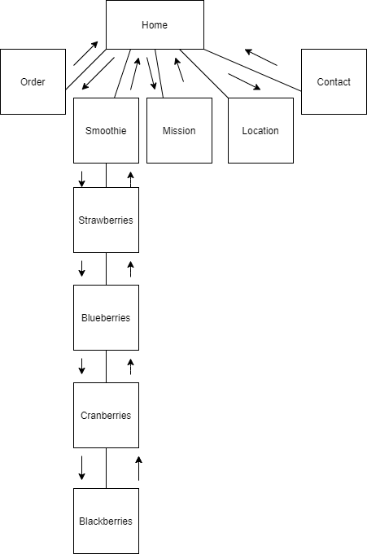

Home:

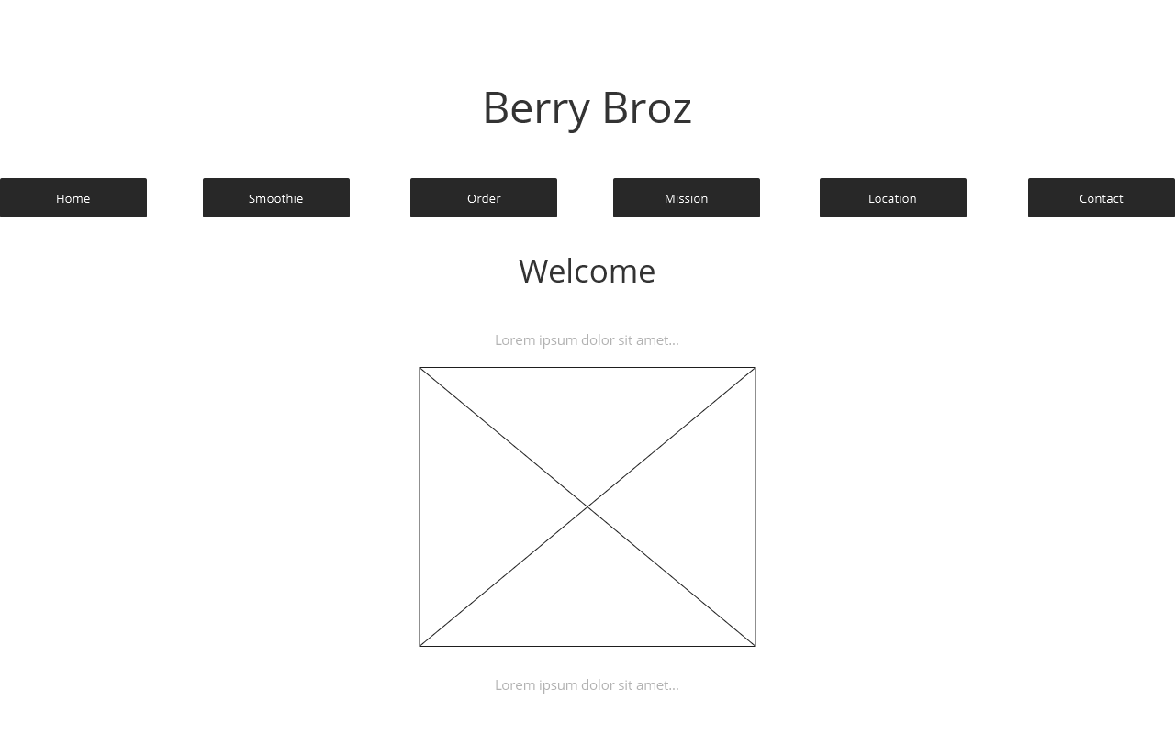

Smoothie:

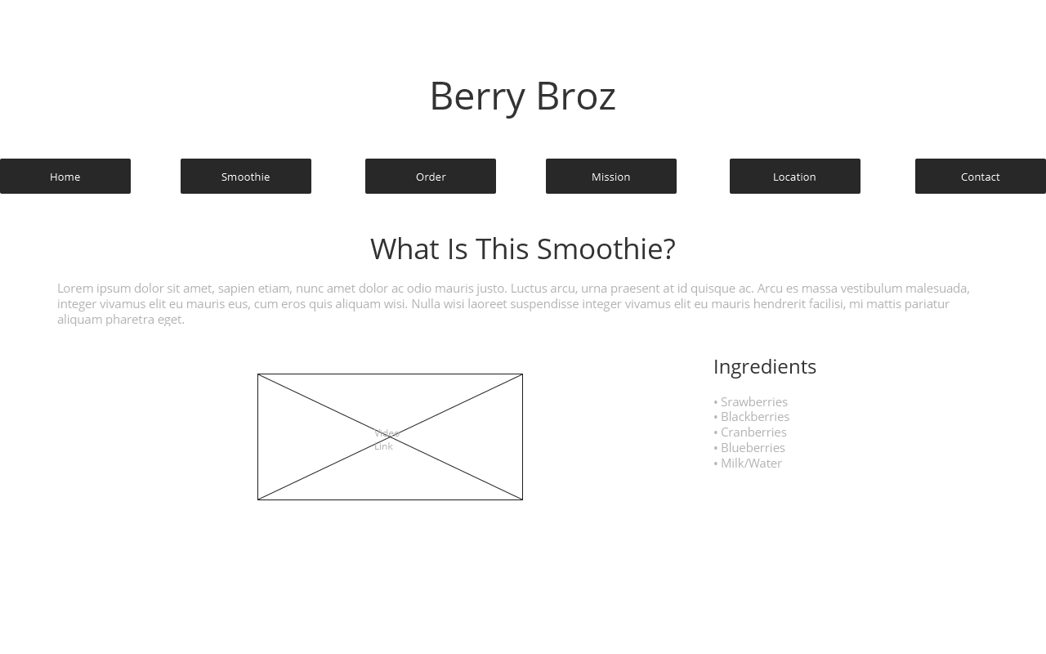

Berries:

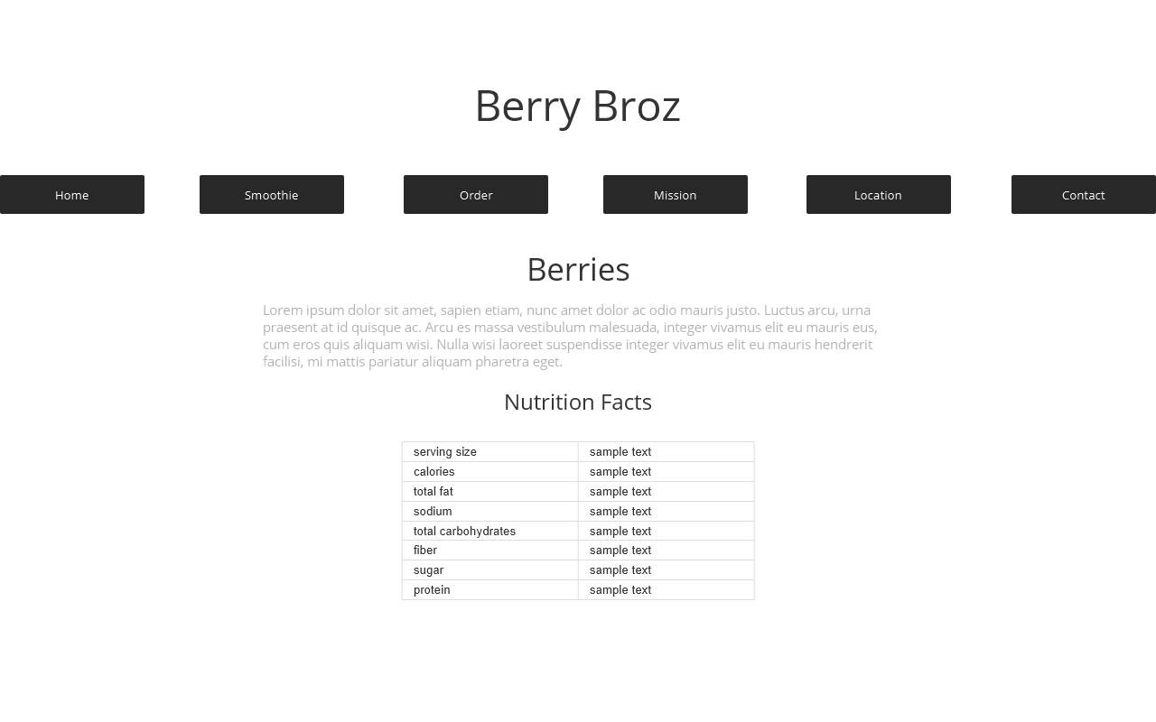

Order:

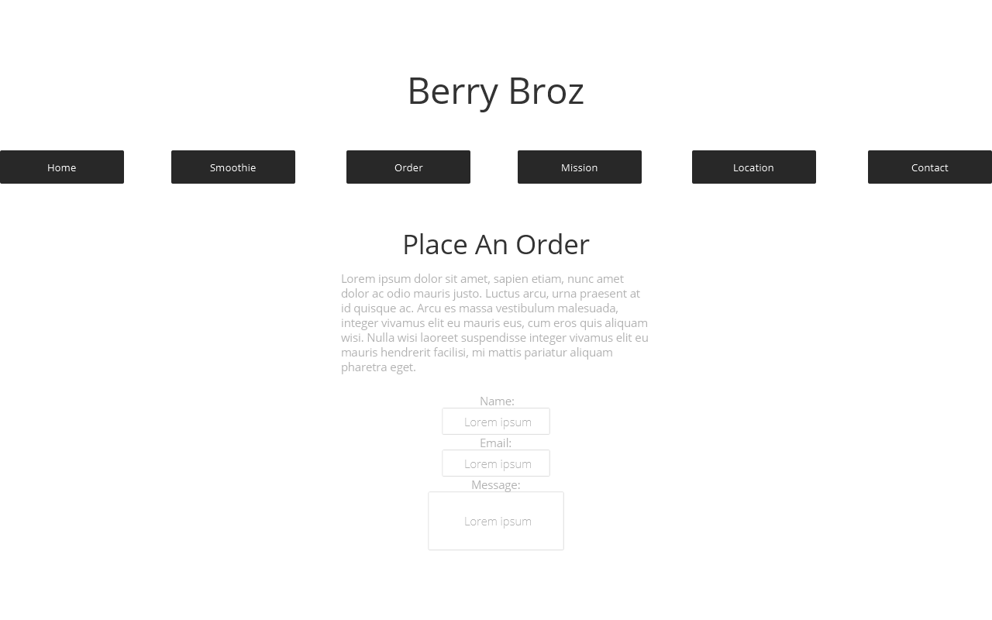

Mission:

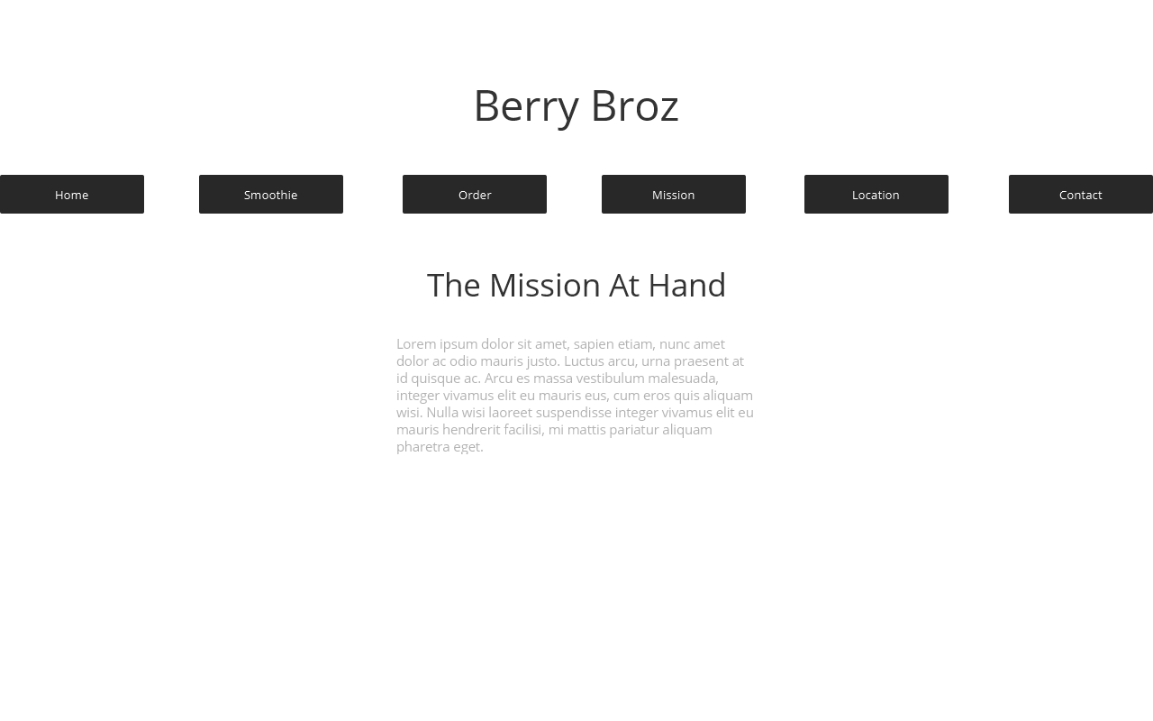

Location:

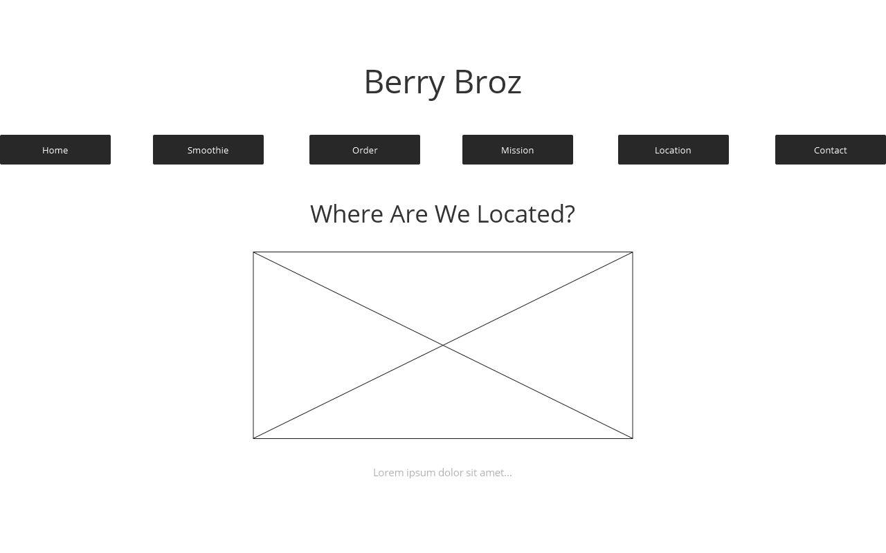

Contact:

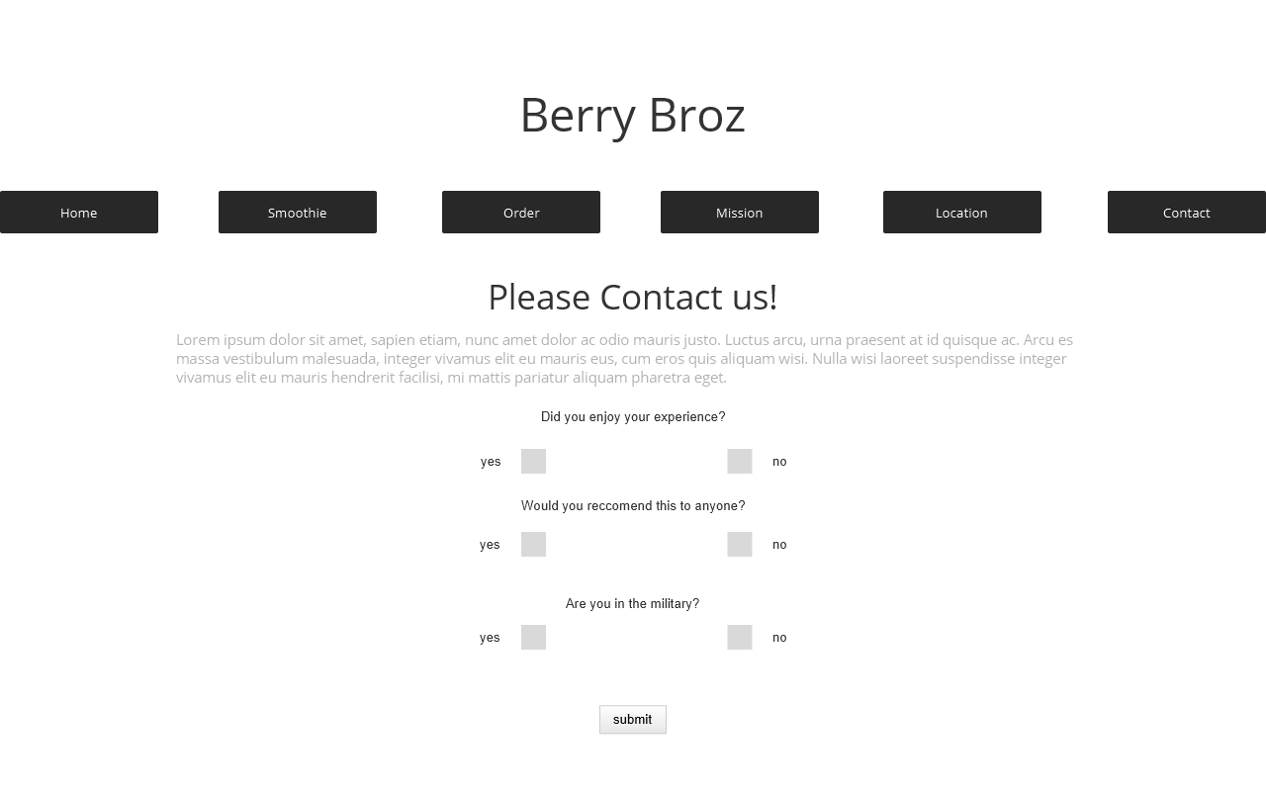

7. Security (50-word minimum):

There will be no e-commerce at this moment, however it may be subjected to change. It's because the ordering within the site focuses on reservation, there will be no need for password authentications. If the transaction were to be done online, then surely I would provide a password for that. Placing a reservation through the site of the company email will encourage customers to come to the location and pay cash. I see it making things trustworthy on our part. The plan is to utilize WordPress to better help manage and secure the site if issues arise. From my research it seems to be the most popular among users.

8. Web Hosting (100-word minimum):Please note that you aren't required to actually register a domain name or sign up for a hosting plan

For this website I am searching for anything that can allow me to program in HTML5 and CSS3. These languages are important because, in order to set up a table for nutrition facts or a survey; I will need HTML5 to do so. To capture the design of my website, I will have to use CSS3, to make sure the dropdowns and the multimedia video I'm using are functional. Reading through available domain names, I saw that berrybroz.us had an available name. Chances are, I just might consider that name to keep things military friendly within my section at work. I also witnessed that godaddy.com has a good domain hostage for cheap, which will be something I'll need just to get my feet wet.

9. Marketing (50-word minimum):

This website will easily be marketed through actions such as flyers within my clinic, or within the global e-mail address of my squadron. Implementing SEO into the fray, I believe keywords that will workout greatly with my site would be "Military, Texas, Smoothie." Pretty simple in regards to pulling the audience I want into my website.

10. Project Reflection (MS Word document or paste the information in the textbox of the Assignment folder on submission) (minimum 250 words)

For this particular assignment I used two applications to prepare for my final project. With my storyboard draw.io was used to construct the paths of my website. As for the wireframes, justinmind was used to create the layout of what I would be shooting for if I developed the site. Dabbling through my flowchart, I got a better idea of how things should be placed. Initially I had an idea of adding my ingredients to the smoothie and placing them into the navigation. However, this idea wouldn't be plausible; because of the length it would take from the spot of the site.

These applications came in handy, and I can't express my gratitude for being provided with the software to create these templates. Prior to the discovery of these avenues, I used to draw out my plan for a website. To be honest I started out attempting to follow that example, until I saw more than one option to choose from. That is something I am truly grateful for. Any issues I developed from constructing this assignment came from the purpose of the website.

It was difficult to come up with a reason to create a website from scratch, that is somewhat original. Luckily, I found my inspiration for the product from having breakfast at the time. I believed it to be a great path that could possibly do more help in the future if I choose to push this product into my work section. Besides the idea of the website, there was nothing else for me to worry about.