Quinton Skilling

Complex Systems 530

**Spatial Investigations of Neuronal Network Formation**

**Introduction**

Cognitive functions of the brain are thought to be the collective results of millions of individual neurons interacting through neuronal networks. These networks are formed via synaptic connections between neurons, which serve to propagate information (e.g. a car honking its horn) to the proper regions in the brain, usually resulting in a behaviorally relevant response (e.g. quickly accelerating at a green light). Formation of neuronal networks thus typically occurs early in development and then remain relatively stable throughout an organism’s lifetime. Network formation and upkeep is thought to be an activity-dependent mechanism. It has been shown, for example, that synaptogenesis is positively affected by the presence of the Wnt protein families, present in high levels during brain formation, and that expression of these proteins is activity dependent (1). Further, modifications of existing synaptic connections occurs throughout the lifetime of organisms, lead to the common phrase “neurons that fire together, wire together.”

Many different experimental methods exist for probing neuronal network structures and are used in various circumstances. PET scans, for example, yield network structures based off observed radioactivity, with resolutions of millimeters at best. Functional magnetic resonance imaging, as the name suggests, correlates behavioral function such as word memory recall to blood flow in the brain, effectively mapping out large regions that cooperate during specific tasks. On a finer resolution, a relatively new technique called BRAINBOW (2) uses multiple colors of fluorescent proteins, expressed stochastically, to reveal a highly detailed, yet difficult to interpret, map of individual network connectivity, such as in the hippocampus formation of mammals. Though these techniques have been used in attempt to map the entire brain, both in terms of structure and function, the data are often hard to interpret or lack necessary resolution to be meaningful at the level of neurons and their connections.

As a result of the complexity of these large-scale network scanning techniques, many researchers opt to use a more simplified system as recording from in-tact brain slices using shank electrodes (3) or (possibly most simply) from networks grown in vitro from dissociated neural tissue (4). These techniques have proven useful in studies of how smaller networks process information but they are often severely limited in terms of functional output. Especially in the case of dissociated cultures, the networks formed don’t necessarily resemble the networks formed in vivo (in fact, networks in vitro are thought to be spontaneously formed).

Things aren’t much better from a computational point of view, either. While simulations of model networks can help to interpret and even predict information about biological neuronal networks, they can be based off incomplete information. Often, modelers assume a certain network topology, such as small-world or scale-free, without much evidence that the structural connections in vivo or in vitro can give rise to such topological distributions. Are scale-free networks formed in spatially constrained neuronal cultures? Can three-dimensional brain regions support small-world networks, with some connections reaching to spatially distant locations? My project for this course aimed to bring together information about how spatial dimension and neuronal activity give rise to networks.

**The model**

In this project, I wanted to explore how simple, activity-based rules of connection formation give rise to networks of different structures and how spatial constraints (here limited to two or three dimensions) affect the networks. To this end, I used agent-based modeling to simulate the system under different assumptions.

Neurons in my model (n = 500) were simulated using the leaky integrate-and-fire equations (5). In this formalism, the membrane voltage of an individual neuron changes based on the total ionic current received by the neuron at each point in time:

$c_{m}\dot{V}=-αV+I_{persistant}+I_{synaptic}$,

where *V* is the membrane voltage, *cm* is the membrane capacitance, α is leakage variable related to passive outward flow of positive ions, *Isynaptic* is the total input received from all other known neurons in the system, and *Ipersistant* is a net current from other, unknown sources. Here, I set *cm* = 1 and α = 0.1 for all simulations. Unlike more sophisticated conductance-based models, the integrate-and-fire neuron model activates (fires) at an arbitrarily-set threshold and must be manually reset,

$$If V(t)> V_{Thresh}:$$

$$V\left(t+1\right)→ V_{reset} and t_{i}^{spk}=t$$

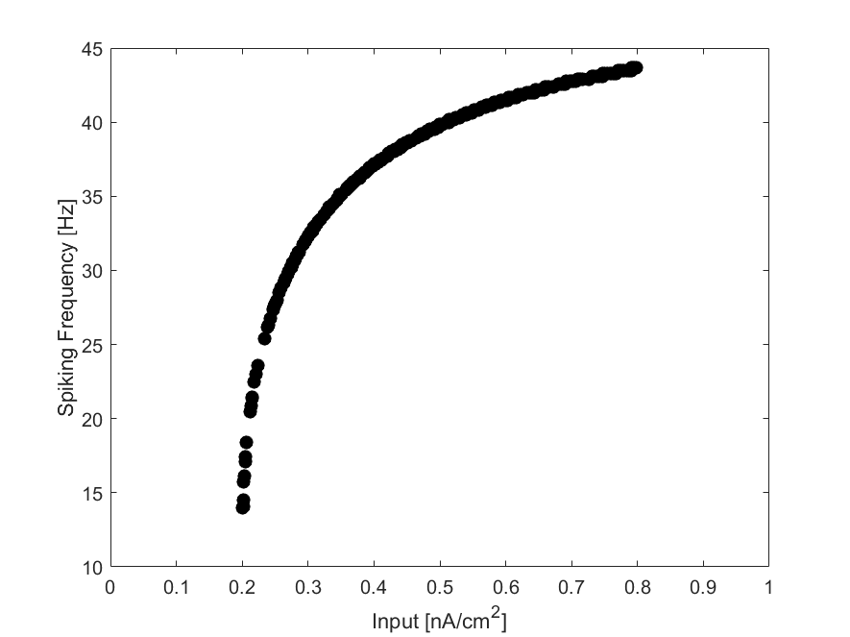Where I have set *Vthresh* = 2.0 mV and *Vreset* = 0, and $t_{i}^{spk}$ records the time of spiking (to be used shortly). The frequency that a neuron fires is controlled mostly by *Ipersistant* and here are assigned heterogeneous values across the system so that each neuron fires with a unique frequency (Figure 1). The lowest frequency occurs for *Ipersistant*  ~ α and the highest frequency of ~ 45 Hz is asymptotically reached for increasing *Ipersistant*. It should be noted that here I have implemented a manually controlled refractory time of 20 ms, during which time Eq. 1 is not updated, consistent with electrophysiological observations.

Figure 1: Spiking frequency as a function of input. Neurons are randomly assigned input in the given interval.

The remaining term, *Isynaptic*, represents the integrated input of all neurons pre-synaptic to the one being updated,

$$I_{synaptic}=\sum_{j∈pre-syn}{w_{j} (EXP\left[-\frac{t_{j}^{spk}}{3}.\right]-EXP\left[-\frac{t_{j}^{spk}}{0.3}.\right])}$$

Where I have chosen the double exponential function to loosely represent the shape of a firing event and subsequent synaptic release with width 10 ms and connection weight *wj*; an example convolution of the spike times with this firing-event-like curve is shown in Figure 2. At the time of simulation onset, all neurons are disconnected, and so no synaptic current is applied. The formation of connections and the subsequent network topologies that form are the true focus of this project.

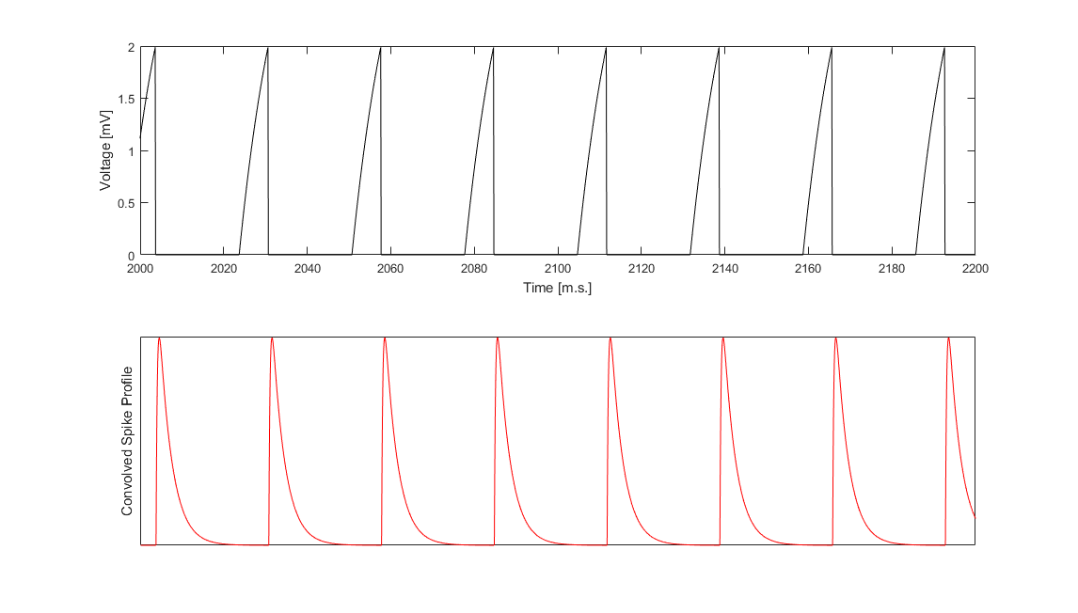

Figure 2: Example of model neuron output. Top: Voltage vs time for a neuron. Spike times correspond to the vertical lines. Bottom: Convolution of the spike times with the double exponential, mimicking the shape of a firing event to be more biologically appropriate.

*Connection formation*

The properties of networks can formidably explain interactions across the network and has become a science in-and-of itself. University of Michigan’s own Professor Mark Newman authors an authoritative text on the subject [source], detailing various network quantifications useful for determining “the most important” nodes (or neurons in this case) among many other things. By applying some of these metrics, I hope to gain understanding about how activity-based network formation under different spatial arrangements gives rise to different network distributions and subsequent activity due to those distributions.

Here, networks form over time as new connections are added between pre-existing neurons in the system. Previous other studies have explored how neurogenesis (the addition of new neurons into a network) affect existing network activity and subsequent topology (6), but I’ve found few studies that explore synaptogenesis solely. This is likely due to the assumption that networks form quickly during development as new neurons establish connections soon after their introduction into the existing network (or cell neighborhood if one looks early enough). Regardless, I here focus on the formation of new connections in fully populated neuronal environments, hopefully toward understanding the differences between networks formed in vitro and in vivo.

To this end, I developed my network-formation model on the following assumptions:

1. Neurons can only form connections to those in a specified range (connection radius hereafter)
2. Neurons with high levels of activity want to form an outgoing connection
3. Neurons with low activity want to form an incoming connection
4. Only one outgoing connection can be formed during each simulation step

The first is a biological restriction on spatial connectivity so that two neurons on far sides of the environment cannot form connections outside the right conditions. The second two assumptions are just reiterations of activity-dependent synapse formation whereas the last assumption I introduced to slow down network formation; without the single-connection-per-step rule, I found that networks very quickly approached networks expected given a neuron’s connection radius.

In order to implement the second two rules, I employed the use of sigmoidal functions to define what I refer to as outgoing and incoming connection propensities:

$$p_{out}(t)=1/(1+EXP[-(\left(\sum_{t^{spk}∈\left(t-t^{spk}\right)<2000ms}{1}\right)-h_{out})/s ]$$

$$p_{in}\left(t\right)=1- 1/(1+EXP[-(\left(\sum_{t^{spk}∈\left(t-t^{spk}\right)<2000ms}{1}\right)-h_{in})/s]$$

Where the sum is over all the spikes for a given neuron within the past 2000 ms, the period of creating new connections, *s* represents how quickly the propensities decay from unity to zero, and *hx* is the location of the half-maximum of the sigmoidal curve in question in “activity units.” Clearly, the number of connections formed relies on the *hx* and s values, though exactly in what way is unclear. To study this, I rand simulations for $h_{x}∈\{5, 15, 25, 35, 45, 55, 65, 75, 85, 100\}$ for s = 0.5 (referred to as “fast decay”) and for $s= {h_{x}}/5$ (referred to as “slow decay”), as shown in Figure 3.

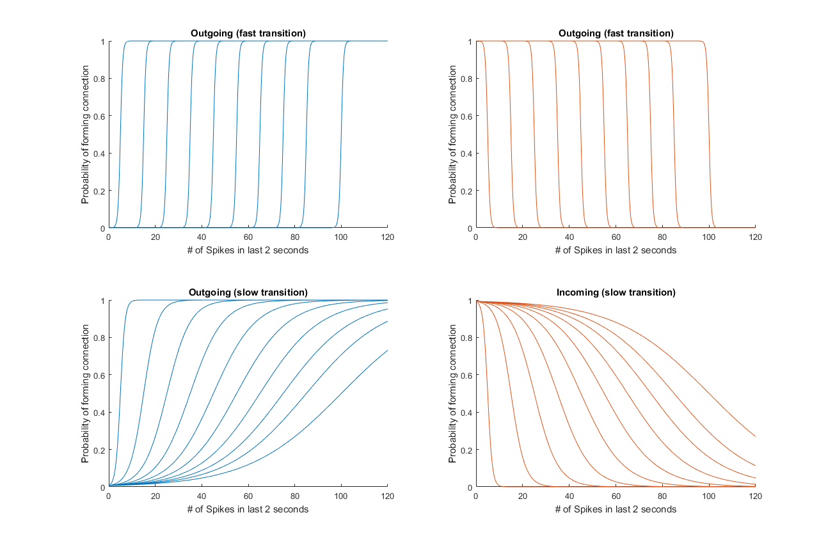The propensities are used to determine whether or not a connection should be formed based on a random probability, following

Figure 3: Outgoing (left) and incoming (right) connection propensities. Top panels show the fast transition case and the bottom panels show the slow transition case. Note the difference in shape between outgoing vs incoming propensities: incoming propensity stays high for increasing the half-maximal value whereas the outgoing propensity decreases over most spike counts for increasing the half-maximal value.

$$p∈\left[0,1\right)<p_{out}p_{in}$$

Thus, if one neuron has high frequency and it senses a low frequency neuron, for the appropriate values the respective *hx*’s, a connection will be formed. Here, however, only one connection per neuron is formed per connection-forming events (again, with period 2000ms) and only those neurons in connectivity range can form connections. For small connection radii, networks will be localized to a small region around neurons but for larger range, full network connectivity is possible; Figure 4 shows example connectivity radii, illustrating the number of neurons that can form connections. The values of the connectivity radius is homogeneously set for all neurons to be either 200, 500, 1000, 2500, and 5000, in an environment with 10% neuron density.

*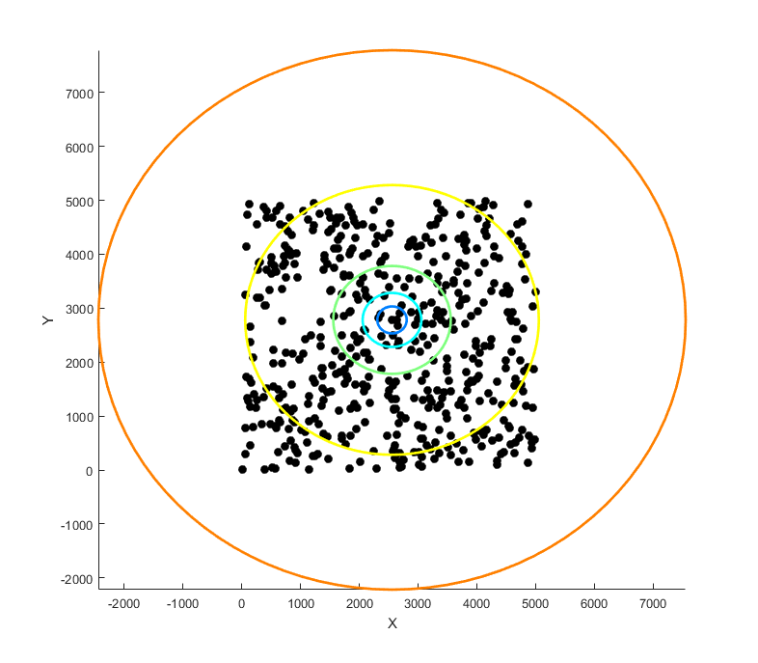Connection strengthening*

Figure 4: Example model environment. Neurons are shown as black dots, with their position indicated by their cartesian coordinates. Example connection radii for the middle-most neuron shows that for large enough connection radius, full network connectivity is at least possible.

In this project, I wanted to include medication of neuronal networks, through strengthening and weakening of synaptic connections, to possibly quantify how network interactions affect pairwise neuronal activity. The idea is that a neuron will have greater influence over a connected partner if the connection is stronger. As such, I included the spike-timing dependent plasticity protocol [source to Bi and Poo], which strengthens connections if a post-synaptic neuron fires before its down-stream target but weakens the connection if the spike timing relationship is the other way around (i.e. post- firing before pre-), as illustrated in Figure 5.

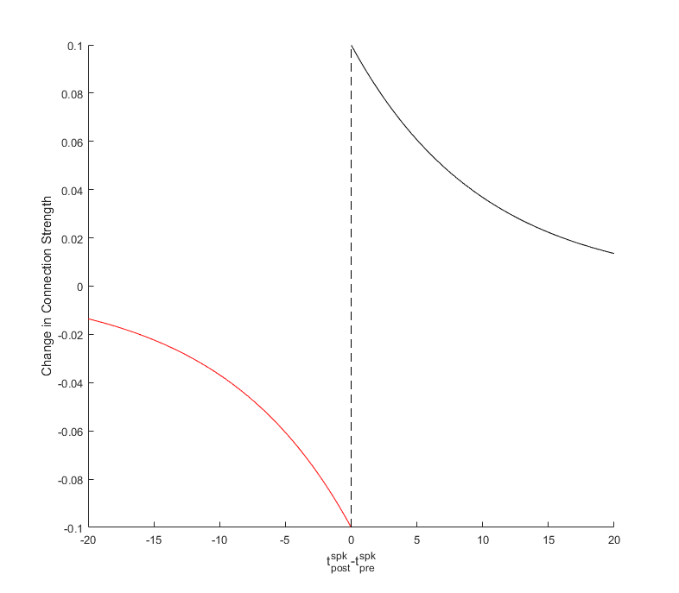**Model schedule**

Figure 5: Change in synaptic weight as a function of spike timing difference.

The model simulations were written in python 2.7 and executed in python 3 on the Flux HPC at the University of Michigan; no known compatibility issues were noted at the time of simulation. The model simulations took the following steps, in order:

1. Neurons are initialized
   1. Voltages are randomly set so that $V_{i}(t=0)∈[0, V_{threshold})$
   2. Inputs are randomly set so that $I_{persistant}∈[0.2, 0.8]$
   3. Each neuron is assigned a randomly cartesian position
2. Spatial environment is initialized and populated with neurons
   1. Neurons are placed randomly according to their position
   2. Neurons construct a list of all neurons within their connectivity range to reduce computational time
3. Time iteration in the main program loop
   1. Neuronal Inputs are integrated synchronously
      1. Synaptic inputs are calculated if any connections exist
   2. Neuronal voltages are integrated synchronously
   3. Connections are formed or strengthened
      1. Connection formation has a period of 2000 ms starting at the 2000 ms mark
         1. Propensities are calculated and their product is compared to a random number to see if a connection is formed
      2. When connections are not being formed, existing connections strengthen or weaken based on the STDP rule
   4. Steps a-c are repeated
4. Data is printed to a file for offline analysis

**Results**

All results were analyzed offline in Matlab 2018b and 2019a; the latest version was used for all graph centrality measures, as it is the first version of Matlab to incorporate these analyses in the main program.

Models explored how networks form and their corresponding network properties for changing connection-formation rules. I did a parameter sweep over just 3 variables: outgoing propensity half-maximum, incoming propensity half-maximum, and connectivity radius, for fast and slowly decaying sigmoidal slopes.

First, I started generally and wanted to see the size of the connected network, also known as the size of the (possibly) giant component [source to Newman]. Figure 6 shows the size of the giant component (normalized to the network size) as a function of connectivity radius and incoming- and outgoing- propensities for the slowly decaying sigmoidal functions and Figure 7 shows the same but for quickly decaying sigmoidal functions.

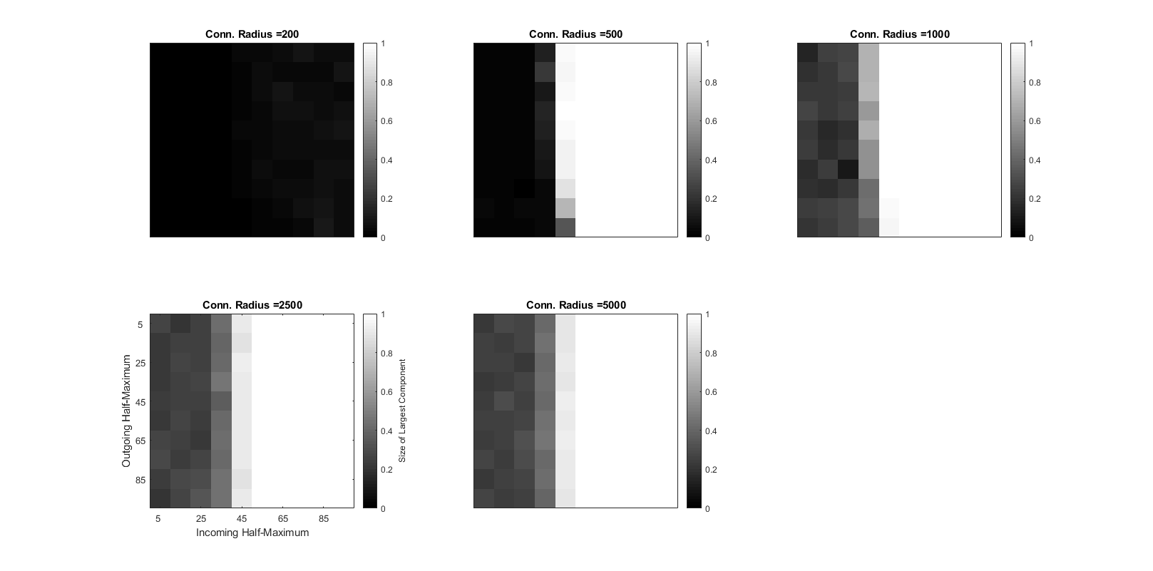

Figure 6: Size of the largest component of the formed network for slow decay of the corresponding propensity sigmoidal functions.

We see that in the case of the slowly-decaying sigmoidal functions, connections form so that the entire network is connected in most cases. Interestingly, for large enough connection radius, outgoing half-maximum did not seem to have much affect on the component size whereas the incoming half-maximum acted as a sort of switch, where everything below a critical value of 45 resulted in low connectivity.

Conversely, quickly-decaying sigmoidal functions gave rise to more diverse component sizes, especially when the connectivity radius was greater than 500. Here, we also see that the outgoing propensity interacts with the incoming propensity in a more interesting way, resulting in a “triangular” parameter space, where the upper triangle resulted in medium sized components and the lower in components of very low size. Note here also that for the maximal value of outgoing propensity half-maximum, no connections are formed.

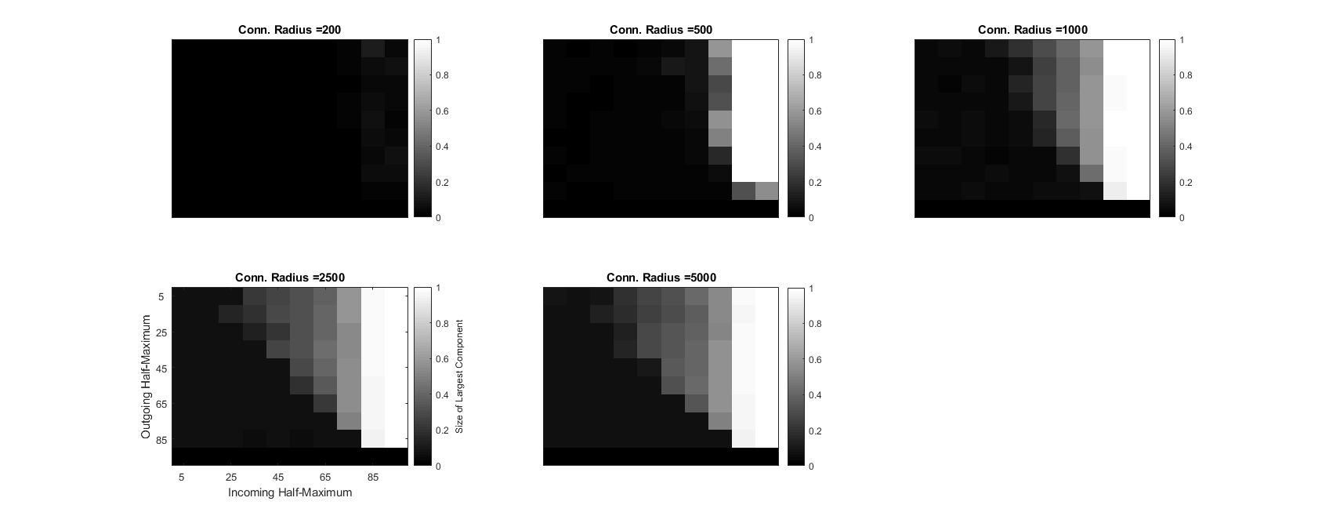

Figure 7: Size of the largest component of the formed network for fast decay of the corresponding propensity sigmoidal functions.

The analysis of degree distributions are important for quantifying properties of networks [source]. I was especially interested in understanding how the distributions change due to fast- and slow-decay of sigmoidal dynamics. To this end, I tabulated the in-degree (number of incoming connections) and out-degree (number of outgoing connections) and compare the histograms of each as a function of radius and propensity. However, these figures are very large, as I couldn’t find a suitable way to condense the figures without loss of information. I’ve thus uploaded these figures to my github repository (github link) and here provide qualitative descriptions and figure captions (online figure captions located at the end).

For a connection radius of 200 and slowly-decaying propensity functions (Online Figure 1), both the in- and out-degrees peaked near zero connections and decayed over ~ 10 connections for all *hx* values. However, as *hout* increased, we see what looks like the beginning of emergence of Gaussian degree distributions. By contrast, the quickly-decaying propensity functions (Online Figure 2) don’t have emergence of Gaussian distributions and, when the outgoing half-maximum is at its largest value, no connections form in the network, as previously discussed.

Increasing the connectivity radius to 500 has a profound affect in both the slow-decay (Online Figure 3) and fast-decay (Online Figure 4) cases. For slow decay and outgoing half-maximum less than 35, we see a Gaussian-like outdegree distribution and a peak near 1 connection for the incoming degree distributions, indicating that many neurons only receive one connection but send connections to many others (though these are likely different neurons). Then, for increasing the outgoing half-maximum value to 35 or above, we see a bimodal out-degree distribution, with one peak near zero and another near 15 connections, and the emergence of a Guassian-like in-degree distribution. For quickly decaying propensity functions, we see Gaussian-like out-degree distributions for lower values of the out-degree half-maximum values and corresponding in-degree distributions that peak near 1 connection. Here, conversely to the slow-decay case, we observe that increasing the outgoing half-maximum reduces network formation except between a few high out-degree nodes which project to only a few neurons, causing Gaussian-like in-degree distributions.

These trends largely continue for increasing the connection radius: slowly-decaying propensity functions result in few incoming connections for low outgoing half-maximal values but show emergence of Gaussian-like in-degree distributions when the outgoing-half maximal increases and causes ~ 50% of the network to form most of the outgoing connections (Online Figures 5, 7, and 9) and quickly-decaying propensity functions see no qualitative changes due to increased connection radius (Online Figures 6, 8, and 10).

These results are a bit surprising, as when they are taken into context with the observed component size indicates that the parameters leading to more fully connected networks (i.e. slowly-decaying propensity functions) have the most diverse degree distributions whereas networks which show diverse connected-network size don’t have significantly diverse degree distributions.

Next, in order to expand on these network analyses, I calculated the out-degree centrality together with the betweenness centrality to better determine which neurons are “more important” in the network. The degree centrality is simply the number of connections a given neuron has, and so it very closely resembles the pre-histogram degree distribution in the Online Figures 1-10. The betweenness centrality, on the other hand, quantifies how often one neuron is along the shortest path (in terms of connections) between two other neurons. Here, as with the degree distributions, the figures are found online.

When starting this portion of the, I expected that the highest out-degree nodes would have correspondingly high betweenness centrality. However, this was not always the case. Indeed for slowly-decaying propensity functions and connection radius less than 1000, the general trend was for the neurons medial out-degrees have the largest betweenness centrality (Online Figures 11, 12). When the connectivity radius reached 1000 (Online Figure 13), the same trend persists for all values of outgoing propensity half-maximum when incoming propensity half maximum is below 45. Above 45 however, we see that the nodes with the highest degree also have the largest distribution of betweenness centrality scores as well as the highest. The large distribution is to be expected, as if all neurons have the same number of connections, betweenness centrality in this context becomes dependent on the spatial location of the neuron in the environment: neurons near the center will likely be on many paths between other neurons compared to those neurons near the edges, especially when the giant component does not span the entire network (data not shown; this is an assumption). Unsurprisingly, when the outdegree distribution approaches a single value, viewing the betweenness centrality as a function of outgoing degrees becomes unintuitive (Online Figures 14, 15).

The same general trend was observed for the quickly-decaying propensity functions (Online Figure 16-20) except that instead of being uniform over the parameter space, these trends were confined to the upper triangular portions of the parameter space, consistent with the size of the giant component under the same context (Figure 7).

I next wanted to view the betweenness centrality in the context of neuronal firing frequencies. Similarly to before, I expected to see, generally, that the neurons with the highest frequency were the ones that would have the largest betweenness centrality (based off the connection-formation protocol). I found that with slowly-decaying propensity functions and low connectivity radius (less than 2500) that the distribution of betweenness centrality increased in width for increasing frequency, with the average betweenness centrality often occurring near the highest frequency (Online Figures 21-23). However, the distributions were quite noisy and often showed maximal betweenness centrality values at random frequencies. Interestingly, when the connectivity radius was 2500 or 5000 and the incoming propensity half-maximum was between 45 and 75, I saw the emergence of negatively correlated betweenness centrality and firing frequency (Online Figures 24, 25), indicating the neurons firing the slowest were “more central” to the network.

Conversely for the quickly-decaying propensity functions, only very high incoming propensity half-maximal at low connectivity (radii 200 and 500; Online Figures 26, 27) produce high-frequency, high-betweenness centrality scores, with many cases instead showing medial frequencies producing the maximal betweenness centrality. Interestingly, further increasing the connection radius (Online Figures 28-30) gave rise to a step-like function in betweenness centrality vs frequency. The middle value of the step, so that the number of points in the step arrange equally along the frequency access, seemed to increase regularly for increasing both half-maximum values whereas the width of the step seems to increase with the incoming half-maximum.

Taken together, these results indicate a highly complicated network generation from relatively simple rules. When the parameter space produces highly connected networks, as in the case of slowly-decaying propensity functions, connections are distributed in nonlinear (though sadly not apparently scale-free) ways dependent mostly on the connection radius. In this scenario, neurons with the highest frequency (and usually highest outgoing connectivity) are not necessarily those that are most important to information propagation in the system (assuming betweenness centrality as a good measure for what is important), contrary to what I thought I would observe. When the parameter space produced more sparsely connected networks (as with quickly-decaying propensity functions) the degree distributions did not change drastically due to increasing connection radius but we observe the emergence of the middle-frequency neurons as being the most important for information propagation.

Finally, I wanted to take the first steps of correlating functional activity to different properties of networks. Here, functional connectivity refers to the apparent network connectivity as define by performing metrics on the neuronal spiking data. I compared the activity of my neuron model in different parameter spaces across time as networks form using the mean phase coherence functional connectivity metric (7). Here, I averaged over the connected network to try to discern whether degree distribution or connected component size made a difference for functional interactions.

Figure 8 shows the mean phase coherence probability distribution as a function of increasing time in the system. As time increases, so too does the size of the giant component. Despite these models having different parameters, when the network is at least somewhat connected (compare the parameters in each panel to the parameters in Figures 6 and 7), no real difference can be seen in mean phase coherence. Similarly, the last panel shows that spike-timing dependent plasticity in my model did not have much affect on functional network interactions.

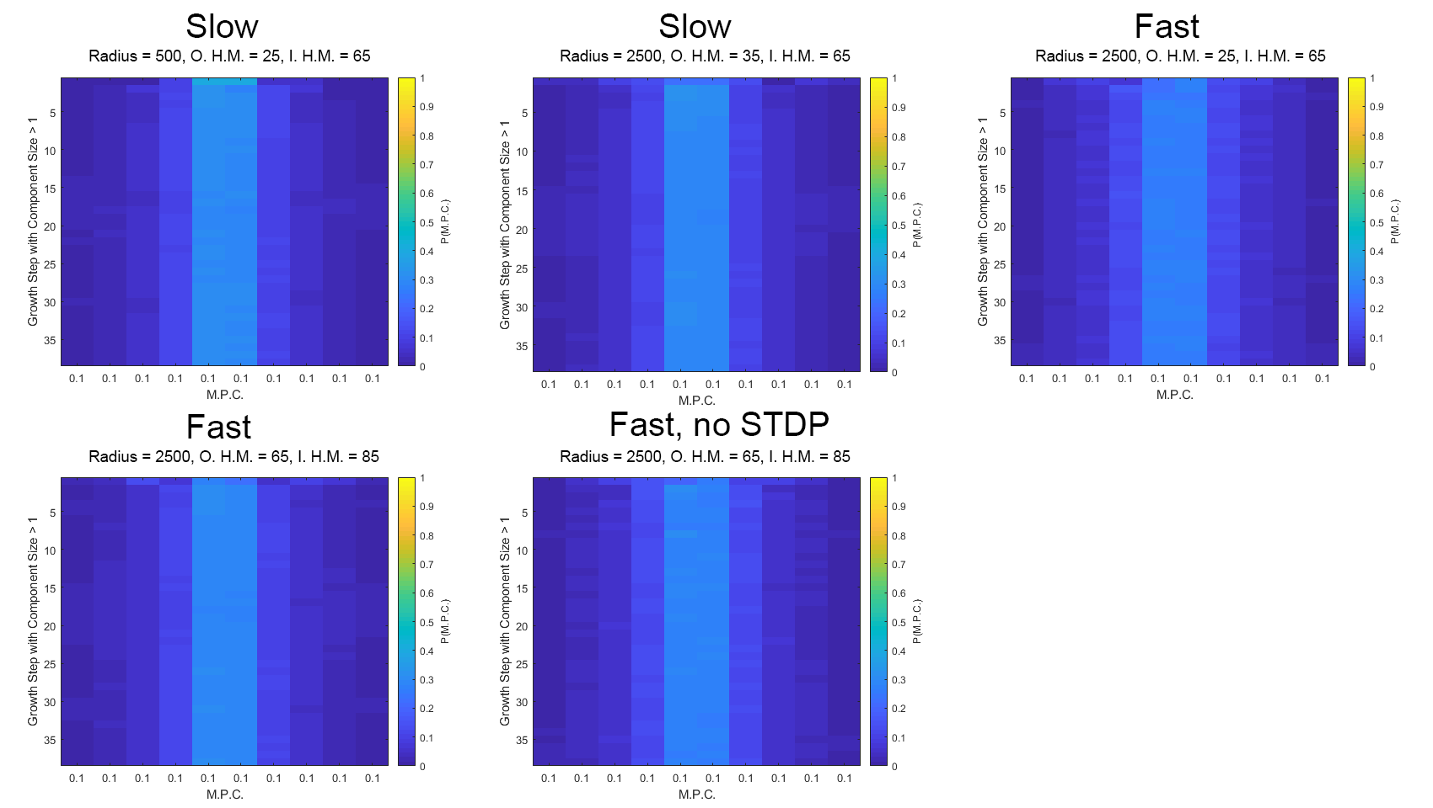**Future Directions**

Figure 8: Mean phase coherence histogram color plot for different iterations of the model. Mean phase coherence probability is shown in color as a function of mean phase coherence for increasing time in the system (increasing top to bottom of each panel. Despite having largely different networks and parameter, the mean-phase coherence did not change appreciably.

This study was intended to be a starting point for a personal project on network formation in different spatial dimensions toward understanding how networks form in vitro and whether they can be “scaled up” to in vivo systems. I believe the assumptions I made for the model were valid but I did not anticipate the complexity of the data that the model would generate, ultimately limiting this study to the two dimensional case. For starters, I thought I would get very normal distributions of incoming and outgoing connections based on the propensity functions, but for some reason they did not always produce the types of figures I thought they would (especially with slowly-decaying propensity functions). I’ve checked for bugs, especially in how the incoming propensity function works, but have been unable to find a good explanation for the what I am seeing, other than the possibility the slope of that function decays so slowly that neurons always want to form new connections above a certain threshold.

Likewise, when I attempted to correlate spiking activity to the networks that formed, I found nothing interesting. Part of the reason for this could be that the mean-phase coherence in the way that I used it is insufficient to pick up miniscule changes in functional connectivity architecture. It would probably be beneficial to generate these functional networks and compare network properties, such as centrality measures, with the known structural network. However, this will only provide so much information that can be readily applied to biological networks, as they are notoriously complicated to probe for network structure.

On the other hand, the model neuron that I chose to use, the leaky integrate-and-fire model, was one of convenience. It is very easy to integrate (not requiring something like an RK4 algorithm) but can only produce “type 1” dynamics, which do not synchronize well (8). In the future, it would be interesting to employ a more sophisticated model, like the Hodgkin-Huxley model, which can be adapted to produce both type 1 and “type 2” dynamics, the latter of which have been shown to synchronize well (8)

**References**

1. Budnick V and Salinas PC. “Wnt signaling during synaptic development and plasticity.” *Curr Opin Neurobiol* 21(1): 151-159 (2011).
2. Livet J et al. “Transgenic strategies for combinatorial expression of fluorescent proteins in the nervous system.” *Nature* 450: 56-62 (2007).
3. Suter KJ, Smith BN, and Dudek FE. “Electrophysiological recording from brain slices.” *Methods* 18(2): 86-90 (1999).
4. Gordon J, Amini S, and White MK. “General Overview of neuronal cell cultures.” *Methods Mol Biol.* 1078:1-8 (2013).
5. Gerstner W, Kistler WM, Naud R, and Paninski L. “Integrate-and-Fire Models” 1ED. Neuronal Dynamics. Cambride: *Cambridge University Press. (*2014).
6. Skilling Q, Roach J, Althaus AL, Murphy GG, Sander L, Zochowski M, Chapter 19 - Modifications in Network Structure and Excitability May Drive Differential Activity-Dependent Integration of Granule Cells into Dentate Gyrus Circuits During Normal and Pathological Adult Neurogenesis, In The Rewiring Brain, edited by Arjen van Ooyen and Markus Butz-Ostendorf, Academic Press, San Diego, 2017, Pages 409-423
7. Kreuz T “Measures of Neuronal signal synchrony.” *Scholarpedia* 6(12):11922 (2011).
8. Izhikevich EM. “Dynamical Systems in Neuroscience: The geometry of excitability and bursting.” Paperback Ed. Cambridge Massachesetts and London England: *MIT Press*. (2010).

**Online Figure Captions**

Online Figures 1-10: Outgoing (left axis of each panel) and incoming (right axis of each panel) degree distributions for the parameter space. Incoming propensity half-maximum increases from left to right and outgoing propensity half-maximum increases from top to bottom. Odd figures are for slowly decaying dynamics. Even figures are for fast decaying dynamics. Figures correspond to increasing connection radius of 200 (Figures 1 and 2), 500 (Figures 3 and 4), 1000 (Figure 5 and 6), 2500 (Figures 7 and 8), and 5000 (Figures 9 and 10).

Online Figures 11-20: Betweenness centrality vs outgoing degree centrality for the parameter space. Incoming propensity half-maximum increases from left to right and outgoing propensity half-maximum increases from top to bottom. Odd figures are for slowly decaying dynamics. Even figures are for fast decaying dynamics. Figures correspond to increasing connection radius of 200 (Figures 11 and 16), 500 (Figures 12 and 17), 1000 (Figure 13 and 18), 2500 (Figures 14 and 19), and 5000 (Figures 15 and 20).

Online Figures 21-30: Betweenness centrality vs neuron firing frequency for the parameter space. Note here that neurons with zero frequency are not included. Incoming propensity half-maximum increases from left to right and outgoing propensity half-maximum increases from top to bottom. Odd figures are for slowly decaying dynamics. Even figures are for fast decaying dynamics. Figures correspond to increasing connection radius of 200 (Figures 21 and 26), 500 (Figures 22 and 27), 1000 (Figure 23 and 28), 2500 (Figures 24 and 29), and 5000 (Figures 25 and 30).