

PET CARE SYSTEM

* **Faculty: Ho Hoan Kiem**
* **Batch:**
* **Team Member:**
  + - * **Nguyễn Minh Quân**
      * **Nguyễn Trung Nhân**

**Ho Chi Minh City, Oct 12 2017**

Table of Contents

1. Review 1

* **Problem Definition..…………………………………………………………………………………01**
* **Customer Request Specification……………………………………………………………… 02**

1. Review 2

* ***Use Case Diagram* 04**
* ***Class Diagram* 15**
* ***Sequence Diagram* 16**
* ***ERD* 18**
* ***Entity Description* 19**
* ***Table Relationship Diagram* 26**

1. Review 3

* Interface Design………………………………………………………………………………..... 27
* Site Map……………………………………………………………………………………………… 51
* Report ………………………………………………………………………………………………..53
* Tasksheet……………………………………………………………………………………………. 56

REVIEW 1

Problem Definition

1. **The Object Of The Project**

This project will aim at creation of a Pet Care System. This will be accessible to all carers who have a valid User Id and Password. This system provides the following facilities:

* Pet Management (Add, Search, Delete, Update).
* Check information of pet.
* Return pet back to its owner.

Customer Request   
 Specification

1. **Functional Requirements**

Following is a list of functionalities of the system:

* Carers must have a valid User Id and Password to login to the system
* After the valid user logs in, system will show you the list of pets that having in the system.
* Carer can manage pets. Manage pets include add new pets, delete pets and update pets. If the action is successful a notification should appear to the carer, in case it is unsuccessful, a proper message should be given to the carer as to why it failed.
* Carer can return pets back to its owner. After that action, that pet will be disappear in the list of pets that having in the system. That pet will move to other list which include all pet that expired this pet care system.
* Carer can view the list of information about all pets which have been in the system.

# Hardware/ Software Requirements

By adding new technologies such as Windows Presentation Foundation and 3-tier architecture, the web site becomes more interactive with users, security and easily updated.

1. **System Requirement**

* **For Users**
  + **Hardware**
    - CPU: Pentium IV 2.0 GHz or higher
    - RAM: 512 MB or higher
  + **Software**
    - OS: Windows 7/XP Professional/Server 2003…
    - Browser: Internet Explorer 8.0 or higher
* **For Software Developers**
  + **Hardware**
    - CPU: Pentium IV 2.0 GHz or higher
    - RAM: 512 MB or higher
  + **Software**
    - OS: Windows XP Professional/Server 2003…
    - Environment: Microsoft .NET Framework 3.5
    - Database Management System: Microsoft SQL Server 2008
    - IDE: Microsoft Visual Studio 2010
    - Web Server: Internet Information Services (IIS) JSP / Servlets Dev. Kit

|  |  |  |
| --- | --- | --- |
| **Date: Obt 12, 2017** | **Prepared by Project Group 6**  **Team Leader:** | **Approved by**  **Mr Ho Hoan Kiem** |
| **Signature** |  |  |

REVIEW 2

**USE CASE DIAGRAM**

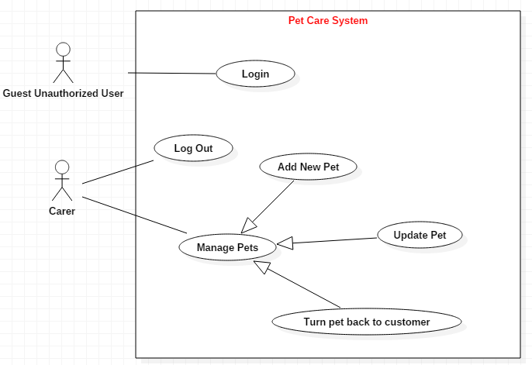

**USE CASE DESCRIPTION**

1. **Actor:**

* **Carer :** include all carers that use this application. They are guests and members. ***Guest*** is the person that uses this application but doesn’t login. ***Member*** is the person that uses this application and login to use.
* **Usecase:**

|  |  |
| --- | --- |
| **Usecase** | Login |
| **Short Description** | Log in application to use any function of member. |
| **Pre-Conditions** |  |
| **Post-Conditions** |  |
| **Main flow** | _Guest inputs the login information :   * Login ID. * Password.   _Guest clicks on the Login button.  _System check the Login ID and Password.  _If Login ID and Password are valid, system will move member to Homepage.  _If a wrong password, a proper message should be given to the carer as to why it failed and let them input again. |
| **Alternative flow(s)** | _If guest clicks on “Reset” button, the Login ID field and Password field are blank.  _If Login ID field or Password field is invalid form or blank when guest clicks on the “Login” button, system will notify the error.  _If server notifies any error when it’s processing, system must be write report into Log file. |

|  |  |
| --- | --- |
| **Usecase** | Manage Pets |
| **Short Description** | Manage all information about pet. |
| **Pre-Conditions** |  |
| **Post-Conditions** |  |
| **Main flow** | _Manage all information of pet. |
| **Alternative flow(s)** | _If server notifies any error when it’s processing, system must be write report into Log file. |

|  |  |
| --- | --- |
| **Usecase** | View Pet’s Information |
| **Short Description** | Carer view pets’s information. |
| **Pre-Conditions** |  |
| **Post-Conditions** |  |
| **Main flow** | _Carer choose the pet that carer wants to see information.  _Carer clicks on the row of the pet which they want to see the information.  _System shows the pet’s information to the carer. |
| **Alternative flow(s)** | _If server notifies any error when it’s processing, system must be write report into Log file. |

|  |  |
| --- | --- |
| **Usecase** | Insert Pets |
| **Short Description** | Insert all information about a pet. |
| **Pre-Conditions** |  |
| **Post-Conditions** |  |
| **Main flow** | _Carer can Insert pet’s information.  _Carer chooses the correlative function. |
| **Alternative flow(s)** | _If server notifies any error when it’s processing, system must be write report into Log file. |

-

|  |  |
| --- | --- |
| **Usecase** | Update pets |
| **Short Description** | Update all information about pet’s information. |
| **Pre-Conditions** |  |
| **Post-Conditions** |  |
| **Main flow** | _Carer can update pets’s information.  _Carer chooses the correlative function. |
| **Alternative flow(s)** | _If server notifies any error when it’s processing, system must be write report into Log file. |

|  |  |
| --- | --- |
| **Usecase** | Search |
| **Short Description** | Search all information about one or many pets. |
| **Pre-Conditions** |  |
| **Post-Conditions** |  |
| **Main flow** | _Carer inputs the information that wants to see in the search field.  _Carer clicks on the “Search” button.  _System shows the result to the carer. |
| **Alternative flow(s)** | _If server notifies any error when it’s processing, system must be write report into Log file. |

|  |  |
| --- | --- |
| **Usecase** | Return the pet back to its owner |
| **Short Description** | Move all information about pet’s information. |
| **Pre-Conditions** |  |
| **Post-Conditions** |  |
| **Main flow** | _Carer can delete pets’s information  _All information of that pet will be moved to Expiry Pet List. |
| **Alternative flow(s)** | _If server notifies any error when it’s processing, system must be write report into Log file. |

|  |  |
| --- | --- |
| **Usecase** | View Expiry Pet’s Information |
| **Short Description** | Carer views all expiry pets’s information. |
| **Pre-Conditions** |  |
| **Post-Conditions** |  |
| **Main flow** | _Carer views all pets which have been taken care of this system.  _Carer clicks the button to see list of expiry pet.  _System shows the pet’s information that have been taken care. |
| **Alternative flow(s)** | _If server notifies any error when it’s processing, system must be write report into Log file. |

**CLASS DIAGRAM**

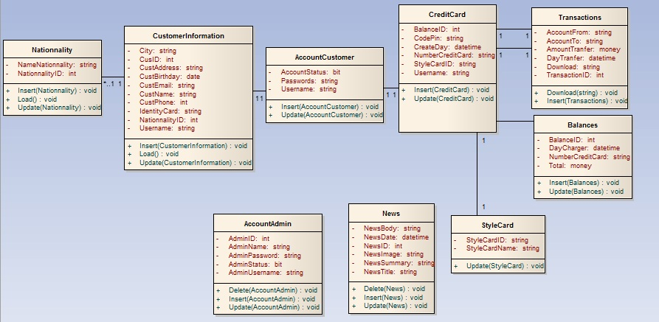

**ENTITY RELATIONSHIP DIAGRAM (ERD)**  
 **Note:  
  
  
ENTITY DESCRIPTION**

Have

Have

Belong

Have

Nationality

Customer  
Information

Account  
Customer

Account  
Admin

Style  
Card

News

Credit  
Card

Transaction

CountHitPage

Contain

Entity

Entity Relationship

One to  
 many relationship

**1.Account Customer :**

**Account  
Customers**

**2. Customer Information :  
3. Nationality :**

**Customer  
Information**

**4. Style Card :  
  
  
  
  
  
  
  
  
5. Transaction :  
  
6. News :**

**Transaction**

**Style Card**

**Nationality**

**News**

**7. Credit Card :**

**8. CountHitPage:**

**Credit Card**

**CountHitPage**

**9. Account Admin :**

**Account  
Admin**

**TABLE DESIGN**

1. **Account Customer :**

|  |  |  |  |  |  |
| --- | --- | --- | --- | --- | --- |
| **No** | **Column Name** | **Data Type** | **Size** | **Check** | **Description** |
| 1 | **🗝**Username | Varchar | 15 | Not Null | Customer ID |
| 2 | Passwords | Varchar | 20 | Not Null | Customer’s password |
| 3 | Account Status | Bit |  | Not Null | Customer’s user name |

1. **Customer Information :**

|  |  |  |  |  |  |
| --- | --- | --- | --- | --- | --- |
| **No** | **Column Name** | **Data Type** | **Size** | **Check** | **Description** |
| 1 | **🗝**CustID | Int | Identity | Not Null | ID |
| 2 | IdentityCard | Varchar | 9 | Null | IdentityCard Customer |
| 3 | CustName | Varchar | 30 | Null | Name Customer |
| 4 | CustBirthday | Date |  | Null | Birthday Customer |
| 5 | CustEmail | Varchar | 50 | Null | Email Customer |
| 6 | CustAddress | Varchar | 100 | Null | Address Customer |
| 7 | CustPhone | Varchar | 15 | Null | Phone Customer |
| 8 | NationalityID | Int |  | Null | Nationality Customer |
| 9 | City | Varchar | 15 | Null | City |
| 10 | Username | Varchar | 15 | Not Null | Customer ID |
| 11 | CustGender | Varchar | 6 | Null | Customer Gender |

1. **Nationality :**

|  |  |  |  |  |  |
| --- | --- | --- | --- | --- | --- |
| **No** | **Column Name** | **Data Type** | **Size** | **Check** | **Description** |
| 1 | **🗝**Nationality ID | Int |  | Not Null |  |
| 2 | Name Nationality | Varchar | 30 | Not Null |  |

1. **StyleCard:**

|  |  |  |  |  |  |
| --- | --- | --- | --- | --- | --- |
| **No** | **Column Name** | **Data Type** | **Size** | **Check** | **Description** |
| 1 | **🗝**Style Card ID | Varchar | 5 | Not Null | Style Card ID |
| 2 | Style Name | Varchar | 10 | Not Null | Name Style Card |

1. **Transactions:**

|  |  |  |  |  |  |
| --- | --- | --- | --- | --- | --- |
| **No** | **Column Name** | **Data Type** | **Size** | **Check** | **Description** |
| 1 | **🗝**Transaction ID | Int |  | Not Null | Transaction ID |
| 2 | Account From | Varchar | 12 | Not Null | Account From |
| 3 | Account To | Varchar | 12 | Not Null | Account To |
| 4 | Day Transfer | Datetime |  | Not Null | Day Tranfer |
| 5 | Amount Transfer | Money |  | Not Null | Amount Tranfer |

1. **News :**

|  |  |  |  |  |  |
| --- | --- | --- | --- | --- | --- |
| **No** | **Column Name** | **Data Type** | **Size** | **Check** | **Description** |
| 1 | **🗝**News ID | Int |  | Not Null | News ID |
| 2 | News Title | Varchar | 300 | Not Null | News Title |
| 3 | News Summary | Varchar | 200 | Not Null | News Summary |
| 4 | News Body | Varchar | Max | Not null | News Body |
| 5 | News Date | Datetime |  | Not Null | News Datetime |
| 6 | News Image | Varchar | 100 | Not Null | News Image |

1. **Credit Card:**

|  |  |  |  |  |  |
| --- | --- | --- | --- | --- | --- |
| **No** | **Column Name** | **Data Type** | **Size** | **Check** | **Description** |
| 1 | **🗝**NumberCreditCard | Varchar | 12 | Not Null | Number Credit Card |
| 2 | Balance | Money |  | Not Null | Balance ID |
| 3 | StyleCardID | Varchar | 15 | Not Null | StyleCard ID |
| 4 | CodePin | Varchar | 250 | Not Null | Code Pin |
| 5 | CreateDay | Datetime |  | Not Null | Create Day |
| 6 | Username | Varchar | 15 | Not Null | Customer ID |

1. **CountHitPage:**

|  |  |  |  |  |  |
| --- | --- | --- | --- | --- | --- |
| **No** | **Column Name** | **Data Type** | **Size** | **Check** | **Description** |
| 1 | Page_Name | Varchar | 100 | Not Null | Page_Name |
| 2 | Dem | int |  | Not Null | Count Page |

1. **Account Admin:**

|  |  |  |  |  |  |
| --- | --- | --- | --- | --- | --- |
| **No** | **Column Name** | **Data Type** | **Size** | **Check** | **Description** |
| 1 | **🗝**AdminID | Int |  | Not Null | Admin ID |
| 2 | AdminStatus | Bit |  | Not Null | Status Admin |
| 3 | AdminUsername | Varchar | 25 | Not Null | Username Admin |
| 4 | AdminPassword | Varchar | 12 | Not Null | Password Admin |
| 5 | AdminName | Varchar | 30 | Not Null | Name Admin |

**Note**

**🗝** Primary key

✓ Unique constraint

**TABLE RELATIONSHIP DIAGRAM**

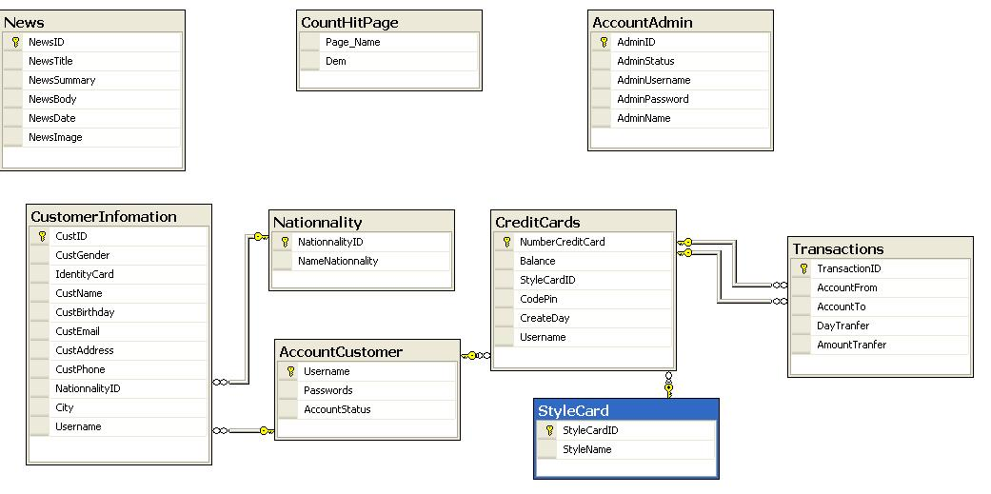

|  |  |  |
| --- | --- | --- |
| **Date: Sep 20, 2012** | **Prepared by Project Group 4**  **Team Leader:** | **Approved by**  **Mr. Ho Hoan Kiem** |
| **Signature** |  |  |

REVIEW 3

**INTERFACE DESIGN**

1. **Home Page**



|  |  |  |  |  |  |
| --- | --- | --- | --- | --- | --- |
| **Name** | **Type** | **Event** | **Validation** | **Description** | **Status** |
| User Name | TextBox |  | String, not null | Input Customer’s user name |  |
| Password | TextBox |  | String, not null, | Input Customer’s password |  |
| Remember Me | Check Box |  | Stick | Remember Customer next time |  |
| Login | Button |  | Click | Choose Login |  |
| Forgot your Password | Hyperlink |  | Click | When Customer forgot password, they can help service supply again. |  |
| Create an Account | Hyperlink |  | Click | Create New Account when Customer like to create. |  |

1. **Login:**

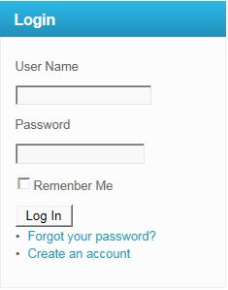

|  |  |  |  |  |  |
| --- | --- | --- | --- | --- | --- |
| **Name** | **Type** | **Event** | **Validation** | **Description** | **Status** |
| User Name | TextBox |  | String, not null | Input Customer’s user name |  |
| Password | TextBox |  | String, not null, | Input Customer’s password |  |
| Remember Me | Check Box |  | Stick | Remember Customer next time |  |
| Login | Button |  | Click | Login |  |

**3.Create Account Customer:**

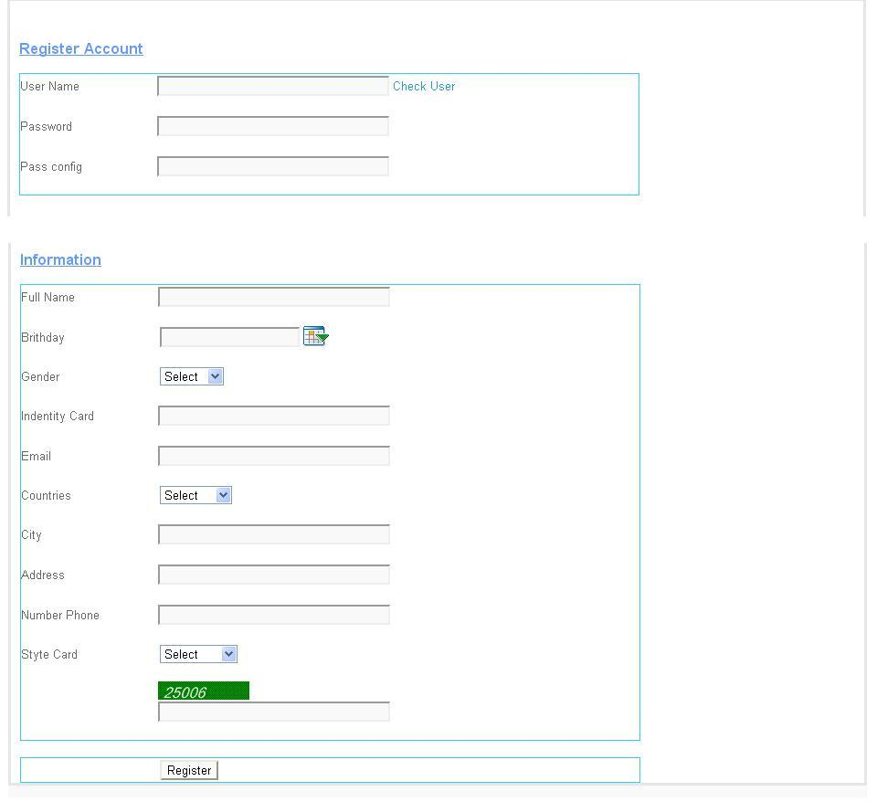

|  |  |  |  |  |  |
| --- | --- | --- | --- | --- | --- |
| **Name** | **Type** | **Event** | **Validation** | **Description** | **Status** |
| UserName | TextBox | Onchange | String, not null | Input UserName Customer |  |
| Password | TextBox |  | String, not null, | Input Customer’s New password |  |
| Config Password | TextBox |  | String,not null | Input Customer’s Config Password |  |
| Full Name | TextBox |  | String, not null | Input Full Name Customer |  |
| Birthday | BasicDate picker |  | Date,not null | Input BirthDay customer |  |
| Gender | DropdownList |  | Select Male,female | Input Male,Female |  |
| Identity Card | TextBox |  | Number, not null | Input Number Identity card |  |
| Email | TextBox |  | String ,not null, have Validation | Input Email Customer |  |
| Countries | Dropdownlist |  | Select | Input Countries Customer |  |
| City | TextBox |  | String, not null | Input City Customer |  |
| Address | TextBox |  | String, not null | Input Address Customer |  |
| Phone Number | TextBox |  | Number,not null | Input Phone Number Customer |  |
| Styte Card | DropDownList |  | Select | Input Styte Card Customer |  |
| CapChar | TextBox |  |  | Input number follow Image at above Text Box |  |
| Register | Button |  | Click | Register Customer |  |

**4.Forgot Password:**

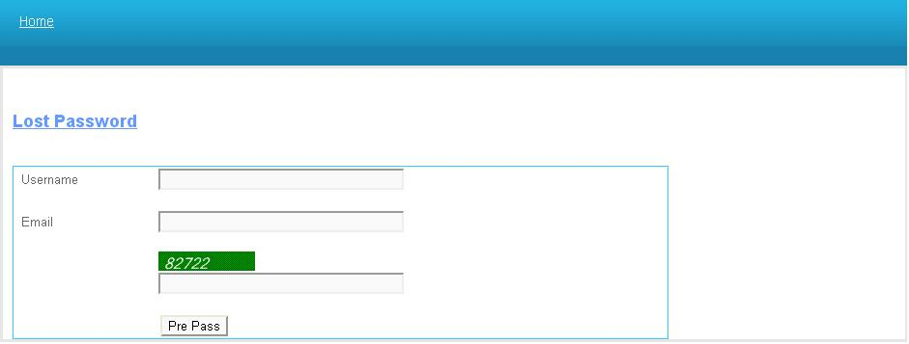

|  |  |  |  |  |  |
| --- | --- | --- | --- | --- | --- |
| **Name** | **Type** | **Event** | **Validation** | **Description** | **Status** |
| UserName | TextBox |  | String,not null | Input UserName Customer |  |
| Email | TextBox |  | String ,not null, have Validation | Input Email Customer |  |
| CapChar | TextBox |  |  | Input number follow Image at above Text Box |  |

**5.Change Password:**

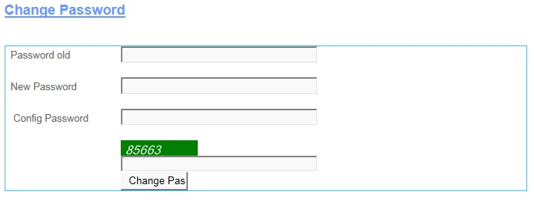

|  |  |  |  |  |  |
| --- | --- | --- | --- | --- | --- |
| **Name** | **Type** | **Event** | **Validation** | **Description** | **Status** |
| Password Old | TextBox |  | String, not null | Input Customer’s Password old |  |
| New Password | TextBox |  | String, not null, | Input Customer’s New password |  |
| Config Password | TextBox |  | String,not null | Input Customer’s Config Password |  |
| CapChar | TextBox |  |  | Input number follow Image at above Text Box |  |
| Change Password | Button |  | Click | Change Password |  |

**6.Change CodePin:**

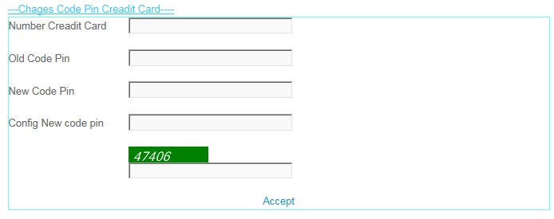

|  |  |  |  |  |  |
| --- | --- | --- | --- | --- | --- |
| **Name** | **Type** | **Event** | **Validation** | **Description** | **Status** |
| Number Credit Card | TextBox |  | int, not null | Input Customer’s Number Credit Card |  |
| Old Code Pin | TextBox |  | int, not null, | Input Customer’s Old Code Pin |  |
| New Code Pin | TextBox |  | int,not null | Input Customer’s New Code Pin |  |
| Config New Code Pin | TextBox |  | int, not null | Input Customer’s Config New Code Pin |  |
| CapChar | TextBox |  | int ,not null | Input number follow Image at above Text Box |  |
| Accept | LinkButton |  | Click | Accept Change code Pin . |  |

**7.Create Information:**

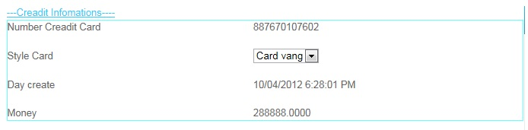

|  |  |  |  |  |  |
| --- | --- | --- | --- | --- | --- |
| **Name** | **Type** | **Event** | **Validation** | **Description** | **Status** |
| Number Credit Card | Label |  | Read Only | View Number Credit Card |  |
| Style Card | Drop Down List |  | Select | View and select Card |  |
| Day Create | Label |  | Read Only | View Day Create |  |
| Money | Label |  | Read Only | View Money |  |

**8.Edit Account User:**

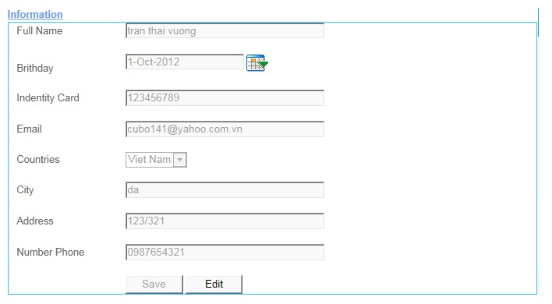

|  |  |  |  |  |  |
| --- | --- | --- | --- | --- | --- |
| **Name** | **Type** | **Event** | **Validation** | **Description** | **Status** |
| Full Name | TextBox |  | String, not null | Input Full Name |  |
| Birthday | TextBox |  | DatetTime | Input DateTime |  |
| Calendar Tool | Calendar |  | Select | Select Date on Calendar |  |
| Identity Card | TextBox |  | Int , not null | Input identity Card |  |
| Email | TextBox |  | String ,not null, have Validation | Input Customer’s Email |  |
| Country | DropDownList |  | Select | Select country |  |
| Address | TextBox |  | Int, not null | Input Customer’s Address |  |
| Number Phone | TextBox |  | Int, not null | Input Customer’s Number Phone |  |
| Save | Button |  | Click | click save edit enable |  |
| Edit | Button |  | Click | click edit Save unenable |  |

**9.Transaction:**

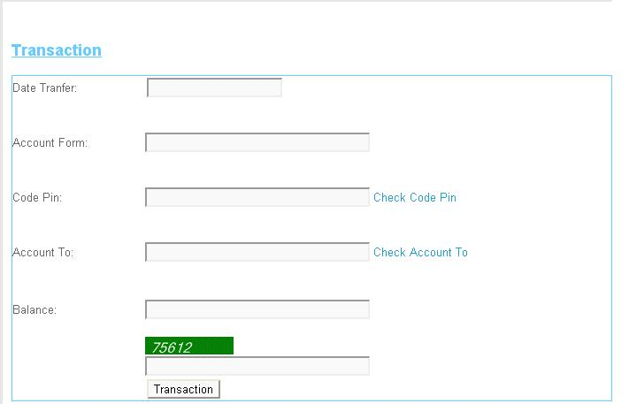

|  |  |  |  |  |  |
| --- | --- | --- | --- | --- | --- |
| **Name** | **Type** | **Event** | **Validation** | **Description** | **Status** |
| Date Tranfer | TextBox |  | DateTime, not null | Input Date Tranfer |  |
| Account From | TextBox |  | DatetTime | Input Account From |  |
| Code Pin | TextBox |  | Int, not null and Valiadaton | Input Code Pin |  |
| Account To | TextBox |  | DateTime, not null and Validation | Input Account To |  |
| Balance | TextBox |  | String ,not null, have Validation | Input Customer’s Balance |  |
| Transaction | Button |  | Click | Transaction |  |
| Check CodePin | LinkButton |  | Click | Check Codepin inval or not inval.. |  |
| Check Account To | LinkButton |  | Click | Check Account Inval or Not inval |  |
| CapChar | TextBox |  | int ,not null | Input number follow Image at above Text Box |  |

**10.Transaction Admin:**

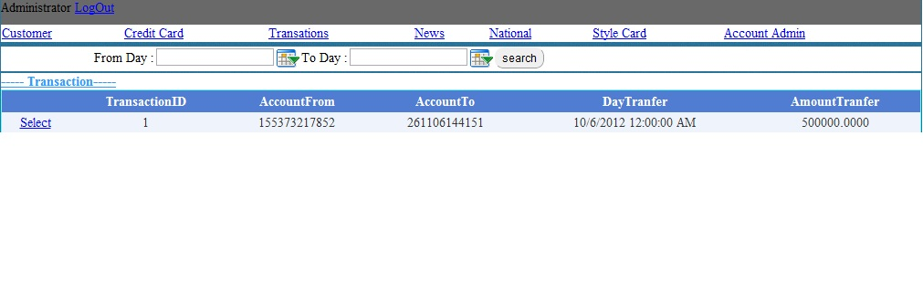

|  |  |  |  |  |  |
| --- | --- | --- | --- | --- | --- |
| **Name** | **Type** | **Event** | **Validation** | **Description** | **Status** |
| Log Out | LoginStatus |  | Click | Click Log Out |  |
| From Day | BasicdatePicker |  | Date time | Input From Date tranfer |  |
| To Day | BasicDatePicker |  | Date Time | Input To Date Tranfer |  |
| Transaction | Drop Down List |  | Select inform | Select Transaction |  |
| List Transaction | Grid view |  | Read Only | View inform Transaction |  |
| Select | LinkButton |  | Select | Select then view Detail |  |

**11.View Transaction:**

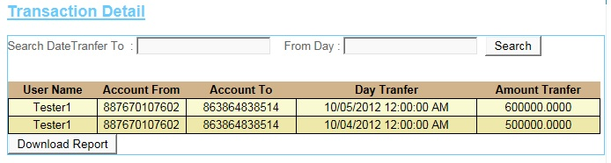

|  |  |  |  |  |  |
| --- | --- | --- | --- | --- | --- |
| **Name** | **Type** | **Event** | **Validation** | **Description** | **Status** |
| Search Date Transfer To | TextBox |  | DateTime , not null | Input DateTime |  |
| From Day | TextBox |  | DateTime , not null | Input DateTime |  |
| Search | Button |  | Click | Search |  |
| Transaction Detail | GridView |  | Read Only | View Inform of Detail’s Transaction |  |
| DownLoad Report | Button |  | Click | DownLoad Report |  |

**12.News:**

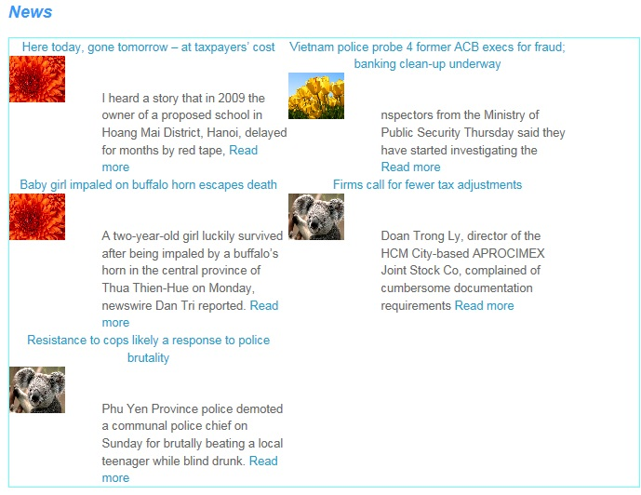

**13.AdminLogin:**

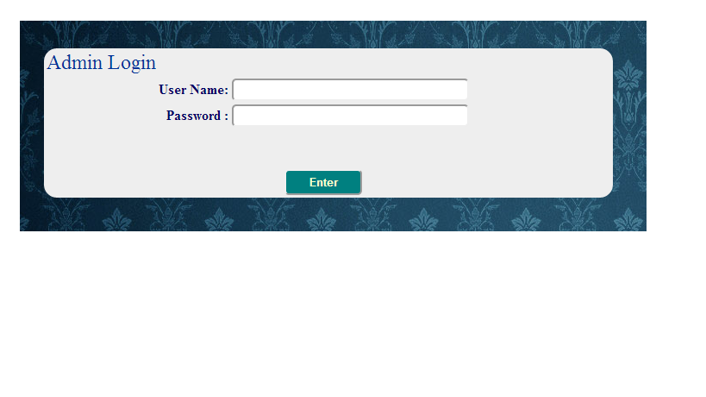

|  |  |  |  |  |  |
| --- | --- | --- | --- | --- | --- |
| **Name** | **Type** | **Event** | **Validation** | **Description** | **Status** |
| User Name | TextBox |  | String, not null | Input Admin’s user name |  |
| Password | TextBox |  | String, not null, | Input Admin’s password |  |
| Enter | Button |  | Click |  |  |

**14.AccountAdmin:**

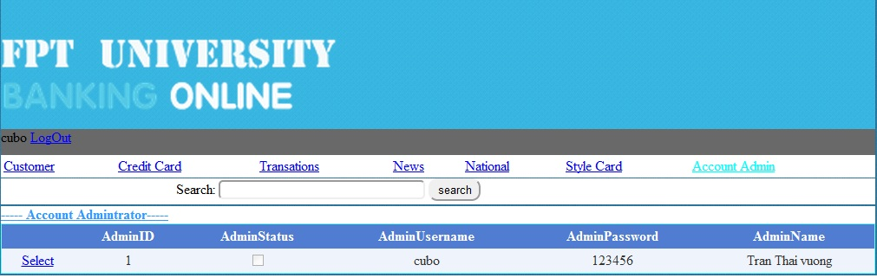

|  |  |  |  |  |  |
| --- | --- | --- | --- | --- | --- |
| **Name** | **Type** | **Event** | **Validation** | **Description** | **Status** |
| Search | TextBox | Onkeydown | String, | Search Admin’s Usernmae |  |
| Select Object | Hyperlink |  |  |  |  |
| DetailView1 | DetailsView |  |  | Select Account Admin |  |
| Select | Linbutton |  |  | Select Details Account Admin |  |

**15.AccountCustomer:**

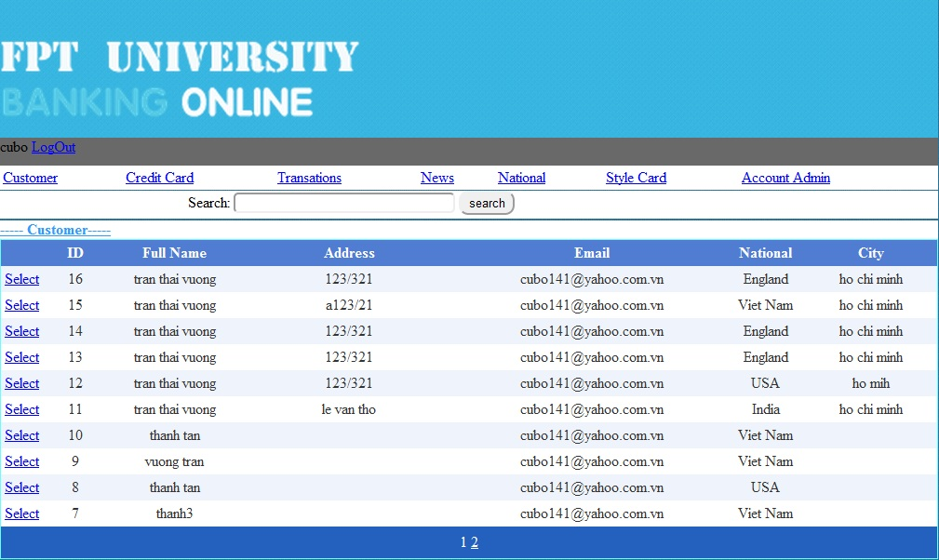

|  |  |  |  |  |  |
| --- | --- | --- | --- | --- | --- |
| **Name** | **Type** | **Event** | **Validation** | **Description** | **Status** |
| Search | TextBox |  | String | Search Customer’s Username |  |
| Select Object | Hyperlink |  |  |  |  |
| GridviewAccountCustomer | Gridview |  |  | Select Account Customer |  |
| Select | Linbutton |  |  | Select Details Account Customer |  |

**16.CreditCard:**

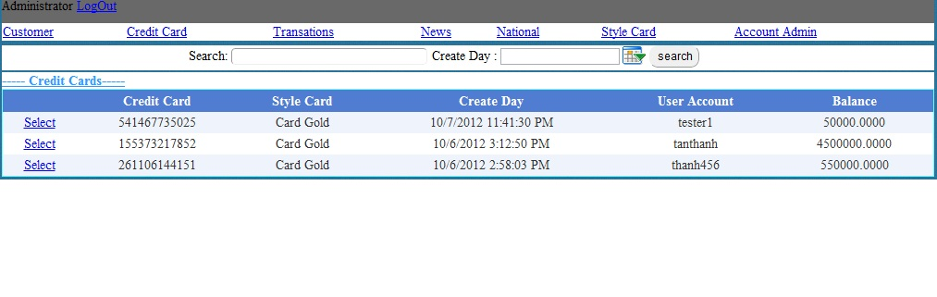

|  |  |  |  |  |  |
| --- | --- | --- | --- | --- | --- |
| **Name** | **Type** | **Event** | **Validation** | **Description** | **Status** |
| Search | TextBox | OnKeyDown | String | Search UserName |  |
| Select Object | Hyperlink |  |  |  |  |
| GvCreditCard | Gridview |  |  | Select ListCreditCard |  |
| Select | Linbutton |  |  | Select Details CreditCard |  |

**17.StyleCard:**

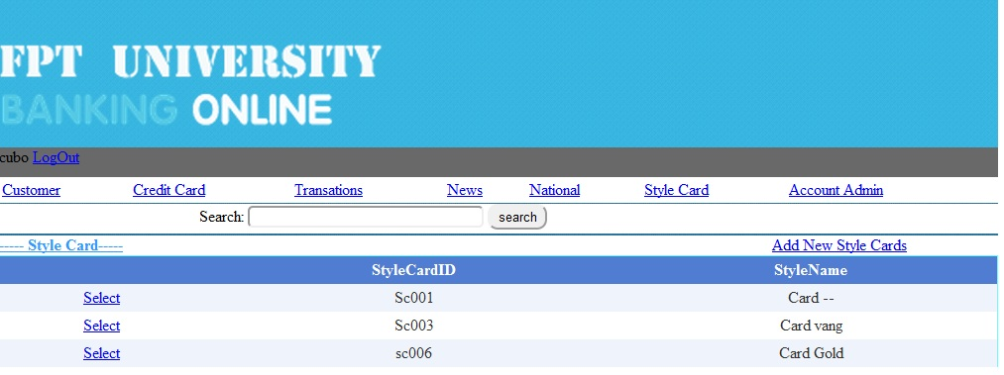

|  |  |  |  |  |  |
| --- | --- | --- | --- | --- | --- |
| **Name** | **Type** | **Event** | **Validation** | **Description** | **Status** |
| Search | TextBox | OnkeyDown | String | Search Style CardName |  |
| Select Object | Hyperlink |  |  |  |  |
| GvStyleCard | Gridview |  |  | Select Style Card |  |
| Select | Linbutton |  |  | Select Details Style Card |  |

**18.News:**

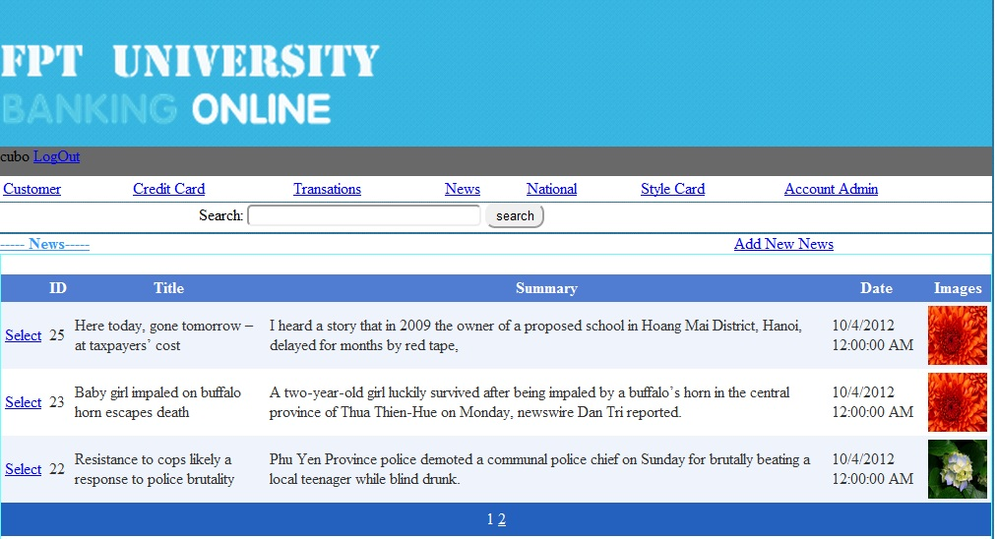

|  |  |  |  |  |  |
| --- | --- | --- | --- | --- | --- |
| **Name** | **Type** | **Event** | **Validation** | **Description** | **Status** |
| Search | TextBox | Onkeydown | String | Search Title News |  |
| Select Object | Hyperlink |  |  | Go Add new News |  |
| GvNews | Gridview |  |  | Select News |  |
| Select | Linbutton |  |  | Select Details News |  |

**19.National:**

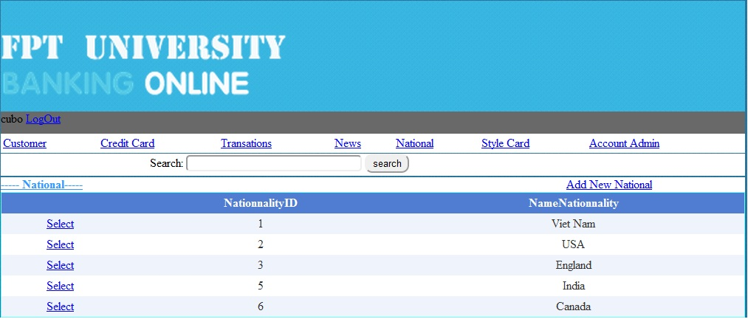

|  |  |  |  |  |  |
| --- | --- | --- | --- | --- | --- |
| **Name** | **Type** | **Event** | **Validation** | **Description** | **Status** |
| Search | TextBox | onKeydown | String | Search Name Nationality |  |
| Select Object | Hyperlink |  |  |  |  |
| Gv Nationality | Gridview |  |  | Select Nationality |  |
| Select | Linbutton |  |  | Select Details Nationality |  |

**20.Details Account Admin:**

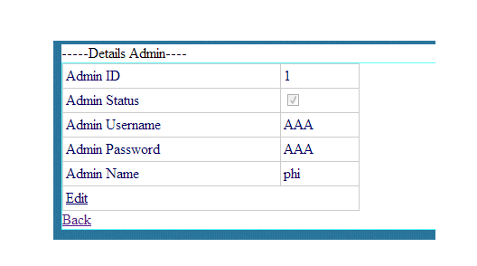

|  |  |  |  |  |  |
| --- | --- | --- | --- | --- | --- |
| **Name** | **Type** | **Event** | **Validation** | **Description** | **Status** |
| Edit | LinkButton |  |  | Edit Account Admin |  |
| Back | LinkButon |  |  | Back to MainAdmin.aspx |  |
| DetailsView1 | DetailsView |  |  | Select Details Admin |  |

**21.Details Account Customer:**

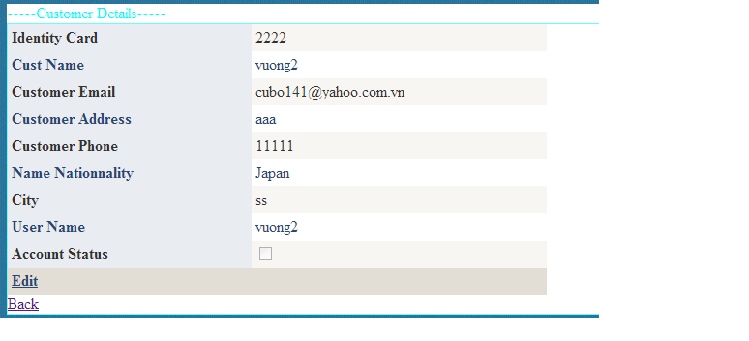

|  |  |  |  |  |  |
| --- | --- | --- | --- | --- | --- |
| **Name** | **Type** | **Event** | **Validation** | **Description** | **Status** |
| Edit | LinkButton |  |  | Edit Account Customer |  |
| Back | LinkButon |  |  | Back to MainAdmin.aspx |  |
| DetailsView1 | DetailsView |  |  | Select Customer Information |  |

**22.Details Credit Card:**

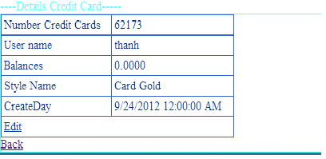

|  |  |  |  |  |  |
| --- | --- | --- | --- | --- | --- |
| **Name** | **Type** | **Event** | **Validation** | **Description** | **Status** |
| Edit | LinkButton |  |  | Edit Balance of Customer |  |
| Back | LinkButon |  |  | Back to MainAdmin.aspx |  |
| DetailsView1 | DetailsView |  |  | Select Details Credit Card of |  |

**23.Details Style Card:**

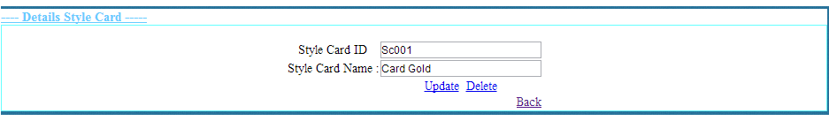

|  |  |  |  |  |  |
| --- | --- | --- | --- | --- | --- |
| **Name** | **Type** | **Event** | **Validation** | **Description** | **Status** |
| txtStyleCardID | TextBox |  | String,Not null | Input Style CardID |  |
| txtStyleCardName | TextBox |  | String,Not null | Input Style Card Name |  |
| Update | LinkButton |  |  | Update Style Card |  |
| Delete | LinkButton |  |  | Delete Style Card |  |
| Back | LinkButtom |  |  | Back to MainAdmin.aspx |  |

**24.News:**

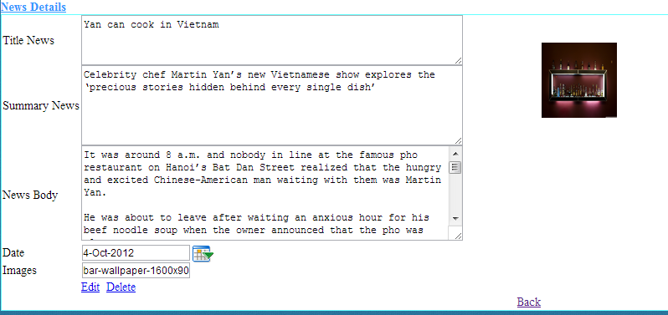

|  |  |  |  |  |  |
| --- | --- | --- | --- | --- | --- |
| **Name** | **Type** | **Event** | **Validation** | **Description** | **Status** |
| txtTitle News | TextBox |  | String,Not null | Input Title News |  |
| txtSummary News | TextBox |  | String,Not null | Input Summary News |  |
| txtNews Body | TextBox |  | String,Not null | Input News Body |  |
| txtDay | BasicDatePicker |  | Datetime,Not null | Input Datetime |  |
| txtImages | TextBox |  | String ,Not null | Input Images |  |
| Edit | LinkButton |  |  | Update Style Card |  |
| Delete | LinkButton |  |  | Delete Style Card |  |
| Back | LinkButtom |  |  | Back to MainAdmin.aspx |  |

**24.Details Nationality:**

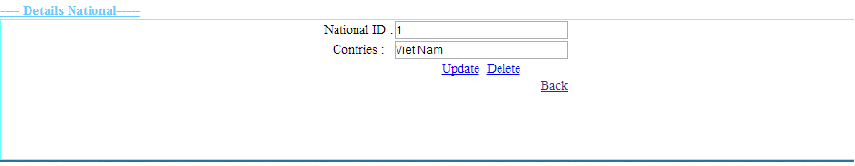

|  |  |  |  |  |  |
| --- | --- | --- | --- | --- | --- |
| **Name** | **Type** | **Event** | **Validation** | **Description** | **Status** |
| txtID | TextBox |  | String,Not null | Input CardID |  |
| txtNationalityName | TextBox |  | String,Not null | Input Nationality |  |
| Update | LinkButton |  |  | Update Nationality |  |
| Delete | LinkButton |  |  | Delete Nationality |  |
| Back | LinkButtom |  |  | Back to MainAdmin.aspx |  |

**Support:**

**+ Connected**

* **Gold :**

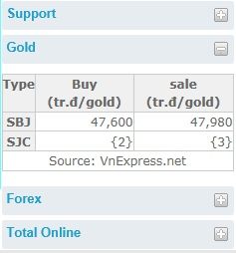

* **Forex :**

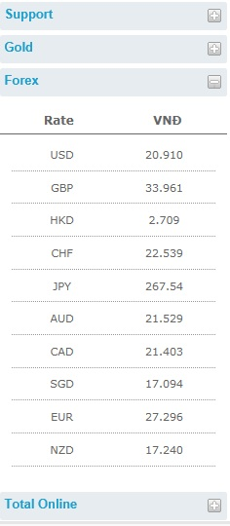

**+Disconnection**

* **Gold :**

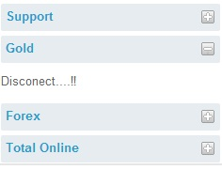

* **Forex :**

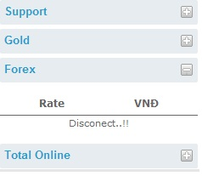

**+Total Online**

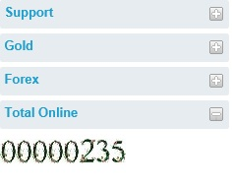

**TASK SHEET**

|  |  |  |  |  |  |  |
| --- | --- | --- | --- | --- | --- | --- |
| **Project Group FFG** | | **Project Title**  **Laptop Shop Online** | | **Date of Preparation** | | **Activity Plan Prepared by**  **Le Hoang Hai** |
| **No** | **Task Title** | | **Planned Start Date** | **Planned Completed Date** | **Team Mate Names** | **Status** |
| 1 | Login Customer | | Sep 10, 2012 | Oct 10, 2012 |  |  |
| 2 | Search admin evevnt onkeydown | |  |
| 3 | Change CodePin Credit Card | |  |
| 4 | Load News Masterpage Customer | |  |
| 5 | Design Masterpage Customer | |  |
| 6 | Register Customer | |  |  |
| 7 | Change Password | |  |
| 8 | Forget Password | |  |
| 9 | Credit card Infomation | |  |
| 10 | Your`s Profile | |  |
| 11 | Login Admin | |  |  |
| 12 | Edit Credit Card | |  |
| 13 | Edit Style Card | |  |
| 14 | Edit National | |  |
| 15 | Masterpage Admin | |  |
| 16 | Edit Status Customer | |  |  |
|  |
| 17 | Show Transaction | |  |
| 18 | Edit Balance | |  |
| 19 | Add, Edit, Delete news | |  |
| 20 | Customer Transaction | |  |  |
| 21 | Detail Transaction | |  |
| 22 | Download Report Transaction | |  |
| 23 | Create Report | |  |
| 25 | Contact | |  |
| 26 | Search Report | |  |
| 27 | Design Masterpage Customer | |  |

|  |  |  |
| --- | --- | --- |
| **Date: Oct 10, 2012** | **Prepared by Project Group 4**  **Team Leader:** | **Approved by**  **Mr. Ho Hoan Kiem** |
| **Signature** |  |  |